KARNATAK LAW SOCIETY’S

GOGTE INSTITUTE OF TECHNOLOGY

UDYAMBAG, BELAGAVI-590008

(An Autonomous Institution under Visvesvaraya Technological University, Belagavi)

**(APPROVED BY AICTE, NEW DELHI)**



*Course Seminar Report*

**TITLE**

*GEOSYNTHETICS*

*Submitted in the partial fulfillment for the academic requirement**of*

***…II… Semester B.E.***

***in***

*(Name of the Programme*)**_____*Engineering Mechanics*__________________**

*Submitted by*

|  |  |  |  |
| --- | --- | --- | --- |
| **Name** | **USN** | **Roll Number** | **Signature** |
| Shradha.M.Patil | 2GI20CS144 | I 2 |  |
| Gouri.N.Huddar | 2GI20EE009 | I 45 |  |
| Omprakash Jat | 2GI20IS020 | I 47 |  |
| Smruti.S.Bhandiwad | 2GI20IS041 | I 49 |  |

**GUIDE**

Prof. R.D.Deshpande,Dept of Civil Engineering

**20…. – 20….**

CONTENTS:

1. Concept of geosynthetics
2. Role of geosynthetics
3. Geosynthetics products
4. Application of geosynthetics
5. Geosynthetic products of natural material
6. Tests for Geosynthetics
7. Advantages
8. Analysis of present scenario (Usage, graphs)
9. References
10. Concept of geosynthetics:

Geosynthetics – a planar product manufactured from polymeric materials used with rock, earth, or other geotechnical engineering related material as an integral part of a human-made project, structure, or system.

Geosynthetics are synthetic products used to stabilize terrain. They are generally polymeric products used to solve civil engineering problems. This includes eight main product categories: geotextiles, geogrids, geonets, geomembranes, geosynthetic clay liners, geofoam, geocells and geocomposites.  The polymeric nature of the products makes them suitable for use in the ground where high levels of durability are required. They can also be used in exposed applications.

The term ‘Geosynthetics’ has two parts: the prefix ‘geo’, referring to an end use associated with improving the performance of civil engineering works involving earth/ground/soil and the suffix ‘synthetics’, referring to the fact that the materials are almost exclusively from man-made products. The materials used in the manufacture of geosynthetics are primarily synthetic polymers generally derived from crude petroleum oils; although rubber, fiberglass, and other materials are also sometimes used for manufacturing geosynthetics.

2.Role of geosynthetics:

* Preventing intermixing of soil types or soil/aggregate to maintain the integrity of each material yet still allowing the free passage of liquids/gases. Commonly used in between sub-base/subgrade and around drainage materials.
* Allowing fluids and gases to flow both through the plane of the material. Commonly used as components in geocomposites used for surface water runoff or for gas collection under membranes.
* Restraining soil particles subject to hydraulic forces whilst allowing the passage of liquids/gases. This function is often partnered with separation e.g. in coastal defence applications or wrapped drains.
* Providing additional strength to soils to enable steep slopes and soil structures to be constructed, and allow construction over weak and variable soils.

3.Geosynthetics products:

Geosynthetic products include eight main product categories:

*i)Geotextiles:*

Geotextiles are permeable textiles or fabrics used to separate, filter, reinforce, protect, or drain. In roads and rail applications, they allow filtration and separation of granular layers. They are also used to protect membranes in landfill applications and in coastal defense applications. Geotextiles are high in strength to allow for maximum slope support, stabilization and erosion control. They are textiles consisting of synthetic fibers rather than natural ones such as cotton, wool, or silk. This makes them less susceptible to bio-degradation.

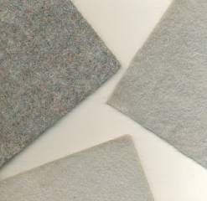

*ii)Geogrids:*

A geogrid is geosynthetic material used to reinforce soils and similar materials. Geogrids are commonly used to reinforce retaining walls, as well as subbases or subsoils below roads or structures. Soils pull apart under tension. Compared to soil, geogrids are strong in tension. This fact allows them to transfer forces to a larger area of soil than would otherwise be the case.

Geogrids are commonly made of polymer materials, such as polyester, polyvinyl alcohol, polyethylene or polypropylene

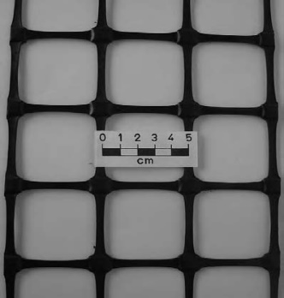

*iii)Geonets/Geospacers:*

Geonets, and the related *ge*ospacersby some, constitute another specialized segment within the geosynthetics area. They are formed by a continuous extrusion of parallel sets of polymeric ribs at acute angles to one another. When the ribs are opened, relatively large apertures are formed into a netlike configuration. Two types are most common, either biplanar or triplanar. Alternatively many very different types of drainage cores are available. They consist of nubbed, dimpled or cuspated polymer sheets, three-dimensional networks of stiff polymer fibers in different configurations and small drainage pipes or spacers within geotextiles. Their design function is completely within the drainage area where they are used to convey liquids or gases of all types.

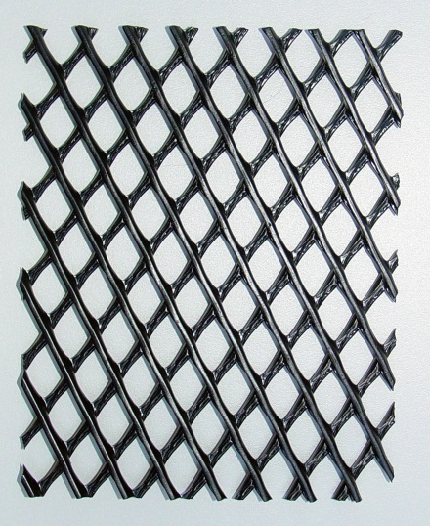

*iv)Geomembranes:*

It is a planar, relatively impermeable, synthetic sheet manufactured from materials of low permeability to control fluid migration in a project as a barrier or liner. The materials may be polymeric or asphaltic or a combination thereof. The term barrierapplies when the geomembrane is used inside an earth mass. The term lineris usually reserved for the cases where the geomembrane is used as an interface or a surface revetment. The primary function is always containment as a liquid or vapor barrier or both.

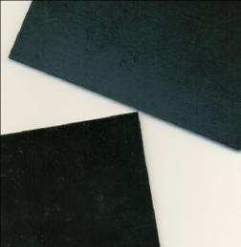

*v)Geosynthetic clay liners:*

Geosynthetic clay liners, or GCLs, are an interesting juxtaposition of polymeric materials and natural soils. They are rolls of factory fabricated thin layers of bentonite clay sandwiched between two geotextiles or bonded to a geomembrane. Structural integrity of the subsequent composite is obtained by needle-punching, stitching or adhesive bonding. GCLs are used as a composite component beneath a geomembrane or by themselves in geoenvironmental and containment applications as well as in transportation, geotechnical, hydraulic, and many private development applications.

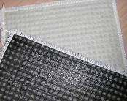

*vi)Geofoam:*

Geofoam is a polymeric product created by processing polystyrene into a foam consisting of many closed cells filled with air and/or gases. The skeletal nature of the cell walls resembles bone-structures made of the unexpanded polymeric material. The resulting product is generally in the form of large, but extremely light, blocks which are stacked side-by-side and in layers providing lightweight fill in numerous applications.

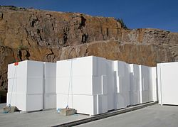

*vii)Geocells:*

Geocells (also known as Cellular Confinement Systems) are three-dimensional honeycombed cellular structures that form a confinement system when infilled with compacted soil. Extruded from polymeric materials into strips welded together ultrasonically in series, the strips are expanded to form the stiff (and typically textured and perforated) walls of a flexible 3D cellular mattress. Infilled with soil, a new composite entity is created from the cell-soil interactions. The cellular confinement reduces the lateral movement of soil particles, thereby maintaining compaction and forms a stiffened mattress that distributes loads over a wider area. Traditionally used in slope protection and earth retention applications, geocells made from advanced polymers are being increasingly adopted for long-term road and rail load support. Much larger geocells are also made from stiff geotextiles sewn into similar, but larger, unit cells that are used for protection bunkers and walls.

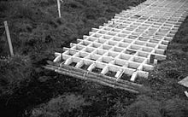

*viii)Geocomposites:*

A geocomposite consists of a combination of geotextiles, geogrids, geonets and/or geomembranes in a factory fabricated unit. Also, any one of these four materials can be combined with another synthetic material (e.g., deformed plastic sheets or steel cables) or even with soil. As examples, a geonet or geospacer with geotextiles on both surfaces and a GCL consisting of a geotextile/bentonite/geotextile sandwich are both geocomposites. This specific category brings out the best creative efforts of the engineer and manufacturer. The application areas are numerous and constantly growing. The major functions encompass the entire range of functions listed for geosynthetics discussed previously: separation, reinforcement, filtration, drainage, and containment.

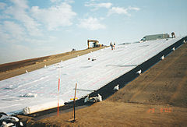

4.Application of Geosynthetics:

Environmental Protection:

* Land Engineering
* Coastal Protection
* Rock fall protection
* Canal Lining
* Flood Control

Infrastructure Development

* Roads
* Railways
* Ground Improvement
* Slope Stabilization

Roads:

* Roads often have to be constructed across weak and compressible soil subgrades. It is therefore common practice to distribute the traffic loads in order to decrease the stresses on the soil subgrade.
* This is generally done by placing a granular layer over the soil subgrade. The granular layer should present good mechanical properties and enough thickness.
* The long-term interaction between a fine soil subgrade and the granular layer, under dynamic loads, is likely to cause pumping erosion of the soil subgrade and penetration of the granular particles into the soil subgrade, giving rise to permanent deflections and eventually to failure.
* At present, geosynthetics are being used to solve many such problems.

Railways:

* Railway tracks serve as a stable guide way to trains with appropriate vertical and horizontal alignment.
* To achieve this role each component of the track system must perform its specific functions satisfactorily in response to the traffic loads and environmental factors imposed on the system.
* Geosynthetics play an important role in achieving higher efficiency and better performance of modern-day railway track structures. They are nowadays used to correct some track support problems.
* Acceptance and use of geotextiles for track stabilization is now common practice in the USA, Canada and Europe.
* Geotextiles are also being used in high maintenance locations such as turnouts, rail crossings, switches and highway crossings. One of the most important areas served by geotextiles is beneath the mainline track for stabilization of marginal or poor subgrade, which can suffer from severe mud-pumping and subsidence.

Slope Stabilization:

In recent years geosynthetic-reinforced slopes have provided innovative and cost-effective solutions to slope stabilization problems, particularly after a slope failure has occurred or if a steeper than safe unreinforced slope is desirable. They provide a wide array of design advantages as mentioned below :

* reduce land requirement to facilitate a change in grade;
* provide additional usable area at toe or crest of slope;
* use available on-site soil to balance earthwork quantities;
* eliminate import costs of select fill or export costs of unsuitable fill;
* meet steep changes in grade, without the expense of retaining walls;
* eliminate concrete face treatments, when not required for surficial stability or erosion control;
* provide a natural vegetated face treatment for environmentally sensitive areas;
* offer a design that is easily adjustable for surcharge loadings from buildings and vehicles.

5.Geosynthetic products of natural material:

* Although most of the geosynthetics are made from synthetic polymers, a few specialist geosynthetics, especially geotextiles, may also incorporate steel wire or natural biodegradable fibres such as jute, coir, paper, cotton, wool, silk, etc.
* Biodegradable geotextiles are usually limited to erosion control applications where natural vegetation will replace the geotextile’s role as it degrades. Jute nets are marketed under various trade names, including *geojute, soil saver, and anti-wash*.
* They are usually in the form of a woven net with a typical mesh open size of about 10 by 15 mm, a typical thickness of about 5 mm and an open area of about 65%.
* Vegetation can easily grow through openings and use the fabric matrix as support. The jute, which is about 80% natural cellulose, should completely degrade in about two years. An additional advantage of these biodegradable products is that the decomposed jute improves the quality of the soil for vegetation growth.

6. Tests for Geosynthetics:

* UV resistance
* Chemical and biological resistance
* Fire resistance
* Mechanical damage resistance
* Toxicity
* Water flow or permeability
* Tensile strength
* Shear resistance

7. Advantages:

* Saving in labour
* Construction is easy and speedy
* Easy for complicated structures
* No noise pollution
* Aesthetically good and eco-friendly
* Reliable and easy to install
* Lightweight with minimum maintenance.
* Geosynthetics have low handling and overall costs.

References:

* <https://en.wikipedia.org/wiki/Geosynthetics#Functions>.
* <https://www.corrosionpedia.com/definition/1947/geotextile>.
* www.btraindia.com