**Git Merge with Beyond Compare(BC3) Professional Version**

* Please install Beyond Compare 3 Professional Version available in the software center.
* Install Git from software center
* Go to command prompt and verify that you have git installed and you do not see bc3 as diff tool or merge tool

git config --list

* To install bc3 as diff tool for git run the following commands:

git config --global diff.tool bc3

git config --global difftool.bc3.path "c:/Program Files (x86)/Beyond Compare 3/bcomp.exe"

* Run:

git config --list

* You should see:

diff.tool=bc3

difftool.bc3.path=c:/Program Files (x86)/Beyond Compare 3/bcomp.exe

* Modify a versioned file(foofile.txt for instance) and run:

git difftool foofile.txt

* To install bc3 as merge tool (the interesting part) run the below commands:

git config --global merge.tool bc3

git config --global mergetool.bc3.path "c:/Program Files (x86)/Beyond Compare 3/bcomp.exe"

git config --global mergetool.keepBackup false

* Run:

git config --list

* You should see:

merge.tool=bc3

mergetool.bc3.path=c:/Program Files (x86)/Beyond Compare 3/bcomp.exe

mergetool.keepbackup=false

* Lets walk through a merge scenario.

After you make a change commit the file in GitEye and pull. You end up with a merge conflict and see this:

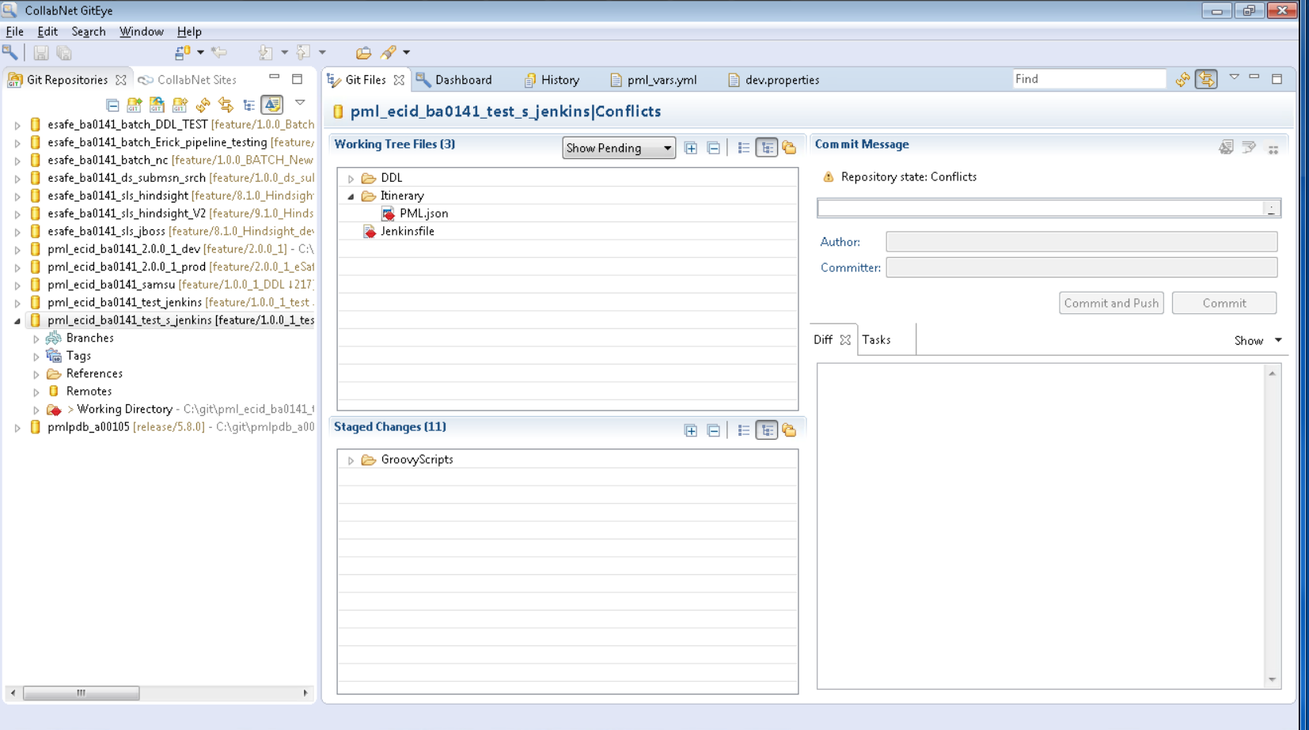

In the command window navigate to the folder that has the file and run this command:

git mergetool <file>

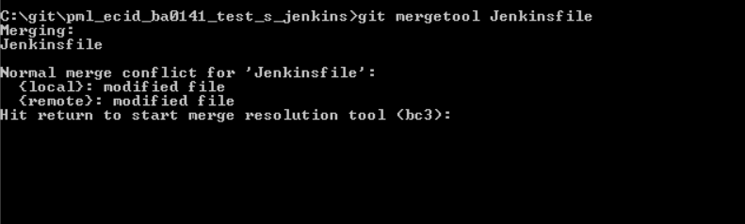

Hit enter and you will see beyond compare come up:

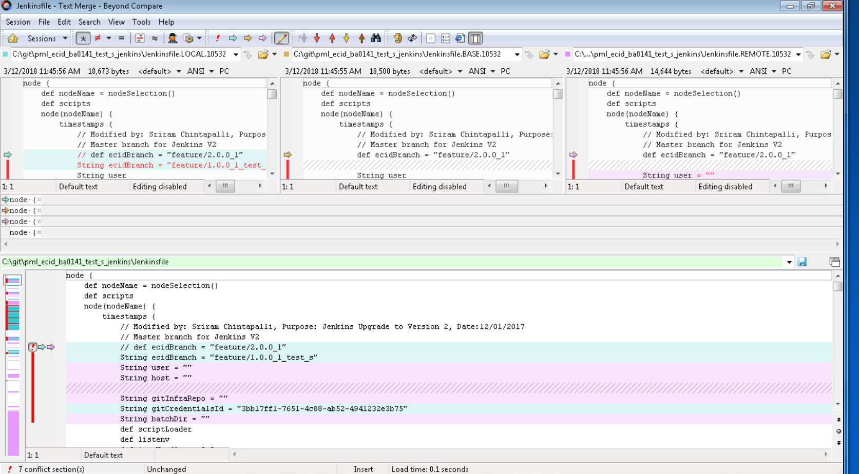

In the top 3 windows the left has your changes, the right has changes from the branch you are trying to merge from and the middle is where the last common state for both left and right(you can ignore the middle). Bottom window is where the merge happens. Red exclamation shows a conflict. Click on the blue arrow and your changes get selected or click the purple arrow and the remote changes get selected. You can click on the next conflict button on top to navigate to the next conflict and work your way through your changes. After the file is merged save and exit beyond compare and you will notice in GitEye that the file is automatically added to staged changes. You can commit this file. You can do this for all the files that are in conflict state.

