Installation
- Start Eclipse.
- Select Window>Preferences>... menu item.
- Select Java>Code Style> Formatter>
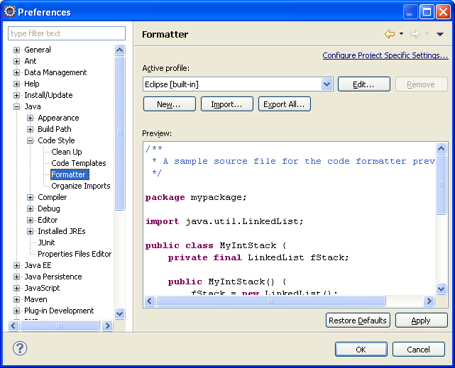
- Import Active Profile. EclipseJavaStandards.xml is already in the same folder as this document.
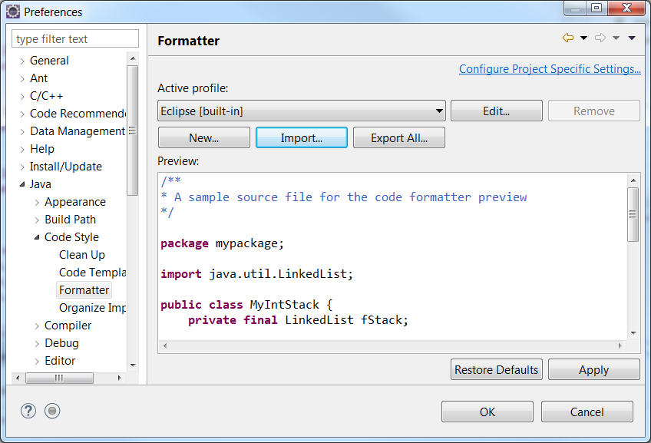
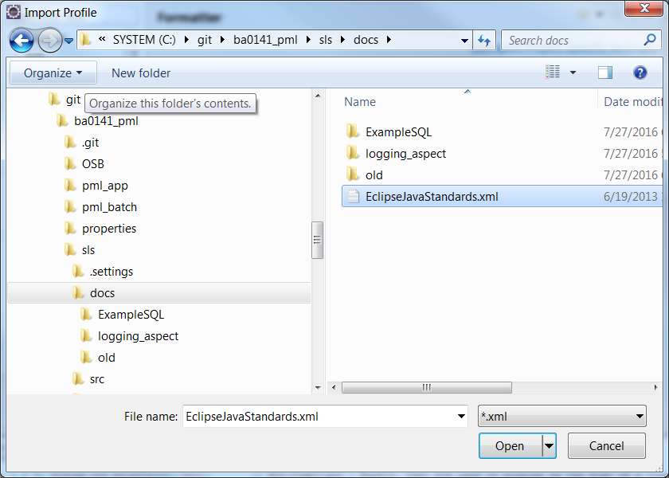
- The following screen will come.
Please select the java code style formatter file from this path(C:\Development\EsafeRepositories_SLSNG_SPRINGBOOT\esafe_ba0315_submissionlinkservice\SubmissionLinkService\docs\java code style formatter\EclipseJavaStandards.xml)
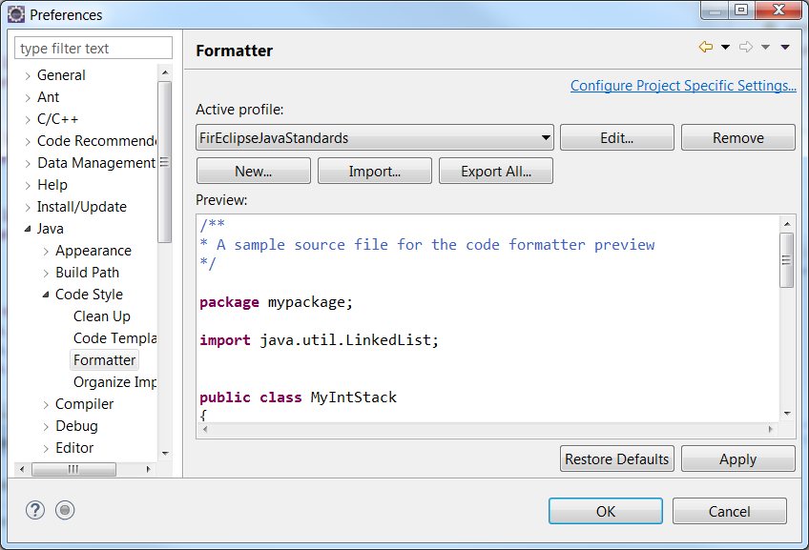
- Select Apply and OK. (profile is set for formatting)

- Now to use the for the source code, Open the Source Code in Eclipse,
Select All (Ctrl+A) and Right Click > Source> Format
Alternatively, Ctrl+A and Ctrl+Shift+F

