Technologies used

Spring Boot, Junit, AOP

Please follow the below steps for execution

Steps

1. Check out the project
2. Do mvn clean install
3. Start the Main class(com.vehicle.VehicleApplication.java)
4. For AOP, added @EnableAspectJAutoProxy(proxyTargetClass=**true**) in main class and created LoogingAspect.java class to configure the before and after aop pointcuts
5. Call the rest service with valid payload

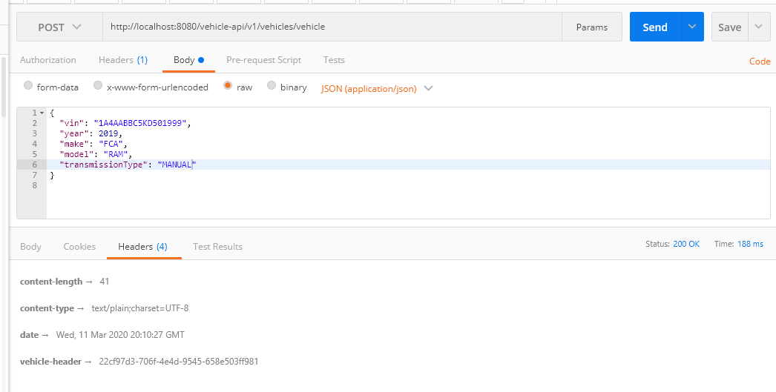

UUID generation number is added to header (**vehicle-header →**22cf97d3-706f-4e4d-9545-658e503ff981)

The above payload is valid, we can see 200 OK status

1. Call the service, with invalid payload

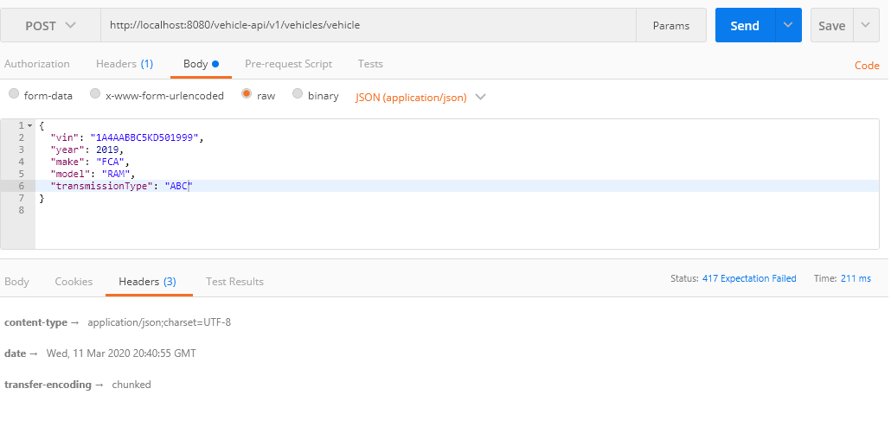

The above one is failed due to invalid input (tranmissionType is ABC). We can see 417 Expectation Failed.

1. If it is valid payload, aop log is displaying and vehicle details are printing in logs.

We don’t need write entry and ending method logs in individual methods (AOP Before and After is taking care of the methods). We just need to focus on logical implementations.

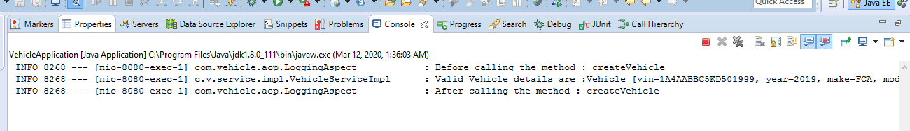

1. Execute the unit testcases in VehicleServiceImplTest.java file

