SPINACH

PARALLEL DISTRIBUTION AND SWARM MEMORY
VERSION 1.0

Mehmet KAYA
11/01/2009

1- PACKAGE AND CLASS DIAGRAM
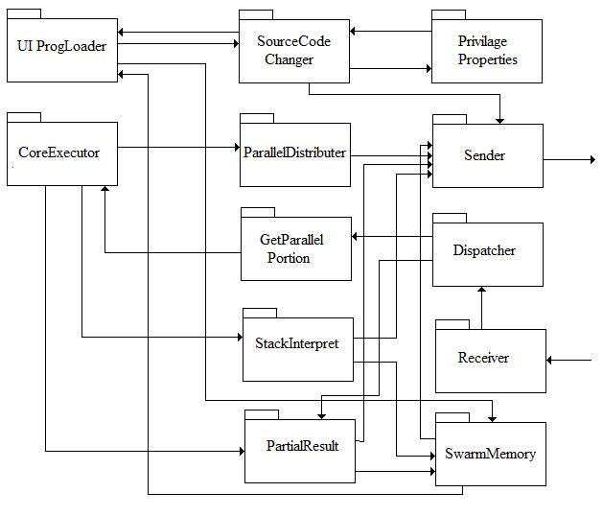
Package Diagram for Swarm memory and Parallel Distributor.

- Source Code Changer: when a computer wants to change the source code it has, sends the Pid to Privilege Properties to see if it has the write privilege on that program. If the computer has the privilege, it sends the changed code to all the other computers.

- Privilege Properties: it gives the privilege status of the computer on the particular program represented by Pid

- Parallel Distributer: when core executor encounters a parallel statement, it sends the code to this package. Then the codes get distributed among all the other computers based on some criteria such as number of the computer in the swarm.

- Sender: sends the messages to the specified end point

- GetParallelPortion: gets a set of code which is a part of some parallel statements of a program loaded by an other machine in the swarm to be executed and send them to the core executor

- Dispatcher: this package is used to understand what the received message actually means and to deliver it to the appropriate methods.

- StackInterpreter: gets an XML message which includes some data from an execution along with the Pid of the program. This is representation of a stack into XML. The received XML strings are interpreted and saved in swarm memory of the program and sent to the other computers for data consistency.

- PartialResults: this package gets results for some partial codes of a parallel statement from two source:
  - From CoreExecutor of local machine: from the local machine, the result calculated on this machine will be received
  - From Other computers: the result calculated on other machines
After getting the result it updates the result table for this particular program. If all the result is collected, the calculation for the parallel part ends.

- Swarm Memory: this package keeps all the data related to a programs execution and variables. When a new program get loaded a new record for this program is created, as execution runs, the corresponding data structures get filled with data. If a new program is loaded, it sends the Pid of this program to all the other computers so that they can create a memory for the program too.

Class Diagram:
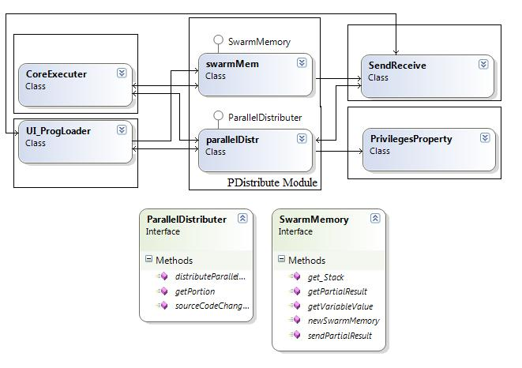
Class Diagram for PDistribute Module

2- PUBLIC INTERFACES

The public methods of the classes shown below:

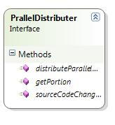
/// <summary>
/// when the source code gets changed, checks the privilage table to see
/// if this computer has the writing privilage. if it does not, then return False to
/// the UI to let them the user know that he cannot make this changes.
/// Otherwise the method sends the new_code too all the other computers in the Swarm network
/// so that they can update their source codes.
/// </summary>
/// <param name="new_code">
/// the parameter new_code basically includes the changes made on the source code along with
/// Program Identification Number and if this is a portion of the source code the location of
/// this fragment in the entire source code (line number?) the exact structure of this msg is
/// up to UI team since they will handle this message at the terget machine.
/// </param>
/// <returns>
/// the method returns a bool value which represents the possesion of writing privilage
/// False: no privilige
/// True: changes can be made
/// </returns>
public bool sourceCodeChanged(string new_code);
/// <summary>
/// this method is to distribute the parallel codes among the other computers in the swarm.
/// when the Core team encounters a prallel statement in the source code, they send those
/// codes to this method. the method will distribute this codes among other computers
/// based on some criteria( # of computers in the Swarm)
/// this method will probably be used in the computer which loads the program.
/// </summary>
/// <param name="statement">
/// this parameter represents the source code for parallel portion of the program gotten
/// from Core team to be decomposed and sent to other computers.
/// the statement parameter should include Pid of the program so that all the computers know
/// to which program this statement belongs and fill the swarm memory correctly.
/// </param>
public void distributeParallelCode(string statement);
/// <summary>
/// whenever a program gets distributed in the Swarm network, the compuers in the swarm
/// get the portion to execute via this method. what basically this method does is it
/// gets the set of code and sends them to the Core team to be executed.
/// </summary>
/// <param name="portion">
/// this parameter represents a part of parallel statment which will be executed on this
/// particular machine and includes the Pid of the program.
/// </param>
public void getPortion(string portion);

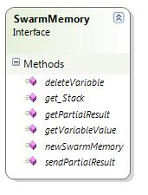

/// <summary>
/// this method is to create a new swarm memory which stores all the data for programs
/// whenever a new program get loaded, this method of the SwarmMemory Class's is called.
/// And the method creates a new record in a data structure which has a key being Pid
/// and other data.
/// If we create a new swarm memory for a newly loaded program, we tell all the other
/// computers to update their memory
/// </summary>
/// <param name="Pid">
/// all the programs running in Swarm had a unique program id (Pid).
/// if one wants to create a memory for his program, the only thing he needs to do is
/// to call this method with Pid parameter
/// </param>
/// <returns>
/// The method returns a bool value.
/// if somehow the swarm memory cannot be created due to an unexpected reason
/// such as that Pid might already existed in the swarm, False will be returned.
/// if the swarm memory gets created successfully, True will returned.
/// </returns>
public bool newSwarmMemory(string Pid);
/// <summary>
/// After some execution the Core team will send the stack info as an XML string
/// which includes some data related to the execution as well as the Pid. this
/// method will parse the string and store the data in to a stack.
/// Lastly it send the Stack to all
/// the computers in Swarm. This method gets the parameter from Core module of
/// the local machine.
/// </summary>
/// <param name="programStack">
/// this is an XML string which includes data and Pid.
/// Decomposing data from the string, the Stacks corresponding to that Pid gets filled.
/// </param>
public void get_Stack(string programStack);
/// <summary>
/// this method is used to get the value of a variable during execution.
/// </summary>
/// <param name="Pid">
/// this parameter represents the program which uses the variable.
/// </param>
/// <param name="variable">
/// this parameter is the variable whose value has been asking.
/// based on the Pid, this method gets the value of the variable from the
/// data structure which belongs to that Pid.
/// </param>
/// <returns>
/// the double return value stands for the value of the variable in the program.
/// </returns>
public double getVariableValue(string Pid, string variable);
/// <summary>
/// this method is used to delete a variable.
/// </summary>
/// <param name="Pid">
/// this parameter represents the program which uses the variable.
/// </param>
/// <param name="variable">
/// this parameter is the variable to delete.
/// based on the Pid, this method deletes the variable from the
/// data structure which belongs to that Pid.
/// </param>
public void deleteVariable(string Pid, string variable);
/// <summary>
/// this method gets the result which has been come up at the end of
/// execution of a parallel portion by some other machine. when this method is called,
/// it fills the result table of this program with this partial result.
/// </summary>
/// <param name="resultInfo">
/// the resultInfo parameter is an XML string which includes the result along with Pid of
/// that portian of code. when all the result for all the portions has been received, namely
/// the result table gets filled up completely, the parallel computation will be done.
/// </param>
public void getPartialResult(string resultInfo);
/// <summary>
/// this method is used in order for a local machine to send its parallel portion
/// result to the other machine so that they update their result table for that program.
/// </summary>
/// <param name="resultInfo">
/// this is again an XML string which includes the result as well as Pid.
/// </param>
public void sendPartialResult(string resultInfo);

3-ISSUE

- How to create one swarm memory per program with data consistency
- How to know that all portion of a parallel program received to end parallel execution

