Swarmed Parallel Interpreter for Numerical Analysis with Collaborated Hosts



PLOTTING MODULE
Design Document
Version 1.0

JAGADISH PRADEEP BEZAWADA
11/02/2009

Rohan Pandit

Uma Mahesh
Rushabh Gandhi
- Package Diagram

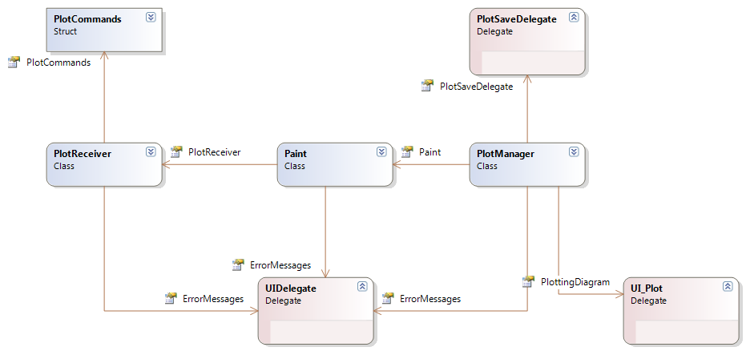

The above package diagram shows the high level interaction between various components in the plotting module and also with the UI module and the Interpreter Core module. Plot Commands class aggregation with the PlotReceiver. Aggregation between the PlotReceiver, Paint, PlotManager. Then the UI delegate for error messages, UI_plot delegate for displaying image and then the saving function for the save of the plot.

Class Diagram:
The class diagram deals with the interaction between classes within the module, their relationships and the function signatures. All the classes and their functions with their prototypes are as follows: The access modifier is internal to the paint and the plot manager, PlotReceiver is public and the PlotCommands is also public. The locked members are private and the orange indicators are the internal members in the diagram shown below:
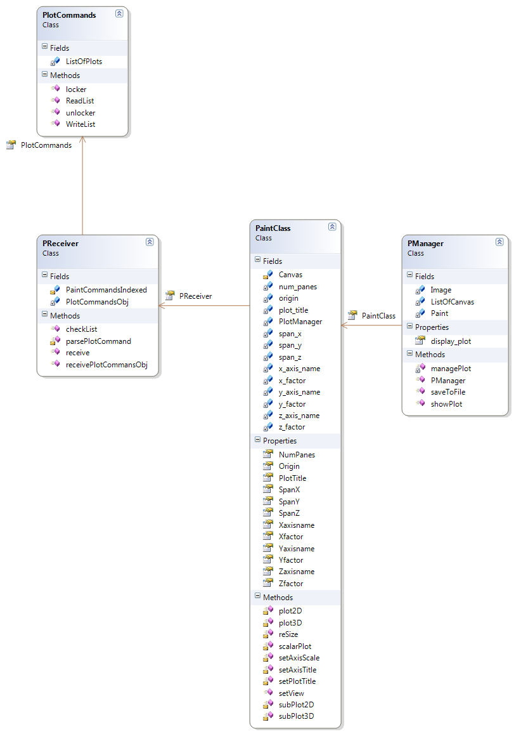
Details of the Classes:
The PlotCommands class will have the List<Plot> objects which have the various methods in the Plot Object to retrieve the commandname, dataset (vector or matrix), modes. Titles of plot, tiles of axes and even the subplot commands. The locking and unlocking facilities are provided through the public methods. The read list will be used by the receiver to read the List and delete the List item read. The write List will write to the List. The shared object between the Interpreter Core module and the Plotting module would be created by the core module and be sent to the plotting module with the receivePlotCommandObj in the PlotReceiver.
The PlotReceiver is the entry point to the plotting module and hence would aggregate the Paint class and the Paint class would aggregate the PlotManager class.
The PlotReceiver also has the PaintCommandsIndexed object of a hashtable which is used to call the specific function in the Paint module basing on the index value of the functions. The checklist method in the plot receiver is meant for checking the list if any commands are present for plotting. The receive function would start the receiver which spawns the thread with the checklist method and then parse Command function would run the command by calling the specific function in the paint class using the PaintCommandsIndexed.
The Paint class now has the functions for every command supported by the plotting module as given in the B-Specification. These functions result on a drawing upon a canvas object, where upon completion of the drawing the PlotManager’s function showPlot is called. The various parameters like the scaling factors, span values, the plot titles, the axes titles, the number of panes, the origin are provided as the properties which facilitates ease with which the PlotManager and Paint can interact (querying purpose of PlotManager to Paint whenever it converts the drawing to BitMapImage after managing the plots in the showPlot function).
The PlotManager class has the list of canvas (size of 4) as only 4 subplots are supported at maximum on a window by this plotting module. The show Plot will call the manage Plot function which queries the number of panes in the Paint class. Then using this it merges the List of canvas on to a single canvas and then converts this base canvas to a bitmap image. The save file in the plot manager converts the image object in the PlotManager into file and saves that on to the hard disk taking the filename and the location on the hard disk from the UI.
The classes above are the best cohesive and has least amount of coupling.

- Responsibilities:
- Responsibility of PlotReceiver
PlotReceiver is the module which will receive the plot command from the core module, where the core will create a object which contains the various data required to plot. The object will be stored in a list which is a common data structure between the core and the plot module. The Plot module will continuously check for any new element inserted and will call a function to parse the object and call the appropriate plot function in plot module with the data as parameters.
- Responsibility of Paint
One more functionality is to set the scale of the axis based on the data set. Initially the origin has to be calculated such that all 4 quadrants are displayed if negative values are present else only 1st quadrant will be displayed. The axis is scaled based on the values of data and the size of the pane.
While setting the axes, the properties of origin and difference between two points on each axis are set and accordingly the list of points is used for plotting either in 2D or 3D mode. The pane object on which the plotting is done will be sent to the Plot manager object for displaying purpose.
In case of subplots, it will follow the same procedure for plotting depending on the mode and also an additional management task is added. By looking at the pane number in the command, number of panes and pane sizes are adjusted and list of panes are sent to the Plot manager object.
- Responisibility of PlotManager
PlotManager performs the function of managing all the plots. It receives paint objects from paint class and performs following functions.
Checking the type of command from the pane number.
If there are more than one paint object then plot manager will resize the initial paint object and then merge two objects.
It will then convert it to bitmap image and give the reference of the image to User Interface team. Before converting paint object to an image it will store it to the list which will help plot manager to keep track of all the paint objects which have been converted to an image and for passing the paint object for resizing in case of more than one paint object are to be plotted on the screen i.e subplot.
For passing the image reference it will invoke the event to which user interface team will be registering.It will also save the image to local directory when it gets a save command from user interface team.

Design Issues:
- PlotManager be initialized by receiver?
PlotManager Object is created by the receiver as it is the entry point to the plot module.
- Which class Paint or PlotManager will manage sub plots?
Paint has the facility to plot the 2D dimensional data. The manage subplots
- Should we redraw the previous drawing and how?
Yes we need to design the document that redraws the previous plot received and we do
this by calling the resize function of the paint where the redrawing basing on the size of
the canvas takes place.
- PlotReceiver Commands Interface with interpreter core team?
Plot Objects are pushed on to the list at the end of the list and then the plot receiver,
will read from it at the head and then delete the item after reading the list item.

Present Working Status:
- Scaling the axis for plots.
- Plotting on the scaled axis
- Delegate for image and save

