Swarmed Parallel Interpreter for Numerical Analysis with Collaborated Hosts
(SPINACH)

Interpreter Core Team
(ICT)

B Level Specification
for
Software Development

version 1.0
19 September, 2009

Rajika Tandon
M.S., Computer Engineering

Team members:
Sushma Thimmappa (M.S., Computer Science)
Rucha Bapat (M.S., Computer Science)
Chetan Thawani (M.S., Computer Engineering)

Table of Contents

1. Architecture 4
2. Reference Documents 5
2.1. Customer A-Specification 5
3. Requirements 5
3.1. Functional Requirements 6
3.1.1. Traversing 7
3.1.1.1. inputs 7
3.1.1.2. processing 7
3.1.1.3. outputs 7
3.1.2. Interpreting plot 7
3.1.2.1. Visiting 8
3.1.2.1.1 inputs 8
3.1.2.1.2 processing 8
3.1.2.1.3 outputs 9
3.1.2.2. semantic check 9
3.1.2.2.1 inputs 9
3.1.2.2.2 processing 9
3.1.2.2.3 outputs 9
3.1.3. Interpreting plot 9
3.1.3.1. Visiting & semantic checking 10
3.1.3.1.1. inputs 10
3.1.3.1.2. processing 10
3.1.3.1.3 outputs 10
3.1.3.2. data structure conversion 11
3.1.3.2.1. inputs 11
3.1.3.2.2. processing 11
3.1.3.2.3 outputs 11
3.1.3.3. Non-parallel commands executing 11
3.1.3.3.1. inputs 11
3.1.3.3.2. processing 11
3.1.3.3.3 outputs 11
3.1.4. integrating code results 12
3.1.4.1. inputs 12
3.1.4.2. processing 12
3.1.4.3. outputs 12
3.2. Process Requirements 12
3.2.1. Physical Structure 12
3.2.2. Development Environment 13
4. Data Dictionary 14
5. Requirements Traceability Matrix 15

GLOSSARY 16
refERENCES 16

Architecture
Interpreter Core Processing to be carried out by the ICT, takes data structure (abstract syntax tree - AST), from the parsing/ front team (the grammar to be used in the program is decided by the Front End Team according to the A-level requirements).

From this AST, the non-parallel part is executed by the ICT and parallel commands are packaged into bytes codes and stored in swarm memory, where, the swarm team (parallel commands executing) is notified when this happens. After execution of the parallel commands, the swarm team updates the swarm memory with the complete results of the parallel execution, and the ICT team is notified when the same happens. ICT also packages the plot commands and related data in the form of data sets to be send to the plotting team. The entire result map along with the semantic errors (if any) encountered will be notified to the display team.

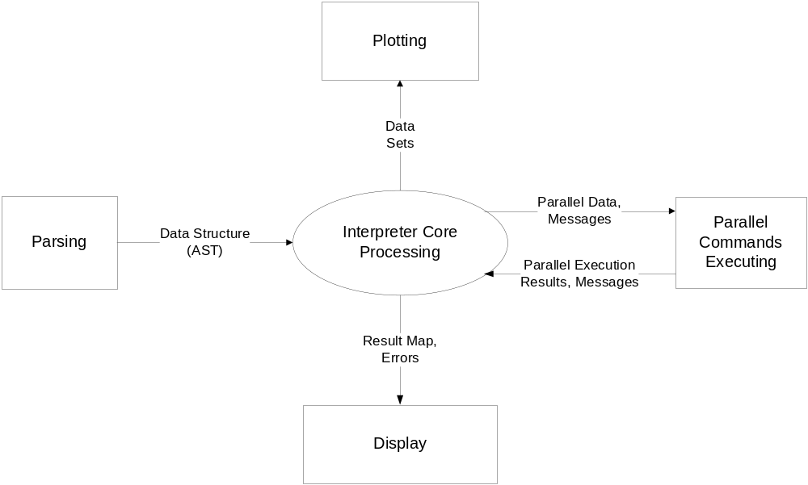

Figure 1: SPINACH - ICT Context Diagram

The above diagram depicts the context diagram of the Interpreter Core Team (ICT)’s interaction with other teams. Processing performed by ICP is divided into five major components, as shown in fig. 1 and described below:

- Interpreter Core Processing (ICP) accepts SPINACH commands stored in abstract syntax trees (ASTs). These commands can be declarations or processing of variables (strings and scalars or matrices of either doubles or integers), structures, functions, assignments, if, for, paraller-for, sync-for statements and plot commands. ICP stores all the variables in a result (hash) map.

- Among all the input statements, ICP is responsible for executing all the non-parallel instructions, which can be any statement other than parallel-for, sync-for and plot commands. Whenever parallel commands are encountered, ICP packages them to swarm memory so that the further execution is done in parallel by the Swarm.

- While ICP is not responsible for executing plot commands, it packages them for execution by the plotting team.

- ICP performs semantic check on all the commands and throws any semantic error encountered.

- After execution of commands, ICP sends the result map and errors (if encountered) to the User Interface for display.

Reference Documents

Customer A-Specification
SPINACH, Architectural Concept Document Version 1.0,
Monday 12 October, 2009

Requirements
Processing for the ICP program is divided into four major processes:
- traversing,
- interpreting plot,
- interpreting code, and
- integrating code results.

Each of these processes is responsible for a set of requirements, described in this section.

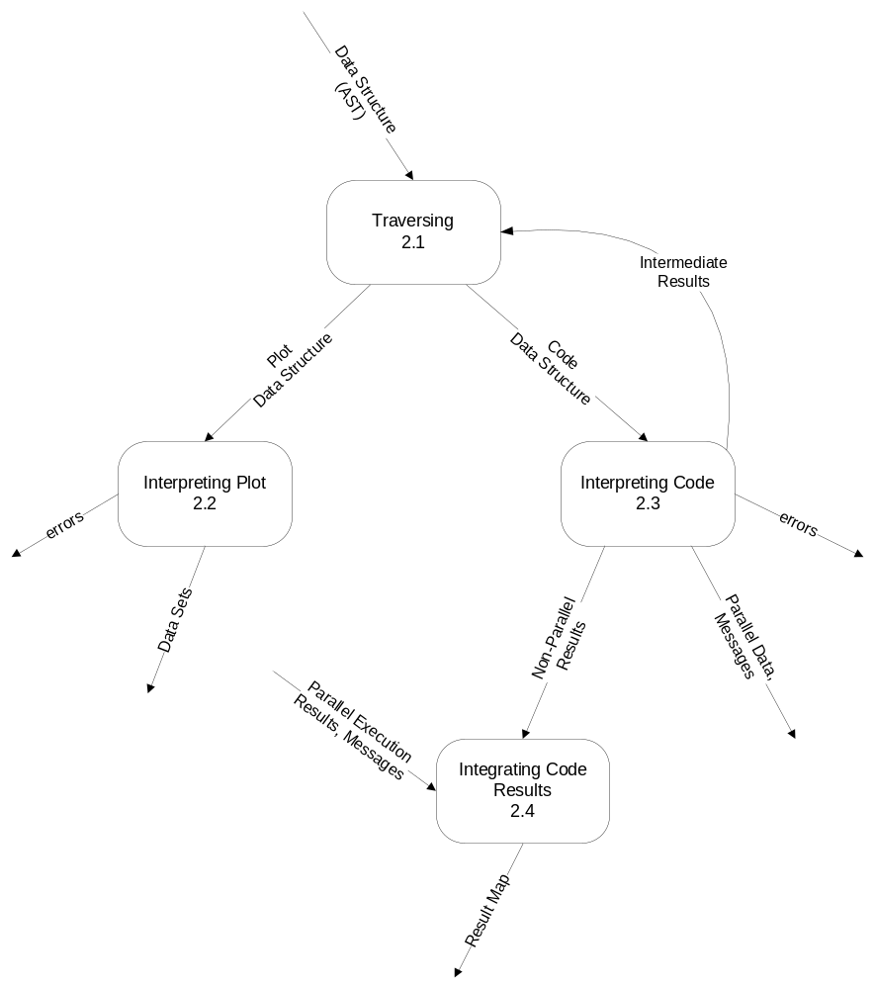
Figure 2 - Data Flow Diagram 1

Functional Requirements
This section describes the activities required of the ICP program.

Traversing
The AST (abstract syntax tree) received from the parsing module, needs to be traversed for identifying the plot and code elements present in it.

inputs
- Data structure of the entire code (submitted by a user), in the form of AST, is received from the parsing module as input.
- Intermediate results needed for the construction of certain plot data structure (AST) will be received from the Interpreting Code process.

processing
The traversing process shall identify the plot commands and rest of the code elements and send the same to the Interpreting Plot and Interpreting Code processes respectively.

Any data for the plot commands, dependent on the code part, shall be processed by the Interpreting Code process and sent back to the Traversing process, where this process shall communicate the same to the Interpreting Plot process.

outputs
This process will output the identified plot data structures and code data structures.

Interpreting Plot
The Interpreting Plot process will process the plot data structure received from the traversing process and will form the data sets for the plotting team, as shown in fig. 3.
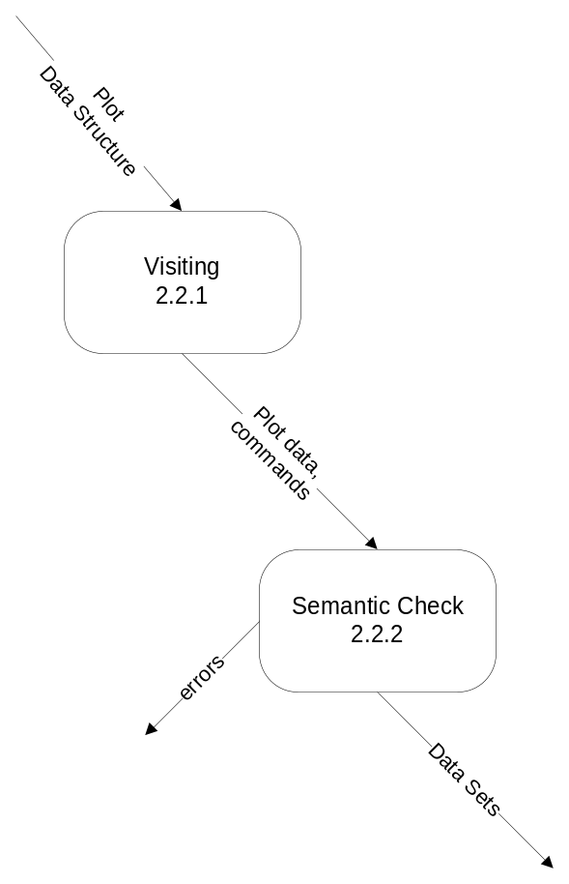
Figure 3 - Data Flow Diagram 2.2

Visiting
This process is responsible for visiting all the commands in AST and constructing a data structure containing plot commands and the data associated with them.

inputs
This process will get the input, part of AST which has the plot commands, in the form of plot data structure.

processing
This process will traverse this part of AST and shall save the data/parameters of the plot commands in a data structure so that the same can be used to execute the plot commands.

3.1.2.1.3. outputs
The plot commands and the required data by these commands are collected, and the same is packaged in a data structure.

Semantic Check
This process is responsible for carrying out semantic analysis on the plot data structure and construct the data sets out of semantically correct plot information.

inputs
This process will get the plot data and commands as the input from Visiting Process.

processing
This process shall perform semantic analysis (data types of parameters, etc.) on the plot information received and shall prepare data sets with respect to the plot commands and data/parameters to these commands.

3.1.2.1.3. outputs
The plot commands and the required data by these commands are packaged in a data structure and sent out for actual execution or plotting.

Interpreting Code
The Interpreting Code process, as shown in fig. 4, will process the code data structure (AST) received from the traversing process and is responsible for execute the non-parallel commands while packaging the parallel commands for execution by the swarm.

Data computed during the non-parallel commands’ execution which are required by plot commands, are sent back to the traversing process (2.1), as shown in fig. 2, in the form of intermediate results.

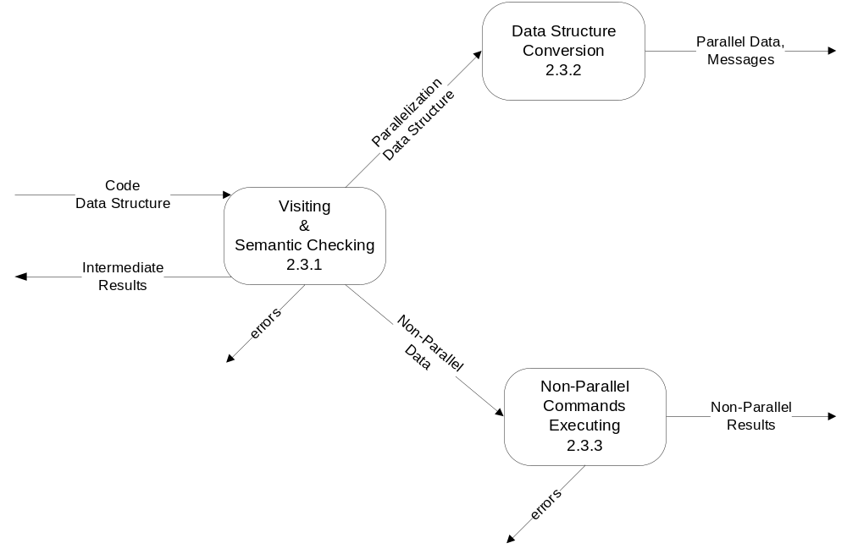
Figure 4 - Data Flow Diagram 2.3

Visiting & Semantic Checking
This process is responsible for visiting all the commands in ASTs and identifying parallel and non-parallel commands for further execution alongwith performing semantic checks.

inputs
Receives all the input commands to be executed in the form of a data structure.

processing
Visiting process shall identify the parallel and non-parallel commands and separate them as two different instruction sets. It shall send out the respective instruction sets only if they are semantically correct. Otherwise, it shall send out error messages.

3.1.2.1.3. outputs
This process will give out the parallel data structure and non-parallel data to be executed separately.

It will generate error messages in case of semantic exceptions.

Data Structure Conversion
This process is responsible for packaging all parallel commands to swarm memory.

inputs
Inputs to this process are parallel data set which contains only instructions that can be executed in parallel, i.e. data containing the parallel commands: parallel-for and sync-for.

processing
Parallelization data shall be converted into intermediate code form (such as byte codes) and is then stored in the swarm memory. A notification message shall also send to the swarm upon loading the swarm memory. These instructions are then picked up from the swarm memory by the swarm and executed in parallel.

3.1.2.1.3. outputs
Commands which are to be executed in parallel, and a message which says that the parallel execution can be started.

Non-parallel Commands Executing
This process is responsible for executing all the non-parallel commands.

inputs
Input to this process is the non-parallel data which includes a set of instructions that are to be executed by Interpreter Core Team.

processing
This process shall execute all the input instructions in a non-parallel way. It shall throw any error encountered during execution.

3.1.3.3.3. outputs
This process will give out the results of execution of all the non-parallel commands.

It will generate error messages in case of non-parallel commands’ execution.

Integrating Code Results
This process is responsible for forming the result map/proper data structure to store all the results obtained from parallel and non-parallel computations.

inputs
- Results of non-parallel execution.
- Notification messages from the swarm when the swarm memory is loaded with the results of parallel execution.
- Results of parallel execution fetched from the swarm memory.

processing
This process shall integrate all the results obtained from the non-parallel and parallel execution of the code, into a result (hash) map, and pass this data structure to the display team.

outputs
This process will output the result map which contains the computed values of all the variables present in the code.

Process Requirements
These requirements specify physical structure of the code developed and the environment where it must operate. The input will be syntactically correct data structure received from the front end team.

Physical Structure
The Interpreter Core program (ICP) shall consist of modules. A module is either an executive of which there is only one per program, or a server. There may be as many server modules as deemed appropriate by the development team. An executive module shall consist of a single implementation file (.cs). Each server module shall be provided with a test configuration. The user interfaces shall delegate all operation to server modules, not directly associated with providing the user interfaces. There will be one executive module and multiple server modules.

Each module in C# shall contain the following elements:
- preprocessor statements preventing multiple compilations embedded around each header file
- a manual page containing a prologue, a paragraph describing module operations, and a list of the public interface with interpretations to help a designer to use the module
- a maintenance page describing the build process, specifically naming the required files and compilation commands
- a main function defined within some class.

The main function shall be enclosed by preprocessor statements preventing compilation unless the preprocessor detects a directive of the form TEST_MODULENAME, where MODULENAME is the name of the module with no extension.

Each implementation file in C# shall begin with a prologue that contains descriptions of the following elements:
- file name with a few word summary
- version number
- language of implementation
- platform, e.g., computer and operating system
- application
- author with address, telephone number, and e-mail account

Development Environment
Interpreter Core source code shall be implemented using Visual C# .Net, and shall operate under the Windows XP/Vista or higher version of Windows operating system The Interpreter Core program (ICP) shall build and operate in the ECS clusters, e.g., Link 010, 201, 202, 274, or CST 2-112.

Data Dictionary

Message Name | Interpretation | DFD
Data Structure (AST) | Input code in the form of ASTs | DFD 2.1
Plot Data Structure | Data Structure containing the plot commands and data | DFD2.2
Plot data, commands | Commands to plot the data which contain the parameters | DFD2.2
Data sets | Semantically correct data to be sent to the plotting team for execution | DFD2.2
errors (process 2.2.2) | Semantic errors reported in the case of semantically incorrect plot commands | DFD2.2
Code Data Structure | AST which contains both parallel and non-parallel commands | DFD 2.3
errors (process 2.3.1) | Semantic errors reported in the case of semantically incorrect commands present in the code | DFD2.3
Parallelization Data Structure | Code containing parallel commands to be executed by the Swarm | DFD 2.3
Non-parallel data | Non-parallel code statements to be executed by ICT | DFD 2.3
errors (process 2.3.3) | Errors reported during the execution of non-parallel commands | DFD2.3
Parallel data, Messages | Intermediate parallel code for Swarm and notification messages | DFD 2.3
Non-parallel results | Result of execution of all non-parallel code statements | DFD 2.3
Parallel Execution Results, Messages | Result of execution of parallel code statements, and notification messages | DFD 2
Result Map | Data structure containing computed values of all the variables encountered during code execution | DFD 2

Figure 5 - Data Dictionary

Requirements Traceability Matrix

B-specification | A-Specification | Comment
3.1.1.2 | Derived | Traversing ASTs for finding plot and code commands
3.1.3.2.2 | 3.1.2.2 | Storing packaged parallel code
3.1.3.3.2a | 3.1.2.1 | Executing non-parallel instructions
3.1.3.3.2b | Derived | Reporting errors
3.1.2.1.2 | 3.1.2.4 | Executing a set of plot commands for plotting team
3.1.2.2.2 | 3.1.2.5 | Reporting (plot) semantic errors
3.1.3.1.2 | 3.1.2.5 | Reporting (code) semantic errors
3.1.4.2 | 3.1.2.3 | Use of result (hash) map / proper data structure for storing variables

Figure 6 - Requirements Traceability Matrix

GLOSSARY

AST | : | Abstract Syntax Tree is a tree representation of the abstract (simplified) syntactic structure of source code written in a certain programming language.
SPINACH | : | Swarmed Parallel Interpreter for Numerical Analysis with Collaborated Hosts (Refer to Architectural Concept Document, Version 1.1, for details).
ICT | : | Interpreter Core Team
ICP | : | Interpreter Core Processing

REFERENCES
- Architectural Concept Document Version 1.0 by Yehong Wang

- Duplicates B-Level Requirements Specification by Dr. Jim Fawcett
http://pcpratts.mysite.syr.edu/cse784/lec01/

