SPINACH Project


B Level Specification
for
Interpreter Front End

version 1.0
18 October, 2009

CSE 784 – Software Studio

Kuldeep Gandhi
Deepak Goyal

Table of Contents
1. Architecture 3
2. Reference 4
2.1. Acronyms and Abbreviations 4
2.2. Reference Documents: 4
3. Requirements: 5
3.1. Functional Requirements 5
3.1.1. Parser and Validate: 5
3.1.1.1. Inputs 5
3.1.1.2. Processing 5
3.1.1.3 OUTPUTS…………………………………………………………………………………………….…10
4. Data Dictionary 10
5. Requirements Traceability Matrix 11
6 Notes 12

Architecture

SPINACH front-end team is responsible for creating grammar syntax and defining the prototype for classes to parse the Abstract syntax tree. Interpreter Front End Team shall use ANTLR3 to generate the abstract syntax tree.

SPINACH
Program Tokens AST
Lexer
Parser

Figure 1
Use of ANTLR

The first translation phase is called lexical analysis and operates on the incoming character stream. The second phase is called parsing and operates on a stream of vocabulary symbols, called tokens, emanating from the lexical analyzer. ANTLR automatically generates the lexical analyzer and parser, by analyzing the grammar.

- Reference

2.1. Acronyms and Abbreviations
Acronyms and abbreviations used in this specification are defined below:

SPINACH | Swarmed Parallel Interpreter for Numerical Analysis with Collaborating Hubs
UI | User Interface

2.2. Reference Documents:
The following references provide external standards and guidelines that are used, in part, for the definition of the guidelines provided in this document.

Ref No. | Document ID. | Document Title | Revision or Date
A | A-level Spec | SPINACH detailed A-level specification Document | 1.1
B | Architectural Document | SPINACH architectural concept document. | 1.1

Requirements:
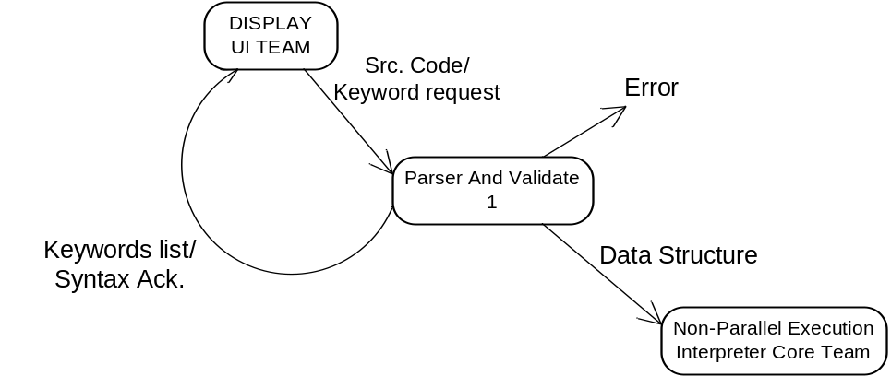

Figure 1
DFD1

Functional Requirements
These sections describe the activities required of the SPINACH program.

Parser and Validate:

Inputs

The input to this process will be either keyword request command or a SPINACH program to evaluate.

Processing
The requirements for this process are:

3.1.1.2.1
The SPINACH program shall have the following syntax capabilities:
- Shall support creation of variables
a.1 shall support creation of int and double scalar variables.
int a;
double b;
a.2 shall support creation of int and double vector variables.
scalar<int>[number] a;
scalar<double>[number] b;
a.3 shall support creation of int and double matrix variables.
matrix<int>[number][number] a;
matrix<double>[number][number] b;
a.4 shall support creation of string.
string a;

- Shall support struct declaration
b.1 shall support int and double scalar variable declaration.
b.2 shall support declaration of single object at the end of struct.
b.3 shall support dot (.) to access the struct variables.

Struct str{
int a;
double b;
}s;

s.a = value;

- Shall support matrix operation.
c.1 shall support matrix-matrix addition operation.
c.2 shall support matrix-matrix multiplication operation.
c.3 shall support matrix-matrix subtraction operation.
c.4 shall support matrix transpose operation.
c.5 multiple matrix operations on a single line shall be supported.
c.6 multiple matrix operations on a single line shall use BODMAS rule.

var = var1 (+/*/-) var2 [ (+/*/-) var3 ]*;
var = T(var);

- Shall support scalar operation
d.1 shall support scalar-scalar addition operation.
d.2 shall support scalar-scalar multiplication operation.
d.3 shall support scalar-scalar subtraction operation.
d.4 shall support use of matrix and vector single element in scalar operations
d.5 shall support constant values in scalar operations.
d.6 multiple scalar operations on a single line shall be supported.
d.7 multiple scalar operations on a single line shall use BODMAS rule to evaluate the expression.
d.8 dot product shall be supported for two vector variables.

var = var1 (+/*/-/dot) var2 [ (+/*/-/dot) var3 ]*;

- Shall support assignment operation
e.1 shall support assignment of constant values to scalar, vector and matrix operation.
e.2 shall support assignment to variables.
e.3 shall support assignment of the function return values.

var = function();
var = var1;
var = var1 + 2;
var = 2;
varVector = {1,2,3,4};
varMatrix = {1,2,3,4};
varMatrix = varMatrix1 + varMatrix2;

- Shall support creation of functions

f.1 shall support functions which accept multiple values.
f.2 shall support functions which return single value.
f.3 function shall accept values for scalar, vector and matrix type.
f.4 function shall return values for scalar, vector and matrix type.
f.5 function body shall support if, for, parallel-for and parallel-for with synchronization.
f.6 function body shall support creation of variables.
f.7 function body shall support function calls to other functions.
f.8 function body shall support scalar and matrix operation.
f.9 function body shall have arbiter number of lines.

returnType FunctioName(arguments*)
{
Body*
return value;
}

- Shall support if statements for arbitrary number of lines
g.1 if condition shall have equality and inequality.
g.2 if and else body shall support if, for, parallel-for and parallel-for with synchronization.
g.3 if and else body shall support creation of variables.
g.4 if and else body shall support function calls to other functions.
g.5 if and else body shall support scalar and matrix operation.
g.6 Else block with the if statement is optional.
g.7 body part in if and else block is optional.

If (condition)
{
Body*
}
else
{
Body*
}

- Shall support test for equality and inequality
h.1 shall support test for equality and inequality for scalar and matrix variable.
h.2 shall compare constant value with scalar variable.

var == var1; //-- equality.
var == 1;
varMatrix == varMatrix1;
varMatrix != varMatrix1; //-- non-equality.

- Shall support for-loops for arbitrary number of lines
i.1 for-loop condition shall have range.
i.2 range shall be in Int values.
i.3 for-loop body shall support if, for, parallel-for and parallel-for with synchronization.
i.4 for-loop body shall support creation of variables.
i.5 for-loop body shall support function calls to other
functions.
i.6 for-loop body shall support scalar and matrix operation.

for(range)
{
Body+
}

- Shall support parallel-for-loops for arbitrary number of lines
j.1 parallel-for loop condition shall have range.
j.2 range shall be in int values.
j.3 parallel-for loop body shall support if and for-loop.
j.4 parallel-for loop body shall support creation of variables.
j.5 parallel-for loop body shall support scalar operation.

parallel-for(range)
{
Body+
}

- Shall support parallel-for synchronization statement.
k.1 a synchronization statement shall be allowed to use inside a parallel-for loops.

parallel-for(range)
{
Body+
Synchronize;
Body+
}
- Shall support deletion of variables

delete variableName;

- Shall support display of variables.

print variableName;

- Shall support display of string.

print “display string”;

- Shall support single line comments

//- comment

- Shall support creation of variable name with alphanumeric characters.
- Shall support plot functions. (to be defined by plotting team!)

3.1.1.2.2

Shall validate the syntax of SPINACH program and report an error if the SPINACH program syntax is incorrect.

3.1.1.2.3

Shall send a list of all the keywords supported by SPINACH program on receiving a keyword request.

3.1.1.2.4

The code shall generate an Abstract syntax tree from the SPINACH program.

      - Output:
The output of this process will be an Abstract syntax tree, for the given grammar file, if there are no syntax error. If syntax error are found than an error message will be send to User Interface team. Other output of this process will be list of keywords used in a SPINACH program.

3.1.2.

Shall document SPINACH input language syntax and error messages on web pages. The document shall have table of contents.

- 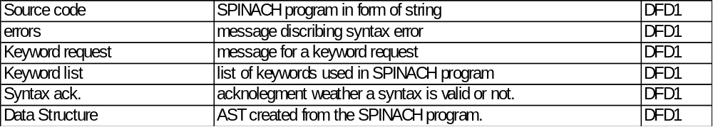Data Dictionary:

Figure 2
Data Dictionary

Requirements Traceability Matrix

B-Specification | A-Specification | Comment
3.1.1.2.1 | 3.1.1.1 | Interpret spinach input syntax
3.1.1.2.1.a | 3.1.1.1.a | creation of variables
3.1.1.2.1.a.1 | derived | creation of int and double scalar variables
3.1.1.2.1.a.2 | derived | creation of int and double vector variables
3.1.1.2.1.a.3 | derived | creation of int and double matrix variable
3.1.1.2.1.a.4 | derived | creation of string
3.1.1.2.1.b | 3.1.1.1.b | creation of structures
3.1.1.2.1.b.1 | derived | support int and double variable declaration
3.1.1.2.1.b.2 | derived | declaration of single object at the end of struct
3.1.1.2.1.b.3 | derived | support dot(.) to access the struct variables
3.1.1.2.1.c | 3.1.1.1.c | support matrix operation
3.1.1.2.1.c.1 | derived | support matrix addition
3.1.1.2.1.c.2 | derived | support matrix multiplication
3.1.1.2.1.c.3 | derived | support matrix subtraction
3.1.1.2.1.c.4 | derived | support matrix transpose
3.1.1.2.1.c.5 | derived | multiple matrix operations on a single line
3.1.1.2.1.c.6 | derived | support BODMAS rule
3.1.1.2.1.d | 3.1.1.1.c | support scalar operation
3.1.1.2.1.d.1 | derived | support scalar addition
3.1.1.2.1.d.2 | derived | support scalar multiplication
3.1.1.2.1.d.3 | derived | support scalar subtraction
3.1.1.2.1.d.4 | derived | support use of matrix and vector single element
3.1.1.2.1.d.5 | derived | support constant values
3.1.1.2.1.d.6 | derived | multiple scalar operations on a single line
3.1.1.2.1.d.7 | derived | support BODMAS rule
3.1.1.2.1.d.8 | derived | support dot product between two vector variables
3.1.1.2.1.e | 3.1.1.1.d | support assignments
3.1.1.2.1.e.1 | derived | support assignment of constant values
3.1.1.2.1.e.2 | derived | support assignment to variables
3.1.1.2.1.e.3 | derived | support assignment of function return values
3.1.1.2.1.f | 3.1.1.1.e | support non-recursive functions
3.1.1.2.1.f.1 | derived | support functions that accept multiple values
3.1.1.2.1.f.2 | derived | support functions that return single value
3.1.1.2.1.f.3 | derived | accept values for scalar, vector and matrix types
3.1.1.2.1.f.4 | derived | return values for scalar, vector and matrix type
3.1.1.2.1.f.5 | derived | support if, for parallel-for and parallel-for with synchronization
3.1.1.2.1.f.6 | derived | support creation of variables
3.1.1.2.1.f.7 | derived | support function calls to other functions
3.1.1.2.1.f.8 | derived | support scalar and matrix operation
3.1.1.2.1.g | 3.1.1.1.f & 3.1.1.2 | support if statements
3.1.1.2.1.g.1 | derived | support conditions for equality and non-equality
3.1.1.2.1.g.2 | derived | support if, for parallel-for and parallel-for with synchronization
3.1.1.2.1.g,3 | derived | support creation of variables
3.1.1.2.1.g.4 | derived | support function calls to other functions
3.1.1.2.1.g.5 | derived | support scalar and matrix operation
3.1.1.2.1.h | 3.1.1.1.g | test equality and inequality
3.1.1.2.1.h.1 | derived | test equality and inequality for scalar and matrix variables
3.1.1.2.1.h.2 | derived | compare constant value with scalar variables
3.1.1.2.1.i | 3.1.1.1.h & 3.1.1.2 | support for loops
3.1.1.2.1.i.1 | derived | support ranges
3.1.1.2.1.i.2 | derived | ranges are in Int values
3.1.1.2.1.i.3 | derived | support if, for parallel-for and parallel-for with synchronization
3.1.1.2.1.i.4 | derived | support creation of variables
3.1.1.2.1.i.5 | derived | support function calls to other functions
3.1.1.2.1.i.6 | derived | support scalar and matrix operation
3.1.1.2.1.j | 3.1.1.1.i | support parallel-for loops
3.1.1.2.1.j.1 | derived | support ranges
3.1.1.2.1.j.2 | derived | ranges are in Int values
3.1.1.2.1.j,3 | derived | support if and for-loop
3.1.1.2.1.j.4 | derived | support creation of variables
3.1.1.2.1.j.5 | derived | support scalar operation
3.1.1.2.1.k | 3.1.1.1.j | support parallel-for synchronization
3.1.1.2.1.k.1 | derived | support synchronization statement inside parallel-for loop
3.1.1.2.1.l | 3.1.1.1.k | deletion of variables
3.1.1.2.1.m | 3.1.1.1.l | display of variables
3.1.1.2.1.n | derived | display of strings
3.1.1.2.1.o | 3.1.1.1.m | comments
3.1.1.2.1.p | derived | creation of variable with alphanumeric characters
3.1.1.2.1.q | 3.1.1.5 | interpret a set of plot commands
3.1.1.2.2 | 3.1.1.3 | validate the syntax and report an error if any
3.1.1.2.3 | derived | Send keywords
3.1.2 | 3.1.1.5 | Create documentation
3.1.1.2.5 | 3.1.1.6 | Create AST

Figure 3
Requirements traceability

- Notes
Revisions: 1.0 Date: 10/19/09
Initial Release, without plot syntax definition.

