
Swarmed Parallel Interpreter for Numerical Analysis with Collaborated Hubs

Interpreter Core Team
(ICT)
B Level Specification
for
Software Development

version 1.1
23 October, 2009

Rajika Tandon
M.S., Computer Engineering

Team members:
Sushma Thimmappa (M.S., Computer Science)
Rucha Bapat (M.S., Computer Science)
Chetan Thawani (M.S., Computer Engineering)

Table of Contents

1. Architecture 4
2. Reference Documents 5
2.1. Customer A-Specification 5
3. Requirements 5
3.1. Functional Requirements 6
3.1.1. Traversing & Executing 7
3.1.1.1. Traversing & Semantic Check 8
3.1.1.1.1. inputs 8
3.1.1.1.2. processing 8
3.1.1.1.3. outputs 8
3.1.1.2. Non-Parallel Commands Executing 9
3.1.1.2.1. inputs 9
3.1.1.2.2. processing 9
3.1.1.2.3. outputs 9
3.1.1.3. Plot Handling 10
3.1.1.3.1. inputs 10
3.1.1.3.2. processing 10
3.1.1.3.3. outputs 10
3.1.2. Parallel Handling 10
3.1.2.1. Data Structure Conversion 11
3.1.2.1.1. inputs 11
3.1.2.1.2. processing 11
3.1.2.1.3. outputs 12
3.1.2.2. Sending 12
3.1.2.2.1. inputs 12
3.1.2.2.2. processing 13
3.1.2.2.3. outputs 13
3.1.2.3. Receiving & Interpreting 13
3.1.2.3.1. inputs 13
3.1.2.3.2. processing 13
3.1.2.3.3. outputs 14
3.2. Process Requirements 14
3.2.1. Physical Structures 14
3.2.2. Development Environment 15
4. Data Dictionary 15
5. Requirements Traceability Matrix 17
6. Notes 19
GLOSSARY 20
REFERENCES 20

Architecture
Interpreter Core Processing to be carried out by the ICT, takes data structure (abstract syntax tree - AST), from the parsing/ front team (the grammar to be used in the program is decided by the Front End Team according to the A-level requirements).

From this AST, the non-parallel part is executed by the ICT and parallel commands are packaged into an intermediate code form and stored in swarm memory, where, the swarm team (parallel commands executing) is notified when this happens. After execution of the parallel commands, the swarm team updates the swarm memory with the complete results of the parallel execution, and notifies the ICT team when the same happens. ICT also packages the plot commands and related data in the form of data sets to be send to the plotting team. The result map along with the semantic errors (if any) encountered will be notified to the display team.

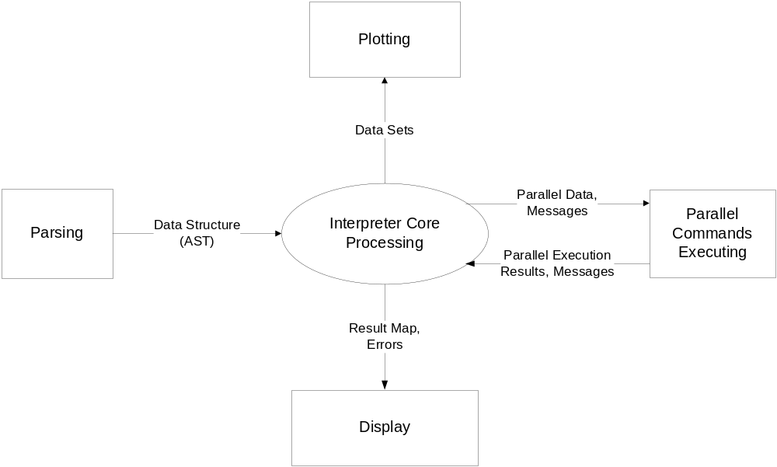

Figure 1: SPINACH - ICT Context Diagram

The above diagram depicts the context diagram of the Interpreter Core Team (ICT)’s interaction with other teams. Processing performed by ICP is divided into five major components, as shown in fig. 1 and described below:

- Interpreter Core Processing (ICP) accepts SPINACH commands stored in abstract syntax trees (ASTs). These commands can be declarations or processing of variables (strings and scalars or matrices of either doubles or integers), structures, functions, assignments, if, for, parallel-for, sync-for statements and plot commands. ICP stores all the variables in a result (hash) map. (Note that the term “synch-for” has been used to denote parallel-for synchronization statement, throughout the B-Spec document).

- Among all the input statements, ICP is responsible for executing all the non-parallel instructions, which can be any statement other than parallel-for, sync-for and plot commands. Whenever parallel commands are encountered, ICP packages them to swarm memory so that the further execution can be performed in parallel by the Swarm.

- While ICP is not responsible for executing plot commands, it packages them into data sets for execution by the plotting team.

- ICP performs semantic check on all the commands and throws any semantic error encountered.

- After execution of commands, ICP sends the result map and errors (if encountered) to the User Interface for display.

Reference Documents

Customer A-Specification
SPINACH, Architectural Concept Document Version 1.1,
Monday 19 October, 2009

Requirements
Processing for the ICP program is divided into two major processes:
- traversing and executing, and
- parallel handling.

Each of these processes is divided into a set of sub processes and responsible for a set of requirements, described in this section.
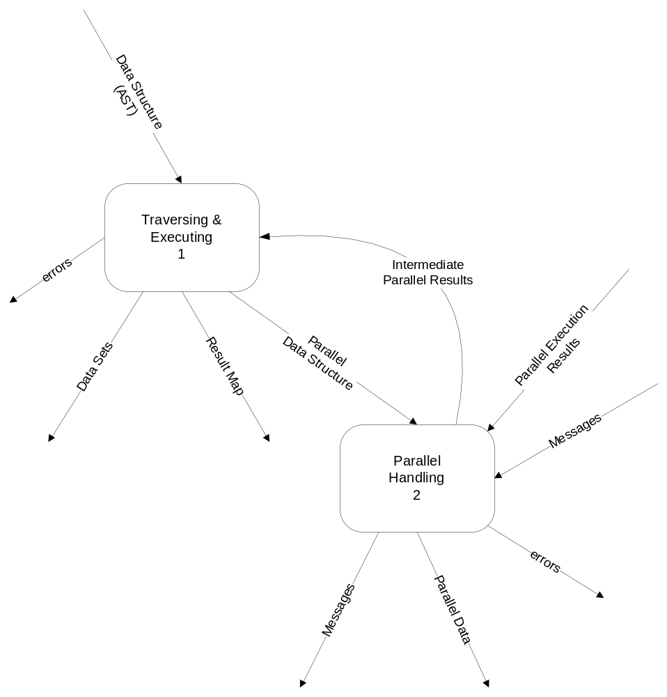

Figure 2 - Data Flow Diagram 1

Functional Requirements
This section describes the activities required of the ICP program.

Traversing & Executing
This process is responsible for traversing the AST (abstract syntax tree) received from the parsing module, for identifying the various data and code elements present in it. The identified non-parallel commands are to be executed and the parallel-commands along with the required data are to be sent to the parallel handling module. After receiving the intermediate results from the parallel module, further execution will take place. This process will output the result set, report semantic errors, as well as, identify the plot data and commands and package them as data sets.
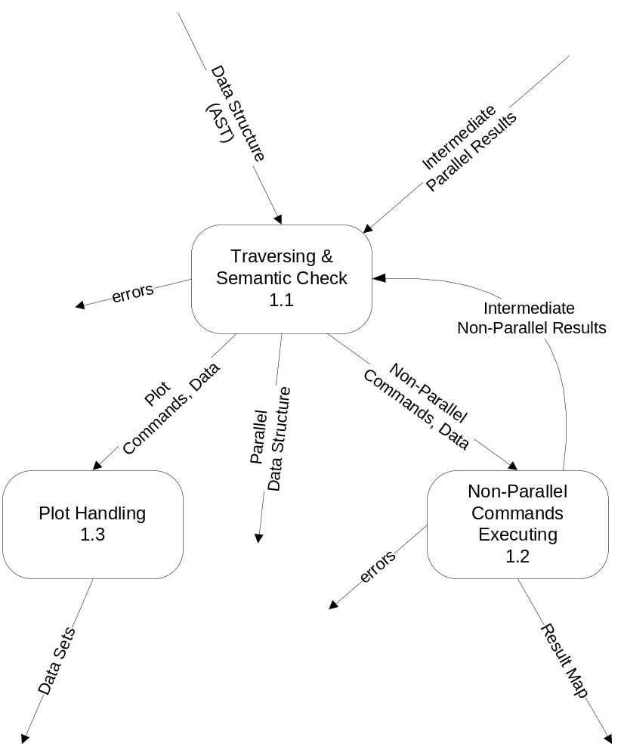

Figure 3 - Data Flow Diagram 1.1

Traversing & Semantic Check
This process is responsible for traversing the AST and identifying the non-parallel, parallel as well as plot commands encountered. Semantic errors are also checked in this process.

inputs
- Data structure of the entire code in the form of AST, as received from the parsing module.
- Parallel intermediate results, which might be needed for processing rest of the AST.
- Non-parallel intermediate results, which might be needed for processing rest of the AST.

processing
This process shall traverse the AST and identify the non-parallel, parallel and plot data/commands, as well as, shall report semantic errors found (if any).

The parallel commands shall be identified by using the keywords such as parallel-for or sync-for, as decided by the front-end team. These commands when encountered shall be returned as it is with the statements present in their bodies and the required data.

The plot commands shall be identified by using the names of the functions as specified by the plotting. The semantic evaluation for these commands includes type checking of the parameters to the plot functions, where the data types of the parameters are syntactically correct. The data needed for plot shall be returned when its computation is over since this data might come from parallel and non-parallel execution.

The rest of the commands (which are not parallel or plot commands), shall be identified as the non-parallel commands and checked semantically.

3.1.1.1.3. outputs
- The plot commands (along with their parameters in the form of variables and constants just the way present in the code) are returned, as well as, the related data (computed values of the variables) needed by these commands are returned.
- Parallel portions of the code in the form of a data structure (AST).
- Non-parallel commands and required data needed for execution.
- Semantic errors encountered in the code.

Non-Parallel Commands Executing
This process is responsible for executing all the non-parallel commands.

inputs
- Commands and data to be executed in a non-parallel manner.

processing
This process shall execute all the input instructions in a non-parallel way. The input includes creation of variables (strings and scalars or matrices of either doubles or integers), creation of structures, assignment, support for non recursive functions that can accept multiple values and return single value, if statements, tests for equality and inequality, for loops, deletion of variables, display of variables (strings and scalars or matrices of either doubles or integers). Comments encountered shall not be executed.

This process shall use a proper data structures (like hash map) for storing the values of variables encountered.

Only the print commands shall be used to construct the result map, where the print commands either contain a string message or a variable.

It shall throw any error encountered during execution.

3.1.1.2.3. outputs
- It will return the results of non-parallel computation (in the form of intermediate results) since these results might be needed for further execution of the code, or needed by the plot commands.
- This process will return the result map which contains the final values of all the variables/computation performed in the code.
- It will generate error messages in case of exceptions which occur during non-parallel commands’ execution.

Plot Handling
This process is responsible for constructing and returning the data sets (plot commands and required data) for plotting.

inputs
This process will get the plot commands and required data.

processing
This process shall package the plot commands along with the related data (values of the parameters of the plot commands) in a data structure so that those data sets can be used by the plotting team to execute the plot commands.

outputs
The data sets (plot data structure) will be returned.

Parallel Handling
This process is responsible for packaging the parallel commands for execution by the swarm.

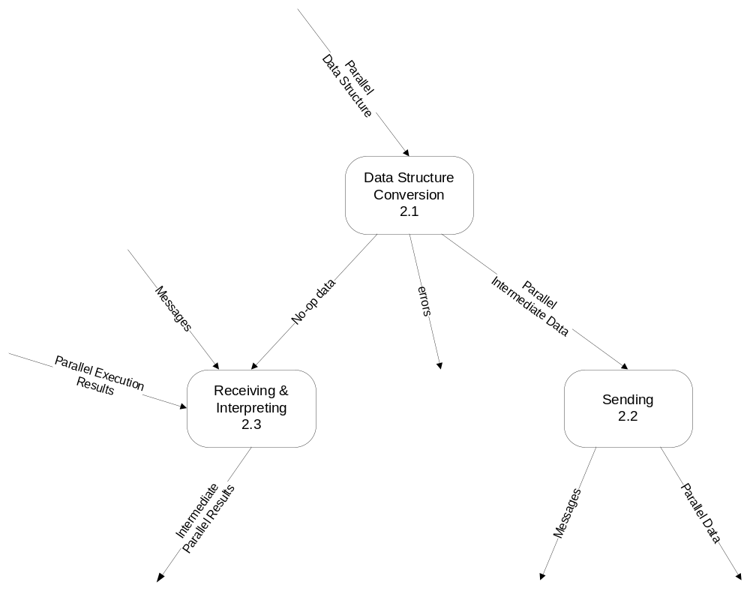
Figure 4 - Data Flow Diagram 2.3

Data Structure Conversion
This process is responsible for packaging all parallel commands to an intermediate code form.

inputs
Input to this process is the parallel data structure which contains only those instructions that can be executed in parallel, i.e. data containing the parallel commands: parallel-for and sync-for.

processing
Commands to be executed in parallel and the related data shall be converted into an intermediate code form such that it is easily transferrable over a network and can be constructed back into the AST data structure by other computers in the swarm.

Prior to the conversion, this process shall perform loop condition check. For e.g. if a parallel-for, of the form:
parallel-for x = 5 to 3 step 1
…..
end for;
such that the loop condition is not satisfied the first time itself (here x=5 to 3 with a positive increment will dissolve the loop at the initial condition itself), then there is no need to convert the entire parallel-for loop into intermediate code form.

Errors occurring during the conversion of the loop bodies shall be reported, i.e. validity of the loop and its statements are checked before conducting such expensive operations like converting into intermediate code form which is to be transmitted over a network, though it has to result in error. For e.g. if a matrix ‘a’ has size 4, but the following is mentioned inside a parallel for:
parallel-for x = 5 to 8 step 1
b[x]=a[x] + c[x];
end for;

3.1.2.1.3. outputs
- The intermediate parallel data is returned.
- No-op is returned which means that the parallel/sync for loop cannot be executed.
- Errors that may have occurred during processing as described above.

Sending
This process is responsible for saving the parallel data (intermediate code which represents parallel commands along with their related data) to the swarm memory, as well as, notifying the swarm about the same.

inputs
Inputs to this process are the intermediate parallel data.

processing
The received input in the intermediate code form shall be stored in the swarm memory.

A request/notification message shall also be send to the swarm (swarm head in our case) upon loading the swarm memory (upon which these instructions will be picked up from the swarm memory by the swarm head for parallel execution).

3.1.2.2.3. outputs
- Parallel data (commands which are to be executed in parallel along with required data)
- A message which says that the parallel execution can be started.

Receiving & Interpreting
This process is responsible for un-packaging/assembling all the parallel execution results into a parallel result map.

inputs
- No-op will be received when the parallel/synch for-loop cannot be executed.
- A notification message will be received when the swarm memory will be ready for fetching the parallel results.
- Parallel execution results which will be in an intermediate code form.

processing
This process shall receive notification messages which signal that the swarm memory is loaded with results of parallel execution by the swarm.

This process shall then fetch the parallel execution results, which will be in the intermediate code form, from the swarm memory and extract values of the modified variables, i.e. convert the information present in the swarm into useful data.

Upon results conversion, this process shall send the results (to the traversing and executing process as shown in fig. 2) for further execution of the code. If it received a no-op, i.e. the parallel/sync for-loop was never executed, then this process shall return the parallel data (values of variables originally received) unchanged in the intermediate parallel results.

3.1.2.3.3. outputs
The intermediate parallel data is returned.

Process Requirements
These requirements specify physical structure of the code developed and the environment where it must operate. The input shall be syntactically correct data structure received from the front end team.

ICP shall document SPINACH input language semantics and error messages on web pages. The documentation shall have a table of contents.

Physical Structures

3.2.1.1 The Interpreter Core Processing (ICP) program shall consist of modules. A module is either an executive of which there is only one per program, or a server. There may be as many server modules as deemed appropriate by the development team.

3.2.1.2 ICP shall be implemented using Visual C# .Net.

3.2.1.3 The user interfaces shall delegate all operation to server modules, not directly associated with providing the user interfaces.

3.2.1.4 Each module in C# shall be provided with manual pages and correct maintenance pages.

3.2.1.5 Each server module shall be provided with a test configuration.

3.2.1.6 The main function shall be enclosed by preprocessor statements preventing compilation unless the preprocessor detects a directive of the form TEST_MODULENAME, where MODULENAME is the name of the module with no extension.

3.2.1.7 Each implementation file in C# shall begin with a prologue that contains descriptions of the following elements:
- file name with a few word summary
- version number
- language of implementation
- platform, e.g., computer and operating system
- application
- author with address, telephone number, and e-mail account

Development Environment

3.2.2.1 The Interpreter Core Processing program shall build and operate in the ECS clusters, e.g., Link 010, 201, 202, 274, or CST 2-112.

Data Dictionary

Message Name | Interpretation | DFD
Data Structure (AST) | Input code in the form of ASTs | DFD 1
errors (process 1) | Semantic errors reported in the code | DFD 1
Data sets | Semantically correct data to be sent to the plotting team for execution | DFD 1
Result Map | Data structure containing messages or computed values of the variables given in print command | DFD 1
Parallel Data | Code containing parallel commands to be executed by the Swarm | DFD 1
Intermediate Parallel Results | Results of parallel computation (as fetched from the swarm memory) | DFD 1
Messages (outgoing to process 2) | Notification messages that informs the swarm that the execution can begin | DFD 1
Messages (incoming to process 2) | Notification messages that informs the parallel handling process that it can fetch results from swarm memory | DFD 1
Parallel Execution Results | Result of execution of parallel code statements | DFD 1
errors (process 2) | Errors reported during the parallel commands’ handling | DFD 1
Parallel Data | Code to be executed in parallel and required data represented in intermediate code form for Swarm | DFD 1
Plot Commands, Data | Commands to plot the data which contain the parameters | DFD 1.1
Non-Parallel Commands, Data | Non-parallel code statements to be executed by ICT and the required data for execution | DFD 1.1
Intermediate Non-Parallel Results | Results of execution of non-parallel code statements (which may be needed in further execution of code) | DFD 1.1
errors (process 1.2) | Errors reported during the execution of non-parallel commands | DFD 1.1
No-op data | The same values of variables to be returned as it is when the parallel/sync for cannot be executed | DFD 2.1
Parallel Intermediate Data | Intermediate parallel code and data | DFD 2.1
errors (process 2.1) | Errors reported during the conversion of parallel commands into intermediate code form | DFD 2.1

Figure 5 - Data Dictionary

Requirements Traceability Matrix

B-specification | A-Specification | Comment
3.1.1.1.2.a | Derived | Traversing ASTs for identifying non-parallel, parallel and plot commands
3.1.1.1.2.b | 3.1.2.6 | Reporting semantic errors
3.1.1.1.2.c | Derived | Identification of commands to be executed in parallel
3.1.1.1.2.d | Derived | Parallel commands and required data to be returned
3.1.1.1.2.e | Derived | Identification of plot commands
3.1.1.1.2.f | Derived | Data needed for plotting
3.1.1.1.2.g | Derived | Identification of non-parallel commands
3.1.1.2.2.a | 3.1.2.1 | Execution of non-parallel commands
3.1.1.2.2.b | Derived | Comments to be ignored
3.1.1.2.2.c | 3.1.2.5 | Storing variables and their values in a proper data structure
3.1.1.2.2.d | Derived | Only variables/messages mentioned in the print commands to be displayed
3.1.1.2.2.e | Derived | Errors encountered during the execution of non-parallel commands
3.1.1.3.2 | 3.1.2.2 | Forming data sets for plotting team
3.1.2.1.2.a | 3.1.2.3 | Construction of equivalent intermediate code form of the parallel commands
3.1.2.1.2.b | Derived | Conditional checks on parallel/synch for loops prior to converting into intermediate code form
3.1.2.1.2.c | Derived | Errors encountered during the conversion of parallel commands
3.1.2.2.2.a | 3.1.2.3 | Storing the intermediate code form in the swarm memory
3.1.2.2.2.b | 3.1.2.4 | Request message (notification) to swarm to start execution, upon loading the swarm memory
3.1.2.3.2.a | Derived | Receipt of notification message from the swarm when it loads the swarm memory with results
3.1.2.3.2.b | 3.1.2.4 | Assembling of results fetched from swarm memory which were stored by the swarm
3.1.2.3.2.c | Derived | Returning parallel results which might be used in further execution of the code
3.1.2.3.2.d | Derived | Returning variables as it is if the parallel/sync for loop was never executed
3.2.a | 3.1.2.7 | Documentation of SPINACH language semantics and error messages
3.2.b | 3.1.2.7 | Documentation containing a table of contents
3.2.1.1 | 3.2.1.1 | Source code consisting of modules
3.2.1.2 | 3.2.1.2 | Program to be implemented in Visual C# .Net
3.2.1.3 | 3.2.1.3 | User interfaces, which are not directly providing user interfaces, delegating all operations to server modules
3.2.1.4 | 3.2.1.4 | Modules to be provided with manual and maintenance pages
3.2.1.5 | 3.2.1.5 | Each server module providing a test configuration
3.2.1.6 | Derived | A function’s compilation to be performed only if appropriate preprocessor directive is defined
3.2.1.7 | Derived | Implementation File prologues to be provided
3.2.1.2 | 3.2.1.1 | Development environment

Figure 6 - Requirements Traceability Matrix

6. Notes
Revisions:

Original 3.1: Parallel execution handled by:
- Interpreting Code process for packaging parallel data into intermediate code, and
- Integrating Code Results for un-packaging/assembling parallel results
Revised 3.1: Separate sender and receiver processes in parallel handling process.

Original 3.1.3.2.2: Initial Release described intermediate code form of parallel commands and data to be represented in the form of byte codes.
Revised 3.1.2.1.2: Byte codes methodology omitted in this release.

GLOSSARY

AST | : | Abstract Syntax Tree is a tree representation of the abstract (simplified) syntactic structure of source code written in a certain programming language.
SPINACH | : | Swarmed Parallel Interpreter for Numerical Analysis with Collaborated Hosts (Refer to Architectural Concept Document, Version 1.1, for details).
ICT | : | Interpreter Core Team
ICP | : | Interpreter Core Processing
Synch-for | : | Parallel for synchronization statement

REFERENCES
- | Architectural Concept Document Version 1.1 by Yehong Wang
- | Duplicates B-Level Requirements Specification by Dr. Jim Fawcett  http://pcpratts.mysite.syr.edu/cse784/lec01/

