
Swarmed Parallel Interpreter for Numerical Analysis with Collaborating Hubs

Interpreter Core Team
(ICT)

C Level Specification
for
Software Development

version 1.1
5 November, 2009
CSE 784 – Software Engineering Studio

Team members:
Sushma Thimmappa
Rajika Tandon
Chetan Thawani
Rucha Bapat
Table of Contents:

1. Architecture 3
2. REFERENCE DOCUMENTS: 4
3. Package Diagram: 5
4. Class Diagrams for ICT: 7
4.1 Class Diagram for Non-Parallel Execution : 7
4.1.1 Class : Traversal 8
4.1.2 Class : NonParallelExecutor 8
4.1.3 Class : Plot 8
4.2 Class Diagram: ParallelHandling 9
4.2.1 Class : Main 9
4.2.2 Class : ParallelFor 10
4.2.3 Class : Executor 10
4.2.4 Class : IntegrateResultsOfParallelFor 10
5. Process Requirements 11
5.1 Physical Structures 11
5.2 Development Environment 11
6. Team Summary Of Issues : 12
7. Team Summary of Status: 12
GLOSSARY 13

Architecture
Interpreter Core Processing (ICP) to be carried out by the ICT, takes data structure (abstract syntax tree - AST), from the parsing/ front team (the grammar to be used in the program is decided by the Front End Team according to the A-level requirements).

From this AST, the non-parallel part is executed by the ICT and parallel commands are packaged into an intermediate code form and stored in swarm memory, where, the swarm team (parallel commands executing) is notified when this happens. After execution of the parallel commands, the swarm team updates the swarm memory with the complete results of the parallel execution, and notifies the ICT team when the same happens. ICT also packages the plot commands and related data in the form of data sets to be send to the plotting team. The result map along with the semantic errors (if any) encountered will be notified to the display team.

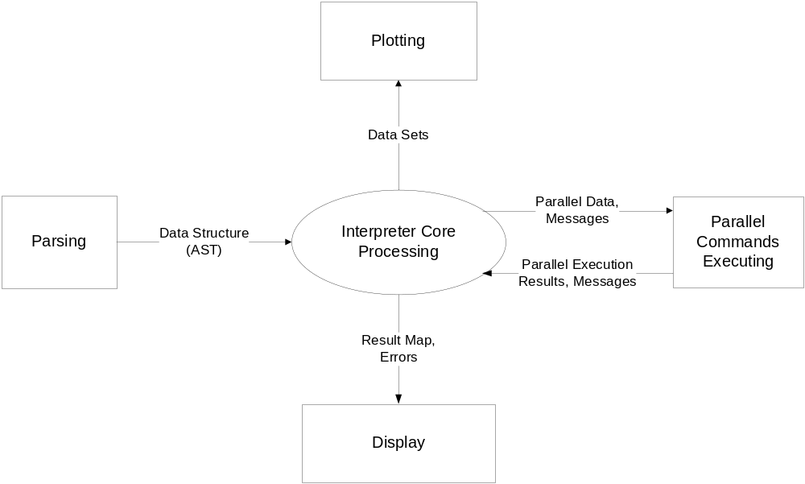

Figure 1: SPINACH - ICT Context Diagram

2. REFERENCE DOCUMENTS:
- | Architectural Concept Document Version 1.1 by Yehong Wang
- | Revised BSpec Version 1.1 by Rajika Tandon.
- | Duplicates Program C-Spec Version 1.1 by Dr. James Fawcett.

3. Package Diagram:

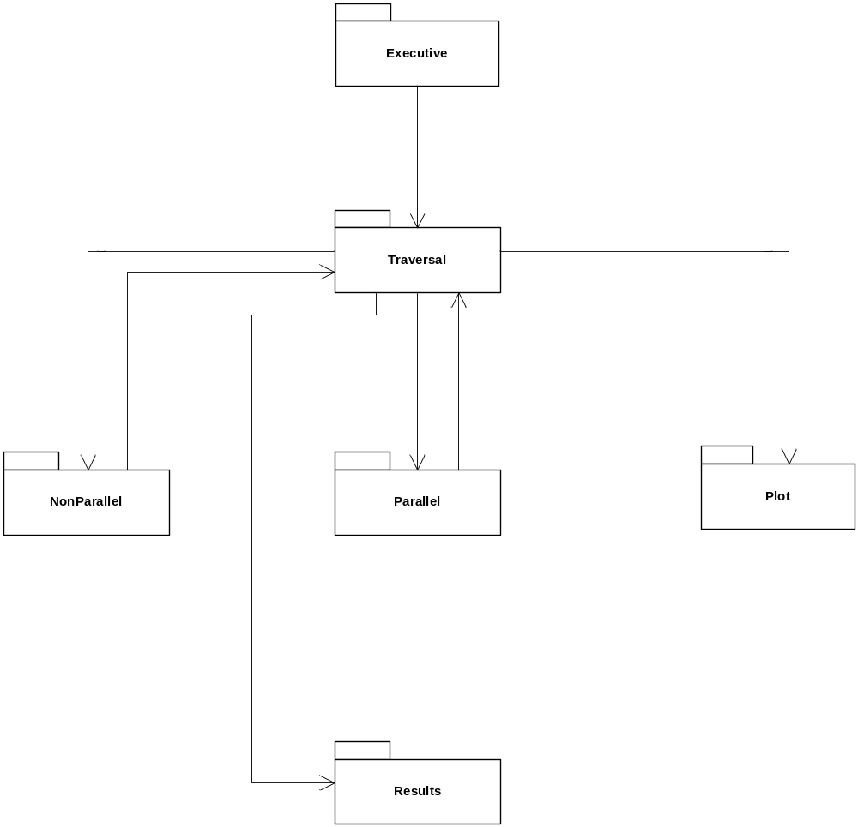

Figure 2 : Package Diagram for ICT

Figure 2. shows the package diagram for the ICT.

Executive : Takes the input from the Front End in the form of ASTs.

Traversal : Has all the related classes and data structures, for traversing the AST. All the variables and data encountered during the traversal are stored in the hashtables for further references.

NonParallel: Responsible for executing all the non-parallel statements, and checking the semantic errors.

Plot : Any input command if related to plot will be processed, and all the data related to plotting will be stored in objects, which are further sent to plotting team. Any semantic error will be shown during processing.

Parallel: Whenever any parallel-for is encountered, the body within parallel-for is converted to an intermediate form and executed.

Result Display: All the results are to be sent to the UI module for display.

4. Class Diagrams for ICT:

4.1 Class Diagram for Non-Parallel Execution :

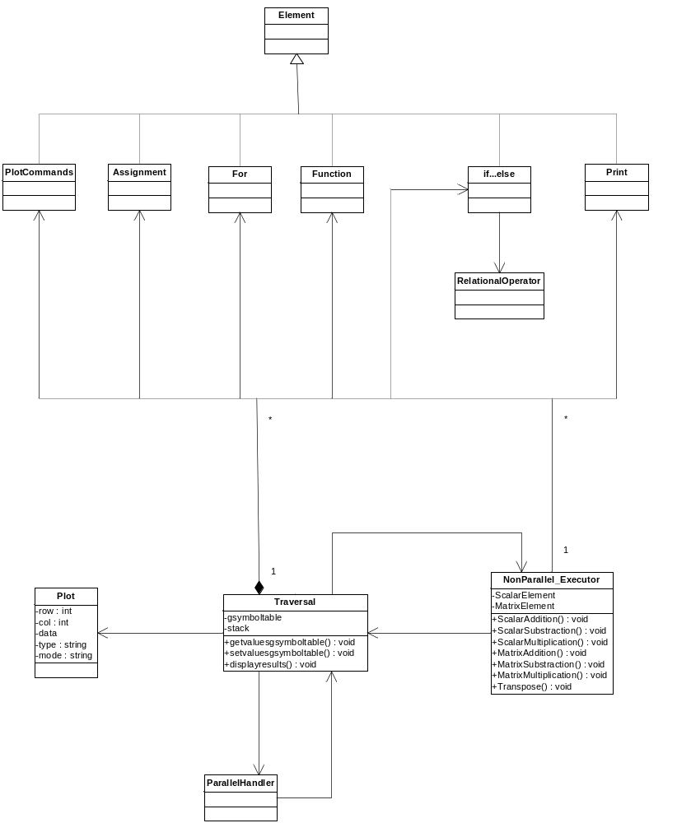

Figure 3: Class Diagram for non-parallel execution part of ICT
Classes and their responsibilities :

4.1.1 Class : Traversal
Description :
Responsible to maintain hashtables for storing data, its datatype and value. It will be traversing the ASTs received from the Front End team, and fill the hashtables appropriately. During the traversal, if there are any semantic errors, they will be shown to the user .
Traversal class will be using the other three classes i.e. non-parallel, plot and parallel class.

4.1.2 Class : NonParallelExecutor
Description :
Responsible to implement all the functions for the operations like addition, subtraction, multiplication of scalars and matrices, transpose of matrices i.e. it will implement all the functions needed to execute the non-parallel portions of the given program input. Classes from Front End will be used for scalar, matrices, strings, for-loop.
For implementing these functions, non-parallel class will need ‘assignment’, ‘for’, ‘function’, ‘if-else’, ‘print’ classes. So, there will be aggregation between these classes and non-parallel class.

4.1.3 Class : Plot
Description :
Responsible for sending the information related to plotting commands. When the plot commands will be encountered, the parameters of the commands will be stored in this class by using getter methods implemented in this class. This class will be used to pass the plot commands information to the plotting team by creating its object and passing that object through interface to the plotting team.

Interface for Plot:
Class DrawPlot
{
virtual void Draw(Plot *p);
}

Plotting team will be implementing the above interface to plot.

4.2 Class Diagram: ParallelHandling

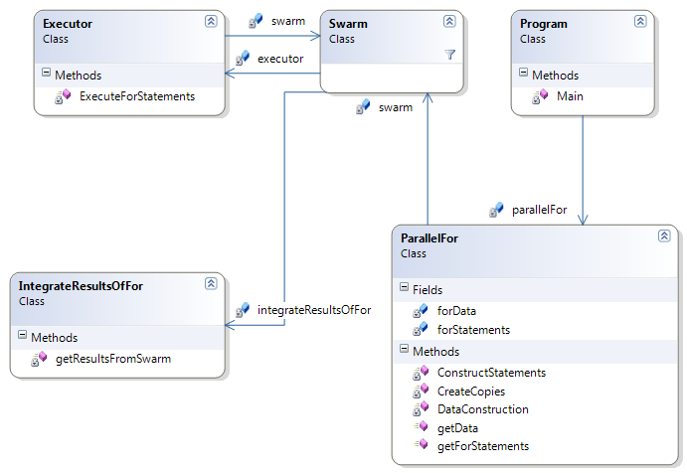

Figure 4: Class diagram for Parallel-For Loop execution

Classes and their responsibilities :

4.2.1 Class : Main
Description :
Responsible for identifying parallel-for and sending the body of the parallel-for loop to the ParallelFor class.

4.2.2 Class : ParallelFor
Description:
Responsible for converting the body of parallel-for to an intermediate form to facilitate sending of data and statements across machines.

Important data members and getter methods:
private string[] forStatements;
private string forData;
public string getData();
public string[] getForStatements();

Important functions:
private void ConstructStatements(Element[] elements);
To convert ASTs received in the form of elements into string stream.

private void CreateCopies();
To create copies of all the statements as per the range of for.
For example, consider a[i]=b[i]+c[i]; if i ranges from 1 to 3
The above statement will be 3 copies, a[0]=b[0]+c[0];, a[1]=b[1]+c[1] and a[2]=b[2]+c[2]

private void DataConstruction();
Any data used within parallel-for will be written to xml using this function. Both the data and copies of parallel-for body will be accessible through the public getter functions.

4.2.3 Class : Executor
private void ExecuteForStatements(string statement);
Description :
Responsible for executing any statement received by it. It converts the statements back to AST form, and uses the data in XML to execute them. The result is given to Swarm after the execution finishes.

4.2.4 Class : IntegrateResultsOfParallelFor
Description:
Responsible for integrating all the results given by Swarm to form the final result of the parallel-for.

Process Requirements
These requirements specify physical structure of the code developed and the environment where it must operate. The input will be syntactically correct data structure received from the front end team.

Physical Structures

ICT program consists of several modules. A module is either an executive of which there is only one per program, or a server. There may be as many server modules as deemed appropriate by the development team. ICT will be implemented using Visual C# .Net.

The main function will be enclosed by preprocessor statements preventing compilation unless the preprocessor detects a directive of the form TEST_MODULENAME, where MODULENAME is the name of the module with no extension.

Each implementation file in C# in our project begins with a prologue that contains descriptions of the following elements:
- file name with a few word summary
- version number
- language of implementation
- platform, e.g., computer and operating system
- application
- author with address, telephone number, and e-mail account

Development Environment

The Interpreter Core Team program builds and operates in the ECS clusters, e.g., Link 010, 201, 202, 274, or CST 2-112.

6. Team Summary Of Issues :

Swarm input related:

- Initial design for handing out the parallel commands and data to the swarm computing module had been to convert the AST of parallel commands into an intermediate code form such as byte codes, as these will be easier while transferring over the network.

- But the above design involved some issues like overhead of converting into byte codes, which should follow a very complicated and stringent protocol, as agreed by both the Interpreter Core and Swarm Computing teams. These need to be very specific (pertaining to the sequence to be communicated) as per the commands encountered.

- Current design includes a much simpler way to communicate the same by using an XML file for transmitting data, and an array of strings, for transmiting the commands.

Grammar related:

Plot:
- Initially all the fourteen plot functions were thought of being represented by different classes, each class representing a single plot functionality.

- But now the Front End team communicated that they’ll represent all the fourteen plot functions, via only six classes. We are yet to receive the exact inputs from them.

Matrix variable declaration and definition:
- Initially, matrices can be defined anywhere in the code once they have been declared.

- But since this way our team won’t be receiving the specified values in a matrix, so the Front End team now will take care that the matrix is initialized at the time of declaration itself.

7. Team Summary of Status:

The team has been able to complete the following tasks till now:
- B-Spec submitted.
- Roles identified and distributed among the team members.
- Working prototypes for each of the team members’ modules.
- All the team members have an idea of how to implement their modules, and with which other teams, they need to interact.
- Design of each member’s module within ICT.

GLOSSARY

AST | : | Abstract Syntax Tree is a tree representation of the abstract (simplified) syntactic structure of source code written in a certain programming language.
SPINACH | : | Swarmed Parallel Interpreter for Numerical Analysis with Collaborating Hubs (Refer to Architectural Concept Document, Version 1.1, for details).
ICT | : | Interpreter Core Team
ICP | : | Interpreter Core Processing

