Software Test Plan


Swarmed Parallel Interpreter for Numerical Analysis with Collaborating Hubs

November 23, 2009

Submitted By:
Sandhya
Harmish
Kunal
Chetan
Shashi

Table of Contents

1 Introduction 3
2 Test Objective 3
3 Overview 3
4 Testing Strategy 4
4.1 Qualification Testing 6
4.1.1 White Box Testing(debugging) 6
4.1.2 Black Box Testing 6
4.1.3 Specifications for which application will be tested are: 7
4.2 Stress testing 7
5 Bug Tracking/ Bug Process 7
5.2 Various Roles in Bug Resolution 8
5.3 Bug Report Form 9
5.4 Software Testing Process 11
6 Test Schedules 11
7 References 11

1 Introduction

This document sets forth a testing framework for SPINACH program built for the Software Studio class conducted by Phill Pratt Szeliga. This document will address the standards that will apply to the Qualification and stress testing of the specified application. We will utilize testing criteria under the white box, black box paradigm. This paradigm will include the testing criteria, methods, and test cases of the overall design.
.

Test Objective

The objective our test plan is to find and report as many bugs as possible to improve the integrity of our program. Although exhaustive testing is not possible, we will exercise a complete Qualification test and a stress test on the application to make sure that the final product meet all the requirement specifications.

Overview
The following represents the overall flow of the testing process:
- Identify the requirements to be tested. All test cases shall be derived using the current Program Specification.
- Identify which particular test(s) will be used to test each requirement.
- Identify the expected results for each test.
- Document the test case configuration, test data, and expected results.
- Perform the test(s).
- Document the test data, test cases, and test configuration used during the testing process. This information shall be submitted via Test Report .
- Unsuccessful testing requires a Bug Report Form to be generated. This document shall describe the test case, the problem encountered, its possible cause, and the sequence of events that led to the problem. It shall be used as a basis for later technical analysis.
- Test documents and reports shall be submitted. Any specifications to be reviewed, revised, or updated shall be handled immediately.

Testing Strategy

The following outlines the types of testing that will be done during Qualification testing and Stress testing. While it includes what will be tested, the specific cases that determine how the testing is done will be detailed in the Test Design Document. The template that will be used for designing cases is shown below.

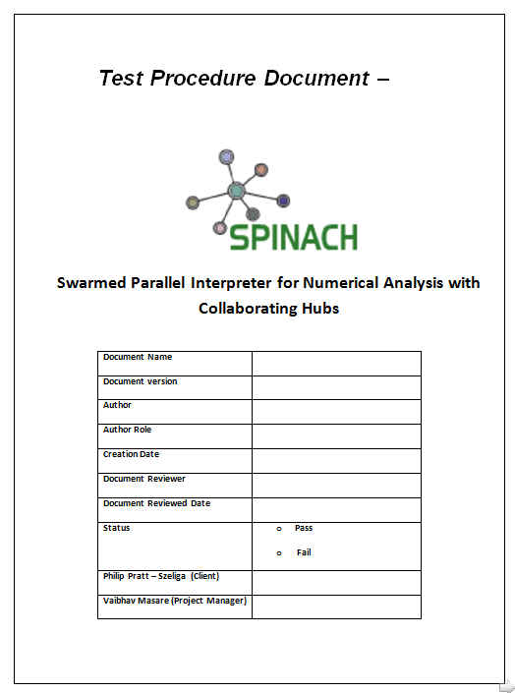

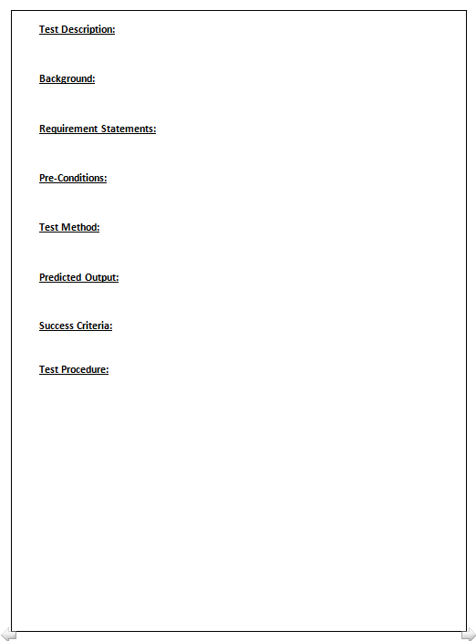

Qualification Testing

The integrated SPINACH Application will be tested based on the requirements to ensure that we built the right application. To ensure that the correction of defects found during testing is done efficiently therefore maximizing the iteration of test cycles, a clearly defined set of objectives is established. They are as follows:

- Verify that the system satisfies the functional requirements
- Verify internal system interfaces
- Verify external interfaces

All the functionality of the SPINACH are clubbed into 5 major modules. So these five modules will be tested to make sure that all the A and B specification implemented in the final product.

Modules | Expected Behavior
USER INTERFACE | see User interface Specification
INTERPRETER FRONTEND | see Interpreter frontend Specification
INTERPRETER CORE | see Interpreter Core Specification
SWARM | see Swarm Specification
PLOT | see Plot Specification

.

White Box Testing(debugging)

In Debugging testing, the UI is bypassed. Inputs and outputs are tested directly at the code level and the results are compared against specifications. This form of testing ignores the function of the program under test and will focus only on its code and the structure of that code.

Black Box Testing

Black box testing typically involves running through every possible input to verify that it results in the right outputs using the software as an end-user would.

Specifications for which application will be tested are:

User Interface………..Sandhya and harmish

Interpreter Frontend …Kunal and Chetan

Interpreter Core………Kunal and Chetan

Swarm………………..Sandhya and Harmish

Plot ……………………Kunal and Chetan

Stress testing

This test will be conducted to evaluate the performance of SPINACH application. It will be done using black-box testing method.

Bug Tracking/ Bug Process

During testing, the testing team members normally encounter behavior that goes against a specified or implied design requirement in the product. When this happens, we will document and reproduce the bugs for the developers.

5.1 Reporting a bug:

- Keep track of what version of the application the bug is found
- Determine if bug has already been written up
- Indicate the steps to reproduce the bug – write enough details for others looking at the bug to be able to duplicate it; exclude unnecessary steps (i.e. If access point is irrelevant, be more general in your steps).
- Actual results – be specific on your findings.
- Expected results – how the product should behave based on the specified or implied requirements.
- Implications – How does the defect affect the quality of the product?

The following chart defines the impact levels to be used when entering bugs.

Impact | Definitions
1 – Fatal | Stops test team from being able to move forward with any other test cases.
2 – Serious | One or more of the requirements for the test case cannot be tested due to functional defects.
3 – Minor | A bug that must be fixed before the product is officially completed.

5.2 Various Roles in Bug Resolution

- Author – The person who wrote the bug; this will be someone on the testing team
- Resolver – Normally an Engineer assigned to a specific area of the application.
- Verifier – normally a test team member responsible for testing the fix and closing the bug.

Bug Report Form
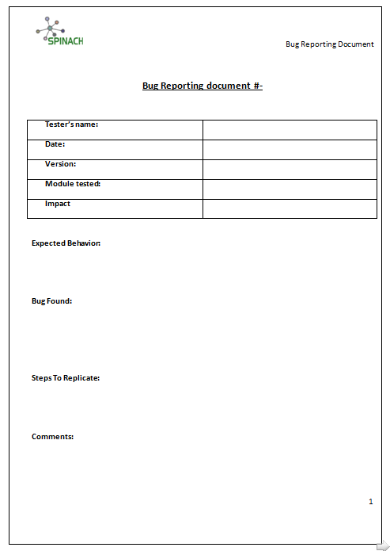

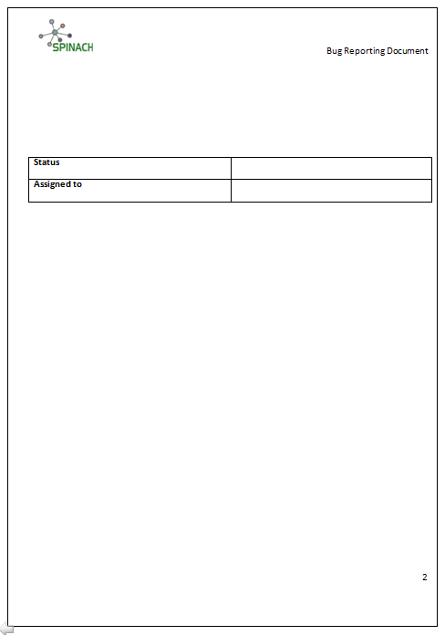

Software Testing Process
We shall adopt the following Testing Process:

  - Once the developer /finishes development/adds a new feature/fixes a bug he/she will check-in the code into the repository currently located in our github website
  - A notification will be sent to all the testers.
  - The Tester downloads a copy of the working code into his/her working environment
  - He/She then compiles the code using the software development environment available in their machines
  - He/She then runs the pre-defined test cases on the compiled code to verify that the software meets all test specifications
  - Any new issues that are discovered during the testing process are reported into the bug repository which is again located at our github website.Go back to step 1.

Test Schedules
Listed below are some of the major deliverables along with the deadlines

No | Deliverables | Planned Date | Date Completed
1 | Test Plan | 23/11/09 | 23/11/09
2 | Qualification and Stress Testing Specification | 30/11/09
3 | Qualification and Stress Testing Results
4 | Test Report

References

1. http://www.engr.sjsu.edu/~gaojerry

2.http://www.ecs.syr.edu/faculty/fawcett/handouts/webpages/CSE784.htm

