ENRICH SCADA
Standard Excel Template & Dynamic Device Configuration
Implementation specification based on Bhokar - Address Details.xlsx
Document control | Value
Version/date | 1.0 / 13 October 2026
Source standard | Bhokar - Address Details.xlsx
Purpose | Define how the SCADA EXE imports the workbook and creates dynamic devices, tags and runtime configuration.
Audience | Product owner, PLC/Modbus engineers, developers, commissioning and O&M teams

Governing rule: preserve the approved workbook format and make the software adapt to it.

Contents
- 1. Purpose and principles
- 2. Actual workbook structure
- 3. Dynamic inverter port generation
- 4. Device Array groups
- 5. Import and validation workflow
- 6. Tag/address decoding rules
- 7. Installer and wizard
- 8. 24×7 runtime
- 9. Database/versioning
- 10. SCADA screens with reference images
- 11. Error handling and security
- 12. API/service contract
- 13. Commissioning checklist
- 14. Decisions requiring confirmation
- Appendices: workbook examples and glossary
Screenshots in this document are supplied visual references, not proof that the UI is already implemented or connected to live data.

1. Purpose and Governing Principles
This document defines the SCADA configuration path using the approved workbook “Bhokar - Address Details.xlsx”. The importer must read the standard layout, validate it and convert it into normalized configuration records. Engineers should not have to re-enter the same values into a different generic template.
Principle | Required behavior
Workbook is the contract | Read the approved sheet/layout; use a versioned importer profile if the layout changes.
Dynamic devices | Generate inverter instances from the inverter count and port rule.
Separate Device Array | Treat WMS, Trafo, TVM, Annunciator and future groups as distinct logical devices/groups.
No hard-coded tags | Names, addresses, function codes and counts come from the workbook or approved decoding profile.
Validate before activation | Import → validate → preview → test → publish.
Independent runtime | Acquisition and sync continue after browser closure.
Auditability | Record source workbook name/hash, import user/time, warnings and published version.

Initial scope is monitoring, historian, alarms and reports. PLC writes, remote switching and safety/control commands are outside this specification unless separately reviewed.

2. Actual Workbook Structure
The uploaded workbook contains sheet “Venus 4.0MWp” with 140 rows and 11 columns. The upper rows hold site/inverter settings; the left table is the inverter parameter map; the right table is the Device Array parameter map.
Source field | Value visible in workbook | Interpretation
Customer | Venus Wire Industries Pvt.Ltd. | Customer metadata
Site | Bhokar, MH. | Site identity
Capacity | 2.65 MW AC, 4 MWp DC | Store AC/DC capacity separately where possible
Inverter Make / Count | Hopewind / 08 Nos | Manufacturer and number of generated inverter instances
Function Code | FC3 / Holding | Modbus operation/register profile; confirm normalization
Inverter endpoint | IP 192.168.X.X; base port 501 | Shared IP and sequential inverter ports described in workbook
Inverter Start / Data Count | 1 / 124 | Metadata requiring agreed address/count semantics
Device Array endpoint | IP Other Paramerts; port None | Separate endpoint for additional device group
Device Array Start / Data Count | None / None | Separate array-section configuration
Inverter table | Sr. No. / Parameters / Address | Parameter-to-address mapping
Device Array table | Sr. No. / Parameters / Address / Device Name | Additional equipment mapping grouped by Device Name

Area | Current workbook cells (observed) | Use
Site summary | B2:D6 | Customer, site, capacity, make/count and function metadata
Inverter endpoint | B9:D12 | IP, base port, start address and data count
Device Array endpoint | G9:J12 | IP, port, start address and data count
Inverter mapping | B:D from row 15 onward | Serial number, parameter, address
Device Array mapping | G:J from row 15 onward | Serial number, parameter, address, Device Name

The current layout is the import contract. If the team changes row/column positions, the importer should detect the mismatch and request a new importer profile rather than silently misread values.

3. Dynamic Inverter Port Generation
The workbook example describes 8 inverters on the same configured IP, using ports 501–508, and the Device Array endpoint on port 509. The planned 10-inverter example uses ports 501–510 and Device Array port 511.
8-inverter workbook example:
INV-01 → configured IP : 501
INV-02 → configured IP : 502
...
INV-08 → configured IP : 508
Device Array → configured IP : 509

10-inverter planned example:
INV-01 → configured IP : 501
...
INV-10 → configured IP : 510
Device Array → configured IP : 511

Field | Rule
Inverter count | Parse “08 Nos” as integer 8; require positive integer.
Base port | Read from workbook; validate 1–65535.
Port formula | inverter_port(i) = base_port + (i - 1), where i starts at 1.
Shared IP | Apply the same IP to each endpoint only when the gateway design confirms that pattern.
Device Array port | If workbook explicitly provides it, use that value and compare it with the calculated next port. If not, use configured rule base_port + inverter_count only after approval.
Port collision | Validate duplicates and range; show generated list before publishing.
Connectivity | Test each port; a generated port is valid only if the gateway/device actually exposes/routes it.

Do not hard-code the Device Array port to 509 or 511. In the current example it is explicitly 509; in the future 10-inverter scenario the calculated port is 511. Explicit workbook input should take precedence, with a warning if it conflicts with the configured sequential rule.

4. Device Array Groups and Relay/Annunciator Tags
In this workbook, “Device Array” means the right-hand additional-equipment parameter section, not automatically a mathematical array. Group rows by Device Name. A Device Name entered on the first row applies to following rows until the next nonblank Device Name, unless the workbook owner specifies otherwise.
Device Name | Examples from workbook | SCADA treatment
WMS | GTI, cumulative/total GTI, GHI, shadow irradiation, rain, ambient/module temperature, humidity, wind speed/direction | Weather/irradiance asset group
Trafo | WTI 01/02, OTI 01/02 | Transformer temperature group
TVM | R/Y/B voltage/current, neutral current, active/reactive/apparent power, frequency, PF, export/import | Metering group; confirm naming and meaning
Annunciator | Ann Status: W-1 through W-24 | Status/relay/alarm points; bit semantics require engineering map
Future group | Any new Device Name value | Create configurable group after validation; no code change should be required

- Do not clone inverter tags into the Device Array section.
- Use the Device Array endpoint by default; allow per-group endpoint overrides only if the standard is extended to support them.
- Preserve parameter names and addresses, while mapping them to stable Universal Tag Codes separately.
- Allow shared equipment to map to one or more plants without duplicate physical acquisition.
- Relay/annunciator entries must specify register type, bit offset/mask or raw-value enum, normal state, alarm state and severity before alarm behavior is enabled.

5. Import, Validation and Preview Workflow
Select workbook
↓ Validate workbook/sheet profile and required fields
Parse site metadata + inverter map + Device Array groups
↓ Normalize count, IP, ports, function/register type and addresses
Generate inverter instances + group Device Array parameters
↓ Validate address/count/ports/tags/data decoding
Preview generated devices, ports, tags and warnings
↓ Test connections and representative reads
Save DRAFT → approve/publish immutable configuration version
↓ Acquisition service loads ACTIVE version

Validation | Examples | Action
Workbook profile | Missing sheet or required fields | Reject import; show exact issue
Inverter count | Cannot parse or zero/negative | Block publish
Port generation | Port outside 1–65535 or collision | Block publish
Endpoint test | One port unreachable | Show result per device; apply agreed partial-commissioning policy
Address map | Duplicate or invalid address | Warn/block based on explicit overlap rules
Function code | Unknown/contradictory register type | Require engineering confirmation
Data Count | Meaning unclear or exceeds request limit | Do not assume it is Modbus quantity; block activation until defined
Device grouping | Address row has no resolved Device Name | Warn and require mapping review
Decoder metadata | No data type/scale/unit/byte order | Use approved model profile or require engineering input
Config diff | Existing tags/addresses changed | Preview affected devices before publish

5.1 Configuration states
DRAFT → VALIDATING → VALIDATED → PUBLISHED → ACTIVE
↘ FAILED
A failed draft never replaces the active version. Rollback is auditable.

5.2 Data Count caution
The workbook shows Data Count 124, while the address list contains entries extending beyond the first 124 parameter rows depending on how the column is interpreted. The engineering team must define whether Data Count means Modbus registers per request, tags/parameters in the map, or a vendor-specific setting. The software must not blindly use 124 as a read length.

6. Tag, Address and Decoder Rules
The workbook visibly supplies parameter labels and addresses, but not all decoding details. Data type, signedness, register type, byte/word order, scale, offset, unit, bit location and polling interval must come from an approved manufacturer/model profile or explicit engineering input.
Layer | Purpose | Example
Display parameter | Original label in workbook | Active Power
Universal Tag Code | Stable company standard semantic identifier | AC_POWER
Template mapping | Device-specific function/address/decoder | FC3 + address 4001 + approved type/scale
Asset tag instance | Concrete device-specific tag | INV-01 / AC_POWER
Live/history value | Typed value, quality and timestamp | 125.6 kW, GOOD, timestamp

- Preserve the original workbook address value; separately store its addressing convention.
- Confirm whether 4001 means a protocol offset, a 4xxxx reference, or a vendor-specific address. Never silently subtract one or rewrite it.
- Normalize FC3/Holding only after engineering confirms how the workbook uses these labels.
- Use contiguous block reads only when the device supports the range and the mapping defines child offsets correctly.
- Validate data type/register count, request limits, overlapping addresses and invalid/sentinel values.
- Create stable Tag Codes through a reviewed dictionary; preserve original display names for traceability.
- Do not infer relay alarm polarity or state meanings from labels alone.
engineering_value = raw_value × scale_factor + offset

7. Installer and First-Run Wizard
Step | Screen/action | Output
1 | Install prerequisites and application services | One customer-facing installer completed
2 | Create administrator | Secure initial account
3 | Import standard workbook | Draft configuration + validation report
4 | Review site and inverter count | Confirmed site and device count
5 | Review endpoint generation | IP and generated inverter ports preview
6 | Review Device Array groups | WMS/Trafo/TVM/Annunciator grouping and endpoint
7 | Review decoder profile | Function, address, type, scale, units and polling
8 | Test connection/read | Per-device results and raw/decoded values
9 | Central server and retention | Central sync and local retention settings
10 | Validate and publish | Active immutable configuration version
11 | Runtime health | Service status, live data, sync backlog

SCADA-Setup.exe installs/registers:
React/TypeScript frontend
FastAPI service
Modbus acquisition service
Central sync service
Retention service
Optional watchdog/health service
PostgreSQL as a managed prerequisite or installer-managed component

Suggested Windows services: EnrichSCADA_API, EnrichSCADA_Acquisition, EnrichSCADA_Sync, EnrichSCADA_Retention and optional EnrichSCADA_Watchdog. The browser is not responsible for polling PLCs.

8. Runtime and 24×7 Behavior
Windows boot → PostgreSQL ready → API starts
→ Acquisition loads ACTIVE config snapshot
→ connect to generated inverter endpoints and Device Array endpoint
→ poll/decode/scale/quality-check
→ write current values + historian + alarms + sync outbox
→ sync worker uploads batches to central API
→ retention service manages local history

Scenario | Expected behavior
Browser closed | Acquisition, local database, alarms, sync and retention continue.
Internet unavailable | Local reads/history continue; outbox remains pending; sync resumes later.
One inverter offline | That endpoint shows communication failure/stale quality; other devices continue.
Service crash | Windows recovery restarts service; health log records outage.
Bad import | Draft rejected; active version unchanged.
Count changed | Preview generated endpoints/tags and validate port conflicts before publish.
Template update | Show a diff; affected assets migrate only after explicit approval.

Never display failed communication as a valid zero. Keep last known value with its timestamp and STALE/COMMUNICATION_FAILURE quality.

9. Database Model and Versioning
Table/group | Purpose
sites / plants | Site and plant identity/capacity/timezone
assets | Generated inverters and logical Device Array assets/groups
asset_plant_mappings | Map shared WMS/Trafo/TVM/Annunciator/PLC to one or more plants
communication_configurations | Protocol, IP/port or serial settings, timeout/retry and Unit ID
tag_definitions | Universal Tag Codes, names, units, category and approval state
device_templates | Versioned manufacturer/model register map
template_tag_mappings | Workbook parameter/address and decoder metadata
asset_tag_instances | Resolved tags per generated device, with effective address/index
register_blocks | Contiguous read ranges and child offsets
current_values | Latest value, quality and timestamp per tag instance
historical_values | Time-series records, partitioned by time
device_status | Connection state, last success/failure and response time
alarm_rules / alarm_events | Alarm definitions and lifecycle
sync_queue | Durable outbox with unique event ID and retry state
configuration_versions / changes | Immutable snapshots and old/new differences
service_heartbeat / audit_logs / users | Runtime health, traceability and access control

- Store the imported workbook name, format version, content hash, importer user and timestamp.
- Store a normalized snapshot; do not depend on a mutable Excel file at runtime.
- Published versions are immutable. Corrections create a new version.
- Acquisition reports which configuration version it loaded.
- Failed validation/reload leaves the last known-good version active.
- Use PostgreSQL time partitioning for high-volume history; retention should not delete unsynced outbox events.

10. SCADA Screens and Visual References
Use the agreed dark theme: background #132238, panels #1E2D3D, header #0D1B2A, white primary text, #D6DCE5 secondary text, #29B6F6 accent, #00C853 healthy, #FFC107 warning, #FF5252 alarm, #FFCA28 solar generation, #42A5F5 grid flow, #26A69A export and #EF5350 import. Every live value should show unit and freshness/quality.

10.1 Dashboard / Portfolio
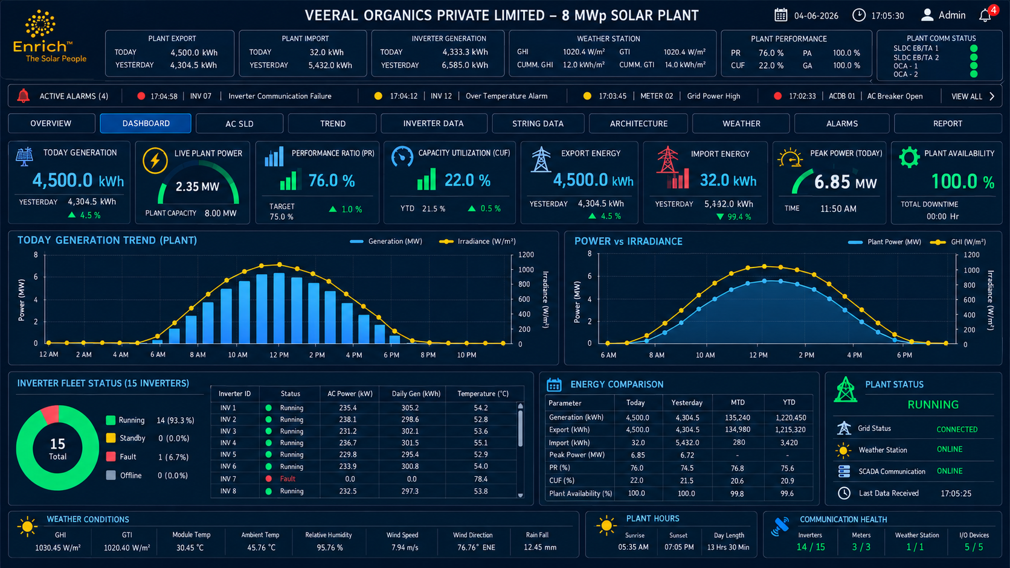
Reference: dashboard
Portfolio KPIs, plant status, live generation, energy, trend, alarm summary and last-data timestamp. Filters follow selected site/plant.

10.2 AC Single-Line Diagram
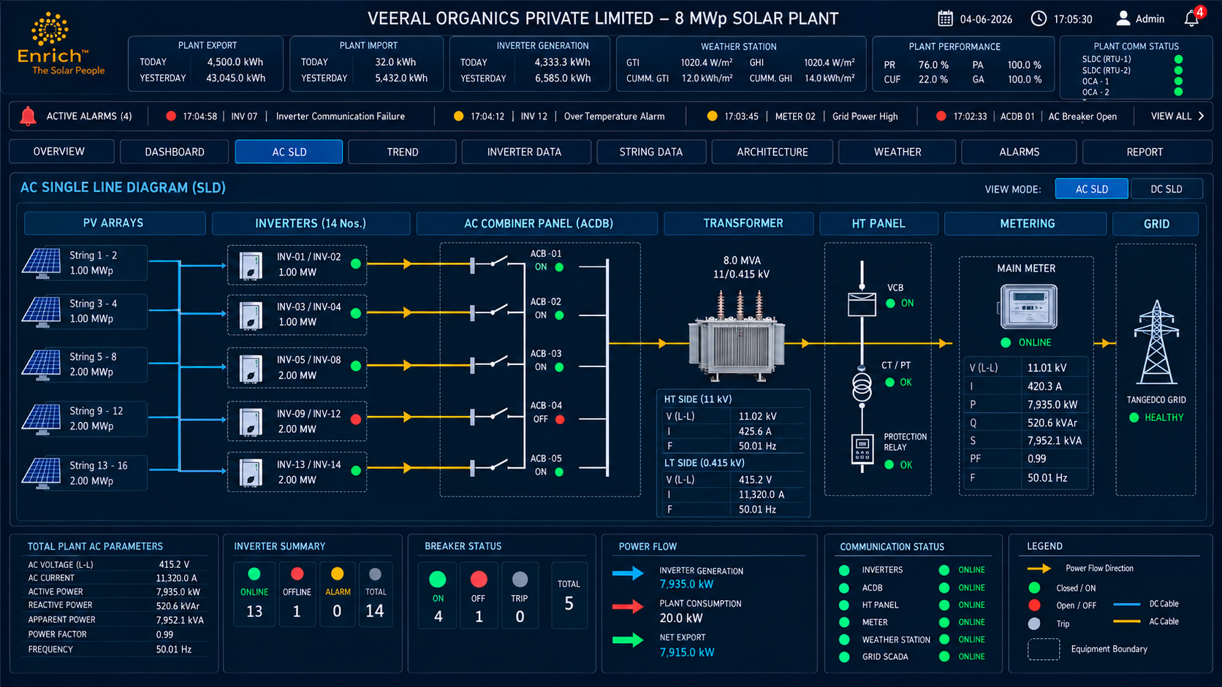
Reference: AC SLD
Configured electrical topology with live power flow, equipment state and alarm/communication indicators. Topology must be configurable per plant.

10.3 Trend / History
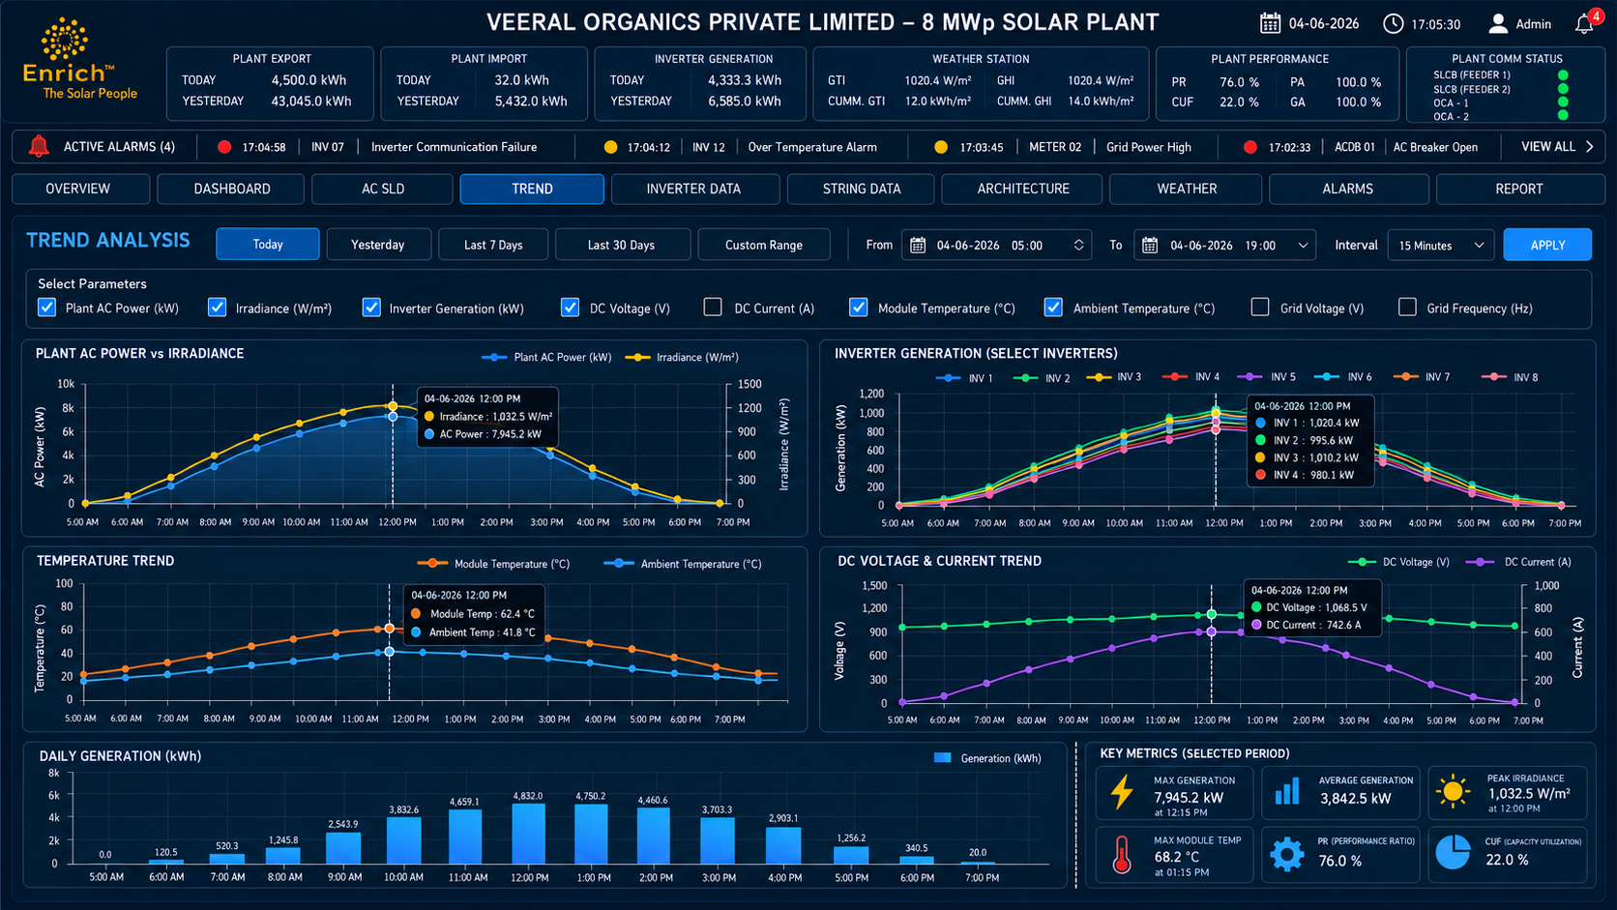
Reference: trend
Tag selection, custom time range, multi-series charts, zoom/cursor and export. Use historian queries and downsampling.

10.4 Inverter Data
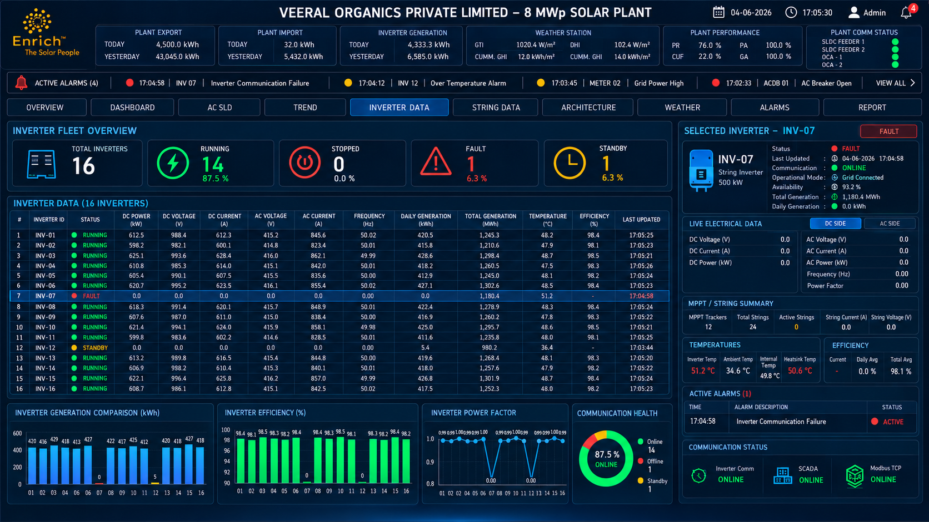
Reference: inverter data
Display dynamically generated inverter instances, connection status, values, quality, last read and device drill-down.

10.5 String Data
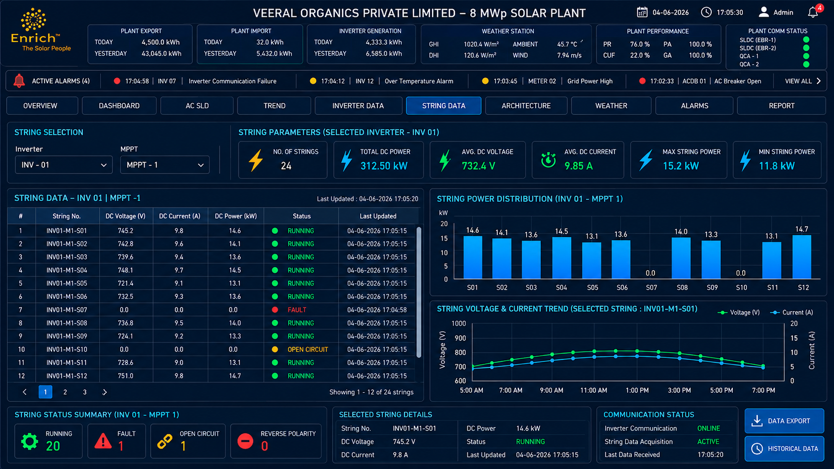
Reference: string data
Display string/MPPT values only when supported by the selected inverter map; do not invent unsupported values.

10.6 Architecture / Topology
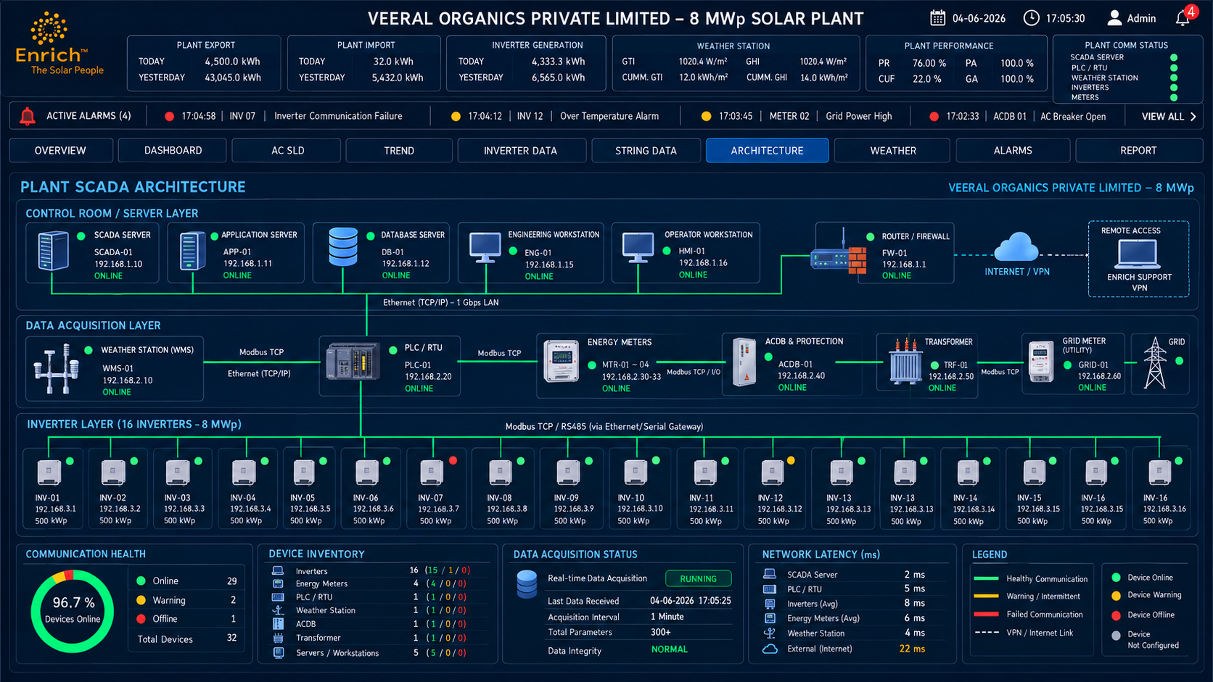
Reference: architecture
Site, plants, inverter groups and shared WMS/other assets. Shared assets may map to multiple plants without duplicate acquisition.

10.7 Alarms
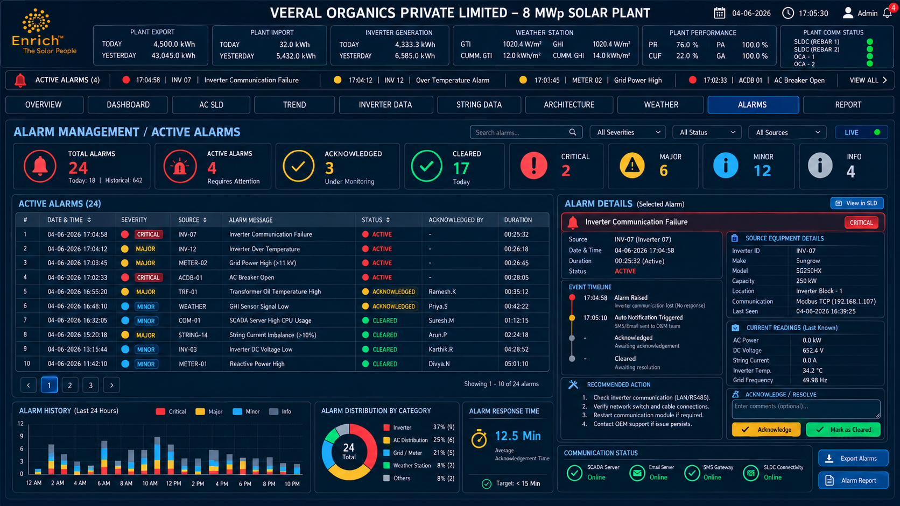
Reference: alarms
Active/acknowledged/cleared events with severity, time, asset, tag, value, message and acknowledgement identity.

10.8 Reports / Analytics
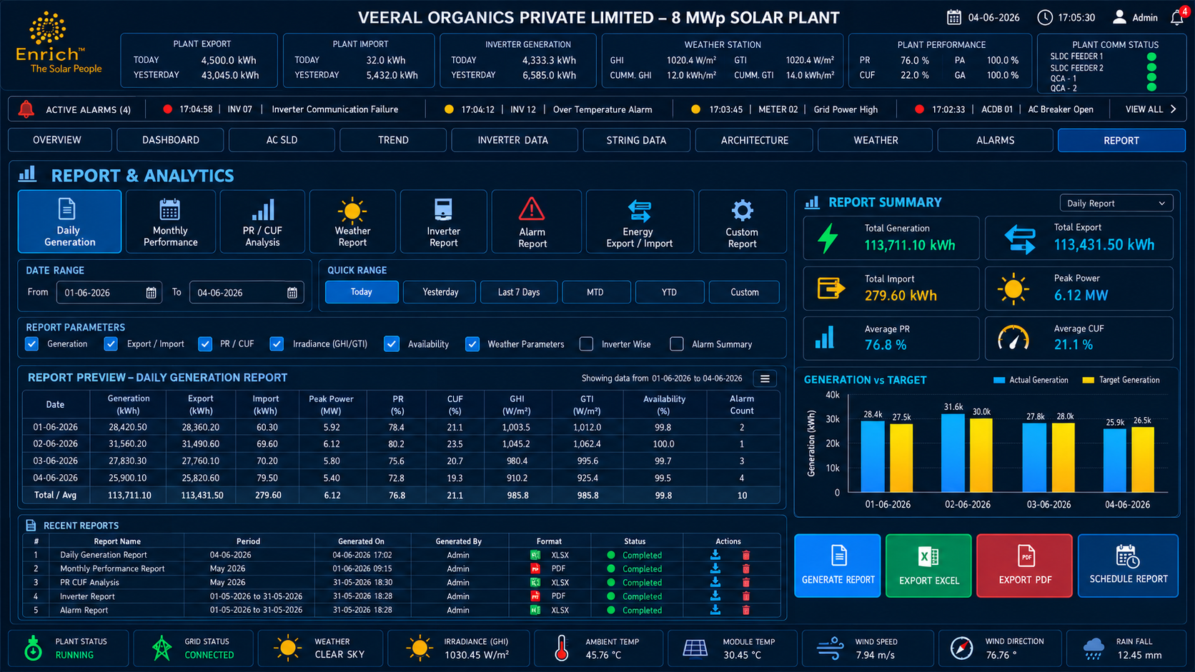
Reference: reports
Daily, MTD, YTD and custom reports. Document formula, timezone, counter reset and missing-data handling.

10.9 WMS
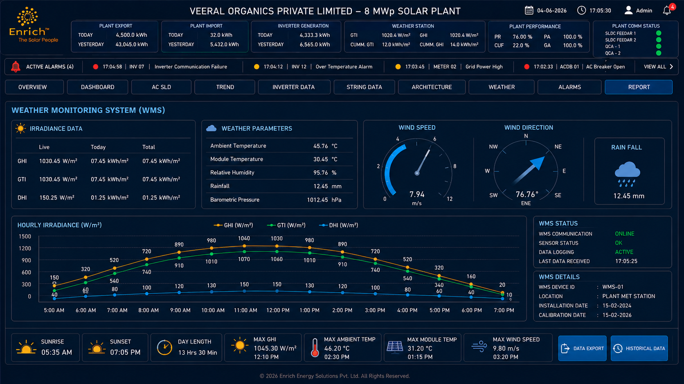
Reference: WMS
Show supported irradiance, temperature, humidity, wind and rain tags from the Device Array mapping.

10.10 Required configuration screens
Screen | Required fields/actions
Workbook Import | File selection, detected sheet/profile, validation results and source hash
Inverter Port Preview | IP, count, base port, generated ports and conflicts
Device Array Manager | Device Name, endpoint, parameters, addresses, enable/disable and preview
Universal Tag Dictionary | Add/review/approve stable Tag Codes, names, units and categories
Template/Address Map | Function/register type, address, data count, type, byte/word order, scale, unit and test read
Publish Configuration | Diff, validation summary, confirmation and rollback
System Health | Service heartbeats, loaded version, device states, last read, sync backlog, DB/disk and retention

11. Error Handling, Security, Backup and Updates
Condition | Required behavior
Workbook layout mismatch | Explain changed/missing fields; never guess silently.
Invalid count/port | Block publish and identify the offending field.
Unreachable endpoint | Show per-device result and apply agreed commissioning policy.
Unknown function/address/count | Require engineering correction before activation.
Unknown data type/scaling | Require approved decoding profile; never assume a type.
Database unavailable | Report unhealthy and retry; no false persistence success.
Central API unavailable | Retain pending outbox and retry with backoff.
Disk nearly full | Raise critical health alarm and follow documented safe degradation.

- Use least-privilege Windows service accounts and PostgreSQL roles.
- Enforce RBAC server-side; protect secrets and validate TLS.
- Audit workbook imports, publishing/rollback, user changes and alarm acknowledgement.
- Keep rotating structured logs; never log credentials/tokens.
- Default local historian retention is 365 days; partition by time at scale.
- Do not delete unsynced sync events solely because historian data is old.
- Back up configuration/database and test restore; use versioned DB migrations for upgrades.

12. API and Service Contract
Area | Suggested endpoint | Purpose
Workbook import | POST /api/v1/config/import-workbook | Parse workbook into draft; return warnings and preview ID
Import preview | GET /api/v1/config/imports/{id}/preview | Show endpoints, Device Array groups and generated tags
Connection test | POST /api/v1/assets/{id}/test-connection | Test endpoint
Tag test | POST /api/v1/assets/{id}/test-read | Return raw registers, decoded value, quality and timestamp
Validation | POST /api/v1/config/versions/{id}/validate | Validate draft
Publish | POST /api/v1/config/versions/{id}/publish | Activate immutable version
Rollback | POST /api/v1/config/rollback | Reactivate known-good version
Live/history | GET /api/v1/current-values; GET /api/v1/history; WebSocket /ws/live | Dashboard and trends
Health/sync | GET /api/v1/system/health; /services; /sync/status | Runtime monitoring

These are proposed contracts for implementation, not claims that the APIs already exist.

13. Commissioning and Acceptance Checklist
Test | Acceptance criteria
Workbook import | Approved workbook imports without manual restructuring.
Site metadata | Customer, site, capacity, make/count and function are parsed and shown for confirmation.
Port generation | 8 devices with base 501 produce 501–508; 10 produce 501–510; Device Array follows explicit/configured rule.
IP/port reality | Each generated endpoint is tested; port pattern matches actual gateway routing.
Device Array grouping | WMS, Trafo, TVM and Annunciator rows are grouped correctly.
Address preservation | Workbook values are not silently shifted or transformed.
Data Count | Meaning is confirmed and protocol/device limits validated.
Decoder validation | Type, byte/word order, scaling and units are tested against known values.
Version safety | Failed drafts cannot replace active configuration; rollback is audited.
24×7 runtime | Closing browser does not stop acquisition; reboot restarts services.
Offline sync | Local data persists during central outage and later sync is idempotent.
Retention/backup | Retention protects unsynced queue; database restore is tested.
Screen acceptance | Supplied screen references guide implementation; all live values are API-driven.

14. Decisions Requiring Engineering Confirmation
Decision | Why | Required action
Data Count=124 | Could mean read count, tag count or vendor-specific setting | Document precise meaning per profile before runtime use
Address convention | 4001 may be offset/reference/vendor notation | Store convention and test read; do not auto-shift
FC3/Holding | Function code and register type need exact normalization | Approve internal mapping
Data types and scaling | Workbook does not specify all decoder metadata | Create approved model-specific decoding profile
Device Array port | Example is 509 for 8 inverters; planned 511 for 10 | Explicit workbook value takes precedence; calculate only if policy says so
Device Name carry-down | Group labels may only appear at first row | Approve carry-forward rule until next nonblank group label
Relay/annunciator states | Labels do not define bit polarity or alarm meaning | Document bit/enum values, normal/alarm state and severity
Shared IP | Ports only work if gateway routes/listens there | Test every endpoint

Appendix A. Workbook-Derived Parameter Examples
Inverter parameter | Address shown | Engineering note
Active Power | 4001 | Decoder and unit must be confirmed
DC Power | 4002 | Confirm address convention and type
Reactive Power | 4003 | Confirm type and scale
Today Generation | 4004 | Confirm unit/reset behavior
Total Generation | 4005 | Confirm counter type/rollover
Power Factor | 4006 | Confirm range and scaling
Grid Frequency | 4007 | Confirm unit/scaling
Internal Temp. | 4009 | Confirm unit/scaling
Status | 4010 | Define raw-value enum
R/Y/B Phase Voltage | 4014–4016 | Check contiguous block feasibility
String Current 01–32 | 4026–4057 | Repeated parameter group in source
MPPT Voltage 01–12 | 4058–4069 | Repeated parameter group in source
MPPT Current 01–12 | 4070–4081 | Repeated parameter group in source

Device Array group | Examples
WMS | GTI, cumulative/total GTI, GHI, shadow irradiation, rain, ambient/module temperature, humidity, wind
Trafo | WTI 01/02, OTI 01/02
TVM | Phase voltage/current, neutral current, active/reactive/apparent power, frequency, PF, import/export
Annunciator | Ann Status: W-1 through W-24

Names and addresses above are transcribed from the workbook for documentation only; they do not define the correct raw data decoding.

Appendix B. Final Implementation Rules
- Use the approved workbook as the source configuration contract.
- Generate inverter ports dynamically from count/base port; use explicit Device Array port when supplied.
- Treat Device Array as grouped additional equipment, not automatically as a mathematical array.
- Do not guess function codes, address conventions, data types, scaling or Data Count semantics.
- Preview and test endpoints/tags before publishing.
- Keep active configuration immutable and preserve rollback.
- Continue local acquisition when UI or Internet is unavailable.
- Use supplied SCADA screen images as visual guidance; bind production UI to live APIs.

