Lab Manual
Lab Practice II [TE IT] 2019 Pattern
Web Application Development
[314458]

Prepared By: Asst.Prof. Nayan Sadaphal

List of Practical
Sr.No | Experiment List WAD
1 | 1.a. Create a responsive web page which shows the ecommerce/college/exam admin dashboard with sidebar and statistics in cards using HTML, CSS and Bootstrap.  1.b. Write a JavaScript Program to get the user registration data and push to array/local storage with AJAX POST method and data list in new page.
2 | a. Create version control account on GitHub and using Git commands to create repository and push your code to GitHub.  b. Create Docker Container Environment (NVIDEIA Docker or any other).  c. Create an Angular application which will do following actions: Register User, Login User, Show User Data on Profile Component
3 | a. Create a Node.JS Application which serves a static website.  b. Create four API using Node.JS, ExpressJS and MongoDB for CURD Operations on assignment 2.C.
4 | a. Create a simple Mobile Website using jQuery Mobile.  b. Deploy/Host Your web application on AWS VPC or AWS Elastic Beanstalk. Mini Project
5 | Develop a web application using full stack development technologies in any of the following domains:  1. Social Media  2. ecommerce  3. Restaurant  4. Medical  5. Finance  6. Education  7. Any other

Practical No. 1A
Title: Create a responsive web page using HTML, CSS, Bootstrap
Problem Statement: Create a responsive web page which shows the ecommerce/college/exam admin dashboard with sidebar and statistics in cards using HTML, CSS and Bootstrap.
Theory:
HTML
HTML stands for Hyper Text Markup Language
HTML is the standard markup language for creating Web pages
HTML describes the structure of a Web page
HTML consists of a series of elements
HTML elements tell the browser how to display the content
HTML elements label pieces of content such as "this is a heading", "this is a paragraph", "this is a link", etc
A simple HTML Document
<! DOCTYPE html>
<html>
<head>
<title>Page Title</title>
</head>
<body>
<h1>My First Heading</h1>
<p>My first paragraph.</p>
</body>
</html>
The <!DOCTYPE html> declaration defines that this document is an HTML5 document
The <html> element is the root element of an HTML page
The <head> element contains meta information about the HTML page
The <title> element specifies a title for the HTML page (which is shown in the browser's title bar or in the page's tab)
The <body> element defines the document's body, and is a container for all the visible contents, such as headings, paragraphs, images, hyperlinks, tables, lists, etc.
The <h1> element defines a large heading
The <p> element defines a paragraph
Different HTML Tags used
<a> tag-Hyperlink
The <a> or anchor tag is used to add a hyperlink.
Attributes
i) href – used to mention the link
e.g. <a href="https:// jspmjscoe.edu.in" target="_self">CLICK ME</a>
Open in same window
e.g. <a href="https:// jspmjscoe.edu.in" target="_blank">CLICK ME</a> Open in different window
HTML Unordered Lists
An unordered list starts with the <ul> tag. Each list item starts with the <li> tag.
e.g. <ul>
<li>Coffee</li>
<li>Tea</li>
<li>Milk</li>
</ul>
Example –Disc style
<ul style="list-style-type:disc;">
<li>Coffee</li>
<li>Tea</li>
<li>Milk</li>
</ul>
HTML Ordered Lists
An ordered list starts with the <ol> tag. Each list item starts with the <li> tag
Example
<ol>
<li>Coffee</li>
<li>Tea</li>
<li>Milk</li>
</ol>
The type attribute of the <ol> tag, defines the type of the list item marker:

Type | Description
type="1" | The list items will be numbered with numbers (default)
type="A" | The list items will be numbered with uppercase letters
type="a" | The list items will be numbered with lowercase letters
type="I" | The list items will be numbered with uppercase roman numbers
type="i" | The list items will be numbered with lowercase roman numbers

CSS- Cascading Style Sheet
CSS stands for Cascading Style Sheets
CSS describes how HTML elements are to be displayed on screen, paper, or in other media
CSS saves a lot of work. It can control the layout of multiple web pages all at once
External style sheets are stored in CSS files
CSS is used to define styles for your web pages, including the design, layout and variations in display for different devices and screen sizes.
Simple CSS example
<!DOCTYPE html>
<html>
<head>
<style> body {
background-color: lightblue;
}
h1 {
color: white;
text-align: center;
}
p {
font-family: verdana; font-size: 20px;
}
</style>
</head>
<body>
<h1>My First CSS Example</h1>
<p>This is a paragraph.</p>
</body>
</html>
CSS Navigation Bar Examples-
Vertical
- Home
- News
- Contact
- About
Horizontal
- Home
- News
- Contact
- About
Having easy-to-use navigation is important for any web site.

With CSS you can transform boring HTML menus into good-looking navigation bars.
Navigation Bar = List of Links Example code - Vertical
<ul>
<li><a href="default.asp">Home</a></li>
<li><a href="news.asp">News</a></li>
<li><a href="contact.asp">Contact</a></li>
<li><a href="about.asp">About</a></li>
</ul> ul {
list-style-type: none; margin: 0;
padding: 0; width: 60px;
}
li a {
display: block;
}
Link to refer : https://www.w3schools.com/css/css_navbar_vertical.asp
Example1 –Horizontal
li {
display: inline;
}
Example 2
ul {
list-style-type: none; margin: 0;
padding: 0; overflow: hidden;
background-color: #333;
}
li {
float: left;
}
li a {
display: block; color: white;
text-align: center; padding: 14px 16px; text-decoration: none;
}
/* Change the link color to #111 (black) on hover */ li a:hover {
background-color: #111;
}
Link for reference: https://www.w3schools.com/css/css_navbar_horizontal.asp

Bootstrap
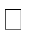
Bootstrap is a free and open-source tool collection for creating responsive websites and web applications. It is the most popular HTML, CSS, and JavaScript framework for developing responsive, mobile-first websites. It solves many problems which we had once, one of which is the cross-browser compatibility issue. Nowadays, the websites are perfect for all the browsers (IE, Firefox, and Chrome) and for all sizes of screens (Desktop, Tablets, Phablets, and Phones).


Why Bootstrap?
Faster and Easier Web Development.
It creates Platform-independent web pages.
It creates Responsive Web-pages.
It is designed to be responsive to mobile devices too.
It is Free! Available on www.getbootstrap.com

Bootstarp Example
<!DOCTYPE html>
<html lang="en">
<head>
<title>Bootstrap Example</title>
<meta charset="utf-8">
<meta name="viewport" content="width=device-width, initial- scale=1">
<link rel="stylesheet" href="https://maxcdn.bootstrapcdn.com/boots trap/3.4.1/css/bootstrap.min.css">
<script src="https://ajax.googleapis.com/ajax/libs/jquery/3.6.0/jq uery.min.js"></script>
<script src="https://maxcdn.bootstrapcdn.com/bootstrap/3.4.1/js/bo otstrap.min.js"></script>
</head>
<body>
<div class="container">
<h1>My First Bootstrap Page</h1>
<p>This is some text.</p>
</div>
</body>
</html>

Ways to add Bootstrap
Include Bootstrap from a CDN

<!-- Latest compiled and minified CSS -->

<link href="https://cdn.jsdelivr.net/npm/bootstrap@5.2.3/dist/css/bootstrap.min.css" rel="stylesheet">
<!-- Latest compiled JavaScript -->

<script src="https://cdn.jsdelivr.net/npm/bootstrap@5.2.3/dist/js/bootstrap.bundle.min.js"></script>

Download Bootstrap from getbootstrap.com
Link to refer: https://www.w3schools.com/bootstrap5/bootstrap_get_started.php

Responsive web design
Responsive web design (RWD) is a web development approach that creates
dynamic changes to the appearance of a website, depending on the screen size and orientation of the device being used to view it.
Responsive web design is about creating web pages that look good on all devices!
A responsive web design will automatically adjust for different screen sizes and viewports.
Responsive Web Design is about using HTML and CSS to automatically resize, hide, shrink, or enlarge, a website, to make it look good on all devices (desktops, tablets, and phones)

Bootstrap Container

The .container class provides a responsive fixed width container
The .container-fluid class provides a full width container, spanning the entire width of the viewport

Fixed Container
Use the .container class to create a responsive, fixed-width container. Note that its width (max-width) will change on different screen sizes:
<div class="container">
<h1>My First Bootstrap Page</h1>
<p>This is some text.</p>
</div>
Fluid Container
Use the .container-fluid class to create a full width container that will always span the entire width of the screen (width is always 100%):
<div class="container-fluid">
<h1>My First Bootstrap Page</h1>
<p>This is some text.</p>
</div>

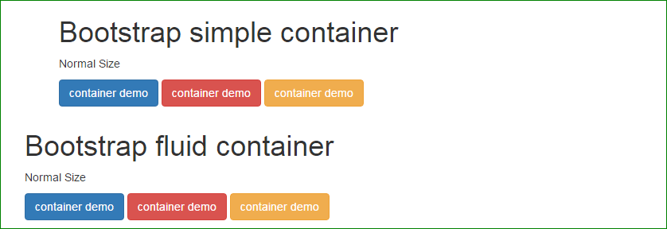

Bootstrap Grid system

Bootstrap's grid system is built with flexbox and allows up to 12 columns across the page.

If you do not want to use all 12 columns individually, you can group the columns together to create wider columns:

span 1 | span 1 | span 1 | span 1 | span 1 | span 1 | span 1 | span 1 | span 1 | span 1 | span 1 | span 1
 | span 4 |  |  |  | span 4 |  |  |  | span 4
 | span 4 |  |  |  |  |  | span 8
 |  | span 6 |  |  |  |  |  | span 6
 |  |  |  |  | span 12

The grid system is responsive, and the columns will re-arrange automatically depending on the screen size. Make sure that the sum adds up to 12 or fewer (it is not required that you use all 12 available columns).
Grid Classes

The Bootstrap 5 grid system has six classes:

.col- (extra small devices - screen width less than 576px)
.col-sm- (small devices - screen width equal to or greater than 576px)
.col-md- (medium devices - screen width equal to or greater than 768px)
.col-lg- (large devices - screen width equal to or greater than 992px)
.col-xl- (xlarge devices - screen width equal to or greater than 1200px)
.col-xxl- (xxlarge devices - screen width equal to or greater than 1400px)

The classes above can be combined to create more dynamic and flexible layouts.

Tip: Each class scales up, so if you want to set the same widths for sm and md, you only need to specify sm.

Basic Structure of a Bootstrap 5 Grid

The following is a basic structure of a Bootstrap 5 grid:

<!-- Control the column width, and how they should appear on different devices -->
<div class="row">
<div class="col-*-*"></div>
<div class="col-*-*"></div>
</div>
<div class="row">
<div class="col-*-*"></div>
<div class="col-*-*"></div>
<div class="col-*-*"></div>
</div>

<!-- Or let Bootstrap automatically handle the layout -->
<div class="row">
<div class="col"></div>
<div class="col"></div>
<div class="col"></div>
</div>

First example: create a row (<div class="row">). Then, add the desired number of columns (tags with appropriate .col-*-* classes). The first star (*) represents the responsiveness: sm, md, lg, xl or xxl, while the second star represents a number, which should add up to 12 for each row.

Second example: instead of adding a number to each col, let bootstrap handle the layout, to create equal width columns: two "col" elements = 50% width to each col, while three cols = 33.33% width to each col. Four cols = 25% width, etc. You can also use .col-sm|md|lg|xl|xxl to make the columns responsive.

Link for Reference:
https://www.w3schools.com/bootstrap5/bootstrap_containers.php
https://www.jquery-az.com/bootstrap-container-and-container-fluid-what-is-the-difference/
https://getbootstrap.com/docs/5.0/layout/containers/

Problem Statement: Create a responsive web page which shows the commerce/college/exam admin dashboard with sidebar and statistics in cards using HTML, CSS and Bootstrap.
Steps for Implementation:
Create workspace in Visual studio code
Use basic HTML tags
Use “CSS Navbar” for creation of dashboard
A navigation bar with user settings;
A sidebar with navigation items;
A section to show the title, tagline, and breadcrumbs for the current page;
The main content area with a couple of widget cards;
Last of but not least footer.
Use bootstrap container, grid system.
Run using live webserver

Programming Code:

<!DOCTYPE html>
<html lang="en">
<head>
<meta charset="UTF-8">
<meta name="viewport" content="width=device-width, initial-scale=1.0">
<title>sign up Ash creation</title>
<link href="https://cdn.jsdelivr.net/npm/bootstrap@5.3.3/dist/css/bootstrap.min.css" rel="stylesheet" integrity="sha384-QWTKZyjpPEjISv5WaRU9OFeRpok6YctnYmDr5pNlyT2bRjXh0JMhjY6hW+ALEwIH" crossorigin="anonymous">
<link rel="stylesheet" href="bootstrap.css">
</head>
<body>
<section class="h-100 bg-dark">
<div class="container py-5 h-100">
<div class="row d-flex justify-content-center align-items-center h-100">
<div class="col">
<div class="card card-registration my-4">
<div class="row g-0">
<div class="col-xl-6 d-none d-xl-block">

</div>
<div class="col-xl-15">
<div class="card-body p-md-5 text-black">
<h3 class="mb-5 text-uppercase">Student registration form</h3>

<div class="row">
<div class="col-md-6 mb-4">
<div data-mdb-input-init class="form-outline">
<input type="text" id="form3Example1m" class="form-control form-control-lg" />
<label class="form-label" for="form3Example1m">First name</label>
</div>
</div>
<div class="col-md-6 mb-4">
<div data-mdb-input-init class="form-outline">
<input type="text" id="form3Example1n" class="form-control form-control-lg" />
<label class="form-label" for="form3Example1n">Last name</label>
</div>
</div>
</div>

<div class="row">
<div class="col-md-6 mb-4">
<div data-mdb-input-init class="form-outline">
<input type="text" id="form3Example1m1" class="form-control form-control-lg" />
<label class="form-label" for="form3Example1m1">Mother's name</label>
</div>
</div>
<div class="col-md-6 mb-4">
<div data-mdb-input-init class="form-outline">
<input type="text" id="form3Example1n1" class="form-control form-control-lg" />
<label class="form-label" for="form3Example1n1">Father's name</label>
</div>
</div>
</div>

<div data-mdb-input-init class="form-outline mb-4">
<input type="text" id="form3Example8" class="form-control form-control-lg" />
<label class="form-label" for="form3Example8">Address</label>
</div>

<div class="d-md-flex justify-content-start align-items-center mb-4 py-2">

<h6 class="mb-0 me-4">Gender: </h6>

<div class="form-check form-check-inline mb-0 me-4">
<input class="form-check-input" type="radio" name="inlineRadioOptions" id="femaleGender"
value="option1" />
<label class="form-check-label" for="femaleGender">Female</label>
</div>

<div class="form-check form-check-inline mb-0 me-4">
<input class="form-check-input" type="radio" name="inlineRadioOptions" id="maleGender"
value="option2" />
<label class="form-check-label" for="maleGender">Male</label>
</div>

<div class="form-check form-check-inline mb-0">
<input class="form-check-input" type="radio" name="inlineRadioOptions" id="otherGender"
value="option3" />
<label class="form-check-label" for="otherGender">Other</label>
</div>

</div>

<div class="row">
<div class="col-md-6 mb-4">

<select data-mdb-select-init>
<option value="1">State</option>
<option value="2">Option 1</option>
<option value="3">Option 2</option>
<option value="4">Option 3</option>
</select>

</div>
<div class="col-md-6 mb-4">

<select data-mdb-select-init>
<option value="1">City</option>
<option value="2">Option 1</option>
<option value="3">Option 2</option>
<option value="4">Option 3</option>
</select>
</div>
</div>
<div data-mdb-input-init class="form-outline mb-4">
<input type="text" id="form3Example9" class="form-control form-control-lg" />
<label class="form-label" for="form3Example9">DOB</label>
</div>
<div data-mdb-input-init class="form-outline mb-4">
<input type="text" id="form3Example90" class="form-control form-control-lg" />
<label class="form-label" for="form3Example90">Pincode</label>
</div>
<div data-mdb-input-init class="form-outline mb-4">
<input type="text" id="form3Example99" class="form-control form-control-lg" />
<label class="form-label" for="form3Example99">Course</label>
</div>
<div data-mdb-input-init class="form-outline mb-4">
<input type="text" id="form3Example97" class="form-control form-control-lg" />
<label class="form-label" for="form3Example97">Email ID</label>
</div>
<div class="d-flex justify-content-end pt-3">
<button type="button" data-mdb-button-init data-mdb-ripple-init class="btn btn-light btn-lg">Reset all</button>
<button type="button" data-mdb-button-init data-mdb-ripple-init class="btn btn-warning btn-lg ms-2">Submit form</button>
</div>
</div>
</div>
</div>
</div>
</div>
</div>
</div>
</section>

</body>
</html>
Expected Output
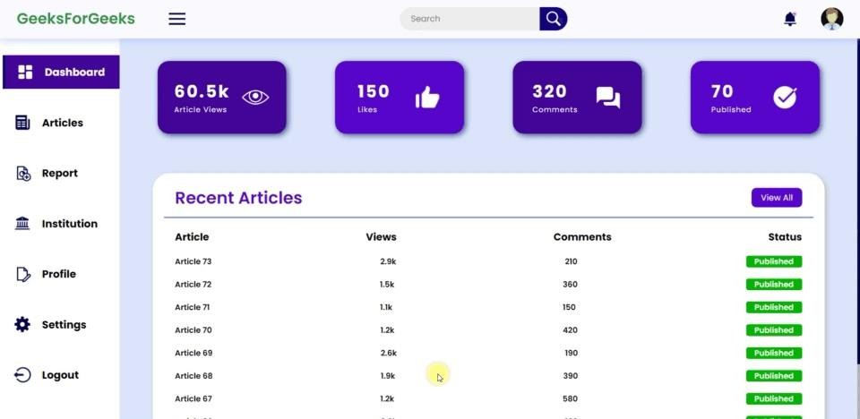

Conclusion: Responsive web page design is implemented by creating admin Dashboard with side bars using HTML,CSS and Bootstrap successfully.

Assignment No. 1.B
Title: AJAX Communication
Problem Statement: Write a JavaScript Program to get the user registration data and push to array/local storage with AJAX POST method and data list in new page.
Theory:
AJAX
AJAX stands for Asynchronous JavaScript and XML.AJAX is a new technique for creat- ing better, faster, and more interactive web applications with the help of XML, HTML, CSS, and Java Script.
Ajax uses XHTML for content, CSS for presentation, along with Document Object Model and JavaScript for dynamic content display.
Conventional web applications transmit information to and from the sever using synchronous re- quests. It means you fill out a form, hit submit, and get directed to a new page with new infor- mation from the server.
With AJAX, when you hit submit, JavaScript will make a request to the server, interpret the re- sults, and update the current screen. In the purest sense, the user would never know that anything was even transmitted to the server. XML is commonly used as the format for receiving server da- ta, although any format, including plain text, can be used. AJAX is a web browser technology in- dependent of web server software.
A user can continue to use the application while the client program requests information from the server in the background.
Intuitive and natural user interaction.
Clicking is not required; mouse movement is a sufficient event trigger. Data-driven as opposed to page-driven.
AJAX is based on the following open standards –
Browser-based presentation using HTML and Cascading Style Sheets (CSS).
Data is stored in XML format and fetched from the server.
Behind-the-scenes data fetches using XMLHttpRequest objects in the browser.
JavaScript to make everything happen
AJAX cannot work independently. It is used in combination with other technologies to create interactive webpages.

XMLHttpRequest
– JavaScript object that performs asynchronous interaction with the server.
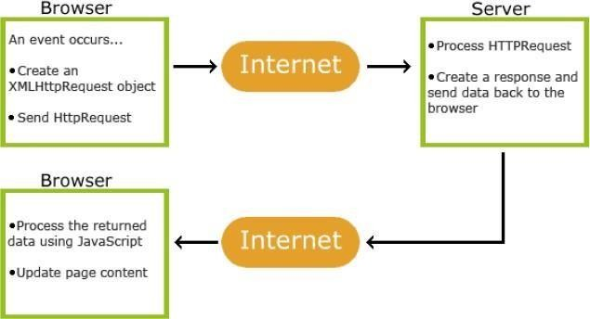

Fig 1. How AJAX works AJAX – Events : onreadystatechange Event Properties

Property | Description
onReadyStateChange | It is called whenever readystate attribute changes. It must not be used with synchronous requests.
readyState | Represents the state of the request. It ranges from 0 to 4.  0: request not initialized (open() is not called.)  1: server connection established (open is called but send() is not called.)  2: request received (send() is called, and headers and status are available.)  3: processing request (Downloading data; responseText holds the data.)  4: request finished and response is ready (The operation is completed fully.)
status | 200: "OK"  403: "Forbidden" 404: "Page not found"
XMLHttpRequest object properties

Property | Description
readyState | An integer from 0. . .4. (0 means the call is uninitialized, 4 means that the call is complete.)
onreadystatechange | Determines the function called when the objects readyState changes.
responseText | Data returned from the server as a text string (read-only).
responseXML | Data returned from the server as an XML document object (read-only).
status | HTTP status code returned by the server
statusText | HTTP status phrase returned by the server

XMLHttpRequest object methods

Method | Description
open('method', 'URL', asyn) | Specifies the HTTP method to be used (GET or POST as a string, the target URL, and whether or not the request should be handled asynchronously (asyn should be true or false, if omitted, true is assumed).
send(content) | Sends the data for a POST request and starts the request, if GET is used you hould call send(null).
setRequestHeader('x','y') | Sets a parameter and value pair x=y and assigns it to the header to be sent with the request.
getAllResponseHeaders() | Returns all headers as a string.
getResponseHeader(x) | Returns header x as a string.
abort() | Stops the current operation.

Sample code :
ajaxcommunication.html
<html>
<body>
<div id="xyz">
Hello Friends <br> Welcome to Pune!!!!!<br>
<button type="button" onclick="load()">Submit
</button>
</div>
<script>
function load(){
var req=new XMLHttpRequest() req.onreadystatechange=function() {
if(this.readyState == 4 && this.status ==
200){ document.getElementById("xyz").innerHTML=this.responseText
}
}
req.open('GET','data.txt',true)req.send()
}
</script>

</body>
</html>

Data.txt
I am enjoying learning JavaScript!!!!!!
JavaScript
Loosely typed scripting language.
JavaScript function is called when an event occurs in a page.
Glue for the whole AJAX operation.

How To Use Local Storage With JavaScript
Local storage is data stored locally in a client’s browser. It is also pure JavaScript.
There are two types of storage you can use:
Local storage: Data that persists even if you refresh the page or close the browser. Session storage: Data that will get cleared when the browser is closed.
Methods for Local Storage
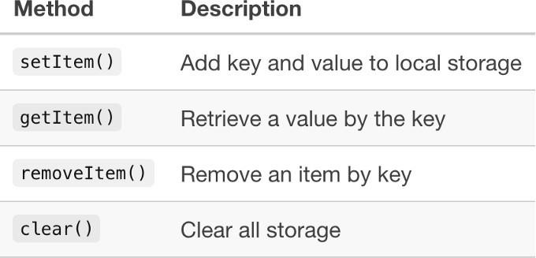

Setting data into local storage:
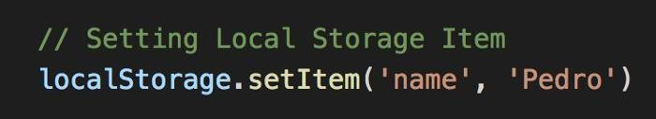
Setting data into session storage:
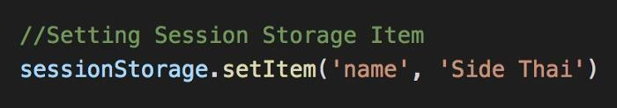
If you go into your console in your browser (CMD+Option+J) and go into the Application tab you can see your data.
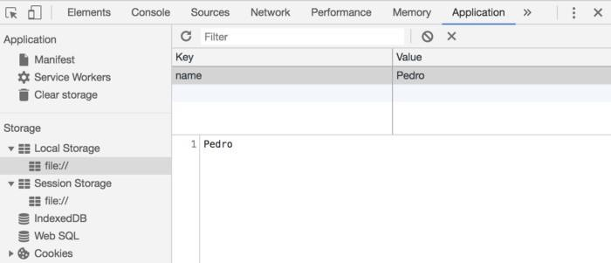
We can get from storage:
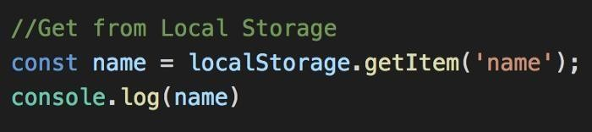

We can remove from storage:
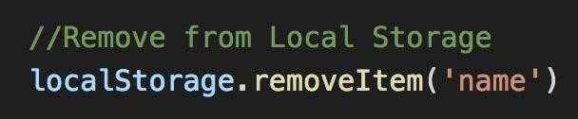

We can clear all from storage:
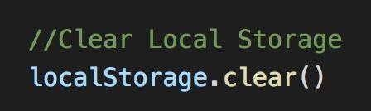

Problem Statement: Write a JavaScript Program to get the user registration data and push to array/local storage with AJAX POST method and data list in new page.
Steps for implementation of assignment
Create user registration form [Student/employee/patient] using Bootstrap. Try to use different form controls for taking input. [index.html]
Create “Add data” button for a form.
Write a jQuery code on button event for storing form data in to local storage using AJAX [“storeData.js” file in script tag]
Write a jQuery code for getting a data from local storage and display the same in “dis- playData.html” file. Use “DisplayData.js script file for writing jQuery code.

Programming Code:
<!DOCTYPE html>
<html lang="en">
<head>
<meta charset="UTF-8">
<meta name="viewport" content="width=device-width, initial-scale=1.0">
<title>sign up Ash creation</title>
<link href="https://cdn.jsdelivr.net/npm/bootstrap@5.3.3/dist/css/bootstrap.min.css" rel="stylesheet" integrity="sha384-QWTKZyjpPEjISv5WaRU9OFeRpok6YctnYmDr5pNlyT2bRjXh0JMhjY6hW+ALEwIH" crossorigin="anonymous">
<link rel="stylesheet" href="bootstrap.css">
</head>
<body>
<section class="h-100 bg-dark">
<div class="container py-5 h-100">
<div class="row d-flex justify-content-center align-items-center h-100">
<div class="col">
<div class="card card-registration my-4">
<div class="row g-0">
<div class="col-xl-6 d-none d-xl-block">

</div>
<div class="col-xl-15">
<div class="card-body p-md-5 text-black">
<h3 class="mb-5 text-uppercase">Student registration form</h3>

<div class="row">
<div class="col-md-6 mb-4">
<div data-mdb-input-init class="form-outline">
<input type="text" id="form3Example1m" class="form-control form-control-lg" />
<label class="form-label" for="form3Example1m">First name</label>
</div>
</div>
<div class="col-md-6 mb-4">
<div data-mdb-input-init class="form-outline">
<input type="text" id="form3Example1n" class="form-control form-control-lg" />
<label class="form-label" for="form3Example1n">Last name</label>
</div>
</div>
</div>

<div class="row">
<div class="col-md-6 mb-4">
<div data-mdb-input-init class="form-outline">
<input type="text" id="form3Example1m1" class="form-control form-control-lg" />
<label class="form-label" for="form3Example1m1">Mother's name</label>
</div>
</div>
<div class="col-md-6 mb-4">
<div data-mdb-input-init class="form-outline">
<input type="text" id="form3Example1n1" class="form-control form-control-lg" />
<label class="form-label" for="form3Example1n1">Father's name</label>
</div>
</div>
</div>

<div data-mdb-input-init class="form-outline mb-4">
<input type="text" id="form3Example8" class="form-control form-control-lg" />
<label class="form-label" for="form3Example8">Address</label>
</div>

<div class="d-md-flex justify-content-start align-items-center mb-4 py-2">
<h6 class="mb-0 me-4">Gender: </h6>
<div class="form-check form-check-inline mb-0 me-4">
<input class="form-check-input" type="radio" name="inlineRadioOptions" id="femaleGender"
value="option1" />
<label class="form-check-label" for="femaleGender">Female</label>
</div>

<div class="form-check form-check-inline mb-0 me-4">
<input class="form-check-input" type="radio" name="inlineRadioOptions" id="maleGender"
value="option2" />
<label class="form-check-label" for="maleGender">Male</label>
</div>
<div class="form-check form-check-inline mb-0">
<input class="form-check-input" type="radio" name="inlineRadioOptions" id="otherGender"
value="option3" />
<label class="form-check-label" for="otherGender">Other</label>
</div>
</div>
<div class="row">
<div class="col-md-6 mb-4">
<select data-mdb-select-init>
<option value="1">State</option>
<option value="2">Option 1</option>
<option value="3">Option 2</option>
<option value="4">Option 3</option>
</select>
</div>
<div class="col-md-6 mb-4">
<select data-mdb-select-init>
<option value="1">City</option>
<option value="2">Option 1</option>
<option value="3">Option 2</option>
<option value="4">Option 3</option>
</select>
</div>
</div>
<div data-mdb-input-init class="form-outline mb-4">
<input type="text" id="form3Example9" class="form-control form-control-lg" />
<label class="form-label" for="form3Example9">DOB</label>
</div>
<div data-mdb-input-init class="form-outline mb-4">
<input type="text" id="form3Example90" class="form-control form-control-lg" />
<label class="form-label" for="form3Example90">Pincode</label>
</div>
<div data-mdb-input-init class="form-outline mb-4">
<input type="text" id="form3Example99" class="form-control form-control-lg" />
<label class="form-label" for="form3Example99">Course</label>
</div>
<div data-mdb-input-init class="form-outline mb-4">
<input type="text" id="form3Example97" class="form-control form-control-lg" />
<label class="form-label" for="form3Example97">Email ID</label>
</div>
<div class="d-flex justify-content-end pt-3">
<button type="button" data-mdb-button-init data-mdb-ripple-init class="btn btn-light btn-lg">
Reset all</button>
<button type="button" data-mdb-button-init data-mdb-ripple-init class="btn btn-warning btn-lg ms- 2">Submit form</button>
</div>
</div>
</div>
</div>
</div>
</div>
</div>
</div>
</section>
</body>
</html>

Output:
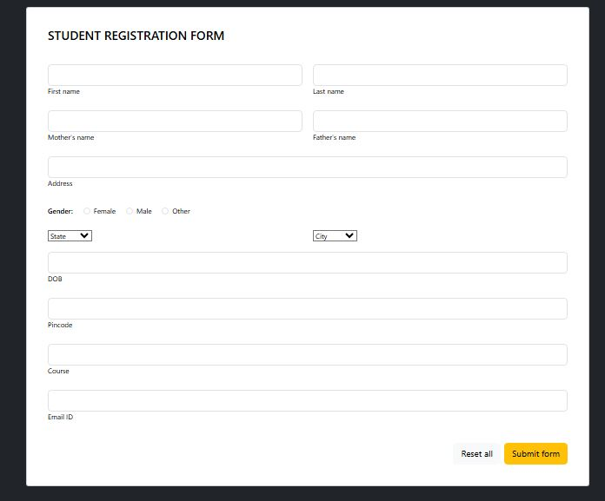

Conclusion: registration form data is successfully stored in local storage and retrieved and displayed in new web page using AJAX.

Practical No 2.A
Title: Create version control account on GitHub and using Git commands to create repository and push your code to GitHub.

Theory:
What is Git?
It is a popular version control system. It was created by Linus Torvalds in 2005, and has been hen.
What is version control?

Version control allows you to keep track of your work and helps you to easily explore the changes you have made, be it data, coding scripts, notes, etc. You are probably already doing some type of version control, if you save multiple files, such as Dissertation_script_25thFeb.R, Dissertation_script_26thFeb.R, etc. This approach will leave you with tens or hundreds of similar files, making it rather cumbersome to directly compare different versions, and is not easy to share among collaborators. With version control software such as Git, version control is much smoother and easier to implement. Using an online platform like Github to store your files means that you have an online back up of your work, which is beneficial for both you and your collaborators.
It is used for:
Tracking code changes Tracking who made changes Coding collaboration
What does Git do?

Manage projects with Repositories Clone a project to work on a local copy
Control and track changes with Staging and Committing
Branch and Merge to allow for work on different parts and versions of a project Pull the latest version of the project to a local copy
Push local updates to the main project

Working with Git:

Initialize Git on a folder, making it a Repository
Git now creates a hidden folder to keep track of changes in that folder

When a file is changed, added or deleted, it is considered modified You select the modified files you want to Stage
The Staged files are Committed, which prompts Git to store a permanent snapshot of the files Git allows you to see the full history of every commit.
You can revert back to any previous commit.
Git does not store a separate copy of every file in every commit, but keeps track of changes madein each commit!
Why Git?
Over 70% of developers use Git!
Developers can work together from anywhere in the world. Developers can see the full history of the project.
Developers can revert to earlier versions of a project.

What is GitHub
Git is not the same as GitHub. GitHub makes tools that use Git.
GitHub is the largest host of source code in the world, and has been owned by Microsoft since2018.
Steps for Implementation to Push and PULL version control repository to GitHub
Step No | Command |  | Description
1 | Git Installation |  | Download Git from the website: https://www.git-scm.com/
2 | Command line  >git –version |  | If Git is installed, it should show something like gitversion X.Y
3 | git config --global user.name "w3schools-test"  git config --global user.email "test@w3schools.com" |  | Configure Git  Change the user name and e-mail address to your own
4 | mkdir myprojectcd myproject |  | Creating Git Folder
5 | git init |  | Initialize Git  Initialized empty Git repository in  /Users/user/myproject/.git/
6 | git status |  | To check the status
7 | gitadd index.html |  | Add file to staging environment
8 | gitadd --all |  | add all files in the current directory to the Staging Environment:
9 | git commit -m "First releaseof Hello World!" |  | The committ command performs a commit, and the - m "message" adds a message.
10 | git commit -a -m "Updated index.html with a new line" |  | Skips staging environment
11 | git log |  | To view the history of commits for a repository, you can use the log command
12 | git command -help |  | See all the available options for the specific command
13 | git help --all | See all possible commands
14 | git commit -help | See help for specific command
15 | git branch hello-world-images | a branch is a new/separate version of the main repos- itory. This command creates a new branchhello- world-images
16 | git checkout hello-world-images | checkout is the command used to check out/ move to a branch
17 | git checkout master | Used to switch between branches
18 | https://github.com/ | Create a new account on github
19 |  | Create a Repository on GitHub
20 | git remote add origin https://github.com/w3schools- test/hello-world.git | Push Local Repository to GitHub
21 | git push --set-upstream originmaster | push master branch to the origin url,
22 |  | go back into GitHub and see that the repository has been updated:
23 | git fetch origin | fetch gets all the change history of a tracked branch/repo
24 | git merge origin/master | merge combines the current branch, with a specified branch.
25 | git pull origin | pull is a combination of fetch and merge  It is used to pull all changes from a remote repository into the branch you are working on.

Create a new repository on the command line
touch README.md git init
git add README.md
git commit -m "first commit"
git remote add origin git@github.com:alexpchin/<reponame>.git
git push -u origin master

Push an existing repository from the command line
git remote add origin git@github.com:alexpchin/<reponame>.git git push -u origin master
OUTPUT:
STEP 1: CREATE A GITHUB ACCOUNT
Step | Action
1 | Open a web browser and navigate to https://github.com
2 | Click on 'Sign up' button on the homepage
3 | Enter your email address, create a password, and choose a username
4 | Verify your account via email and complete the setup wizard
5 | You are now logged into your GitHub account dashboard

STEP 2: INSTALL GIT (UBUNTU/LINUX)
Installation Commands
$ sudo apt update
$ sudo apt install git -y
$ git --version

✓ Terminal Output
Hit:1 http://archive.ubuntu.com/ubuntu focal InRelease
Reading package lists... Done
Building dependency tree... Done
The following NEW packages will be installed:
git
Setting up git (1:2.34.1-1ubuntu1) ...
git version 2.34.1

STEP 3: CONFIGURE GIT GLOBALLY
Set your identity — this information is used in every commit you make:

Git Global Configuration
$ git config --global user.name "YourName"
$ git config --global user.email "youremail@example.com"
$ git config --global init.defaultBranch main
# Verify the configuration
$ git config --list

✓ Configuration Output
user.name=YourName
user.email=youremail@example.com
init.defaultbranch=main
core.repositoryformatversion=0
core.filemode=true
core.bare=false

STEP 4: CREATE A NEW REPOSITORY ON GITHUB
Step | Action
1 | Log in to GitHub and click the '+' icon (top-right) → 'New repository'
2 | Enter Repository Name: my-first-repo
3 | Add a Description (optional): My first GitHub repository
4 | Set visibility to Public (or Private)
5 | DO NOT initialize with README (we will do it locally)
6 | Click 'Create repository' — note the repository URL shown

Repository URL will be: https://github.com/YourUsername/my-first-repo.git

STEP 5: CREATE LOCAL PROJECT AND INITIALIZE GIT
Initialize Local Repository
# Create a project directory
$ mkdir my-first-repo
$ cd my-first-repo
# Initialize Git repository
$ git init
# Create a Python file
$ nano hello.py

hello.py — Python Source Code
# Content of hello.py
# Simple Hello World Program
# Author: YourName
# Date: 2024
def greet(name):
return f"Hello, {name}! Welcome to Git & GitHub!"
if __name__ == "__main__":
print(greet("World"))
print("Version Control with Git is awesome!")

Create Supporting Files
# Create a README file
$ echo "# My First Repo" > README.md
$ echo "This project demonstrates Git & GitHub usage." >> README.md
# Create a .gitignore file
$ echo "__pycache__/" > .gitignore
$ echo "*.pyc" >> .gitignore
$ echo ".env" >> .gitignore
# Verify directory structure
$ ls -la

✓ Directory Listing Output
total 24
drwxrwxr-x 3 student student 4096 Jan 10 10:30 .
drwxr-xr-x 5 student student 4096 Jan 10 10:29 ..
drwxrwxr-x 7 student student 4096 Jan 10 10:30 .git
-rw-rw-r-- 1 student student 18 Jan 10 10:30 .gitignore
-rw-rw-r-- 1 student student 220 Jan 10 10:30 hello.py
-rw-rw-r-- 1 student student 49 Jan 10 10:30 README.md

✓ git init Output
Initialized empty Git repository in /home/student/my-first-repo/.git/

STEP 6: ADD FILES AND MAKE FIRST COMMIT
Stage and Commit
# Check current repository status
$ git status
# Stage all files for commit
$ git add .
# Or stage individual files
$ git add hello.py README.md .gitignore
# Verify staged files
$ git status
# Commit with a meaningful message
$ git commit -m "Initial commit: Add hello.py, README, and .gitignore"

✓ git status Output
On branch main
No commits yet
Untracked files:
(use "git add <file>..." to include in what will be committed)
.gitignore
README.md
hello.py
nothing added to commit but untracked files present
─── After git add . ────────────────────────────────
On branch main
No commits yet
Changes to be committed:
(use "git rm --cached <file>..." to unstage)
new file: .gitignore
new file: README.md
new file: hello.py

✓ git commit Output
[main (root-commit) a1b2c3d] Initial commit: Add hello.py, README, and .gitignore
3 files changed, 18 insertions(+)
create mode 100644 .gitignore
create mode 100644 README.md
create mode 100644 hello.py

STEP 7: CONNECT LOCAL REPO TO GITHUB (REMOTE)
STEP M: (Optional) NVIDIA Docker Setup
For GPU workloads (AI/ML), install nvidia-container-toolkit:
M1 — Prerequisites: NVIDIA driver must already be installed on the host:
$ nvidia-smi
+-----------------------------------------------------------------------------+
| NVIDIA-SMI 535.54.03 Driver Version: 535.54.03 CUDA Version: 12.2 |
|-------------------------------+----------------------+----------------------+

✓ git remote -v Output
origin https://github.com/YourUsername/my-first-repo.git (fetch)
origin https://github.com/YourUsername/my-first-repo.git (push)

STEP 8: PUSH CODE TO GITHUB
Push to GitHub
# Push to GitHub (first time — sets upstream)
$ git push -u origin main
# Enter GitHub credentials when prompted
# Username: YourUsername
# Password: (use Personal Access Token, not password)

✓ git push Output — Success
Username for 'https://github.com': YourUsername
Password for 'https://YourUsername@github.com': **********
Enumerating objects: 5, done.
Counting objects: 100% (5/5), done.
Delta compression using up to 4 threads
Compressing objects: 100% (4/4), done.
Writing objects: 100% (5/5), 512 bytes | 512.00 KiB/s, done.
Total 5 (delta 0), reused 0 (delta 0), pack-reused 0
To https://github.com/YourUsername/my-first-repo.git
* [new branch] main -> main
Branch 'main' set up to track remote branch 'main' from 'origin'.

STEP 9: MAKE CHANGES AND PUSH AGAIN
Update and Push
# Edit hello.py to add more functionality
$ nano hello.py
# Check what changed
$ git diff
# Stage and commit changes
$ git add hello.py
$ git commit -m "feat: Add farewell function to hello.py"
# Push changes
$ git push origin main

✓ git diff Output
diff --git a/hello.py b/hello.py
index 7b1e93d..4a2f8b1 100644
--- a/hello.py
+++ b/hello.py
@@ -8,3 +8,7 @@ if __name__ == "__main__":
print(greet("World"))
print("Version Control with Git is awesome!")
+
+def farewell(name):
+ return f"Goodbye, {name}! Keep coding!"
+
+print(farewell("Developer"))

✓ git push Output — Update
[main d4e5f6a] feat: Add farewell function to hello.py
1 file changed, 5 insertions(+)
Enumerating objects: 5, done.
Counting objects: 100% (5/5), done.
Writing objects: 100% (3/3), 298 bytes | 298.00 KiB/s, done.
Total 3 (delta 1), reused 0 (delta 0), pack-reused 0
To https://github.com/YourUsername/my-first-repo.git
a1b2c3d..d4e5f6a main -> main

Conclusion: Version control account on GitHub is created and using Git commands repository is created successfully.

Practical no: 2 B
Title: Create Docker Container Environment (NVIDEIA Docker or any other.
Problem Statement: To create and configure a Docker container environment, understand container lifecycle management, and perform basic Docker operations including pulling images, running containers, managing volumes, and using Docker Compose.
Theory:
Docker is an open-source containerization platform that allows developers to package applications along with their dependencies into lightweight, portable containers. Unlike virtual machines, Docker containers share the host OS kernel, making them faster to start and more resource-efficient.

Component | Description
Docker Daemon (dockerd) | Background service managing Docker objects: images, containers, networks, volumes
Docker Client (docker) | CLI tool that communicates with dockerd via REST API
Docker Images | Read-only templates used to create containers (built from Dockerfiles)
Docker Containers | Running instances of images — isolated, ephemeral processes
Docker Hub | Public registry hosting thousands of official and community images
Docker Compose | Tool to define and run multi-container apps using a YAML file
Docker Volume | Persistent storage mechanism that survives container lifecycle

NVIDIA Docker (nvidia-container-toolkit)
NVIDIA Docker allows containers to access the host GPU (CUDA drivers). It is widely used in AI/ML workloads (TensorFlow, PyTorch). The toolkit exposes NVIDIA drivers to containers without bundling them in the image.
STEP-BY-STEP PROCEDURE WITH COMMANDS & OUTPUT
STEP A: Uninstall Older Versions of Docker
STEP B: Install Docker Engine on Ubuntu
Step B1 — Update the apt package index and install required packages:
Step B2 — Add Docker's official GPG key and repository:
Step B3 — Install Docker Engine, CLI, and Compose plugin:
STEP C: Start and Enable Docker Service
STEP D: Post-Install — Add User to Docker Group
STEP E: Verify Docker Installation
STEP F: Run Hello-World Container
STEP G: Work with Docker Images
G1 — Pull Ubuntu image from Docker Hub:
G2 — List all locally available images:
STEP H: Run and Manage Containers
H1 — Run an interactive Ubuntu container:
H2 — Run an Nginx web server container in detached mode with port mapping:
H3 — List running containers:
H4 — List all containers (including stopped):
H5 — Test the Nginx web server:
STEP I: Container Lifecycle Management
STEP J: Docker Volumes — Persistent Storage
Create a volume and mount it inside a container:
STEP K: Write a Custom Dockerfile
Create a simple Python Flask web application container:
K1 — Create project directory and files:
K2 — Create Dockerfile:
K3 — Build the Docker image:
.K4 — Run the Flask container
STEP L: Docker Compose — Multi-Container Application
STEP M: (Optional) NVIDIA Docker Setup

For GPU workloads (AI/ML), install nvidia-container-toolkit:
M1 — Prerequisites: NVIDIA driver must already be installed on the host:
M2 — Install nvidia-container-toolkit:
M3 — Test GPU access inside a container:
STEP N: Docker Cleanup Commands

6. DOCKER COMMANDS
Command | Purpose
docker pull <image> | Download image from registry
docker images | List local images
docker run <image> | Create and start a container
docker run -d ... | Run container in background
docker run -it ... | Run interactive container
docker run -p H:C ... | Map host port H to container port C
docker run -v vol:/path | Mount volume inside container
docker ps | List running containers
docker ps -a | List all containers
docker stop <name> | Stop a running container
docker start <name> | Start a stopped container
docker restart <name> | Restart a container
docker rm <name> | Remove a container
docker rmi <image> | Remove an image

:

Practical: 2 C
Title: Develop web application using front end as Angular
Problem Statement: Create an Angular application which will do following actions: Register User, Login User, Show User Data on Profile Component
Theory:
Angular
Angular was introduced to create Single Page applications. This framework brings structure and consistency to web applications and provides excellent scalability and maintainability.
Angular is an open-source, JavaScript framework wholly written in TypeScript. It uses HTML's syntax to express your application's components clearly.
Angular is an open-source JavaScript MVC framework for the web applications.
It extends the HTML and makes it dynamic.
A component-based framework for building scalable web applications
A collection of well-integrated libraries that cover a wide variety of features, including routing, forms management, client-server communication, and more.
A suite of developer tools to help you develop, build, test, and update your code

Difference between Angular JS and Angular

Feature | AngularJS | Angular
Language | JavaScript | TypeScript
Architecture | Supports Model-View-Controller design | Uses components and directives
Mobile support | Not supported by mobile browsers | Supports all popular mobile browsers
Dependency Injection | Doesn’t support | Supports
Routing | @routeProvider is used to provide routing information | @Route configuration is used to define routing information
Management | Difficult to manage with an increase in source code size | Better structured, easy to create and manage bigger applications

Angular Components
Components are the building blocks that compose an application. A component includes a TypeScript class with a @Component () decorator, an HTML template, and styles. The @Component() decorator specifies the following Angular-specific information:
A CSS selector that defines how the component is used in a template. HTML elements in your template that match this selector become instances of the component. An HTML template that instructs Angular how to render the componentAn optional set of CSS styles that define the appearance of the template's HTML elements Minimal code for component
import { Component } from '@angular/core'; @Component({
selector: 'hello-world', template: `
<h2>Hello World</h2>
<p>This is my first component!</p>
})
export class HelloWorldComponent {
// The code in this class drives the component's behavior.
}
How to install Angular on your local system? Setup
Requirement
Node.js- Angular requires an active LTS or maintenance LTS version of Node.js.
npm package manager- Angular, the Angular CLI, and Angular applications depend on npm packages for many features and functions
Install the Angular CLI
1. Open terminal window and type following command
npm install -g @angular/cli
Create a workspace and initial application
Run the CLI command ng new and provide the name my-app, as shown here:
ng new my-app
The ng new command prompts you for information about features to include in the initial app. Accept the defaults by pressing the Enter or Return key. The CLI creates a new workspace and a simple Welcome app, ready to run.
The Angular CLI includes a server, for you to build and serve your app locally.
Navigate to the workspace folder, such as my-app.
Run the following command:
my-app
ng serve –open
The ng serve command launches the server, watches your files, and rebuilds the app as you make changes to those files.
The --open (or just -o) option automatically opens your browser to http://localhost:4200/.
Code:
- Create Components
ng new userapp .
ng g c register
ng g c login
ng g c profile

Add FormsModule in app.module.ts.
import { FormsModule } from '@angular/forms';

- app.component.html
<app-register> </app-register>
<hr>
<app-login></app-login>
<hr>
<app-profile></app-profile>
- Register Component

register.component.html
<h3>Register</h3>

<input placeholder="Name" [(ngModel)]="name"><br>
<input placeholder="Email" [(ngModel)]="email"><br>
<input placeholder="Password" [(ngModel)]="pass"><br>
<button (click)="save()">Register</button>

register.component.ts
import { Component } from '@angular/core';

@Component({
selector:'app-register',
templateUrl:'./register.component.html'
})

export class RegisterComponent{

name=''; email=''; pass='';

save(){
localStorage.setItem("name",this.name);
localStorage.setItem("email",this.email);
localStorage.setItem("pass",this.pass);
alert("Registered");
}
}

Login Component

login.component.html
<h3>Login</h3>

<input placeholder="Email" [(ngModel)]="email"><br>
<input placeholder="Password" [(ngModel)]="pass"><br>

<button (click)="login()">Login</button>

Login Component

login.component.html
import { Component } from '@angular/core';

@Component({
selector:'app-login',
templateUrl:'./login.component.html'
})

export class LoginComponent{

email=''; pass='';

login(){

if(this.email==localStorage.getItem("email") &&
this.pass==localStorage.getItem("pass"))
alert("Login Success");
else
alert("Wrong User");
}
}

. Profile Component

profile.component.html
<h3>Profile</h3>
Name: {{name}} <br>
Email: {{email}}

profile.component.ts

import { Component } from '@angular/core';

@Component({
selector:'app-profile',
templateUrl:'./profile.component.html'
})

export class ProfileComponent{

name=localStorage.getItem("name");
email=localStorage.getItem("email");

}

Output:

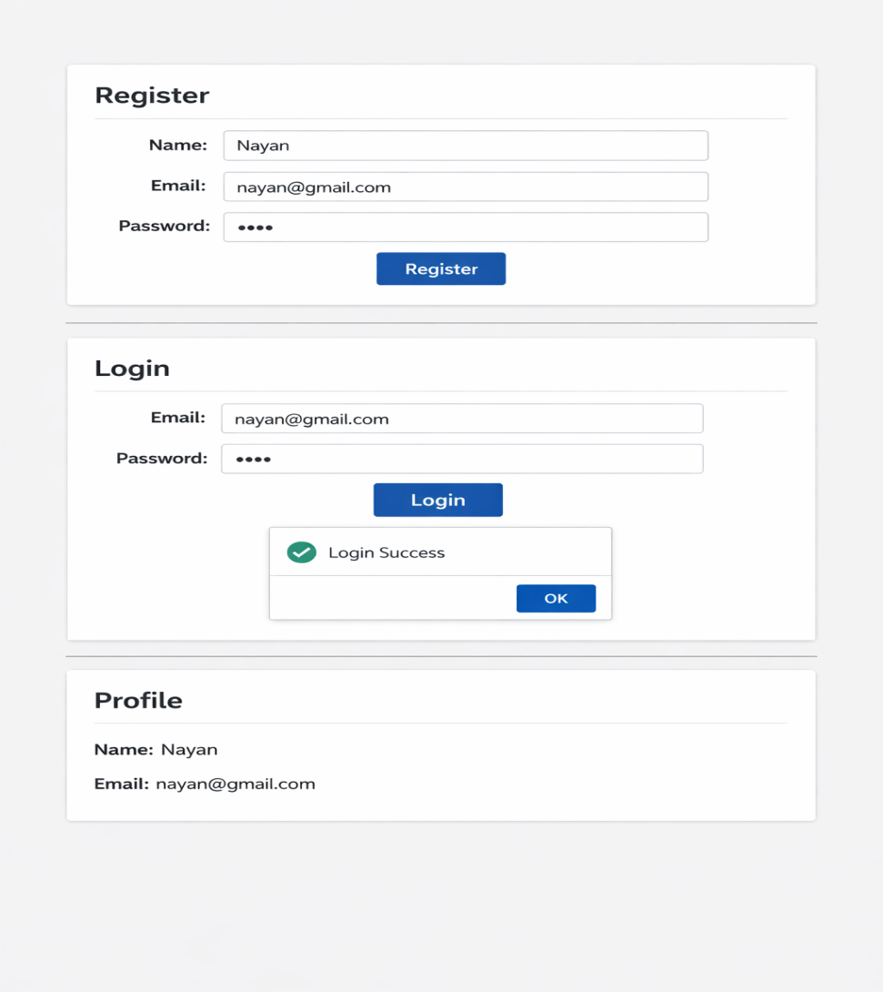

Conclusion: Angular application is developed successfully.

Practical No: 3 A
Title: Create a Node.JS Application
Problem Statement: Create a Node.JS Application which serves a static website.
Theory:
Installation: Node.js (site – Node.js), Express.Js(installed through cmd)
Node.js overview
In basic terms, Node is an open source cross-platform library for server-side programming that permits clients to develop web applications rapidly. With Node, we can execute JavaScript applications or network applications. Its basic modules are engraved in JavaScript.
It is generally utilized for server applications in real-time. Node.js permits JavaScript to execute locally on a machine or a server.
Node.js gives numerous systems to utilize. One of such structures is Express.js. It is more valuable and mainstream than the different structures of Node.js.
Features of Node.js
Versatility: Node is incredibly adaptable as the server reacts in a non-blocking way.
Zero Buffering: Applications yield the measurements in enormous pieces. This gives the advantage of ‘No buffering’ to developers.
Network: Node.js upholds an open-source community. This is the main explanation that numerous glorious modules have been added to Node.js applications over time.
Occasion driven Input and output: APIs of Node.js are non-blocking, meaning that the server won’t wait for the arrival of information from an API. Rather, it will move to another API.
Advantages of Node.js
Easy to learn: NodeJs quite simple for developers to utilize and learn. Learning Node.js is less difficult than React.
Better Performance: Node.js takes the code of JavaScript via Google’s V8 JavaScript engine. The main advantage of this process is that it complies with the JavaScript code directly into the machine code
Freedom: Node.js offers a lot of freedom when it comes to development. There are generally less constraints with Node.
Extended support for tools: Another advantage of Node.js is that developers have more community support.
Extensible: Node.js is known to be quite extensible. You can utilize JSON to give the degree to trade of information between the web server and the client.
Scalability: Node.js makes it simple to scale applications in horizontal as well as vertical directions. The applications can be scaled even by the option of extra hubs to the current framework.
Limitations of Node.js
Programming interface isn’t steady: The Application Programming Interface (API) of Node can be challenging to work with. It changes regularly and doesn’t remain stable.
No strong library support system: JavaScript does not hold a strong library system. This limits the developers to implement even common programming tasks using Node.js.
Programming model is not synchronous: Many developers find this programming model tougher in comparison to linear blocking I/O programming.
Express.js
"Express is a fast, opinionated minimalist web framework for Node.js" - official web site: Expressjs.com
Express.js is a web application framework for Node.js. It provides various features that make web application development fast and easy which otherwise takes more time using only Node.js.
Express.js is based on the Node.js middleware module called connect which in turn uses http module. So, any middleware which is based on connect will also work with Express.js.
Advantages of Express.js
Makes Node.js web application development fast and easy.
Easy to configure and customize.
Allows you to define routes of your application based on HTTP methods and URLs.
Includes various middleware modules which you can use to perform additional tasks on request and response.
Easy to integrate with different template engines like Jade, Vash, EJS etc.
Allows you to define an error handling middleware.
Easy to serve static files and resources of your application.
Allows you to create REST API server.
Easy to connect with databases such as MongoDB, Redis, MySQL
Steps for implementation
1 .Install Node.js
Setting up express.js
Structuring files
Creating your express server
Servicing your static files
Building your web page
Running your project
Open Node.js command terminal &run the following in your terminal- Setting up Express.JS
Create a new directory for your project - mkdir your-project-name
Change into your new directory - cd your-project-name
Initialize a new Node project with defaults. This will set a package.json file to access your dependencies: npm init -y
Create your entry file, index.js. This is where you will store your Express server: if you are working on Linux, you can run : touch index.js. if you are working on windows, you can edit in VSCode
Install Express as a dependency : npm install express –save
Edit package.json. Within your package.json, update your start script to include node and your index.js file.
Let express-static-file-tutorial is your project name Package.json
{
"name": "express-static-file-tutorial", "version": "1.0.0", "description": "",
"main": "index.js", "scripts": {
"start": "node index.js" // change start value as node index.js
}, // This will allow you to use the npm start command in your terminal to launch "keywords": [], your express server "author": "Paul Halliday",
"license": "MIT"
}
Structuring Your Files
To store your files on the client-side, create a public directory and include an index.html file express-static- file-tutorial
Project Structure/
│
├── server.js
└── public/
├── index.html
├── style.css
└── script.js
CODE:
- Install Node.js Modules
npm init -y
npm install express
- server.js (Main Code)
const express = require('express');
const path = require('path');

const app = express();
const PORT = 3000;

// Serve static files from "public" folder
app.use(express.static(path.join(__dirname, 'public')));

// Start server
app.listen(PORT, () => {
console.log(`Server running at http://localhost:${PORT}`);
});
- index.html (Inside public folder)
<!DOCTYPE html>
<html>
<head>
<title>My Static Website</title>
<link rel="stylesheet" href="style.css">
</head>
<body>
<h1>Welcome to My Node.js Website</h1>
<p>This is a static page served using Express.</p>

<button onclick="showMessage()">Click Me</button>

<script src="script.js"></script>
</body>
</html>
- style.css
body {
font-family: Arial;
text-align: center;
background-color: lightblue;
}
h1 {
color: darkblue;
}
- script.js
function showMessage() {
alert("Hello from JavaScript!");
}
- Run the Application
node server.js
open :
http://localhost:3000
Output:

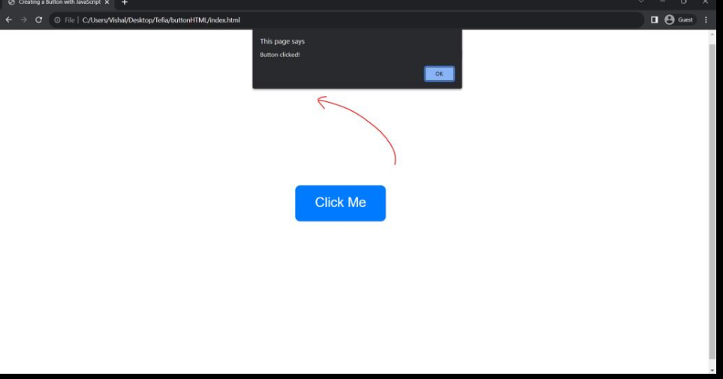

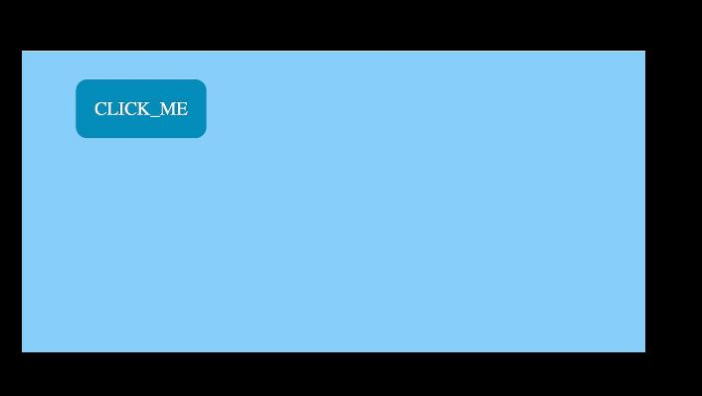

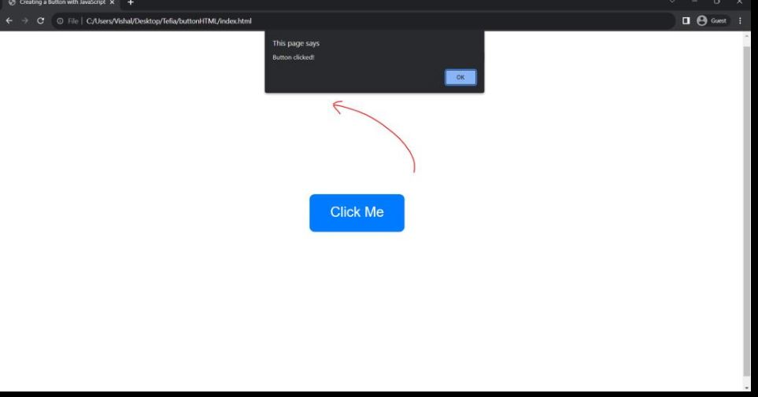

Conclusion: Node.js application is created successfully.

Practical No: 3.B

Title: Create four API using Node.JS, ExpressJS and MongoDB for CURD Operations
Problem Statement: Create four API using Node.JS, ExpressJS and MongoDB for CURD Operations
Node.js and MongoDB Connectivity

Theory: Node.js can be used in database applications. One of the most popular NoSQL database is MongoDB.
Express is one of the most popular web frameworks for Node.js that supports routing, middleware, view system…
Mongoose is a promise-based Node.js ODM for MongoDB that provides a straight-forward, schema-based solution to model our application data along with built-in type casting, validation, query building, business logic hooks…
MongoDB
We can download a free MongoDB database at https://www.mongodb.com.
Or get started right away with a MongoDB cloud service at https://www.mongodb.com/cloud/atlas.
Install MongoDB Drive
Access a MongoDB database with Node.js.
To download and install the official MongoDB driver, open the Command Terminal and execute the following:
C:\Users\Your Name>npm install mongodb
Download and install mongodb package:
Now you have downloaded and installed a mongodb database driver. Node.js can use this module to manipulate MongoDB databases:
var mongo = require('mongodb');

Creating a Database
To create a database in MongoDB, start by creating a MongoClient object, then specify a connection URL with the correct ip address and the name of the database you want to create.
MongoDB will create the database if it does not exist, and make a connection to it.

Example
Create a database called "mydb":
var MongoClient = require('mongodb').MongoClient; var url = "mongodb://localhost:27017/mydb"; MongoClient.connect(url, function(err, db) {

if (err) throw err; console.log("Database created!"); db.close();
});
Save the code above in a file called "demo_create_mongo_db.js" and run the file: Run "demo_create_mongo_db.js"
C:\Users\Your Name>node demo_create_mongo_db.js Which will give you this result:
Database created!
Collection
Creating a Collection
A collection in MongoDB is the same as a table in MySQL
To create a collection in MongoDB, use the createCollection() method:
Example
Create a collection called "customers":
var MongoClient = require('mongodb').MongoClient; var url = "mongodb://localhost:27017/"; MongoClient.connect(url, function(err, db) {
if (err) throw err;
var dbo = db.db("mydb"); dbo.createCollection("customers", function(err, res) { if (err) throw err;
console.log("Collection created!"); db.close();
});
});
Save the code above in a file called "demo_mongodb_createcollection.js" and run the file: Run "demo_mongodb_createcollection.js"
C:\Users\Your Name>node demo_mongodb_createcollection.js which will give you this result:
Collection created!
Insert Into Collection
To insert a record, or document as it is called in MongoDB, into a collection, we use the insertOne() method.
A document in MongoDB is the same as a record in MySQL
The first parameter of the insertOne() method is an object containing the name(s) and value(s) of each field in the document you want to insert.
It also takes a callback function where you can work with any errors, or the result of the insertion: Example
Insert a document in the "customers" collection:
var MongoClient = require('mongodb').MongoClient; var url = "mongodb://localhost:27017/";
MongoClient.connect(url, function(err, db) { if (err) throw err;
var dbo = db.db("mydb");
var myobj = { name: "Company Inc", address: "Highway 37" }; dbo.collection("customers").insertOne(myobj, function(err, res) { if (err) throw err;
console.log("1 document inserted"); db.close();
});
});
Save the code above in a file called "demo_mongodb_insert.js" and run the file:

Run "demo_mongodb_insert.js"
C:\Users\Your Name>node demo_mongodb_insert.js Which will give you this result:
1 document inserted
Insert Multiple Documents
To insert multiple documents into a collection in MongoDB, we use the insertMany() method.
The first parameter of the insertMany() method is an array of objects, containing the data you want to insert.
Step by step procedure to build Node.js Restful API for CRUD operations using Express, Mongoose with MongoDB database.
Step1: First, Install MongoDB on machine
Step2: Node.js MongoDB Rest CRUD API overview
We will build Rest Apis that can create, retrieve, update, delete
First, we start with an Express web server. Next, we add configuration for MongoDB database, create Tutorial model with Mongoose, write the controller. Then we define routes for handling all CRUD operations (including custom finder).
The following table shows overview of the Rest APIs that will be exported:

Methods | Urls Actions
GET | api/tutorials get all Tutorials
GET | api/tutorials/:id get Tutorial by id
POST | api/tutorials add new Tutorial
PUT | api/tutorials/:id update Tutorial by id
DELETE | api/tutorials/:id remove Tutorial by id
DELETE | api/tutorials remove all Tutorials
GET | api/tutorials/published find all published Tutorials
GET api/tutorials?title=[kw] find all Tutorials which title contains 'kw'
Step 3: Create Node.js App
First, we create a folder:
$ mkdir nodejs-express-mongodb
$ cd nodejs-express-mongodb
Next, we initialize the Node.js App with a package.json file:
npm init
name: (nodejs-express-mongodb) version: (1.0.0)
description: Node.js Restful CRUD API with Node.js, Express and MongoDB entry point: (index.js) server.js
test command:
git repository:
keywords: nodejs, express, mongodb, rest, api author: bezkoder
license: (ISC)

Is this ok? (yes) yes

We need to install necessary modules: express, mongoose and cors. Run the command:
npm install express mongoose cors --save
The package.json file should look like this:
{
"name": "node-express-mongodb", "version": "1.0.0",
"description": "Node.js Restful CRUD API with Node.js, Express and MongoDB", "main": "server.js",
"scripts": {
"test": "echo \"Error: no test specified\" && exit 1"
},
"keywords": [
"nodejs", "express", "rest",
"api", "mongodb"
],
"author": "bezkoder", "license": "ISC", "dependencies": { "cors": "^2.8.5",
"express": "^4.18.1",
"mongoose": "^6.4.2"
}
}
Step4: Setup Express web server
In the root folder, let’s create a new server.js file:
const express = require("express"); const cors = require("cors");

const app = express();

var corsOptions = {
origin: "http://localhost:8081"
};
app.use(cors(corsOptions));
// parse requests of content-type - application/json app.use(express.json());
// parse requests of content-type - application/x-www-form-urlencoded app.use(express.urlencoded({ extended: true }));

// simple route app.get("/", (req, res) => {
res.json({ message: "Welcome to bezkoder application." });
});
// set port, listen for requests const PORT = process.env.PORT || 8080; app.listen(PORT, () => {
console.log(`Server is running on port ${PORT}.`);
});
Step 5: import express and cors modules:
Express is for building the Rest apis
cors provides Express middleware to enable CORS with various options.
create an Express app, then add body-parser (json and urlencoded) and cors middlewares using app.use() method. Notice that we set origin: http://localhost:8081.
define a GET route which is simple for test.
listen on port 8080 for incoming requests.
Now let’s run the app with command: node server.js.
Open your browser with url http://localhost:8080/, you will see:
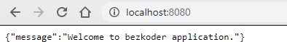
Step6: Configure MongoDB database & Mongoose
In the app folder, we create a separate “config” folder for configuration with db.config.js file like this:
module.exports = {
url: "mongodb://localhost:27017/bezkoder_db"
};
Step 7: Define Mongoose
We’re gonna define Mongoose model (tutorial.model.js) also in app/models folder in the next step.
Now create app/models/index.js with the following code: const dbConfig = require("../config/db.config.js"); const mongoose = require("mongoose");
mongoose.Promise = global.Promise;
const db = {}; db.mongoose = mongoose; db.url = dbConfig.url;
db.tutorials = require("./tutorial.model.js")(mongoose); module.exports = db;
Don’t forget to call connect() method in server.js:
...
const app = express(); app.use(...);
const db = require("./app/models"); db.mongoose
.connect(db.url, { useNewUrlParser: true, useUnifiedTopology: true
})
.then(() => {
console.log("Connected to the database!");
})
.catch(err => {
console.log("Cannot connect to the database!", err); process.exit();
});
Define the Mongoose Model
In models folder, create tutorial.model.js file like this:
module.exports = mongoose => { const Tutorial = mongoose.model( "tutorial", mongoose.Schema(
{
title: String, description: String, published: Boolean
},
{ timestamps: true }
)
);
return Tutorial;
};
Step
Step8: Create the Controller
Inside app/controllers folder, let’s create tutorial.controller.js with these CRUD functions: create
findAll findOne update delete deleteAll
findAllPublished
const db = require("../models"); const Tutorial = db.tutorials;
// Create and Save a new Tutorial exports.create = (req, res) => { };
// Retrieve all Tutorials from the database. exports.findAll = (req, res) => {
};
// Find a single Tutorial with an id exports.findOne = (req, res) => {
};
// Update a Tutorial by the id in the request exports.update = (req, res) => {
};
// Delete a Tutorial with the specified id in the request exports.delete = (req, res) => {
};
// Delete all Tutorials from the database. exports.deleteAll = (req, res) => {
};
// Find all published Tutorials exports.findAllPublished = (req, res) => {
};
Reference: https://www.bezkoder.com/node-express-mongodb-crud-rest-api/

Conclusion: API using Node.JS, ExpressJS and MongoDB for CURD Operations is created and implemented successfully

Practical 4.A
Title: Create a simple Mobile Website using jQuery Mobile.
Theory:
jQuery Mobile
JQuery Mobile is a user interface framework, built on jQuery Core and used for developing responsive websites or applications that are accessible on mobile, tablet, and desktop devices. It uses features of both jQuery and jQueryUI to provide API features for mobile web applications. This tutorial will teach you the basics of jQuery Mobile framework. We will also discuss some detailed concepts related to jQuery Mobile.
Why Use jQuery Mobile?
It creates web applications that it will work the same way on the mobile, tablet, and desktop de- vices.
It is compatible with other frameworks such as PhoneGap, Whitelight, etc.
It provides a set of touch-friendly form inputs and UI widgets.
Features of jQuery Mobile
It is built on jQuery Core and "write less, do more" UI framework.
It is an open source framework, and cross-platform as well as cross-browser compatible.
It is written in JavaScript and uses features of both jQuery and jQuery UI for building mobile- friendly sites.
Download jQuery Mobile
When you open the link https://jquerymobile.com/ you will see there are two options to download jQuery mobile library.
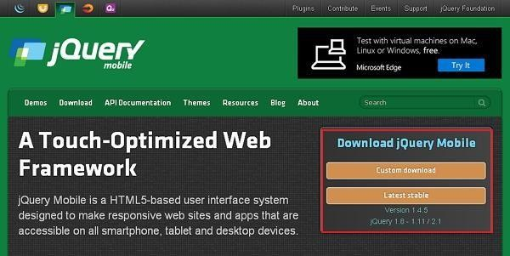

Custom Download − Click this button to download a customized version of library.
Latest Stable − Click this button to get the stable and latest version of jQuery mobile library.

Example Code
<!DOCTYPE html>
<html>
<head>
<meta name = "viewport" content = "width = device-width, initial-scale = 1">
<link rel = "stylesheet" href = "https://code.jquery.com/mobile/1.4.5/jquery.mobile-1.4.5.min.css">
<script src = "https://code.jquery.com/jquery-1.11.3.min.js"></script>
<script src = "https://code.jquery.com/mobile/1.4.5/jquery.mobile-1.4.5.min.js"></script>
</head>

<body>
<div data-role = "page" id = "pageone">
<div data-role = "header">
<h1>Header Text</h1>
</div>
<div data-role = "main" class = "ui-content">
<h2>Welcome to TutorialsPoint</h2>
</div>
<div data-role = "footer">
<h1>Footer Text</h1>
</div>
</div>
</body>
</html>

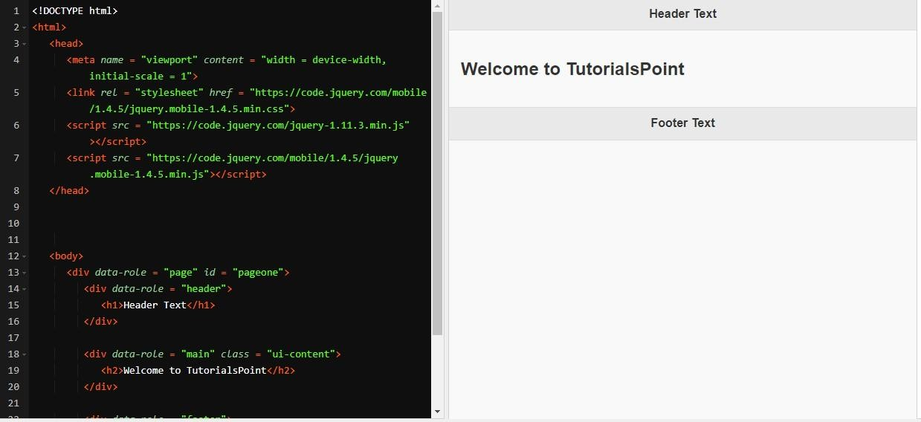
Above Code run and expected output

Details of the above code are –
This code is specified inside the head element.
<meta name = "viewport" content = "width = device-width, initial-scale = 1">
The viewport is used to specify (by the browser) to display the page zoom level and dimension.
content = "width = device-width" is used to set the pixel width of the page or screen device.
initial-scale = 1 sets the initial zoom level, when the page is loaded for the first time.

Include the following CDNs
<link rel = "stylesheet" href = "https://code.jquery.com/mobile/1.4.5/jquery.mobile-1.4.5.min.css">
<script src = "https://code.jquery.com/jquery-1.11.3.min.js"></script>
<script src = "https://code.jquery.com/mobile/1.4.5/jquery.mobile-1.4.5.min.js"></script>

Content inside the <body> tag is a page displayed in the browser.
<div data-role = "page">
</div>
data-role = "header" creates the header at the top of the page. data-role = "main" is used to define the content of the page. data-role = "footer" creates the footer at the bottom of the page.
class = "ui-content" includes padding and margin inside the page content.
The HTML for the two pages in the body of one HTML file:
<div data-role="page">
<header data-role="header"><h1>SJV Town Hall</h1></header>
<section data-role="content">
<h3>The 2011-2012 Speakers</h3>
<a href="#toobin">
<h4>Jeffrey Toobin<br>October 19, 2011</h4>
<img src="images/toobin75.jpg" alt="Jeffrey Toobin"></a>
<!-- THE ELEMENTS FOR THE REST OF THE SPEAKERS -->
</section>
<footer data-role="footer"><h4>&copy; 2011</h4></footer>
</div>
<div data-role="page" id="toobin">
<header data-role="header"><h1>SJV Town Hall</h1></header>
<section data-role="content">
<h3>The Supreme Nine:<br>Black Robed Secrets</h3>
<img src="images/toobin_court.cnn.jpg" alt="Jeffrey Toobin">
<p>Author of the critically acclaimed best seller, <i>The Nine:
<!-- THE COPY CONTINUES -->
</section>
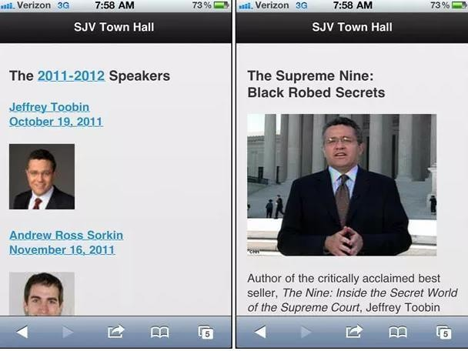
<footer data-role="footer"><h4>&copy; 2011</h4></footer>
Above Code run and expected output for multiple pages
The transitions that can be used
slide | The next page slides in from right to left.
slideup | The next page slides in from bottom to top.
slidedown | The next page slides in from top to bottom.
pop | The next page fades in from the middle of the screen.
fade | The next page fades into view.
flip | The next page flips from back to front similar to a playing card being flipped over. This transition isn’t supported on some device.

HTML that opens the page as a dialog box with the “pop” transition:
<a href="#toobin" data-rel="dialog" data-transition="pop">
HTML that opens the page with the “fade” transition:
<a href="#toobin" data-transition="fade">
Create buttons
The HTML for the buttons in the section:
<!-- For inline buttons, set the data-line attribute to true -->
<a href="#" data-role="button" data-inline="true">Cancel</a>
<a href="#" data-role="button" data-inline="true">OK</a>
<!-- To add an icon to a button, use the data-icon attribute -->
<a href="#" data-role="button" data-icon="delete">Delete</a>
<a href="#" data-role="button" data-icon="home">Home</a>
<!-- To group buttons, use a div element with the attributes that follow -->
<div data-role="controlgroup" data-type="horizontal">
<a href="#" data-role="button" data-icon="check">Yes</a>
<a href="#" data-role="button" data-icon="arrow-d">No</a>
<a href="#" data-role="button">Maybe</a>
</div>
<!-- To code a Back button, set the data-rel attribute to back -->
<a href="#" data-role="button" dat-rel="back" data-icon="back"> Back to previous page</a>
The HTML for the buttons in the footer:
<footer data-role="footer" class="ui-bar">
<a href="http://www.facebook.com" data-role="button" data-icon="plus">Add to Facebook</a>
<a href="http://www.twitter.com" data-role="button" data-icon="plus">Tweet this Page</a>
</footer>
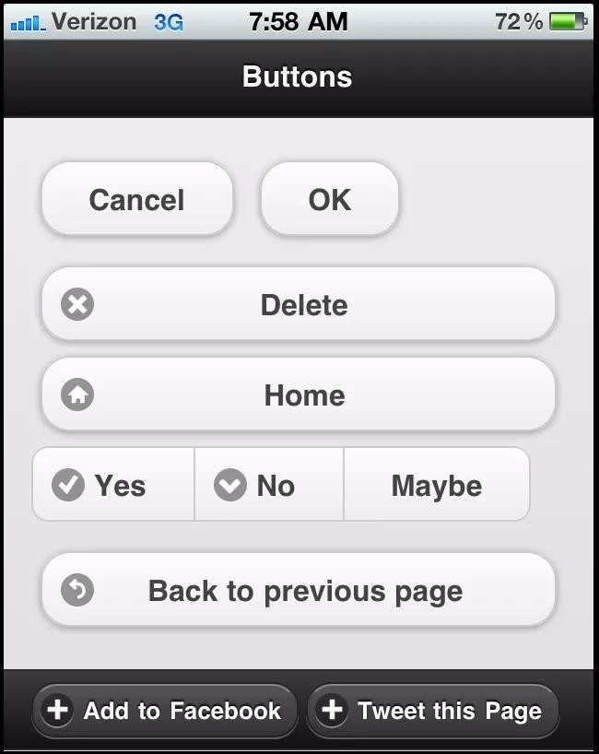
Above Code run and expected output for buttons

To create a navigation bar
The HTML for the navigation bar
<header data-role="header">
<h1>SJV Town Hall</h1>
<div data-role="navbar">
<ul>
<li><a href="#home" class="ui-btn-active"
data-icon="home" data-theme="b">Home</a></li>
<li><a href="#speakers"
data-icon="star" data-theme="b">Speakers</a></li>

<li><a href="#contactus
data-icon="grid" data-theme="b">Contact Us</a></li>
</ul>
</div>

</header>

Above Code run and expected output for navigation bar

Conclusion: Hence we have created Simple website Using JQuery ,its component and media query.
Practical No. 4.B
Title: Deploy web application on Cloud
Problem Statement: Deploy/Host Your web application on AWS VPC or AWS Elastic Beanstalk
Theory:
What is Cloud Computing?
Cloud computing is a term referred to storing and accessing data over the internet. It doesn’t store any data on the hard disk of your personal computer. In cloud computing, you can access data from a remote server.
What is AWS?
The full form of AWS is Amazon Web Services. It is a platform that offers flexible, reliable, scalable, easy- to-use and, cost-effective cloud computing solutions.
AWS is a comprehensive, easy to use computing platform offered Amazon. The platform is developed with a combination of infrastructure as a service (IaaS), platform as a service (PaaS) and packaged software as a service (SaaS) offerings.
It is a secure cloud services platform, offering compute power, database storage, content delivery and other functionality to help businesses scale and grow.
In simple words AWS allows you to do the following things- Running web and application servers in the cloud to host dynamic websites.
History of AWS
2002- AWS services launched
2006- Launched its cloud products
2012- Holds first customer event
2015- Reveals revenues achieved of $4.6 billion
2016- Surpassed $10 billon revenue target
2016- Release snowball and snowmobile
2019- Offers nearly 100 cloud services
2021- AWS comprises over 200 products and services

Important AWS Services
Amazon Web Services offers a wide range of different business purpose global cloud-based products. The products include storage, databases, analytics, networking, mobile, development tools, enterprise applications, with a pay-as-you-go pricing model.
Applications of AWS services
Amazon Web services are widely used for various computing purposes like:
Web site hosting
Application hosting/SaaS hosting
Media Sharing (Image/ Video)
Mobile and Social Applications
Content delivery and Media Distribution
Storage, backup, and disaster recovery
Development and test environments
Academic Computing
Search Engines
Social Networking
1. Creating an AWS Account is the first step you need to take in order to learn Amazon Web Services.
Steps to follow are as follows :
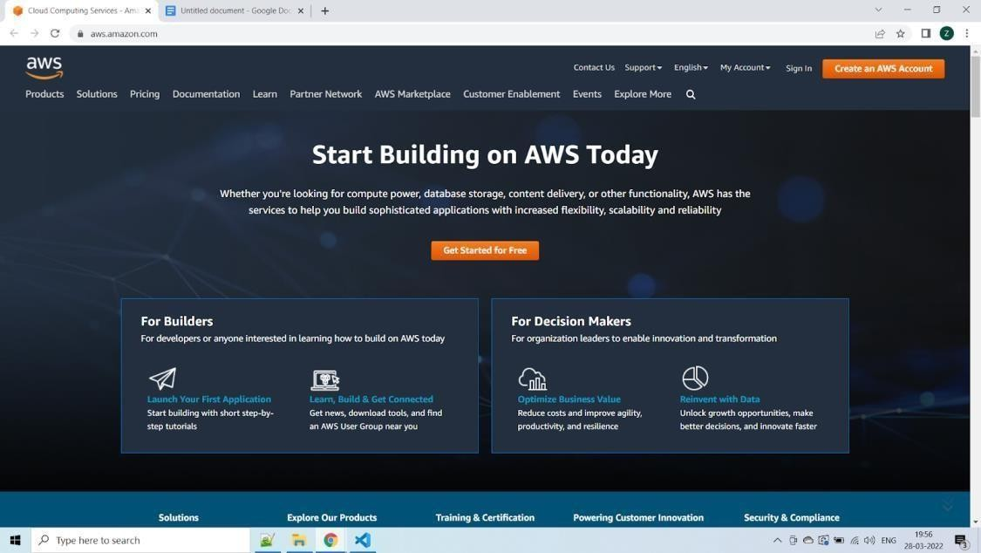
Step 1 – Visiting the Signup Page Go to https://aws.amazon.com You should see something like below:
In order to continue, click the Complete Sign Up button in the middle of the screen or on the top right corner of the screen. You will see the below screen.

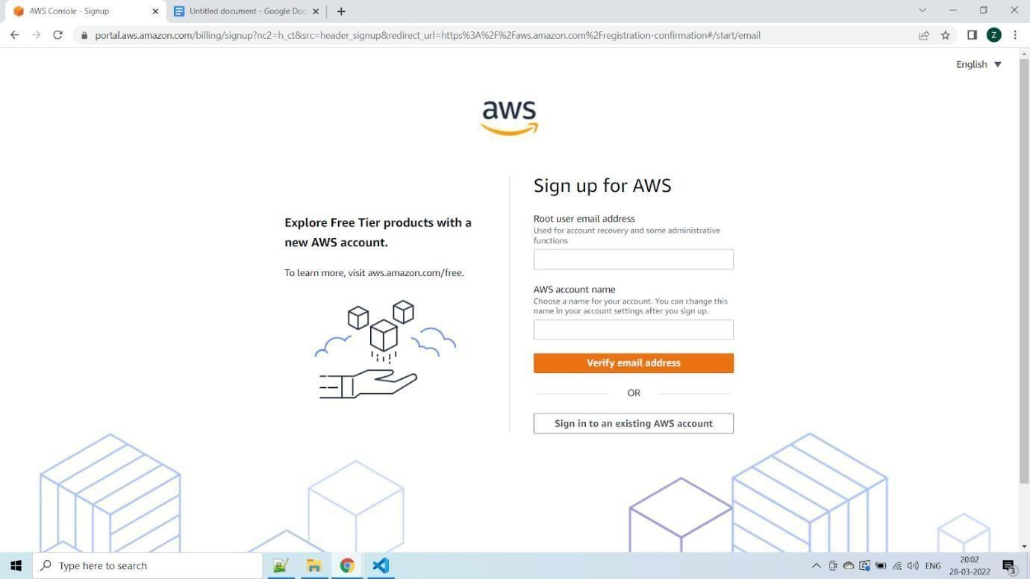

Step 2 – Entering User Details
After you have chosen to Create a new AWS account, you will see the below screen asking for few details.
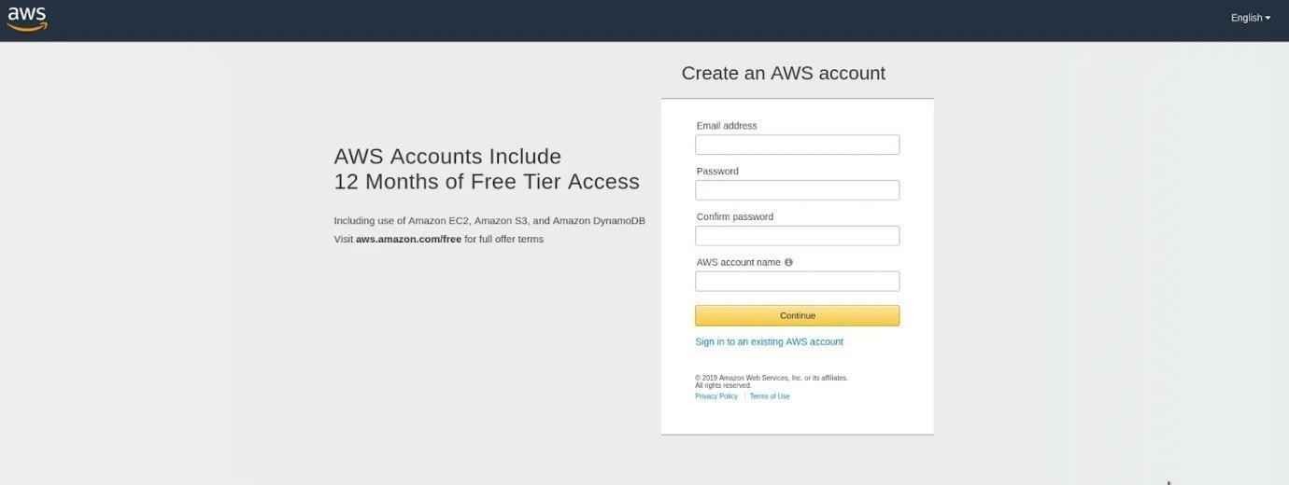
You can fill up the details as per your requirements and click Continue.
Next you will be asked to fill up your contact details such contact number, country, address and so on. You should fill them up properly because your contact number is important for further steps.

After filling up the details, click on the Create Account and Continue button at the bottom of the form.

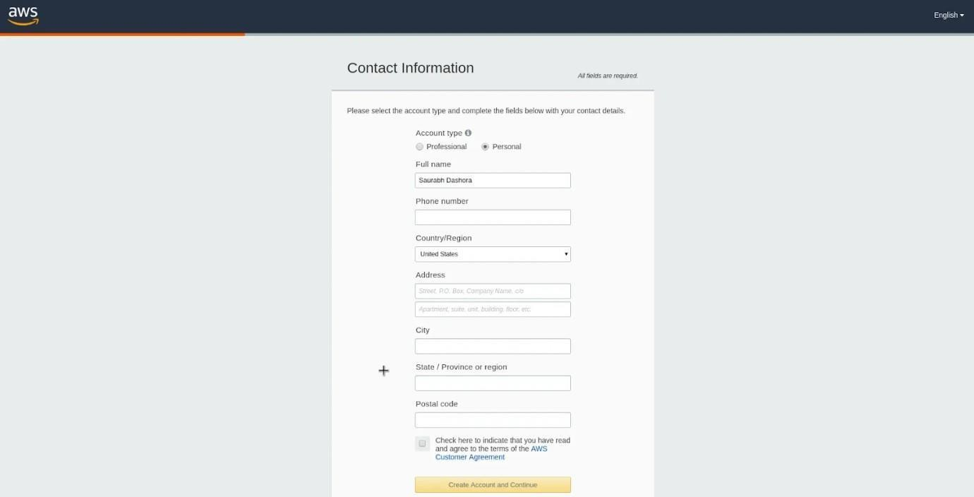
Step 3 – Filling up the Credit Card details
For Creating an AWS Account, you need to enter your Credit Card details
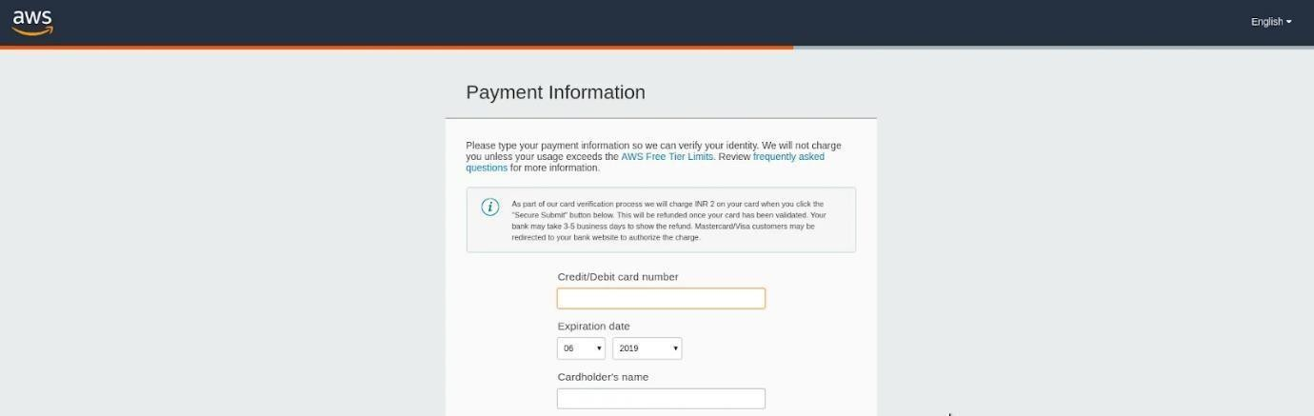
After entering the details, click on Secure Submit button. It might take a while to process the request depending on your bank/credit card company servers.
Step 4 – Identity Confirmation
Once the credit card details are confirmed, you will need to complete the Identity Confirmation step. You will see the below screen:

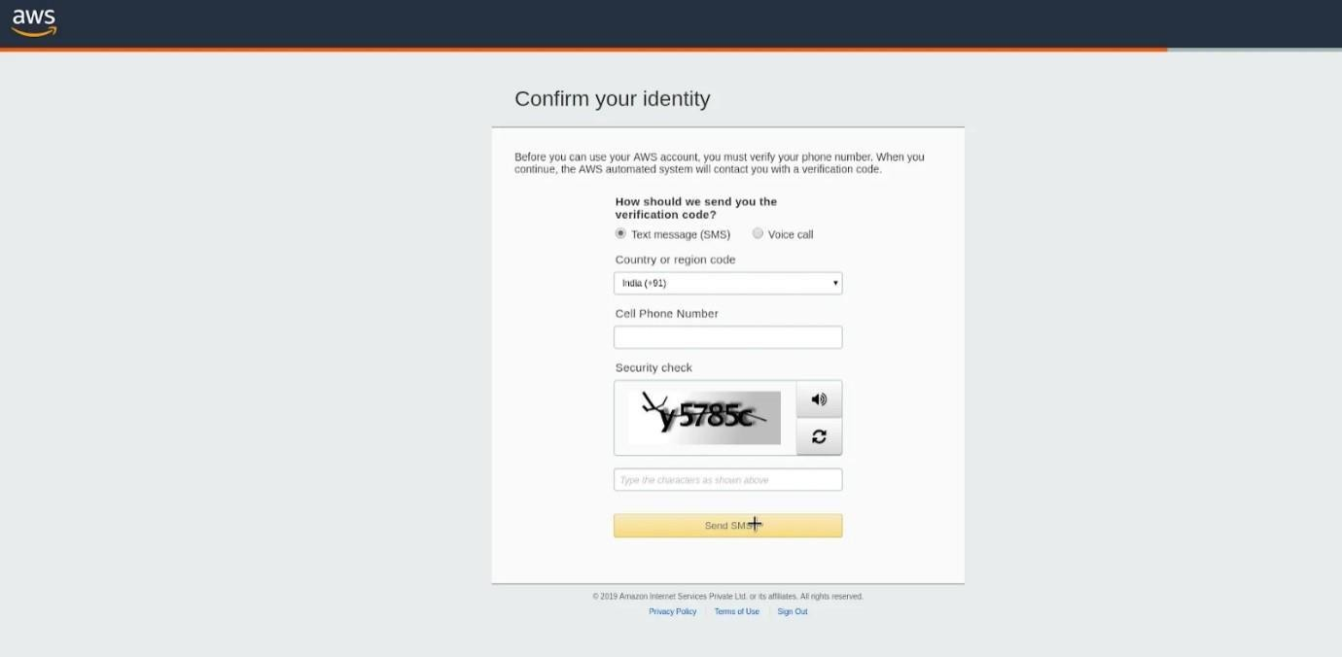

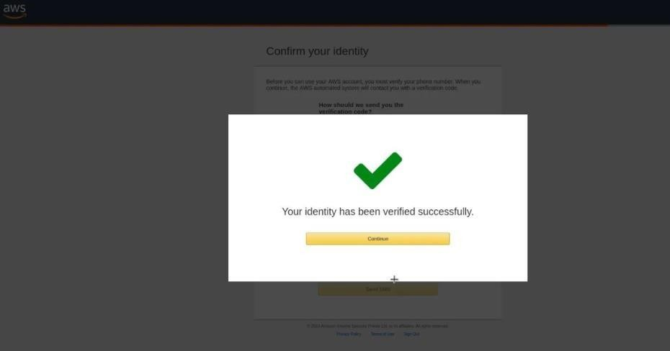
Once you have verified successfully, you should see a screen like below:

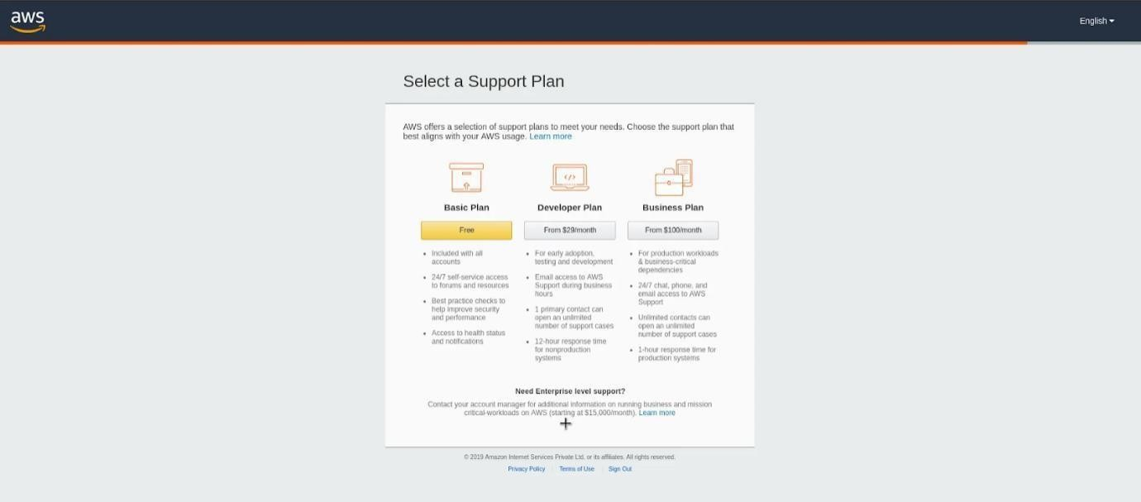
Step 5 – Selecting a Support Plan
Go for Basic Plan. It is Free of cost and great for learning purposes. The other plans are Developer Plan and a
Business Plan. But both of them are paid options.
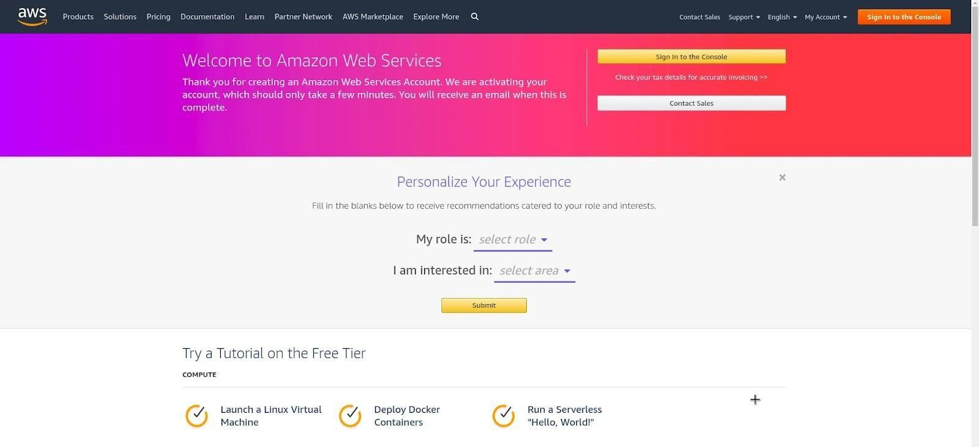

Finally, after logging in, you should be able to see the AWS Management Console as below:

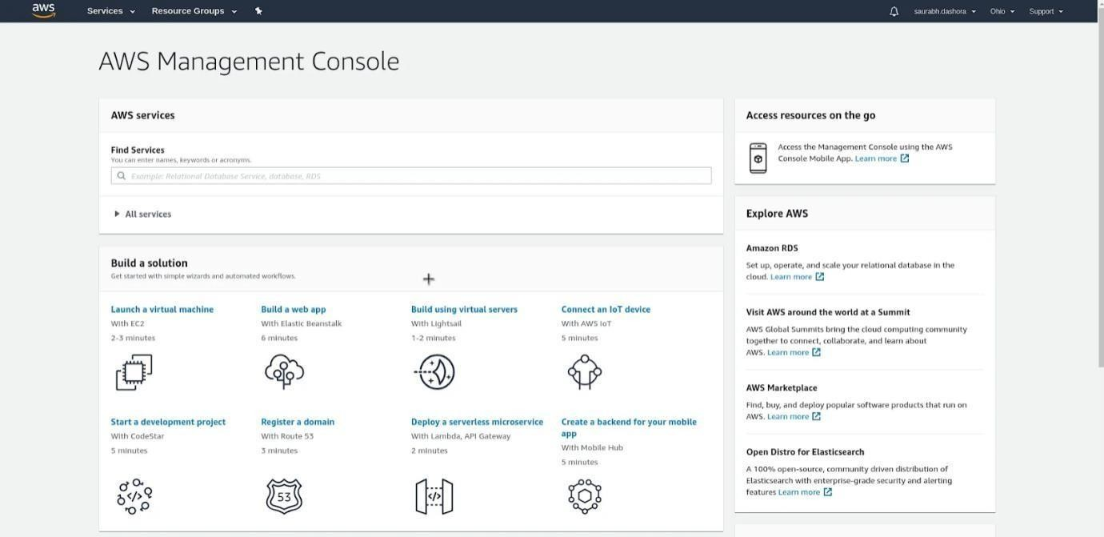

If you have reached this far, you have successfully finished Creating an AWS Account.
Deployment Steps:
Step 1: Launch a Windows Server Amazon EC2 instance.
Step 2: Configure your source content to deploy to the Windows Server Amazon EC2 instance.Step 3: Upload your "hello, world!”...
Step 4: Deploy your Hello World application.
Step 5: Update and redeploy your "hello, world!”...
Step 6: Clean up your "hello, world!"

Conclusion: Web application deployment is done successfully.

