A MINI PROJECT REPORT

ON

“Measuring Emigration Risk of Bank Customers Using Artificial Neural Network”

Submitted to

SAVITRIBAI PHULE PUNE UNIVERSITY

in completion of
SKILL DEVELOPMENT LABORATORY
(T.E Computer Engineering)

BY

Shravan Honade Exam No :
Piyush Dhakate Exam No :
Shreyansh Gilbile Exam No :
Dhaval Jain Exam No :

Department of Computer Engineering
Sinhgad College of Engineering, Pune-41
Accredited by NAAC with grade ‘A’

YEAR 2017-18

CERTIFICATE

Sinhgad Technical Education Society,
Department of Computer Engineering
Sinhgad College of Engineering, Pune-41
Accredited by NAAC with grade ‘A’

“MINI PROJECT TITLE”

Submitted to

SAVITRIBAI PHULE PUNE UNIVERSITY

in completion of

SKILL DEVELOPMENT LABORATORY
(T.E Computer Engineering)

BY

Shravan Honade Exam No :
Piyush Dhakate Exam No :
Shreyansh Gilbile Exam No :
Dhaval Jain Exam No :

Prof. G.G.Chiddarwar Prof. M. P. Wankhade
Internal Guide Head of Dept.
Department of Computer Engineering Department of Computer Engineering

Dr. S.D. Lokhande
Principal,SCOE,Pune

CONTENTS

Sr. No. Titles Page No.
1. ACKNOWLEDGEMNT 4
2. ABSTRACT 5
3. INTRODUCTION
3.1 Background and Basics 6
3.2 Problem Statement 7
3.2.1 Scope of Statement
4. PROJECT PLANNING AND MANAGEMENT
4.1 Hardware requirement 9
4.2 Software requirement 9
4.3 Process Model 10
5. ANALYSIS AND DESIGN
5.1 Use-Case Diagrams 11
5.2 Class Diagrams 12
6. IMPLEMENTATION AND CODING
6.1 Methodology 13
6.2 Algorithm 18
6.3 GUI Design/Screen Shots 19
7. RESULTS AND DISCUSSION
7.1 Visualization of Results 22
8. CONCLUSION 25
9. REFERENCES 25

1. ACKNOWLEDGEMENT

I feel great pleasure in expressing my deepest sense of gratitude and sincere thanks to my guide Prof. G.G.Chiddarwar for her valuable guidance during the Project work, without which it would have been very difficult task. I have no words to express my sincere thanks for valuable guidance, extreme assistance and cooperation extended to all the Staff Members of my Department.
This acknowledgement would be incomplete without expressing my special thanks to Prof. Wankhede Sir, Head of the Department (Computer Engineering) for his support during the work.
I would also like to extend my heartfelt gratitude to my Principal, Dr. S. D. Lokhande who provided a lot of valuable support, mostly being behind the veils of college bureaucracy.
Last but not least I would like to thanks all the Teaching, Non-Teaching staff members of my Department, my parent and my colleagues those who helped me directly or indirectly for completing of this Project successfully.

2. ABSTRACT

In many studies, the relationship between development of financial markets and economic growth has been proved. Immigration risk is one of problems which banks are faced with it while doing their tasks. Immigration risk means the probability of customers to flee from the bank due some underlying causes. If the Immigration risk decreases, banks will be more successful in performing their duties and have greater effect on economic growth of the country. Credit score of customers and identifying good and bad customers, help banks lend to their good payers and hereby, they reduce probability of immigration and fraud. This project aims to identify classification criteria for good customers and bad customers in private sector banks. The major role of the project is to predict the immigration of the customer and segregation of the good customers from bad customers so that appropriate steps like taking feedback from the bad or unsatisfied customers and making a proper relationship bond between them. The major contribution of this project will be to generate the list of most probable customers who are on the verge of leaving the bank.

3. INTRODUCTION

3.1 Background and Basics
Banking systems are an integral part of every nation’s economy. In this modern times money and its necessity is very important. A developed financial system of the country can ensure scope for attaining economic development. By adopting modern technologies such as Machine learning and Artificial Intelligence some banks automated operational processes resulting in cost reduction and faster turn-around time. These functionalities are also used for quantifying and minimizing risks, customer satisfaction, hiring and retaining staff, detecting and blocking frauds, forecasting and avoiding delinquencies, identifying new customers for marketing of new products and services.

In this report we are going to investigate at one such application which is trying to predict customer’s behavior in accordance to the bank. This report contains brief description of advancements in Machine learning that are influencing development of Banking Industries. In this project our aim is to find out and explain the concepts of Machine learning and Artificial Intelligence in as non-technical and practical way as possible, although some mathematical notation is essential for specifying certain rules, procedures and structures quantitatively.

It contains the findings and analysis of the dataset used to judge the importance of various attributes that influence the satisfaction of customers in different manner. Further an attempt has been made to categorize the customer’s likelihood of emigrating the bank based on various factors such as age, sex, income, geography etc.

3.2 Problem Statement:
“The Frequency of customer emigration has been increasing day by day which is leading to an unusual loss in the economical growth of banks”
Apply an approach to predict the risk of customer emigration to take necessary steps to improve the status of the bank.

3.2.1. Scope of Statement:
The Functionality of the project includes 2 parts
1) Predicting customer emigration.
2) Finding an optimum solution for the above mentioned functionality.

4. PROJECT PLANNING AND MANAGEMENT

4.1 Hardware requirements:

1. Intel Core2 duo processor and above
2. 8 GB RAM
3. External GPU (if required)
4.2 Software requirements:

1. Operating system: Mac OS, Microsoft Windows 7/10, Ubuntu and all other Linux
distributions

2. MS-Excel, Libre-Office etc.

3. Anaconda, Python 3.4 or above

4. Modules required: Tensorflow, Keras, Numpy, Matplotlib, Pandas

4.3 Process Model:

Waterfall approach was first SDLC Model to be used widely in Software Engineering to ensure success of the project. In "The Waterfall" approach, the whole process of software development is divided into separate phases. In this Waterfall model, typically, the outcome of one phase acts as the input for the next phase sequentially.

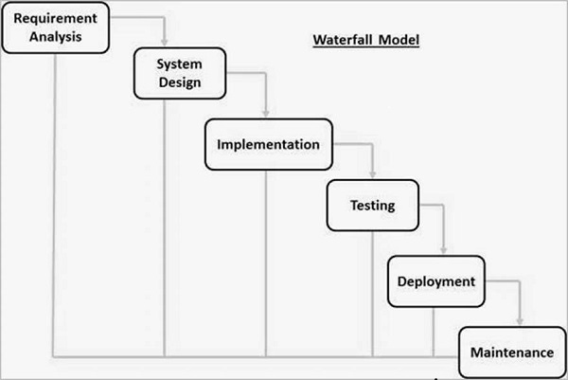

Figure 4.3 Waterfall Model.

5. ANALYSIS AND DESIGN

5.1 Use-Case Diagram:

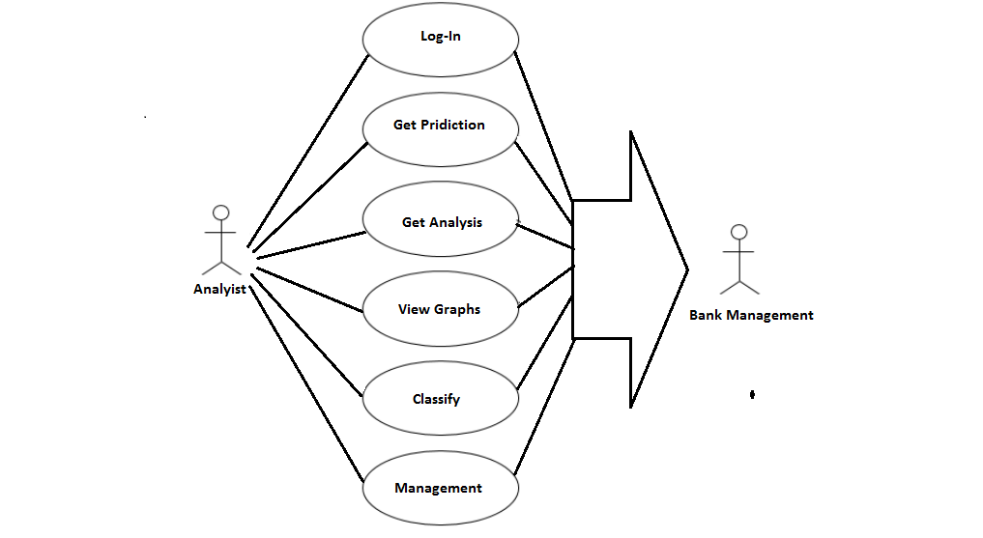

5.1 Class Diagram:

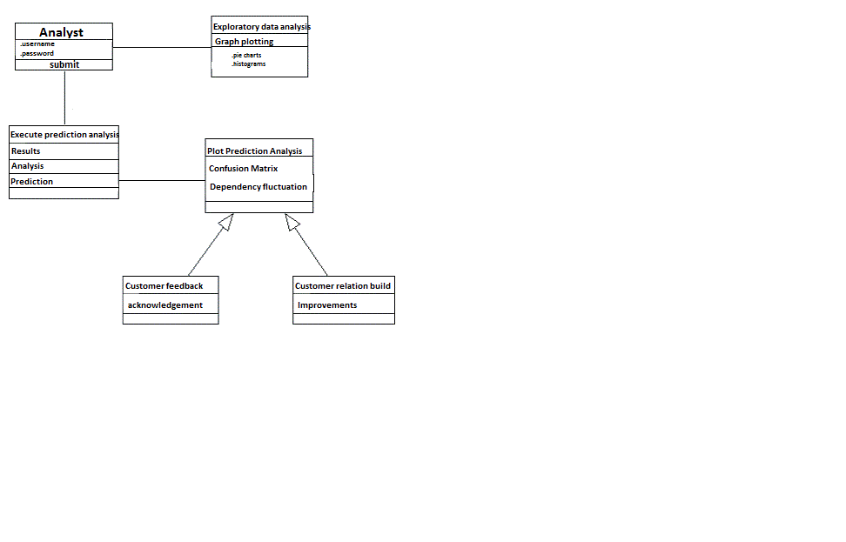

6. IMPLEMENTATION AND CODING

6.1 Methodology:

6.1.1 Neural networks – An Overview

The term "Neural networks" is a very evocative one. It suggests machines that are something like brains and is potentially laden with the science fiction connotations of the Frankenstein mythos. One of the main tasks of this book is to demystify neural networks and show how, while they indeed have something to do with brains, their study also makes contact with other branches of science, engineering and mathematics. The aim is to do this in as non-technical a way as possible, although some mathematical notation is essential for specifying certain rules, procedures and structures quantitatively. Nevertheless, all symbols and expressions will be explained as they arise so that, hopefully, these should not get in the way of the essentials: that is, concepts and ideas that may be described in words.

This chapter is intended for orientation. We attempt to give simple descriptions of what networks are and why we might study them. In this way, we have something in mind right from the start, although the whole of this book is, of course, devoted to answering these questions in full

What are neural networks?

A neural network is an interconnected assembly of simple processing elements, units or nodes, whose functionality is loosely based on the animal neuron. The processing ability of the network is stored in the interunit connection strengths, or weights, obtained by a process of adaptation to, or learning from, a set of training patterns.

To flesh this out a little we first take a quick look at some basic neurobiology. The human brain consists of an estimated 10¹¹ (100 billion) nerve cells or neurons, a highly stylized example of which is shown in Figure 1.1. Neurons communicate via electrical signals that are short-lived impulses or "spikes" in the voltage of the cell wall or membrane. The interneuron connections are mediated by electrochemical junctions called synapses, which are located on branches of the cell referred to as dendrites. Each neuron typically receives many thousands of connections from other neurons and is therefore constantly receiving a multitude of incoming signals, which eventually reach the cell body. Here, they are integrated or summed together in some way and, roughly speaking, if the resulting signal exceeds some threshold then the neuron will "fire" or generate a voltage impulse in response. This is then transmitted to other neurons via a branching fibre known as the axon.

It is this architecture and style of processing that we hope to incorporate in neural networks and, because of the emphasis on the importance of the interneuron connections, this type of system is sometimes referred to as being connectionist and the study of this general approach as connectionism. This terminology is often the one encountered for neural networks in the context of psychologically inspired models of human cognitive function. However, we will use it quite generally to refer to neural networks without reference to any particular field of application.

The artificial equivalents of biological neurons are the nodes or units in our preliminary definition and a prototypical example is shown in Figure 1.2. Synapses are modelled by a single number or weight so that each input is multiplied by a weight before being sent to the equivalent of the cell body. Here, the weighted signals are summed together by simple arithmetic addition to supply a node activation. In the type of node shown in Figure 1.2 the so-called threshold logic unit (TLU) the activation is then compared with a threshold; if the activation exceeds the threshold, the unit produces a high-valued output (conventionally "1"), otherwise it outputs zero. In the figure, the size of signals is represented by

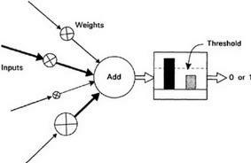

Figure 1.2 Simple artificial neuron

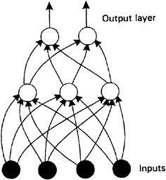

Figure 1.3 Artificial Neural Network

6.1.2 Keras:

Keras is a high-level neural networks API, written in Python and capable of running on top of TensorFlow, CNTK, or Theano. It was developed with a focus on enabling fast experimentation. Being able to go from idea to result with the least possible delay is key to doing good research.
Use Keras if you need a deep learning library that:
- Allows for easy and fast prototyping (through user friendliness, modularity, and extensibility).
- Supports both convolutional networks and recurrent networks, as well as combinations of the two.
- Runs seamlessly on CPU and GPU.
Read the documentation at Keras.io.
Keras is compatible with: Python 2.7-3.6.
The core data structure of Keras is a model, a way to organize layers. The simplest type of model is the Sequential model, a linear stack of layers. For more complex architectures, you should use the Keras functional API, which allows to build arbitrary graphs of layers.
Here is the Sequential model:
from keras.models import Sequential

model = Sequential()
Stacking layers is as easy as .add():
from keras.layers import Dense, Activation

model.add(Dense(units=64, input_dim=100))
model.add(Activation('relu'))
model.add(Dense(units=10))
model.add(Activation('softmax'))
Once your model looks good, configure its learning process with .compile():
model.compile(loss='categorical_crossentropy',
optimizer='sgd',
metrics= ['accuracy'])
If you need to, you can further configure your optimizer. A core principle of Keras is to make things reasonably simple, while allowing the user to be fully in control when they need to (the ultimate control being the easy extensibility of the source code).
model.compile(loss=keras.losses.categorical_crossentropy,
optimizer=keras.optimizers.SGD(lr=0.01, momentum=0.9, nesterov=True))
You can now iterate on your training data in batches:
# x_train and y_train are Numpy arrays --just like in the Scikit-Learn API.
model.fit(x_train, y_train, epochs=5, batch_size=32)
Alternatively, you can feed batches to your model manually:
model.train_on_batch(x_batch, y_batch)
Evaluate your performance in one line:
loss_and_metrics = model.evaluate(x_test, y_test, batch_size=128)
Or generate predictions on new data:
classes = model.predict(x_test, batch_size=128)

6.1.3 Tensorflow:

TensorFlow is an open source software library for numerical computation using data flow graphs. Nodes in the graph represent mathematical operations, while the graph edges represent the multidimensional data arrays (tensors) communicated between them. The flexible architecture allows you to deploy computation to one or more CPUs or GPUs in a desktop, server, or mobile device with a single API. TensorFlow was originally developed by researchers and engineers working on the Google Brain Team within Google's Machine Intelligence research organization for the purposes of conducting machine learning and deep neural networks research, but the system is general enough to be applicable in a wide variety of other domains as well.
TensorFlow provides multiple APIs. The lowest level API--TensorFlow Core-- provides you with complete programming control. We recommend TensorFlow Core for machine learning researchers and others who require fine levels of control over their models. The higher level APIs are built on top of TensorFlow Core. These higher level APIs are typically easier to learn and use than TensorFlow Core. In addition, the higher level APIs make repetitive tasks easier and more consistent between different users. A high-level API like tf.estimator helps you manage data sets, estimators, training and inference.

6.2 Algorithm:

1. Import the necessary libraries.
2. Data Preprocessing :-
2.1-Import the dataset.
2.2-Prepare matrix of dependent and independent variable.
2.3-Encode the categorical data.
3. Split the dataset into Training Set and Test set.
4. Scale the features of Training Set.
5. Initialize the Artificial Neural Network.
6. Add the neurons and hidden layers in the ANN.
7. Compile the ANN and then fit it into the Training set.
8. Predict the test results.
9. Analyse the results using confusion matrix.
10. Visualize the accuracy results using different combinations of number of neurons ,number of hidden layers,epochs etc.

6.3 GUI Design:



Figure 6.3.1 Home Page



Figure 6.3.2 Login Page


Figure 6.3.3 Options

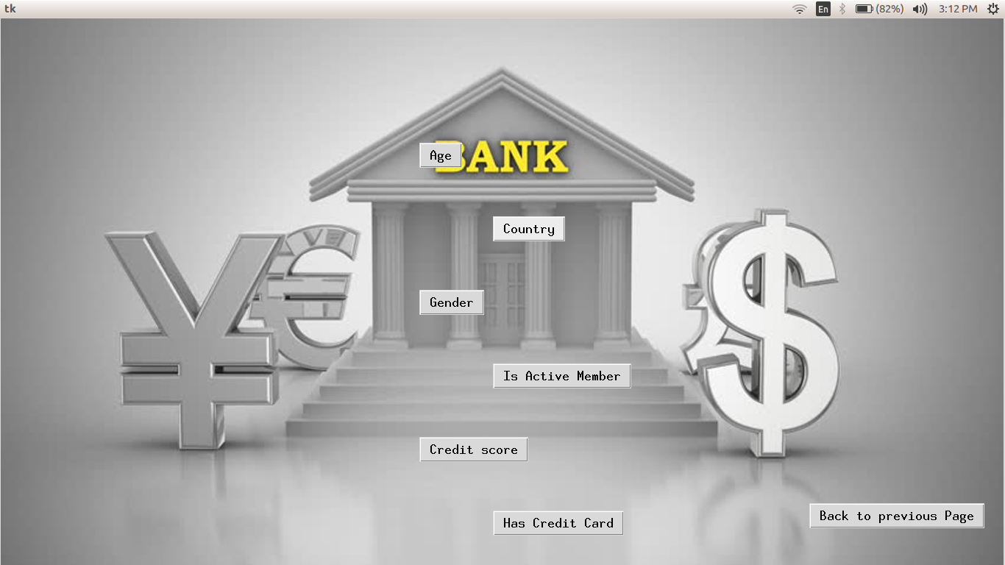

Figure 6.3.4 Exploratory Data Analysis



Figure 6.3.5 Execute Prediction Analysis



Figure 6.3.6 Analysis
7. RESULTS AND DISCUSSION

7.1 Visualization:

Table 7.1. Network Information:-

Input Layer  Hidden Layer(s)  Output Layer | Factors 1.  2.  3.  4.  5.  6.  7.  8.  9.  10.  Number of Hidden Layers  Number of Neurons in Hidden Layer 1  Activation Function  Dependent Variables  Number of Neurons  Activation Function  Error Function | Gender  Age  Credit Score  Geography  Tenure  Balance  Number of Products  Has Credit Card  Is Active Member  Estimated Salary  2  6  ReLu  Will customer leave?  1  Sigmoid  Binary Cross-entropy
`

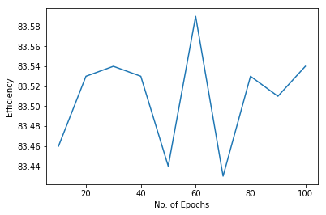
Figure 7.2. Effect of No. of Epochs on Efficiency.
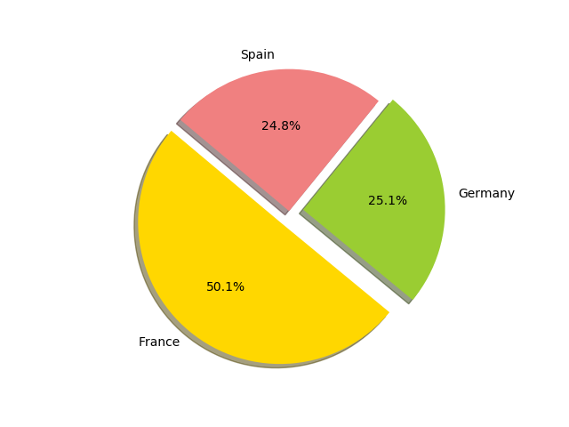

Figure 7.3 Distribution of Customers according to Geography

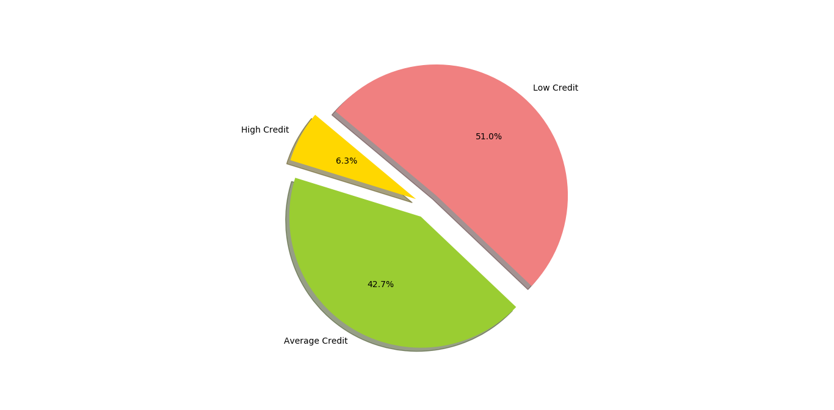
Figure 7.4 Distributions of Customers according to Credit Score

Table 7.5. Validation Analysis
Sample | Observed | Predicted
Training | Overall Percent | 85%
Testing | 0 1  0 1538 57  1 237 168  86.64 74.66 | 86%
8. CONCLUSION

The project created model which is used to predict the emigration of customer based on certain dependencies and by figuring out the emigration risk of the customer we can judge the behavioral patterns for effective management and maintenance of the customer relationship, bank productivity and bank growth for competitive advantage.
The predictions help the banks to make significant improvements like cost-reduction, customer services, and enhance the banking operation efficiency to their system in order to retain their potentially flee-risk customers.
Further the project has successfully classified customers which are more likely to emigrate.

9. REFERENCES

- An introduction to neural network by kevin gurney.
- tensorflow.org
- keras.org

