CNN Crop and Weed Classification using VGG16
Deep Learning Study Project Report
Individual Project • Roll Number 43
B.Tech IV Year I Semester • CSE DS
Nalacherla Shravan Kumar
23EG110C43
Under Guidance of Dr P Rajeshwari

Department of Computer Science Engineering Data Science
ANURAG UNIVERSITY
Venkatapur, Ghatkesar, Medchal Malkajgiri, Telangana 500088
One-sided printing • October 2026

Index
Topic | Page
Abstract | 3
Introduction | 3
Problem statement | 4
Objectives | 4
Dataset description | 5
Data preprocessing | 5
VGG16 architecture | 6
Framework and tools | 6
Methodology | 7
Hyperparameters | 7
Training procedure | 8
Model performance | 9
Accuracy graph | 10
Loss graph | 11
Confusion matrix | 12
Analysis and results | 12
Misclassified examples | 13
Sample predictions | 14
Conclusion | 14
Limitations and future work | 14
References | 15

Abstract
This individual project develops a binary Crop and Weed classifier using ImageNet-pretrained VGG16. The V2 Plant Seedlings dataset supplies twelve species mapped to two classes. A stratified image-level split separates training, validation and testing before augmentation. The method first trains a new classification head, then fine-tunes only the final convolution block using a smaller learning rate. Balanced class weights address the majority Weed class. A shared Python core drives a local Jupyter notebook and command-line runner. Held-out evaluation reports class-specific precision, recall, F1, AUC and a confusion matrix. Measured full-run results appear in the performance section. The held-out test accuracy was 97.71% on 831 images.

Introduction
Crop and weed discrimination can support selective weed management. Visually similar seedlings make this a challenging image-classification task. Transfer learning adapts previously learned image features to a smaller agricultural dataset. This project aligns with the syllabus units on optimization, convolutional networks and transfer learning.

Problem statement
Given one RGB image, predict Crop or Weed according to the defined species mapping. Controlled dataset accuracy does not establish reliable field deployment.

Objectives
Implement an individual VGG16 project for Roll 43; reproduce data validation and nonoverlapping splits; compare training and validation behavior; evaluate the held-out test set; provide local setup, notebook, model and documented outputs.

Dataset description
V2 Plant Seedlings contains 5,539 RGB images from twelve species. The original source describes approximately 960 unique plants recorded at multiple growth stages. Source: Kaggle vbookshelf/v2-plant-seedlings-dataset and Aarhus University. License: CC BY-SA 4.0. Crop contains Maize, Common Wheat and Sugar Beet (973 images). Weed contains the remaining nine species (4,566 images). The verifier decodes all files and checks every species count. Folder nesting and apostrophe variants are normalized.

Data preprocessing
Recursively identify species from parent folders, validate image readability and convert to RGB. Resize to 224×224. Keep float pixel values in 0–255; VGG16 preprocessing converts RGB to BGR and subtracts ImageNet means. Split before augmentation, using seed 42 and binary stratification. Training-only transforms apply horizontal flips, rotation 0.05, zoom 0.1 and translation 0.05.

VGG16 architecture
The ImageNet convolution base contains 13 convolutional layers grouped into five blocks, each followed by pooling. include_top=False removes the original classifier. The model contains input and augmentation, VGG16 preprocessing, VGG16 base, GlobalAveragePooling2D, Dense 128 ReLU, Dropout 0.5 and Dense 1 sigmoid. Sigmoid output estimates Weed probability and a 0.5 threshold selects the binary class. Assertions confirm the VGG16 structure, requested ImageNet weights, trainability and sigmoid output.

Framework and tools
Python 3.11, TensorFlow/Keras, NumPy, pandas, scikit-learn, Matplotlib, Seaborn and Pillow implement the experiment. Kaggle and kagglehub acquire data. JupyterLab and ipykernel support local notebook execution. A repository-specific .venv isolates dependencies. Native Windows uses CPU; WSL2 or optional Colab supports NVIDIA acceleration.

Methodology
Verify environment and dataset, explore distributions, create stratified 70/15/15 partitions and assert path disjointness. Calculate balanced class weights only from training labels. Create a tf.data pipeline that loads raw RGB images without normalizing by 255. Train the classification head, fine-tune block5, reload the global best validation-loss checkpoint and evaluate test predictions once.

Hyperparameters
Measured local run: batch size 4; 3 frozen-head epochs and 2 block5 epochs (5 total). The default maximum budgets remain 10 and 5 epochs. Training loss uses balanced class weights; validation and test losses are unweighted. Input size is 224×224×3, seed 42, Dense 128 ReLU, Dropout 0.5, binary cross-entropy and Adam. Head learning rate is 0.001; block5 learning rate is 0.00001. Early stopping uses patience 3; learning-rate reduction halves the rate after patience 2. The default batch size is 16, configurable for available memory.

Training procedure
Phase 1 freezes all VGG16 layers and learns the binary head. Phase 2 enables only block5 layers and recompiles the model. The checkpoint retains the best validation loss across both phases. No augmentation runs on validation or test images. The quick smoke test uses balanced subsets drawn after splitting and runs one head epoch; it checks forward/backward computation, block5 flags, preprocessing, model reload and prediction generation.

Model performance
Measured test loss: 0.07600. Test accuracy: 97.71%. AUC: 0.99182. Test images: 831.
Class | Precision | Recall | F1
Crop | 97.04% | 89.73% | 93.24%
Weed | 97.84% | 99.42% | 98.62%

Accuracy graph
Training and validation accuracy by epoch, with the fine-tuning boundary marked.
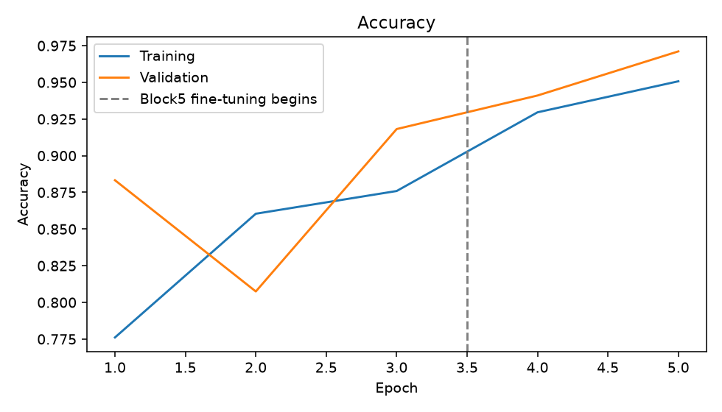

Loss graph
Training and validation binary cross-entropy; the best validation loss selects the model.
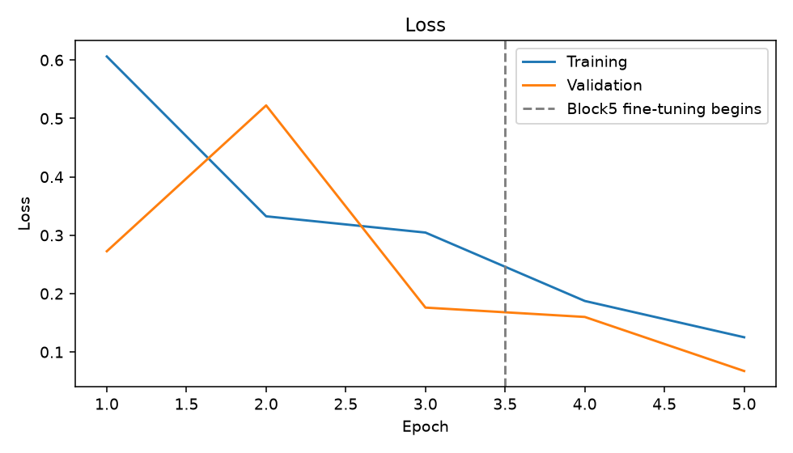

Confusion matrix
Rows represent actual class and columns predicted class. Crop false negatives represent crop images predicted as weeds, a potentially harmful error in future agricultural use.
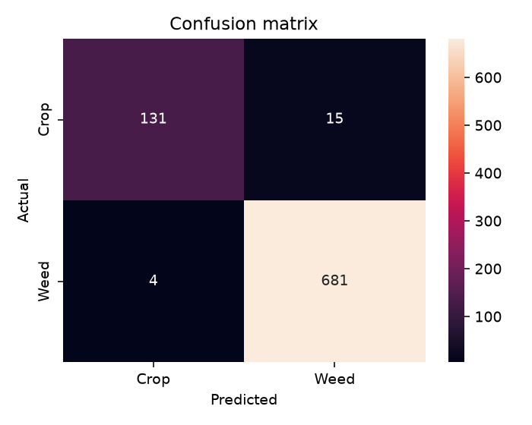

Analysis and results
The model correctly classified 812 of 831 test images. Crop recall was 89.73%, while Weed recall was 99.42%. There were 15 crops predicted as Weed and 4 weeds predicted as Crop. Overall accuracy was 97.71%, compared with the 82.43% majority-Weed baseline. ROC AUC was 0.99182; class decisions used threshold 0.5. These measurements describe this held-out image split, with the plant-identity and field-background limitations discussed below.

Misclassified examples
The saved test predictions contain 19 incorrect classifications. The examples below are actual held-out test errors. Sigmoid Weed probabilities are model scores and are not calibrated confidence guarantees.
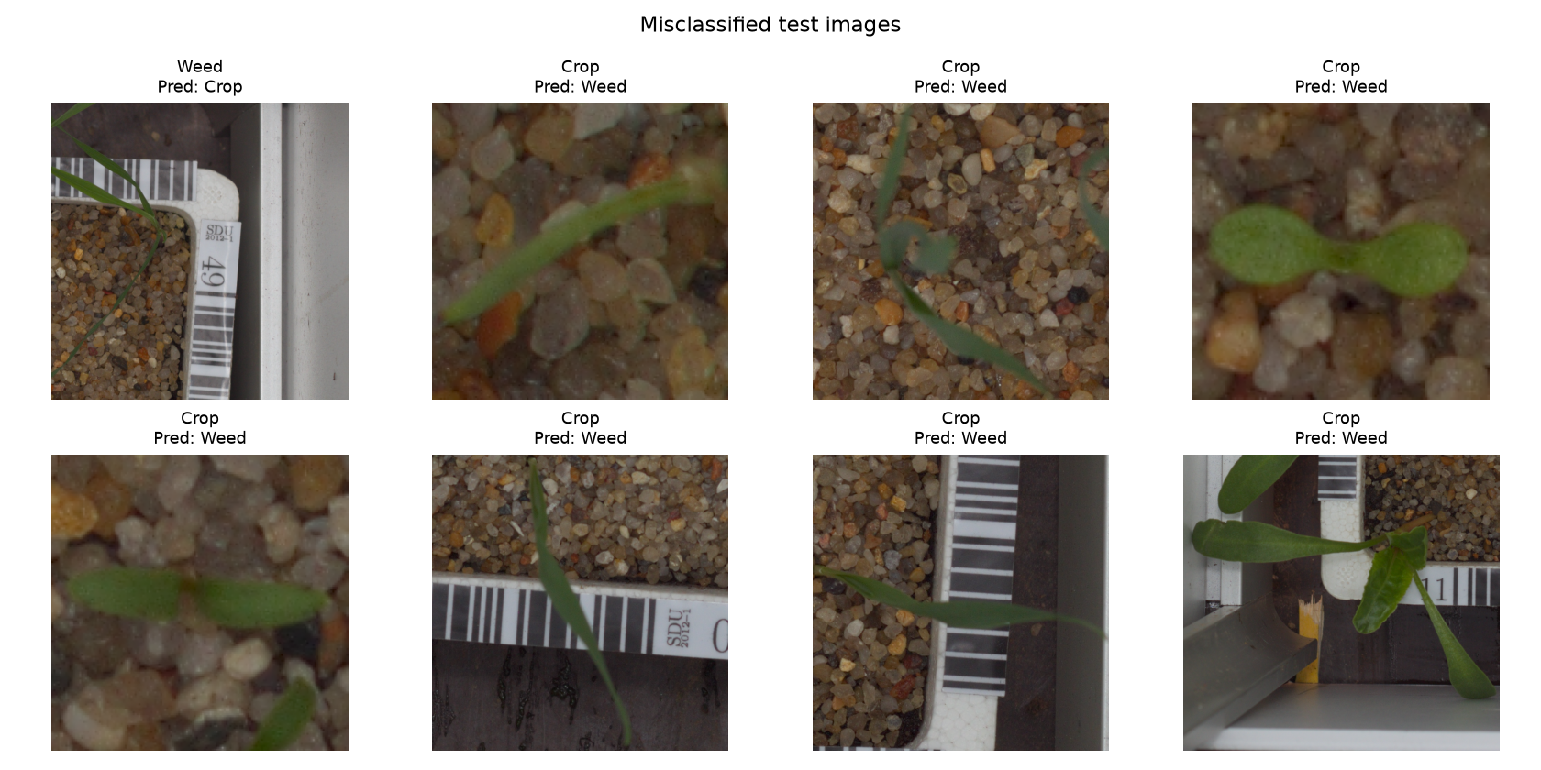

Sample predictions
Review correct and incorrect test predictions using the generated image grids. A confident sigmoid output is not a calibrated guarantee.
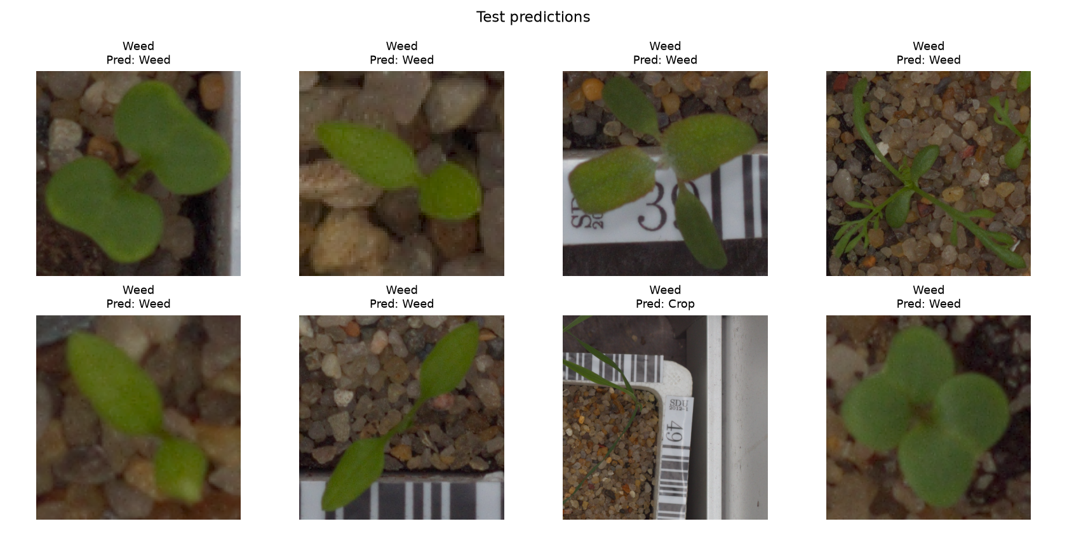

Conclusion
The individual project implements and executes a complete local VGG16 transfer-learning pipeline. The selected checkpoint achieved 97.71% accuracy, 0.07600 test loss and 0.99182 AUC on 831 held-out images after five measured epochs. Results, predictions and the saved model support reproducible review of this image-level experiment.

Limitations and future work
Controlled lighting and backgrounds limit field generalization. Multiple images may depict the same plant at different growth stages, so disjoint image paths do not ensure plant-level independence. Future work should verify plant identities for grouped splitting, obtain field images, calibrate probabilities and examine Crop recall under varied thresholds. CPU fine-tuning can be slow and memory intensive.

References
1. Supplied DL Syllabus, ML Deep Learning Lab Programs, List of study projects and Sample report (references/).
2. Giselsson et al. (2017), A Public Image Database for Benchmark of Plant Seedling Classification Algorithms. https://arxiv.org/abs/1711.05458
3. Aarhus Plant Seedlings Dataset. https://vision.eng.au.dk/plant-seedlings-dataset/
4. Kaggle V2 dataset. https://www.kaggle.com/datasets/vbookshelf/v2-plant-seedlings-dataset
5. Simonyan and Zisserman (2014), Very Deep Convolutional Networks for Large-Scale Image Recognition. https://arxiv.org/abs/1409.1556
6. TensorFlow VGG16 and installation documentation. https://www.tensorflow.org/api_docs/python/tf/keras/applications/VGG16 and https://www.tensorflow.org/install/pip
7. CC BY-SA 4.0. https://creativecommons.org/licenses/by-sa/4.0/

