K8S Installation:

1 sudo su -

2 apt update -y

3 curl -LO "https://dl.k8s.io/release/$(curl -L -s https://dl.k8s.io/release/stable.txt)/bin/linux/amd64/kubectl"

4 ls -l

5 curl -LO "https://dl.k8s.io/$(curl -L -s https://dl.k8s.io/release/stable.txt)/bin/linux/amd64/kubectl.sha256"

6 echo "$(cat kubectl.sha256) kubectl" | sha256sum --check

7 sudo install -o root -g root -m 0755 kubectl /usr/local/bin/kubectl

8 chmod +x kubectl

9 mkdir -p ~/.local/bin

10 mv ./kubectl ~/.local/bin/kubectl

11 kubectl version --client

12 apt install docker.io -y

13 systemctl status docker

14 curl -LO https://storage.googleapis.com/minikube/releases/latest/minikube-linux-amd64

15 ls -l

16 sudo install minikube-linux-amd64 /usr/local/bin/minikube

17 minikube start --driver=docker --force

18 minikube status~

19 minikube status

20 clear

21 history

Kubectl cluster-info (to get the k8s cluster info)



Kubectl run nginx - -image=nginx

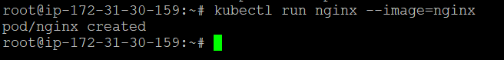

Kubectl get pods

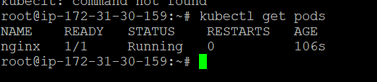

Kubectl get nodes

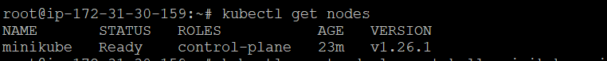

kubectl get node -o wide

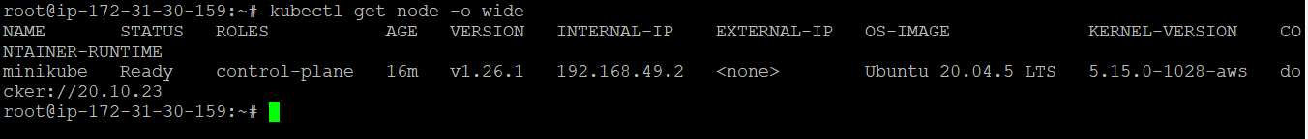

kubectl create deployment hello-minikube --image=k8s.gcr.io/echoserver:1.10 (deployment)



Kubectl get deployments

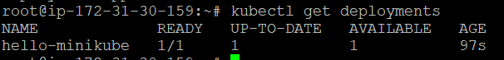

kubectl expose deploy hello-minikube --type=NodePort --port=8080



Kubectl service hello-minikube –url

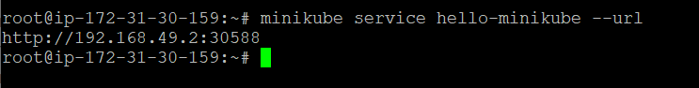

Kubectl delete service hello-minikube

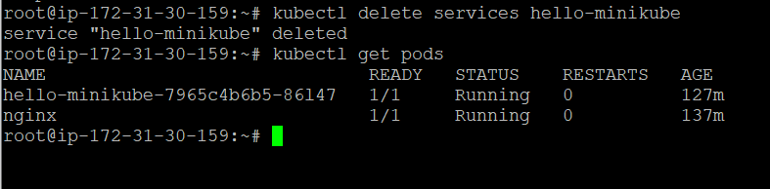

kubectl delete deployment hello-minikube



Deleted pod, node ,service…

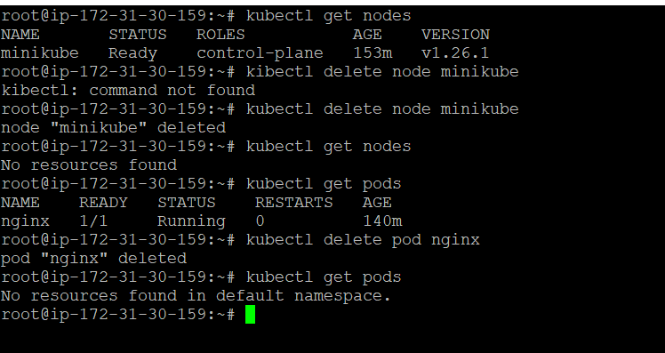

kubectl run nginx --image=nginx --dry-run=client -o yaml > nginx.yaml

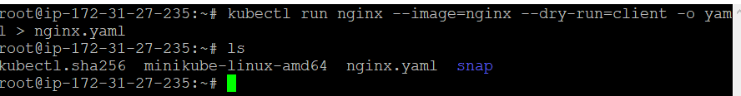

Yaml file generated..

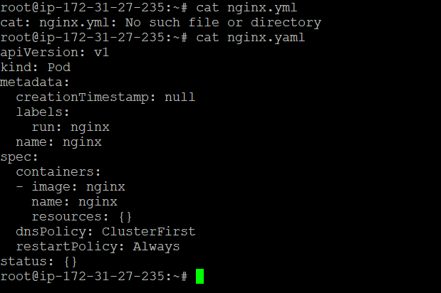

kubectl apply -f nginx.yaml

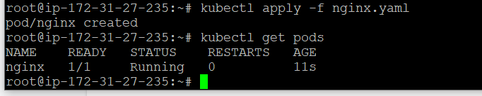

kubectl get nodes --show-labels

To get the list of worker nodes and their status..

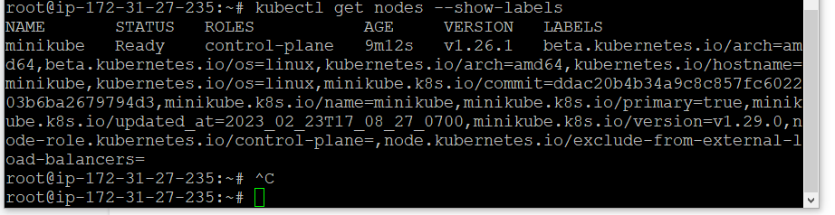

Vi replicaset.yaml

kubectl apply -f replicaset.yaml

apiVersion: apps/v1

kind: ReplicaSet

metadata:

name: web

labels:

env: dev

role: web

spec:

replicas: 4

selector:

matchLabels:

role: web

template:

metadata:

labels:

role: web

spec:

containers:

- name: testnginx

image: nginx

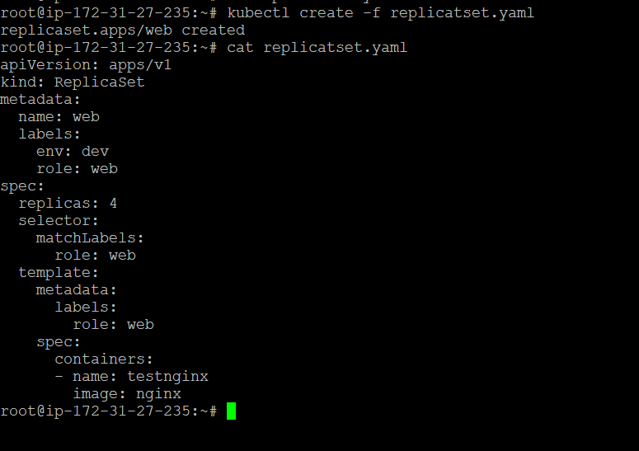

kubectl get rc

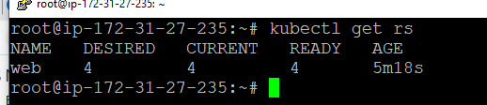

Kubectl get pods.

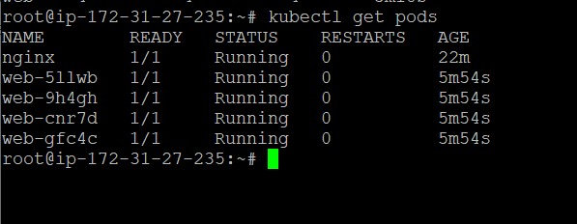

Kubectl delete pod web-gfc4c (if deleted one pod again one more pod will be created)

