Replicas scale up and scale down..

kubectl scale replicaset web --replicas=10

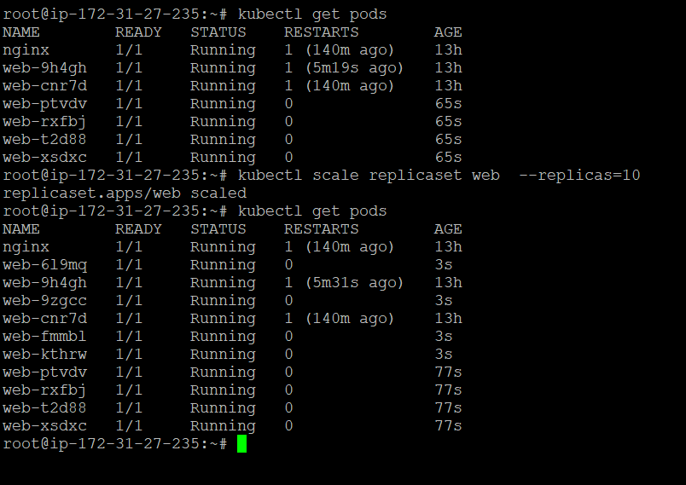

kubectl describe replicaset web

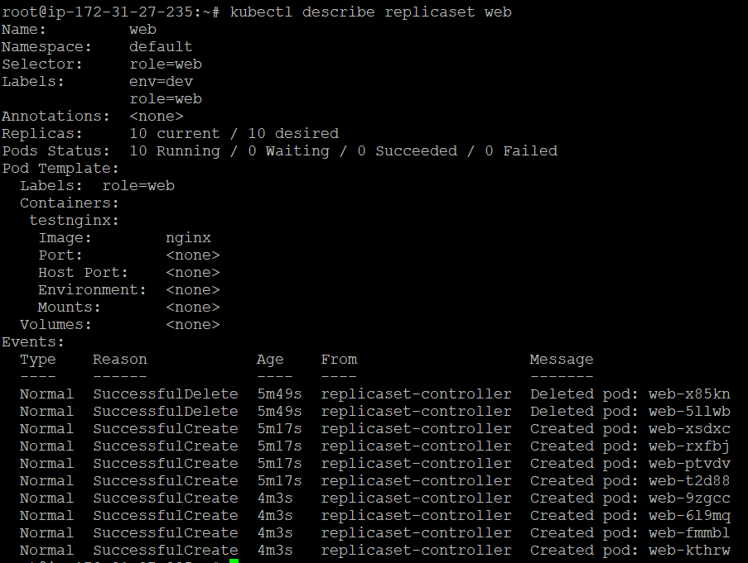

Deployment of nginx ymal file.

apiVersion: apps/v1

kind: Deployment

metadata:

name: myapp-deployment

spec:

selector:

matchLabels:

app: nginx

replicas: 2

template:

metadata:

labels:

app: nginx

spec:

containers:

- name: nginx

image: nginx

kubectl create -f deployment.yaml



Kubectl get pods:



Deployment scale 👍

kubectl scale --replicas=3 deployment/myapp-deployment

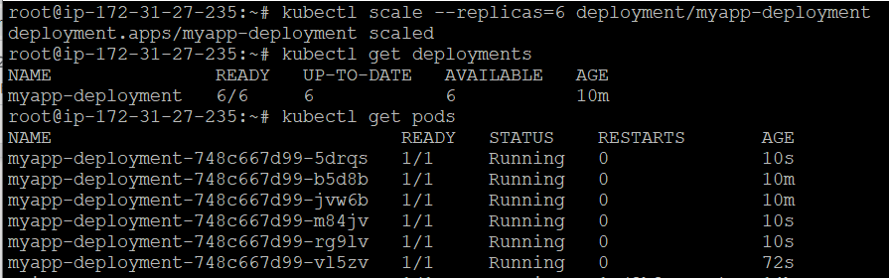

kubectl rollout status deployment.apps/myapp-deployment