**Name:** Jidigam Shravan

**Batch:** June 01, 2022

**Tutor:** Raham Shaik

**Project: Integration of different tools with Jenkins**

**Project:**

1. Created EC2 instance for Jenkins server and installed java git and jenkins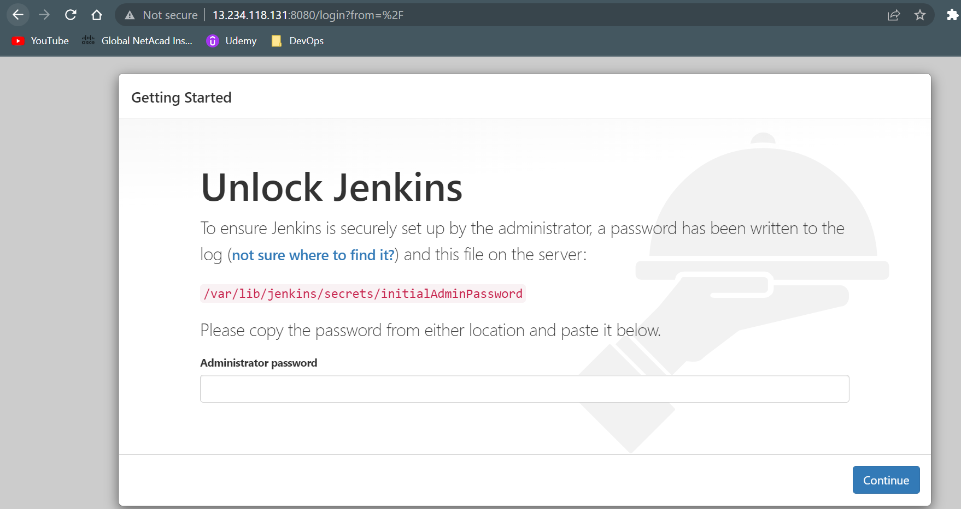
2. Created tomcat server and installed Java and tomcat server in that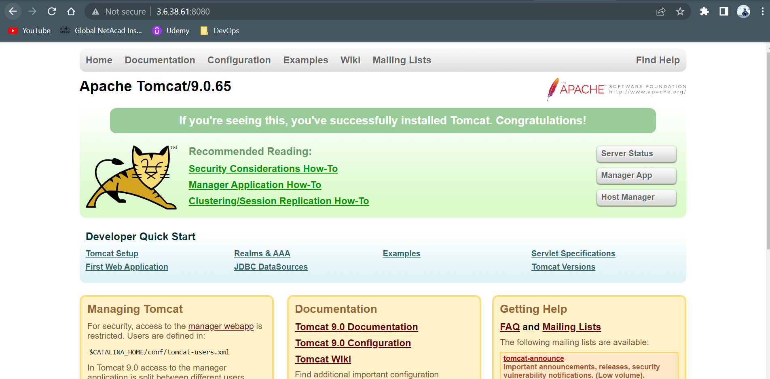A picture containing calendar

   Description automatically generated

1. Created EC2 instance and installed Maven Sonarqube and Nexus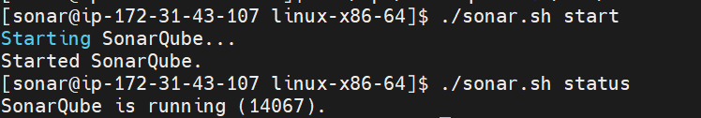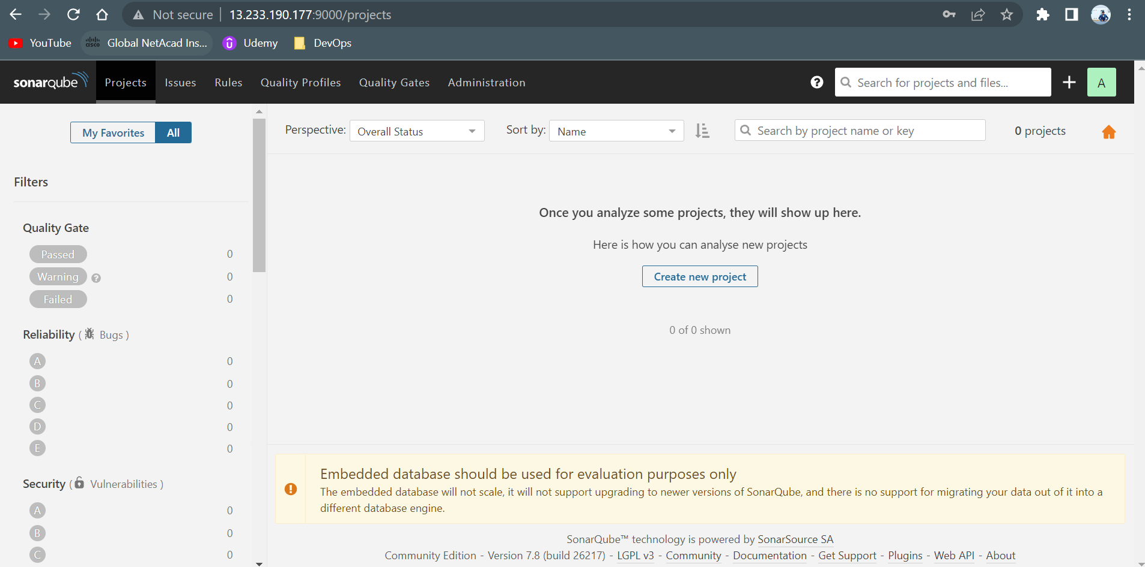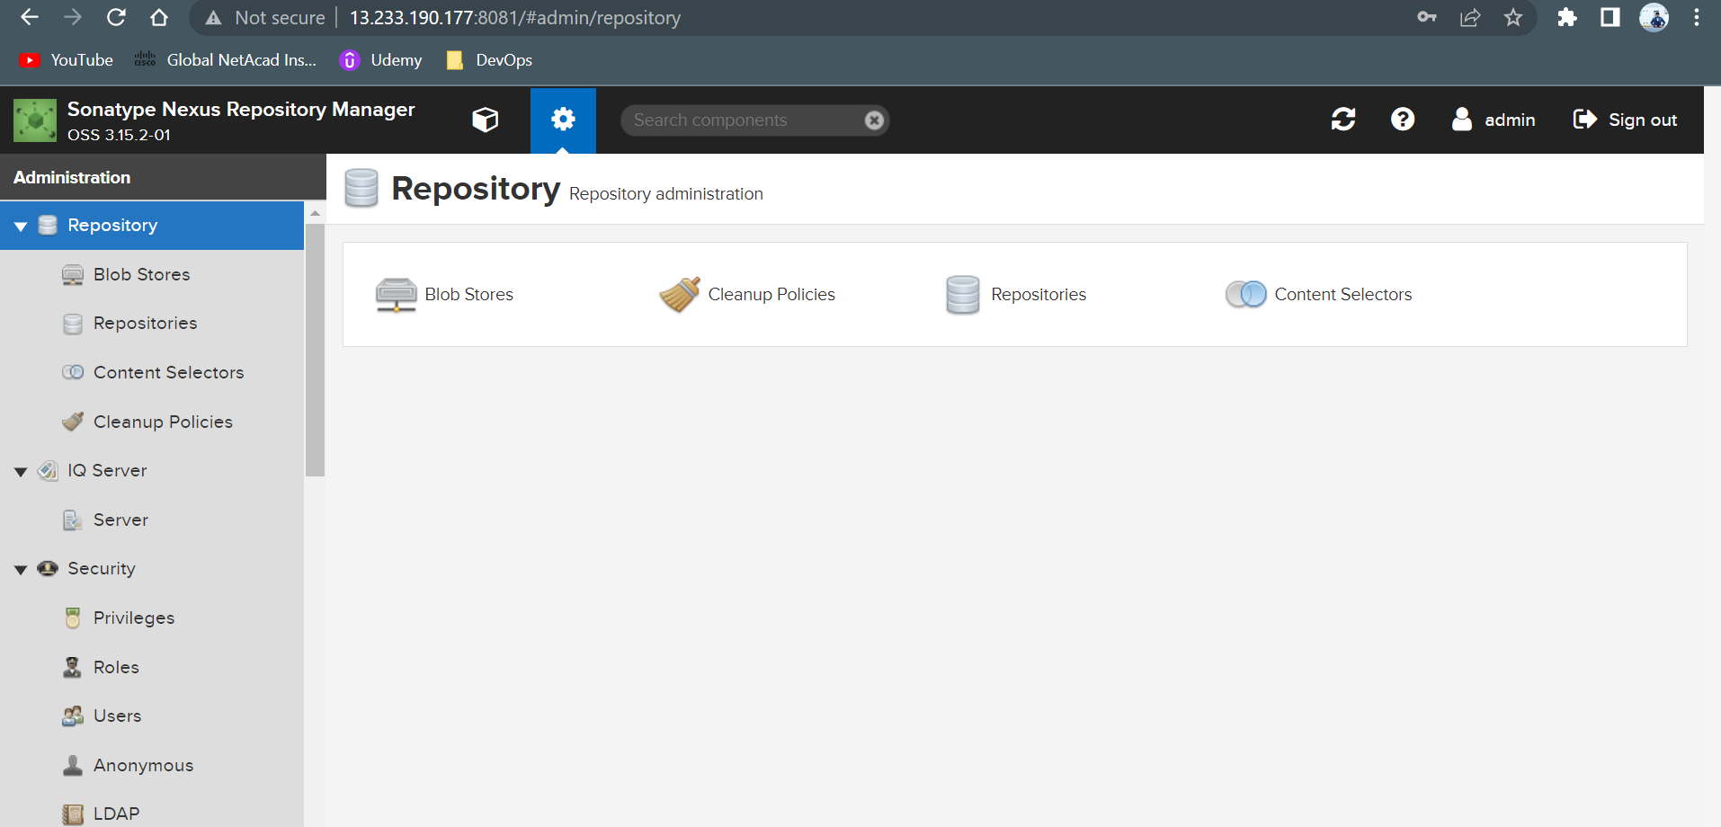
2. Created Tokens in Sonarqube and nexus to use for authentication and created repo in nexus to store artifcats snapshot and releases
3. Logged into Jenkins page and created a new project
4. **Integrated** Github by adding repo url in source code management
5. **Integrated** maven by installing maven in Jenkins by going to global tools cofnig and added maven version
6. In project configured maven and added maven goals like clean package sonar:sonar to create a package and code quality report in sonar qube.
7. Sonarqube details are configured in pom.xml of project and token was added for authentication
8. Nexus details configured in pom,xml and credentials configures in settings.xml under conf in maven clean deploy was applied in maven goals
9. Build the job and the job was success