Software Requirements Specification

for

Machine Learning in Diabetes

Version 1.0

Prepared by

Shravan

***1. Introduction***

The purpose of this Software Requirements Specification (SRS) document is to outline the requirements and specifications for a Diabetes Prediction System. The system will utilize Machine Learning (ML) algorithms to predict the likelihood of a person developing diabetes based on various factors such as blood pressure, and glucose levels.

***2. Scope***

The Diabetes Prediction System aims to assist healthcare professionals in early identification and prediction of diabetes in patients. It will provide a user-friendly interface for entering patient information and generate accurate predictions using ML algorithms. The system will be a web-based application accessible through standard web browsers.

***3. Functional Requirements***

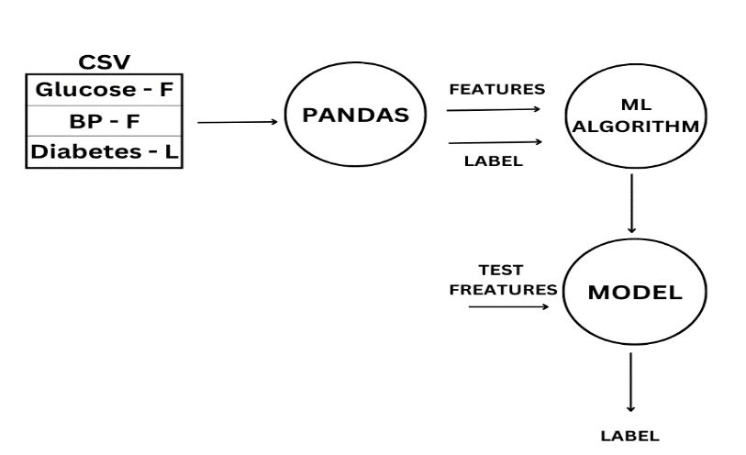

**3.1 User Management**

* The system shall provide user registration and login functionality for healthcare professionals.
* Users shall be able to update their profile information.

**3.2 Patient Management**

* The system shall allow healthcare professionals to add, edit, and delete patient records.
* Patient records shall include personal details, such as name, age, gender, and contact information.
* Healthcare professionals shall be able to input medical data,blood pressure, and glucose levels.

**3.3 Data Preprocessing**

* The system shall preprocess the input data to ensure accuracy and compatibility with ML algorithms.
* Input data shall be cleaned, normalized, and missing values shall be handled appropriately.

**3.4 ML Model Training**

* The system shall include ML algorithms for training a diabetes prediction model.
* ML algorithms, such as logistic regression, decision trees, or support vector machines, shall be implemented and evaluated for accuracy.
* The system shall utilize a training dataset to train the ML model.

**3.5 Diabetes Prediction**

* The system shall provide prediction functionality to determine the likelihood of a patient developing diabetes.
* The ML model shall take patient data as input and generate a prediction result.
* The prediction result shall indicate the probability or a binary classification (e.g., "diabetic" or "non-diabetic").

**3.6 Reporting and Visualization**

* The system shall generate reports and visualizations to present prediction results.
* Reports shall include patient details, input data, and the prediction outcome.
* Visualizations, such as graphs or charts, shall be used to represent data patterns and trends.

**3.7 System Administration**

* The system shall have an administrative interface for managing user roles and access permissions.
* Administrators shall be able to add, edit, or delete user accounts.
* User roles, such as "admin" and "healthcare professional," shall be defined to control system access.

***4. Non-functional Requirements***

**4.1 Performance**

* The system shall provide real-time or near real-time prediction results.
* The prediction process shall not exceed a maximum response time of 3 seconds.

**4.2 Security**

* The system shall ensure the confidentiality and integrity of patient data.
* User authentication and authorization mechanisms shall be implemented to prevent unauthorized access.
* Patient data shall be encrypted during transmission and storage.

**4.3 Usability**

* The user interface shall be intuitive, user-friendly, and accessible to healthcare professionals.
* The system shall provide clear instructions and guidance on data input and usage.

**4.4 Reliability**

* The system shall be available and operational 24/7 with minimal downtime.
* Backup and recovery mechanisms shall be implemented to prevent data loss.

**4.5 Scalability**

* The system shall be designed to handle a large volume of patient records and user traffic.
* The system architecture shall support horizontal scaling to accommodate future growth.

**4.6 Compatibility**

* The system shall be compatible with popular web browsers, such as Chrome,

Chrome and Microsoft Edge.

* The system shall support multiple operating systems, including Windows, macOS, and Linux.

***5. Constraints***

* The system shall comply with applicable privacy and data protection regulations, such as GDPR and HIPAA.
* The ML algorithms and models used shall be based on well-established and validated methodologies.
* The system shall require internet connectivity for accessing and utilizing the ML model.

***6. Assumptions and Dependencies***

* The system assumes that healthcare professionals have the necessary knowledge and expertise to interpret and utilize the prediction results.
* The system depends on the availability of relevant patient data for accurate predictions.
* The ML algorithms used depend on the quality and representativeness of the training dataset.