Construction-Pricing-api/iMPLEMENTAION
Ops — GET /health
Think of this as a "are you alive?" check. It simply asks the server "are you running fine?" and the server replies with a quick status report — like a pulse check for the application.
1. Health Check
- Method: GET
- URL: http://localhost:8000/health
- Click Send — no body needed
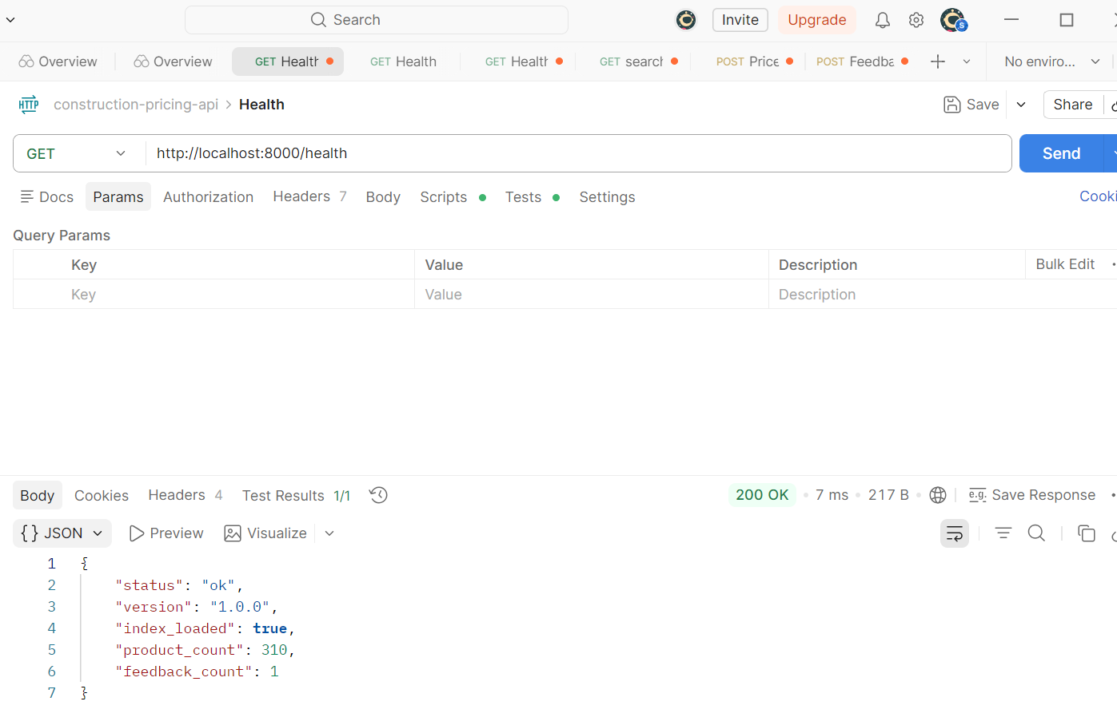
Postman
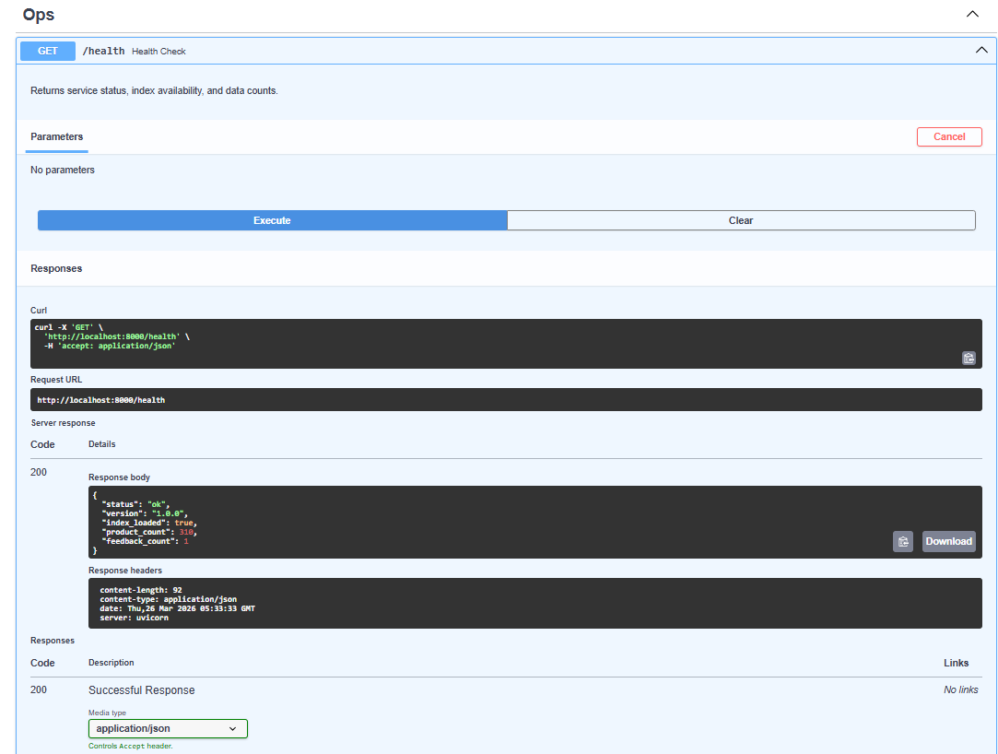
Through UI

Search — GET /search
This lets you search for construction/home improvement products using plain English. Instead of searching by exact product name, you can type something like "waterproof paint for bathroom" and it finds the most relevant products using AI-powered semantic understanding (meaning it understands the intent of your words, not just keywords).
2. Search
- Method: GET
- URL: http://localhost:8000/search?q=water+heater&top_k=5
- Click Send — no body needed

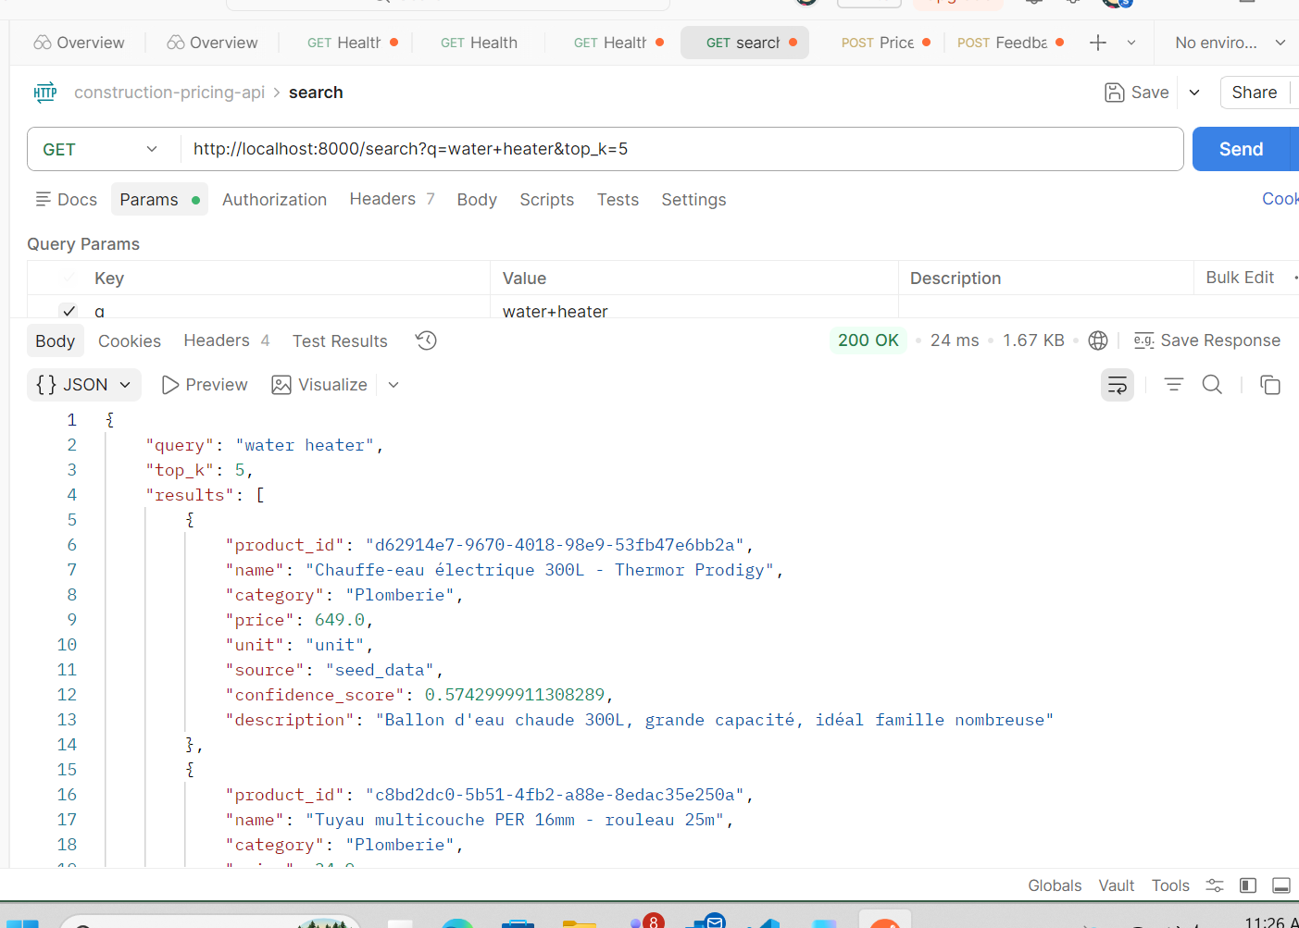
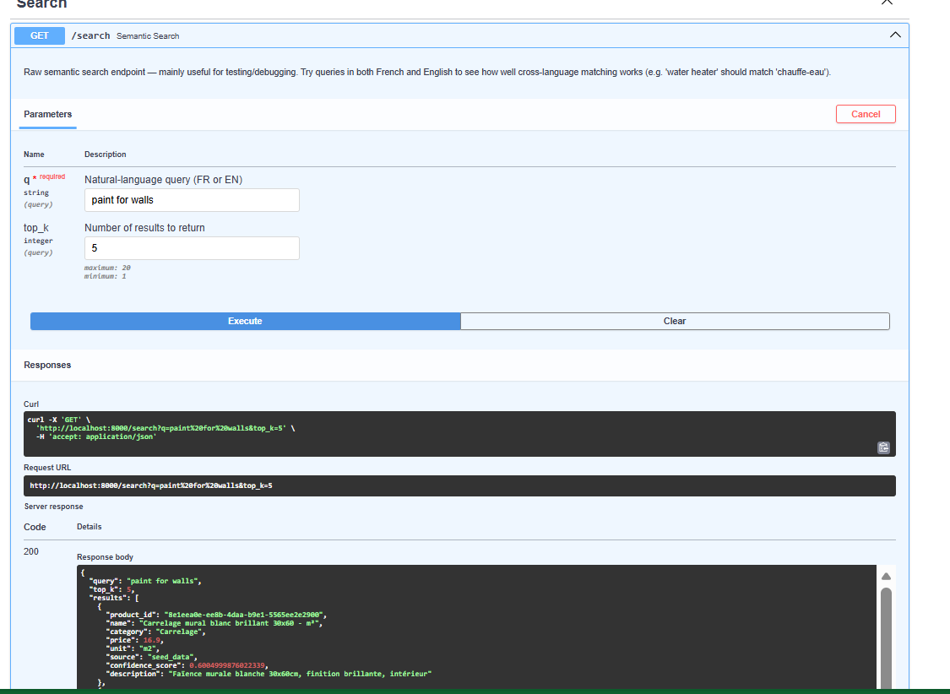

Pricing — POST /price
This is the core feature. You describe a renovation job (e.g., "install a new water heater in a 10 sqm bathroom"), and the engine automatically:
- Figures out what materials and tasks are needed
- Looks up product prices
- Applies any adjustments (labour, complexity, etc.)
- Returns a full cost proposal/estimate
3. Pricing
- Method: POST
- URL: http://localhost:8000/price
- Go to Body → select raw → select JSON from the dropdown
- Paste this:
{
"proposal_id": "test_001",
"metadata": {
"city": "Montpellier",
"region": "Occitanie",
"jobType": "Water Heater Installation"
},
"contractor_margin": 0.15,
"tasks": [
{
"id": 1,
"label": "Removal of the old water heater",
"category": "Plomberie",
"zone": "Bathroom",
"phase": "Prep",
"unit": "unit",
"quantity": 1,
"duration": "2 hours"
},
{
"id": 2,
"label": "Installation of the 200L water heater",
"category": "Plomberie",
"zone": "Bathroom",
"phase": "Install",
"unit": "unit",
"quantity": 1,
"duration": "3 hours"
}
],
"materials": [
{ "label": "200L Water Heater (Cumulus)", "unit": "unit", "quantity": 1, "usedIn": [2] },
{ "label": "Water heater connection kit", "unit": "unit", "quantity": 1, "usedIn": [2] }
]
}
- 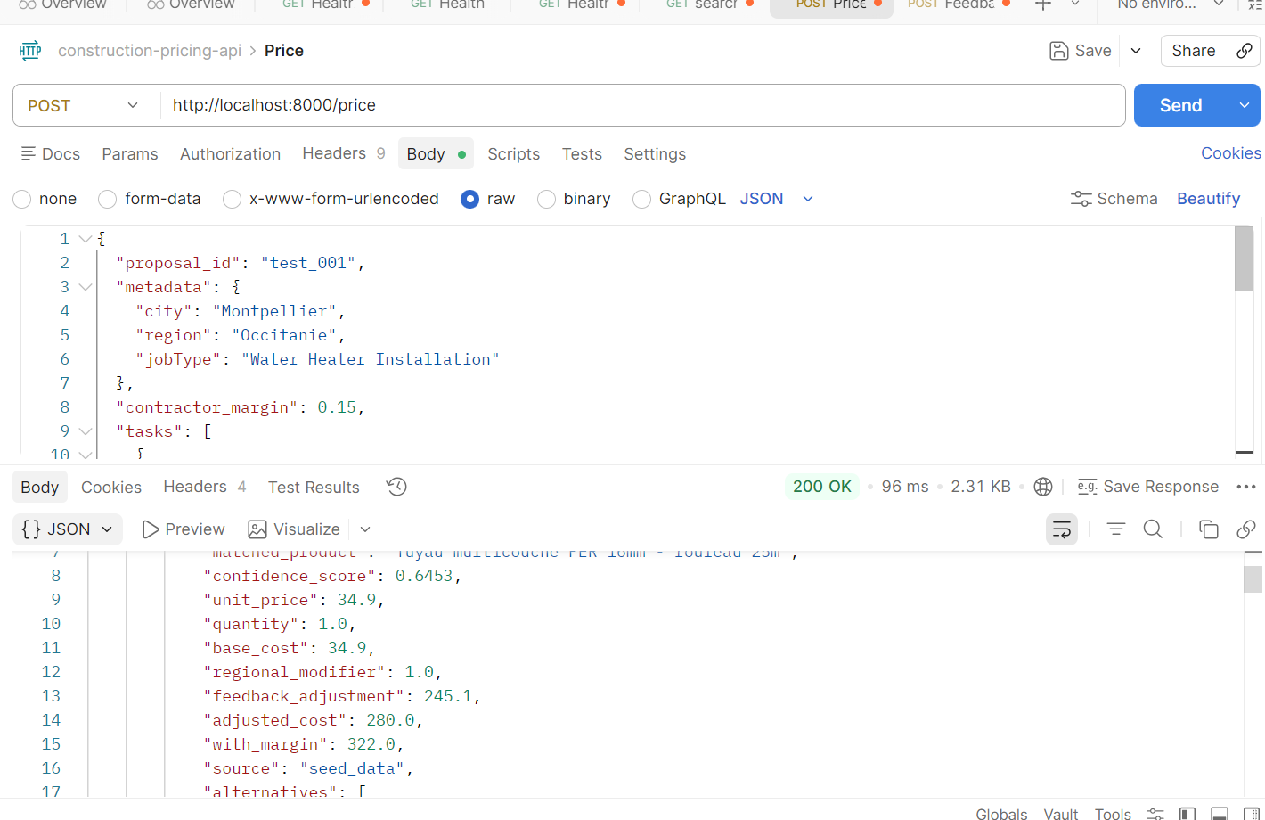
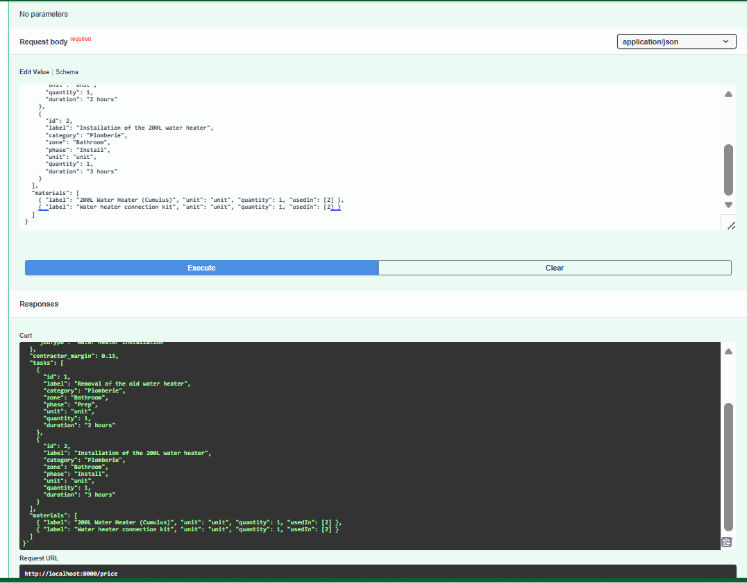

Feedback — POST /feedback
After getting a price proposal, users can rate it or leave comments (e.g., "this quote was too high"). The system collects this feedback to improve future pricing estimates over time — like a thumbs up/down on a recommendation.
4. Feedback
- Method: POST
- URL: http://localhost:8000/feedback
- Body → raw → JSON
- Paste this:
{
"proposal_id": "test_001",
"item_type": "material",
"item_label": "200L Water Heater (Cumulus)",
"feedback_type": "too_high",
"actual_price": 280.00,
"comment": "Found it cheaper locally"
}
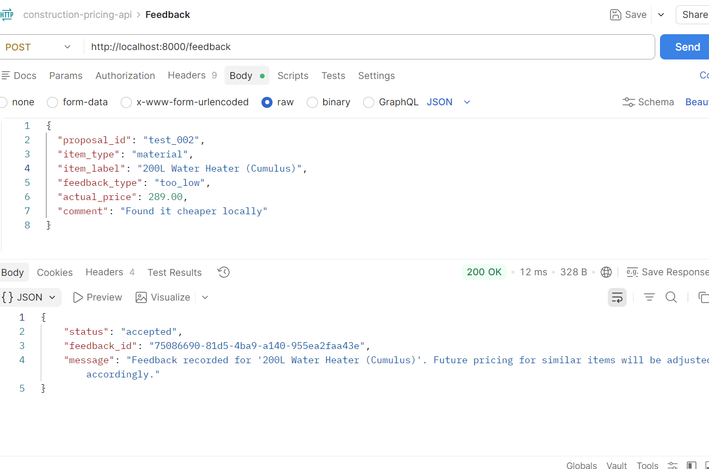

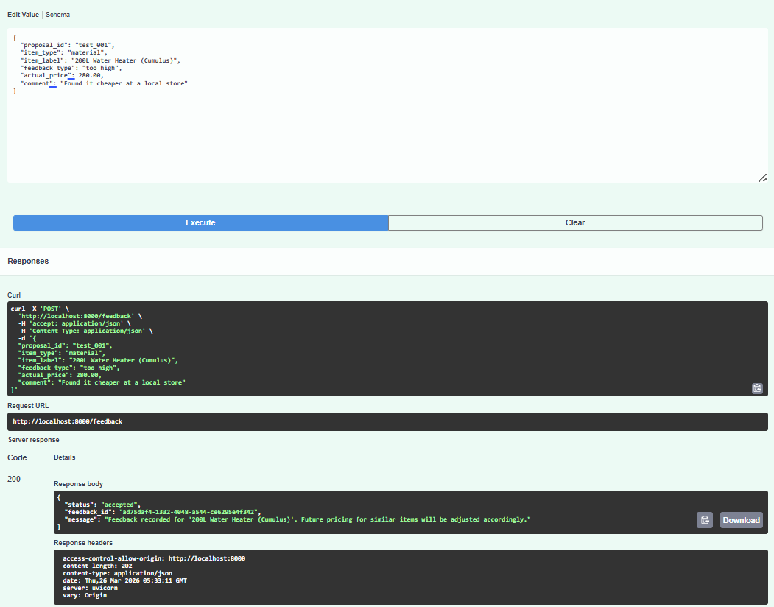
In short: Search helps you find products, Pricing builds you a cost estimate, Feedback lets you rate the estimate, and Health just confirms the whole system is running.

Field | What it means | Allowed values
proposal_id | Which quote you're giving feedback on | Any string (match the one from /price)
item_type | Are you rating a material or a task? | material or task
item_label | Name of the specific item | Free text
feedback_type | Was the price right? | too_low, too_high, or correct
actual_price | What the real price was (optional) | A number like 280.00
comment | Any extra notes (optional) | Free text
The system saves this feedback and uses it to adjust future price estimates for similar items.

