Multimodal AI Assistant with RAG Memory
System Architecture Document

1. Architecture Diagram
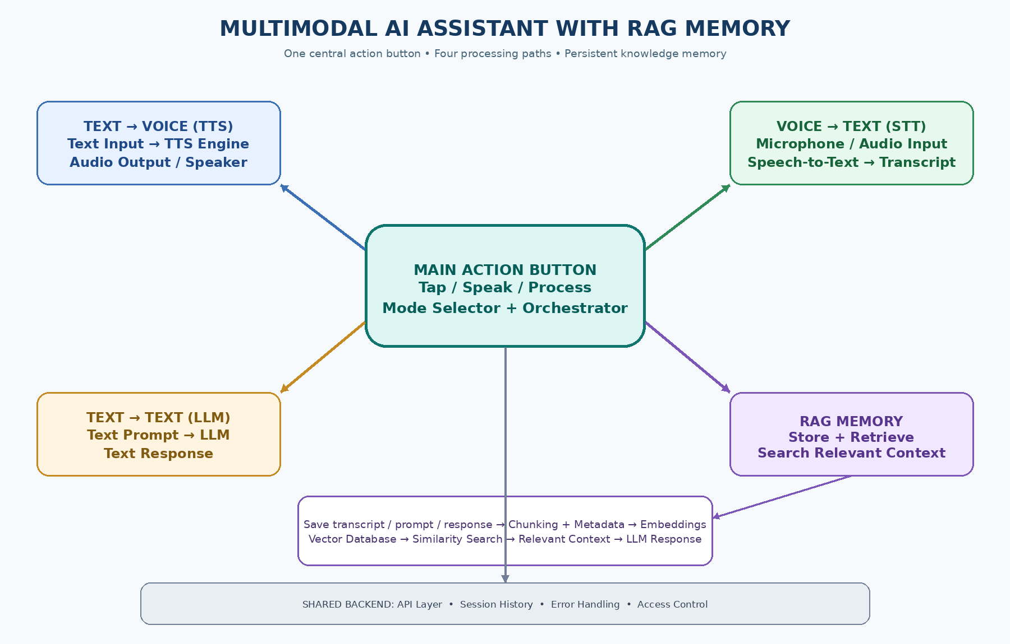

2. Main Components
- Central Action Button and Orchestrator: The user chooses a mode, then the orchestrator sends the request to the correct processing pipeline.
- Text-to-Voice (TTS): Accepts typed text, converts it into speech, and plays the audio through a speaker or headphones.
- Voice-to-Text (STT): Accepts microphone audio, converts speech into text, and returns a transcript.
- Text-to-Text (LLM): Accepts a text prompt, processes it using a language model, and generates a text response.
- RAG Memory (Store and Retrieve): Stores selected prompts, transcripts, and responses. It creates embeddings and saves them in a vector database so relevant information can be retrieved later.
- Shared Backend: Handles API requests, session history, errors, and access control.

3. End-to-End Working
- The user presses the central button and selects or activates Text-to-Voice, Voice-to-Text, or Text-to-Text mode.
- The orchestrator routes the input to the matching service: TTS, STT, or the LLM.
- The system generates audio or text output, depending on the selected mode.
- The user can choose to save the input, transcript, response, or all of them to RAG memory.
- The RAG pipeline splits saved content into chunks, adds metadata, generates embeddings, and stores them in a vector database.
- For a future question, the system searches the vector database for relevant chunks and passes the retrieved context to the LLM.
- The LLM produces a context-aware response, which can also be saved to RAG memory.

4. Recommended Data Flow
User Input → Central Button / Mode Selector → Orchestrator → TTS / STT / LLM → Output → Optional Save to RAG → Chunking and Metadata → Embedding Model → Vector Database. When needed: User Query → Similarity Search → Retrieved Context → LLM → Final Response.

5. Important Implementation Note
The central button is the single entry point, but the application should still show a mode choice or mode indicator. Text-to-Voice needs a text input; Voice-to-Text needs microphone permission; Text-to-Text needs a prompt field. RAG storage should be configurable so private or sensitive content is not saved without the user's consent.

