Assignment 1
- Create table Salespeople
mysql> create table salespeople(
-> Snum int(4),
-> Sname varchar(10),
-> City varchar(10),
-> Comm float(3,2)
-> );
Query OK, 0 rows affected, 2 warnings (0.03 sec)

mysql> insert into salespeople
-> values('1001','Peel','London',0.12);
Query OK, 1 row affected (0.01 sec)

mysql> insert into salespeople
-> values('1002','Serres','San Jose',0.13);
Query OK, 1 row affected (0.01 sec)

mysql> insert into salespeople
-> values('1004','Motika','London',0.11);
Query OK, 1 row affected (0.01 sec)

mysql> insert into salespeople
-> values('1007','Rifkin','Barcelona',0.15);
Query OK, 1 row affected (0.00 sec)

mysql> insert into salespeople
-> values('1003','Axelrod','New York',0.10);
Query OK, 1 row affected (0.00 sec)

mysql> select * from salespeople;

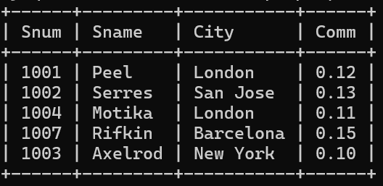

- Create table customers
mysql> create table Customers(
-> Cnum int(4),
-> Cname varchar(10),
-> City varchar(10),
-> Rating int(4),
-> Snum int(4)
-> );
Query OK, 0 rows affected, 3 warnings (0.03 sec)

mysql> insert into Customers
-> values('2001','Hoffman','London',100,'1001');
Query OK, 1 row affected (0.01 sec)

mysql> insert into Customers
-> values('2002','Giovanni','Rome',200,'1003');
Query OK, 1 row affected (0.01 sec)

mysql> insert into Customers
-> values('2003','Liu','San Jose',200,'1002');
Query OK, 1 row affected (0.01 sec)

mysql> insert into Customers
-> values('2004','Grass','Berlin',300,'1002');
Query OK, 1 row affected (0.01 sec)

mysql> insert into Customers
-> values('2006','Clemens','London',100,'1001');
Query OK, 1 row affected (0.00 sec)

mysql> insert into Customers
-> values('2008','Cisneros','San Jose',300,'1007');
Query OK, 1 row affected (0.00 sec)

mysql> insert into Customers
-> values('2007', 'Pereira','Rome',100,'1004');
Query OK, 1 row affected (0.00 sec)

mysql> select * from Customers;

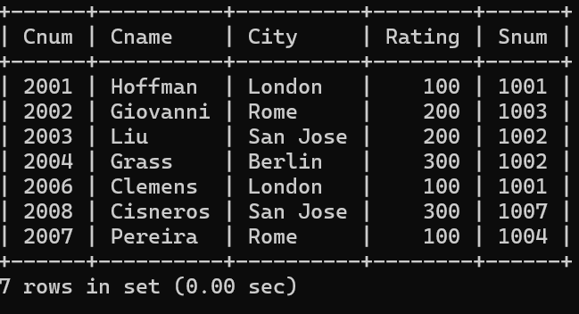

- Create table Orders

mysql> create table orders(
-> Onum int(4),
-> Amt float(7,2),
-> Odate date,
-> Cnum int(4),
-> Snum int(4)
-> );
Query OK, 0 rows affected, 4 warnings (0.02 sec)

mysql> insert into Orders
-> values('3001',18.69,'1990-10-03','2008','1007');
Query OK, 1 row affected (0.01 sec)

mysql> insert into Orders
-> values('3003',767.19,'1990-10-03','2001','1001');
Query OK, 1 row affected (0.01 sec)

mysql> insert into Orders
-> values('3002',1900.10,'1990-10-03','2007','1004');
Query OK, 1 row affected (0.01 sec)

mysql> insert into Orders
-> values('3005',5160.45,'1990-10-03','2003','1002');
Query OK, 1 row affected (0.01 sec)

mysql> insert into Orders
-> values('3006',1098.16,'1990-10-03','2008','1007');
Query OK, 1 row affected (0.00 sec)

mysql> insert into Orders
-> values('3009',1713.23,'1990-10-04','2002','1003');
Query OK, 1 row affected (0.01 sec)

mysql> insert into Orders
-> values('3007',75.75,'1990-10-04','2004','1002');
Query OK, 1 row affected (0.01 sec)

mysql> insert into Orders
-> values('3008',4723.00,'1990-10-05','2006','1001');
Query OK, 1 row affected (0.01 sec)

mysql> insert into Orders
-> values('3010',1309.95,'1990-10-06','2004','1002');
Query OK, 1 row affected (0.01 sec)

mysql> insert into Orders
-> values('3011',9891.88,'1990-10-06','2006','1001');
Query OK, 1 row affected (0.01 sec)

mysql> SELECT * FROM ORDERS;

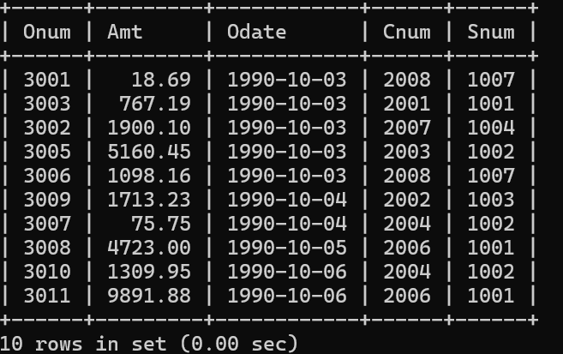

Assignment 2
- Which field of the Customers table is the primary key?
- Cnum
- What is the 4th column of the Customers table?
- Rating
- What is another word for row? For column?
- Row - Field , Column - Tuple
- Why isn’t it possible to see the first five rows of a table?
- SQL tables are unordered sets. Unless you explicitly use ORDER BY, the database engine can return rows in any sequence. That’s why “first five rows” might look random or fragmented.

Assignment 3
- Does ANSI recognize the data type DATE?
- Yes , the ANSI SQL standard recognizes the date data type. A DATE column stores only the calendar date (year, month, day) without time-of-day information.
- Which subdivision of SQL is used to insert values in tables?
- DML (Data Manipulation Language ) .

Assignment 4
- Write a select command that produces the order number, amount, and date for all rows in the Orders table.

mysql> select Onum,Amt,Odate from Orders;
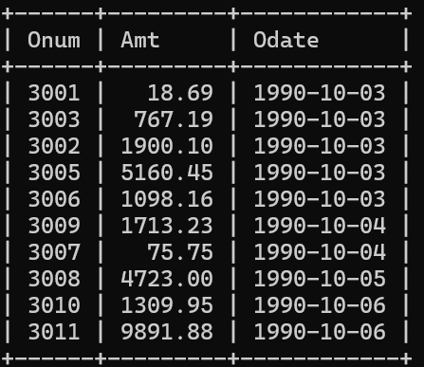

- Write a query that produces all rows from the Customers table for which the salesperson’s number is 1001.
mysql> select * from Customers
-> where Snum = '1001';
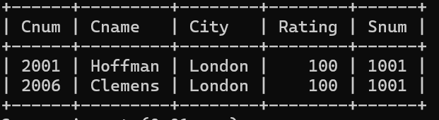

- Write a query that displays the Salespeople table with the columns in the following order: city, sname, snum, comm.
mysql> select City, Sname, Snum, Comm from salespeople;

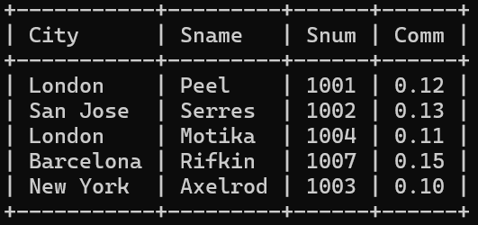

- Write a select command that produces the rating followed by the name of each customer in San Jose.
mysql> select Rating, Cname from Customers
-> where City = 'San Jose';
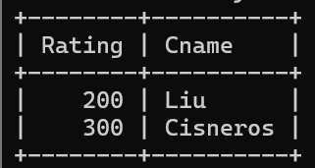

- Write a query that will produce the snum values of all salespeople (suppress the duplicates) with orders in the Orders table.
mysql> select distinct Snum from Orders;
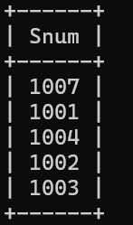

Assignment 5 Relational and Logical Operators.

- Write a query that will give you all orders for more than Rs. 1,000.

mysql> select * from orders
-> where Amt > 1000;
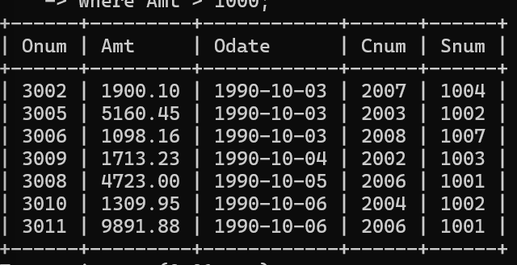

- Write a query that will give you the names and cities of all salespeople in London with a commission above .10.

mysql> select Sname,City from salespeople
-> where city = 'London' and Comm > '.10';

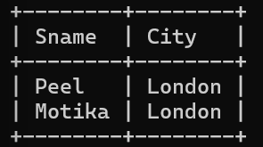

- Write a query on the Customers table whose output will exclude all customers with a rating <= 100, unless they are located in Rome.

mysql> select * from Customers
-> where Rating > 100 OR City = 'Rome';
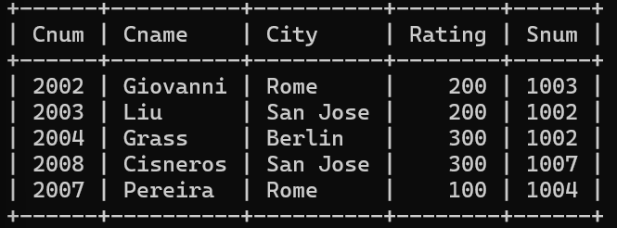

- What will be the output from the following query?
Select * from Orders
where (amt < 1000 OR
NOT (odate = ‘1990-10-03’
AND cnum > 2003));
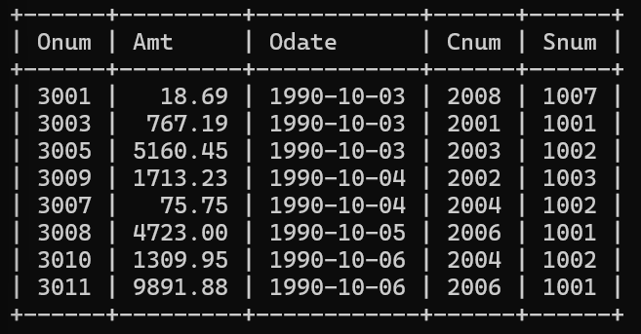
- What will be the output of the following query?
Select * from Orders
where NOT ((odate = ‘1990-10-03’
OR snum >1006) AND amt >= 1500);

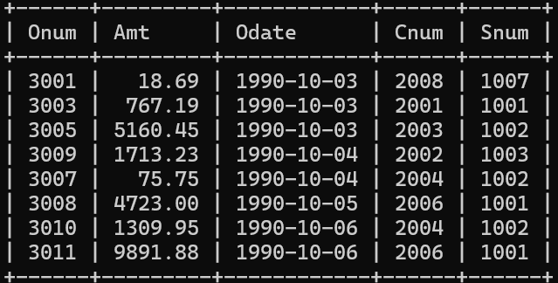

- What is a simpler way to write this query?
Select snum, sname, city, comm From Salespeople
where (comm > .12 OR comm < .14);

mysql> select * from salespeople;

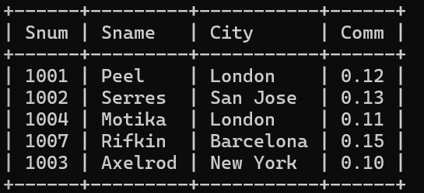

Assignment –6 Using Special Operators in Conditions.

- Write two different queries that would produce all orders taken on October 3rd or 4th, 1990.

- mysql> select * from orders
- where Odate ='1990-10-03' OR Odate = '1990-10-04';
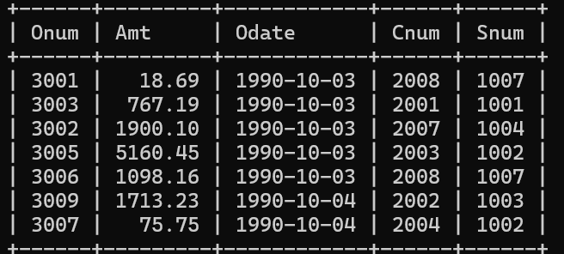

mysql> select * from orders
-> where Odate between '1990-10-03' and '1990-10-04';
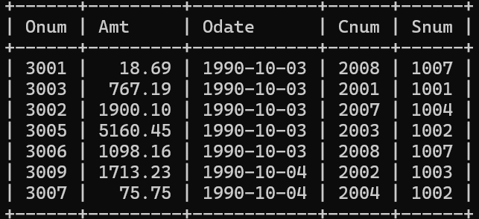

- Write a query that selects all of the customers serviced by Peel or Motika. (Hint: the snum field relates the two tables to one another).
- mysql> select * from Customers
-> where Snum = '1001' OR Snum = '1004';

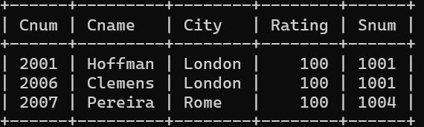

- Write a query that will produce all the customers whose names begin with a letter from ‘A’ to ‘G’.
- mysql> select Cname from Customers
-> where Cname between 'A%' and 'H%';
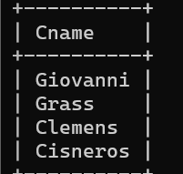

- Write a query that selects all customers whose names begin with the letter ‘C’.
- select * from Customers
-> where Cname like 'C%';
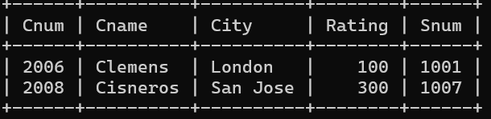

- Write a query that selects all orders except those with zeroes or NULLs in the amt field.
- mysql> select * from orders
-> where Amt != 00.00;

