Cybersecurity Internship Assignment Report
Name: Shravani Laxman Salaskar
Issued by: Digisuraksha Parhari Foundation
Submission Deadline: 28th April 2025
1. TryHackMe Room: Hello World
Link: Hello World
🎯 Learning Objective
The “hello world” lab is for the beginner to understand the layout and basic navigation of TryHackme interface. To learn how to start and manage virtual machine.
🛠️Key Tools/Commands Used
Web Browser: Used to access the TryHackMe platform.
Navigation tools: to explore the dashbox
🧠 Concepts Learned
  - Launching & using Virtual machine(VM)
  - Understanding the purpose and structure of TryHackMe.
  - Introduction of ethical hacking, and cybersecurity
  - To join rooms, and complete the tasks step by step and then submit it
🔍 Walkthrough / How You Solved It
      - Login to the TryHackme website with my email.
      - Visit the page through the link from pdf.
      - Read all the instruction provided on the page.
      - Follow the instruction and solve the task, for doubt used the hint provided there.
      - Click on submit button once the task is completed.

- 💡 Reflections or Notes
“Hello World” is an excellent lab for a beginner to get familiar to the TryHackMe site. It builds comfort with this interface. Interactive environment fosters curiosity and encourages further exploration of cybersecurity topics.
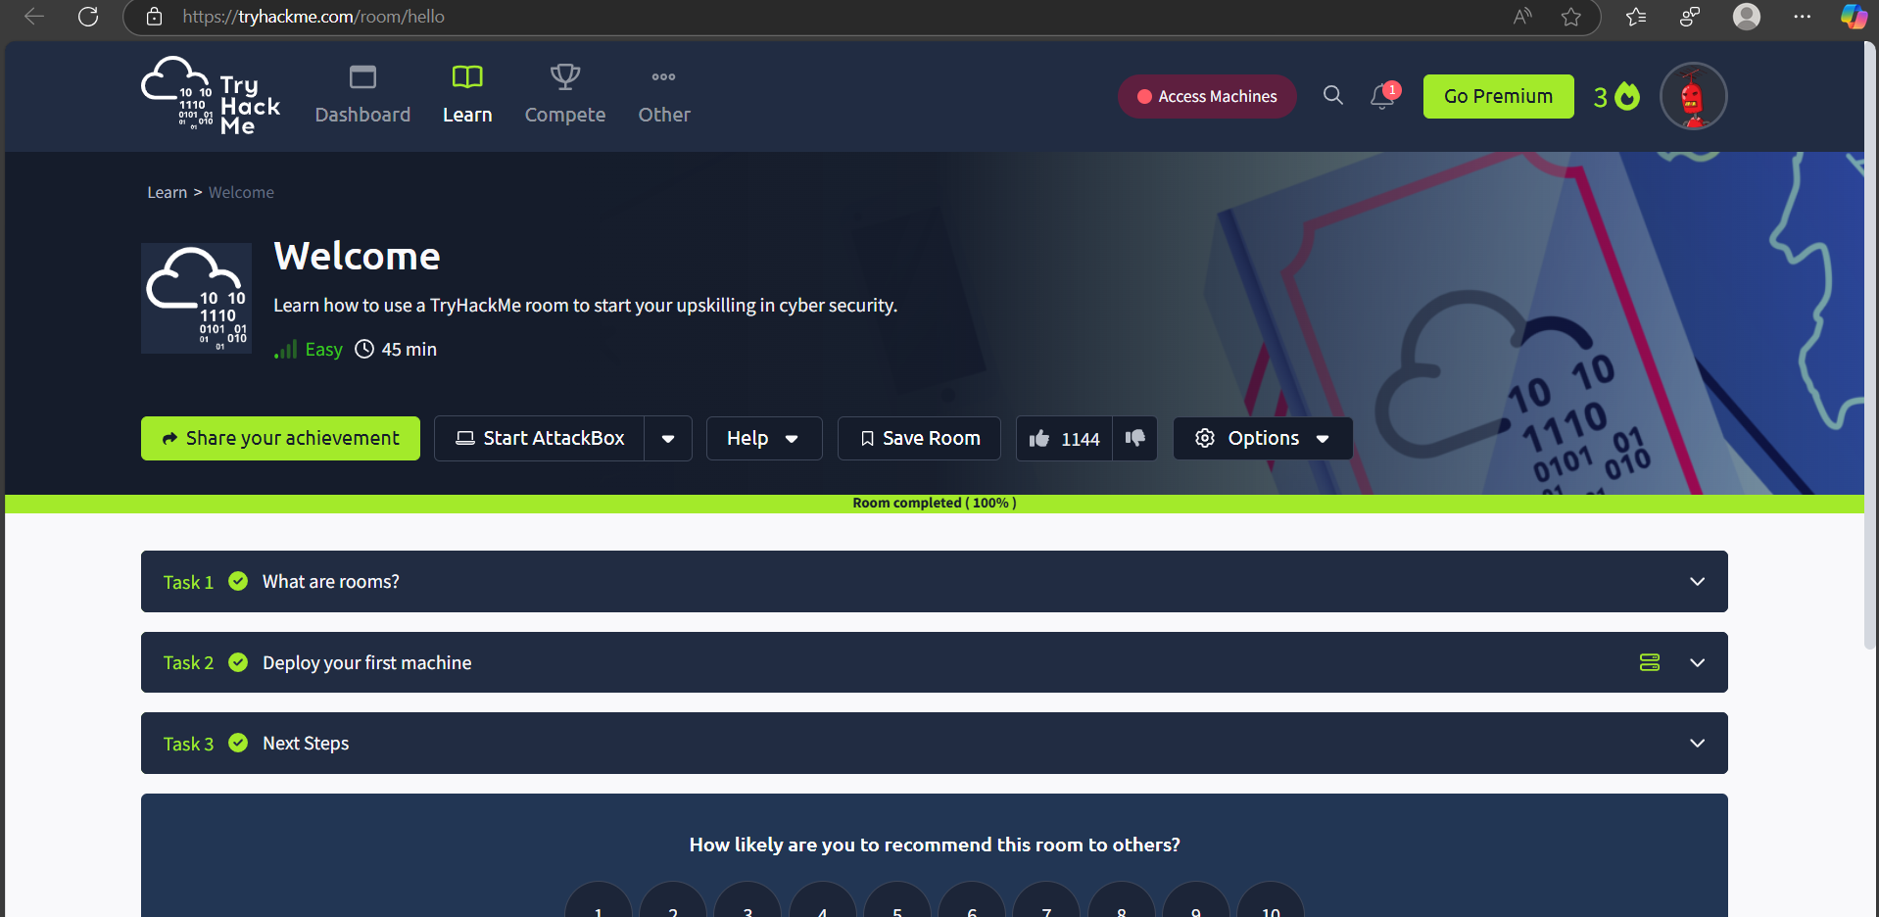

- TryHackMe Room: How to Use TryHackMe
Link: How to Use TryHackMe
🎯 Learning Objective
It helps the user to know the objectives, structure, features and navigation tools in tryhackme. It explains in details with steps that how to start it, to complete tasks in it and submit it.
🛠️Key Tools/Commands Used
TryHackMe interface
Learned how to access and interact with virtual machines (VMs) and tasks.
Understanding the basics in TryHackme
🧠 Concepts Learned
  - Spliting Screen feature
  - Reading hints if in doubt
  - Starting and terminating attackbox and VM.
  - Understanding room types such as walkthroughs, challenges, and tutorials.
🔍 Walkthrough / How You Solved It

  - Login into TryHackMe and navigated to the "How to Use TryHackMe" room via the provided link (TryHackMe How to Use TryHackMe).
  - Here we learn, practice, grow, & get known to many new things.
  - Reviewed available learning paths and room categories.

- 💡 Reflections or Notes
“How to use tryhackme” gives the understanding & overview of tryhackme use. It helps to know what to do and what to not ie. Does & Doesn’t init. Completing the tasks in this lab help to get better familiar to tryhackme session and build interest. The structured guidance ensures users can confidently explore more advanced rooms after completing this one.

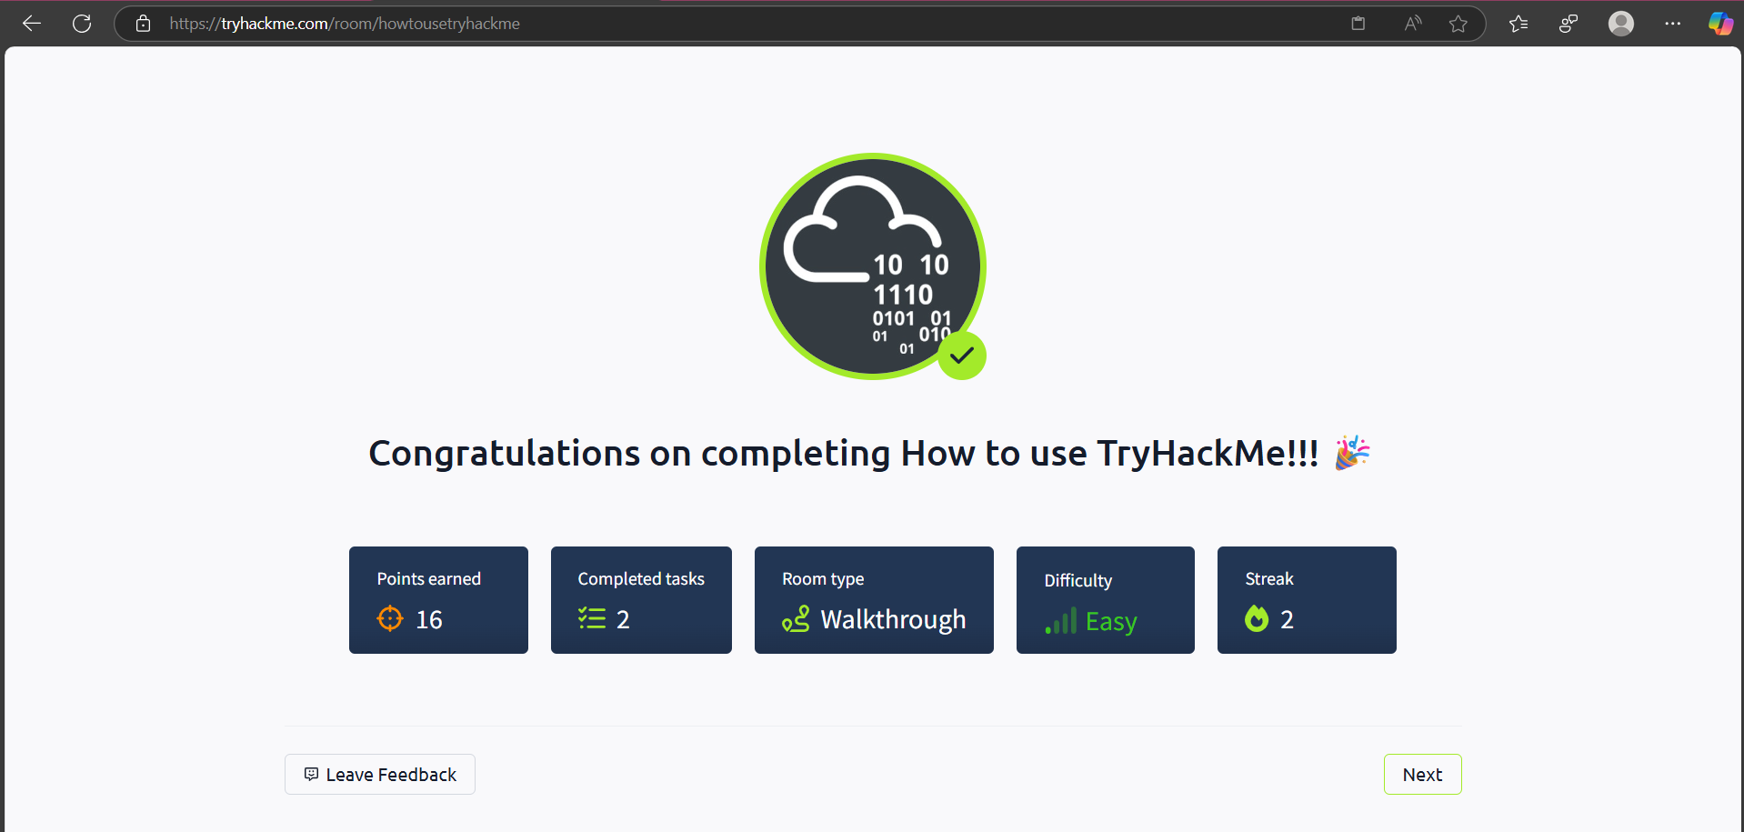

- TryHackMe Room: Getting started
Link: Getting Started
🎯 Learning Objective
The “Getting Started” lab is to introduce users to the platform's functionality and guide them through the initial steps required to begin their cybersecurity.
🛠️Key Tools/Commands Used
Web Browser: Used to access the TryHackMe platform.
Navigation tools: to explore the dashboard
Terminal/Command Line
Open VPN and to explore it

🧠 Concepts Learned
  - Launching & using Virtual machine(VM)
  - To join rooms, and complete the tasks step by step and then submit it
  - Testing connectivity with ping
  - Understanding the importance of secure connections via VPN.
  - To get hidden information in website

🔍 Walkthrough / How You Solved It
      - Login to the TryHackme website with email.
      - Visit the page through the link from pdf.
      - Read all the instruction provided on the page.
      - Using the view page source option to view the website and find the hidden source.
      - Follow the instruction and solve the task, for doubt used the hint provided there.
      - Click on submit button once the task is completed.

- 💡 Reflections or Notes
“Getting started” is good tool to get familiar about the hidden source knowledge in the website.
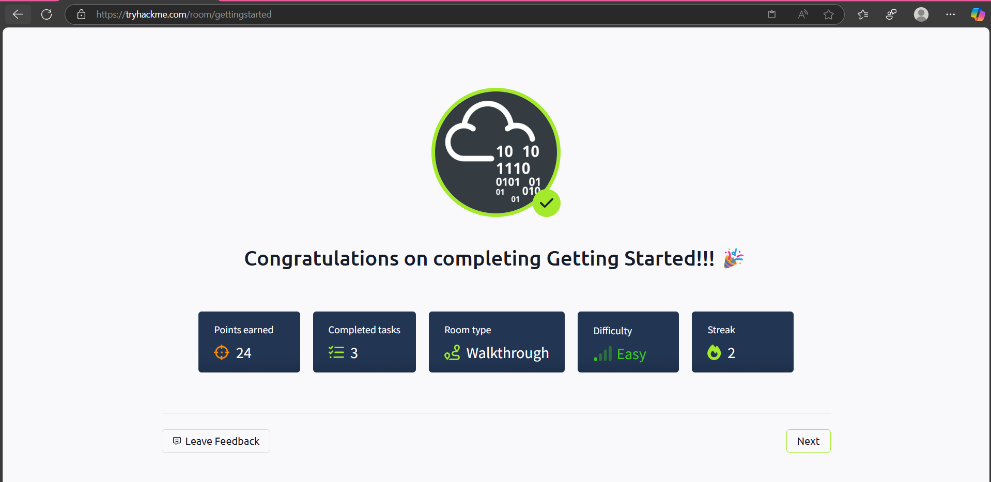
- TryHackMe Room: Welcome
Link: Welcome
🎯 Learning Objective
To understand the concept of introductory is in welcome room. And it gives brief information about cybersecurity. Aims to provide a high-level overview of TryHackme.
5. TryHackMe Room: TryHackMe Tutorial
Link: TryHackMe Tutorial
🎯 Learning Objective
The “Tutorial” lab aims to guide users through the fundamental features of TryHackMe. To hack a virtual machine. Navigate techniques, interactive elements for effectively platform cybersecurity.
🛠️Key Tools/Commands Used
Understanding the concept of question answer.
Web Browser: Used to access the TryHackMe platform.
Navigation tools: to explore the dashboard.
Terminal/Command Line
🧠 Concepts Learned
  - Launching & using Virtual machine(VM)
  - To join rooms, and complete the tasks step by step and then submit it
  - Using attack boxes to engage in practical cybersecurity exercises
  - Efficiently navigating through rooms, tasks, and learning paths.
  - Deploying and interacting with virtual machines within the room.

🔍 Walkthrough / How You Solved It
      - Login to the TryHackme website with email.
      - Visit the page through the link from pdf.
      - Read all the instruction provided on the page.
      - Using the view page source option to view the website and find the hidden source.
      - Follow the instruction and solve the task, for doubt used the hint provided there.
      - Deployed provided machines and utilized attack boxes to solve practical challenges.
      - Click on submit button once the task is completed.

- 💡 Reflections or Notes
The “Tryhackme tutorial” room is essential for new users, offering a structured introduction.
It improves the hands-on learning interactive tasks and VM.
User get experience in working with tryhackme.
Understanding tutorial content is crucial for effectively utilizing TryHackme’s resource and process.

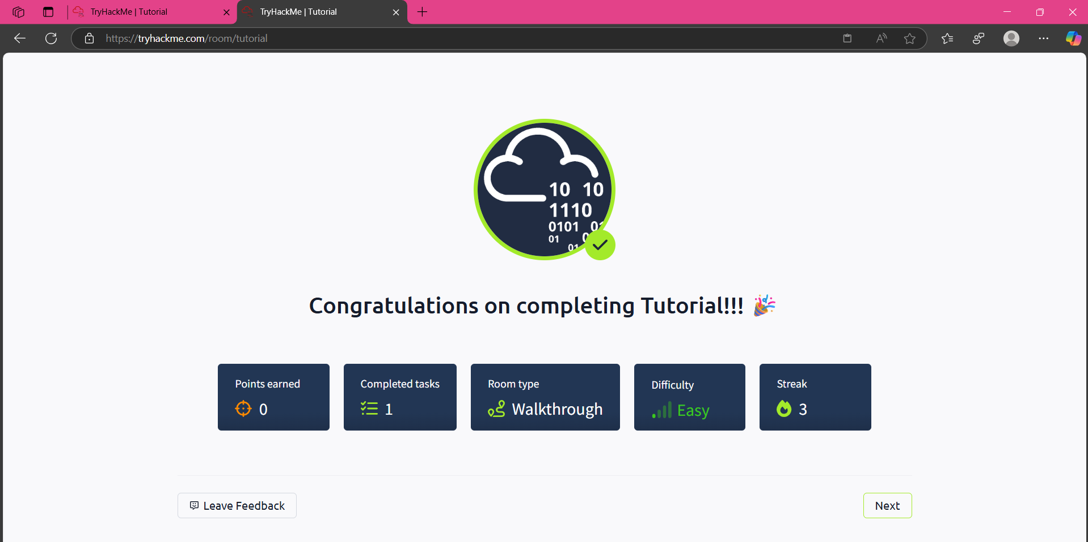
- TryHackMe Room: OpenVPN
Link: OpenVPN
🎯 Learning Objective
The “OpenVPN” lab is to introduce users A guide to connecting to network using OpenVPN. It covers the necessary configuration files,establishing a VPN connection in working correctly.
🛠️Key Tools/Commands Used
Web Browser: Used to access the TryHackMe platform.
Software used to establish a VPN connection.
Navigation tools: to explore the dashboard
Terminal/Command Line
🧠 Concepts Learned
  - Launching & using Virtual machine(VM)
  - To join rooms, and complete the tasks step by step and then submit it
  - Brute force attack concept
  - Checking the assigned IP address and verifying VPN
  - Encure that the VPN is active
  - Understanding the importance of secure connections via VPN.
  - To get hidden information in website

🔍 Walkthrough / How You Solved It
      - Login to the TryHackme website with email.
      - Visit the page through the link from pdf.
      - Read all the instruction provided on the page.
      - Installing the OpenVPN clients on local machine(apt-get install openvpn on linux,MacOs, windows)
      - Used the command line to connect to TryHackMe's network using the downloaded configuration file (sudo openvpn <your_username>.ovpn).
      - Follow the instruction and solve the task, for doubt used the hint provided there.
      - Click on submit button once the task is completed.
- 💡 Reflections or Notes
“OpenVPN” is crucial for ensuring secure access to Tryhackme labs. It provides VPN connection, which is skill in cybersecurity.
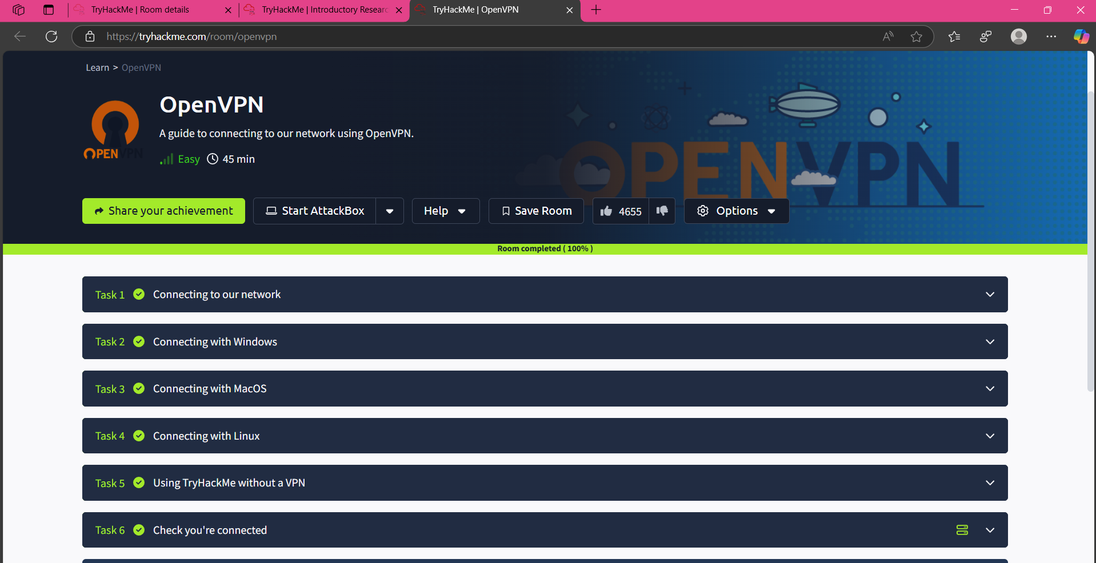

- NameTryhackMe Room: Learning TryHackMe
Link: Begineer Path Introduction
🎯 Learning Objective
The “Beginner Path Introduction” lab is a beginner learning path offered on this platform. It helps to Learn how to use a TryHackMe room to start your upskilling in cyber security.

🛠️Key Tools/Commands Used
Web Browser: Used to access the TryHackMe platform.
Navigation tools: to explore the dashboard
Terminal/Command Line
Open VPN and to explore it

🧠 Concepts Learned
  - Web application security: to attack web, understand how it works.
  - Network security: scanning and identifying what is on network.
  - Learning Roadmap: Offensive pentesting, presecurity, cyber defence.
🔍 Walkthrough / How You Solved It
      - Login to the TryHackme website with email.
      - Follow the instruction and solve the task, for doubt used the hint provided there.
      - Click on View site and after reading the instruction and rules the tasks are completed.
      - Click on submit button once the task is completed.

- 💡 Reflections or Notes
“Beginner Path introduction” gives you Complete Beginner learning path will walk you through the networking concepts and give you enough knowledge to get started in your cyber security journey. The skills you acquire from the learning paths will prepare you for a career as an ethical hacker, penetration tester or cyber security analyst.
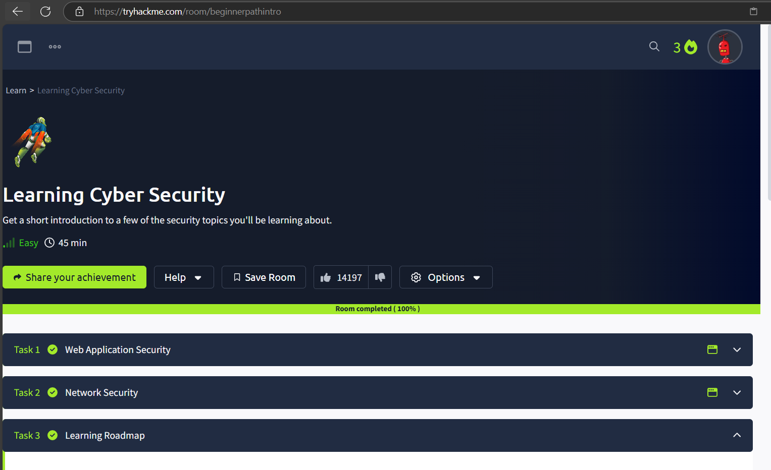

- Tryhackme room: Starting out in Cyber Sec
Link: Starting out in Cyber Security
🎯 Learning Objective
The “Starting out in Cyber Security” lab is to introduce users about the different career paths in Cyber Security and how TryHackMe can help.
🛠️Key Tools/Commands Used
Web Browser: Used to access the TryHackMe platform.

Reviewing the responsibilities and requirements of different roles.
Navigation tools: to explore the dashboard
Terminal/Command Line
Open VPN and to explore it

🧠 Concepts Learned
  - Identifying the responsibilities and tasks associated with each role.
  - Understanding the importance of continuous learning and skill development .
  - Act of Offensive Security, Defensive Security.
🔍 Walkthrough / How You Solved It
      - Login to the TryHackme website with email.
      - Visit the page through the link from pdf.
      - Read all the instruction provided on the page.
      - Recognized the essential skills needed for each role, including technical knowledge, analytical abilities, and soft skills.
      - Using the view page source option to view the website and find the hidden source.
      - Follow the instruction and solve the task, for doubt used the hint provided there.
      - Click on submit button once the task is completed.

- 💡 Reflections or Notes
“Starting out in Cyber Security” this room is invaluable for individuals starting their journey in cybersecurity, offering a clear overview of the field. It helps beginners understand the different roles available, the skills required, and how to structure their learning. Understanding this information is crucial for making informed decisions and planning a successful career in cybersecurity.

9.TryHackme Room: Introduction to Research
Link: Introduction to Research
🎯 Learning Objective
The “Introduction to Research” lab aims to equip users with fundamental research skills essential for cybersecurity. It covers effective searching, understanding credible sources, and utilizing search engines and databases to gather relevant information for security. A brief introduction to research skills for pentesting.
🛠️Key Tools/Commands Used
Web Browser: Used to access the TryHackMe platform.
Online Databases (e.g., NIST, CVE): Explored to access vulnerability and security information.
Documentation and Whitepapers:
Search Engines like google etc.
Navigation tools: to explore the dashboard
Terminal/Command Line
🧠 Concepts Learned
  - Learning how to refine search results to find accurate and relevant information.
  - Understanding how to formulate effective search queries using relevant keywords
  - Exploring and using online databases such as NIST's National Vulnerability Database (NVD) and the Common Vulnerabilities and Exposures (CVE) database
  - Learning basic research methodologies for cybersecurity tasks, such as threat analysis, vulnerability assessment, and incident response.

🔍 Walkthrough / How You Solved It
      - Login to the TryHackme website with email.
      - Visit the page through the link from pdf.
      - Read all the instruction provided on the page.
      - Using the view page source option to view the website and find the hidden source.
      - Follow the instruction and solve the task, for doubt used the hint provided there.
      - Click on submit button once the task is completed.
- 💡 Reflections or Notes
“Indroductory Research” is good tool that highlights the importance of effective searching, evaluating sources, and utilizing databases to gather reliable information .

