Java

Java is Platform independent & Object Oriented language

Platform Independent: You can run your code on any platform without recompiling

Object Oriented: You can create applications that will have real world entities which are objects.

Object will have properties & behaviours

Ex:

Customer

properties: id, name, dob, gender, ....  
 behaviours: withdraw(), deposit(), ..

Basic Building block of OOPs

1. class: Blueprint of an object
2. object: Instance of a class

Some of the java commands:

1. javac
2. java
3. javap
4. jar

HelloApp.java

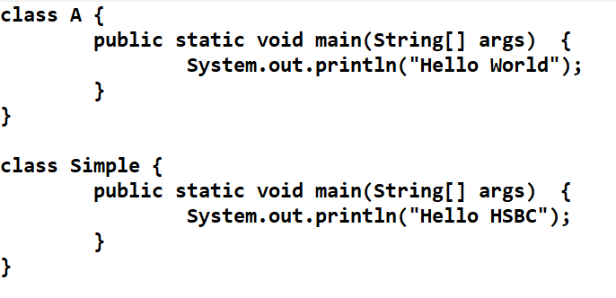

Output:

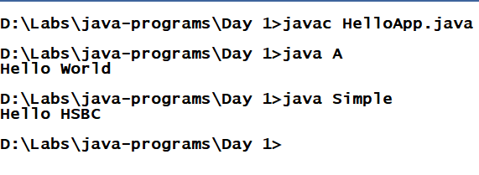

Fundamentals of Java

1. Datatypes
2. Operators
3. Conditions
4. Arrays
5. Loops
6. Keywords
7. Class & Objects

Datatypes:

Describes a variable can store what kind of value, there are two types

1. primitive type
2. derived type (user-defined type)

Primitive Datatypes:

|  |  |  |  |
| --- | --- | --- | --- |
| Integers | Floats | Boolean | Character |
| byte (1)  short (2)  int (4)  long (8) | float (4)  double (8) | boolean (1) | char (2) |

Derived Datatypes:

class, interface, array

Operators:

=, +, -, *, /, %, ++, --, <, >,<=, >=, !=, ==

TestDatatypes.java

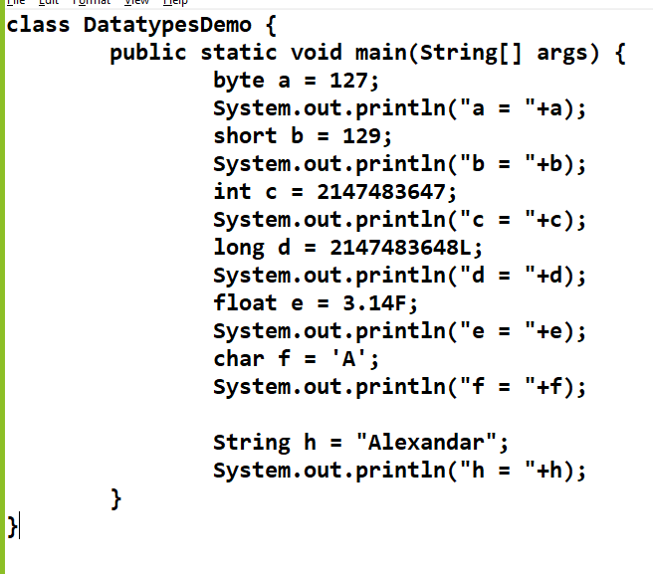

Output:

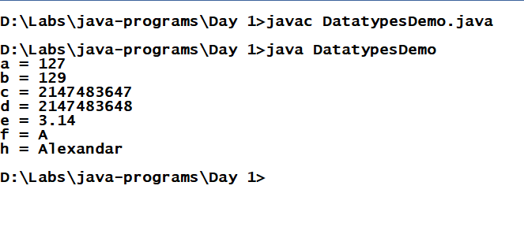

OperatorsDemo.java

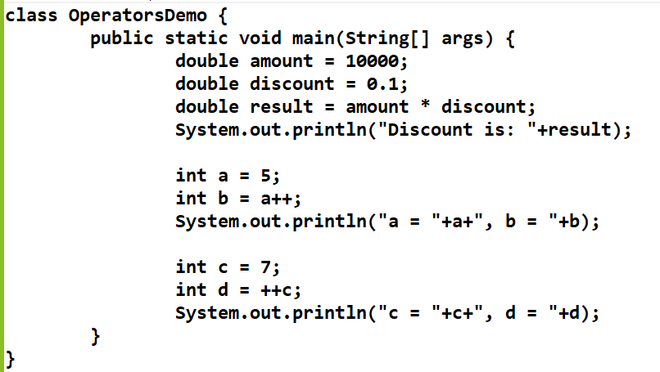

Output

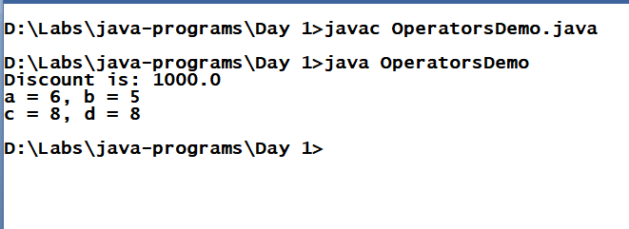

Conditional Statements

1. If
2. If Else
3. If Else If.... Else
4. Switch

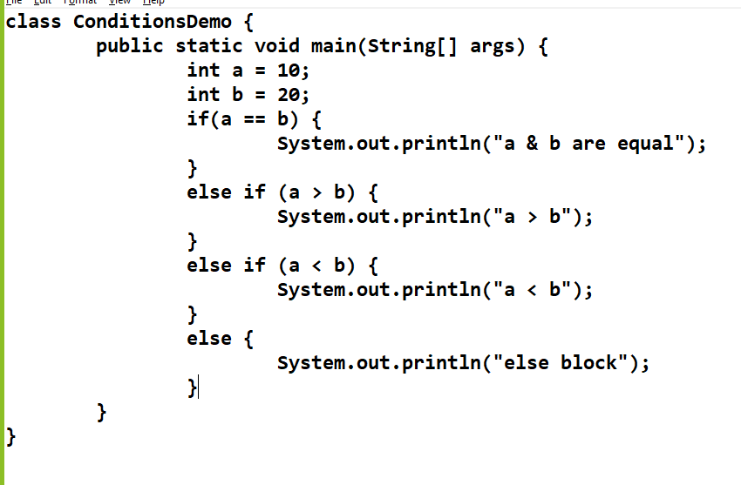

Switch

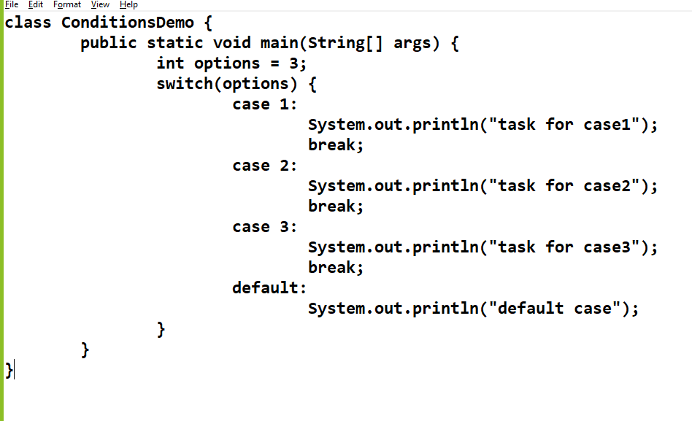

Note: Switch can be used only for numbers, strings, char & enum

Loops:

1. For
2. While
3. Do-While

ForDemo

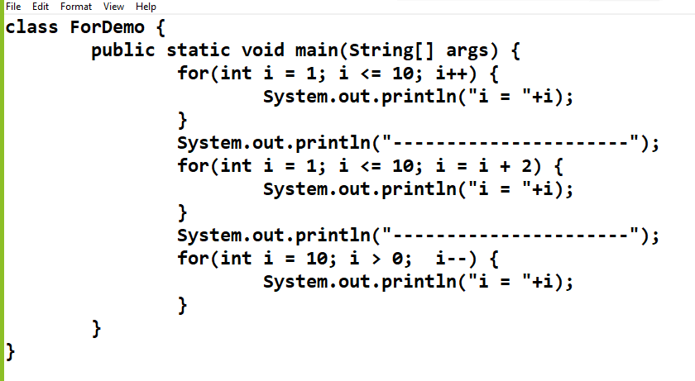

While & Do While Demo

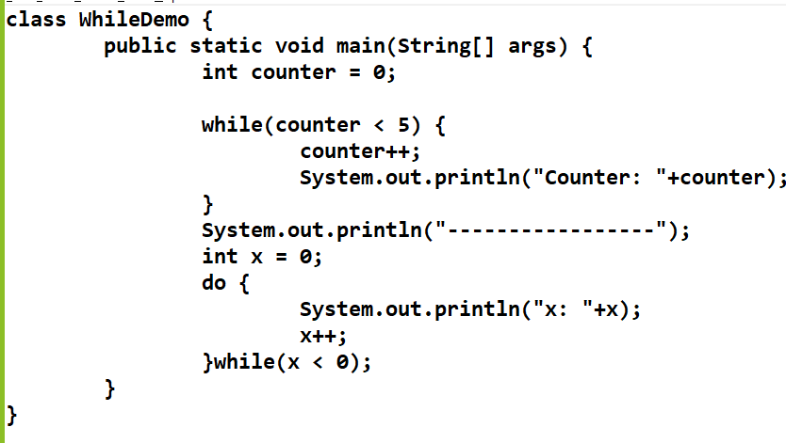

main(String[] args);

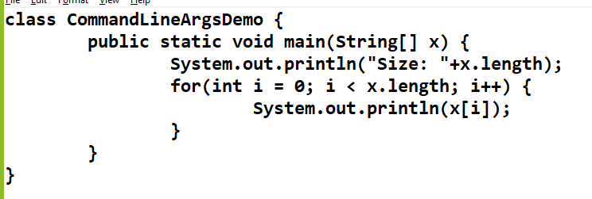

Command line argument is string type, you can convert to int or double or char or boolean using some inbuilt classes

Integer.parseInt(“10”); returns int

Double.parseDouble(“10.25”); return double

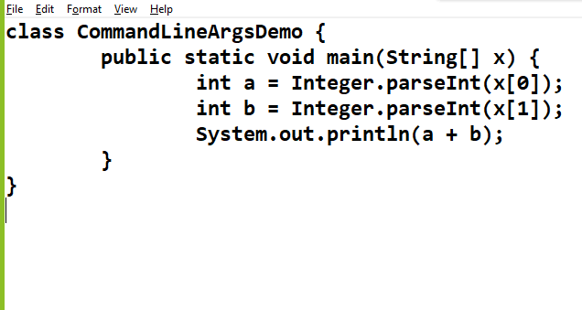

Arrays:

It stores multiple items of same types

Type[] variable = new Type[size];

Type[] variable = {value, value, .....};

ArraysDemo.java

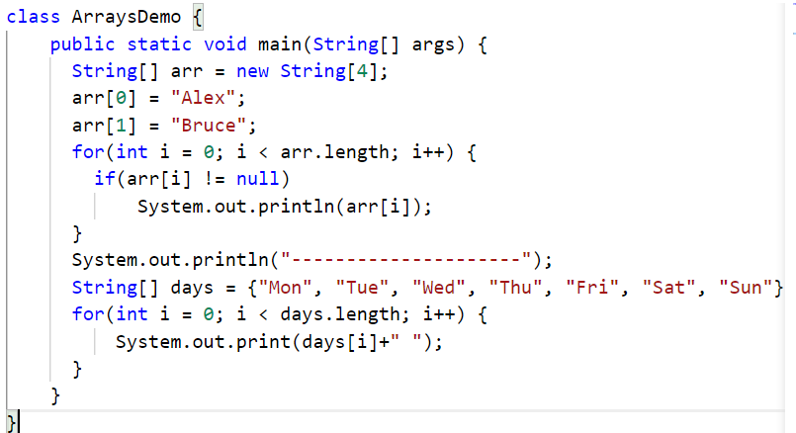

for each loop:

This is introduced in Java 5, to simplify writing the traditional for loop, it doesn’t need any variable initialization, comparison, increment statement, index access

Syntax:

for(Type t : collection) { ... }

collection could be an array or any collection

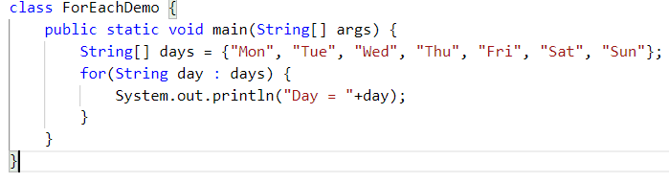

Output:

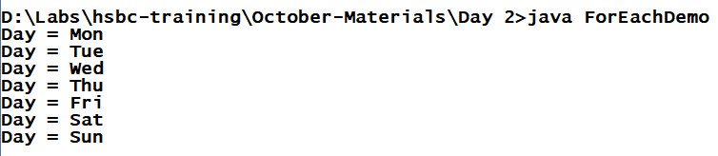

Enhanced for loop:

* It iterates only in forward direction
* It iterates all the items, if you want to iterate only few items you must write extra logics

classes & objects

Class: It is a template of an object

Object: It is a real world entity or it is an instance of a class

Classname t = new Classname();

Inside class you can have

1. variables
2. methods
3. constructors

Variables are fields to store state of an object

Methods will have logics

What are constructors?

* Constructors are called when object is created
* Their name will be same as class name
* They will not have return types
* By default compile creates a constructor if class doesn’t have any constructor, which is called as default constructor
* If you provide a constructor in a class then compiler retains what is provided, it doesn’t add any default constructor

javap command can be used to check the informations of the class file

User.java

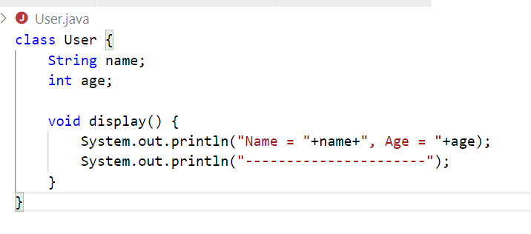

UserDemo.java

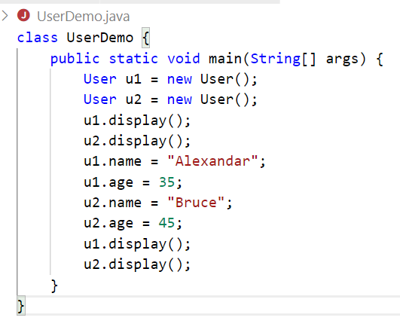

Output:

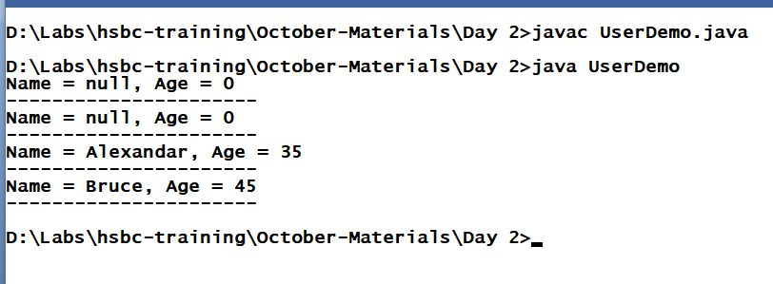

Constructor Overloading: You can have constructors with different parameters in the class, it initializes the variables at the time of object creation

User.java

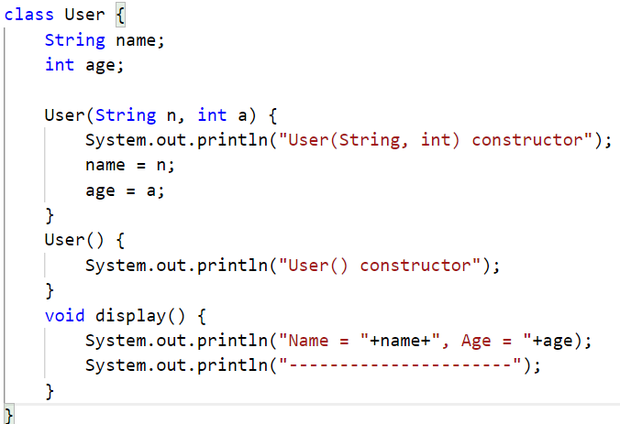

UserDemo.java

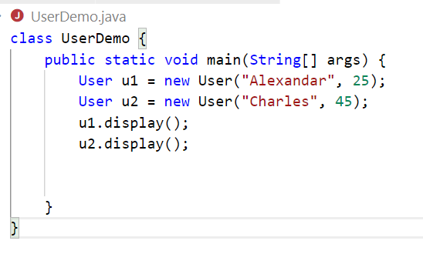

Output:

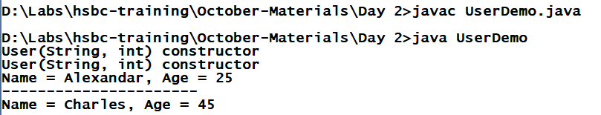

You can also initialize only few members

User.java

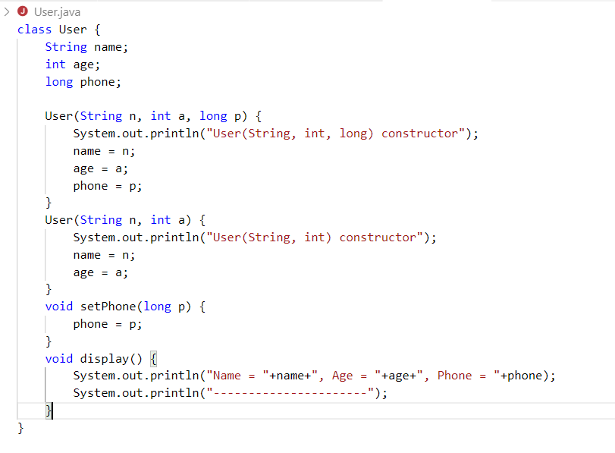

UserDemo.java

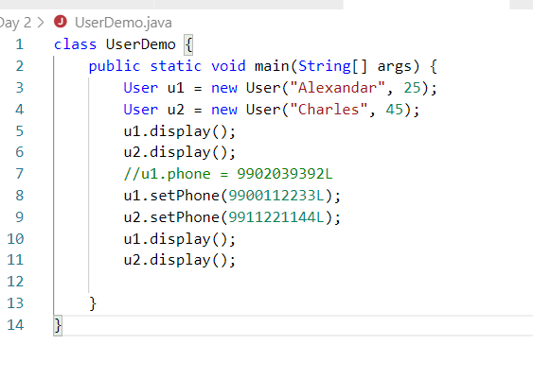

Output:

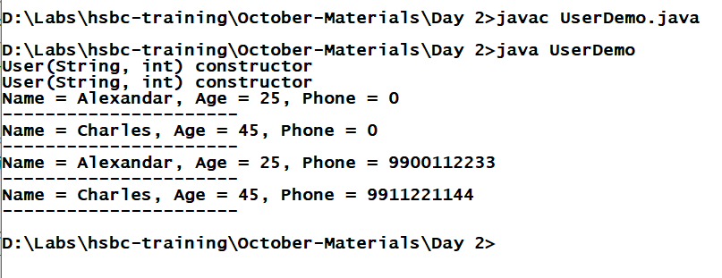

Assignment:

Create one savings account class and provide multiple constructors,

* Fields: accountNo, name, balance, ifsc, state, city, pin
* Methods: deposit(), withdraw(), display()
* Constructors:
  + Initialize accountNo, name, state, city & default value for ifsc=”HSBC001”, balance 0.0
  + Initialize accountNo, name, balance, state, city & default value for ifsc=HSBC001
* Create 5 objects for different constructors & call withdraw(), deposit() & display()

Static Members:

You can make variables & methods static

* static variables: common data for all the objects
* static methods: common logics for all the objects
* static members are loaded at the time of class loading
* static members can be accessed through class name or reference variable

Note: Accessing through reference variable is not recommended, compiler converts reference variable to its class-name

this: It is a reference to the current object, you will use this to differentiate between instance variable & local variable when they share same name,

Another use of `this` keyword is call the constructor from another constructor

Pass by reference

Identifier.java

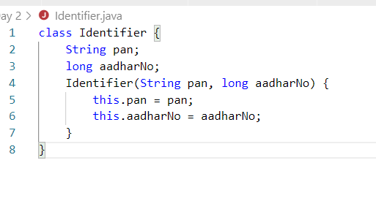

User.java

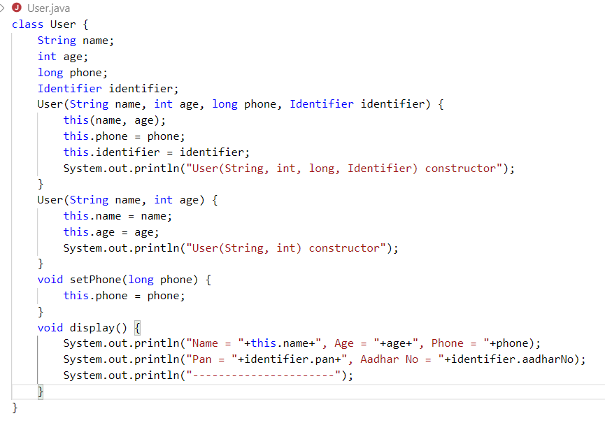

UserDemo.java

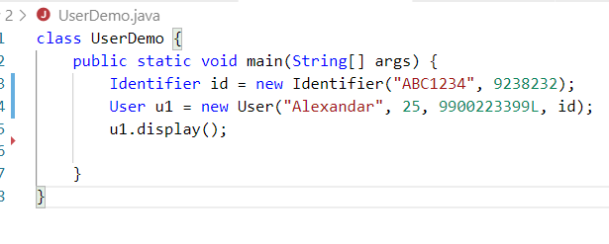

Assignment:

1. Create an array of type Employee and store employee objects into the array, display only those employees who has salary > 50000 through for each loop.

Note: Atleast have 5 employee objects

1. Modify the Employee class to have Address(state, city, pin) variable with a Has-a relationship, display the employees with address

Note: You must have a constructor to take Address also as a parameter

OOPs concepts

1. Inheritance
2. Polymorphism
3. Encapsulation
4. Abstraction

Inheritance:

Process acquiring members from parent class to child class.

* extends keyword is used
* super class *default constructor* is automatically called from *subclass constructor*
* super() calls default constructor, super(args) calls argument constructor

Inheritance forms a is-a relationship

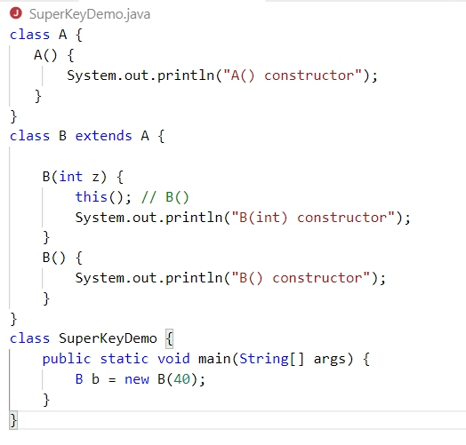

Output:

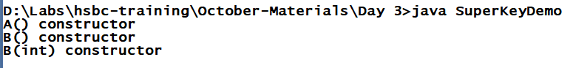

Account.java

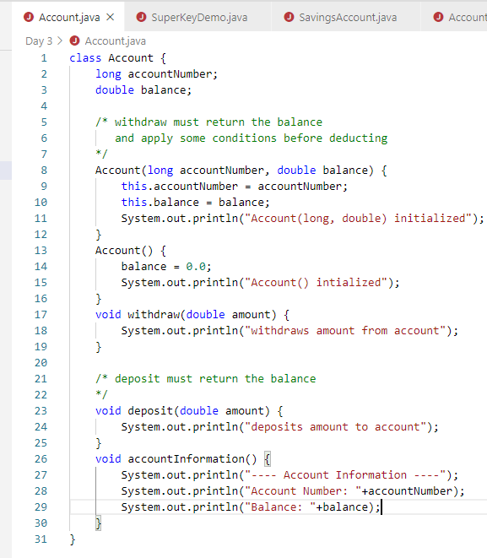

SavingsAccount.java

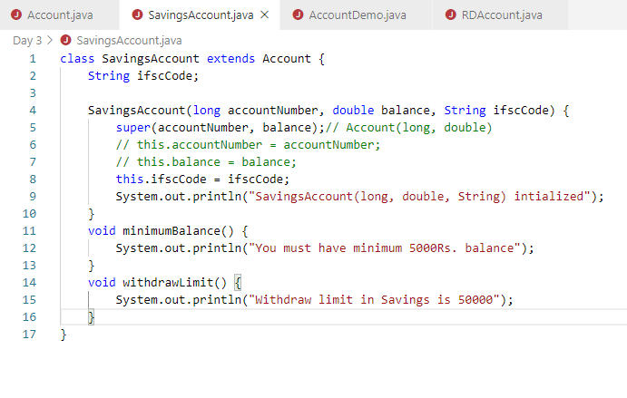

RDAccount.java

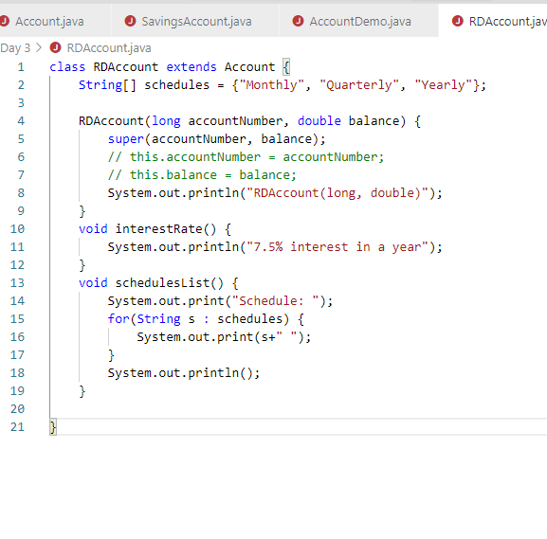

AccountDemo.java

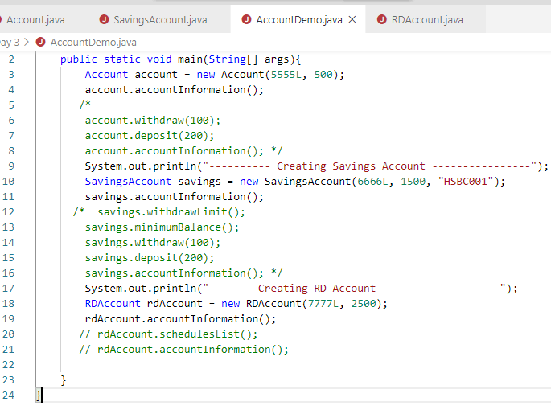

Output:

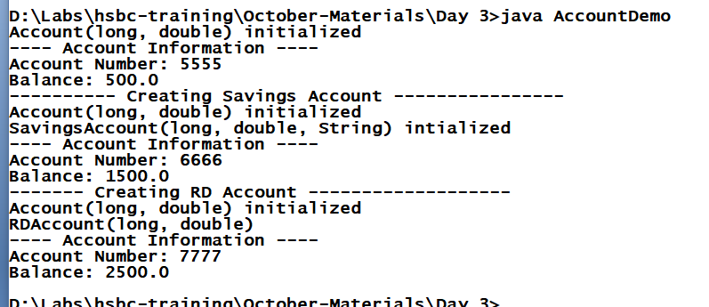

Polymorphsim:

Polymorphism means ability of a method to have many forms

1. compile time - method overloading
2. runtime - method overriding

Account.java

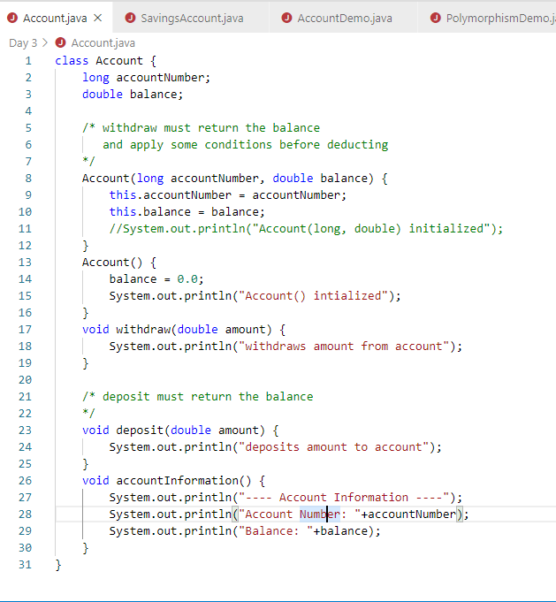

SavingsAccount.java

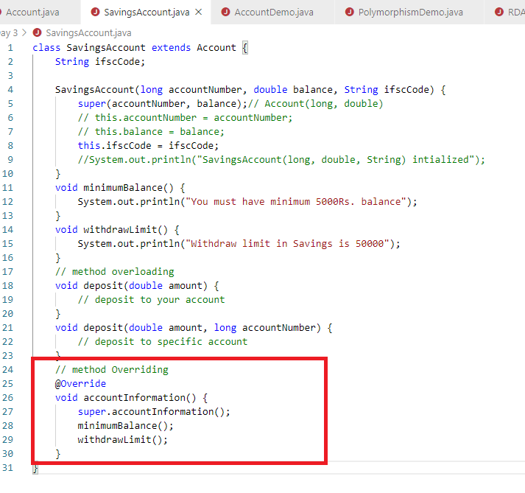

RDAccount.java

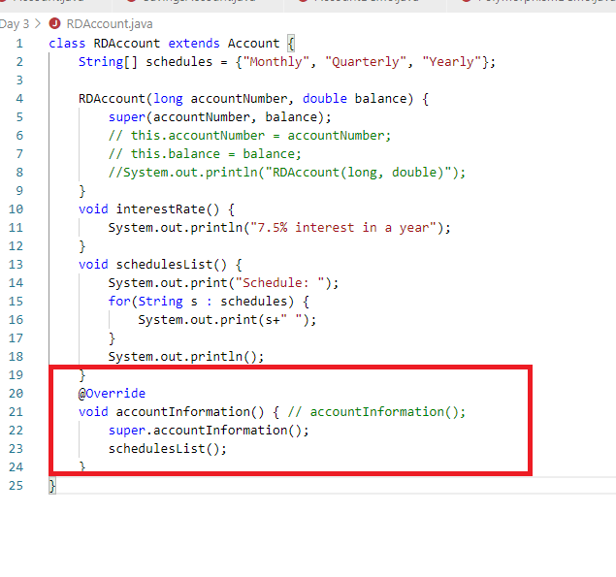

PolymorhismDemo.java

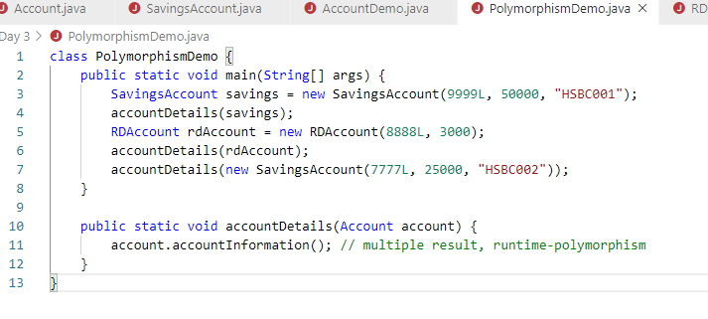

Output:

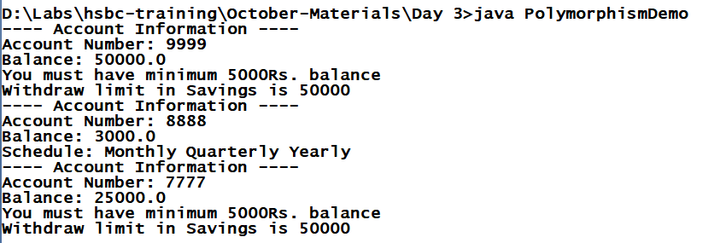

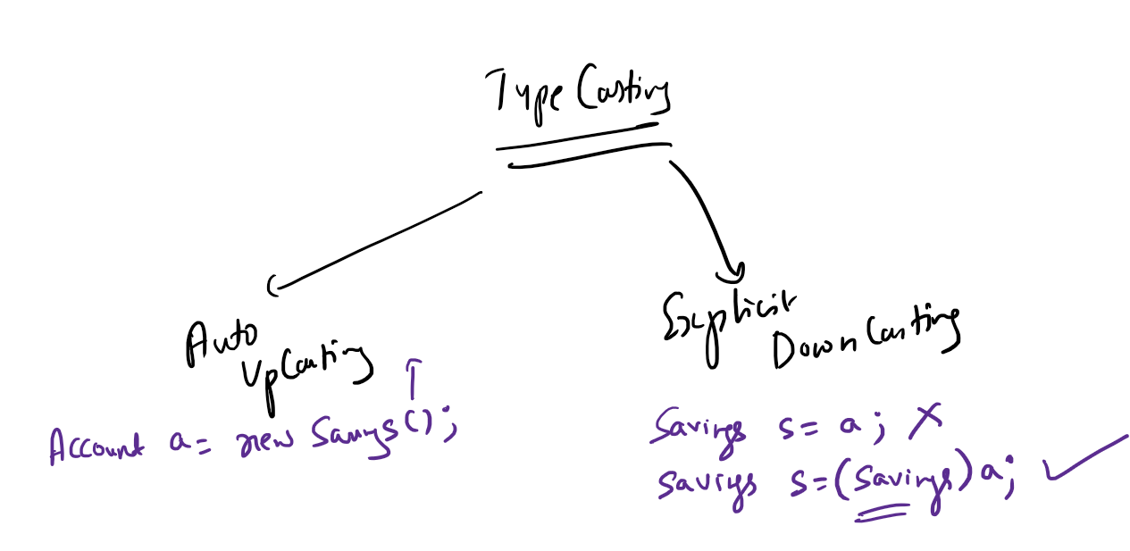

Encapsulation:

Hiding the data and accessing through public members, it gives control over the data.

Account.java

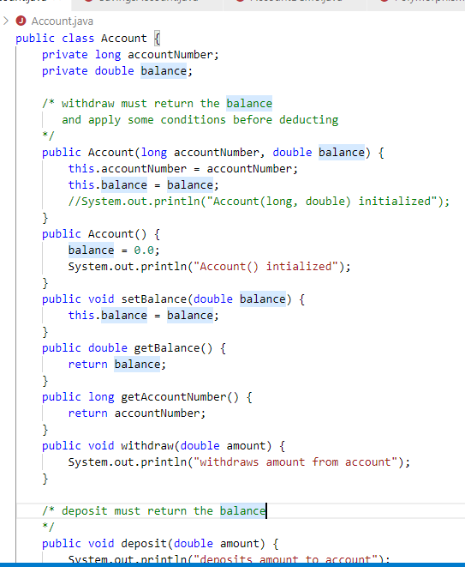

Encapsulation.java

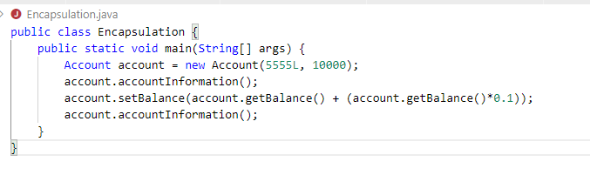

Output:

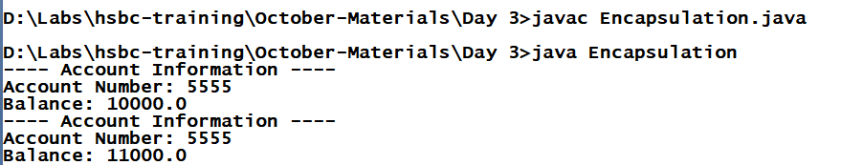

Abstract class & abstract methods:

When you don’t want a class to be instantiated and when you want to force subclass to override methods you will use them.

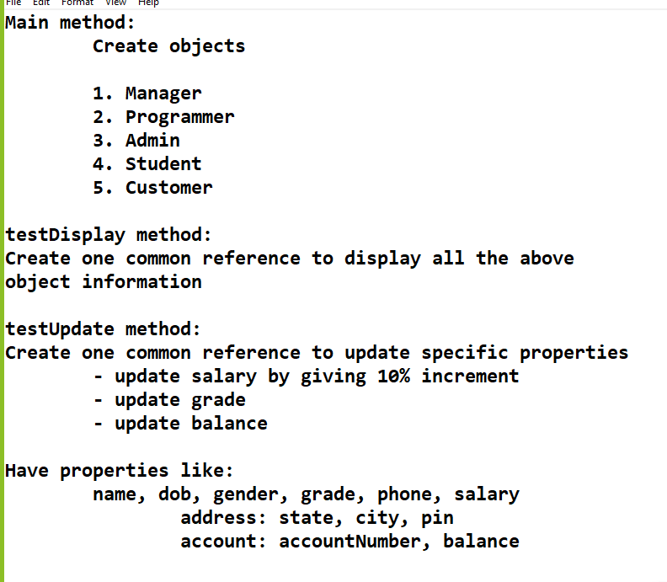

Abstraction: Hiding the implementation & showing only the necessary details to the user.

Abstraction can be achieved in 2 ways:

1. Abstract class: partial abstraction
2. Interface: 100% abstraction

TestInterfaceDemo.java

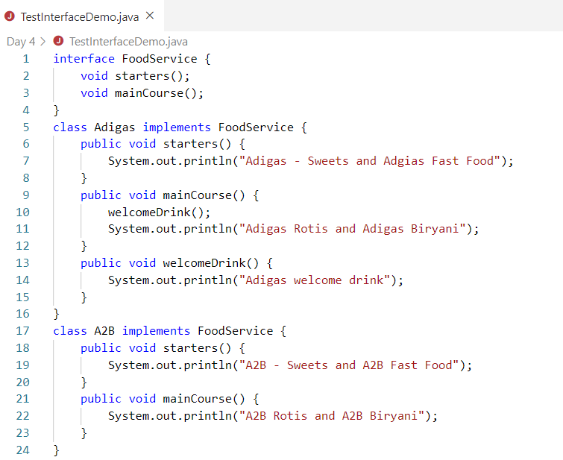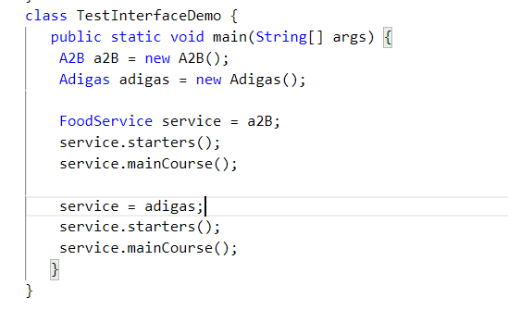

Some important points on interface

1. It is used to connect multiple programs
   1. Banking transactions can be done through IRCTC, PhonePay, PayTM, GooglePay, Amazon
2. It allows you to complete hide implementations from the caller
3. All the members of interface are public by default
4. You can’t have constructors inside interface
5. You can’t create object of interface, but you can create reference of interface
6. Methods are abstract by default
7. Variables are constants (static & final)
8. You can achieve multiple inheritance, i.e, an interface can extend one or more interfaces

interface A { }   
interface B { }   
interface C extends A, B { }

1. A class can also implement more than one interface at a time

class Impl implements A, B, C { }

1. A class can extend one class and implement more than one interface

class Impl extends Thread implements A, B, C { }

final keyword:

final keyword can be applied on variables, methods & classes

final variables can’t be modified

final methods can’t be overridden

final classes can’t be inherited

Access specifiers

There are 4 access specifiers

1. private: visible within the class
2. no keyword: visible within the package
3. protected: visible within the package & outside the package only to sublcass
4. public: visible to all

Predefined packages:

1. java.lang: by default all the classes of lang package you can use without importing
2. java.util
3. java.io
4. java.sql

java.lang:

String, System, Thread, Object, Exception, Integer, Double, Float, RuntimeException, NumberFormatException, NullPointerException,....

java.util:

Scanner, List, ArrayList, Set, HashSet, TreeSet, LinkedList, Map, HashMap, TreeMap,...

Object: It is the root class in java, some of the commonly used methods of Object

* toString()
* equals()
* hashCode()

toString(): it is a method which is called automatically whenever you print any object, you can override to represent custom description, by default it represents memory address

Exception:

It is an event that will disturb the normal flow of execution, you need to handle it

Five keywords used in Exception Handling

try, catch, finally, throws & throw

Exceptions are of two types

1. Checked Exceptions: Has to be handled at compilation time
2. Unchecked Exceptions: Recognized at runtime

try: statements that cause exceptions must be kept.

catch: to handle the exception

finally: to execute some mandatory statements even if exception is not handled

throws: propagates the exception to the caller when the code doesn’t know how to handle the exception

throw: you want to manually create & throw an exception

Factory Pattern:

It is a design pattern used to create object for different classes

Requirement:

Enhance the user management project to have

1. Option no 3 must be implemented
2. Implement fetchById(int userId) method in DAO layer & Service layer
3. Exception class named UserNotFoundException (Checked Exception) in com.hsbc.exception package
4. propagate the exception UserNotFoundException from dao layer to service layer & handle it in controller and display the error message in System.err.println(“...”)

Next Requirement

1. You must implement methods to update phoneNo and password, however in DAO you must update user object and service layer will take care of updating each properties through methods
2. Complete the implementation of updateUser() in dao, updatePhoneNo() and updatePassword() in service
3. Complete the other 2 options in main i.e, update phone & update password.

Limitations of array:

* Size is fixed
* Algorithms you must write

Collection: It is used to maintain the data, its size is not fixed.

Collection Framework hierarchy

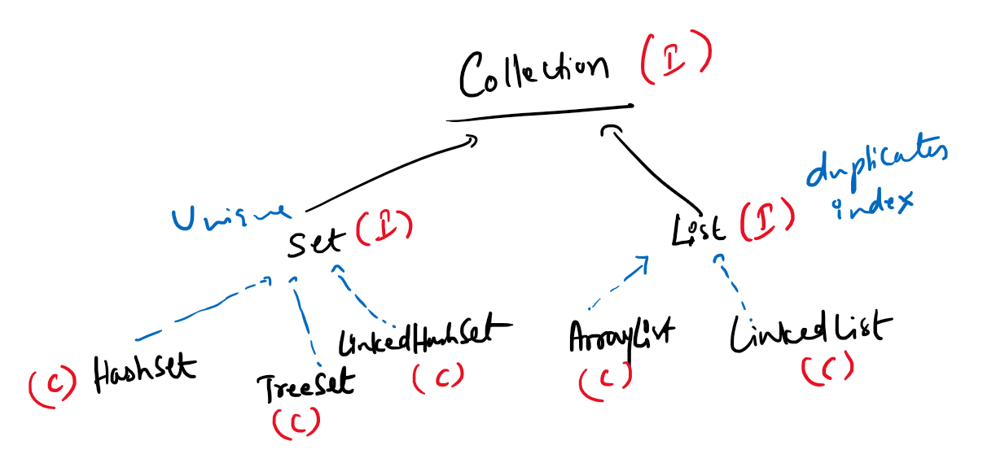

Collection has some common methods:

1. add(item)
2. remove(item)
3. size()
4. clear()
5. isEmpty()

List has some methods

1. add(index, item)
2. remove(index)
3. get(index)

Set doesn’t have any new methods, but it concentrates on uniquness

Set has 3 implementations

1. HashSet
2. TreeSet
3. LinkedHashSet

HashSet: It maintains data in random order, but retrieval is faster

TreeSet: It maintains data in sorted order

LinkedHashSet: it maintains data in insertion order

List has 2 implementations

ArrayList: It maintains elements in contiguous memory address, it shifts the items when you add or remove the items in between, however the retrieval is faster in ArrayList

LinkedList: It maintains elements in non-contiguous memory address, it doesn’t shift the items rather it removes the links between the items and adds new links between the elements whenever you add/remove elements, however the retrieval is slower but adding & removing is faster

There are other algorithms as well in Collection like:-

ArrayDeque, PriorityQueue, Vector, Stack, BlockedQueue,...

All these collection API’s are part of java.util.*

Different way instantiating the collection implementations:

Non-Generics Way

*ArrayList list1 = new ArrayList();  
List list2 = new ArrayList();  
LinkedList list3 = new LinkedList();  
List list4 = new LinkedList();*

Here they allow any kind of elements, like int, double, string, employee, customer, account and etc

Note: this way of instantiating is not-preferred

Generic Way

*ArrayList<String> list1 = new ArrayList<String>();  
List<String> list2 = new ArrayList<String>();  
List<Employee> list3 = new ArrayList<Employee>();  
List<Customer> list4 = new LinkedList<Customer>();*

Here they allow only specific kind of elements, like list1 & list2 allows only strings, list3 allows only employee types....

ListDemo.java

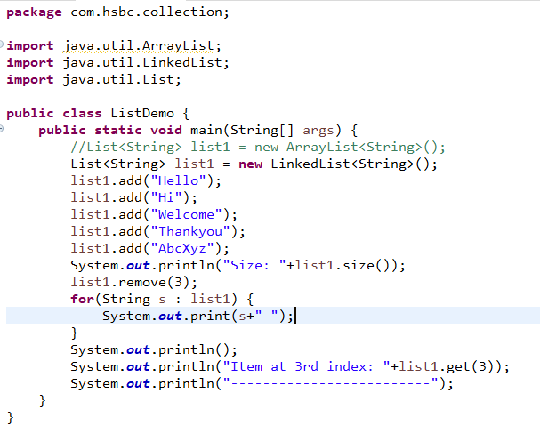

SetDemo.java

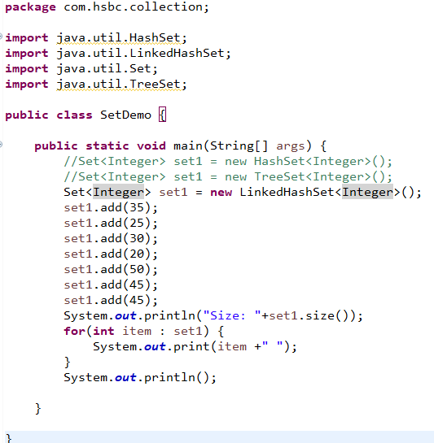

Iterator: It is an interface used to iterate the elements in the collection, it is same like for loop but it can perform one extra job at the time iterating, i.e., removing the iterated element:

Iterator has 3 methods

1. hasNext: to check the next item availability
2. next: to retrieve the next item
3. remove: to remove the item that is been iterated

Requirement:

Item class:

itemId, name, price, ratings  
 constructors  
 setters & getters

Add some 5 instance of Item to the HashSet & iterate the items

equals & hashCode:

Object class has equals & hashCode works on memory, you can override these two methods and customize as per your requirement, to generate hashCode & equals based on the properties

Hands-on exercise on hashCode & equals method on Item & Student class

Sorting:

Usually primitives are automatically sorted, but complex objects are not sorted, you had to use some comparing interfaces

Collections class has a sort method

Collections.sort(list);

There are 2 interfaces usually sorting algorithms use

1. Comparable: Natural order, implemented in the same class, default ordering
2. Comparator: Custom order, implemented in the different class

Comparable can only give default sorting method, however you may want the objects to have different way of sorting like ascending & descending order and also on many properties you want to sort, in that case you must use Comparator

SortByRollNo.java

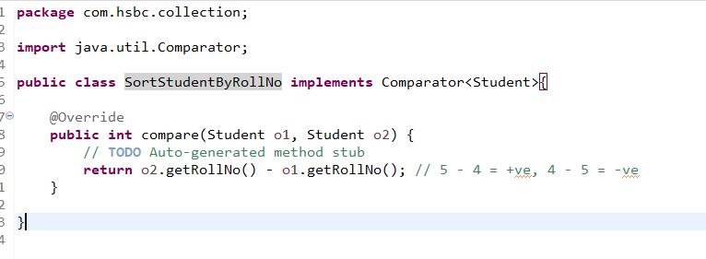

SortingStudentDemo.java

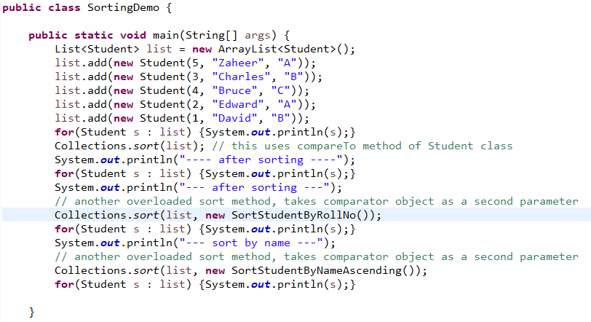

You need to create separate java files & separate classes inorder to sort different properties to avoid that you can go for nested classes which comes in same java files

class Outer {   
 class Inner1 implements Comparator {...}  
 class Inner2 implements Comparator {...}  
}

Requirement:

create nested classes for sorting item instance in ascending & descending order

1. sort itemId
2. sort itemName
3. sort itemPrice
4. sort ratings