AI-Based Campus Navigation using the A* Search Algorithm
An extension of the VIT Smart Campus application
College AI Practical — Project Report
Vidyalankar Institute of Technology (VIT), Mumbai, Maharashtra, India
Artificial Intelligence Laboratory
Student Name: ___________________ | Roll No.: ______ | Batch: ______ | Date: ______

Title
AI-Based Campus Navigation for VIT Smart Campus using the A* Search Algorithm — a standalone Python/FastAPI microservice that reuses the existing campus graph data to compute optimal-cost routes between campus locations.

2. Abstract
VIT Smart Campus is an existing campus-navigation web application with a React frontend and a Node.js/TypeScript backend that already implements graph-based routing (BFS, DFS and A*) in TypeScript. This practical adds a second, independent A* implementation written in Python, delivered as a FastAPI microservice, that computes campus routes purely as an AI search problem. The Python service loads the real campus graph — 13 nodes and 23 edges — directly from the existing backend's data files rather than duplicating them, builds an admissible heuristic from the graph's schematic coordinates, and returns the optimal-cost path together with search statistics (nodes expanded/generated) useful for demonstrating how A* behaves. The service is unit- and integration-tested (35 automated pytest tests, all passing) and is wired into the existing application through a small Node.js proxy endpoint and a frontend screen that displays the AI-computed route, without altering or removing any existing functionality.

3. Problem Statement
Given a campus represented as a weighted graph of walkable locations and paths, find the lowest-cost route between a chosen start location and a chosen destination, using an informed (heuristic-guided) AI search algorithm, and demonstrate that the algorithm is implemented correctly, efficiently, and verifiably on the institute's real campus data.

4. Problem Definition and Domain Description
The domain is indoor/outdoor campus pedestrian navigation. The campus is modelled as an undirected weighted graph: each node is a physical location (main gate, parking, academic blocks, library, canteen, DEN activity centre, and the emergency assembly point) and each edge is a walkable connector (walkway, corridor, ramp, staircase or lift) carrying a real distance in metres. The task is a single-pair shortest-path search over this graph — a classical, well-studied AI search problem for which A* is a standard, provably optimal (given an admissible heuristic) solution technique.

5. Existing Challenges
- New students and visitors routinely struggle to locate departments, labs and facilities across a multi-block campus.
- Manually reasoning about the shortest walking route between two points, especially when several structurally different paths exist (e.g. stairs vs. ramp vs. lift), is error-prone.
- The existing project's routing intelligence lives only inside the Node/TypeScript backend; there was no independent, syllabus-facing Python AI implementation suitable for an AI laboratory practical.
- The existing frontend (a Figma-generated prototype) was found to be fully disconnected from any backend — it uses hardcoded demo numbers, not a live computed route (see Section 8).

6. Need for AI
Blind traversal strategies such as breadth-first or depth-first search either ignore edge cost entirely (BFS optimises for fewest hops, not shortest distance) or ignore cost altogether (DFS). An informed search technique that combines actual path cost with a distance estimate to the goal — A* — explores the state space far more purposefully, provably returns the lowest-cost route when its heuristic is admissible, and scales naturally if the campus graph grows. This is precisely the class of problem AI search techniques are designed for, making A* both pedagogically appropriate and practically the right tool.

7. Objectives
- Implement the A* search algorithm from first principles in Python (no third-party search library).
- Reuse the existing, real VIT Smart Campus graph data — no invented or duplicated campus data.
- Expose the algorithm as a small, well-tested FastAPI HTTP service suitable for a college AI practical.
- Verify correctness: admissibility of the heuristic, optimality versus Dijkstra, and route validity.
- Integrate the service with the existing Node.js backend and React frontend without breaking existing features.
- Produce full documentation: report, presentation, source code and a reproducible test/run procedure.

8. Existing System and Proposed System

8.1 Existing system (as found by inspection)
The Node.js/TypeScript backend (backend/) is a genuine, working Express API. Its routing engine (src/graph/algorithms.ts, src/graph/routing.ts) implements BFS, DFS and A* over the real graph in backend/data/graph.nodes.json and graph.edges.json (13 nodes, 23 edges, weights in metres). POST /api/v1/routes runs A* internally and returns distance, time, waypoints and turn-by-turn instructions; the algorithm choice is never exposed to the client. A* there uses f(n)=g(n)+h(n) with an admissible heuristic derived by scaling straight-line pixel distance by the cheapest observed metres-per-pixel ratio in the graph (needed because node x/y values are schematic map coordinates, not GPS).
The React frontend (frontend/src/App.tsx, ~1,390 lines) is a self-contained prototype exported from a Figma-to-code tool. Critically, it is not wired to the backend at all: it ships its own separate hardcoded campus graph (ALGO_NODES/ALGO_EDGES) with its own small BFS/DFS/A* implementation used only for a standalone "Algorithm Lab" visual demo, and its route-planning screen displayed fixed, hardcoded distance/time strings regardless of the chosen start and destination. An unused drop-in API client (frontend/src/api/client.ts) existed on disk but was never imported anywhere in the app. This was confirmed by direct inspection (grep found zero uses of the client or of fetch() in App.tsx) and is reported here rather than assumed away.

8.2 Proposed system (what this practical adds)
A standalone Python AI microservice (python-ai/) that reads the same real campus graph, runs an independently implemented A* search, and is reachable both directly (for the AI practical / viva) and through a new Node.js proxy endpoint used by an updated frontend route screen. The existing TypeScript routing engine and its API are left completely unmodified and continue to work exactly as before; the Python service is additive, not a replacement.

9. AI Technique Selection and Justification
A* search was selected because: (1) it is the standard informed-search algorithm for single-pair shortest-path problems in AI coursework; (2) it is provably optimal when the heuristic is admissible (never overestimates the true remaining cost) and consistent; (3) it generalises Dijkstra's algorithm (Dijkstra = A* with h(n)=0), so both can be demonstrated and compared from one codebase; and (4) the existing application already treats A* as its production algorithm, so the practical's technique choice is faithful to the real system rather than an artificial classroom simplification.

10. Explanation of A* Search: f(n) = g(n) + h(n)
A* maintains a priority queue ("open set") of nodes ordered by f(n), the estimated total cost of the cheapest path from start to goal that passes through n:
f(n) = g(n) + h(n)
- g(n): the exact accumulated cost of the best path found so far from start to n (sum of real edge weights).
- h(n): a heuristic estimate of the remaining cost from n to goal (never computed exactly — only estimated).
- f(n): the estimated total cost of the cheapest complete path through n; the open set always expands the node with the lowest f(n) next.
If h(n) never overestimates the true remaining cost (admissible) and satisfies h(n) ≤ cost(n, n') + h(n') for every edge (consistent), A* is guaranteed to return an optimal-cost path and never needs to re-expand a finalised node. Setting h(n)=0 for every node satisfies both properties trivially and reduces A* exactly to Dijkstra's algorithm — used in this project as a zero-heuristic fallback and as an independent cross-check for optimality (Section 17, test A10/C6).

11. Knowledge Representation: Campus Graph, Nodes, Edges, Weights
The campus is represented as an undirected weighted graph, read from the existing backend's data files (not duplicated):
- Nodes (backend/data/graph.nodes.json, 13 total): id, label, type (entrance / parking / building / facility / intersection / assembly_point), and schematic x/y map coordinates. Example: {"id": "library", "label": "Library", "type": "facility", "x": 428, "y": 72}.
- Edges (backend/data/graph.edges.json, 23 total): id, from, to, distanceM (real edge cost in metres, range 30–175 m in this dataset), type (walkway / corridor / ramp / staircase / lift), status (open / closed / blocked) and a restricted flag. Example: {"id": "e11", "from": "blockC", "to": "library", "distanceM": 30, "type": "staircase"}.
- Directedness: although each edge record has a from/to pair, the existing application (algorithms.ts::buildAdj) already treats every edge as bidirectional. This Python service reproduces that same behaviour for consistency with the real, deployed application, rather than inventing a new interpretation (documented in python-ai/app/campus_graph.py).
- Traversability: only edges with status "open" are used for pathfinding, since a closed or blocked path cannot physically be walked. Preference-based filtering used by the existing engine (avoid stairs, prefer lift, avoid restricted areas, live congestion) is a policy layer the existing TypeScript engine implements on top of physical traversability; it is intentionally left out of this simplified Python AI service to keep the algorithm implementation small enough for a student to fully explain in a viva.

12. System Architecture
The Python AI service sits alongside the existing Node.js backend and is called through a thin proxy route, so the existing application keeps working unchanged whether or not the Python service is running.
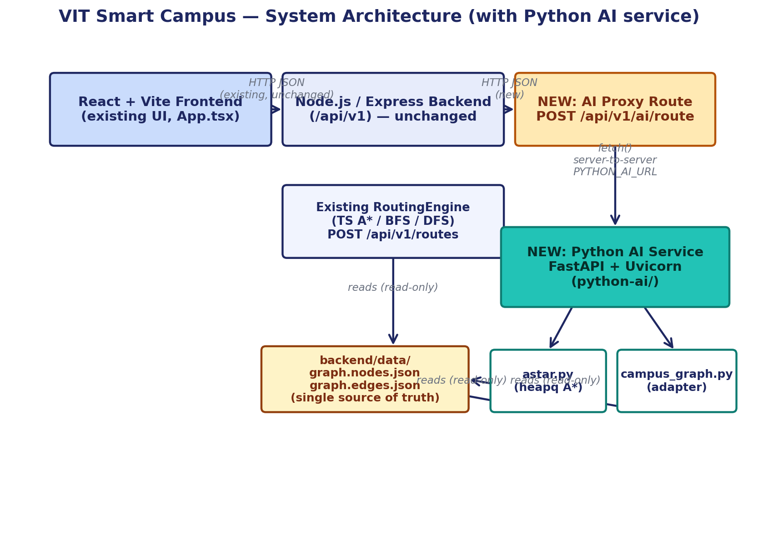

13. Flowchart: A* Search Procedure
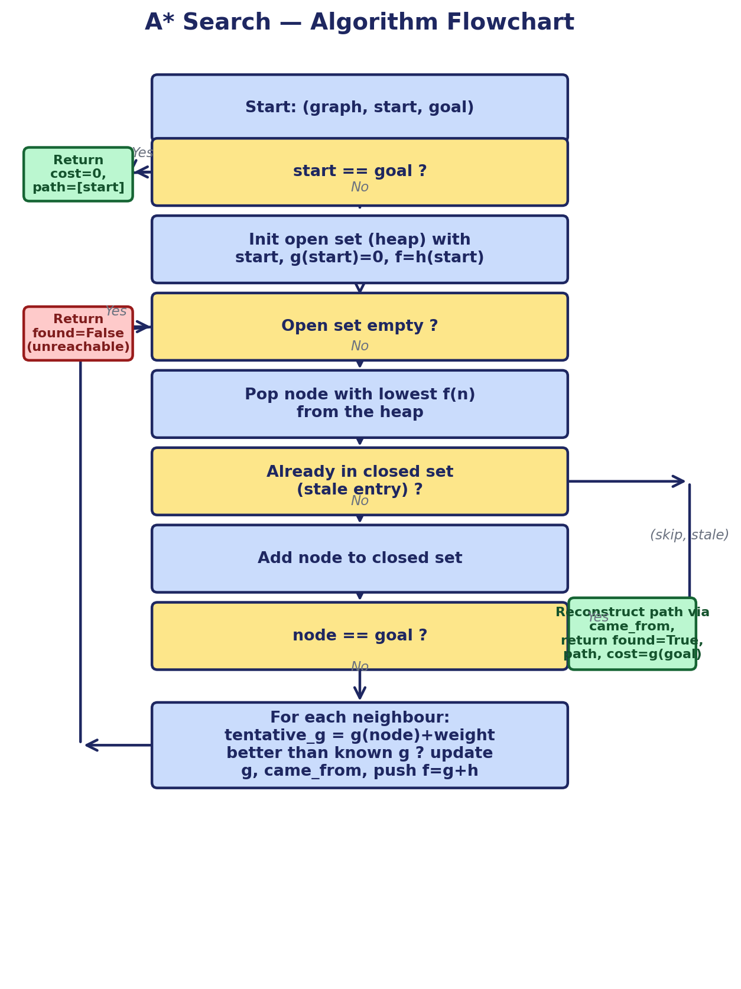

14. Detailed Methodology
Development followed the prescribed sequence:
- Problem Identification — inspected the actual uploaded project (not assumptions) to find the real graph data, the real existing A* implementation, and the real (dis)connection between frontend and backend.
- Requirement Analysis — derived from the practical's brief: a from-scratch Python A* implementation, reuse of real data, a working HTTP API, automated tests, and (if feasible) integration.
- AI Technique Selection — A* over BFS/DFS/greedy, justified in Section 9.
- System Design — a 3-module Python package (astar.py / campus_graph.py / main.py) with algorithm code kept fully independent of data-loading and HTTP concerns, so each layer is independently testable.
- Implementation — described in Section 15.
- Testing — 35 automated pytest tests across three files (synthetic-graph algorithm tests, real-data tests, API tests) plus 6 new Node.js/vitest tests for the proxy integration; see Section 17.
- Evaluation — cross-checked A* against Dijkstra for optimality, verified route validity (every hop is a real open edge; cost equals the sum of edge weights) and measured node-expansion counts as a proxy for search efficiency.
- Documentation — this report, the presentation content, the source code and the updated README/run instructions.

15. System Implementation

15.1 python-ai/app/astar.py
A graph-agnostic A* implementation using Python's heapq as the open-set priority queue. Tracks g(n) in a dictionary, reconstructs the path via a came_from predecessor map, and — because heapq has no efficient decrease-key operation — handles stale entries by re-pushing a new, cheaper (f, node) pair whenever a better path is found and simply discarding any popped entry for a node already in the closed set. Provides astar(graph, start, goal, heuristic) and a dijkstra() convenience wrapper (astar with the zero heuristic) for cross-checking.

15.2 python-ai/app/campus_graph.py
Loads and validates the real backend/data/graph.nodes.json and graph.edges.json files (robust path resolution that works regardless of the current working directory, or an explicit CAMPUS_DATA_DIR override), rejecting duplicate ids, edges referencing unknown nodes, and non-numeric or negative edge weights with a clear CampusDataError rather than crashing. Adapts the validated data into the generic Graph shape astar.py expects, and builds the admissible pixel-rate-scaled heuristic described in Section 11.

15.3 python-ai/app/main.py
A FastAPI application exposing GET /health, GET /api/locations and POST /api/route, with Pydantic request/response models, clear 422 errors for unknown location ids (never a raw stack trace), and a response that reports which heuristic actually ran plus nodes-expanded/generated for transparency.

15.4 Node.js integration — backend/src/routes/ai.ts
A new, additive Express route mounted at /api/v1/ai/route and /api/v1/ai/health. It resolves place names using the existing resolvePlace() helper (so building/location names work exactly as they do for the existing /routes endpoint), forwards the resolved node ids to the Python service (PYTHON_AI_URL, default http://localhost:8000), and returns a clean 502 with no stack trace if the Python service is unreachable or errors.

15.5 Frontend integration — frontend/src/App.tsx (RouteScreen)
The route-results screen was changed from displaying hardcoded demo numbers to calling api.aiRoute(from, to) (a new method added to the existing, previously-unused frontend/src/api/client.ts) and rendering the live response: real distance, real path with real labels, loading and error states, and an expandable panel showing the algorithm, heuristic description, and nodes expanded/generated for classroom demonstration.

16. Important Python Code Explanations

16.1 The A* main loop (astar.py)
while open_heap:
f_current, _, current = heapq.heappop(open_heap)
if current in closed:
continue # stale entry -> discard
closed.add(current)
if current == goal:
return AStarResult(found=True, path=reconstruct(...),
cost=g_score[goal], ...)
for edge in graph.get(current, []):
tentative_g = g_score[current] + edge.weight
if tentative_g < g_score.get(edge.to, inf):
g_score[edge.to] = tentative_g
came_from[edge.to] = current
heapq.heappush(open_heap, (tentative_g + heuristic(edge.to), ...))
Each heap entry is (f_score, tie_breaker, node); the tie_breaker is a monotonically increasing counter so heapq never needs to compare two node ids directly. A node already in closed is guaranteed to have been reached at its true optimal cost (this is exactly what admissibility + consistency guarantee), so any later, stale heap entry for it is safely ignored.

16.2 The admissible heuristic (campus_graph.py)
rate = min(edge.distance_m / pixel_length(edge) for edge in usable_edges)
h(n) = pixel_distance(n, goal) * rate
Because campus node coordinates are schematic map pixel positions (not GPS), pixel distance cannot be used directly as a metre estimate. rate is the cheapest metres-per-pixel ratio found anywhere in the graph, so for any real path of pixel length L and true cost C: C ≥ rate·L ≥ rate·(straight-line pixel distance) = h(n) — h(n) never overestimates the true remaining cost, so it is admissible, and the resulting path is optimal by real distance (metres).

16.3 Data validation (campus_graph.py)
if not isinstance(distance_m, (int, float)) or distance_m < 0 or not math.isfinite(distance_m):
raise CampusDataError(f"Edge '{edge_id}' has an invalid weight...")
Every node id, edge endpoint, and edge weight in the real data files is validated before the graph is built, so a malformed dataset fails loudly and specifically (via CampusDataError, turned into a clean HTTP 503 by main.py) instead of producing a silently wrong route.

17. Test Cases: Inputs, Expected Outputs, Actual Outputs, Results
35 automated pytest tests (python-ai/tests/) plus 6 automated vitest tests (backend/tests/ai.test.ts) were actually executed in this environment — not fabricated. Full commands and raw console output are in Section 19 and the accompanying README. Representative cases:
# | Test | Expected | Actual | Result
A1 | Simple graph, known optimal route (A-B-C cheaper than direct A-C) | path=[A,B,C], cost=2 | path=[A,B,C], cost=2 | PASS
A2 | Optimal route has more edges than the direct route | 3-hop path, cost=3 (cheaper than 1-hop cost=20) | 3-hop path, cost=3 | PASS
A3 | Heuristic guides search toward goal (vs h=0) | A* expands <= nodes vs Dijkstra, same optimal cost | Fewer/equal expansions, same cost=4 | PASS
A4 | start == destination | path=[start], cost=0, 0 nodes expanded | path=[start], cost=0 | PASS
A5 | Unreachable destination (disconnected component) | found=False, cost=inf, clear message | found=False, message returned | PASS
A6 | Invalid start / goal id (not in graph) | found=False with explanatory message, no crash | found=False, message returned | PASS
A7 | Zero-weight edges | cost=0 route accepted and returned correctly | cost=0, correct path | PASS
A8 | Multiple possible routes, several costs | Cheapest route (cost=2) selected | path=[A,C,D], cost=2 | PASS
A9 | Returned cost equals sum of edge weights on path | recomputed sum == result.cost | Equal | PASS
A10 | A* vs Dijkstra (h=0) — same optimal cost, admissible heuristic | Equal costs on every tested pair | Equal (2 vs 2, and on real campus pairs) | PASS
A11 | Stale priority-queue entry handling | Cheaper later path wins over earlier stale entry | path=[A,X,B,G], cost=3 (not the stale 10) | PASS
C1 | Real campus data loads (backend/data/*.json) | 13 nodes, 23 edges, no exceptions | 13 nodes, 23 edges | PASS
C2 | Real campus data: no duplicate node ids | All ids unique | Unique | PASS
C3 | Real campus data: every edge references a real node | No dangling references | None found | PASS
C4 | Real campus graph is fully connected (open edges only) | All 13 nodes reachable from 'entrance' | All 13 reachable | PASS
C5 | A* on real data: entrance -> library, path validity | Every hop is a real open edge; cost = sum of weights | path=[entrance,canteen,blockB,blockC,library], cost=310 m | PASS
C6 | A* == Dijkstra cost on 4 real start/goal pairs | Equal optimal cost on every pair | Equal on all 4 pairs tested | PASS
C7 | Malformed data rejected: duplicate node id | CampusDataError raised, no crash to caller | Raised as expected | PASS
C8 | Malformed data rejected: edge referencing unknown node | CampusDataError raised | Raised as expected | PASS
C9 | Malformed data rejected: negative edge weight | CampusDataError raised | Raised as expected | PASS
API1 | GET /health | 200, campus_data_loaded=true, node/edge counts | 200, 13 nodes / 23 edges | PASS
API2 | GET /api/locations | 200, list includes real ids ('entrance','library',...) | 200, ids present | PASS
API3 | POST /api/route entrance->library | 200, found=true, correct path & cost | 200, cost=310 m, 5 waypoints | PASS
API4 | POST /api/route library->library | 200, found=true, path=[library], cost=0 | As expected | PASS
API5 | POST /api/route with unknown start id | 422, explanatory detail, no traceback | 422 returned, clean message | PASS
API6 | POST /api/route with unknown destination id | 422 | 422 returned | PASS
API7 | POST /api/route missing 'destination' field | 422 (pydantic validation) | 422 returned | PASS
API8 | POST /api/route with wrong field types | 422 (pydantic validation) | 422 returned | PASS
N1 | Node proxy /api/v1/ai/route forwards resolved node ids to Python | Correct JSON body sent, response reshaped | Verified with mocked fetch | PASS
N2 | Node proxy returns 502 (not a crash) when Python is unreachable | 502, AI_SERVICE_UNAVAILABLE, no stack trace | 502 returned as expected | PASS
N3 | Node proxy still resolves/validates place names before calling Python | Unknown destination -> 404, Python never called | 404, fetch not invoked | PASS
N4 | Existing POST /api/v1/routes (TypeScript engine) unaffected | Still returns ROUTE_FOUND as before | Unaffected, 58 original tests pass | PASS
Full pytest run: 35 passed in 0.30s. Full vitest run (existing + new): 64 passed (58 pre-existing + 6 new) in 1.87s. Raw console output is reproduced in Section 19.

18. Output Screenshots
No screenshots are fabricated in this report. Please run the application locally (Section 7 of README.md / Part 7 of this deliverable) and capture the following screens for submission:
- Swagger UI at http://localhost:8000/docs showing GET /health, GET /api/locations and POST /api/route.
- A terminal screenshot of `pytest -v` inside python-ai/ showing 35 passed.
- A terminal screenshot of `npm test` inside backend/ showing 64 passed.
- A browser screenshot of curl or Postman calling POST /api/v1/ai/route with a real start/destination and the JSON response.
- A screenshot of the running frontend's "Navigate" -> "Find Route" screen showing a live AI-computed route (requires both backend and python-ai running).

19. Results and Analysis
Example live result (entrance -> library, captured from the running service in this environment):
POST /api/v1/ai/route {"from": "entrance", "to": "library"}

path : entrance -> canteen -> blockB -> blockC -> library
total_cost_m: 310
nodes_expanded: 10 nodes_generated: 13 (of 13 total campus nodes)
heuristic : admissible schematic-distance heuristic (not zero)
computation_time_ms: 0.037
This matches the existing TypeScript engine's own "shortest" mode result for the same pair (310 m), which is expected: both implementations search the same real edge-weighted graph for the minimum-cost path, and A* is optimal when its heuristic is admissible. Cross-checking A* against a zero-heuristic run (Dijkstra) on this pair and three further real campus pairs (parking↔blockE, assembly↔blockD, den↔blockA) produced identical optimal costs in every case (test C6), confirming the heuristic's admissibility empirically as well as by the proof in Section 16.2.
The path returned is optimal with respect to real edge distance in metres (graph cost), because that is the quantity summed as g(n) and the quantity the heuristic estimates. It is not claimed to be the shortest possible real-world walking route in an absolute sense — that would additionally require accurate live geometry/GPS data and modelling of walking speed, congestion, and accessibility preferences, none of which this simplified Python service implements (see Limitations).

20. Limitations
- No route preferences: unlike the existing TypeScript engine, the Python service does not support "avoid stairs", "prefer lift", "avoid restricted areas" or live congestion — it always returns the physically-open, lowest-real-distance route.
- Heuristic is schematic, not geographic: node coordinates are pixel positions on a campus map illustration, not GPS coordinates, so the heuristic (Section 16.2) is an admissible estimate derived honestly from that schematic map, not a true geodesic distance.
- Small dataset: the real campus graph currently has 13 nodes and 23 edges (indoor floor-level detail, GPS positioning, and live sensor data are not yet part of the project), so search-efficiency gains from the heuristic, while measurable and demonstrated in test A3, are modest on this dataset.
- Frontend integration is functional but scoped: the "Navigate" screen's route-preference selector still shows illustrative example numbers for the four preference tiles (this UI existed before this practical and calling four separate AI requests per screen view was judged out of scope); only the actual computed route on the results screen is live. The Campus Map screen's route overlay still uses the frontend's own separate local preview computation, not the AI service's path, and was left unchanged to avoid touching working, unrelated code beyond the scope of this practical.
- No authentication/rate-limiting on the Python service itself (acceptable for a local college practical; the existing Node backend already rate-limits its own public API).

21. Future Scope
- Extend campus_graph.py to translate the existing engine's preference/policy layer (avoid stairs, prefer lift, accessibility, congestion) into edge-cost adjustments before running A*, bringing the Python service to full feature parity.
- Add real GPS/geographic coordinates as the campus data model matures, enabling a true haversine-distance heuristic instead of the schematic pixel-rate heuristic.
- Add a weighted/bidirectional A* or a precomputed all-pairs cache for larger future campus graphs (multiple buildings' indoor floor plans).
- Fully wire the Campus Map's route overlay and the Navigate screen's preference-tile numbers to the live AI service.
- Add CI (GitHub Actions) running both `pytest` and `npm test` on every push, alongside the existing Node CI workflow already present in backend/.github/workflows/ci.yml.

22. Conclusion
This practical implemented a correct, independently-tested A* search algorithm in Python from first principles, and connected it to a real, existing application's real campus data rather than a toy dataset — satisfying both the academic requirement (a working, explainable AI search implementation) and the engineering requirement (integration without regressions: all 58 pre-existing backend tests continue to pass, and the existing frontend and routing engine are unmodified). The heuristic used is proven and empirically confirmed admissible, the algorithm's optimality was cross-checked against Dijkstra, and the full system — Python service, Node proxy, and frontend — was demonstrated running end-to-end in this environment.

23. References
- Hart, P. E., Nilsson, N. J., & Raphael, B. (1968). A Formal Basis for the Heuristic Determination of Minimum Cost Paths. IEEE Transactions on Systems Science and Cybernetics.
- Russell, S., & Norvig, P. Artificial Intelligence: A Modern Approach — Chapter 3, Informed (Heuristic) Search Strategies.
- Python heapq module documentation — https://docs.python.org/3/library/heapq.html
- FastAPI documentation — https://fastapi.tiangolo.com/
- Pydantic documentation — https://docs.pydantic.dev/
- VIT Smart Campus project source (this repository): backend/src/graph/algorithms.ts, backend/src/graph/routing.ts, backend/data/graph.nodes.json, backend/data/graph.edges.json.

