Aim: perform the data clustering using clustering algorithm by using R and python.
Step1:
Write the given code in the R tool.
#apply K mean to iris and store result
> newiris <- iris
> newiris$Species <- NULL
> (kc <- kmeans(newiris,3))

Output:
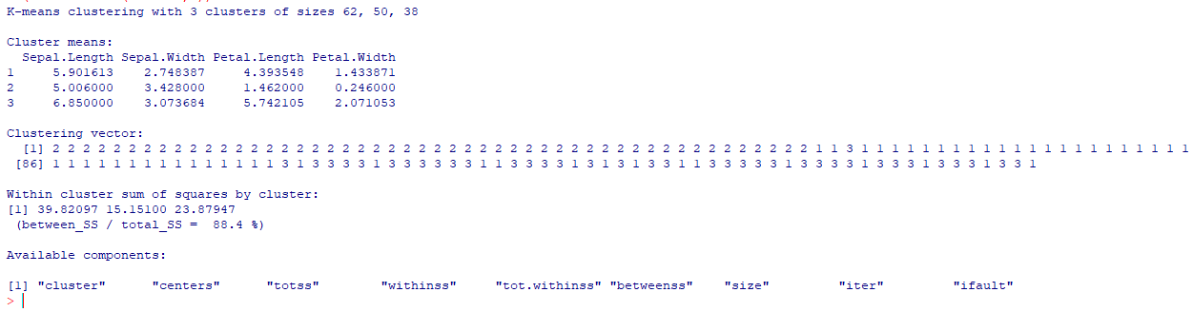

#compare the Species label with the clustering result
table (iris$Species,kc$cluster)
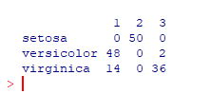

#plot the cluster and their centers
> plot(newiris[c("Sepal.Length","Sepal.Width")],col=kc$cluster)
> plot(kc$centers[,c("Sepal.Length","Sepal.Width")],col=1:3,pch=8,cex=2)
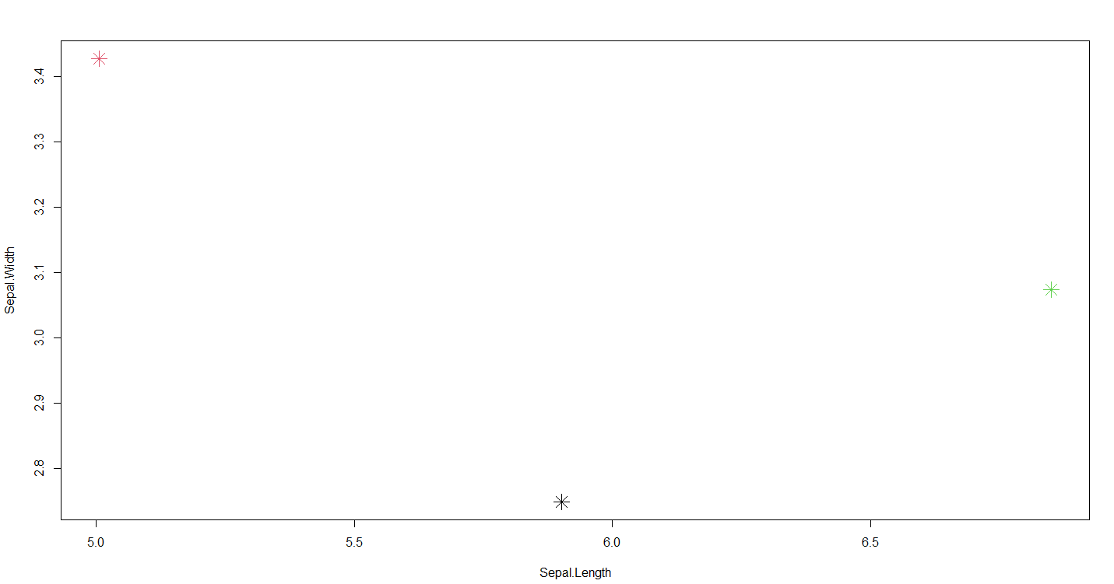

Step2: write the given code in google colab(python).
from sklearn.cluster import KMeans
import numpy as np
#sample data
data = np.array([[1,2],[5.1, 1.8],[8, 8],[1,0.6],[9,11]])
#specify the number of cluster (K)
kmeans = KMeans(n_clusters=2)
#fit the data to the algorithm
kmeans.fit(data)
#get the cluster centroids and labels
centroids = kmeans.cluster_centers_
labels = kmeans.labels_
#print the results
print("Cluster centroids:")
print(centroids)
print("labels:")
print(lables)

output:
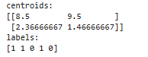
Create a another filr in the google colab and write this code.
import numpy as np
import matplotlib.pyplot as plt
from sklearn.cluster import KMeans
from sklearn.datasets import make_blobs
#generate synthetic dataset
X,Y = make_blobs(n_samples=300, centers=4, cluster_std=0.6, random_state=42)

#visualize the data
plt.scatter(X[:,0],X[:,1], s=30, c='gray')
plt.title("Generated Data")
plt.show()

#apply K_means clustering
kmeans=KMeans(n_clusters=4, random_state=42)
kmeans.fit(X)

#get cluster centroids and labels
centroids = kmeans.cluster_centers_
labels = kmeans.labels_

#visualize the clusters
plt.scatter(X[:,0], X[:,1], c=labels,cmap='viridis', s=30)
plt.scatter(centroids[:, 0], centroids[:, 1], c='red', marker='X', s=200, label='centroids')
plt.title("K-means Clustering")
plt.legend()
plt.show()

Output:
