SLE-3: Architectural Design using Full C4 Model
02AML204 – Introduction to Artificial Intelligence
System Title | Graph Search System using BFS and DFS
PRN | 26UAM307
Name | Shravani Sadashiv Bramhadande
Division | A
Date | 03/10/2026

1. System Title & Short Description
The Graph Search System is a small AI search system that finds a path from a start node to a goal node in a graph. It implements Breadth-First Search (BFS) and Depth-First Search (DFS) on the same graph. BFS explores nodes level by level using a queue, while DFS explores deeply using a stack-based approach. The system tracks visited nodes and the resulting path, and the SLE-2 version also measures execution time using Python's timeit module.
SLE-2 reference: Start node = A, Goal node = E, and both algorithms produced the path A → B → E on the selected graph.

2. C4 Level 1 — Context Diagram
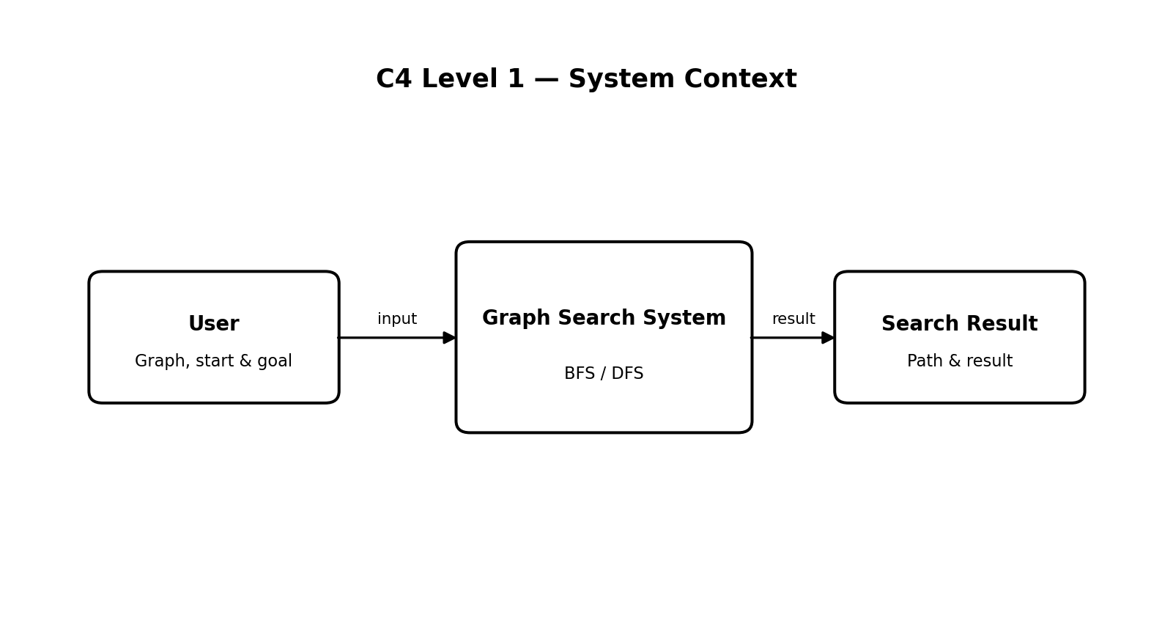
The Context Diagram shows the system as one high-level unit. The user provides the graph and the start/goal information. The Graph Search System performs BFS or DFS and returns the search path and result.

3. C4 Level 2 — Container Diagram
The Container view opens the main system into logical parts that represent the responsibilities visible in the SLE-2 implementation. These are architectural containers, not separate applications.
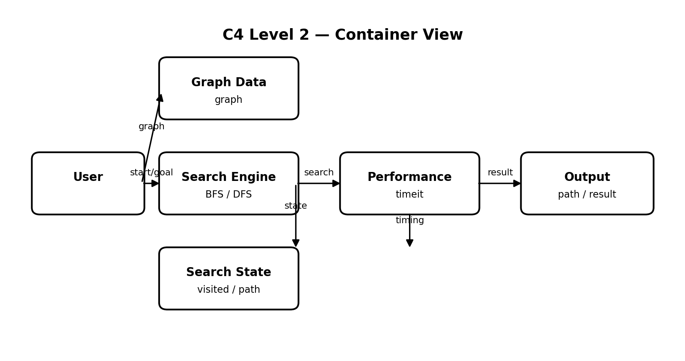
Container | Responsibility
Graph Data | Stores the graph nodes and their connections used by both search algorithms.
Search Engine | Executes BFS or DFS from the selected start node to the goal node.
Search State | Maintains visited information and the path being constructed during search.
Performance | Uses Python timeit-based measurement to obtain execution-time information.
Output | Provides the discovered path and search result for the user.
Data flow: Graph/start/goal → Search Engine → Search State → Output. Performance timing observes the search execution and supports the profiling information used in SLE-2.

4. C4 Level 3 — Component Diagram
For Level 3, the Search Engine container is decomposed into the main logical components involved in BFS/DFS execution.
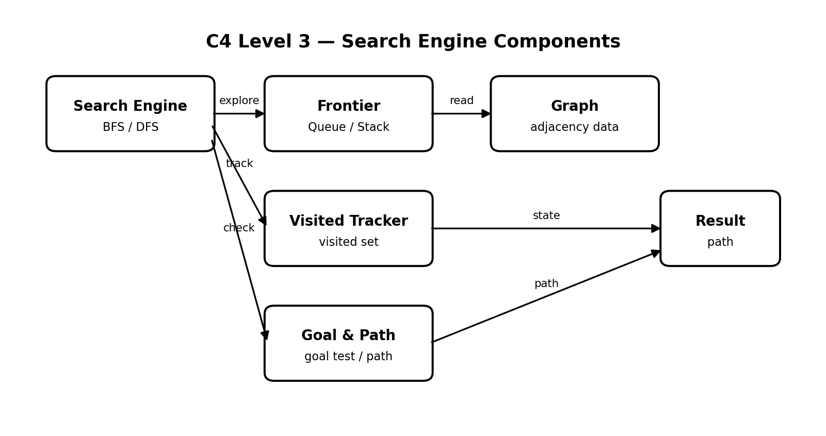
Component | Role
Frontier Manager | Manages the next nodes to explore; BFS follows FIFO queue behavior and DFS follows LIFO stack behavior.
Visited Tracker | Records already processed nodes so the search does not repeatedly process the same node.
Goal & Path Manager | Checks whether the current node is the goal and records the route used to reach it.
Graph Access | Reads neighboring nodes from the graph representation.
Together, these components support the two search strategies while allowing both algorithms to operate on the same graph and start/goal pair.

5. C4 Level 4 — Code-Level Overview
The Code level maps the architecture to the main implementation elements used in the SLE-2 Python program. The report intentionally gives a code overview rather than pasting the complete source code.
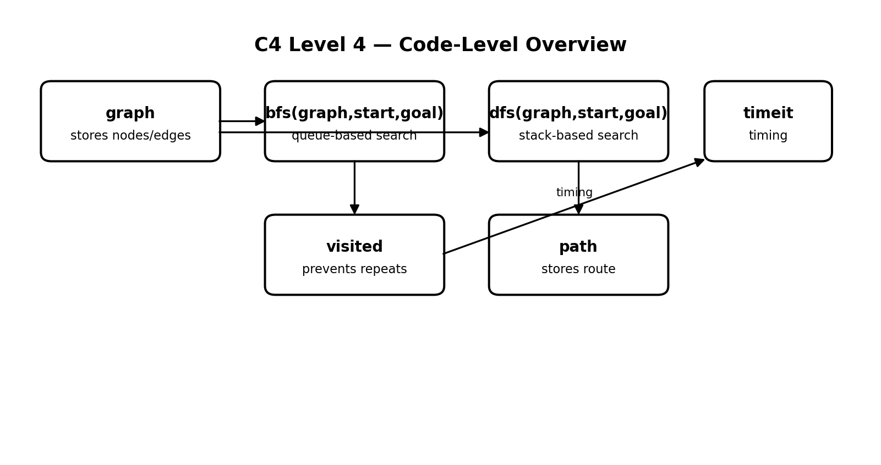
Code Element | Purpose
graph | Stores the graph structure and node connections.
bfs(graph, start, goal) | Performs Breadth-First Search using queue-based exploration.
dfs(graph, start, goal) | Performs Depth-First Search using stack/depth-first exploration.
visited | Tracks nodes that have already been explored.
path | Represents the route reconstructed/found by the search.
timeit | Measures repeated execution time for profiling in SLE-2.

6. Design Decisions
- BFS and DFS are kept in the same search system so that both strategies can be applied to the same graph.
- The graph representation is kept small and simple, matching the SLE-2 objective of comparing search behavior on a manageable problem.
- Visited-node tracking is used to avoid repeated processing during graph search.
- Performance measurement is treated as a supporting concern and is separated conceptually from the search logic.

7. AI Contribution Note
- AI tool used: ChatGPT.
- AI helped with understanding the C4 Model, organizing the architecture, preparing explanations, and structuring this report.
- My own work: I created and ran the BFS/DFS program in VS Code, checked the SLE-2 results, and used the actual project details as the basis for this architectural design.

8. Conclusion
This SLE-3 represents the existing BFS/DFS graph-search system using the Full C4 Model. The Context, Container, Component and Code levels show the system from a high-level user interaction down to the main implementation elements. The architecture connects the search algorithms, graph data, visited tracking, path handling and performance measurement. This helped relate the existing AI code to a clear software architecture.
GitHub Repository: https://github.com/shravani9103/AI-SLE2

