10. Implementing transaction to ensure data integrity and consistency.(use BEGIN TRANSACTION/START TRANSACTION, COMMIT, ROLL BACK along with other sql queries).
use college;
show databases;

start transaction;
COMMIT;
Rollback;
create database job9;
show databases;
use job9;

Create table account4(
account_id int primary key,
name varchar(50),
balance decimal(10,2)
);

Insert into account4 values
(1,'vaishali',1000.00),
(2,'Nisha',500.00);
select*from account4;

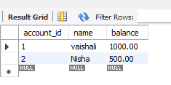

START TRANSACTION;
Update account4
set balance=balance-200
where account_id=1;
select*from account4;
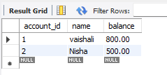

Update account4
set balance=balance+200
where account_id=2;
select*from account4;
COMMIT;
