8. Implement in Aggregation Function(e.g.sum,count,avg) on data base record run on mysql workbench.
use college;
show databases;
create table employee1(
emp_id int primary key auto_increment,
emp_name varchar(50),
department varchar(30),
salary decimal(10,2)
);
insert into employee1(emp_name,department,salary)VALUES
('sheya','IT', 40000),
('neha','HR', 55000),
('priyanka','Finance',60000),
('ankita','HR',70000),
('mohan','Finance',80000),
('shravani','HR',25000);
desc employee1;
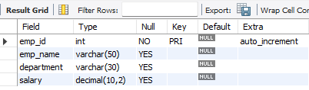

SUM()Total salary per department.
select department,SUM(salary) AS department_salary
FROM employee2
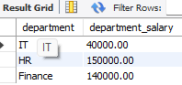
GROUP BY department;

COUNT() employees in each department.
select department,COUNT(*) AS total_employees
FROM employee2
GROUP BY department;
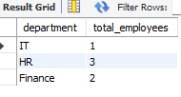

AVG() Average salary per department.
select department, AVG(salary) AS avg_salary
FROM employee2
GROUP BY department;
