7. Joning multiple tables using various types of joins(inner join, outer join).
Create Table 1:
use college;
show databases;
create table employee(
id int primary key,
name VARCHAR(100),
department_id int
);
insert into employee(id,name,department_id)VALUES
(1,'Harsh', 101),
(2,'pratiksha',102),
(3, 'aishwarya',103),
(4,'priya', NULL);
select*from employee;
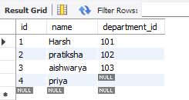

Create Table 2:
CREATE TABLE department1(
id INT PRIMARY KEY,
dept_name VARCHAR(100)
);
insert into department1(id,dept_name)values
(101,'HR'),
(102,'IT'),
(104,'Finance');
select* from department1;

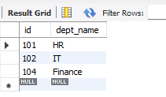

Inner Join:
select e. id, e.name, d. dept_name
from employee e
inner join department d on e . department_id = d.id;

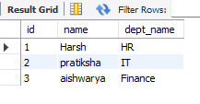

Outer Join:
select e.id, e.name, d.dept_name
from employee e
left join department d on e. department_id= d.id
union
select e.id,e.name,d.dept_name
from employee e
right join department d on e.department_id= d.id;
