3. Inserting and retrieving data form database able using SQLDML commands.
1. Select or create a database
create database science;
use science;
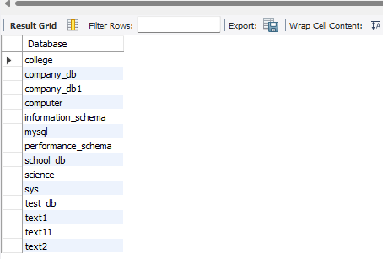
show databases;

2. create a table(teachers)
create table teachers(id int auto_increment primary key,
name varchar(100),
email varchar(100));
desc users;
3. Insert Data into the Table
insert into teachers (name,email)
values("shravani","shravanidakhane@gamil,com"),
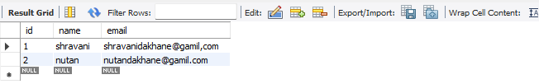
("nutan","nutandakhane@gamil.com");

4. Retrieve Data from the Table.
select*from teachers;
