- Pharmacovigilance (PV)
- Pharmacovigilance (PV) is the science of detecting, assessing, understanding and preventing adverse effects or other drug-related problems, especially after a medicine reaches the market.
- The word Pharmacovigilance comes from pharmacon = drug and vigilance = continuous attention. So, PV basically means keeping continuous watch on the safety of medicines.
- PV became important because of serious drug-related tragedies in the past, which occurred due to inadequate safety monitoring and safety guidelines.
- Sulphanilamide Elixir tragedy: Improper formulation/manufacturing of a sulphanilamide preparation caused many deaths, including children.
- Thalidomide tragedy: Thalidomide was used for morning sickness during pregnancy and caused phocomelia (severe limb deformities) and other birth defects in thousands of babies.
- A drug is tested in limited and controlled patient groups during clinical trials. After marketing, it is used by a much larger and more diverse population, including people with different diseases, genetics, diets, ethnicities and those taking multiple medicines (polypharmacy).
- Therefore, some adverse effects may only become apparent after the drug is widely used.
- PV continues after clinical trials and marketing approval, where safety information is continuously monitored.
- PV professionals collect and assess suspected ADRs reported by patients, doctors, pharmacists and other healthcare professionals, document and report important safety information to relevant stakeholders and regulatory authorities, and help support safety-related changes such as warnings, precautions, indications or product information.

- TOXIC EFFECTS OF DRUGS
Drug toxicity refers to the harmful or unwanted effects produced by a drug when it causes damage to the body or produces an excessive or abnormal response.
- Pharmacological Toxicity – it refers to predictable and usually dose-dependent adverse effects that are related to the known pharmacological action of the drug.
  - Primary Effects – These occur when the main pharmacological action of the drug becomes excessive.
E.g. Nifedipine → Hypotension: Excessive vasodilation caused by nifedipine can lead to an excessive fall in blood pressure
2. Secondary Effects – These occur due to a secondary action of the drug rather than its main therapeutic effect.
E.g. Broad-spectrum antibiotics → Diarrhoea: They can disrupt the normal intestinal flora, resulting in diarrhoea.

- Pathological Toxicity – it occurs when a drug or its metabolite causes direct damage to a body organ or tissue, leading to a pathological condition.
The toxicity may occur because the drug produces a toxic metabolite, particularly when the normal detoxification mechanism becomes overwhelmed.
E.g. Paracetamol - In normal doses, paracetamol is mainly metabolized through safe conjugation pathways.A small amount is converted into a toxic metabolite called NAPQI (N-acetyl-p-benzoquinone imine).Normally, NAPQI is detoxified by glutathione.

- Genetoxic reactions - Genotoxicity refers to the ability of a drug or its metabolites to damage genetic material such as DNA or chromosomes.
E.g. Cyclophosphamide → DNA damage → increased risk of secondary malignancies
Cyclophosphamide is an anticancer alkylating agent. It works partly by damaging DNA in rapidly dividing cancer cells, but it can also damage normal cells and may increase the long-term risk of secondary cancers such as leukemia.

- Allergic Reactions – These reactions are unpredictable, generally non-dose-dependent reactions caused by activation of the immune system against a drug or its metabolites.
They are not related to the drug’s normal pharmacological action and may occur even at normal therapeutic doses.
- Type I - Immediate Hypersensitivity Reaction
Type I reactions are immediate, IgE-mediated allergic reactions. The allergen binds to IgE antibodies attached to mast cells, causing mast-cell degranulation and release of inflammatory mediators such as histamine.
E.g. Penicillin → Anaphylaxis
A patient sensitized to penicillin may develop a rapid and potentially life-threatening allergic reaction after exposure.
- Type II - Cytotoxic Reaction
Type II reactions are antibody-mediated reactions in which IgG or IgM antibodies react with antigens present on cell surfaces, resulting in destruction of the cells.
E.g. Penicillin → Immune-mediated haemolytic anaemia. Penicillin can trigger an immune response against red blood cells, resulting in their destruction.
- Type III - Immune Complex-Mediated Reaction
Type III reactions occur when antigen-antibody complexes form and deposit in tissues or blood vessels, activating the complement system and producing inflammation.
E.g. enicillin → Serum sickness-like reaction
- Type IV -Delayed/Cell-Mediated Reaction
Type IV reactions are delayed allergic reactions mediated mainly by sensitized T-lymphocytes rather than antibodies.
They usually develop hours to days after exposure.
E.g. Lamotrigine → Stevens-Johnson Syndrome (SJS)/Toxic Epidermal Necrolysis (TEN)

- Idiosyncratic Reactions – Idiosyncratic Reactions are unpredictable and unusual reactions that occur in susceptible individuals and are not explained by the normal pharmacological action of the drug. They are generally not dose-dependent and are usually not immune-mediated. Some may be related to genetic differences, while the exact mechanism of others may remain unknown.
E.g. Chloramphenicol → Aplastic anaemia

- Pharmacogenetic variation - refers to the effect of genetic differences between individuals on their response to or metabolism of a drug.
Because of these genetic differences, the same drug and dose may be
Safe and effective in one person → harmful or ineffective in another person.
E.g. G6PD deficiency + Primaquine → Haemolytic anaemia
Patients with G6PD deficiency are more susceptible to oxidative stress. Primaquine can cause destruction of red blood cells and result in haemolytic anaemia in these patients.

- Teratogenicity - Teratogenicity: Ability of a drug to cause fetal harm, such as congenital abnormalities, functional disorders, or miscarriage.
- 18–55 days: Most vulnerable period → major congenital abnormalities
- After 56 days: Mainly functional/developmental disorders
- Risk depends on: Drug + dose + duration + stage of pregnancy

- Category A
No significant fetal risk found in controlled human studies.
Example: Levothyroxine → thyroid hormone replacement; considered safe when appropriately used during pregnancy.

- Category B
No fetal risk shown in animal studies, but adequate human studies are unavailable.
Example: Amoxicillin → commonly used antibiotic with no evidence of fetal harm in animal studies.

- Category C
Fetal risk cannot be ruled out; use when potential benefits justify the risk.
Example: Fluconazole → antifungal drug; certain exposures, especially higher/prolonged doses, may be associated with fetal abnormalities.

- Category D
Evidence of fetal risk exists, but benefits may outweigh the risk in serious maternal conditions.
Example: Phenytoin → controls epilepsy but may cause fetal hydantoin syndrome.

- Category X
Fetal risk clearly outweighs any possible benefit; contraindicated in pregnancy.
Example: Thalidomide → can cause severe limb defects (phocomelia) in the fetus.

- Categorization of ADRs
According to Time of Onset
    - Acute: Occurs within <60 minutes of drug administration.
    - Sub-acute: Occurs within 60 minutes–24 hours.
    - Latent: Occurs after 2 days or later following drug exposure.
According to Severity
    - Minor: No specific treatment, hospitalization, or antidote required.
    - Moderate: Requires change in therapy or additional treatment; hospitalization may sometimes be needed.
    - Severe: Life-threatening or causes permanent damage; requires intensive treatment.
    - Lethal: Results in death of the patient.

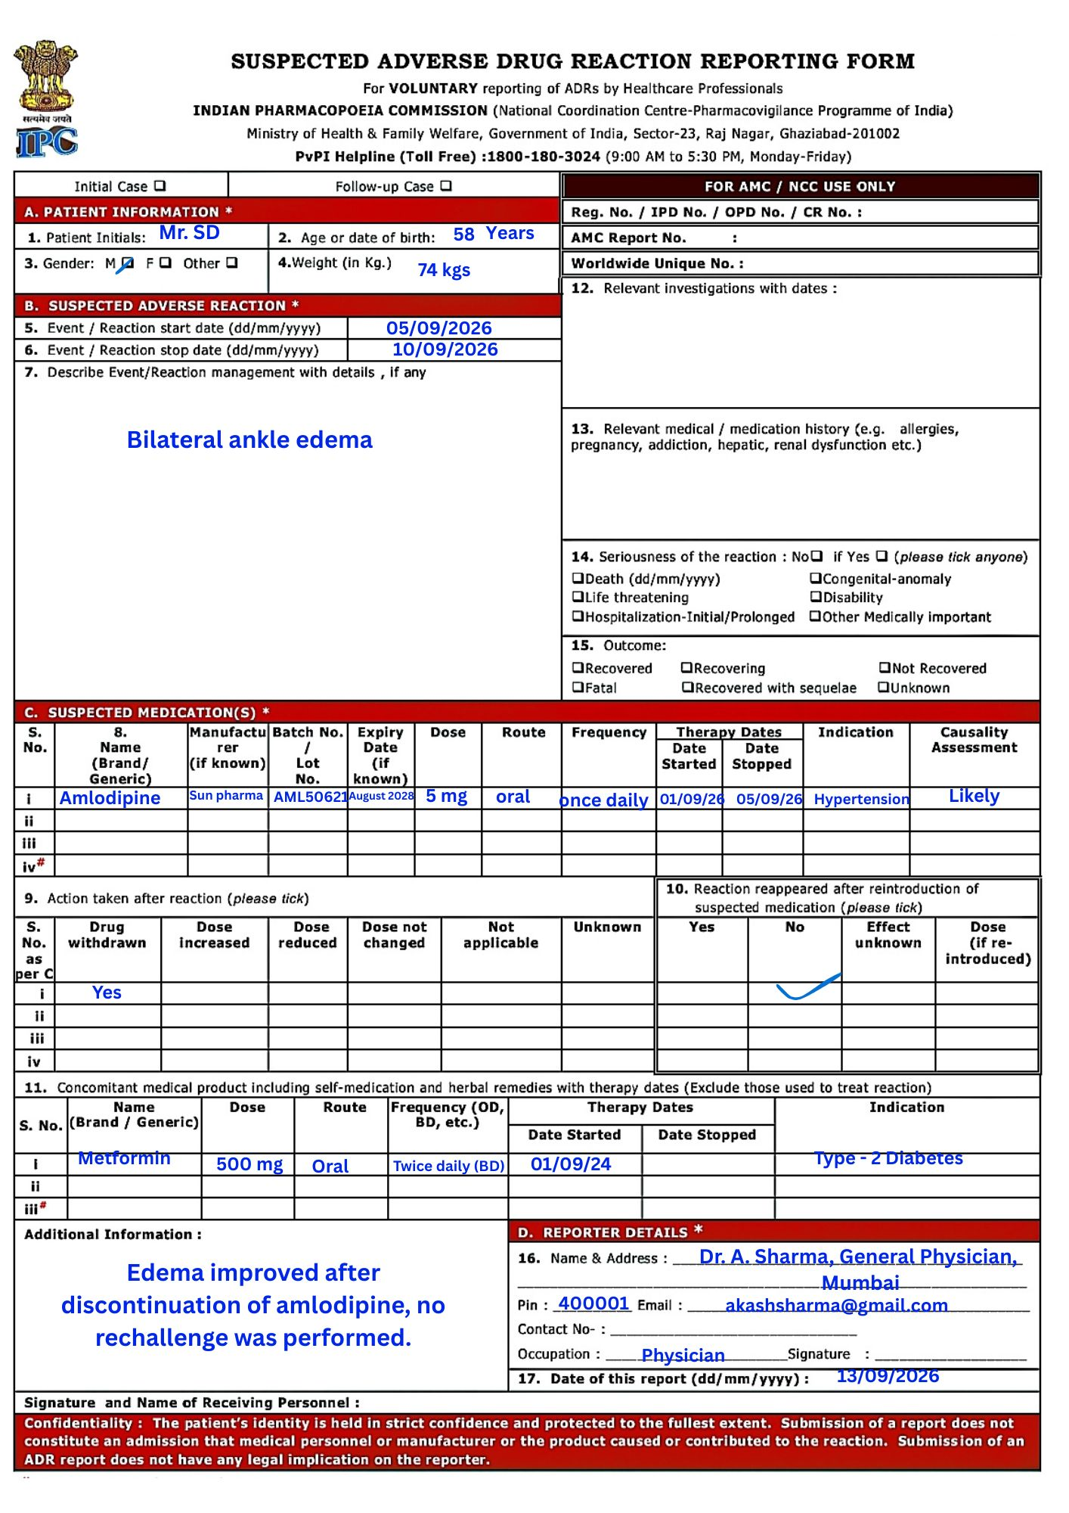
WHAT I LEARNED -:
- Learned the basic concepts of Pharmacovigilance (PV) and ADR identification.
- Understood the different types of drug toxicities and their effects.
- Learned how to identify, assess, and document an ADR.
- Gained practical knowledge of filling an ADR reporting form using a patient case.

