TASK 3
- What is Causality Assessment?
- Causality assessment is also called relatedness assessment. It is the process used to determine whether there is a causal relationship between exposure to a drug and an adverse event. It deals with:
- Adverse Event (AE): An unwanted medical occurrence where the causal relationship with the drug has not yet been established.
- Adverse Drug Reaction (ADR): Once causality has been assessed and a relationship with the drug is established, the AE is considered an ADR.
- SAE (Serious Adverse Event) vs SUSAR (Suspected Unexpected Serious Adverse Reaction): The term “reaction” in SUSAR indicates that a causal relationship with the drug is suspected.
- Causality assessment is generally carried out by a medical reviewer, usually a physician, within a pharmaceutical company.

Four Factors Associated with Causality
  - Drug-Related Factors
- Labeledness: Determines whether the reaction is already known or documented for the particular drug.
- Example: Dry cough is a known adverse effect associated with ACE inhibitors such as enalapril.
- Predisposing factors of the drug itself: Certain characteristics of a drug may increase the possibility of toxicity.
- Example: Digoxin has a narrow therapeutic range, so small increases in its concentration can lead to toxicity.
- Concomitant medications: Other medicines taken by the patient along with the suspected drug may contribute to the adverse event.
- Example: Clarithromycin taken with atorvastatin can increase statin levels and raise the risk of muscle-related toxicity.

  - Event-Related Factors
- These ADRs are identified through documented physical findings, clinical diagnoses, or reported symptoms.
- Example: A patient developing swelling of the face and difficulty breathing after taking a medicine.

  - Patient-Related Factors
- Pharmacogenomics: Different individuals may metabolize and respond to the same medicine differently because of genetic variations.
- Example: Some patients may develop hemolysis after taking primaquine due to G6PD deficiency.
- Medical history and predisposing factors: The patient’s previous medical and medication history can provide information about their susceptibility and response to certain medicines.
- Example: A patient with a history of peptic ulcer may have a higher risk of gastrointestinal bleeding when using NSAIDs.
- Past history: Previous reactions to medicines may increase the possibility of a similar reaction in the future.
- Example: A patient who previously developed a severe rash with a particular antibiotic may experience a similar reaction when exposed to it again.

  - Clinical Factors
- Temporal relationship: The relationship between the drug and the reaction is assessed by considering the time between drug administration and the onset of the event. It may also depend on the half-life of the drug.
- Example: Drowsiness occurring shortly after taking a sedative drug may support a possible temporal relationship.
- Dechallenge/Rechallenge:
- Dechallenge: Stopping the suspected drug and observing whether the adverse event improves or disappears.
- Rechallenge: Restarting the suspected drug and observing whether the adverse event occurs again.
- Response to corrective treatment: This refers to treatment given to manage the adverse event.
- Example: If a patient develops an allergic rash and it improves after receiving an antihistamine, this may support the management of the suspected reaction. If the rash does not improve, another cause may need to be considered.

- Causality Assessment Methods
A. The Naranjo Algorithm
The Naranjo Algorithm is a 10-question scoring tool used for causality assessment. Each question is answered as Yes / No / Do Not Know, with points assigned as +1, +2, -1, or 0, depending on the question.
Score Interpretation Table
Total Score | Causality Assessment
≥ 9 | Definite
5-8 | Probable
1-4 | Possible
0 | Doubtful
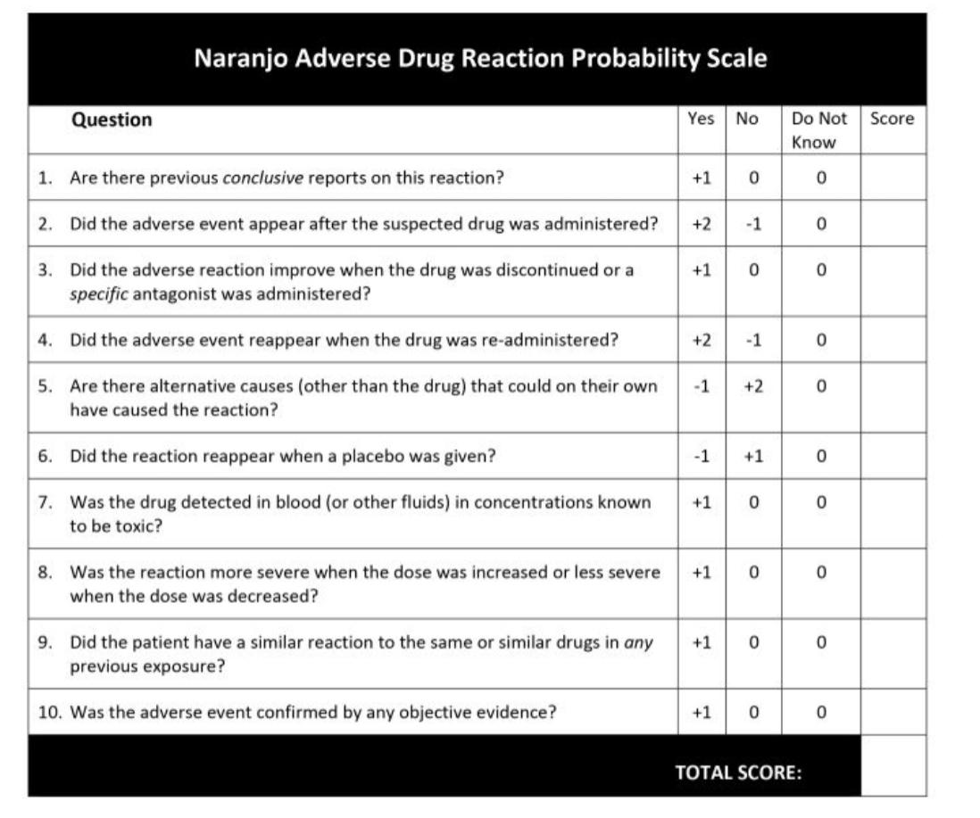
Case 1: On June 1, Raj started Amoxicillin 500mg three times daily for a throat infection.
June 2: Developed itchy rashes all over his body.
June 3: Dose reduced to 250mg TID.
June 4: Rash disappeared.
Due to worsening infection, dose increased back to 500mg.
June 6: Generalized itchy rashes reappeared.
Applying the Naranjo questions:
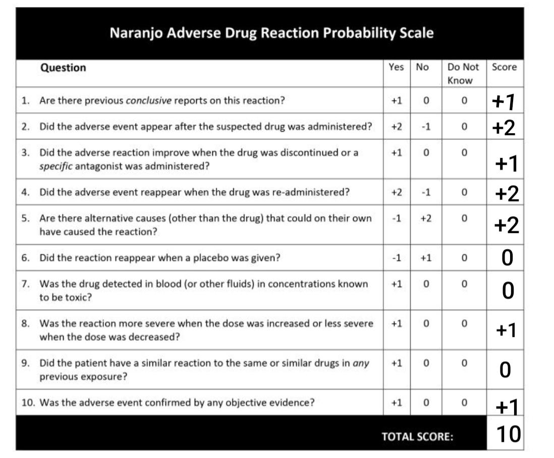
Causality Assessment – Definite.
B. WHO-UMC Causality Assessment System
The WHO-UMC Causality Assessment System was developed by the World Health Organization (WHO) and the Uppsala Monitoring Centre (UMC).
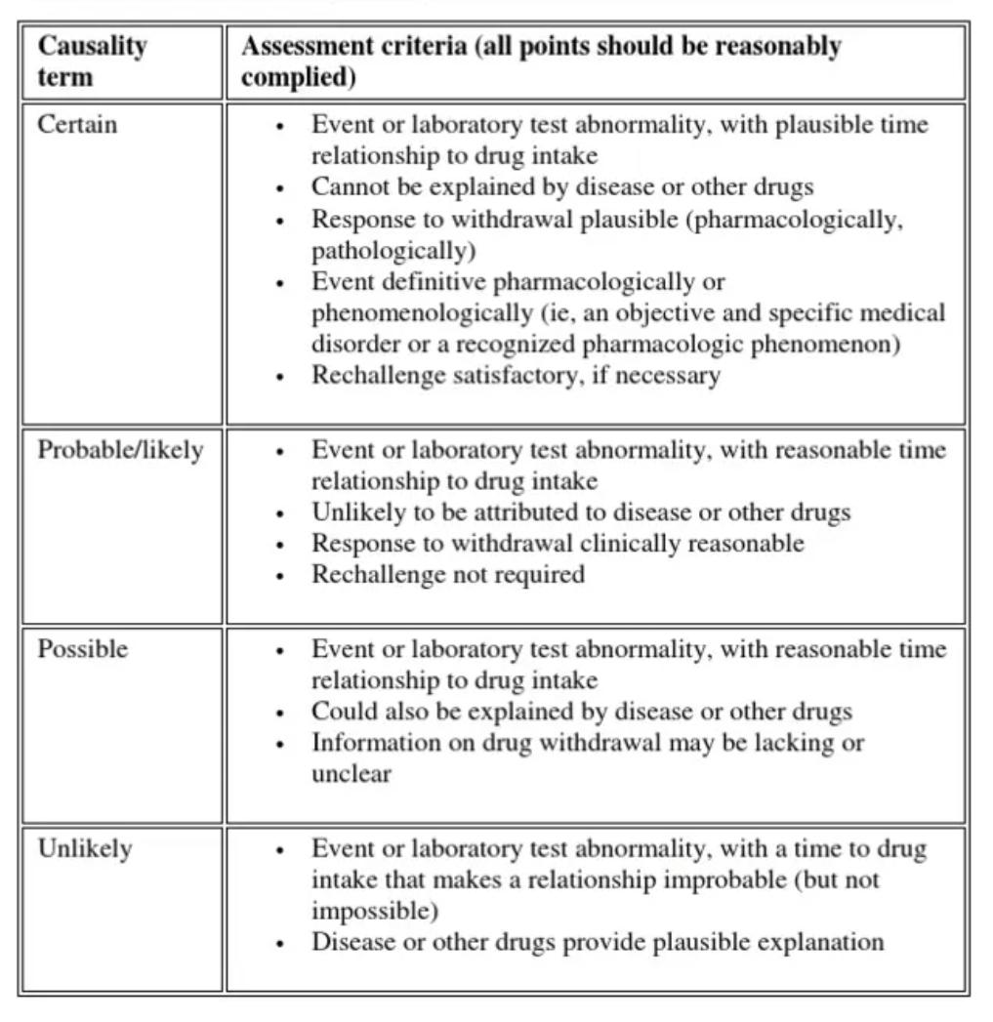
Applying the WHO-UMC Causality Assessment System
The rash appeared after amoxicillin was started, cannot be explained by another drug or disease, disappeared after dose reduction, and reappeared after the dose was increased. Thus, the timing, withdrawal response, and rechallenge support Certain causality.
Case 2 – The Naranjo Algorithm
A 35-year-old patient was prescribed Ibuprofen 400 mg three times daily for severe dental pain.
June 1: Started Ibuprofen 400 mg TID.
June 3: Developed severe stomach pain and black-colored stools.
June 4: Ibuprofen was stopped.
June 6: Stomach pain improved and black stools stopped.
The patient was not taking any other medication and had no previous history of gastrointestinal disease.
June 8: Due to persistent dental pain, the patient accidentally took Ibuprofen 400 mg again.
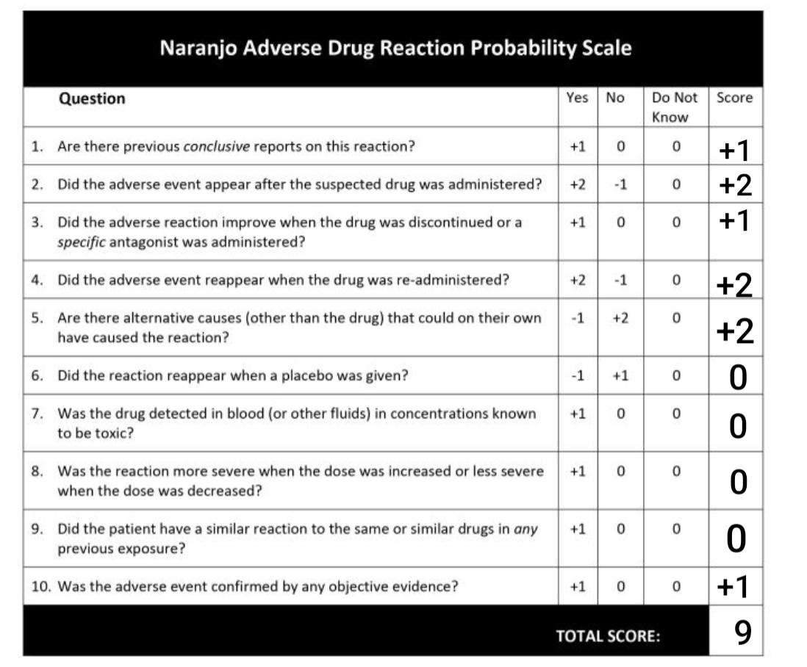
June 9: Stomach pain and black-colored stools reappeared
Causality Assessment – Definite.
B. WHO-UMC Causality Assessment System
The WHO-UMC Causality Assessment System was developed by the World Health Organization (WHO) and the Uppsala Monitoring Centre (UMC).
Applying the WHO-UMC Causality Assessment System
The symptoms appeared after ibuprofen was started, there was no other medication or previous GI disease to explain them, the symptoms disappeared after stopping ibuprofen, and reappeared after restarting it. Thus, the criteria support Certain causality.

- What is Implied Causality?
When a patient experiences an adverse event and reports it either to their physician or directly to the pharmaceutical company, it is considered a spontaneous/implied case report.Even if a company representative personally believes that the event is not related to the drug, they should not immediately exclude a possible causal relationship. Incorrectly ruling out causality may result in a genuine adverse event not being reported, which can have regulatory and patient-safety consequences.This is a safeguard principle: when there is uncertainty, the possibility of relatedness should be considered rather than dismissing it prematurely.
- Causality Assessment for Vaccines
Causality assessment for vaccines differs from drug causality assessment and is known as AEFI (Adverse Event Following Immunization).
- Categories of AEFI Causes
- Vaccine product-related / quality-related:
Example: A vaccine becoming ineffective or contaminated due to improper storage at the required temperature.
- Immunization process/vaccination-related:
This considers factors such as pharmacogenomics and type 2 reactions associated with the vaccination process.
- ADR:These may be coincidental or genuine adverse events related to the vaccine itself.
Example: Fever or mild injection-site swelling following vaccination.

- Five WHO Principles Underpinning AEFI Causality Assessment
- Strength: The strength of the association between the AEFI and administration of the vaccine dose.
- Consistency: Whether the reaction has been repeatedly reported or observed.
- Specificity: Whether the ADR is specifically associated with the drug or vaccine.
- Temporal relationship: The time between vaccination and the onset of the event, such as immediately, the next day, or several weeks later.
- Biological plausibility: Establishing whether there is a possible biological link between the drug or vaccine and the event.

- WHO’s Four-Step Process for AEFI Causality Assessment
  - Eligibility check: Determine whether the event qualifies as an AEFI and complete a checklist to collect all relevant information. This is carried out using the required steps

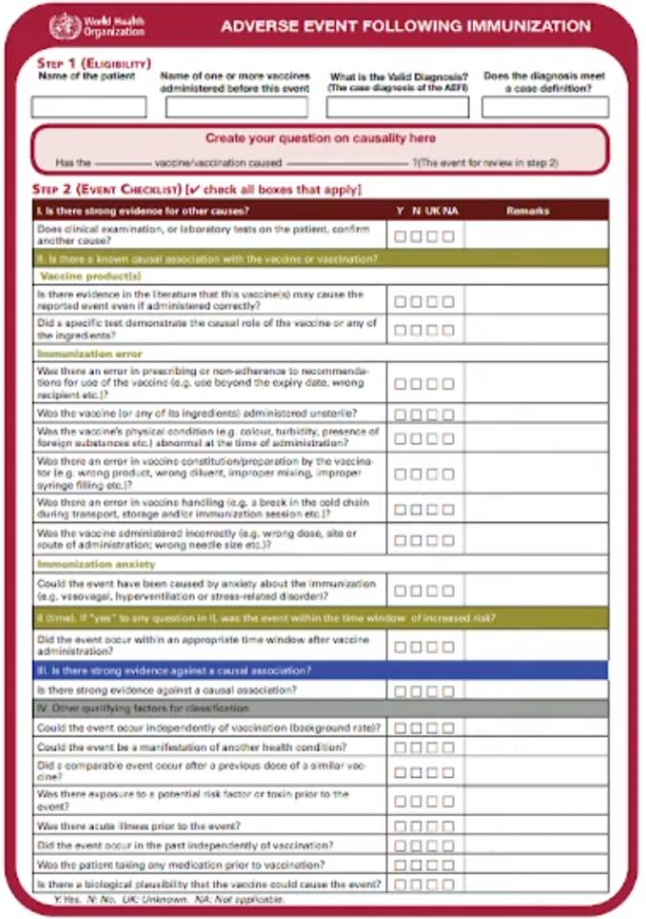
  - Algorithm/flowchart application: Apply the algorithm or flowchart to determine whether there is a known causal relationship with the vaccine.
  - Gathering evidence: Collect evidence to determine whether the ADR was caused by the same drug or vaccine.
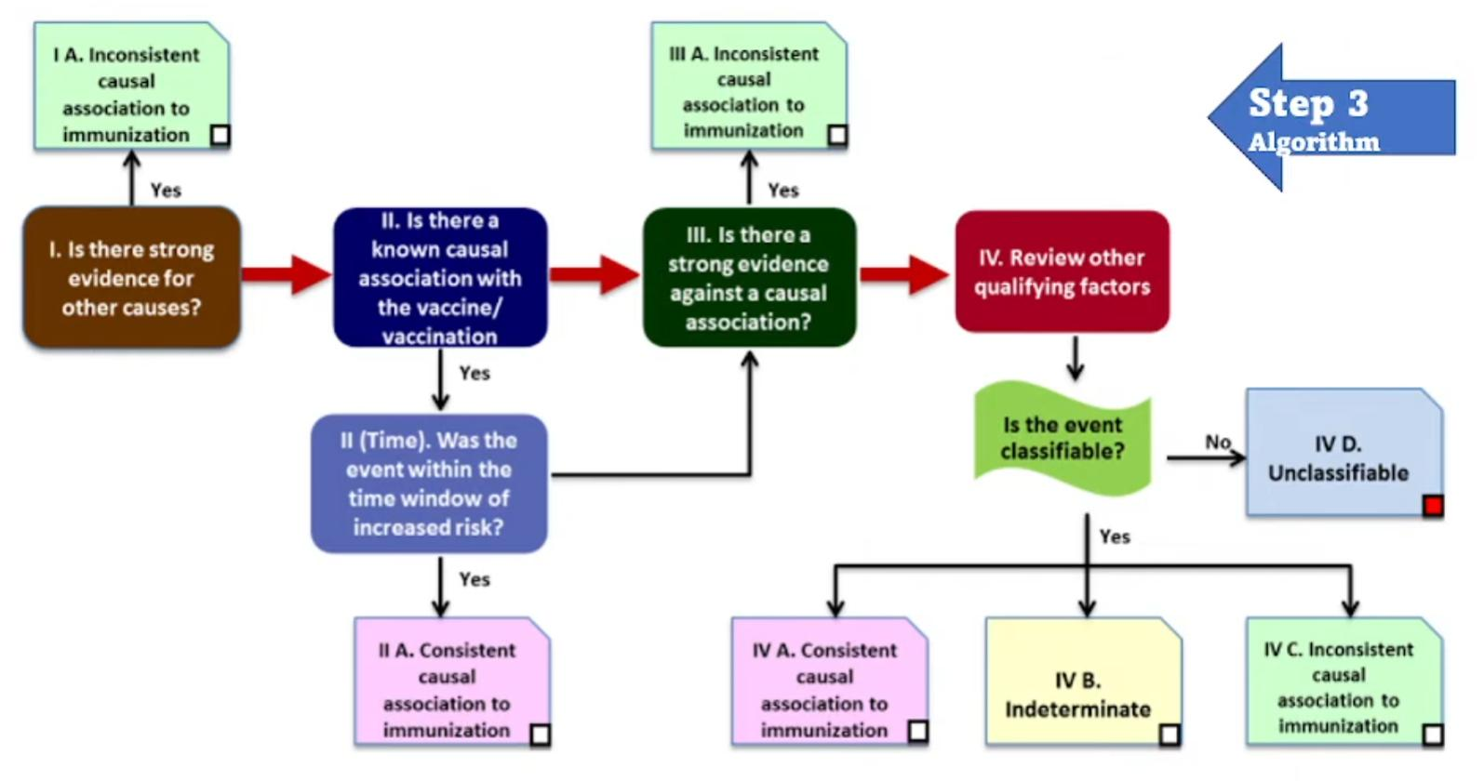
  - lassification into one of the following categories:
- Consistent causal association to immunization: A causal relationship exists.
- Indeterminate: The relationship is unclear or doubtful, or there is insufficient information to make a decision.
- Inconsistent causal association: The event is unlikely to be related to the immunization.
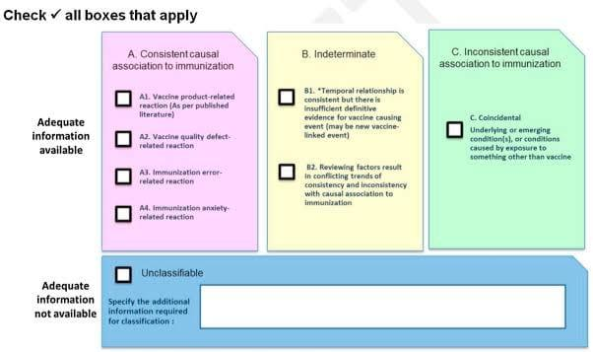
- Unclassifiable: There is insufficient information to categorize the event.

