TASK 5
This task simulates the role of a Drug Safety Associate in pharmacovigilance. In this task, a detailed Individual Case Safety Report (ICSR) will be assessed by applying the learnings from the previous tasks. The assessment includes ADR identification, ADR reporting and documentation, causality assessment, and classification of the case based on seriousness, severity, and expectedness. A complete case narrative and final review will also be prepared based on the available case information.

- Case – Suspected ADR Report
- Patient: TK, 56-year-old female, weight -67kgs .
- Relevant medical history: Rheumatoid arthritis/joint pain and Hypertension
No previous history of gastrointestinal bleeding or peptic ulcer disease
- Concomitant medication: Amlodipine 5 mg once daily.
- Suspect drug: Diclofenac 50 mg BD, orally, prescribed for rheumatoid arthritis/joint pain.
- Timeline of events:
- 05/09/2026: Diclofenac initiated.
- 12/09/2026: Patient developed severe upper abdominal pain, dizziness and black, tarry stools.
- 13/09/2026: Patient admitted to hospital. Hemoglobin was 7.8 g/dL. Endoscopy revealed a gastric ulcer with active bleeding.
- 13/09/2026: Diclofenac discontinued. Patient received IV fluids, PPI therapy and 2 units packed RBCs.
- 18/09/2026: Patient discharged with clinical improvement.
- 20/09/2026: Case reported by treating hospital physician.
- Laboratory Tests / Investigations
  - Hb: 7.8 g/dL on 13/09/2026
  - Upper GI endoscopy: Gastric ulcer with active bleeding
  - Follow-up Hb: 9.6 g/dL
  - Other laboratory results: Not reported
- Outcome: Improved/recovering; gastrointestinal symptoms resolved and hemoglobin improved to 9.6 g/dL.
- Reporter: Treating hospital physician.

- ADR identification: Severe upper abdominal pain, melena and gastric ulcer with active gastrointestinal bleeding.
- Suspected drug: Diclofenac 50 mg BD.
- Expectedness:

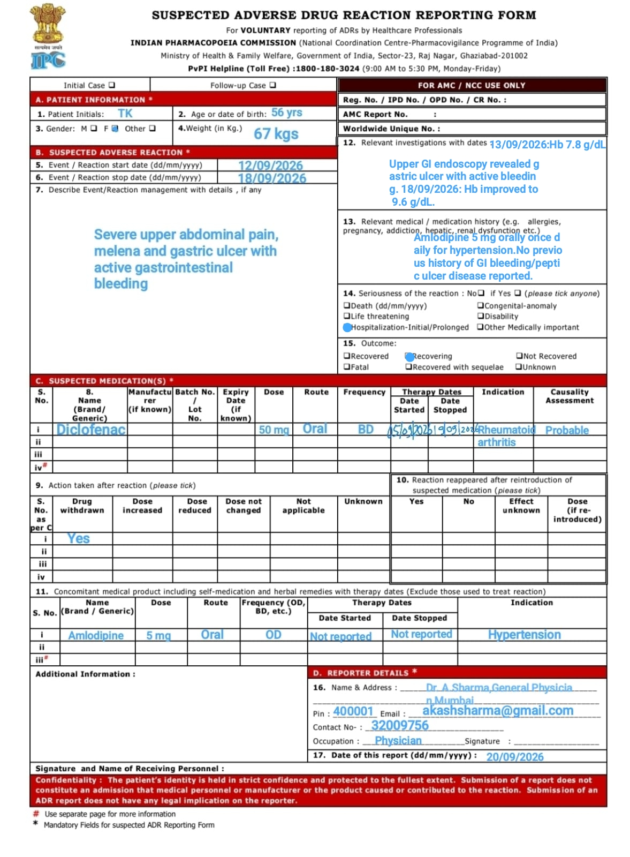
ADR REPORTING FORM-
CAUSALITY ASSESSMENT (BY Naranjo and who-umc method)
- NARANJO METHOD
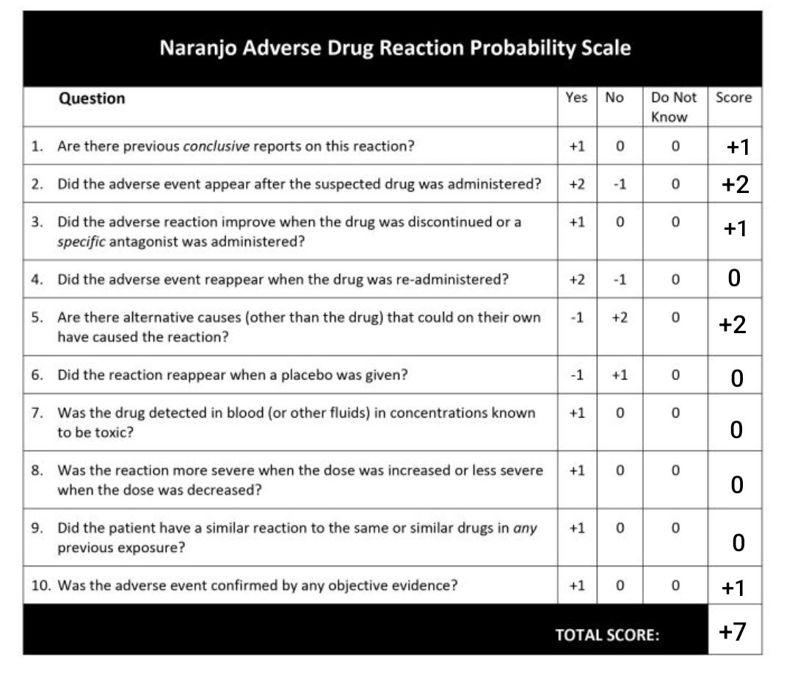
- Interpretation Of Total Score-
Total Score | Causality assessment
≥ 9 | Definite
5-8 | Probable
1-4 | Possible
≤ 0 | Doubtful

Conclusion:
The Naranjo Algorithm resulted in a total score of 7, indicating a Probable relationship between the suspected drug and the reported adverse drug reaction.

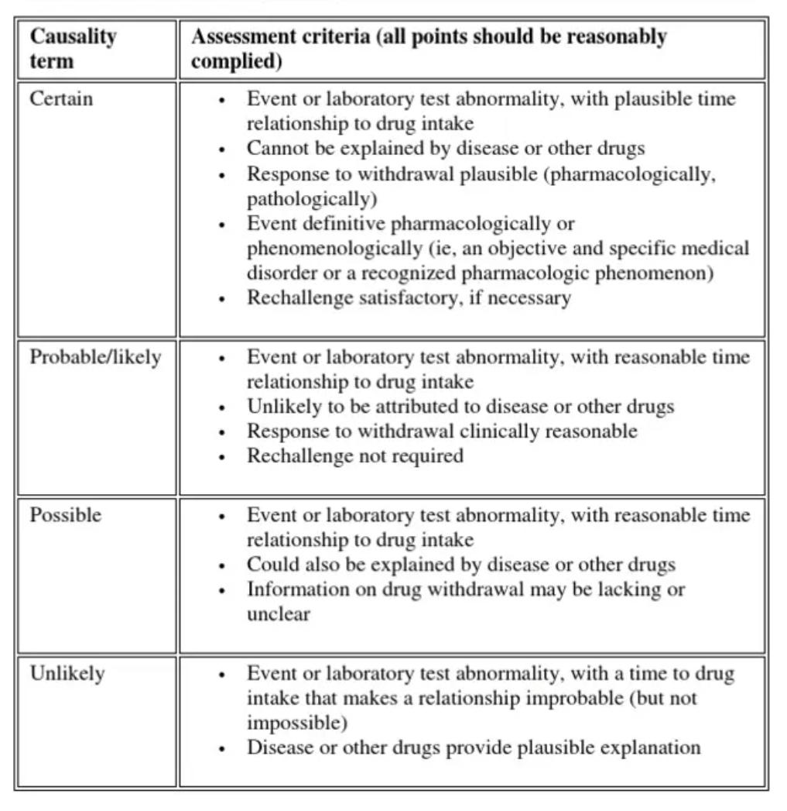
- WHO-UMC METHOD

Conclusion:
According to the WHO-UMC causality assessment, the relationship between the suspected drug and the reported adverse drug reaction was classified as Probable/Likely.

- CLASSIFICATION:
- SERIOUSNESS :
The patient required hospitalization, had a confirmed gastric ulcer with active bleeding, a hemoglobin level of 7.8 g/dL, and required 2 units of packed red blood cells. Therefore, this ADR is classified as Serious – requires/prolongs hospitalization.

- EXPECTEDNESS :
The reported gastrointestinal ulceration and gastrointestinal bleeding are recognized adverse reactions associated with diclofenac and are described in the product information/SmPC. Therefore, the ADR is classified as Expected.

- Case Narrative
A 56-year-old female receiving diclofenac 50 mg twice daily developed severe upper abdominal pain, dizziness, and black/tarry stools after 7 days of treatment. She was hospitalized and diagnosed with a gastric ulcer with active gastrointestinal bleeding. Diclofenac was discontinued, and she received a PPI, IV fluids, and 2 units of packed RBCs. The patient improved following treatment, with resolution of melena and improvement in hemoglobin levels.

- Final Review
The case was assessed as Probable based on the Naranjo score of 7 and Probable/Likely according to WHO-UMC criteria. The ADR was classified as Serious due to hospitalization, Severe in intensity, and Expected based on the known gastrointestinal risks of diclofenac. The patient was improving/recovering, and no rechallenge was performed.

