APEX PLANET SOFTWARE PVT. LTD.

CYBERSECURITY INTERNSHIP

TASK 1: FOUNDATION & ENVIRONMENT SETUP

Internship Duration: 60 Days

Submitted By:
Shravani Balu Dhaybar
Course:
B.Sc. Cyber Security / Digital Science

Task Duration:
Days 1–12

Submitted To:
Apex Planet Software Pvt. Ltd.

Academic Year: 2026–27

TABLE OF CONTENTS

1. Introduction
2. Objectives
3. Cybersecurity Fundamentals
4. CIA Triad
5. Types of Cyberattacks
6. Cybersecurity Attack Vectors
7. Lab Environment Setup
8. Linux Fundamentals and Commands
9. Networking Fundamentals
10. Cryptography Fundamentals
11. Practical Implementation Using OpenSSL
12. Cybersecurity Tool Familiarization
13. Practical Results and Screenshots
14. Conclusion

1. INTRODUCTION

Cybersecurity is the practice of protecting computers, networks, applications, and digital information from unauthorized access, attacks, damage, and data theft.
It plays an important role in protecting personal information, business systems, and online services. Cybersecurity includes different areas such as network security, application security, cryptography, ethical hacking, and information security.
As part of the Apex Planet Cybersecurity Internship, this task focuses on understanding cybersecurity fundamentals, networking concepts, Linux commands, cryptography, and practical security tools.

2. OBJECTIVES

The main objectives of this task are:

1. Understand the basic concepts of cybersecurity.
2. Study the CIA Triad and common cyberattacks.
3. Set up a virtual cybersecurity lab environment.
4. Understand Linux commands and file permissions.
5. Learn networking concepts and protocols.
6. Understand encryption, hashing, and digital certificates.
7. Perform basic practical exercises using OpenSSL.
8. Become familiar with Wireshark, Nmap, Burp Suite, and Netcat.

3. CYBERSECURITY FUNDAMENTALS
Cybersecurity protects digital systems, networks, and information against cyber threats.
It helps maintain the confidentiality, integrity, and availability of information.
3.1 CIA TRIAD
The CIA Triad is a fundamental security model consisting of three principles.
1. Confidentiality
Confidentiality ensures that sensitive information is accessible only to authorized users. Passwords, encryption, and access controls help maintain confidentiality.
2. Integrity
Integrity ensures that information remains accurate and is not modified without authorization. Hashing and digital signatures help verify data integrity.
3. Availability
Availability ensures that systems, applications, and information remain accessible when required. Backups, redundancy, and disaster recovery help maintain availability.

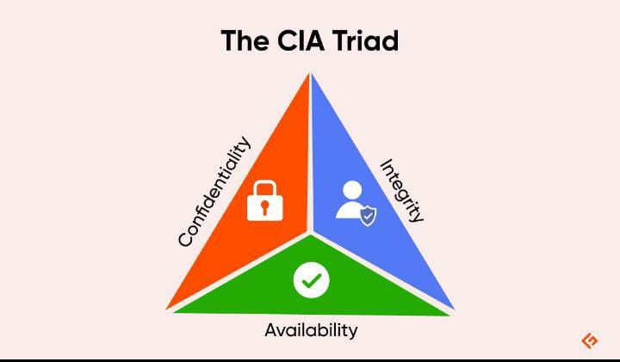
principle | purpose | example
confidentiality | Protect information | Passwords
integrity | Maintain data accuracy | SHA256 hashing
Availability | Ensures access | Data backups

4. TYPES OF CYBERATTACKS
1. Phishing
Phishing is a cyberattack in which attackers use fake emails, messages, or websites to trick users into revealing sensitive information.
2. Malware
Malware is malicious software designed to damage systems, steal information, or gain unauthorized access.
3. Distributed Denial of Service (DDoS)
A DDoS attack attempts to make a website or online service unavailable by overwhelming it with traffic from multiple sources.
4. SQL Injection
SQL Injection is a web application vulnerability in which malicious SQL statements are inserted into input fields to manipulate database queries.
5. Brute Force Attack
A brute force attack attempts to guess passwords by trying multiple combinations.
6. Ransomware
Ransomware is malware that encrypts or locks a victim's files and demands payment for their recovery.

5. CYBERSECURITY ATTACK VECTORS
An attack vector is a method or path used by an attacker to gain unauthorized access to a system or network.
1. Social Engineering
Social engineering involves manipulating people into revealing confidential information or performing unsafe actions.
2. Wireless Attacks
Wireless attacks target Wi-Fi networks and wireless communication systems. Weak passwords and insecure configurations can increase security risks.
3. Insider Threats
Insider threats occur when employees, contractors, or other authorized individuals misuse their access to an organization's systems or information.

Prevention Methods

- Use strong passwords.
- Enable multi-factor authentication.
- Keep software updated.
- Avoid suspicious links and attachments.
- Use secure Wi-Fi networks.
- Apply proper access controls.

6. LAB ENVIRONMENT SETUP
6.1 Introduction
A virtual cybersecurity lab is an isolated environment used to practice cybersecurity concepts and security testing safely.
For this internship task, VirtualBox is used to create and manage virtual machines.
6.2 Lab Components
1. VirtualBox
Oracle VirtualBox is virtualization software that allows multiple operating systems to run on a single physical computer.

2. Kali Linux
Kali Linux is a Linux distribution designed for penetration testing and security assessment. It includes various cybersecurity tools.

3. Ubuntu Server
Ubuntu Server is used as the target environment for practical networking and web application security exercises.

4. DVWA
Damn Vulnerable Web Application (DVWA) is an intentionally vulnerable web application designed for learning and practicing web application security in a controlled environment.

6.3 Network Configuration
A private Host-Only network is used to allow communication between virtual machines without exposing the lab machines directly to an external network.
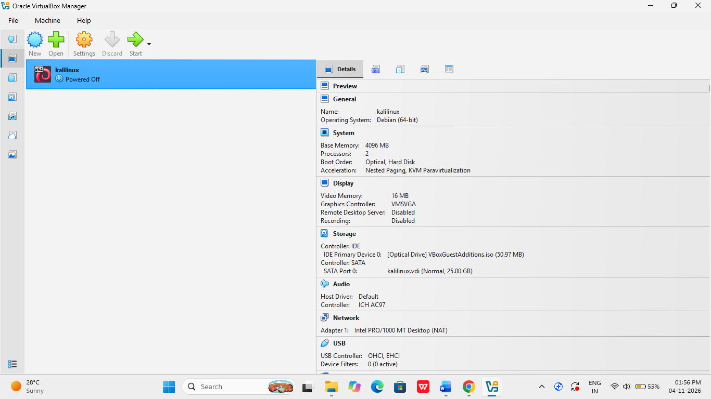
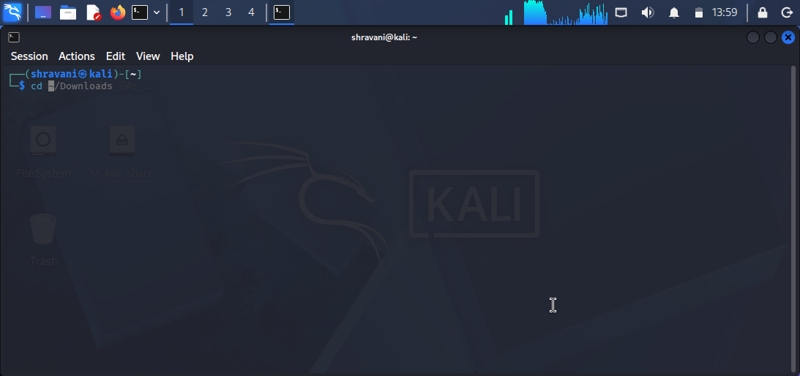
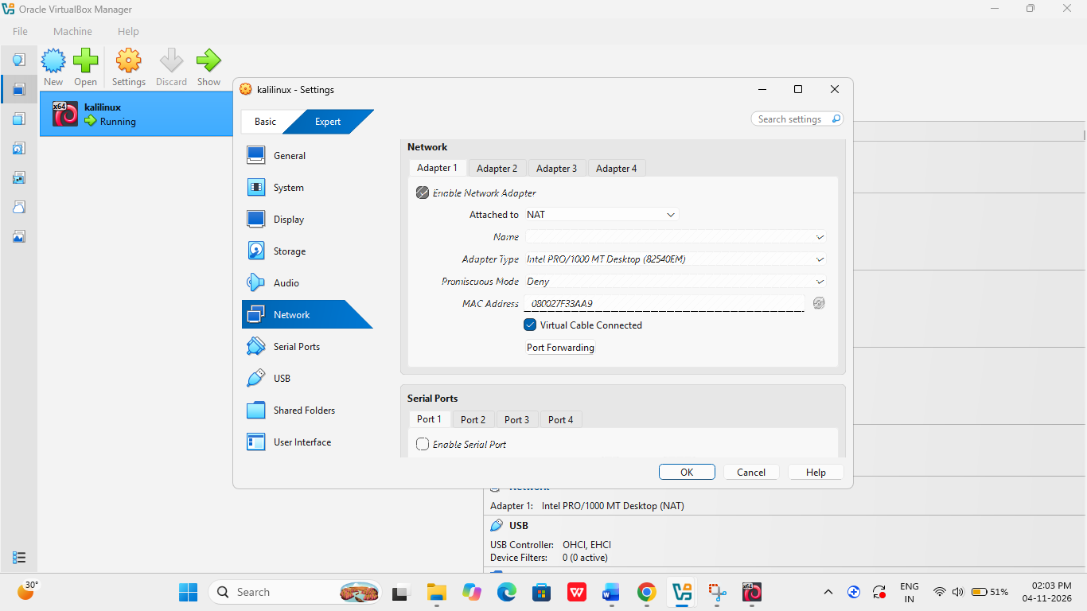

7. LINUX FUNDAMENTALS AND COMMANDS
Linux is an open-source operating system widely used in servers, cybersecurity, and system administration.
The following commands are useful for navigating the Linux file system and managing systems.

7.1 File System Navigation
Command | Purpose
pwd | Displays current directory
ls | Lists files and directories
ls -la | Displays all files with details
cd | Changes directory

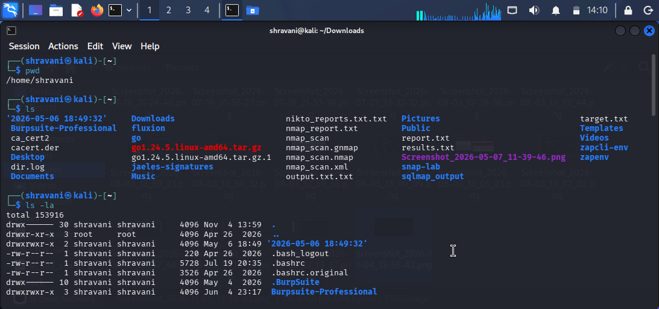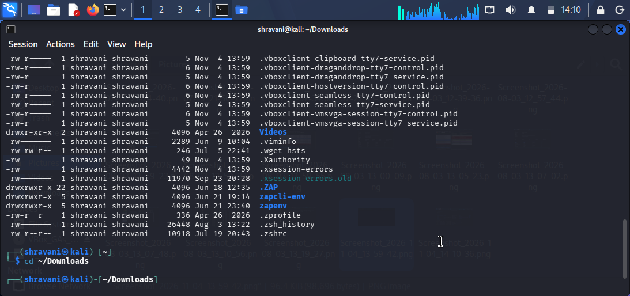

7.2 File and Directory Permissions
Command | Purpose
chmod | Changes file permissions
chown | Changes file ownership
mkdir | Creates a directory
touch | Creates an empty file

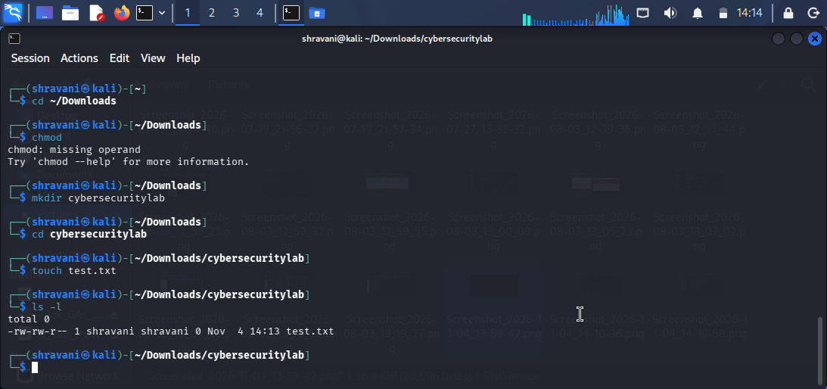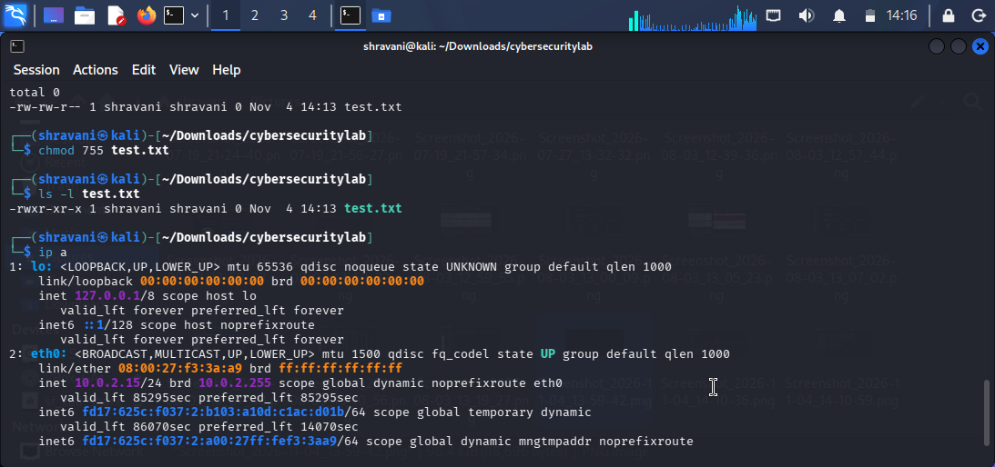
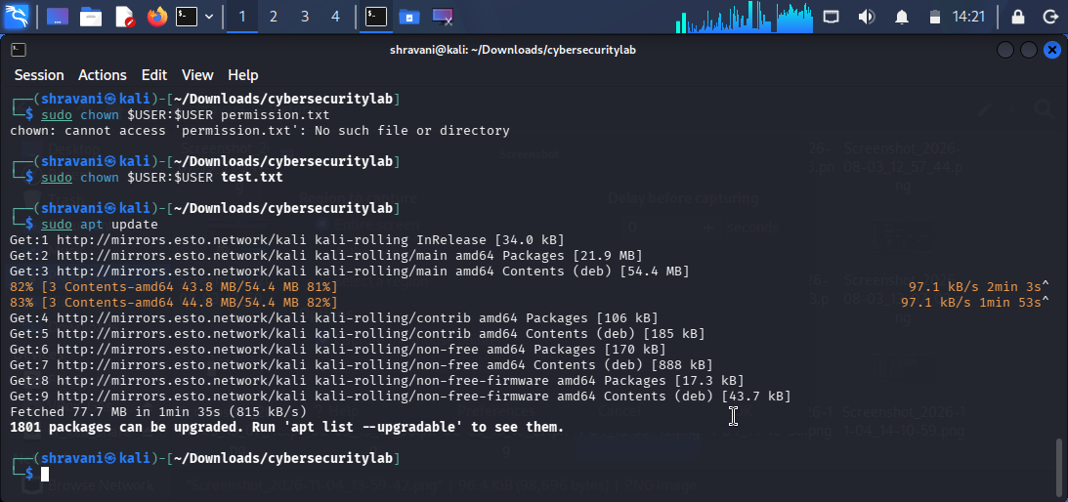

7.3 Package Management
Command | Purpose
apt update | Updates package information
apt install | Installs packages
dpkg -l | Lists installed packages

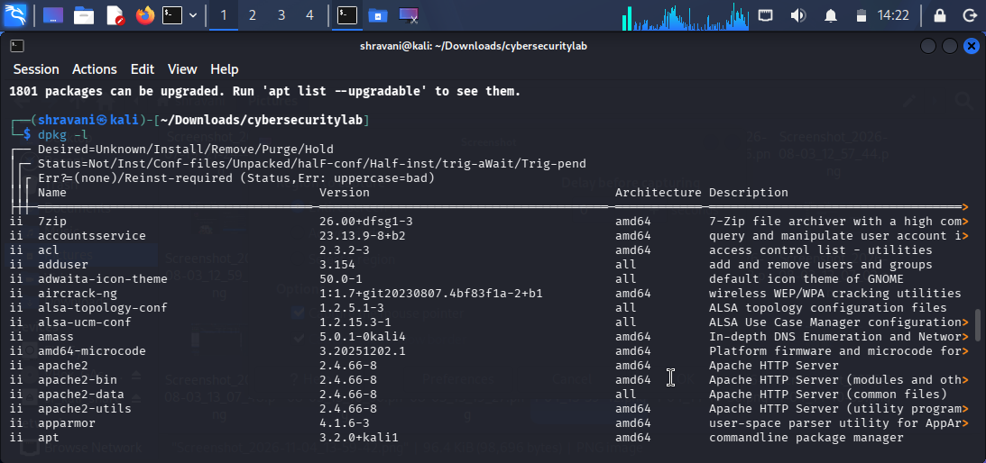

7.4 Networking Commands
Command | Purpose
ip a | Displays IP addresses
ping | Tests network connectivity
netstat | Displays network connections
traceroute | Shows the network route
ifconfig | Displays network interface information

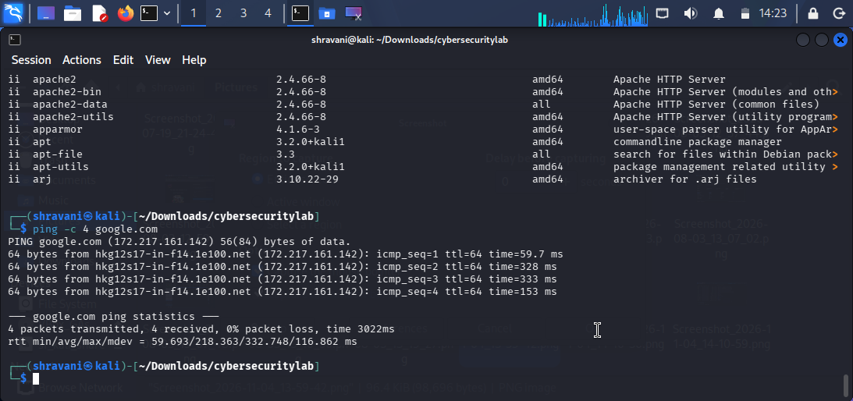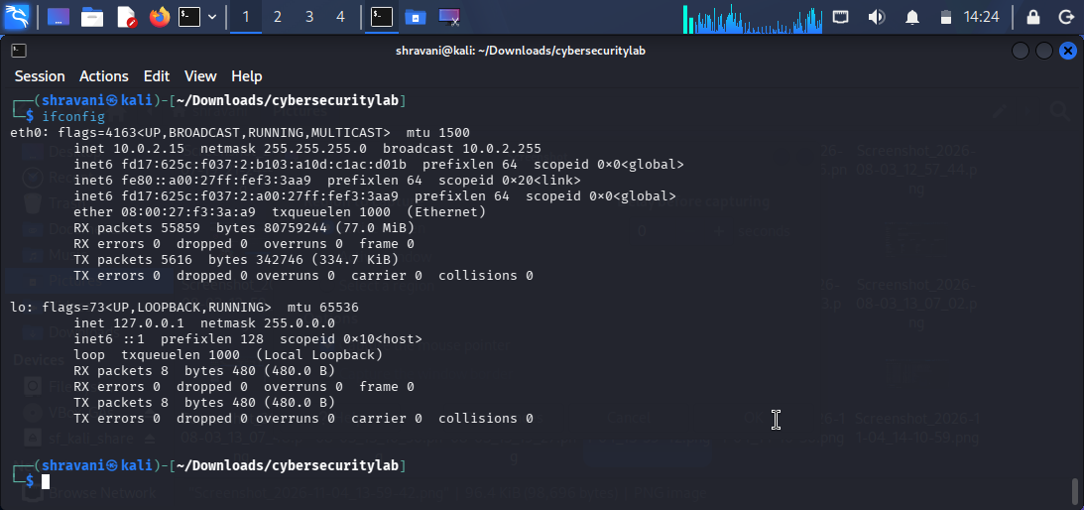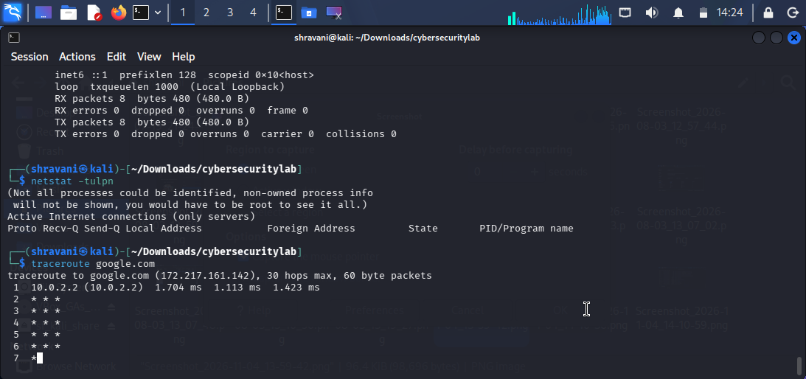

8. NETWORKING FUNDAMENTALS
Computer networking allows devices to communicate and exchange information.
8.1 OSI MODEL
The OSI model contains seven layers.
Layer | Name | Function
7 | Application | Provides network services
6 | Presentation | Data formatting and encryption
5 | Session | Manages communication sessions
4 | Transport | Provides data delivery
3 | Network | Handles IP addressing and routing
2 | Data Link | Handles MAC addressing
1 | Physical | Transmits raw bits

8.2 TCP/IP MODEL
The TCP/IP model is used for communication over the internet. It includes Application, Transport, Internet, and Network Access layers.
8.3 DNS
Domain Name System (DNS) converts domain names into IP addresses.
8.4 HTTP AND HTTPS
HTTP is a protocol used for communication between web browsers and web servers. HTTPS uses TLS to provide encrypted communication.
8.5 IP ADDRESSING
An IP address is a unique logical address assigned to a device on a network. IPv4 uses 32 bits, whereas IPv6 uses 128 bits.
8.6 SUBNETTING AND NAT
Subnetting divides a network into smaller logical networks. Network Address Translation (NAT) allows private IP addresses to communicate with external networks using address translation.
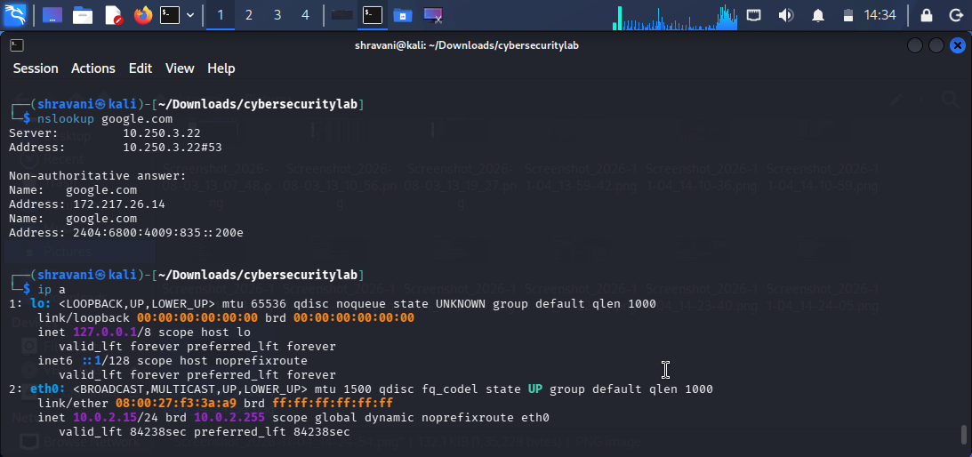

9. CRYPTOGRAPHY FUNDAMENTALS
Cryptography is the technique of protecting information by converting it into a secure format.
9.1 SYMMETRIC ENCRYPTION
Symmetric encryption uses the same secret key for both encryption and decryption.
Example: AES (Advanced Encryption Standard).
9.2 ASYMMETRIC ENCRYPTION
Asymmetric encryption uses two keys: a public key and a private key.
Example: RSA.
9.3 HASHING
Hashing converts input data into a fixed-length output called a hash value. It is commonly used for integrity verification.
Examples:
- MD5
- SHA256
MD5 is considered cryptographically broken and should not be used for security-sensitive integrity or authentication.
9.4 DIGITAL CERTIFICATES
Digital certificates help verify the identity of websites and organizations.
9.5 SSL/TLS
TLS provides encrypted communication between clients and servers. HTTPS uses TLS to protect web communication.

10. PRACTICAL IMPLEMENTATION USING OPENSSL
Objective
To understand basic encryption and decryption using OpenSSL.
Tools Used
- Kali Linux
- OpenSSL
- Linux Terminal
Procedure
1. Created a text file containing a sample message.
2. Generated a SHA256 hash of the message.
3. Encrypted the text file using AES-256-CBC.
4. Decrypted the encrypted file using the same password.
5. Verified the original message after decryption.
Commands Used

Generate SHA256 hash:
"echo "Apex Planet Cybersecurity" | sha256sum"

Create message file:
"echo "My cybersecurity internship" > message.txt"

Encrypt the file:
"openssl enc -aes-256-cbc -salt -pbkdf2 -in message.txt -out encrypted.txt"

Decrypt the file:
"openssl enc -aes-256-cbc -d -pbkdf2 -in encrypted.txt -out decrypted.txt"

Verify the message:
"cat decrypted.txt"

Result
The message was successfully encrypted and decrypted using OpenSSL. The original message was recovered after decryption, demonstrating the basic working of symmetric encryption.
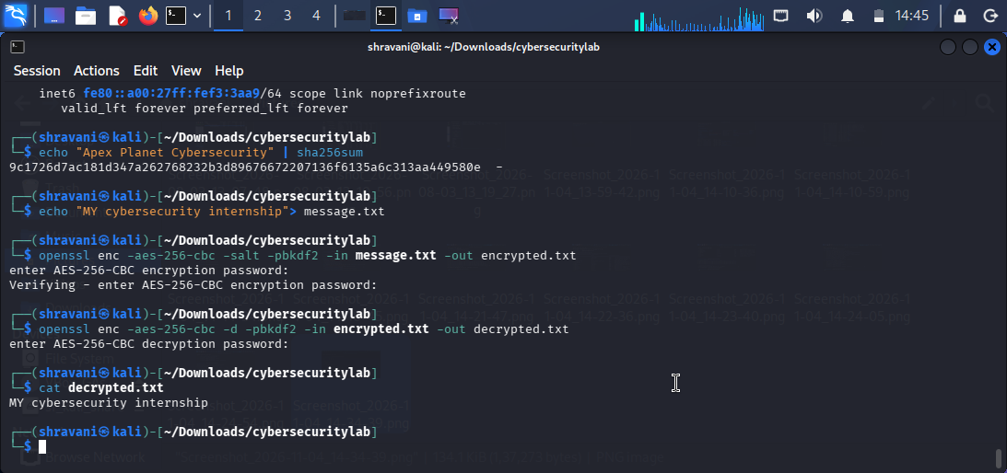

11. CYBERSECURITY TOOL FAMILIARIZATION
11.1 Wireshark
Wireshark is a network protocol analyzer used to capture and inspect network traffic. It helps understand communication between devices.
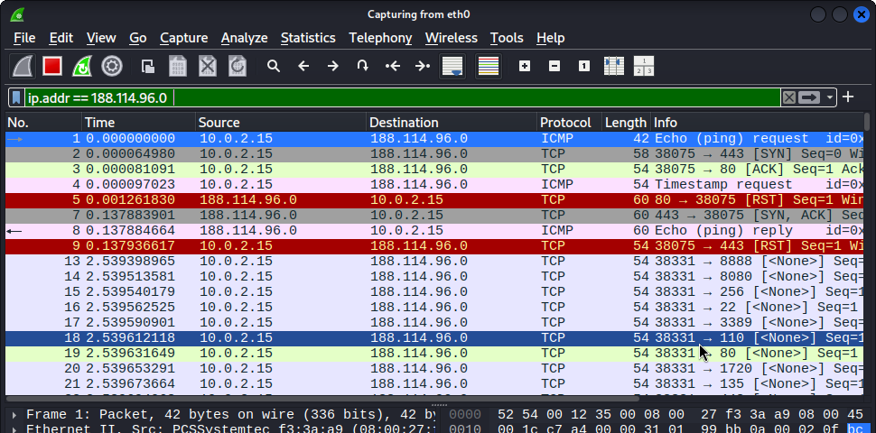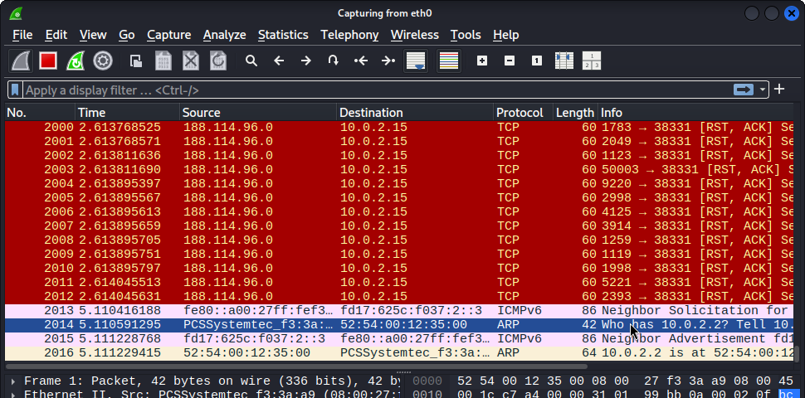

11.2 Nmap
Nmap is a network scanning tool used to discover hosts, identify open ports, and detect running services.
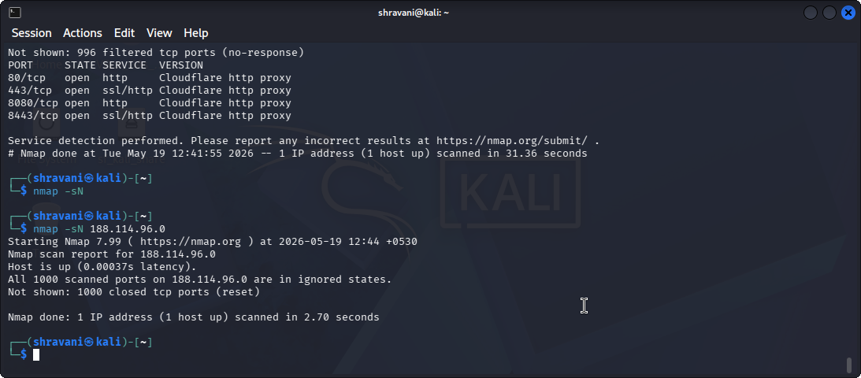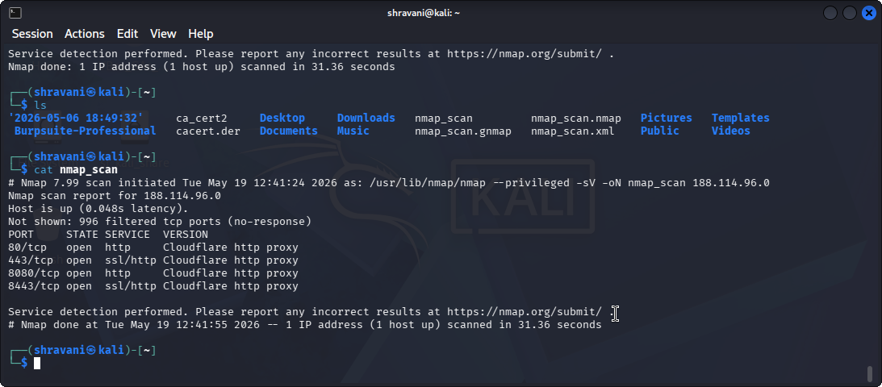
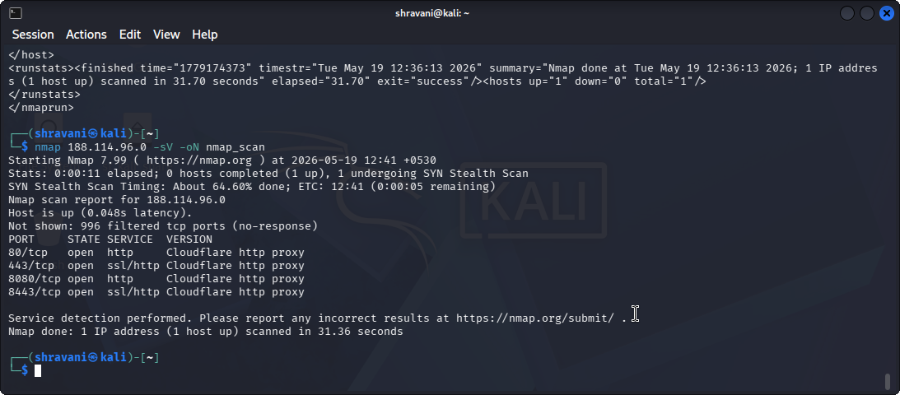
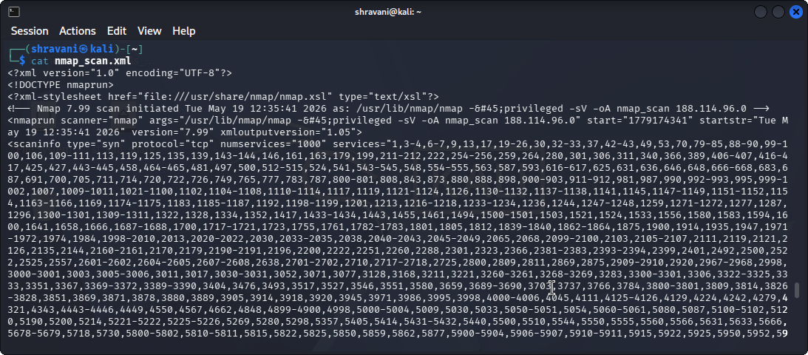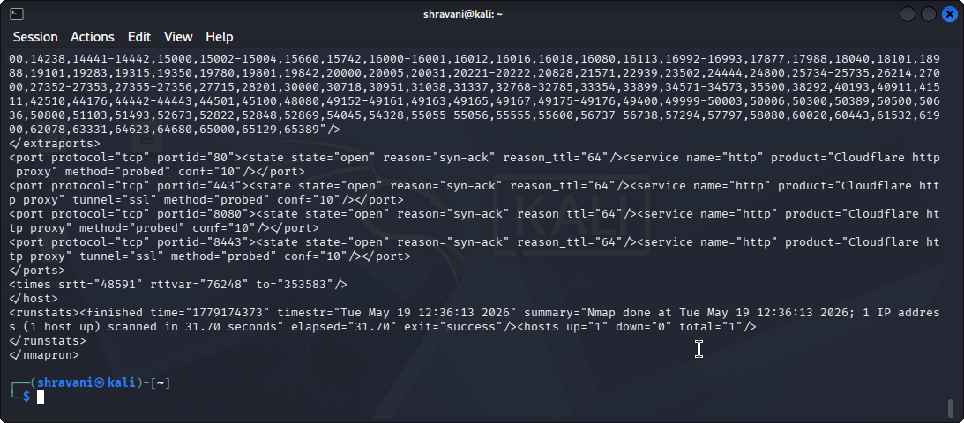
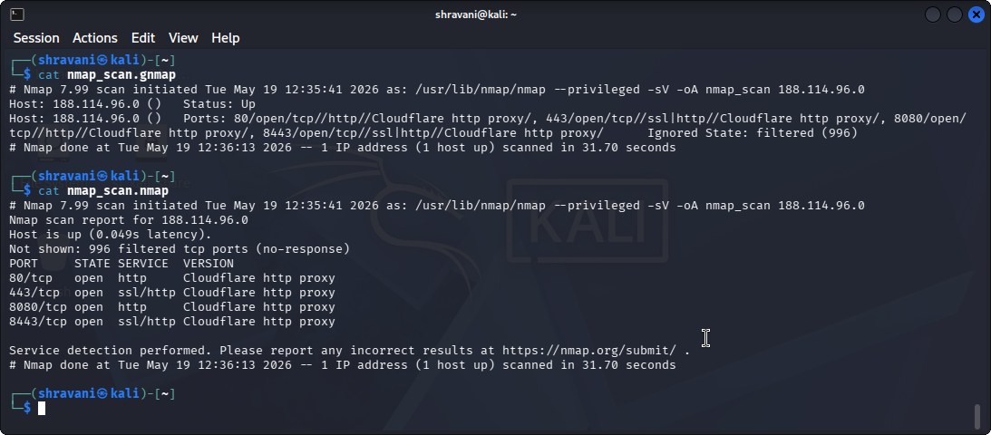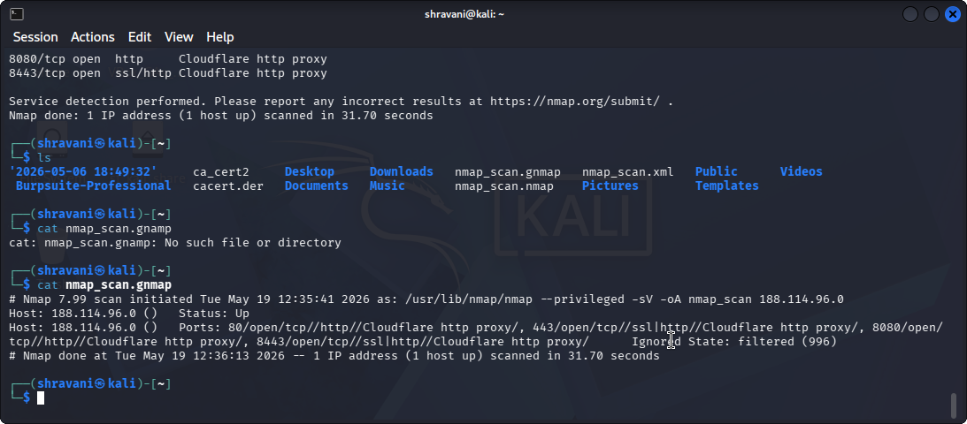
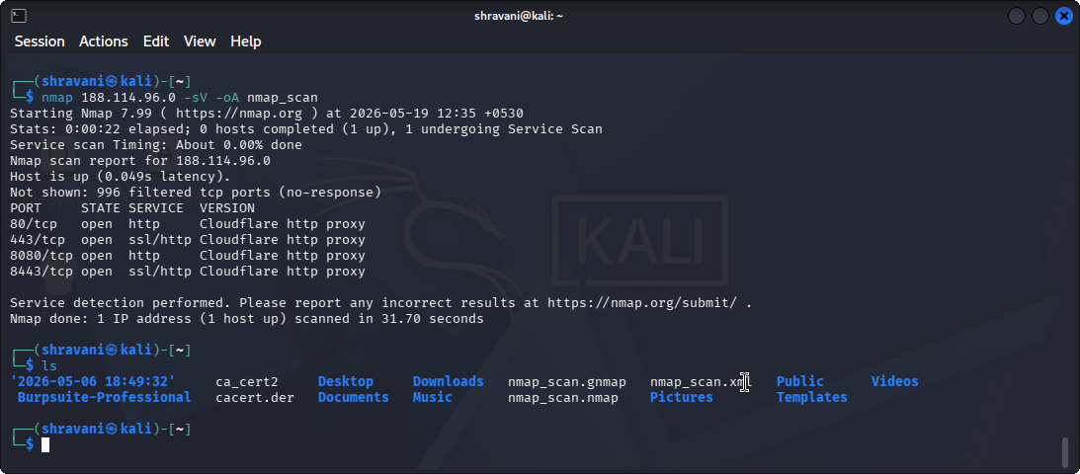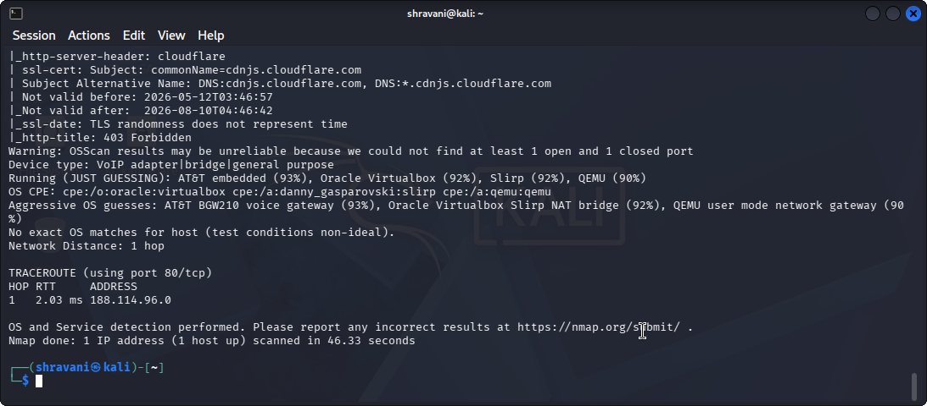
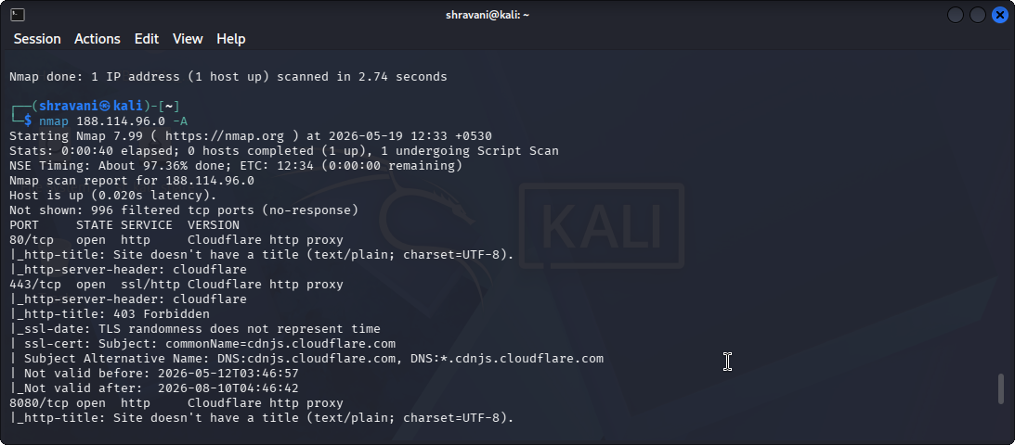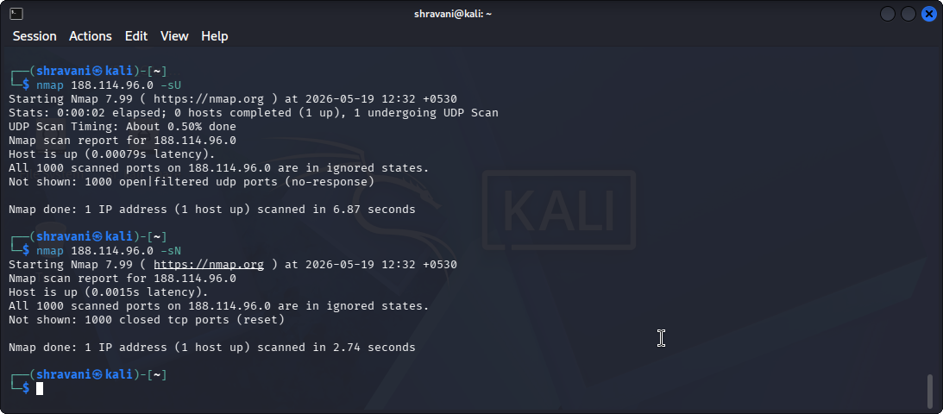
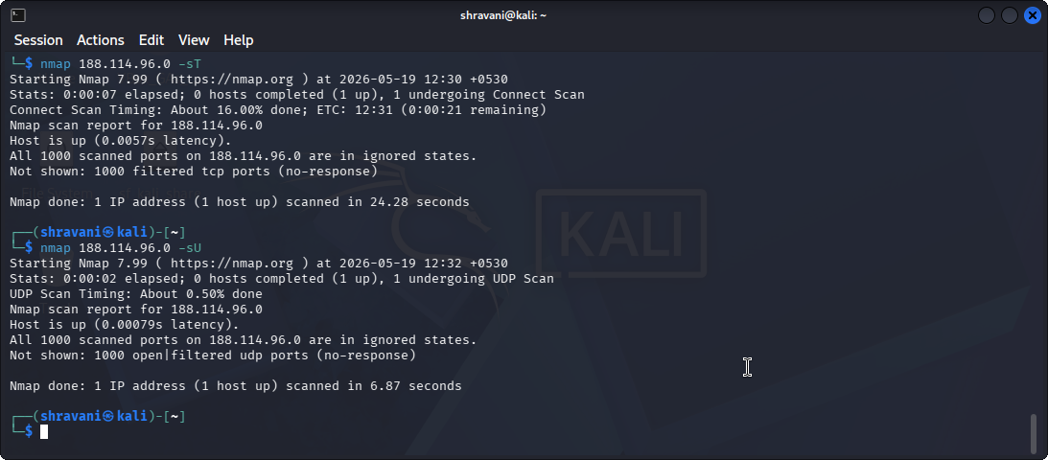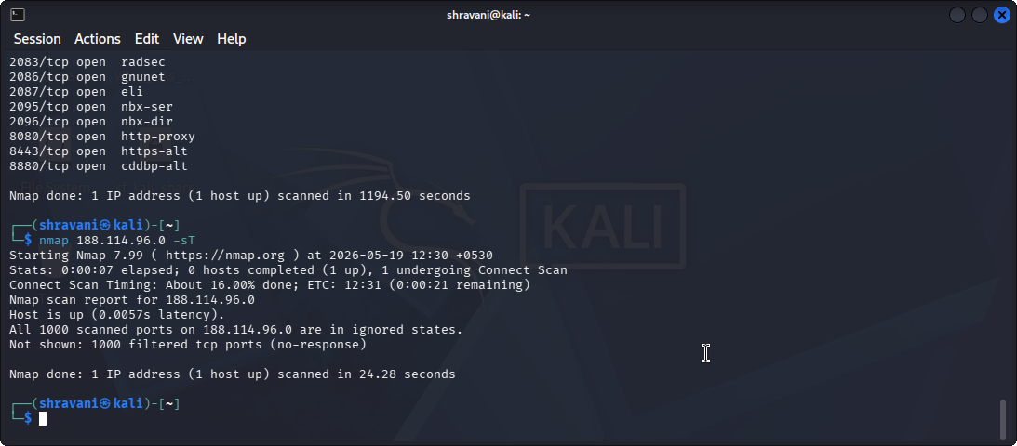
11.3 Burp Suite
Burp Suite is a web application security testing platform. It allows users to intercept and inspect HTTP and HTTPS requests.
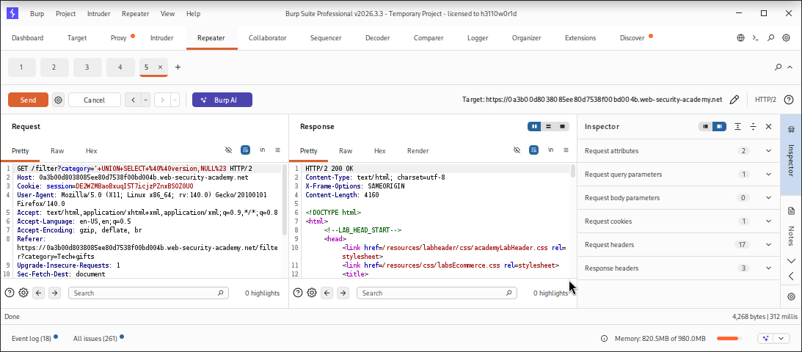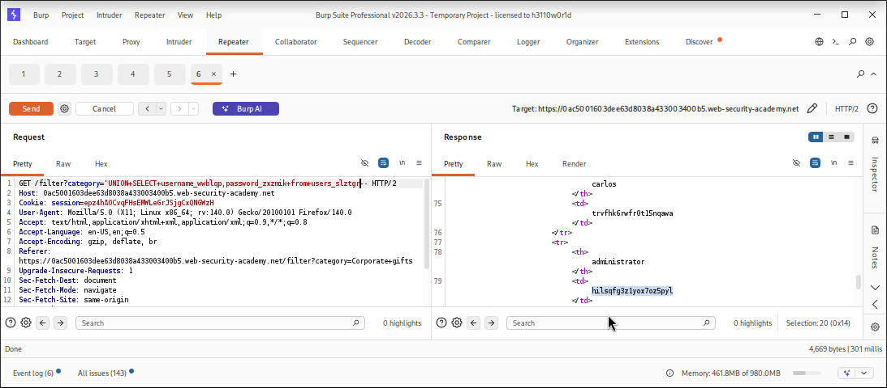
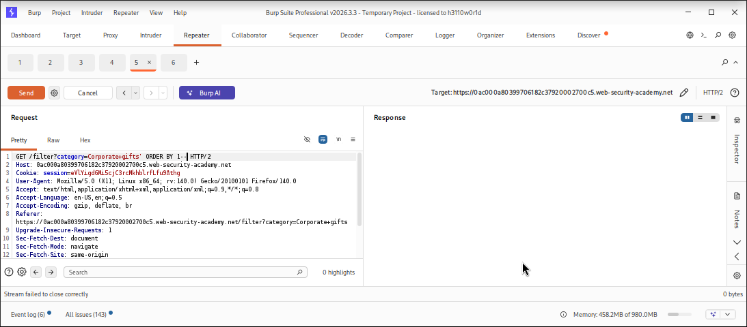
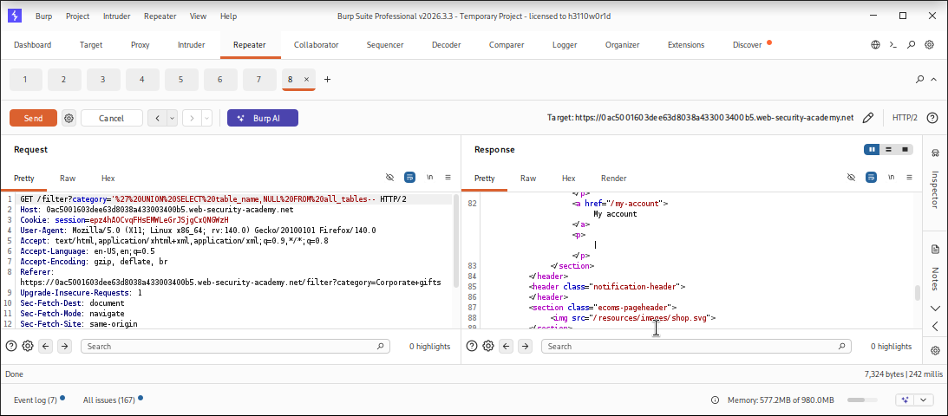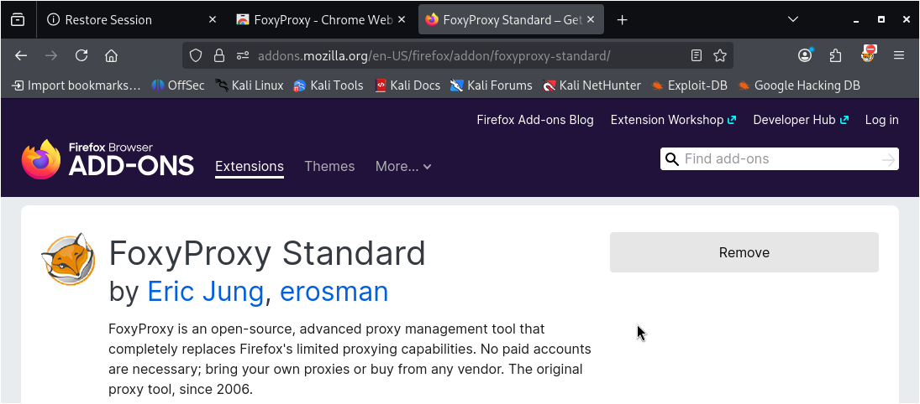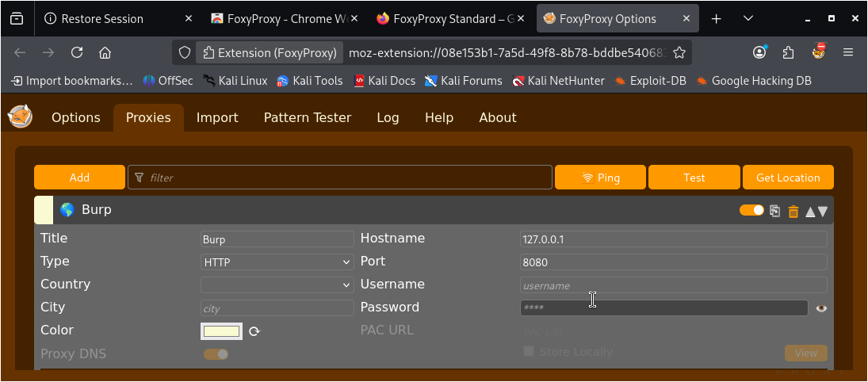
11.4 Netcat
Netcat is a networking utility used for establishing TCP and UDP connections, testing network services, and debugging communication.
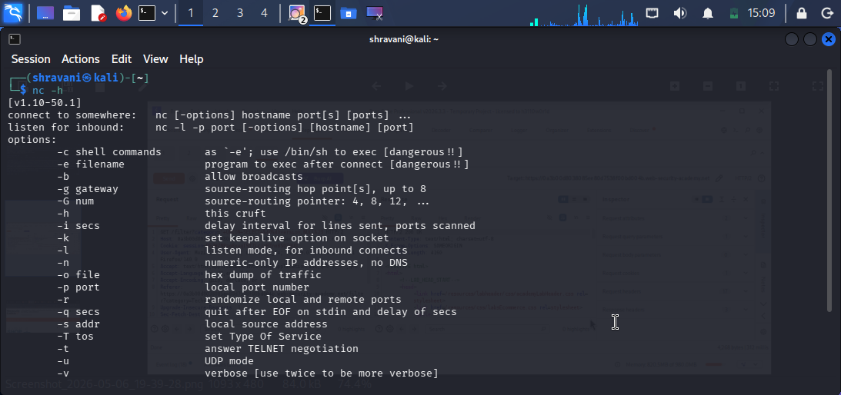
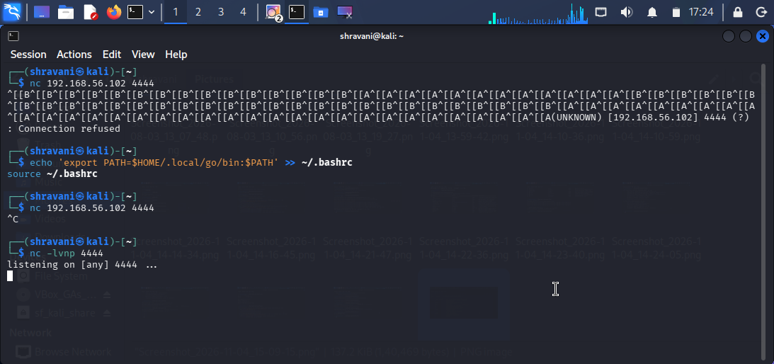
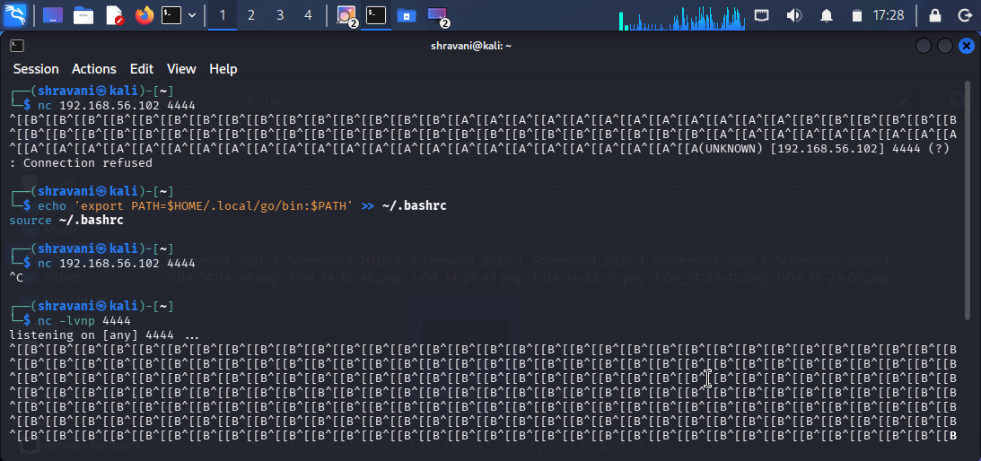

12. PRACTICAL RESULTS AND OBSERVATIONS
During this task, various cybersecurity fundamentals and practical exercises were studied and performed.
The lab environment was used to understand virtual machines and private network communication.
Linux commands were explored for file management, permissions, and network configuration.
Networking concepts such as IP addressing, DNS, and connectivity testing were studied.
OpenSSL was used to perform basic encryption and decryption operations.
Wireshark, Nmap, Burp Suite, and Netcat were explored to understand their applications in cybersecurity.

13. CONCLUSION
The Foundation and Environment Setup task provided an understanding of essential cybersecurity concepts and practical tools.
Through this task, I studied the CIA Triad, common cyberattacks, attack vectors, Linux fundamentals, networking, and cryptography.
I also worked with a virtual lab environment and explored cybersecurity tools such as Wireshark, Nmap, Burp Suite, and Netcat.
The OpenSSL practical helped me understand the basic process of encryption, decryption, and hashing.
Overall, this task helped build a foundation for further learning in ethical hacking, network security, and application security.

