CIPHER COURT: ESCAPE TO JUSTICE
Frontend Prototype Architecture & Level-Wise Component Specification
This technical document provides the complete, level-by-level architectural specification of the frontend prototype for Cipher Court: Escape to Justice. The client application is developed in Unity 6 LTS using the Universal Render Pipeline (URP), leveraging a decoupled UI/UX Canvas Scaler hierarchy, distance-bounded first-person raycasting, and in-memory persistent singletons.
1. Global Frontend Architecture & Interaction Pipeline
Core Interaction Framework: The presentation tier coordinates through a centralized, persistent core engine and unified interaction protocols across all scenes:
- • Responsive Canvas Scaler: Canvas Scaler Hierarchy: Every UI canvas implements CanvasScaler set to ScaleWithScreenSize with a reference resolution of 1920x1080 pixels (MatchWidthOrHeight = 0.5), guaranteeing consistent layout scaling from 16:9 desktop monitors up to 4K displays.
- • SDF Typography Engine: TextMeshPro Signed Distance Field (SDF) Typography: All on-screen and world-space text elements utilize multi-channel SDF font assets (LiberationSans SDF, Orbitron SDF, Inconsolata SDF, NotoSerif SDF), ensuring crisp visual rendering under post-processing depth of field and dynamic camera distances.
- • Global State Persistence: Persistent Singleton State (GameManager.cs): Instantiated on game bootstrap with DontDestroyOnLoad(gameObject), GameManager tracks active investigator identity, room completion bitmasks, aggregate score, and forensic clue inventories across scene transitions.
- • Spatial Interaction Arbitrator: Distance-Bounded Viewport Raycaster (PuzzleInteraction.cs): Center-screen raycasting (ViewportPointToRay(0.5, 0.5)) evaluates spatial intersections with the 'InteractiveProps' LayerMask, enforcing a strict Euclidean reach limit of d <= 2.50 meters.
- • Hardware Cursor Lifecycle: Hardware Cursor Governance: The system dynamically manages cursor states: locked and hidden (CursorLockMode.Locked; Cursor.visible = false) during first-person locomotion; unlocked and visible (CursorLockMode.None; Cursor.visible = true) during puzzle modal inspection.
2. Level-Wise Frontend Prototype Architecture
Level 0: Main Menu Gateway (MainMenu.unity)
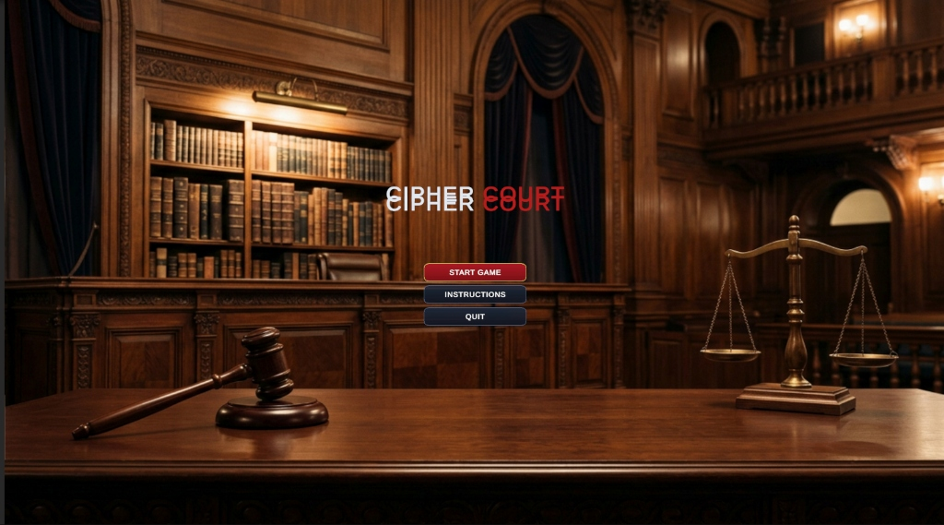
Figure 1: Main Menu Gateway Interface — Cinematic Courtroom Panorama (MainMenu.unity)
- • UI Component Hierarchy: UI Hierarchy: MainMenuCanvas (Screen Space - Overlay) -> BackgroundVignette (RawImage: Dark Navy #0A192F) -> TitleContainer (Gold Embossed TMP) -> ProfileInputModal (TMP_InputField) -> MenuButtonGroup (VerticalLayoutGroup: 'START GAME', 'INSTRUCTIONS', 'QUIT') -> InstructionsModal (CanvasGroup).
- • Primary C# Controllers: Active Interactor Scripts: MainMenuManager.cs, GameManager.cs.
- • User Interactions & Handled Events: Handled Events: OnPointerEnter audio triggers, OnSelect profile field, OnClick(Btn_StartGame) generating active session ID and invoking SceneManager.LoadSceneAsync('Level1_Investigation').
- • Client-Side Validation Rules: Validation Protocols: Alphanumeric regex guard (^[A-Za-z0-9_-]{3,20}$); fallback to default token INVESTIGATOR-9022-<GUID> if blank. Failsafe cursor lock release.
Level 1: Crime Scene Investigation (Level1_Investigation.unity)
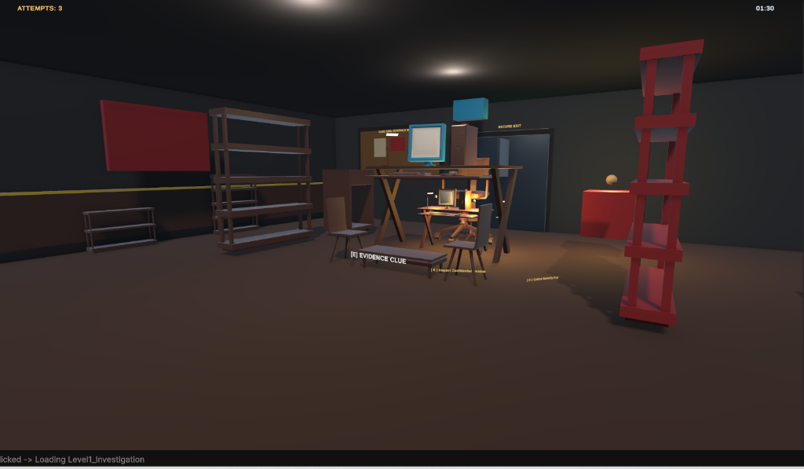
Figure 2: Level 1 Crime Scene — Reticle Clue Interaction Prompt Active (Level1_Investigation.unity)
- • UI Component Hierarchy: UI Hierarchy: MainCamera Stack -> ReticleCanvas (Screen Space - Overlay) -> CenterReticle (Image: Dynamic 12x12 Outline) -> TooltipTag ('[E] Inspect Evidence Marker') -> ClueModalContainer -> ClueImageCard (Image) -> ClueDescription (TMP).
- • Primary C# Controllers: Active Interactor Scripts: PuzzleInteraction.cs, CollectibleItem.cs, PasswordClue.cs, Level1Progress.cs.
- • User Interactions & Handled Events: Handled Events: First-person camera gimbal (WASD + MouseLook), KeyCode.E raycast trigger displaying modal clue card, Close modal returning camera agency.
- • Client-Side Validation Rules: Validation Protocols: Raycast distance <= 2.50m; forward vector dot product >= 0.50. Level1Progress unlocks corridor exit door upon collecting all 4 evidentiary markers.
Level 2: Forensic Cyber Terminal & Password Decryption (Level2_Computer.unity)
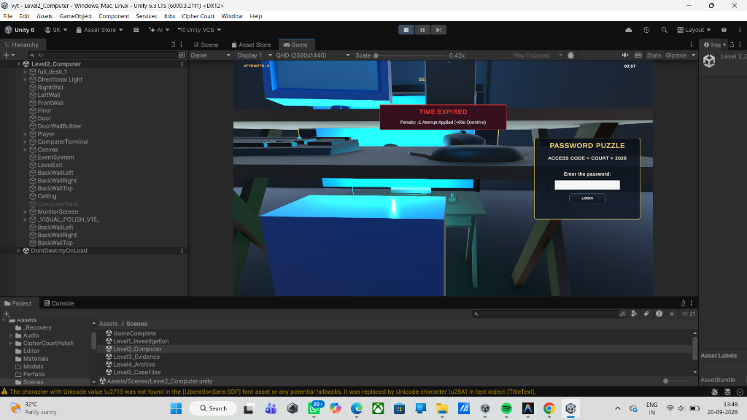
Figure 3: Level 2 Cyber Forensics Terminal & Password Decryption Station (Level2_Computer.unity)
- • UI Component Hierarchy: UI Hierarchy: In-World Monitor Quad (CRT Scanline Material) -> PasswordModal (Screen Space - Overlay) -> TerminalFrame (Cyan Glow #38BDF8) -> Input_Passcode (TMP_InputField) -> AttemptIndicatorGroup (3x Shield Badges) -> Btn_Authenticate -> FeedbackBanner.
- • Primary C# Controllers: Active Interactor Scripts: PasswordPuzzle.cs, PasswordPuzzleInteraction.cs, PasswordPuzzleUI.cs, Level2Progress.cs.
- • User Interactions & Handled Events: Handled Events: CRT raycast focus, password text input, OnClick(Btn_Authenticate) / KeyCode.Return triggering cryptographic verification.
- • Client-Side Validation Rules: Validation Protocols: String sanitization via .Trim().ToUpper(), length clamping (4-16 characters). 3-attempt quota limiter with lockout penalty. Correct key 'COURT2026' slerps open security blast doors.
Level 3: Steganographic Legal Archive & Caesar Cipher (Level3_Evidence.unity)
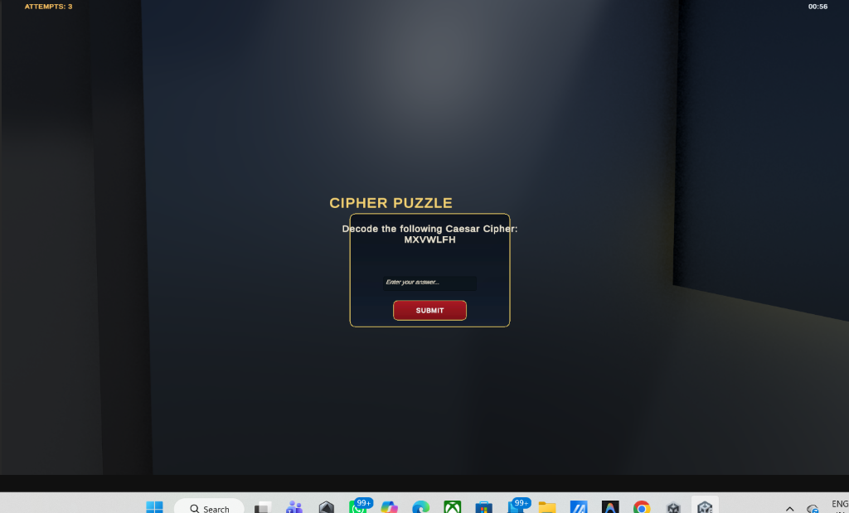
Figure 4: Level 3 Steganographic Caesar Cipher Decoding Interface (Level3_Evidence.unity)
- • UI Component Hierarchy: UI Hierarchy: CaesarCipherModal (Screen Space - Overlay) -> AntiqueParchmentBacking (#F4EEDD) -> CiphertextCard (TMP: 'MXVWLFH') -> RotorWheelAssembly (Concentric 26-character rings) -> ShiftDisplay ('Shift Key: k = 3') -> Input_Plaintext -> Btn_VerifyCipher.
- • Primary C# Controllers: Active Interactor Scripts: CipherPuzzle.cs, PuzzleUI.cs, EvidenceItem.cs, Level3Progress.cs.
- • User Interactions & Handled Events: Handled Events: Rotor wheel mouse drag rotating in 13.84-degree increments, input field typing, OnClick(Btn_VerifyCipher) calculating Pi = (Ci - 3) mod 26.
- • Client-Side Validation Rules: Validation Protocols: Regex filter stripping non-alphabetic symbols ([^A-Za-z]). Plaintext verification against 'JUSTICE' unlatches evidence vault and awards 200 forensic points.
Level 4: Underground Archival Vault & Numeric Keypad Safe (Level4_Archive.unity)
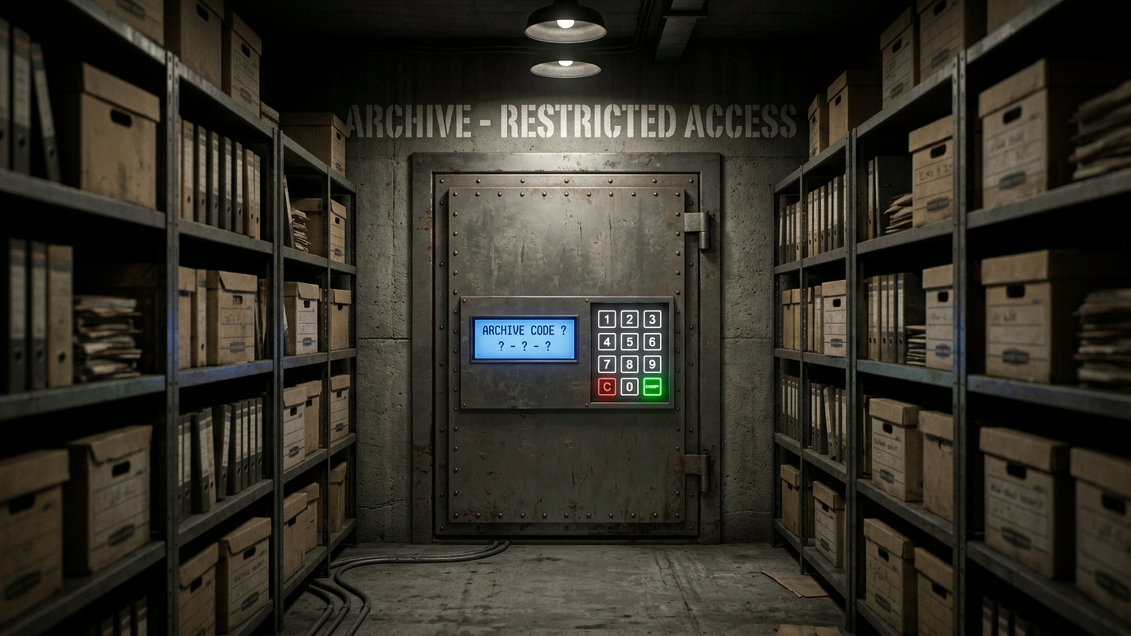
Figure 5: Level 4 Underground Archive Records Vault (Level4_Archive.unity)
- • UI Component Hierarchy: UI Hierarchy: SafeDoorQuad -> SafeKeypadCanvas (World Space) -> BrushedSteelHousing -> LEDDisplayPanel (7-Segment Font: '_ _ _') -> ButtonMatrix_3x4 (GridLayoutGroup: PushButtons 0-9, Btn_Clear, Btn_Enter) -> MechanicalTumblerAudio.
- • Primary C# Controllers: Active Interactor Scripts: ArchiveKeypad.cs, Level4ArchivePuzzle.cs, Level4Clue.cs.
- • User Interactions & Handled Events: Handled Events: Physical push-button mouse clicks with spring depression shader, buffer concatenation, audio tumbler click on each keypress.
- • Client-Side Validation Rules: Validation Protocols: Fixed-length 3-digit buffer clamp; 250ms software debounce. Verification matches '427' (recovered from medical examiner report). Incorrect code flashes red LED and enforces 3s penalty.
Level 5: Case Files & Financial Affidavits (Level5_CaseFiles.unity)
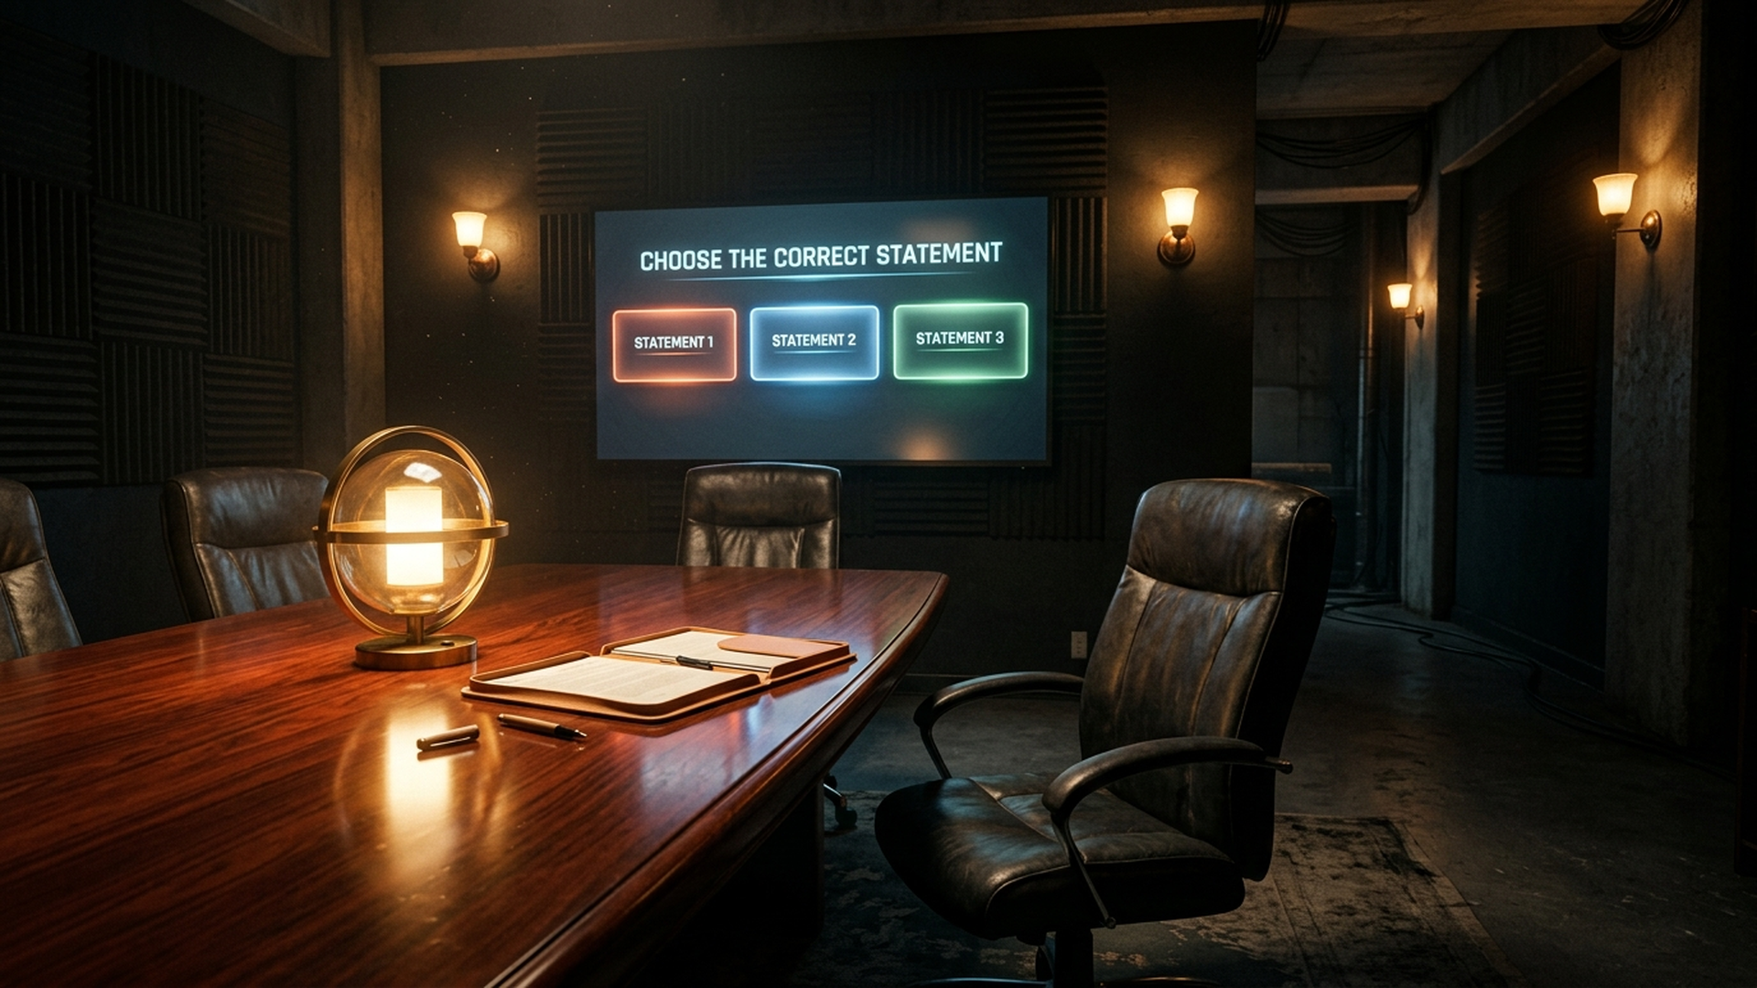
Figure 6: Level 5 Case Files & Sworn Affidavits Deliberation Chamber (Level5_CaseFiles.unity)
- • UI Component Hierarchy: UI Hierarchy: CaseFilesModal (Screen Space - Overlay) -> SplitPaneLayout (HorizontalLayoutGroup) -> LeftPane (ScrollRect: Bank Ledgers & Invoices) -> RightPane (Affidavit Summary, DiscrepancyCodeInput, Btn_ConfirmDiscrepancy) -> StatusBanner.
- • Primary C# Controllers: Active Interactor Scripts: Level5Terminal.cs, Level5CasePuzzle.cs, Level5File.cs.
- • User Interactions & Handled Events: Handled Events: Vertical ledger scrolling, document cross-referencing, typing 3-digit discrepancy code, submitting audit verification.
- • Client-Side Validation Rules: Validation Protocols: Validates transaction code '315' against bank record exhibits. Unlocks double oak doors into Level 6 Courtroom.
Level 6: Grand Judicial Courtroom Final Verdict (Level6_FinalVerdict.unity)
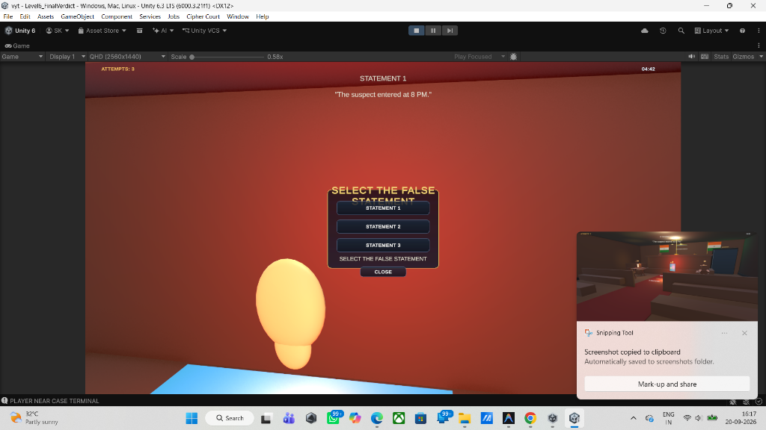
Figure 7: Level 6 Grand Courtroom Witness Cross-Examination Interface (Level6_FinalVerdict.unity)
- • UI Component Hierarchy: UI Hierarchy: CourtroomVerdictModal (Screen Space - Overlay) -> JudicialBannerHeader ('CROSS-EXAMINATION') -> WitnessSpeechBubble (Dynamic Dialogue) -> StatementRadioGroup (VerticalLayoutGroup: 3x Toggles) -> EvidenceReferenceCarousel -> Btn_ObjectAndAccuse (Gavel Action Button).
- • Primary C# Controllers: Active Interactor Scripts: Level6Terminal.cs, Level6Statement.cs, Level6VerdictPuzzle.cs, FinalLevelExit.cs.
- • User Interactions & Handled Events: Handled Events: Statement selection via radio toggles, horizontal evidence carousel scrolling, OnClick(Btn_ObjectAndAccuse) presenting contradiction.
- • Client-Side Validation Rules: Validation Protocols: Mutually exclusive selection via ToggleGroup. Identifies Statement 2 as perjury (contradicting Level 2 timestamped terminal logs). Correct accusation plays gavel audio, displays conviction ruling, and routes to victory.
Level 7: Mission Debriefing & Final Case Verdict (GameComplete.unity)
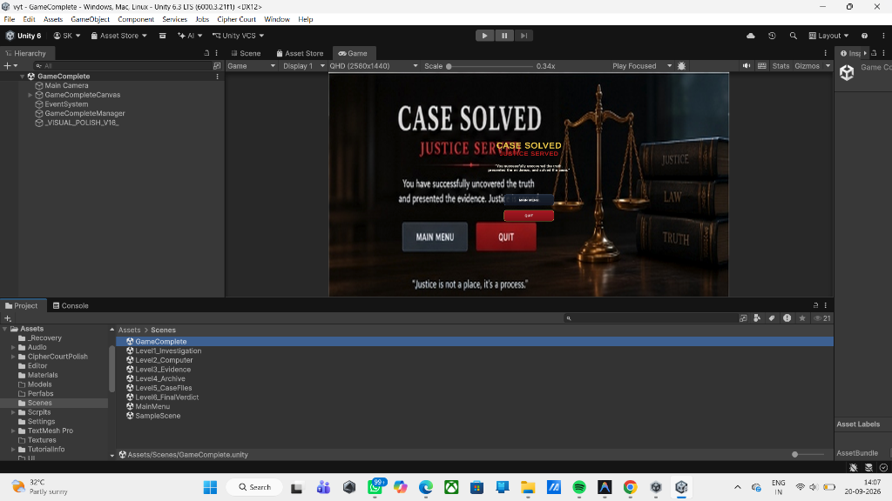
Figure 8: Game Complete Victory Debriefing — Justice Served (GameComplete.unity)
- • UI Component Hierarchy: UI Hierarchy: GameCompleteCanvas (Screen Space - Overlay) -> ParchmentCertificateCard (#F4EEDD) -> GoldenLaurelGavelSeal (Image) -> CongratulatoryHeadline -> MetricsGrid (2x2 Cards: Elapsed Time, Deduction Accuracy %, Evidence Found 6/6, Final Forensic Score) -> ActionButtons (Btn_ExportReport, Btn_ReturnToMenu).
- • Primary C# Controllers: Active Interactor Scripts: GameCompleteManager.cs, GameManager.cs.
- • User Interactions & Handled Events: Handled Events: Automatic aggregate calculation from GameManager on Start(), OnClick(Btn_ExportReport) triggering local JSON audit export, OnClick(Btn_ReturnToMenu) cleanly resetting session singletons.
- • Client-Side Validation Rules: Validation Protocols: Integrity check on completed level flags before calculating score bonuses. Disposes in-memory web request textures upon exit.
3. Level-Wise Component & Script Mapping Matrix
Lvl | Scene File | Primary C# Controller | Canvas Render Mode | Input Method | Validation Guard | Mission Objective
0 | MainMenu.unity | MainMenuManager.cs | Screen Space - Overlay | Mouse / Keyboard | Alphanumeric Regex | Authenticate & Launch Session
1 | Level1_Investigation.unity | PuzzleInteraction.cs / CollectibleItem.cs | HUD Reticle + Modal Card | Raycast (E Key) | Distance <= 2.5m, Vector Dot | Catalog 4 Crime Scene Clues
2 | Level2_Computer.unity | PasswordPuzzle.cs / PasswordPuzzleUI.cs | World Space CRT + Screen Modal | Keyboard InputField | Trim().ToUpper(), 3-Quota | Crack Cyber Terminal ('COURT2026')
3 | Level3_Evidence.unity | CipherPuzzle.cs / PuzzleUI.cs | Screen Space - Overlay | Mouse Drag Rotor / TMP | Shift k=3, Regex [^A-Za-z] | Decrypt Caesar Cipher ('JUSTICE')
4 | Level4_Archive.unity | ArchiveKeypad.cs / Level4ArchivePuzzle.cs | World Space Safe Keypad | Virtual Keypad Buttons | 3-Digit Clamp, 250ms Debounce | Unlock Ballistics Safe ('427')
5 | Level5_CaseFiles.unity | Level5Terminal.cs / Level5CasePuzzle.cs | Split-Pane Dossier Modal | ScrollRect & InputField | Ledger Discrepancy Matching | Identify Anomaly Code ('315')
6 | Level6_FinalVerdict.unity | Level6VerdictPuzzle.cs / FinalLevelExit.cs | Screen Space - Overlay | Radio Toggles & Gavel Btn | Mutually Exclusive Toggle | Expose Perjury in Statement 2
7 | GameComplete.unity | GameCompleteManager.cs | Parchment Certificate Card | Mouse Click Action Buttons | Level Completion Bitmask | Debrief Case & Export Audit

