**Federated Learning:**

**A New Era of Decentralized AI**



A Technical Seminar Report

in partial fulfillment of the degree

### BACHELOR OF TECHNOLOGY

in

**COMPUTER SCIENCE & ARTIFICIAL INTELLIGENCE**

By

**SHRAVANI GURRAM – 2203A52024**

Under the guidance of

Dr. P.CHANDRASHEKAR

Assistant Professor, School of CS&AI.

**Submitted to**





**SCHOOL OF COMPUTE RSCIENCE & ARTIFICIAL INTELLIGENCE**

# SR UNIVERSITY, ANANTHASAGAR, WARANGAL

**November, 2024.**



**SCHOOL OF COMPUTER SCIENCE & ARTIFICIAL INTELLIGENCE**

## CERTIFICATE

This is to certify that this technical seminar entitled **“Federated Learning: A New Era of Decentralized AI**" is the Bonafide work carried out by **SHRAVANI GURRAM** for the partial fulfillment to award the degree **BACHELOR OF TECHNOLOGY** in **COMPUTER SCIENCE & ARTIFICIAL INTELLIGENCE** during the academic year 2024-2025 under our guidance and Supervision.

**RAGHWENDRA & SANTHOSH KUMAR Dr. M. Sheshikala**

Designation, Professor & HOD (CSE),

SR University, SR University,

Ananthasagar, Warangal. Ananthasagar, Warangal.

**External Examiner**

# ACKNOWLEDGEMENT

I owe an enormous debt of gratitude to our Technical Seminar guide **Dr. Chandrashekar, Assistant Professor** as well as Head of the CSE Department **Dr. M.Sheshikala, Professor** for guiding me from the beginning through the end of the Seminar Presentation with their intellectual advices and insightful suggestions. I truly value their consistent feedback on our progress, which was always constructive and encouraging and ultimately drove us to the right direction

I express my thanks to Technical Seminar coordinators **Dr. P Praveen, Assoc. Prof., and Dr. Mohammed Ali Shaik, Assoc. Prof.** for their encouragement and support.

I wish to take this opportunity to express our sincere gratitude and deep sense of respect to our beloved Dean, **Dr. Indrajeet Gupta,** for his continuous support and guidance to complete this technical seminar in the institute.

Finally, I express thanks to all the teaching and non-teaching staff of the department for their suggestions and timely support.

-Shravani Gurram

**Organization of thesis**

|  |  |  |
| --- | --- | --- |
| **S.no** | **Content** | **Pageno** |
| 1 | Abstract | 3 |
| 2 | About the Organization | 4 |
| 3 | Introduction | 5 |
| 4 | Literature Survey | 6 |
| 5 | Design | 7 |
| 6 | Flow Chart | 9 |
| 7 | Diagram | 11 |
| 8 | Conclusion | 13 |
| 9 | Future Scope | 14 |
| 10 | Bibilography | 15 |

**ABSTRACT**

**Federated Learning:**

**A New Era of Decentralized AI**

**Abstract**

Federated Learning (FL) is a revolutionary approach in artificial intelligence that enables collaborative model training across multiple devices or nodes without the need to centralize data. Unlike traditional machine learning methods that rely on aggregating data on a central server, FL ensures that data remains localized, addressing critical concerns around privacy, security, and regulatory compliance. This decentralized framework makes FL particularly valuable for applications requiring sensitive data, such as healthcare, finance, and edge computing in smart devices.

The seminar explores the foundational principles of FL, its system architecture, and the mechanisms that allow secure and efficient model training. Key topics include secure aggregation protocols, managing heterogeneous data from diverse devices, and techniques to reduce communication overhead. Practical applications of FL, such as personalized healthcare models, fraud detection in finance, and enabling smarter IoT devices, highlight its transformative potential across industries.

Despite its advantages, FL faces significant challenges, including the variability of data quality across devices, communication bottlenecks, and vulnerabilities to adversarial attacks. Strategies to overcome these challenges, such as advanced encryption techniques, model optimization, and robust security measures, are also discussed.

By enabling decentralized AI while preserving user privacy and enhancing data security, FL is paving the way for a new era of machine learning. Its ability to integrate distributed computing with innovative AI techniques positions it as a critical innovation for the future. This seminar aims to provide a comprehensive understanding of Federated Learning, its applications, and the roadblocks to its widespread adoption, offering a clear vision of how FL is shaping the future of artificial intelligence.

.

# ABOUT THE ORGANISATION

SR University is a private university located in Warangal, Telangana, India. It was established in 2018 under the Telangana State Private Universities (Establishment and Regulations) Act 2018. SR University is accredited with an 'A' grade by the National Assessment and Accreditation Council (NAAC).

SR University offers a variety of undergraduate and postgraduate programs in engineering, technology, management, commerce, and arts. The university has a strong focus on industry- relevant education and offers a variety of opportunities for students to gain hands-on experience through internships, projects, and workshops. SR University also has a strong incubation center that supports students in developing and launching their startups.

SR University has a well-equipped campus with state-of-the-art facilities, including classrooms, laboratories, libraries, sports facilities, and hostels. The university also has a strong commitment to research and has published several papers in reputed journals and conferences.

SR University has a good placement record. In 2023,the university achieved 90% placements for its engineering students. The university has a strong alumni network that includes several successful entrepreneurs and professionals.

Overall, SR University is a good choice for students who are looking for an industry-relevant education and a strong focus on innovation and entrepreneurship.

# INTRODUCTION

In the age of data-driven innovation, machine learning has become a cornerstone of technological advancement. Traditional machine learning approaches typically rely on centralized data collection, where vast amounts of data are gathered and processed on a central server to train models. While this approach has led to significant breakthroughs, it comes with inherent challenges, including concerns about data privacy, security, and compliance with stringent regulations such as GDPR and HIPAA. Furthermore, as the volume of data grows exponentially, the logistical and infrastructural demands of centralization can become prohibitive.

Federated Learning (FL) offers a transformative solution to these challenges by introducing a decentralized paradigm for training machine learning models. In FL, the data remains distributed across multiple devices or nodes, and only the locally trained model updates are shared with a central server. This ensures that raw data never leaves the local environment, enhancing privacy and security.

The importance of Federated Learning extends beyond its privacy-preserving nature. It addresses practical challenges like reducing bandwidth consumption and enabling edge computing, where devices such as smartphones, IoT gadgets, and edge servers can collaboratively contribute to model training. FL has found applications in diverse fields, including personalized healthcare, predictive maintenance, fraud detection, and autonomous systems.

This seminar aims to delve into the foundational principles of Federated Learning, its architecture, and its practical implementations. It also explores the challenges associated with this technology, such as data heterogeneity, communication inefficiencies, and adversarial threats. By combining distributed computing and advanced AI techniques, Federated Learning is redefining how intelligent systems are built and deployed in a privacy-conscious world. This discussion sets the stage for understanding FL’s potential to revolutionize industries and shape the future of artificial intelligence.

LITERATURE SURVEY

**Literature Survey: Federated Learning - A New Era of Decentralized AI**

Federated Learning (FL) is a recent development in machine learning introduced by Google in 2016 to address privacy and data security concerns in centralized systems. This section highlights key research shaping FL's evolution.

1. **Federated Learning Frameworks**: Konecny et al. (2016) developed the foundational FL framework, introducing Federated Averaging (FedAvg) to aggregate model updates without centralizing data. Later, Smith et al. (2018) proposed asynchronous FL to accommodate devices with varying capabilities.
2. **Privacy and Security Enhancements:** Bonawitz et al. (2017) proposed secure aggregation techniques to combine updates without exposing individual data. Geyer et al. (2018) introduced differential privacy methods to protect user data in aggregated models, particularly useful in healthcare applications.
3. **Handling Data Heterogeneity**: Zhao et al. (2018) addressed challenges with non-IID data across devices, proposing strategies like synthetic data sharing and augmentation to improve model consistency
4. **Applications of Federated Learning**: FL has been applied in diverse areas, including personalized language models for Google’s Gboard (McMahan et al., 2017), healthcare diagnostics (Li et al., 2020), and fraud detection in finance.
5. **Challenges and Future Directions**: Key challenges include communication bottlenecks (Yang et al., 2019) and adversarial vulnerabilities. Solutions such as gradient compression and federated transfer learning are being explored to improve scalability and security.

This survey highlights FL's rapid advancements, transformative potential, and ongoing efforts to overcome technical barriers, making it a cornerstone of decentralized AI.

**DESIGN**

**Design of Federated Learning System**

The design of a Federated Learning (FL) system involves several interconnected components that work together to ensure decentralized model training while preserving privacy. Below is a high-level design outline of an FL system:

### System Components

### a. Clients (Edge Devices)

* **Role: Perform local training on their respective datasets.**
* **Examples: Smartphones, IoT devices, edge servers.**
* **Key Functions**:
* Retrieve the global model from the central server.
* Perform computations for local model updates.
* Transmit updates to the central server securely.

**b. Central Server**

* Role: Orchestrates the FL process by aggregating updates from clients and maintaining the global model.
* Key Features:
* Bandwidth optimization to handle multiple devices.
* Secure transmission protocols to prevent data leaks.

### Workflow of Federated Learning

### Step 1: Global Model Initialization

* The central server initializes a base model and distributes it to participating clients.

**Step 2: Local Training at Clients**

* Each client trains the global model locally on its private dataset for a few epochs.
* Local models are updated without transmitting raw data.

**Step 3: Model Update Aggregation**

* Clients send their model updates (e.g., gradients or weights) to the central server.
* The server uses a secure aggregation method to combine updates into a new global model.

**Step 4: Global Model Update**

* + The central server updates the global model with aggregated data.
  + The updated model is distributed back to clients for the next training round.

**Step 5: Iterative Refinement**

* Steps 2–4 are repeated over several communication rounds until the model converges to a desired accuracy

### Privacy and Security Mechanisms

* **Encryption**: Secure aggregation protocols (e.g., Bonawitz et al.) ensure updates are encrypted before transmission.
* **Differential Privacy**: Noise is added to model updates to prevent individual contributions from being inferred.

### Optimization Techniques

* **Gradient Compression**: Reduces communication overhead by transmitting only significant updates.
* **Client Selection**: Selects a subset of clients per round to balance computational load and reduce delays.
* **Handling Non-IID Data**: Techniques like data augmentation and local model pretraining address heterogeneity.

### Deployment Scenarios

* **Healthcare**: Hospitals collaboratively train models on sensitive patient data.
* **Finance**: Banks develop fraud detection models without sharing customer data.
* **IoT**: Smart devices improve personalization through local learning.

**FLOWCHART**

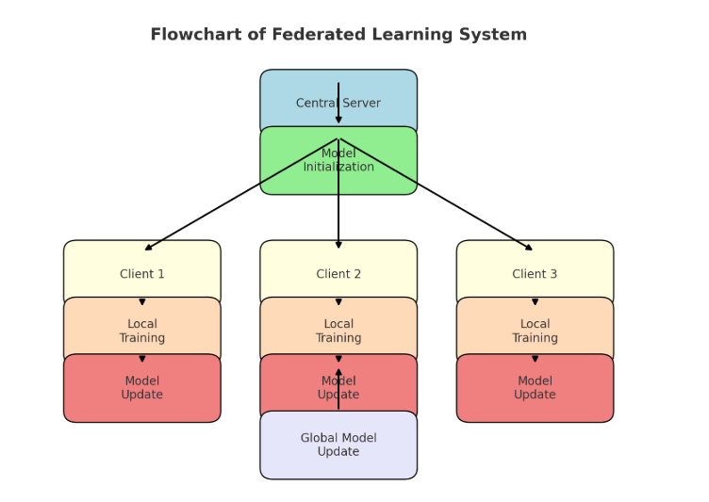

# 

# 

# 

DIAGRAM

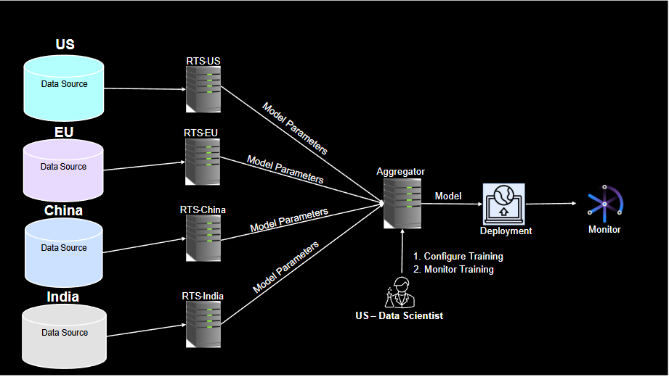

**CONCLUSION**

Federated Learning (FL) represents a significant advancement in machine learning by enabling decentralized model training while ensuring privacy and data security. Unlike traditional centralized approaches, FL allows data to remain on edge devices, which is particularly important in applications where data privacy is paramount, such as healthcare, finance, and mobile computing. Through techniques like Federated Averaging (FedAvg), secure aggregation, and differential privacy, FL minimizes the risks associated with data sharing, ensuring that individual user data is not exposed.

The advantages of FL are further amplified in scenarios involving large-scale, heterogeneous data across multiple devices, where it promotes personalization and adaptability while maintaining efficiency. However, challenges like communication bottlenecks, data heterogeneity, and security threats remain ongoing research areas. Advancements in compression techniques, optimization strategies, and robust aggregation protocols are continually being explored to address these limitations.

Overall, Federated Learning is paving the way for more secure, scalable, and privacy-preserving AI systems. As its application grows, FL is poised to revolutionize industries by enabling collaboration on data-driven insights without compromising individual privacy, making it a vital part of the future of decentralized AI.

**FUTURE SCOPE**

The **Future Scope of Federated Learning**

Federated Learning (FL) holds immense promise for the future, with several exciting avenues for growth and development. As the demand for privacy-preserving, decentralized AI solutions continues to rise, FL is expected to evolve and find broader applications. Here are some key areas where FL could expand in the coming years:

1. **Integration with Edge and IoT Devices:** As the Internet of Things (IoT) continues to grow, with billions of devices generating data, FL will play a crucial role in enabling distributed AI at the edge. This would allow intelligent decision-making at the device level, improving the efficiency of IoT systems while minimizing data transfer to centralized servers. The combination of FL with edge computing could revolutionize industries like smart cities, autonomous vehicles, and home automation.
2. **Healthcare and Personalized Medicine**: The healthcare sector stands to benefit immensely from FL. Collaborative model training across medical institutions, without sharing sensitive patient data, can lead to the development of personalized treatment plans, predictive models, and diagnostic tools. Future research could further optimize FL to handle more complex medical datasets, ensuring faster and more accurate results without violating privacy regulations like HIPAA or GDPR.
3. **Federated Learning in Privacy-Preserving AI**: As concerns about data privacy intensify, FL will become a central technology for building secure, privacy-preserving AI models. Future developments could focus on improving the robustness of privacy-enhancing techniques like differential privacy and homomorphic encryption, ensuring that the information shared during model aggregation cannot be traced back to individuals.
4. **Handling Non-IID Data**: One of the ongoing challenges in FL is the heterogeneity of data across devices (non-IID data). Future advancements could focus on improving algorithms that handle this data variability more efficiently, ensuring that FL can be applied to a wider range of applications, even in fields with highly diverse data sources.
5. **Federated Transfer Learning**: Transfer learning, which involves transferring knowledge from one model to another, could become an important part of FL. Federated Transfer Learning (FTL) would allow for knowledge transfer between distributed clients with different data distributions. This would enable more accurate models in cases where data is sparse or lacks sufficient labels, particularly in domains like remote sensing or rare disease prediction.
6. **Decentralized Autonomous Organizations (DAOs)**: As blockchain and decentralized technologies grow, Federated Learning could be integrated into decentralized autonomous organizations (DAOs). This would enable trust less, autonomous collaboration across a distributed network of devices or participants, potentially leading to more transparent, secure, and efficient AI development and deployment.
7. **Federated Learning for Federated Edge Computing**: Combining FL with federated edge computing can push the boundaries of decentralized learning even further. Future work could integrate these systems to offer real-time, distributed AI capabilities across geographically dispersed nodes, reducing latency and enhancing overall system performance.
8. **Scalability and Optimizations**: As the number of participating clients in FL grows, the need for more efficient algorithms and optimizations to handle large-scale federated systems will increase. Research into reducing communication overhead, improving convergence speed, and ensuring fault tolerance will be vital for scaling FL to support large, dynamic networks.

In summary, the future of Federated Learning is bright and full of potential. With ongoing advancements in algorithms, privacy technologies, and system integration, FL is poised to play a key role in the next generation of AI, ensuring that powerful models can be trained on distributed data without compromising privacy or security.