SRINIVAS UNIVERSITY
INSTITUTE OF ENGINEERING AND TECHNOLOGY
Mukka, Mangaluru – 574146



A Project report on

AGRINOVA: SMART IOT BASED AGRICULTURE MONITORING
& ADVISORY SYSTEM

Submitted by

SANJANA C VERNEKAR
SANJANA M NAIK
SHRADHA K HARIKANTRA
SHRAVANI H P

In partial fulfillment of the requirements for the Degree of

BACHELOR OF TECHNOLOGY
IN
COMPUTER SCIENCE AND ENGINEERING
Under the guidance of
PROF. MAMATHA S J
Associate Professor and Head
Department of Computer Science and Engineering

INSTITUTE OF ENGINEERING AND TECHNOLOGY
Srinivas Nagar, Mukka, Surathkal, Mangaluru – 574146, Karnataka
2025-2026

SRINIVAS UNIVERSITY
INSTITUTE OF ENGINEERING & TECHNOLOGY
Mukka, Mangaluru – 574146

DEPARTMENT OF COMPUTER SCIENCE AND ENGINEERING


CERTIFICATE

Certified that the project work entitled “AGRINOVA: SMART IOT BASED AGRICULTURE MONITORING & ADVISORY SYSTEM” is a bonafide work carried out by

SANJANA C VERNEKAR
SANJANA M NAIK
SHRADHA K HARIKAN
SHRAVANI H P
in partial fulfillment for the award of BACHELOR OF TECHNOLOGY in COMPUTER SCIENCE AND ENGINEERING of the SRINIVAS UNIVERSITY INSTITUTE OF ENGINEERING AND TECHNOLOGY, MUKKA, MANGALURU during the year 2025–2026. It is certified that all corrections/suggestions indicated for Internal Assessment have been incorporated in the report deposited in the departmental library. The project report has been approved as it satisfies the academic requirements in respect of Project work prescribed for the Bachelor of Technology Degree

Mrs. Mamatha S J  Project Guide |  | Dr. Shifana Begum  Head of the Department |  | Dr. Ramakrishna N. Hegde  Dean

Name of the Examiners Signature with Date

1.

2.

SRINIVAS UNIVERSITY

INSTITUTE OF ENGINEERING & TECHNOLOGY
MUKKA, SURATHKAL, MANGALURU – 574146


DEPARTMENT OF COMPUTER SCIENCE AND ENGINEERING

DECLARATION

We, Sanjana C Vernekar, Sanjana M Naik, Shradha K Harikantra, Shravani H P, the students of VIII semester, B.Tech. in Computer Science and Engineering, Srinivas University Institute of Engineering and Technology, Mukka, hereby declare that the project entitled “AGRINOVA: Smart IOT Based Agriculture Monitoring & Advisory System” has been successfully completed by us in partial fulfilment of the requirements for the award of degree in Bachelor of Technology in Computer Science and Engineering of Srinivas University Institute of Engineering and Technology, Mukka and no part of it has been submitted for the award of degree or diploma in any university or institution previously.

Date:
Place: Mukka

Name and Reg. No. of the Students | Signature of the Student
SANJANA C VERNEKAR
SANJANA M NAIK
SHRADHA K HARIKANTRA

SHRAVANI H P

ABSTRACT

Agriculture plays a vital role in sustaining human life and supporting global economies. However, traditional farming methods often rely on manual observation and intuition, which can lead to inefficient use of resources such as water, fertilizers, and labor. With the advancement of modern technology, the integration of the Internet of Things (IoT) into agriculture has created opportunities for smarter and more efficient farming practices.

The AGRINOVA Smart IoT-Based Agriculture Monitoring and Advisory System is designed to provide real-time monitoring of environmental conditions in agricultural fields. The system uses multiple ESP32-based nodes equipped with sensors to measure temperature, humidity, soil moisture, and gas levels. These nodes collect data continuously and transmit it to a cloud platform for storage, analysis, and visualization. The system operates using solar energy, making it suitable for remote areas where electricity supply is limited. The collected data helps farmers make informed decisions regarding irrigation, crop health, and environmental management. Additionally, the system can provide intelligent recommendations through an advisory platform.

By combining sensor technology, wireless communication, and cloud-based analytics, AGRINOVA contributes to precision agriculture and sustainable farming practices. The system improves productivity, reduces operational costs, and supports environmentally friendly agricultural management.

ACKNOWLEDGEMENT

We take this opportunity to express my profound gratitude to our respected project guide Guide Mrs, Mamatha S J, Assistant Professor, Dept. of Computer Science and Engineering for her ever-inspiring guidance, constant encouragement and support.

We also would like to express our deep sense of gratitude and indebtedness to our Project coordinator Dr. Janapati Venkata Krishna, Assistant Professor, Dept. of Computer Science and Engineering or her encouragement and guidance that she has extended in the course of carrying out our project.

We sincerely thank Dr. Shifana Begum, Head of the Department, Computer Science and Engineering, for being an inspiration and support throughout this project.

We are extremely grateful to our respected Dean, Dr. Ramakrishna N Hegde for providing the facilities to carry out the project.

We also would like to thank our Management, A. Shama Rao Foundation, Mangaluru, for providing the means and support for the completion of the project.

We would like to thank all the teaching and non-teaching staff of the Computer Science and Engineering Department for their support and help.

Finally, we express our profound gratitude to our parents and friends who have helped us in every conceived manner with their valuable suggestions, encouragement and moral support.

SANJANA C VERNEKAR
SANJANA M NAIK
SHRADHA K HARIKANTR
SHRAVANI H P

TABLE OF CONTENTS

Abstract |  | i
Acknowledgement |  | ii
Table of Contents |  | iii
List of Figures |  | viii
List of Tables |  | viii
Chapter 1

INTRODUCTION

1.1 | Background | 1
1.2 | Need for Smart Agriculture | 1
1.3 | Objectives of the AGRINOVA System | 1
1.4 | Scope of the Project | 2
Chapter 2
LITERATURE SURVEY

2.1 | Overview of previous research in smart agriculture | 3
2.2 | Existing IoT-based farming systems | 4
2.3 | Limitations of current solutions | 5
2.4 | How AGRINOVA improves upon existing methods | 6
Chapter 3

OVERVIEW OF SMART AGRICULTURE

3.1 | Concept of precision farming | 8
3.2 | Role of sensors and automation in agriculture | 9
3.3 | Benefits of digital agriculture | 10
3.4 | Impact of technology on crop productivity | 12
Chapter 4

INTERNET OF THINGS (IOT) IN AGRICULTURE

4.1 | IoT technology | 14
4.2 | Components of IoT systems | 15
4.3 | Role of sensors, connectivity, and cloud computing | 16
4.4 | Applications of IoT in modern farming | 17
Chapter 5

WIRELESS COMMUNICAY+TION TECHNOLOGIES

5.1 | Importance of wireless communication in IoT | 19
5.2 | Communication protocols used in agriculture systems | 21
5.3 | Technologies such as Wi-Fi, LoRa, Zigbee, and GSM | 22
5.4 | Data transmission methods in AGRINOVA | 23
Chapter 6
SYSTEM ARCHITECTURE OF AGRINOVA

6.1 | Overall architecture of the system | 24
6.2 | Hardware components | 25
6.3 | Software components | 26
6.4 | Interaction between sensors, controller, and cloud | 27
Chapter 7
HARDWARE COMPONENTS AND SENSORS

7.1 | Microcontroller or development board used | 29
7.2 | Soil moisture sensor | 31
7.3 | Temperature and humidity sensor | 32
7.4 | Gas sensor | 33
7.5 | Power supply system | 35
7.6 | Hardware Architecture of AGRINOVA | 36
Chapter 8
SOFTWARE DESIGN AND PROGRAMMING

8.1 | Embedded programming for the microcontroller | 38
8.2 | Data acquisition process | 39
8.3 | Sensor data processing | 40
8.4 | Firmware development | 41
8.5 | Software Architecture | 43
Chapter 9
CLOUD INTEGRATION AND DATA MANAGEMENT

9.1 | Cloud platform used for data storage | 44
9.2 | Data visualization and dashboards | 45
9.3 | Remote monitoring through web or mobile interface | 46
9.4 | Advantages of cloud-based monitoring | 47
Chapter 10
IMPLEMENTATION METHODOLOGY

10.1 | Process | 49
10.2 | Step-by-step development process | 50
10.3 | Hardware assembly | 51
10.4 | Sensor calibration | 53
10.5 | System integration | 54
Chapter 11
WORKING PRINCIPLE OF AGRINOVA

11.1 | How the system collects environmental data | 56
11.2 | Data transmission to cloud platform | 57
11.3 | Monitoring and analysis process | 59
11.4 | Decision support for farmers | 60
Chapter 12
TESTING AND VALIDATION

12.1 | Dashboard | 62
12.2 | Sensor testing procedures | 63
12.3 | Accuracy verification | 64
12.4 | System performance testing | 65
12.5 | Field testing results | 66
Chapter 13
SECURITY IN IOT SYSTEMS

13.1 | Importance of data security in IoT | 67
13.2 | Possible threats and vulnerabilities | 68
13.3 | Secure communication methods | 69
13.4 | Data protection strategies | 70
Chapter 14
ADVANTAGES AND APPLICATIONS

14.1 | Benefits of AGRINOVA system | 72
14.2 | Applications in different farming environments | 73
14.3 | Impact on water conservation and crop yield | 75
Chapter 15
FUTURE SCOPE AND CONCLUSION

15.1 | Possible improvements such as AI integration | 79
15.2 | Automated irrigation systems | 80
15.3 | Drone monitoring integration | 80
15.4 | Final conclusion | 81
References |  | 83
Appendix – A: Budget Allocation for the Project
Appendix – B: Plagiarism Report
Appendix – B: Student and Guide Profile
Appendix – C: Patent Publication / Journal Publication / Project Presentation or Demonstration Certificate

LIST OF FIGURES

Figure No. | Descriptions | Page No.
7.1.1 | Esp8266 | 30
7.1.2 | Ads112 | 31
7.2.1 | Soil Moisture Sensor | 32
7.3.1 | DHT11 Temperature and Humidity Sensor | 33
7.4.1 | Gas Sensor | 34
7.5.1 | Tp4056 Charging Module | 36
7.5.2 | Led Screen | 36
8.5.1 | Layers | 43
10.1.1 | Step by Step Process | 49
10.3.1 | Esp8266 and ads115 Module | 51
10.3.2 | Soldering of Esp8266 and ads115 Module | 52
11.1.1 | Sensor Embedded Node | 57
11.2.1 | Complete Node (Side View) | 58
11.2.2 | Complete Node (Front View) | 59
12.1.1 | AGRINOVA Dashboard | 62
12.1.2 | Circuit and Testing of Node | 63

LIST OF TABLES

Table No. | Descriptions | Page No.
7.6.1 | Communication Module | 37

Budget Allocation for the Project

Plagiarism Report

Student and Guide Profile

PROJECT GUIDE
 | Name: Mrs.Mamatha S J  Designation: Associate Professor and Head  Department: Computer Science and Engineering  Email:  LinkedIn ID: Mamatha S J  Mobile Number:
TEAM MEMBERS
 | Name: Sanjana C Vernekar  USN:  Email:  LinkedIn: Sanjana C Vernekar  Mobile No:
 | Name: Sanjana M Naik  USN:  Email:  LinkedIn ID: Sanjana M  Mobile No:
 | Name: Shradha K Harikantra  USN:  Email:  LinkedIn ID: Shradha Harikantra  Mobile No:
 | Name: Shravani H P  USN:  Email:  LinkedIn ID: Shravani H P  Mobile No:

Patent Publication / Journal Publication / Project Presentation or Demonstration Certificate

CHAPTER 1

INTRODUCTION

  - BACKGROUND

Agriculture is one of the most essential sectors supporting human survival and economic development. However, traditional agricultural practices rely heavily on manual monitoring and experience-based decision-making. Such methods often result in inefficient use of water, fertilizers, and other resources.

With the advancement of digital technologies, agriculture is gradually evolving toward smart farming, where data-driven techniques help farmers optimize crop production and reduce resource wastage. The integration of Internet of Things (IoT) technology enables continuous monitoring of environmental conditions and provides real-time insights for better decision-making.

  - NEED FOR SMART AGRICULTURE

Several challenges in modern agriculture highlight the need for smart monitoring systems:
- Increasing global food demand due to population growth
- Climate variability affecting crop growth patterns
- Water scarcity and inefficient irrigation practices
- Limited availability of skilled agricultural labour
- Lack of real-time field monitoring systems

Smart agriculture systems address these issues by collecting environmental data and assisting farmers in making informed decisions.

  - OBJECTIVES OF THE AGRINOVA SYSTEM

The primary objectives of this project include:

- Developing an IoT-based agricultural monitoring system
- Monitoring temperature, humidity, soil moisture, and gas levels
- Providing real-time environmental data
- Enabling remote monitoring through cloud platforms
- Improving water management and irrigation efficiency
- Supporting precision agriculture practices

  - SCOPE OF THE PROJECT

The AGRINOVA system focuses on monitoring environmental conditions in agricultural fields using distributed sensor nodes. The system provides:

- Continuous monitoring of farm conditions
- Cloud-based storage and visualization of data
- Scalable architecture for multiple sensor nodes

Future enhancements may include automated irrigation systems and AI-based crop advisory features.

CHAPTER 2

LITERATURE SURVEY

  - OVERVIEW OF PREVIOUS RESEARCH IN SMART AGRICULTURE

- Jeyabalu, M., Ghodi, A. S., Balasubramanian, S., Chinnayan, B., & Jayapal, J. (2024). Internet of things-based smart agriculture advisory system. In Intelligent Robots and Drones for Precision Agriculture (pp. 159-177). Cham: Springer Nature Switzerland.

The Internet era provides a lot of automation tools for data analysis, and it is the need of the hour to develop new analytical tools to manage the big data. For task automation, machine learning and expert systems are of primary importance to study the behavior of computer thinking to involve computers in sensible work, known as “computational intelligence.” The data involves varied formats such as structured, unstructured, as well as semi-structured, and it is an automation tool that uses computational intelligence to extract valid and potential information from the sources. The specific purpose of this proposed work is to meet out computing demands which highly rely on computational intelligence. Computational intelligence involves the design and deployment of an analytical tool for multidimensional data analytics. The proposed integrated framework focuses on multidimensional data analytics, for crop and plant data, especially plants that contain medicinal values and components. This research work’s main aim is to create a secured data tool for agriculture crop data management through big data (crops and plants) analytics. The data security is enhanced through applied cryptography, and the final phase prediction on crops is done by various machine and deep learning algorithms. The specific objective of this research work is to help farmers in making informed decisions for the enhancement of cultivation and information.

- Mini, A., Anuradha, M. S., Asha, G. S. R., Rekha, J. S. S., Kamble, S., & Kulkarni, M. (2023). IoT based smart agriculture monitoring system. International research journal of engineering and technology, 10(4), 1442-1448.

India is an agricultural country with agriculture contributing significantly to the country's GDP [2]. However, the Indian agricultural sector is facing several challenges such as inefficient water usage, poor soil quality, and unpredictable weather conditions, which directly impact crop yield and profitability. In recent years, there has been an increasing demand for smart agriculture systems that can help farmers optimize their crop yield and reduce resource wastage [1]. In this paper, we propose an IoT-based smart agriculture robotic system that is designed to sense the temperature, humidity, and moisture levels in the soil, and transmit this data to an IoT platform via the internet. The system is also equipped with wireless and manual control capabilities via a mobile application using Bluetooth, enabling farmers to control the movements of the robotic system in real-time. Compared to the complex and expensive smart agriculture systems currently on the market, our proposed system is both cost-effective and easy to use. This allows farmers to optimize resource usage and reduce waste, and take corrective measures to prevent crop loss when soil moisture falls below a predetermined threshold. The system's rechargeable lithium-ion batteries offer a costeffective and sustainable power supply solution, especially in rural areas with limited access to reliable electricity. Overall, this system has the potential to improve crop yield and profitability while reducing resource waste and environmental damage in the agricultural sector of India.

  - EXISTING IOT-BASED FARMING SYSTEMS

- Many IoT-based farming systems have been developed using microcontrollers such as Arduino, Raspberry Pi, and NodeMCU, which collect data from environmental sensors installed in the field.
- Sensors commonly used in these systems include:
    - Soil moisture sensors
    - Temperature and humidity sensors
    - Light sensors
    - Water level sensors
- The collected data is transmitted using wireless communication technologies such as WiFi, GSM, Bluetooth, Zigbee, or LoRa networks.
- In many systems, the sensor data is uploaded to cloud platforms or IoT dashboards, allowing farmers to monitor farm conditions remotely through web

or mobile applications.
- Research studies have shown that such IoT-based irrigation systems can reduce water usage by around 30% while maintaining optimal soil moisture levels.
- Some advanced systems also incorporate machine learning algorithms to predict irrigation requirements and optimize crop growth.

  - LIMITATIONS OF CURRENT SOLUTIONS

Despite the benefits of IoT-based farming systems, several challenges still exist in current implementations.

- High Implementation Cost
- Many smart agriculture systems require expensive sensors, communication modules, and infrastructure, making them difficult for small-scale farmers to adopt.

- Connectivity Issues
- Reliable internet connectivity is not always available in rural farming areas.
- This can affect the transmission of sensor data to cloud platforms and limit real-time monitoring capabilities.

- Sensor Reliability and Maintenance
- Agricultural environments expose sensors to dust, moisture, extreme temperatures, and physical damage, which can reduce sensor lifespan and accuracy.

- Complex System Design
- Some systems require advanced technical knowledge for installation, configuration, and maintenance.
- Farmers without technical expertise may find these systems difficult to operate.
- Limited Integration
- Many existing solutions focus only on a single function such as irrigation

monitoring and do not provide a comprehensive environmental monitoring system.

  - HOW AGRINOVA IMPROVES UPON EXISTING METHODS

The AGRINOVA smart agriculture monitoring system is designed to overcome many limitations found in previous IoT-based farming systems.

- Integrated Environmental Monitoring
AGRINOVA combines multiple sensors, including:
  - Soil moisture sensor
  - Temperature sensor
  - Humidity sensor
  - Gas sensor
This allows the system to monitor multiple environmental conditions simultaneously.

- Cost-Effective Design
The system uses low-cost microcontrollers such as ESP32 or Arduino, making it affordable for small and medium-scale farmers.

- Cloud-Based Monitoring
AGRINOVA integrates with cloud platforms to store and analyze sensor data, allowing farmers to monitor farm conditions remotely through mobile or web applications.

- Real-Time Data Collection
The system continuously collects environmental data and provides real-time updates, enabling farmers to respond quickly to changes in field conditions.

- Improved Resource Management
By providing accurate soil moisture and environmental data, AGRINOVA helps farmers optimize irrigation, reduce water wastage, and improve crop productivity.

- Scalability and Flexibility
The system can be easily expanded by adding additional sensors or integrating new technologies such as AI-based analytics, automated irrigation systems, or drone monitoring.
CHAPTER 3

OVERVIEW OF SMART AGRICULTURE

Smart agriculture represents the transformation of traditional farming practices through the integration of modern technologies such as sensors, automation systems, data analytics, and the Internet of Things (IoT). With increasing global food demand, changing climate conditions, and limited natural resources, agriculture must adopt innovative methods to improve productivity and sustainability. Smart agriculture focuses on using real-time data and intelligent technologies to monitor and manage farming operations more efficiently. By collecting and analyzing environmental information, farmers can make informed decisions that enhance crop growth, reduce resource wastage, and increase overall agricultural efficiency.

3.1 CONCEPT OF PRECISION FARMING

Precision farming, also known as precision agriculture, is a modern farming approach that aims to optimize agricultural productivity by using accurate data and advanced technologies. Unlike traditional farming methods that treat the entire field uniformly, precision farming recognizes that different parts of a field may have different soil conditions, moisture levels, nutrient availability, and crop requirements. Therefore, it focuses on managing agricultural inputs such as water, fertilizers, and pesticides in a site-specific manner.

The key principles of precision farming include the following:

- Site-Specific Crop Management
Precision farming allows farmers to analyze variations in soil properties and crop conditions across different areas of the farm. By understanding these variations, farmers can apply the right number of resources to specific locations rather than treating the entire field equally. This leads to more efficient use of agricultural inputs.

- Data-Driven Decision Making
Precision agriculture relies heavily on data collected from sensors, satellite imagery, and monitoring devices. This data provides valuable insights into environmental conditions,
crop health, and soil quality. Farmers can use this information to make accurate

decisions regarding irrigation, fertilization, and pest control.

- Efficient Resource Utilization
One of the main objectives of precision farming is to reduce the excessive use of resources such as water, fertilizers, and pesticides. By applying inputs only where they are required, farmers can reduce costs while maintaining optimal crop growth.

- Integration of Advanced Technologies
Precision farming integrates various technologies including GPS systems, geographic information systems (GIS), remote sensing, and IoT devices. These technologies help monitor agricultural fields and provide detailed information about crop conditions.

Overall, precision farming enhances the efficiency of agricultural operations by ensuring that crops receive the precise resources they need at the right time and location.

3.2 ROLE OF SENSORS AND AUTOMATION IN AGRICULTURE

Sensors and automation technologies play a critical role in the development of smart agriculture systems. These technologies allow farmers to continuously monitor environmental conditions and automate several farming operations, reducing the need for manual labor and improving decision-making processes.

The role of sensors in agriculture includes the following functions:

- Environmental Monitoring
Sensors are used to measure important environmental parameters such as soil moisture, temperature, humidity, light intensity, and gas concentration. These parameters directly influence crop growth and health. Continuous monitoring helps farmers understand the conditions in their fields at any given time.

- Soil Condition Analysis
Soil sensors can measure properties such as moisture levels, pH value, and nutrient

content. This information helps farmers determine the appropriate irrigation and fertilization requirements for their crops.

- Early Detection of Environmental Changes
Sensors can quickly detect changes in environmental conditions that may negatively affect crop growth. For example, sudden temperature fluctuations or excessive humidity levels may indicate potential plant diseases or unfavorable weather conditions.

Automation further enhances agricultural efficiency by enabling systems to perform tasks automatically based on sensor data. Key roles of automation in agriculture include:

- Automated Irrigation Systems
Smart irrigation systems use soil moisture data to determine when crops require water. The irrigation system automatically activates when moisture levels fall below a specific threshold, ensuring that plants receive adequate water without wastage.

- Automated Climate Control in Greenhouses
In controlled agricultural environments such as greenhouses, automation systems regulate temperature, humidity, and ventilation to maintain ideal growing conditions.

- Reduction of Human Labor
Automation reduces the need for continuous manual monitoring and labor-intensive tasks. This is particularly beneficial in regions where agricultural labor is limited or expensive.

Through the integration of sensors and automation, smart agriculture systems provide accurate monitoring and efficient control of farming operations.

3.3 BENEFITS OF DIGITAL AGRICULTURE

Digital agriculture refers to the use of digital technologies and data analytics to improve agricultural productivity and sustainability. By integrating IoT devices, cloud computing, and smart monitoring systems, digital agriculture provides several advantages over traditional

farming methods.

The major benefits of digital agriculture include:

- Improved Resource Management
Digital agriculture systems allow farmers to monitor resource usage such as water, fertilizers, and energy. By analyzing real-time data, farmers can optimize resource utilization and minimize wastage.

- Real-Time Monitoring of Agricultural Fields
IoT-based monitoring systems enable farmers to observe environmental conditions in real time. This helps in identifying potential issues such as water stress, pest infestations, or unfavorable weather conditions before they significantly impact crop growth.

- Increased Operational Efficiency
Automation and digital monitoring reduce the need for manual field inspections and repetitive tasks. This improves the overall efficiency of farming operations and allows farmers to focus on strategic decision-making.

- Better Crop Management
Digital tools help farmers track crop growth stages, soil conditions, and environmental factors. This information allows them to apply fertilizers, pesticides, and irrigation at the most appropriate times.

- Data Storage and Analysis
Cloud-based systems store large amounts of agricultural data that can be analyzed to identify patterns and trends. Historical data helps farmers predict crop performance and
make better long-term planning decisions.

- Remote Farm Management
Digital agriculture systems allow farmers to monitor their fields remotely through mobile applications or web dashboards. This is particularly useful for large farms or

situations where farmers cannot always be physically present in the field.

By leveraging digital technologies, agriculture becomes more efficient, sustainable, and capable of meeting the increasing global demand for food.

3.4 IMPACT OF TECHNOLOGY ON CROP PRODUCTIVITY

The adoption of modern technologies in agriculture has significantly improved crop productivity and farm management practices. Technologies such as IoT, sensor networks, data analytics, and automated systems enable farmers to manage crops more effectively and respond quickly to environmental changes.

The impact of technology on crop productivity can be observed in several ways:

- Enhanced Crop Monitoring
Technological systems provide continuous monitoring of environmental conditions, enabling farmers to detect problems at an early stage. Early detection allows farmers to take corrective actions before crops are severely affected.

- Optimized Irrigation Practices
Smart irrigation systems ensure that crops receive the appropriate amount of water based on soil moisture levels. This prevents both over-irrigation and under-irrigation, leading to healthier plant growth and better yields.

- Improved Soil Management
Technological tools help analyze soil properties and nutrient levels, allowing farmers to apply fertilizers more effectively. Proper nutrient management improves soil fertility
and supports sustainable crop production.

- Reduced Crop Losses
Real-time monitoring and predictive analytics help identify potential risks such as pest infestations, diseases, or adverse weather conditions. Timely intervention reduces crop

damage and improves harvest outcomes.

- Higher Agricultural Productivity
By combining accurate data collection, automated systems, and informed decision-making, technology enables farmers to maximize crop yields while minimizing resource consumption.

- Sustainable Farming Practices
Technology supports environmentally sustainable agriculture by reducing excessive use of water, chemicals, and energy. Sustainable farming ensures long-term agricultural productivity without degrading natural resources.

Overall, the integration of advanced technologies into agricultural practices has transformed traditional farming into a more intelligent and efficient system. Smart agriculture systems such as AGRINOVA contribute to this transformation by providing real-time monitoring and data-driven insights that help farmers improve crop productivity and sustainability.

CHAPTER 4

INTERNET OF THINGS (IOT) IN AGRICULTURE

The Internet of Things (IoT) is a modern technology that connects physical devices to the internet so they can collect, exchange, and process data automatically. These devices are equipped with sensors, microcontrollers, and communication modules that allow them to interact with the surrounding environment. In agriculture, IoT technology enables farmers to monitor field conditions in real time and make informed decisions based on accurate data.

IoT technology plays an important role in the development of smart agriculture, where farming operations are supported by digital technologies and automated systems. By integrating sensors, communication networks, and cloud computing platforms, IoT provides a reliable solution for monitoring agricultural environments and optimizing farming practices.

4.1 IOT TECHNOLOGY

The Internet of Things (IoT) refers to a network of interconnected devices that can communicate with each other through the internet. These devices are capable of sensing environmental conditions, processing data, and transmitting information to other systems or users. The main purpose of IoT technology is to enable devices to operate intelligently with minimal human intervention.

An IoT system typically consists of sensors that collect data, a processing unit that analyzes the information, and communication technologies that transmit the data to remote servers or user interfaces. The collected information can then be accessed through mobile applications or web-based dashboards, allowing users to monitor and control the system remotely.

The development of IoT technology has been supported by several technological advancements. These include the availability of low-cost sensors, powerful microcontrollers, wireless communication technologies, and cloud computing platforms. Together, these technologies allow IoT systems to collect large amounts of data and provide useful insights for decision-making.

In agriculture, IoT technology helps farmers monitor environmental factors that affect crop growth, such as soil moisture, temperature, humidity, and air quality. By analyzing this data, farmers can determine the best time to irrigate crops, apply fertilizers, or take preventive measures against pests and diseases. This improves the efficiency of agricultural operations and supports sustainable farming practices.

4.2 COMPONENTS OF IOT SYSTEMS

An IoT system consists of several components that work together to collect, process, and transmit data. The main components of an IoT system used in agriculture include sensors, processing units, communication networks, cloud platforms, and user interfaces.

- Sensors
Sensors are responsible for detecting and measuring physical parameters from the environment. In agricultural applications, sensors measure factors such as soil moisture, temperature, humidity, light intensity, and gas concentration. These sensors convert environmental conditions into electrical signals that can be processed by electronic systems.

- Processing Unit (Microcontroller)
The processing unit, usually a microcontroller, acts as the central control system of the IoT device. It receives data from sensors, processes the information, and prepares it for transmission. Commonly used microcontrollers in agricultural IoT systems include Arduino, ESP8266, and ESP32.

- Communication Network
Communication networks enable IoT devices to send data to remote servers or monitoring platforms. Various wireless communication technologies are used in agriculture, including Wi-Fi, GSM, Zigbee, and LoRa. These technologies allow data to be transmitted over short or long distances depending on the requirements of the farm.

- Cloud Platform
The cloud platform is used for storing and managing the data collected from IoT devices. Cloud systems allow farmers to access real-time information about their fields from anywhere using internet-connected devices. Cloud platforms also provide tools for analyzing data and generating useful reports.

- User Interface
The user interface allows farmers or system administrators to interact with the IoT system. It may be a mobile application, web dashboard, or computer software that displays sensor data in a clear and understandable format. Through this interface, users can monitor environmental conditions and take appropriate actions.

These components work together to create a complete IoT ecosystem that supports real-time monitoring and intelligent management of agricultural fields.

4.3 ROLE OF SENSORS, CONNECTIVITY, AND CLOUD COMPUTING

Sensors, connectivity, and cloud computing are the three key elements that make IoT systems effective in agriculture. Each of these components performs a specific function that contributes to the overall performance of the system.

- Role of Sensors
Sensors play a crucial role in collecting environmental data from agricultural fields. They provide accurate measurements of parameters such as soil moisture, temperature, humidity, and gas levels. This information helps farmers understand the conditions affecting crop growth and allows them to take corrective actions when necessary.

- Role of Connectivity
Connectivity enables communication between IoT devices and remote servers. Without reliable connectivity, sensor data cannot be transmitted or accessed by farmers. Wireless communication technologies such as Wi-Fi, GSM, and LoRa are commonly used in agricultural IoT systems to ensure continuous data transmission.

- Role of Cloud Computing
Cloud computing provides a centralized platform where sensor data can be stored, processed, and analyzed. By using cloud services, farmers can access their agricultural data from anywhere through the internet. Cloud platforms also allow long-term data storage, which helps in analyzing trends and improving farming strategies over time.

The combination of sensors, connectivity, and cloud computing creates a powerful system that enables real-time agricultural monitoring and supports data-driven decision-making.

4.4 APPLICATIONS OF IOT IN MODERN FARMING

IoT technology has many applications in modern farming and has significantly improved the efficiency of agricultural operations. By providing continuous monitoring and automated control, IoT systems help farmers manage their farms more effectively.

- Smart Irrigation Systems
IoT-based irrigation systems use soil moisture sensors to determine when crops require water. The system can automatically activate irrigation pumps when soil moisture levels fall below a specific threshold, ensuring that crops receive adequate water while minimizing wastage.

- Environmental Monitoring
IoT devices monitor environmental conditions such as temperature, humidity, and air quality. Continuous monitoring helps farmers maintain optimal conditions for crop growth.

- Greenhouse Automation
In greenhouse farming, IoT systems regulate environmental factors such as temperature, humidity, and ventilation. Automation ensures that crops grow in a controlled environment, improving productivity and crop quality.

- Crop Health Monitoring
Sensors and monitoring systems can detect early signs of crop stress, pest infestations, or nutrient deficiencies. Early detection allows farmers to take preventive measures and reduce crop losses.

- Livestock Monitoring
IoT technology can also be used to monitor livestock health and activity. Sensors attached to animals track their movement, body temperature, and feeding patterns, helping farmers manage livestock more effectively.
CHAPTER 5

WIRELESS COMMUNICATION TECHNOLOGIES

Wireless communication technologies play a crucial role in the functioning of Internet of Things (IoT) systems. In smart agriculture, wireless communication allows sensor devices deployed in agricultural fields to transmit collected data to central monitoring systems without the need for physical connections. This capability is particularly important in agricultural environments where large areas must be monitored and installing wired networks may not be practical or cost-effective.

In IoT-based agricultural systems, sensors collect environmental data such as soil moisture, temperature, humidity, and gas levels. This data must be transmitted to processing units or cloud platforms so that farmers can monitor field conditions in real time. Wireless communication technologies make this possible by enabling reliable data transmission between sensors, controllers, and remote monitoring platforms.

The choice of communication technology depends on several factors including transmission range, power consumption, data rate, and network availability. Different wireless communication protocols such as Wi-Fi, LoRa, Zigbee, and GSM are commonly used in agricultural IoT systems depending on the requirements of the application. These technologies help create efficient communication networks that support real-time monitoring and management of agricultural operations.

5.1 IMPORTANCE OF WIRELESS COMMUNICATION IN IOT

Wireless communication is one of the most important components of IoT systems because it enables devices to exchange information without the need for physical cables. In agriculture, sensors and monitoring devices are often distributed across large areas of farmland, making wired communication difficult and expensive. Wireless communication provides a flexible and efficient solution for connecting these devices.

The importance of wireless communication in IoT-based agriculture can be explained through several key factors.

- Remote Monitoring
Wireless communication allows sensor devices located in agricultural fields to transmit data to remote servers or cloud platforms. Farmers can monitor environmental conditions such as soil moisture, temperature, and humidity without physically visiting the field.

- Flexibility and Scalability
Wireless networks allow additional sensor nodes to be added easily without major modifications to the existing system. This flexibility makes it possible to expand monitoring systems as agricultural operations grow.

- Reduced Installation Cost
Compared to wired networks, wireless communication systems require less infrastructure and are easier to install. This reduces the overall cost of implementing IoT-based agricultural monitoring systems.

- Real-Time Data Transmission
Wireless communication enables continuous transmission of sensor data to monitoring platforms. Real-time data helps farmers respond quickly to environmental changes that may affect crop growth.

- Improved Farm Management
By receiving accurate and timely data from the field, farmers can make better decisions regarding irrigation, fertilization, and pest management. This leads to improved agricultural productivity and resource efficiency.

Because of these advantages, wireless communication technologies have become essential components of modern smart agriculture systems.

5.2 COMMUNICATION PROTOCOLS USED IN AGRICULTURE SYSTEMS

Communication protocols define the rules and standards that allow devices in an IoT network
to exchange data efficiently. These protocols ensure that information transmitted by sensors can be correctly received, interpreted, and processed by other devices in the system.
Several communication protocols are commonly used in agricultural IoT systems.

- Message Queuing Telemetry Transport (MQTT)
MQTT is a lightweight communication protocol designed for IoT applications that require low bandwidth and minimal power consumption. It operates on a publish–subscribe model where devices send data to a central server called a broker. Other devices can subscribe to the data and receive updates automatically.

- Hypertext Transfer Protocol (HTTP)
HTTP is a widely used protocol for communication over the internet. In IoT systems, HTTP can be used to send sensor data to web servers or cloud platforms. Although it is reliable, it may consume more bandwidth compared to lightweight protocols such as MQTT.

- Constrained Application Protocol (CoAP)
CoAP is designed specifically for IoT devices with limited resources. It allows efficient communication between sensors and servers using minimal power and bandwidth.

- Transmission Control Protocol/Internet Protocol (TCP/IP)
TCP/IP forms the foundation of internet communication. IoT devices use this protocol to establish reliable connections and transmit data over networks.

These communication protocols ensure secure and efficient data exchange between sensors, controllers, and cloud platforms in agricultural IoT systems.

5.3 TECHNOLOGIES SUCH AS WI-FI, LORA, ZIGBEE, AND GSM

Several wireless communication technologies are used in agricultural IoT systems depending on the range, power requirements, and data transmission needs of the application.

- Wi-Fi
Wi-Fi is one of the most commonly used wireless communication technologies in IoT systems. It provides high data transmission speeds and allows devices to connect directly to the internet through wireless routers. Wi-Fi is suitable for farms located near residential areas or locations where internet infrastructure is available. However, its coverage range is limited compared to some other communication technologies.

- LoRa (Long Range Communication)
LoRa is a low-power wireless communication technology designed for long-range data transmission. It is capable of transmitting data over several kilometers while consuming very little power. LoRa is particularly useful for large agricultural fields where sensor nodes are distributed over wide areas.

- Zigbee
Zigbee is a wireless communication technology designed for low-power and low-data-rate applications. It is commonly used in sensor networks where multiple devices communicate with each other in a mesh network. Zigbee networks are reliable and energy-efficient, making them suitable for agricultural monitoring systems.

- GSM (Global System for Mobile Communication)
GSM technology uses cellular networks to transmit data over long distances. IoT devices equipped with GSM modules can send sensor data to cloud platforms using mobile communication networks. This technology is useful in remote agricultural areas where other internet connectivity options may not be available.

5.4 DATA TRANSMISSION METHODS IN AGRINOVA

The AGRINOVA system uses wireless communication methods to transmit environmental data collected from sensors to cloud-based monitoring platforms. The process of data transmission
involves several stages that ensure accurate and reliable communication.

- Data Collection from Sensors
Sensors placed in the agricultural field continuously measure environmental parameters such as soil moisture, temperature, humidity, and gas levels. These sensors generate electrical signals representing the measured environmental conditions.
- Data Processing by Microcontroller
The sensor data is received by a microcontroller, which processes the information and prepares it for transmission. The microcontroller converts the sensor signals into digital data that can be transmitted over communication networks.

- Wireless Data Transmission
The processed data is transmitted wirelessly using communication technologies such as Wi-Fi or GSM. The wireless module connected to the microcontroller sends the data to a cloud server or remote monitoring system.

- Cloud Storage and Visualization
Once the data reaches the cloud platform, it is stored in a database where it can be analyzed and displayed through dashboards or mobile applications. Farmers can access this information remotely to monitor field conditions.

- Real-Time Monitoring and Alerts
The AGRINOVA system allow farmers to receive real-time updates about environmental conditions in their fields. If certain parameters exceed predefined thresholds, alerts can be generated to notify farmers so that appropriate actions can be taken.
CHAPTER 6

SYSTEM ARCHITECTURE OF AGRINOVA

The AGRINOVA system is designed as an Internet of Things (IoT)-based agricultural monitoring platform that collects environmental data from farmland and transmits it to cloud-based platforms for analysis and monitoring. The system architecture defines how different hardware and software components interact with each other to perform data collection, processing, communication, and visualization.

In the AGRINOVA system, sensors are deployed in the agricultural field to measure important environmental parameters such as soil moisture, temperature, humidity, and gas concentration. These sensors are connected to a microcontroller that processes the collected data and transmits it through wireless communication networks to a cloud server. The cloud platform stores and analyzes the data and presents it through dashboards or mobile applications, allowing farmers to monitor their fields remotely.

The system architecture ensures efficient communication between various components and enables continuous monitoring of agricultural environments. By combining sensor networks, microcontrollers, wireless communication, and cloud computing, AGRINOVA provides a reliable and scalable solution for smart agriculture.

6.1 OVERALL ARCHITECTURE OF THE SYSTEM

The overall architecture of the AGRINOVA system consists of three main layers: the data acquisition layer, the processing and communication layer, and the cloud and application layer. These layers work together to ensure smooth data flow from sensors to the user interface.

- Data Acquisition Layer
This layer includes all the sensors used to collect environmental data from the agricultural field. Sensors continuously measure parameters such as soil moisture, temperature, humidity, and gas levels. The collected data represents the real-time conditions of the farm environment.

- Processing and Communication Layer
The processing layer consists of a microcontroller that receives data from sensors and processes it for transmission. The microcontroller converts sensor readings into digital signals and prepares them for communication through wireless modules. The communication module then sends this data to the cloud server using wireless communication technologies such as Wi-Fi or GSM.

- Cloud and Application Layer
The cloud layer stores the data received from the field and provides tools for analyzing and visualizing the information. Farmers can access the data through mobile applications or web dashboards. This layer allows users to monitor environmental conditions remotely and make informed decisions about irrigation and crop management.

The layered architecture ensures that each part of the system performs a specific function, resulting in efficient and organized system operation.

6.2 HARDWARE COMPONENTS

The AGRINOVA system consists of several hardware components that work together to collect and transmit agricultural data. These components include sensors, microcontrollers, communication modules, and power supply units.

- Sensors
Sensors are responsible for measuring environmental conditions in the agricultural field. Different types of sensors are used in the AGRINOVA system, including soil moisture sensors, temperature sensors, humidity sensors, and gas sensors. These sensors convert physical environmental parameters into electrical signals that can be processed by electronic devices.

- Microcontroller
The microcontroller serves as the central processing unit of the system. It receives signals from the sensors, processes the collected data, and controls communication with

external devices. Microcontrollers such as Arduino or ESP-based boards are commonly used in IoT systems because of their flexibility and low power consumption.

- Communication Module
The communication module enables wireless data transmission between the field devices and the cloud platform. Depending on the system configuration, communication modules such as Wi-Fi or GSM can be used to send sensor data to remote servers.

- Power Supply Unit
All electronic components require a stable power source for proper operation. The AGRINOVA system may use battery power or solar energy to operate in remote agricultural fields. Solar-powered systems are particularly useful because they provide a sustainable and independent energy source.

These hardware components work together to collect environmental data and ensure reliable system operation in agricultural environments.

6.3 SOFTWARE COMPONENTS

Software plays an essential role in controlling the hardware components and managing the data generated by the AGRINOVA system. The software components include embedded programs running on the microcontroller as well as cloud-based applications used for data storage and visualization.

- Embedded Software
Embedded software is programmed into the microcontroller to control the sensors and communication modules. This software reads sensor data at regular intervals, processes the data, and sends it to the cloud platform through wireless communication networks.

- Data Processing Algorithms
The system uses simple data processing algorithms to convert raw sensor signals into meaningful information. These algorithms may include data filtering, calibration

adjustments, and threshold detection.

- Cloud Platform Software
The cloud platform stores and processes data received from the field devices. It allows users to access sensor data through dashboards that display real-time information about environmental conditions.

- User Interface Software
The user interface software provides a graphical representation of the collected data. Farmers can use mobile applications or web dashboards to monitor parameters such as soil moisture, temperature, and humidity. This interface allows users to analyze trends and make informed agricultural decisions.

The combination of embedded software and cloud-based applications ensures smooth operation of the AGRINOVA system and enables efficient monitoring of agricultural environments.

6.4 INTERACTION BETWEEN SENSORS, CONTROLLER, AND CLOUD

The AGRINOVA system operates through continuous interaction between sensors, the microcontroller, and the cloud platform. This interaction enables real-time monitoring and efficient data management.

- Sensor Data Collection
Sensors deployed in the agricultural field continuously monitor environmental parameters such as soil moisture, temperature, humidity, and gas levels. These sensors generate electrical signals corresponding to the measured conditions.

- Data Processing by Microcontroller
The microcontroller receives the signals from sensors and converts them into digital data. It processes the data by performing operations such as filtering and calibration to ensure accuracy.

- Wireless Data Transmission
After processing the sensor data, the microcontroller sends the information through a wireless communication module. The data is transmitted over the internet to a cloud server where it can be stored and analyzed.

- Cloud Data Storage and Visualization
The cloud platform stores the incoming data and provides tools for visualizing it through dashboards and graphical interfaces. Farmers can access this data remotely using mobile phones or computers.

- User Monitoring and Decision Making
By analyzing the data displayed on the dashboard, farmers can monitor environmental conditions and take appropriate actions such as adjusting irrigation schedules or applying fertilizers.
CHAPTER 7

HARDWARE COMPONENTS AND SENSORS

Hardware components form the physical foundation of the AGRINOVA system. These components are responsible for collecting environmental data from agricultural fields, processing the information, and transmitting it to cloud-based monitoring platforms. The selection of appropriate hardware devices is essential to ensure accuracy, reliability, and efficient performance of the system.

In the AGRINOVA smart agriculture system, various sensors are used to monitor environmental conditions that influence crop growth. These sensors are connected to a microcontroller or development board that processes the collected data and communicates with cloud platforms through wireless communication modules. Additionally, a stable power supply system is required to ensure continuous operation of the monitoring devices.

The hardware components used in the AGRINOVA system include the microcontroller unit, soil moisture sensor, temperature and humidity sensor, gas sensor, and power supply unit. Each of these components performs a specific function within the system and contributes to the overall effectiveness of the agricultural monitoring process.

7.1 MICROCONTROLLER OR DEVELOPMENT BOARD USED

The microcontroller acts as the central control unit of the AGRINOVA system. It is responsible for receiving data from sensors, processing the information, and transmitting it to the cloud platform through communication modules. The microcontroller coordinates the operation of all connected hardware components and ensures that the system functions efficiently.

Development boards such as Arduino, ESP8266, or ESP32 are commonly used in IoT-based agricultural monitoring systems. These boards are popular because they are affordable, easy to program, and compatible with a wide range of sensors and communication modules.

The main functions of the microcontroller in the AGRINOVA system include:

- Sensor Data Acquisition
The microcontroller reads data from sensors connected to its input pins. Each sensor provides electrical signals representing environmental parameters such as soil moisture, temperature, and gas concentration.

- Data Processing
After receiving the sensor signals, the microcontroller processes the data and converts it into digital values that can be transmitted over communication networks.

- Communication Control
The microcontroller manages the communication module used for wireless data transmission. It sends processed data to the cloud server using protocols such as Wi-Fi or GSM.

- System Coordination
The microcontroller synchronizes the operation of all system components, ensuring that sensors collect data at regular intervals and that communication occurs efficiently.

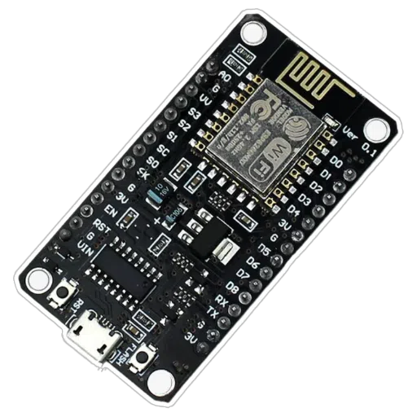
Fig 7.1.1 ESP8266

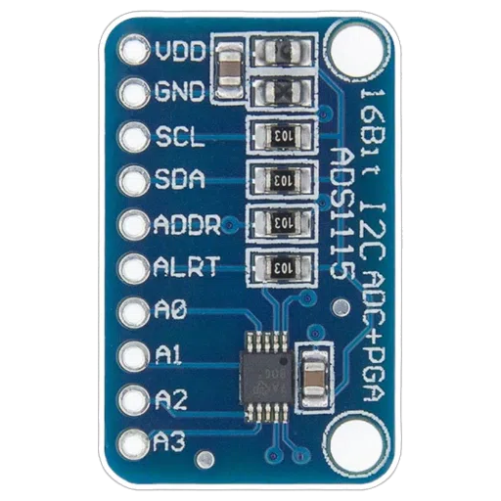
Fig 7.1.2 Ads112

Because of its central role, the microcontroller serves as the brain of the AGRINOVA system and enables the integration of various hardware components into a unified monitoring platform.

7.2 SOIL MOISTURE SENSOR

The soil moisture sensor is one of the most important sensors used in the AGRINOVA system. It measures the amount of water present in the soil and helps determine whether crops require irrigation. Soil moisture levels directly influence plant growth, root development, and nutrient absorption.

The soil moisture sensor operates by detecting the electrical resistance or capacitance of the soil. Wet soil conducts electricity better than dry soil, allowing the sensor to estimate the moisture content of the soil.

The main functions of the soil moisture sensor include:

- Monitoring Soil Water Content
The sensor continuously measures the moisture level in the soil and provides real-time information about soil conditions.

- Supporting Smart Irrigation
By analyzing soil moisture data, farmers can determine when irrigation is required. This helps avoid both overwatering and underwatering of crops.

- Improving Water Efficiency
Efficient irrigation based on soil moisture readings reduces water wastage and promotes sustainable water usage in agriculture.

- Enhancing Crop Health
Maintaining optimal soil moisture levels ensures that crops receive sufficient water for healthy growth and development.

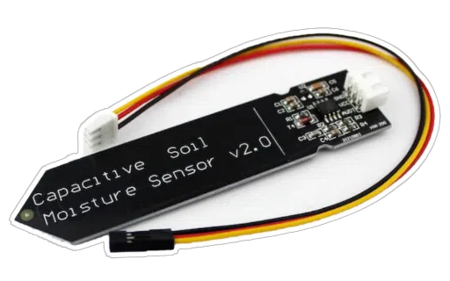
Fig 7.2.1 Soil Moisture Sensor

The soil moisture sensor plays a critical role in precision agriculture by providing accurate information that helps farmers manage irrigation effectively.

7.3 TEMPERATURE AND HUMIDITY SENSOR

Temperature and humidity are important environmental factors that affect plant growth and crop productivity. The temperature and humidity sensor used in the AGRINOVA system measures these parameters and provides valuable information about the climatic conditions of the agricultural field.

Sensors such as DHT11 or DHT22 are commonly used in IoT-based agricultural monitoring systems. These sensors combine temperature and humidity measurement capabilities in a single device.

The functions of the temperature and humidity sensor include:

- Temperature Monitoring
The sensor measures the ambient temperature of the agricultural environment. Temperature variations can significantly influence plant metabolism, flowering, and fruit development.

- Humidity Measurement
Humidity refers to the amount of water vapor present in the air. High humidity levels may encourage plant diseases and fungal growth, while low humidity may cause excessive evaporation and plant stress.

- Climate Analysis
By continuously monitoring temperature and humidity levels, farmers can analyze environmental conditions and adjust farming practices accordingly.

- Supporting Controlled Agriculture
In greenhouse environments, temperature and humidity sensors help maintain optimal climatic conditions for plant growth through automated control systems.

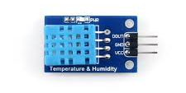
Fig 7.3.1 DHT11 Temperature and Humidity Sensor

The data collected from temperature and humidity sensors helps farmers understand environmental trends and take appropriate measures to protect crops.

7.4 GAS SENSOR

Gas sensors are used in the AGRINOVA system to detect the presence of certain gases in the agricultural environment. Monitoring gas levels can provide useful information about air quality and environmental conditions that may affect plant growth.

Common gas sensors used in IoT-based agricultural systems include sensors from the MQ series, such as MQ-2 or MQ-135. These sensors are capable of detecting gases such as carbon dioxide, ammonia, and other air pollutants.

The role of the gas sensor includes:

- Air Quality Monitoring
Gas sensors measure the concentration of gases present in the air. Poor air quality can negatively impact plant health and agricultural productivity.
- Detection of Harmful Gases
Certain gases such as ammonia or excessive carbon dioxide may indicate unfavorable environmental conditions that could harm crops.

- Environmental Safety
Monitoring gas levels helps farmers identify potential environmental hazards and maintain safe conditions for both crops and farm workers.

- Supporting Smart Agriculture Systems
Gas sensor data can be integrated with other environmental parameters to provide a comprehensive understanding of agricultural conditions.

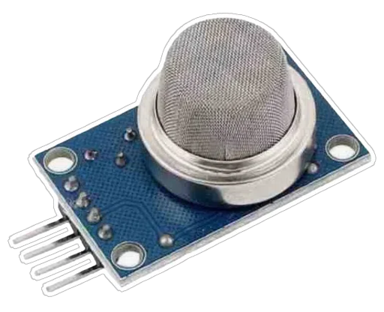
Fig 7.4.1 Gas Sensor

The use of gas sensors enhances the monitoring capabilities of the AGRINOVA system and contributes to a more complete assessment of environmental conditions.

7.5 POWER SUPPLY SYSTEM

A reliable power supply system is essential for the continuous operation of the AGRINOVA hardware components. Sensors, microcontrollers, and communication modules require stable electrical power to function properly.
The power supply system may consist of several components, including batteries, voltage regulators, and solar panels. In many agricultural IoT systems, solar energy is used as a sustainable power source, especially in remote areas where conventional electricity may not be available.

The functions of the power supply system include:

- Providing Stable Electrical Power
The power supply ensures that all hardware components receive the required voltage and current for proper operation.

- Supporting Continuous Monitoring
Since the AGRINOVA system operates continuously to monitor environmental conditions, a reliable power source is necessary to prevent interruptions.
- Energy Efficiency
Low-power microcontrollers and sensors are often used to reduce energy consumption and extend battery life.

- Solar Power Integration
Solar panels can be used to recharge batteries and provide renewable energy for the system, making it suitable for remote agricultural environments.

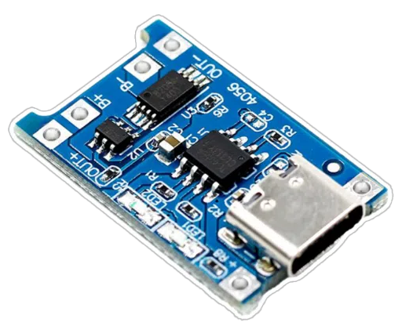
Fig 7.5.1 Tp4056 Charging Module

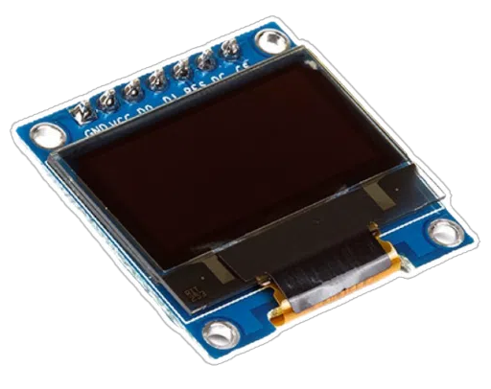
Fig 7.5.2 Led screen

The power supply system plays a critical role in maintaining the reliability and long-term operation of the AGRINOVA monitoring platform.

7.6 HARDWARE ARCHITECTURE OF AGRINOVA

- Hardware Components
- Sensors
- Soil Moisture Sensor
- Temperature Sensor
- Humidity Sensor
- Gas Sensor

- Microcontroller Unit (MCU)
The microcontroller acts as the brain of the AGRINOVA system.

- Common options:
- Arduino Uno
- ESP8266
- ESP32
- Functions:
- Collects data from sensors
- Processes sensor signals
- Sends data to cloud server
- Controls communication module

- Communication Module

Technology | Range | Usage
Wi-Fi | Short | Farm near internet
LoRa | Long | Large farms
GSM | Very long | Remote areas

Table 7.6.1 Communication Module
- Power Supply

Power sources may include:
- Rechargeable batteries
- Solar panels
- Power regulators

Solar power is ideal for remote agricultural areas.

CHAPTER 8

SOFTWARE DESIGN AND PROGRAMMING

Software design plays a crucial role in the successful operation of the AGRINOVA smart agriculture monitoring system. While hardware components such as sensors and microcontrollers are responsible for collecting environmental data, the software enables the system to process, manage, and transmit this data efficiently. Proper software design ensures that sensor readings are accurately captured, processed, and communicated to the cloud platform for monitoring and analysis.

In IoT-based systems like AGRINOVA, embedded programming forms the foundation of the software architecture. The microcontroller is programmed using embedded software that controls sensor operations, manages communication protocols, and ensures continuous monitoring of agricultural parameters such as soil moisture, temperature, humidity, and gas levels.

The software is designed to operate in real-time conditions, allowing the system to collect data at regular intervals and transmit it to remote monitoring platforms. This enables farmers and agricultural managers to observe field conditions without physically visiting the farm. By integrating embedded programming with IoT communication technologies, the AGRINOVA system provides an efficient and automated monitoring solution.

8.1 EMBEDDED PROGRAMMING FOR THE MICROCONTROLLER

Embedded programming refers to the development of software specifically designed to run on microcontrollers or embedded devices. In the AGRINOVA system, the microcontroller acts as the central processing unit that controls all sensor operations and communication tasks.

The embedded program is responsible for initializing the sensors, collecting data from them, processing the information, and sending the results to the cloud platform through wireless communication modules. The programming is typically written using languages such as C or C++, which are widely used in microcontroller-based applications.

The development environment commonly used for programming microcontrollers in IoT projects includes platforms such as Arduino IDE, PlatformIO, or ESP-IDF, depending on the type of microcontroller used. These environments provide libraries that simplify sensor integration and wireless communication.

The main functions performed by the embedded software include:

- Sensor initialization: Configuring sensors so that they operate correctly.
- Data acquisition: Collecting environmental data from sensors at regular intervals.
- Data processing: Converting raw sensor signals into meaningful values.
- Communication management: Sending processed data to cloud platforms or remote servers.

The program operates in a continuous loop where the microcontroller repeatedly reads sensor data, processes it, and transmits it. This ensures that the agricultural environment is constantly monitored.

Embedded programming also includes error handling and system stability mechanisms. These mechanisms allow the system to detect faults such as sensor disconnections or communication failures and respond appropriately to maintain reliable operation.

8.2 DATA ACQUISITION PROCESS

The data acquisition process involves collecting real-time environmental information from various sensors installed in the agricultural field. In the AGRINOVA system, sensors are used to monitor important parameters that affect crop growth and soil conditions.

The process begins when the microcontroller activates the sensors. Each sensor measures a specific environmental parameter and converts it into an electrical signal. These signals are then read by the microcontroller through analog or digital input pins.

The main stages involved in the data acquisition process include:

- Sensor Activation
The microcontroller powers the sensors and prepares them for measurement.

- Signal Measurement
Each sensor measures a specific environmental parameter such as soil moisture, temperature, humidity, or gas concentration.

- Analog-to-Digital Conversion (ADC)
If the sensor provides an analog signal, the microcontroller converts it into a digital value using an analog-to-digital converter.

- Data Sampling
The system collects data at predefined time intervals to ensure continuous monitoring.

- Temporary Data Storage
The acquired data is stored temporarily in the microcontroller’s memory before being processed or transmitted.

The frequency of data acquisition can be adjusted depending on the requirements of the agricultural application. For example, soil moisture may be monitored every few minutes to optimize irrigation decisions.

This structured data acquisition process ensures that accurate and timely environmental information is available for analysis and decision-making.

8.3 SENSOR DATA PROCESSING

Once sensor data is collected, it must be processed before being transmitted to the cloud platform. Raw sensor signals often contain noise or may not be directly interpretable. Therefore, the microcontroller performs several processing operations to convert the raw data into meaningful information.

The data processing stage involves the following steps:

- Signal Conversion
Raw electrical signals from sensors are converted into readable physical values such as degrees Celsius, percentage humidity, or soil moisture levels.

- Data Calibration
Sensors may require calibration to ensure accurate readings. Calibration adjusts the sensor output based on predefined reference values.

- Filtering and Noise Reduction
Environmental sensors may produce unstable readings due to environmental disturbances. Filtering techniques help remove unwanted fluctuations and improve measurement accuracy.

- Threshold Detection
The system may define threshold values for certain parameters. For example, if soil moisture falls below a specific level, it may indicate that irrigation is required.

- Data Formatting
Processed data is organized into a structured format suitable for transmission to cloud servers or monitoring applications.

By processing sensor data locally within the microcontroller, the AGRINOVA system reduces the amount of unnecessary data transmitted over the network. This improves efficiency and reduces communication overhead.

Processed data can then be sent to cloud platforms where it can be visualized, analyzed, or used for automated decision-making systems.

8.4 FIRMWARE DEVELOPMENT

Firmware refers to the low-level software embedded in the microcontroller that directly controls hardware components. It acts as a bridge between the hardware and the higher-level IoT system.

In the AGRINOVA project, firmware development is essential for coordinating sensor operations, managing communication protocols, and ensuring reliable system performance.
The firmware is designed to run continuously and perform multiple tasks such as reading sensors, processing data, and transmitting information. It is typically structured into several modules to simplify development and maintenance.

The main modules of the firmware include:

- Sensor Interface Module
This module handles communication between the microcontroller and sensors. It reads sensor data and converts it into usable digital values.

- Data Processing Module
This module processes the collected data by performing filtering, calibration, and formatting operations.

- Communication Module
This module manages wireless communication between the microcontroller and cloud servers using technologies such as Wi-Fi or GSM.

- Power Management Module
Efficient power usage is important in IoT systems deployed in agricultural fields. The firmware may include power-saving techniques such as sleep modes to reduce energy consumption.

- Error Handling Module
This module detects and handles system errors such as sensor failures or communication
interruptions. It ensures that the system continues functioning reliably even in challenging environments.

Firmware development also involves testing and debugging to ensure that the system operates correctly under different environmental conditions. Once finalized, the firmware is uploaded to the microcontroller and becomes a permanent part of the AGRINOVA device.

8.5 SOFTWARE ARCHITECTURE

- Software Layers
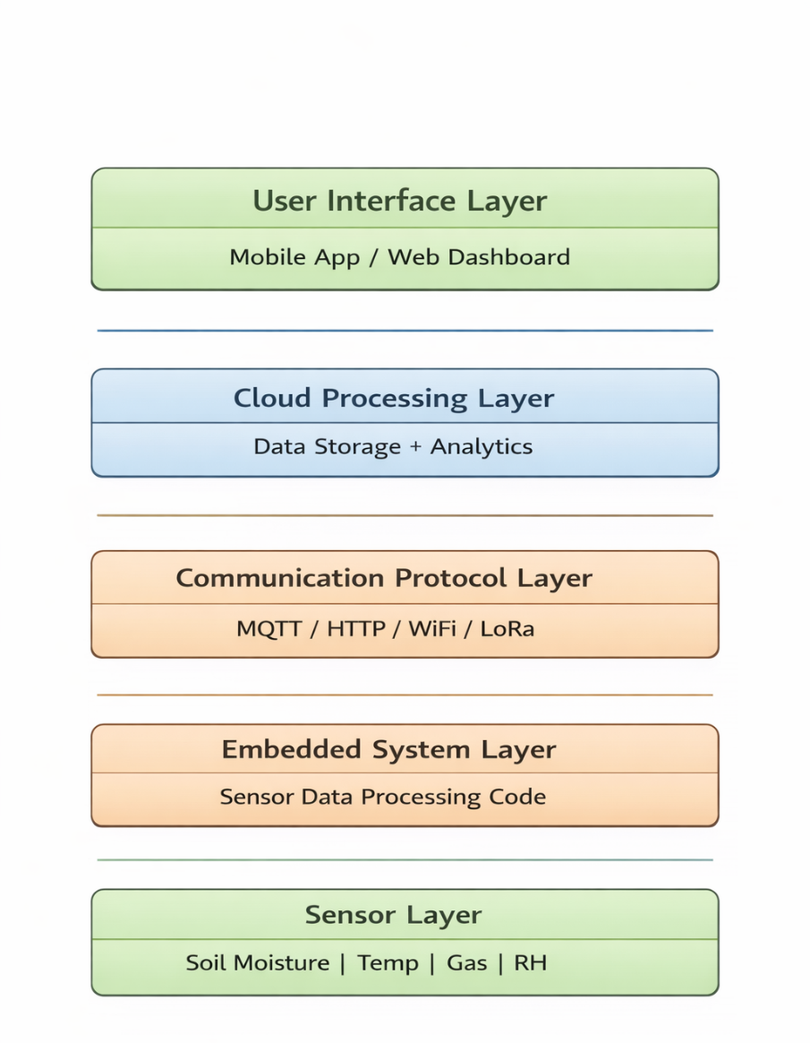
Fig 8.5.1 Layers
CHAPTER 9

CLOUD INTEGRATION AND DATA MANAGEMENT

Cloud integration plays a crucial role in modern Internet of Things (IoT) systems, especially in applications such as smart agriculture. In the AGRINOVA system, cloud technology is used to store, manage, and visualize data collected from various sensors installed in agricultural fields. By integrating the monitoring system with a cloud platform, farmers and agricultural managers can access real-time environmental information from any location using internet-connected devices.

The cloud acts as a centralized storage system where large volumes of sensor data are collected and organized. Instead of storing data locally on the microcontroller, which has limited memory, the AGRINOVA system transmits environmental data to the cloud for long-term storage and analysis. This approach enables continuous monitoring of farm conditions and allows users to analyze historical data trends for better decision-making.

Cloud-based systems also support remote accessibility, automated alerts, and data visualization tools that simplify the monitoring process. These capabilities help farmers track environmental parameters such as soil moisture, temperature, humidity, and gas concentration without physically visiting the farm.

9.1 CLOUD PLATFORM USED FOR DATA STORAGE

The AGRINOVA system uses a cloud platform to store the environmental data collected by the sensors. A cloud platform provides scalable and secure storage infrastructure where large amounts of sensor data can be stored and accessed efficiently.

Common cloud platforms used in IoT-based agricultural systems include:
- ThingSpeak
- Blynk Cloud
- Firebase
- AWS IoT Core
- Google Cloud IoT

For many academic and prototype IoT projects, ThingSpeak or Blynk is commonly used due to their ease of integration with microcontrollers such as Arduino and ESP32. These platforms allow the system to send sensor readings to cloud servers using internet connectivity through Wi-Fi or GSM modules.

The data transmission process generally follows these steps:

- Sensors collect environmental data from the field.
- The microcontroller processes the data.
- The wireless communication module connects to the internet.
- The processed data is sent to the cloud server through an API or HTTP request.
- The cloud platform stores the data in a database.

Cloud storage ensures that sensor data is preserved even if the local device restarts or loses power. It also allows users to retrieve historical data for analysis and comparison.

Another advantage of cloud platforms is scalability, which means additional sensors or sensor nodes can easily be integrated into the system without major changes in the infrastructure.

9.2 DATA VISUALIZATION AND DASHBOARDS

Raw sensor data stored in the cloud is difficult to interpret without proper visualization tools. Therefore, cloud platforms provide dashboards that convert numerical data into graphical formats such as charts, graphs, and gauges. These visual representations help users quickly understand environmental conditions in the agricultural field.

In the AGRINOVA system, the cloud dashboard displays parameters such as:

- Soil moisture level
- Temperature
- Humidity
- Gas concentration

These parameters are typically displayed using line graphs, bar charts, and real-time indicators. For example, a line graph can show how soil moisture changes throughout the day, helping farmers determine when irrigation is required.

Dashboards may include the following features:

- Real-time data updates
- Historical data tracking
- Graphical representation of sensor readings
- Alerts and notifications for abnormal conditions

Data visualization tools allow users to observe patterns and trends in environmental conditions. For example, temperature variations over several days can indicate seasonal changes, while soil moisture trends can guide irrigation scheduling.

Such visual insights enable farmers to make informed decisions regarding crop management and resource utilization.

9.3 REMOTE MONITORING THROUGH WEB OR MOBILE INTERFACE

One of the major advantages of integrating IoT systems with cloud platforms is the ability to monitor agricultural fields remotely. In the AGRINOVA system, users can access sensor data through web dashboards or mobile applications.

The cloud platform provides a user-friendly interface that allows farmers to log in and view real-time information about their farm environment. This eliminates the need for constant physical presence in the field.

Remote monitoring systems typically offer the following functionalities:

- Viewing real-time sensor readings

- Monitoring environmental conditions from any location
- Receiving alerts when parameters exceed safe limits
- Accessing historical data records
- Monitoring multiple sensor nodes simultaneously
Mobile applications are particularly useful for farmers, as they allow quick access to farm data using smartphones. These applications may also provide notification systems that alert users when environmental conditions become unfavorable for crop growth.

For example, if the soil moisture level drops below a certain threshold, the system can send a notification indicating that irrigation is required. This allows timely intervention and prevents crop stress caused by water shortage.

Remote monitoring significantly improves farm management efficiency and helps reduce manual labor.

9.4 ADVANTAGES OF CLOUD-BASED MONITORING

Cloud-based monitoring offers several advantages in agricultural IoT systems. These benefits make cloud integration an essential component of smart farming technologies.

- Real-Time Data Access
Cloud platforms allow users to access environmental data instantly from anywhere with an internet connection. This enables continuous monitoring of agricultural conditions.

- Centralized Data Storage
All sensor data is stored in a centralized database, making it easier to organize and analyze information over long periods.

- Scalability
Cloud systems can easily handle additional devices or sensors as the monitoring network
expands. This allows the AGRINOVA system to support multiple farms or large agricultural areas.

- Data Analysis and Insights
Cloud platforms can analyze large datasets to identify patterns, trends, and anomalies.
This information can help improve crop management strategies.

- Remote Accessibility
Farmers can monitor their fields using web browsers or mobile applications, eliminating the need for constant physical presence in the field.

- Integration with Advanced Technologies
Cloud platforms can integrate with artificial intelligence, machine learning, and big data analytics to provide predictive insights and automated recommendations for crop management.

- Improved Decision Making
By providing accurate and real-time data, cloud-based monitoring enables farmers to make informed decisions regarding irrigation, fertilization, and crop protection.
CHAPTER 10

IMPLEMENTATION METHODOLOGY

The implementation methodology describes the systematic process followed to develop and deploy the AGRINOVA smart agriculture monitoring system. A well-structured implementation process ensures that the hardware and software components of the system function together effectively. The AGRINOVA system was developed through a series of organized steps that include system design, hardware assembly, sensor calibration, programming, and system integration.

The objective of the implementation phase is to transform the conceptual design of the project into a working prototype capable of monitoring environmental conditions in agricultural fields. During this phase, sensors are installed, the microcontroller is programmed, communication modules are configured, and the entire system is tested to ensure proper functionality.

The methodology followed in this project ensures that each component is properly integrated and tested before the final deployment of the system. This structured approach reduces errors, improves reliability, and helps in achieving accurate environmental monitoring.

10.1 PROCESS
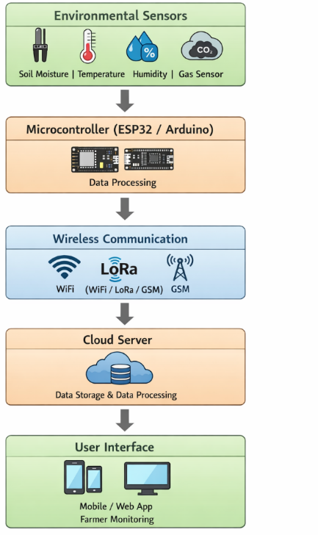
Fig 10.1.1 Step by step process

10.2 STEP-BY-STEP DEVELOPMENT PROCESS

The development of the AGRINOVA system follows a step-by-step procedure to ensure proper implementation and efficient operation. Each stage of development focuses on a specific part of the system and contributes to the overall functionality of the project.

The major steps involved in the development process are described below:

1. Requirement Analysis
The first step involves identifying the requirements of the smart agriculture monitoring system. Important environmental parameters such as soil moisture, temperature, humidity, and gas concentration were selected because they play a critical role in crop growth and soil health. The system was designed to monitor these parameters continuously.

2. System Design
After identifying the requirements, the overall system architecture was designed. This included selecting appropriate sensors, choosing a suitable microcontroller, and deciding the communication technology to transmit data to the cloud platform.

3. Component Selection
In this stage, suitable hardware components were selected based on performance, compatibility, and cost. The main components selected for the AGRINOVA system include soil moisture sensors, temperature and humidity sensors, gas sensors, a microcontroller, wireless communication modules, and power supply units.

4. Circuit Design and Planning
A circuit diagram was created to determine how the sensors, controller, and communication modules would be connected. This step ensures that all components are properly wired and compatible with the microcontroller’s input and output pins.

5. Software Development
Embedded software was written to control the sensors and manage communication with the cloud platform. The software includes programs for reading sensor data, processing the readings, and transmitting them to remote servers.

6. Hardware Assembly and Testing
Once the hardware and software were prepared, the system components were assembled and tested individually to verify correct operation.

7. System Integration and Validation
Finally, all components were integrated into a single system and tested under real environmental conditions to ensure proper functionality.

This step-by-step development process ensures that the AGRINOVA system operates reliably and efficiently.

10.3 HARDWARE ASSEMBLY

Hardware assembly is an important stage in the implementation of the AGRINOVA system. During this stage, all electronic components are physically connected to create a functioning monitoring device.
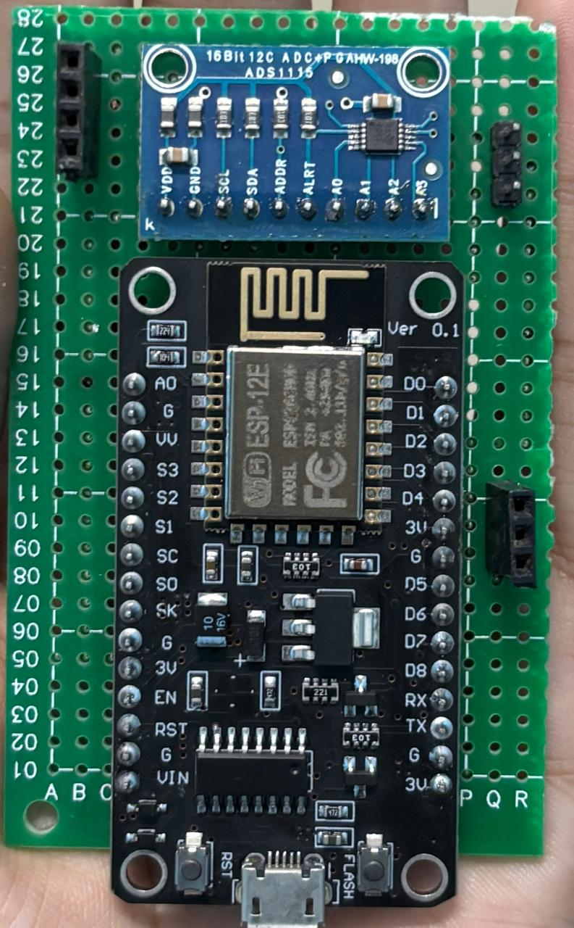
Fig 10.3.1 Esp8266 and Ads115 Module

The hardware assembly process involves the following steps:

- Connecting the Microcontroller
The microcontroller acts as the central unit of the system. It is mounted on a development board or breadboard and connected to power supply lines.

- Sensor Connections
Each sensor is connected to the microcontroller through appropriate input pins. For example:

- Soil moisture sensors are connected to analog input pins.
- Temperature and humidity sensors are connected to digital input pins.
- Gas sensors are connected through analog or digital interfaces depending on the sensor model.

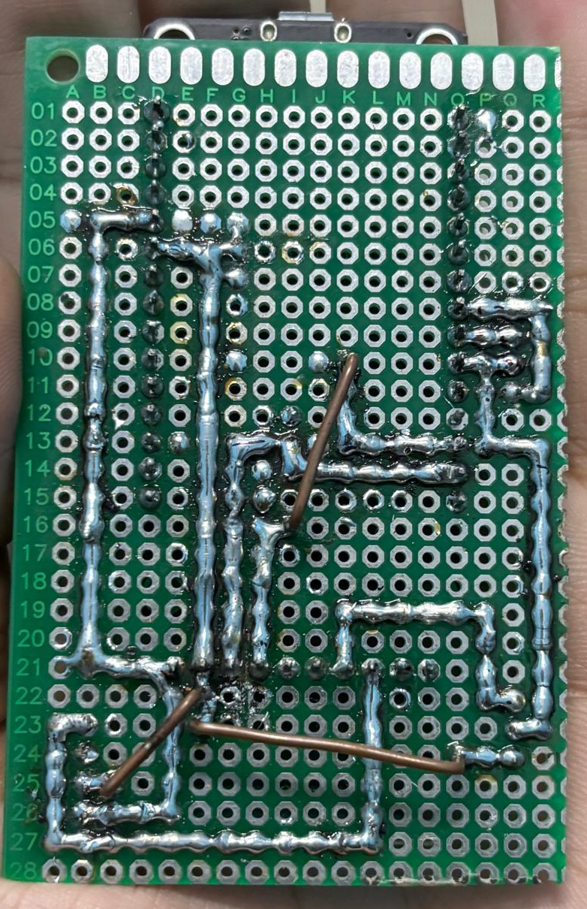
Fig 10.3.2 Soldering of Esp8266 and Ads115 module

Proper wiring ensures that each sensor communicates correctly with the microcontroller.

- Communication Module Integration
The wireless communication module (such as Wi-Fi or GSM) is connected to the

microcontroller through communication interfaces such as UART or SPI. This module allows the system to send data to the cloud platform.

- Power Supply Setup
A stable power supply is required for the proper functioning of the system. The power source may include batteries, adapters, or solar panels depending on the deployment environment. Voltage regulators may also be used to maintain safe operating voltage
levels for electronic components.

- Physical Enclosure and Protection
Since the system is intended for agricultural environments, the hardware components may be placed inside protective enclosures to prevent damage from moisture, dust, and environmental conditions.

Once all components are assembled, the hardware setup is carefully inspected to ensure correct connections and proper operation.

10.4 SENSOR CALIBRATION

Sensor calibration is the process of adjusting sensor readings to ensure accurate measurements. Environmental sensors may sometimes produce inaccurate values due to manufacturing variations or environmental interference. Calibration helps correct these deviations and improve measurement reliability.

In the AGRINOVA system, calibration is performed for each sensor before deploying the system in the field.

- Soil Moisture Sensor Calibration
The soil moisture sensor is calibrated by measuring its output in dry soil and wet soil conditions. These reference values help determine the range of sensor readings corresponding to different moisture levels.

- Temperature and Humidity Sensor Calibration
Temperature and humidity sensors are tested using known environmental conditions or reference devices. The readings from the sensor are compared with standard values to verify their accuracy.

- Gas Sensor Calibration
Gas sensors are calibrated by exposing them to controlled gas concentrations or by
adjusting their sensitivity using calibration parameters provided by the manufacturer.

Calibration ensures that sensor readings accurately represent the real environmental conditions of the agricultural field. Proper calibration improves the reliability of the data collected by the system and enhances the overall performance of the monitoring system.

10.5 SYSTEM INTEGRATION

System integration is the final stage of the implementation process where all hardware and software components are combined into a fully operational system. The goal of integration is to ensure that sensors, the microcontroller, communication modules, and cloud platforms work together seamlessly.

The integration process includes the following steps:

- Sensor Data Collection
The microcontroller reads data from all connected sensors at regular intervals.

- Data Processing
The collected data is processed and converted into meaningful values that represent environmental conditions.

- Wireless Data Transmission
The processed data is transmitted to the cloud platform through the wireless communication module.

- Cloud Storage and Monitoring
The cloud platform receives the data and stores it in a database. The information is then displayed on dashboards for remote monitoring.

- System Testing
After integration, the entire system is tested to ensure that all components are functioning correctly. Testing includes verifying sensor accuracy, checking data transmission reliability, and confirming proper cloud connectivity.

Through system integration, the AGRINOVA project becomes a fully functional IoT-based smart agriculture monitoring solution capable of providing real-time environmental data to farmers and agricultural managers.
CHAPTER 11
WORKING PRINCIPLE OF AGRINOVA

The AGRINOVA system is designed as an Internet of Things (IoT)-based smart agriculture monitoring system that continuously observes environmental conditions in agricultural fields. The working principle of the system is based on the collection of real-time environmental data using sensors, processing the data through a microcontroller, transmitting the information to a cloud platform, and presenting the results to farmers through digital interfaces.

The system operates as a complete monitoring cycle where environmental parameters such as soil moisture, temperature, humidity, and gas levels are measured and analyzed to support better agricultural decision-making. By integrating sensors, wireless communication, and cloud computing technologies, AGRINOVA enables farmers to monitor their crops remotely and respond quickly to changing environmental conditions.

The working mechanism of the AGRINOVA system can be divided into four major stages: environmental data collection, data transmission, monitoring and analysis, and decision support for farmers.

11.1 HOW THE SYSTEM COLLECTS ENVIRONMENTAL DATA

The first stage in the working principle of the AGRINOVA system involves collecting environmental data from the agricultural field. Sensors installed in the field continuously measure various parameters that influence crop growth and soil health.

Each sensor is designed to detect a specific environmental condition. For example, the soil moisture sensor measures the amount of water present in the soil, while the temperature and humidity sensor monitors atmospheric conditions. Gas sensors may also be used to detect harmful gases or air quality levels in the surrounding environment.

These sensors convert physical environmental conditions into electrical signals. The signals generated by the sensors are then sent to the microcontroller, which acts as the central processing unit of the system.
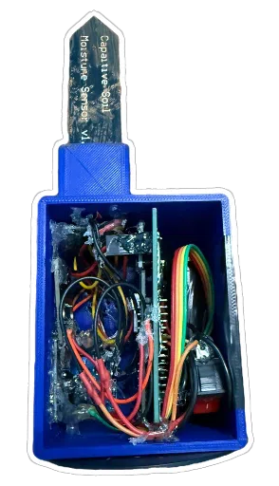
Fig 11.1.1 Sensor Embedded Node

The microcontroller reads sensor signals through its input pins. Depending on the type of sensor, the signals may be analog or digital. Analog signals are converted into digital values using an analog-to-digital converter (ADC) built into the microcontroller. Once converted, the microcontroller interprets these signals and converts them into readable environmental values such as temperature in degrees Celsius, humidity percentage, or soil moisture level.

The data collection process is repeated at regular time intervals to ensure continuous monitoring of the agricultural environment. This continuous sensing allows the system to track changes in environmental conditions over time.

11.2 DATA TRANSMISSION TO CLOUD PLATFORM

After collecting and processing the environmental data, the next step in the working process is transmitting the data to the cloud platform. This step enables remote access and storage of agricultural information.

The microcontroller sends the processed sensor data to a wireless communication module integrated into the AGRINOVA system. Depending on the design of the system, communication technologies such as Wi-Fi, GSM, or other IoT communication protocols may be used.

Once the communication module connects to the internet, the data is transmitted to the cloud platform using network communication protocols such as HTTP or MQTT. These protocols ensure secure and efficient transfer of sensor data from the field device to the cloud server. The transmitted data is then stored in a cloud database where it can be accessed and analyzed at any time. Cloud storage allows the system to maintain large volumes of environmental data without being limited by the memory capacity of the microcontroller.

Regular data transmission ensures that the cloud platform always receives updated information about the field conditions. This enables farmers and agricultural managers to monitor their crops in real time from remote locations.

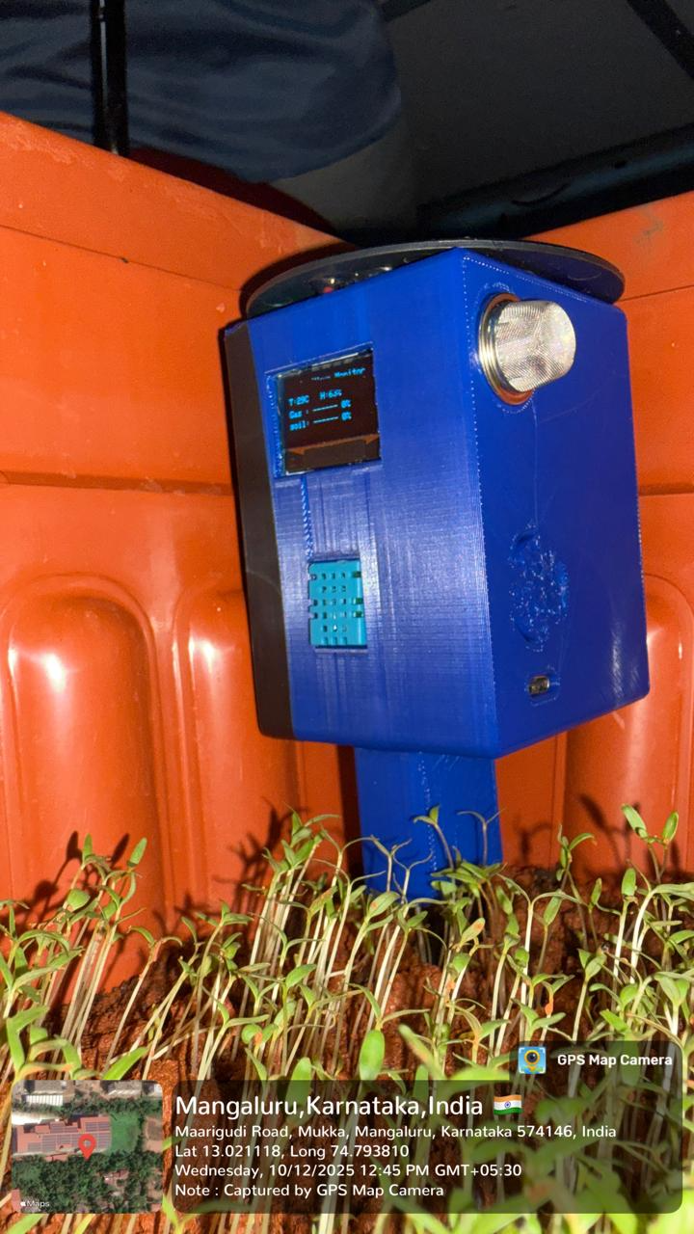
Fig 11.2.1 Complete Node (Side View)

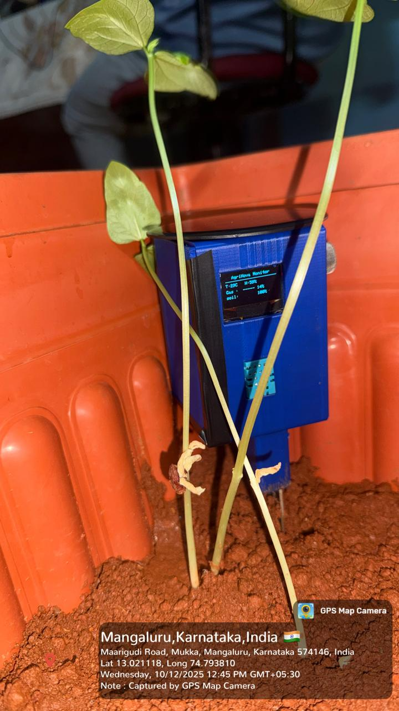
Fig 11.2.2 Complete Node (Front View)

11.3 MONITORING AND ANALYSIS PROCESS

Once the data reaches the cloud platform, it is organized and displayed through monitoring dashboards and visualization tools. These dashboards convert raw sensor data into easy-to-understand graphical representations such as charts, graphs, and indicators.

Farmers can view parameters such as soil moisture levels, temperature variations, humidity changes, and gas concentrations through a web interface or mobile application. These visual tools make it easier to interpret environmental conditions without requiring technical knowledge.

The cloud platform also stores historical data, allowing users to analyze trends over time. For example, farmers can observe how soil moisture changes throughout the day or how temperature variations affect crop conditions.

Data analysis helps identify patterns that may influence crop growth. By studying these patterns, farmers can make informed decisions about irrigation schedules, fertilizer application, and crop protection strategies.

Advanced systems may also include automated analysis tools that detect abnormal environmental conditions and generate alerts or notifications. For example, if the soil moisture level drops below a predefined threshold, the system can notify the farmer that irrigation may be required.

11.4 DECISION SUPPORT FOR FARMERS

One of the most important functions of the AGRINOVA system is providing decision support to farmers. By delivering accurate and real-time environmental information, the system helps farmers make better agricultural management decisions.

Traditional farming methods often rely on manual observation and experience to determine when to irrigate crops or apply fertilizers. However, such methods may lead to inefficient resource usage and inconsistent crop growth.

The AGRINOVA system improves this process by providing reliable data that farmers can use to guide their actions. For example:

- If soil moisture levels are low, farmers can initiate irrigation to prevent crop stress.
- If temperature levels become too high, farmers may take protective measures to reduce heat stress on plants.
- If humidity levels change significantly, farmers can adjust irrigation or ventilation conditions.
- If harmful gases are detected, preventive measures can be taken to protect crops and workers.

By using data-driven insights, farmers can optimize resource utilization, reduce water wastage, and improve crop productivity.

In future implementations, decision support systems may be enhanced with artificial intelligence and machine learning algorithms that automatically recommend farming actions based on collected environmental data.

The working principle of the AGRINOVA system is based on continuous environmental monitoring using sensors, real-time data transmission through wireless communication, and cloud-based analysis of agricultural data. The system collects environmental information from the field, processes the data using a microcontroller, and sends the information to cloud platforms for storage and visualization.

Through remote monitoring dashboards and data analysis tools, farmers can observe field conditions and make informed decisions regarding crop management. By providing accurate environmental insights, the AGRINOVA system supports efficient farming practices and contributes to the development of modern precision agriculture.
CHAPTER 12
TESTING AND VALIDATION

Testing and validation are essential stages in the development of any engineering system. They ensure that the system performs as intended and provides reliable results under real operating conditions. In the AGRINOVA smart agriculture monitoring system, testing was carried out to verify the proper functioning of sensors, the accuracy of collected data, the reliability of system communication, and the overall performance of the integrated system.

The purpose of testing is to identify any potential errors or malfunctions in the hardware and software components before the system is deployed in agricultural environments. Validation ensures that the measured environmental parameters truly represent the actual conditions in the field.

The testing process for AGRINOVA includes sensor testing, accuracy verification, system performance evaluation, and field testing. These procedures help confirm that the system is capable of continuously monitoring agricultural conditions and providing reliable data for farmers and agricultural managers.

12.1 DASHBOARD

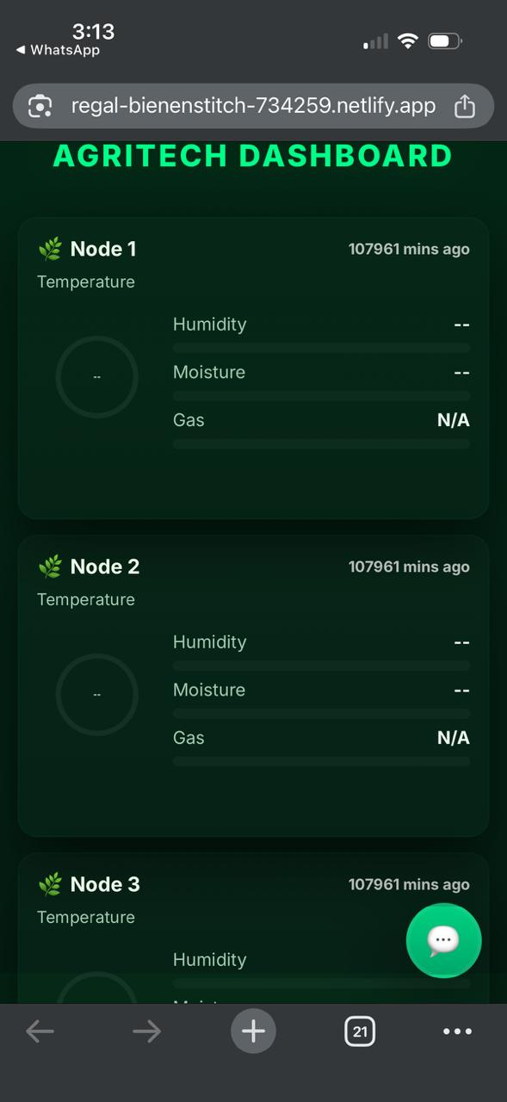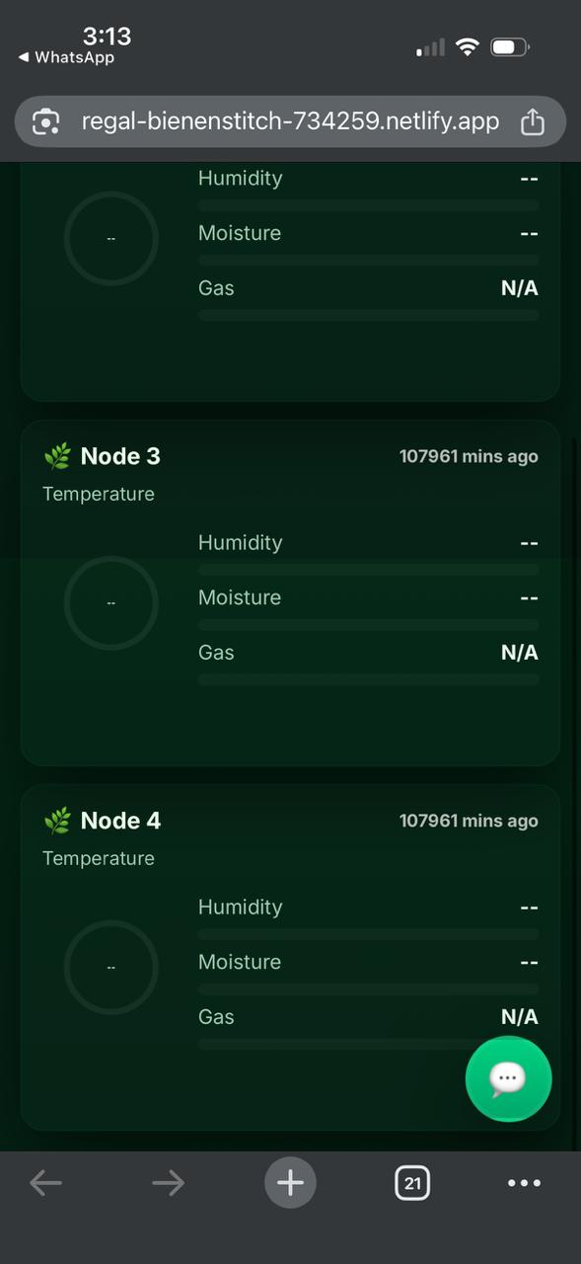
Fig 12.1.1 AGRINOVA Dashboard

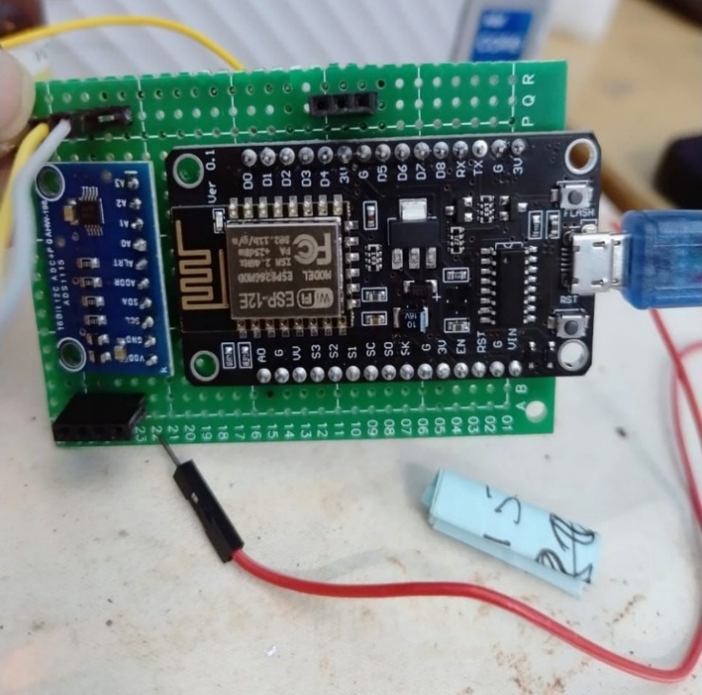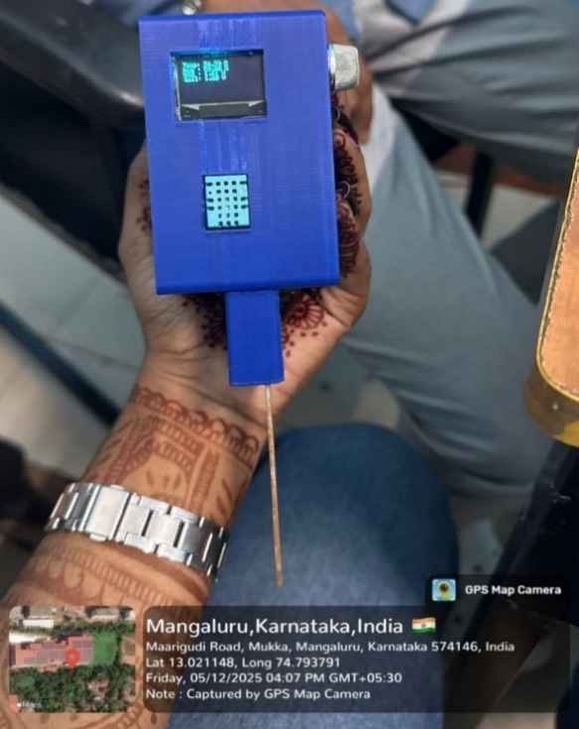
Fig 12.1.2 Circuit and Testing of Node

12.2 SENSOR TESTING PROCEDURES

Sensor testing is the first step in validating the AGRINOVA system. Since sensors are responsible for collecting environmental data, it is important to ensure that they operate correctly and provide stable readings.

Each sensor used in the system was tested individually before being integrated with the microcontroller. The testing process involved checking sensor functionality, verifying electrical connections, and observing sensor responses under different environmental conditions.

- Soil Moisture Sensor Testing
The soil moisture sensor was tested by inserting it into soil samples with varying moisture levels. Tests were conducted under dry soil conditions, moderately moist soil, and wet soil conditions. The sensor readings were observed to ensure that the output values changed according to the moisture content of the soil.

- Temperature and Humidity Sensor Testing
The temperature and humidity sensor was tested by exposing it to different

environmental conditions. For example, the sensor was placed in open air, near warm surfaces, and in controlled indoor environments to observe variations in temperature and humidity readings.

- Gas Sensor Testing
The gas sensor was tested by exposing it to different air conditions to observe its response to gas concentration changes. The sensor output was monitored to ensure that it responded correctly to variations in air quality.

During the testing process, sensor readings were continuously monitored to verify stability and responsiveness. Any irregularities or abnormal readings were carefully analyzed and corrected through proper calibration or hardware adjustments.

12.3 ACCURACY VERIFICATION

Accuracy verification is performed to ensure that the sensor readings provided by the AGRINOVA system closely match actual environmental conditions. Accurate measurements are essential for making reliable agricultural decisions.

To verify accuracy, sensor readings were compared with reference instruments or known environmental conditions. This comparison helps determine the level of deviation between the sensor output and the actual value.

For example, the temperature readings from the temperature sensor were compared with readings from a standard digital thermometer. Similarly, humidity levels measured by the sensor were compared with reference hygrometers to ensure consistency.

For soil moisture sensors, the output readings were compared with physical soil conditions to confirm that the sensor correctly detected dry, moist, and saturated soil states. If any differences were observed between the sensor readings and the reference values, calibration adjustments were made in the system software. Calibration ensures that the system produces readings that closely represent the real environmental conditions.

Through this process, the accuracy of the AGRINOVA monitoring system was improved, ensuring reliable environmental data collection.

12.4 SYSTEM PERFORMANCE TESTING

System performance testing evaluates the overall functionality and reliability of the AGRINOVA system after all hardware and software components have been integrated. This testing ensures that the system operates continuously without failures and successfully performs all required tasks.

Several aspects of system performance were evaluated during testing:

- Sensor Data Acquisition
The system was tested to ensure that the microcontroller correctly reads data from all connected sensors. Continuous data acquisition was verified by observing regular sensor updates over extended periods.

- Communication Reliability
The wireless communication module was tested to verify that sensor data is successfully transmitted to the cloud platform. Multiple data transmission cycles were performed to confirm stable network connectivity and reliable data transfer.

- Cloud Data Storage
The received data was monitored on the cloud platform to confirm that sensor readings were stored correctly in the cloud database. The system was tested for continuous data logging without interruptions.

- Dashboard Visualization
The cloud dashboard was tested to ensure that sensor readings were correctly displayed in graphical formats such as charts and real-time indicators. This step verified that users could easily monitor environmental conditions through digital interfaces.

- Power Stability
The power supply system was tested to ensure that the AGRINOVA device operates reliably without power fluctuations affecting sensor readings or system performance.

System performance testing confirmed that the AGRINOVA system could continuously monitor environmental conditions and transmit accurate data to remote monitoring platforms.

12.5 FIELD TESTING RESULTS

Field testing is conducted to evaluate the performance of the AGRINOVA system under real agricultural conditions. Unlike laboratory testing, field testing exposes the system to natural environmental variations such as temperature changes, humidity fluctuations, soil conditions, and outdoor interference. During field testing, the AGRINOVA device was deployed in an agricultural environment where sensors were placed in soil and exposed to outdoor atmospheric conditions. The system continuously monitored environmental parameters and transmitted the collected data to the cloud platform.

The results obtained from field testing demonstrated that:
- The sensors successfully detected changes in soil moisture levels.
- Temperature and humidity sensors accurately monitored atmospheric conditions.
- Gas sensors responded to changes in surrounding air conditions.
- Sensor data was transmitted successfully to the cloud platform.
- The cloud dashboard displayed real-time environmental data without delay.

The results of the testing process confirmed that the sensors provide accurate environmental measurements and that the system successfully transmits data to the cloud platform for remote monitoring. Field testing further demonstrated that the AGRINOVA system performs effectively in real agricultural environments. These validation procedures ensure that the system can support farmers in monitoring environmental conditions and improving agricultural management through data-driven decision-making.
CHAPTER 13
SECURITY IN IOT SYSTEMS

Security is a critical aspect of Internet of Things (IoT) systems because these systems collect, transmit, and store large amounts of sensitive data. In smart agriculture applications like AGRINOVA, environmental data collected from sensors is transmitted over networks and stored on cloud platforms. If proper security measures are not implemented, this data may be exposed to unauthorized access, manipulation, or cyberattacks.

IoT devices are often deployed in remote locations such as agricultural fields, where they may operate continuously without direct supervision. This makes them vulnerable to both physical and digital security threats. Ensuring data security in such systems is essential to maintain the reliability, privacy, and integrity of the collected information.

The AGRINOVA system incorporates several security principles to protect data during transmission and storage. By implementing secure communication protocols and data protection strategies, the system ensures that environmental information remains accurate and accessible only to authorized users.

13.1 IMPORTANCE OF DATA SECURITY IN IOT

Data security is extremely important in IoT systems because these systems operate through interconnected networks and often communicate with cloud platforms. Any compromise in security can affect the entire system and lead to incorrect data analysis or unauthorized control of devices.

In the context of smart agriculture, IoT devices collect valuable environmental information such as soil conditions, climate data, and crop monitoring information. If this data is altered or accessed by unauthorized users, it could lead to incorrect farming decisions and potentially harm crop productivity.

Another reason data security is important is the protection of cloud-based information. Since
AGRINOVA stores environmental data on cloud servers, strong security measures must be in

place to prevent data theft or unauthorized access.
Secure IoT systems provide several benefits, including:

- Protection of sensitive agricultural data
- Prevention of unauthorized access to monitoring systems
- Maintenance of data integrity and reliability
- Safe communication between devices and cloud servers
- Increased trust in IoT-based agricultural technologies

By implementing proper security mechanisms, IoT systems can operate safely and reliably in agricultural environments.

13.2 POSSIBLE THREATS AND VULNERABILITIES

IoT systems face several security threats due to their connectivity and distributed nature. Understanding these threats is important for designing secure IoT applications.

- One common threat is unauthorized access, where attackers attempt to gain access to the IoT system without proper authentication. This could allow them to view, modify, or delete sensor data stored in the cloud.

- Another potential risk is data interception during transmission. Since IoT devices communicate through wireless networks, transmitted data may be intercepted by malicious users if it is not properly encrypted.

- Device tampering is another possible vulnerability in IoT systems. Since agricultural IoT devices are often installed in open environments, physical access to devices may allow attackers to manipulate hardware components or alter sensor readings.

- Malware attacks can also affect IoT devices. Malicious software can disrupt system operations, corrupt data, or interfere with communication between devices and cloud platforms.

Additionally, denial-of-service (DoS) attacks may target IoT systems by overwhelming them with excessive network traffic. This can prevent the system from transmitting or receiving important data. Identifying these threats helps developers implement proper security measures to protect the AGRINOVA system from potential risks.

13.3 SECURE COMMUNICATION METHODS

Secure communication is essential for protecting data transmitted between IoT devices and cloud platforms. Several methods can be used to ensure that the communication process remains secure.

- One important technique is data encryption. Encryption converts sensor data into coded information that can only be understood by authorized systems. Even if data is intercepted during transmission, it cannot be easily interpreted without the correct decryption key.

- Another important security method is secure communication protocols. Protocols such as HTTPS, SSL, and TLS are commonly used in IoT systems to provide secure data transmission over the internet. These protocols create encrypted communication channels between devices and cloud servers.

- Authentication mechanisms are also used to verify the identity of devices and users. Before transmitting data to the cloud platform, the AGRINOVA system must authenticate itself using secure credentials or authentication tokens. This ensures that only trusted devices can send or receive data.

- Network security techniques such as firewalls and secure gateways may also be used to protect IoT systems from unauthorized network access.

By implementing these secure communication methods, the AGRINOVA system can safely transmit environmental data without exposing it to cyber threats.

13.4 DATA PROTECTION STRATEGIES

Data protection strategies are designed to safeguard the integrity, confidentiality, and availability of information in AGRINOVA system.
- One important strategy is access control. Access control mechanisms ensure that only authorized users can access the monitoring dashboard and cloud data. User authentication through passwords or login credentials helps prevent unauthorized access.

- Another strategy is secure data storage. Cloud platforms should store sensor data in secure databases with proper encryption and backup systems. Regular data backups ensure that information is not lost due to system failures or cyberattacks.

- Firmware updates also play an important role in IoT security. Regularly updating the firmware of the microcontroller and communication modules helps fix vulnerabilities and improves system protection.

- Device authentication is another method used to verify that only trusted devices can connect to the cloud platform. Unique device identification helps prevent unauthorized devices from joining the network.

Additionally, network monitoring and intrusion detection systems can be used to detect unusual network activity and potential cyber threats.

By implementing these strategies, the AGRINOVA system can protect sensitive agricultural data and ensure reliable system operation.

Security is an essential component of IoT-based systems, particularly in applications such as smart agriculture where large amounts of environmental data are collected and transmitted over networks. The AGRINOVA system addresses security concerns by implementing secure communication protocols, data encryption techniques, and access control mechanisms.

Understanding potential threats such as unauthorized access, data interception, and device tampering helps in designing effective security solutions. By applying proper data protection strategies, IoT systems can maintain the integrity and reliability of agricultural data.

Ensuring strong security measures not only protects system data but also increases the trust and adoption of IoT technologies in modern agricultural practices.
CHAPTER 14
ADVANTAGES AND APPLICATIONS

The integration of Internet of Things (IoT) technology into agriculture has created new opportunities for improving farming efficiency and productivity. The AGRINOVA system is designed to provide a smart agricultural monitoring solution that enables farmers to observe environmental conditions in real time. By using sensors, wireless communication, and cloud-based data management, the system provides accurate and continuous information about the farming environment.

Traditional agricultural practices often rely on manual observation and periodic field inspections. These methods may lead to delays in detecting environmental changes, which can negatively affect crop health and productivity. The AGRINOVA system addresses these challenges by offering an automated monitoring solution that continuously collects and analyzes environmental data.

This chapter discusses the advantages of the AGRINOVA system, its applications in different farming environments, and its impact on water conservation and crop yield improvement.

14.1 BENEFITS OF AGRINOVA SYSTEM

The AGRINOVA smart agriculture monitoring system offers several advantages that help improve agricultural practices and farm management. By integrating modern technologies with traditional farming methods, the system provides efficient and reliable monitoring of environmental conditions.

- Real-Time Environmental Monitoring
One of the primary benefits of the AGRINOVA system is the ability to monitor environmental parameters in real time. Sensors installed in the agricultural field continuously measure soil moisture, temperature, humidity, and gas levels. These measurements allow farmers to understand the current conditions of their crops and respond quickly to any changes.

- Improved Decision-Making
The system provides accurate and timely information that helps farmers make informed decisions regarding irrigation, fertilization, and crop management. Data-driven decisions are generally more reliable than traditional experience-based methods.

- Remote Access and Monitoring
With cloud integration, the AGRINOVA system allows farmers to monitor their fields from any location using internet-connected devices such as smartphones or computers. This reduces the need for frequent visits to the field and saves time and effort.

- Efficient Resource Utilization
By monitoring environmental conditions precisely, the system helps farmers use resources such as water, fertilizers, and energy more efficiently. Proper resource management reduces waste and improves sustainability in agriculture.

- Early Detection of Environmental Changes
The AGRINOVA system can detect environmental variations such as sudden temperature changes or low soil moisture levels. Early detection allows farmers to take corrective actions before these conditions negatively affect crop growth.

- Scalability and Flexibility
The system can be expanded to include additional sensors and monitoring nodes for larger farms. This scalability allows the AGRINOVA system to be used in both small-scale and large-scale agricultural environments.

14.2 APPLICATIONS IN DIFFERENT FARMING ENVIRONMENTS

The AGRINOVA system can be applied in various types of farming environments where continuous environmental monitoring is required. Its flexible design allows it to adapt to different agricultural practices and crop types.

- Open Field Farming
In open field farming, crops are grown in large outdoor areas that are exposed to natural environmental conditions. The AGRINOVA system helps monitor soil moisture and atmospheric parameters to ensure optimal crop growth. Farmers can use this information to determine irrigation schedules and manage environmental stress on crops.

- Greenhouse Farming
Greenhouses provide controlled environments for growing plants. However, maintaining the correct temperature, humidity, and air quality is essential for successful greenhouse farming. The AGRINOVA system can monitor these environmental parameters and help maintain optimal conditions for plant growth.

- Precision Agriculture
Precision agriculture focuses on managing crops based on detailed environmental data. The AGRINOVA system supports precision farming by providing accurate measurements of soil and atmospheric conditions. Farmers can analyze this data to optimize irrigation, fertilization, and pest management strategies.

- Urban and Vertical Farming
Urban agriculture and vertical farming are becoming increasingly popular in cities where space is limited. These farming methods require careful monitoring of environmental parameters. AGRINOVA can be used in such systems to track temperature, humidity, and air quality in indoor farming environments.

- Research and Agricultural Studies
Agricultural researchers and institutions can use the AGRINOVA system to collect environmental data for scientific studies. The system can provide valuable insights into crop growth patterns and environmental impacts on agriculture.

14.3 IMPACT ON WATER CONSERVATION AND CROP YIELD

- Efficient Water Management

- The AGRINOVA system plays a crucial role in improving water management in agricultural fields.
- Traditional irrigation systems often follow fixed schedules, which do not consider the actual moisture condition of the soil.
- This can lead to excess irrigation, which wastes water, or insufficient irrigation, which harms crop growth.
- AGRINOVA overcomes this issue by continuously monitoring soil moisture levels using sensors and providing accurate information to farmers.

- Smart Irrigation Based on Soil Moisture

- The system uses soil moisture sensors to measure the exact amount of water present in the soil.
- Farmers receive real-time data, which allows them to irrigate crops only when the soil moisture drops below the required level.
- This ensures that plants receive the right amount of water at the right time, improving irrigation efficiency.

- Reduction in Water Wastage

- By providing accurate soil moisture data, the system prevents unnecessary watering.
- This significantly reduces water wastage, especially in regions where water resources are limited.
- Smart irrigation also prevents water runoff and soil erosion, which are common problems in conventional irrigation methods.

- Lower Operational Costs

- Efficient water usage directly reduces the cost of irrigation for farmers.
- Farmers spend less money on water pumping, electricity, and irrigation system operation.
- Over time, this leads to better farm profitability and sustainable agricultural practices.

- Sustainable Use of Water Resources

- AGRINOVA promotes responsible and sustainable water consumption.
- By reducing unnecessary irrigation, the system helps preserve groundwater levels and protect natural water resources.
- Sustainable water use is especially important for future agricultural productivity and environmental conservation.

- Improved Soil Health

- Overwatering can damage soil structure and reduce soil fertility.
- The AGRINOVA system helps maintain balanced soil moisture, preventing waterlogging and nutrient loss.
- Healthy soil conditions support better root development and improved plant growth.

- Improved Crop Yield

- Crop growth depends heavily on environmental conditions such as soil moisture, temperature, and humidity.
- AGRINOVA continuously monitors these parameters and provides accurate environmental information.
- Maintaining optimal environmental conditions helps crops grow more efficiently and productively, resulting in higher yields.

- Prevention of Crop Stress

- Environmental fluctuations can cause plant stress, which negatively affects crop health and productivity.
- The AGRINOVA system helps detect unfavorable conditions early.
- For example:
    - If soil moisture becomes too low, farmers can immediately start irrigation.
    - If temperature or humidity changes drastically, farmers can take preventive measures.

- Better Farm Management and Decision Making

- Continuous monitoring provides farmers with reliable and real-time agricultural data.
- This data helps farmers make informed decisions about irrigation, crop care, and environmental control.
- Data-driven farming improves efficiency, productivity, and sustainability.

- Support for Modern and Smart Agriculture

- AGRINOVA contributes to the transformation of agriculture into a technology-driven and data-based system.
- The system can be used in multiple farming environments, including:
    - Open field agriculture
    - Greenhouse farming
    - Precision agriculture systems
    - Urban and smart farming setups

- Contribution to Sustainable Agricultural Development

- By combining environmental monitoring, water conservation, and data analysis, AGRINOVA supports sustainable farming practices.
- The system helps farmers optimize resources while improving productivity, which is essential for meeting the growing global food demand.

- Overall Impact

- The AGRINOVA smart agriculture monitoring system provides a modern solution to traditional farming challenges.
- Through real-time monitoring, remote access, and smart irrigation management, it improves both water conservation and crop productivity.
- This makes AGRINOVA an effective step toward sustainable, efficient, and technology-enabled agriculture.

CHAPTER 15
FUTURE SCOPE AND CONCLUSION

The development of smart agriculture technologies has significantly improved the way farming activities are monitored and managed. The AGRINOVA system demonstrates how Internet of Things (IoT) technology can be used to collect real-time environmental data and support better agricultural decision-making. By integrating sensors, wireless communication, and cloud platforms, the system enables farmers to monitor field conditions efficiently and remotely.

Although the AGRINOVA system provides a reliable solution for monitoring agricultural environments, there is still considerable scope for further improvements. As technology continues to advance, new features such as artificial intelligence, automated irrigation, and drone monitoring can be integrated into the system to enhance its capabilities.

This chapter discusses the potential future enhancements of the AGRINOVA system and presents the overall conclusion of the project.

15.1 POSSIBLE IMPROVEMENTS SUCH AS AI INTEGRATION

Artificial Intelligence (AI) has the potential to significantly improve the functionality of smart agriculture systems. Currently, the AGRINOVA system focuses on collecting and displaying environmental data. However, integrating AI technologies can enable the system to analyze data automatically and provide intelligent recommendations to farmers.

AI algorithms can process large amounts of historical and real-time environmental data to identify patterns and predict future agricultural conditions. For example, machine learning models can analyze soil moisture trends and weather patterns to recommend optimal irrigation schedules. Similarly, AI systems can detect unusual environmental changes and provide early warnings for potential crop stress or disease outbreaks.

Another possible improvement is the development of predictive analytics for crop management. AI-based systems can estimate crop growth stages, identify potential yield variations, and

recommend appropriate farming actions. These capabilities would help farmers make proactive decisions rather than reacting to environmental problems after they occur.

By integrating AI into the AGRINOVA system, the monitoring platform can evolve into a smart advisory system that not only observes environmental conditions but also assists farmers with intelligent decision-making.

15.2 AUTOMATED IRRIGATION SYSTEMS

Water management is one of the most critical aspects of modern agriculture. Traditional irrigation methods often rely on fixed schedules or manual observation, which can lead to inefficient water usage. Integrating automated irrigation with the AGRINOVA system can greatly improve irrigation efficiency.

In an automated irrigation system, soil moisture sensors continuously measure the moisture level of the soil. When the moisture level falls below a predefined threshold, the system can automatically activate irrigation pumps or water valves to supply water to the crops. Once the soil moisture reaches the required level, the system can stop irrigation automatically.

Such automation ensures that crops receive the right amount of water at the right time, reducing water wastage and improving plant health. Automated irrigation also reduces the need for manual intervention, allowing farmers to manage their fields more efficiently.

Future versions of the AGRINOVA system can integrate motor controllers, solenoid valves, and smart irrigation controllers to create a fully automated irrigation management system. This integration would further enhance the practical usefulness of the system in real agricultural environments.

15.3 DRONE MONITORING INTEGRATION

Drone technology is increasingly being used in modern agriculture for aerial monitoring and crop assessment. Integrating drone monitoring with the AGRINOVA system can provide

additional insights that cannot be obtained through ground-based sensors alone.

Agricultural drones equipped with cameras and imaging sensors can capture aerial images of large farming areas. These images can help identify crop health conditions, detect pest infestations, and monitor irrigation coverage. Drones can also be used to analyze plant growth patterns and detect areas of the field that require special attention.

When combined with the AGRINOVA sensor network, drone data can provide a more comprehensive understanding of agricultural conditions. For example, sensor data may indicate low soil moisture in certain areas, while drone images can visually confirm the condition of crops in those locations.

Drone integration can also support precision agriculture practices by enabling targeted fertilizer spraying, crop health monitoring, and field mapping. This technology can significantly enhance the efficiency and accuracy of agricultural monitoring systems.

15.4 FINAL CONCLUSION

The AGRINOVA project demonstrates the successful implementation of an IoT-based smart agriculture monitoring system. The system integrates environmental sensors, wireless communication technologies, and cloud-based data management to provide real-time monitoring of agricultural conditions.

Through continuous monitoring of soil moisture, temperature, humidity, and gas levels, the system provides valuable information that helps farmers understand and manage their farming environments more effectively. The cloud-based monitoring platform allows users to access environmental data remotely, enabling timely and informed decision-making.

The project highlights the importance of digital technologies in addressing modern agricultural challenges such as resource management, environmental monitoring, and sustainable farming practices. By adopting IoT-based solutions like AGRINOVA, farmers can improve crop productivity, reduce water wastage, and optimize the use of agricultural resources.

Furthermore, the future integration of advanced technologies such as artificial intelligence, automated irrigation systems, and drone monitoring can significantly expand the capabilities of the AGRINOVA system. These enhancements will support the development of fully intelligent farming systems that combine real-time monitoring with automated decision-making.

In conclusion, the AGRINOVA system represents a significant step toward the adoption of smart farming technologies. It demonstrates how IoT-based monitoring solutions can contribute to the modernization of agriculture and support sustainable food production for the growing global population.

REFERENCES

- Prathibha, S. R., Hongal, A., & Jyothi, M. P. (2017, March). IoT based monitoring system in smart agriculture. In 2017 international conference on recent advances in electronics and communication technology (ICRAECT) (pp. 81-84). IEEE.
- Rajakumar, G., Sankari, M. S., Shunmugapriya, D., & Maheswari, S. U. (2018). IoT based smart agricultural monitoring system. Asian J. Appl. Sci. Technol, 2, 474-480.
- Rajesh, T., Thrinayana, Y., & Srinivasulu, D. (2020). IoT based smart agriculture monitoring system. International Research Journal of Engineering and Technology, 7.
- Mini, A., Anuradha, M. S., Asha, G. S. R., Rekha, J. S. S., Kamble, S., & Kulkarni, M. (2023). IoT based smart agriculture monitoring system. International research journal of engineering and technology, 10(4), 1442-1448.
- Suma, N., Samson, S. R., Saranya, S., Shanmugapriya, G., & Subhashri, R. (2017). IOT based smart agriculture monitoring system. International Journal on Recent and Innovation Trends in computing and communication, 5(2), 177-181.
- Siddiquee, K. N. E. A., Islam, M. S., Singh, N., Gunjan, V. K., Yong, W. H., Huda, M. N., & Naik, D. B. (2022). Development of algorithms for an iot‐based smart agriculture monitoring system. Wireless Communications and Mobile Computing, 2022(1), 7372053.
- Pandey, A. K., & Mukherjee, A. (2021). A review on advances in IoT-based technologies for smart agricultural system. Internet of Things and Analytics for Agriculture, Volume 3, 29-44.
- Boobalan, J. N. K. T., Jacintha, V., Nagarajan, J., Thangayogesh, K., & Tamilarasu, S. (2018, April). An IOT based agriculture monitoring system. In 2018 international conference on communication and signal processing (ICCSP) (pp. 0594-0598). IEEE.
- Jeyabalu, M., Ghodi, A. S., Balasubramanian, S., Chinnayan, B., & Jayapal, J. (2024). Internet of things-based smart agriculture advisory system. In Intelligent Robots and Drones for Precision Agriculture (pp. 159-177). Cham: Springer Nature Switzerland.
- Ayaz, M., Ammad-Uddin, M., Sharif, Z., Mansour, A., & Aggoune, E. H. M. (2019). Internet-of-Things (IoT)-based smart agriculture: Toward making the fields talk. IEEE access, 7, 129551-129583.

- Patil, K. A., & Kale, N. R. (2016). A model for smart agriculture using IoT. In 2016 international conference on global trends in signal processing, information computing and communication (ICGTSPICC) (pp. 543-545). IEEE.
- Gogoi, P., & Bhuyan, M. H. (2018). Smart agriculture system using IoT technology. International Journal of Engineering Research & Technology, 7(3), 1-5.
- Kumar, S., Tiwari, P., & Zymbler, M. (2019). Internet of Things is a revolutionary approach for future technology enhancement: a review. Journal of Big Data, 6(1), 1-21.
- Elijah, O., Rahman, T. A., Orikumhi, I., Leow, C. Y., & Hindia, M. N. (2018). An overview of Internet of Things (IoT) and data analytics in agriculture: Benefits and challenges. IEEE Internet of Things Journal, 5(5), 3758-3773.
- Navarro, E., Costa, N., & Pereira, A. (2020). A systematic review of IoT solutions for smart farming. Sensors, 20(15), 4231.
- Zhang, Y., Wang, G., Wang, D., & Zhao, Y. (2017). Research on agricultural environment monitoring system based on IoT. International Journal of Online Engineering, 13(5), 4-15.
- Ramesh, M. V., & Rajesh, R. (2017). Real-time wireless sensor network for landslide detection and monitoring. Journal of Sensor Technology, 7(2), 45-53.
- Jawad, H. M., Nordin, R., Gharghan, S. K., Jawad, A. M., & Ismail, M. (2017). Energy-efficient wireless sensor networks for precision agriculture: A review. Sensors, 17(8), 1781.
- Kour, V. P., & Arora, S. (2020). Recent developments of the Internet of Things in agriculture: A survey. IEEE Access, 8, 129924-129957.
- Mekala, M. S., & Viswanathan, P. (2017). A survey: Smart agriculture IoT with cloud computing. In 2017 international conference on microelectronic devices, circuits and systems (ICMDCS) (pp. 1-7). IEEE.

