Graph Based Product Recommendation Engine
Scalable Data Science Mini Project Report

1 Abstract
This project develops a product recommendation engine using implicit customer feedback and compares traditional collaborative filtering with graph algorithms. The Retailrocket event dataset provides product views, cart additions and transactions. After cleaning, chronological splitting and activity filtering, the training set contains 16,053 users, 12,015 products and 152,818 user-product interactions. These interactions form both a sparse matrix and a weighted bipartite graph.
Item-Item Collaborative Filtering, Common Neighbors and Personalized PageRank generate five unseen products for each user. A popularity model provides a non-personalised reference. In the saved experiment on 300 users, PageRank achieves the highest average Precision@5 and NDCG@5, but takes about 504 milliseconds per user. Common Neighbors provides an intermediate quality and latency trade-off. A Streamlit dashboard exposes the recommendations, explanations, graph structure and experimental results.

2 Introduction and Problem Statement
Large online catalogues make manual product discovery difficult. A useful recommender should identify products that match a visitor's interests while returning results quickly. Retailrocket contains behaviour rather than explicit ratings, so user interest must be inferred from actions. Sparse histories, unequal product popularity and the appearance of new users make this task challenging.
The project investigates whether indirect relationships in a user-product network improve top-five recommendations compared with item similarity. It also examines the computational cost of these methods. The work is an implementation and comparative study of established algorithms; it does not introduce a new graph learning model.

3 Aim and Objectives
The aim is to build an interpretable recommendation pipeline and assess quality, execution time and scalability. The objectives are to clean and weight event data; prevent future information from entering training; construct a bipartite graph; implement three personalised recommenders; evaluate them on identical users; and present the findings in an interactive application.

4 Scope
The system recommends anonymised product IDs from the training catalogue. It focuses on offline ranking accuracy and a local demonstration dashboard. Product descriptions, online experiments, purchase conversion prediction, distributed processing and production deployment are outside the implemented scope.

Dataset and Data Preparation

5 Data Source and Characteristics
The source is the Retailrocket recommender system dataset, attributed in the repository to Retailrocket on Kaggle. The event log spans 137 days, from 3 May to 18 September 2015. Required fields are timestamp, visitorid, event and itemid. Timestamps are converted to a consistent millisecond representation; visitor and product identifiers are anonymised.
Characteristic | Recorded value
Raw events | 2,756,101
Distinct raw visitors | 1,407,580
Distinct raw products | 235,061
Duplicate events removed | 460
Clean events | 2,755,641
Training matrix sparsity | 99.9208%

6 Cleaning and Interaction Weights
Column names and event labels are normalised. Rows with missing required fields or unsupported event types are removed, followed by duplicate event removal. Events are ordered by time. The saved clean data contains 2,664,312 views, 69,332 cart additions and 22,457 transactions, showing that most feedback consists of browsing activity.
Views receive weight 1, cart additions weight 3 and transactions weight 5. For each user-product pair, the weights of training events are summed and capped at 15. This makes stronger actions more influential while limiting repeated activity. These weights are modelling assumptions rather than probabilities or learned purchase preferences.

7 Temporal Split and Activity Filtering
A global timestamp cutoff separates approximately the earliest 80% of events for training from the latest 20% for testing. The saved cutoff is 18 August 2015 at 04:23:20.445. Training uses timestamps strictly below the cutoff. This preserves the order in which interactions became available.
After training events are aggregated, users with more than 500 distinct products are removed as potentially automated visitors. Products with fewer than five users and users with fewer than five products are removed iteratively. The resulting active population contains 16,053 users, 12,015 products and 152,818 pairs. Filtering depends only on training data.

8 Ground Truth
A relevant test item must belong to the training catalogue and be new to that user. Test users must also exist in training. Of 308,551 test-period visitors, 1,425 remain known training users and 861 have eligible new products. Their average relevant set contains approximately 5.50 products. This restriction is essential when interpreting the evaluation coverage.

System Architecture and Graph Model

9 Processing Architecture
The project has two stages. The Phase 1 notebook prepares the raw data, fits the models, evaluates recommendations and exports artifacts. The Phase 2 Python application loads those artifacts and provides live recommendations through Streamlit. This avoids repeating full model construction whenever a user opens the dashboard.
Component | Responsibility
Data preparation | Clean events, split chronologically, aggregate weights and filter activity
Model construction | Build a weighted bipartite graph and sparse item similarity matrix
Recommendation engine | Load artifacts and expose histories, rankings and explanations
Evaluation | Calculate ranking metrics, confidence intervals and timing summaries
Dashboard | Present live recommendations and saved experimental comparisons

10 Weighted Bipartite Representation
The graph contains two disjoint node sets: users U and products P. An edge connects a user to a product only when the user interacted with it during training. User nodes have the prefix U_ and product nodes P_. Edge weights are the capped interaction strengths. The graph is undirected, so recommendation algorithms can move between users and products in both directions.
The saved graph has 28,068 nodes and 152,818 edges. It contains two connected components; the largest includes 27,976 nodes, or approximately 99.67% of all nodes. The average user connects to 9.52 products and the average product to 12.72 users. Bipartite density is about 0.000792, confirming that only a small fraction of all possible user-product links are observed.

11 Artifacts and Recovery
The exported files include training interactions, test ground truth, item popularity, the graph pickle, item_similarity.npz and a JSON index mapping IDs to matrix positions. Results include per-user metrics, top-five recommendations and scalability measurements. The engine rebuilds the graph from training interactions if the saved graph cannot be loaded, and refits collaborative filtering when the similarity artifacts are unusable.

12 Application Features
Seven dashboard pages cover Home, User Recommendations, Baseline Item-Item CF, Graph Recommendations, Algorithm Comparison, Graph Visualization and Scalability Analysis. Users can select an evaluated visitor or enter an ID. The application shows histories, ranking scores, future-interaction hits, contributing products and similar users. A dark theme styles native widgets, recommendation cards and charts. Live results are cached to reduce repeated work.

Recommendation Algorithms

13 Item Item Collaborative Filtering
A sparse user-item matrix R stores the weighted training interactions. Each product is represented by its column of user weights. The columns are L2-normalised, and pairwise dot products give cosine similarities. Similarities are computed in chunks to avoid constructing the complete dense item-by-item matrix at once. Self-similarities are removed and up to 50 positive neighbours are retained for each item.
For a target user u and candidate product j, the score is the sum of w(u,i) multiplied by similarity(i,j) across products i in the user's history. Already-seen products are excluded. The five highest positive scores are returned; popularity fills any missing positions. This model supports explanations by identifying which historical products contributed most strongly to a candidate score.

14 Common Neighbors
Two users are considered similar when they share products. Their similarity is the number of common product neighbours. The method follows paths from the target user to products and then to other users. It retains the 50 users with the highest shared-product counts. Each unseen candidate receives a score equal to the sum of common-neighbour counts multiplied by those neighbouring users' edge weights to the candidate.
For example, if two users share three products and the second user has weight 5 on a candidate, that user contributes 15 to the candidate score. This is an illustrative calculation rather than a recorded dataset example. Shared-product counting is unweighted, while candidate contributions use interaction weights. The method is easy to explain, although active users and popular products can influence the ranking strongly.

15 Personalized PageRank
Personalized PageRank performs a weighted random walk over the complete bipartite graph. At each step, the walk follows graph transitions with probability 0.85 and restarts at the target user with probability 0.15. Transition probabilities depend on incident edge weights. The resulting stationary probabilities represent how frequently each node is visited under this process.
Unseen product nodes with positive probability are ranked, and the five highest are recommended. The implementation uses NetworkX power iteration with a maximum of 100 iterations and tolerance 0.000001. If iteration fails to converge, the method returns popularity recommendations. Traversing the complete graph for each user makes it substantially more expensive than the local methods.

16 Popularity and Fallback Behaviour
The popularity reference orders products by their number of distinct training users, breaking ties by product ID. Personalised methods also use popularity when a user is unknown or has fewer than two historical products. Seen products remain excluded whenever history exists. Zero-score popularity entries can pad short personalised lists, so the evaluation records both fallback and padding behaviour.

Evaluation and Experimental Results

17 Evaluation Protocol
The saved experiment selects 300 eligible users with random seed 42 and evaluates every method on the same users and temporal split. The task is to retrieve previously unseen, in-catalogue test items. Precision@5 divides correct recommendations by five. Recall@5 divides correct recommendations by the user's relevant set size. F1@5 is their harmonic mean. NDCG@5 rewards placing relevant products earlier, while Hit@5 indicates whether at least one relevant product appears.
Method | Precision@5 | Recall@5 | NDCG@5 | Time ms
Item-Item CF | 0.60% | 1.71% | 0.0131 | 0.353
Common Neighbors | 1.80% | 4.33% | 0.0311 | 3.688
PageRank | 2.33% | 4.89% | 0.0462 | 503.617
Popularity | 0.13% | 0.33% | 0.0019 | 0.008

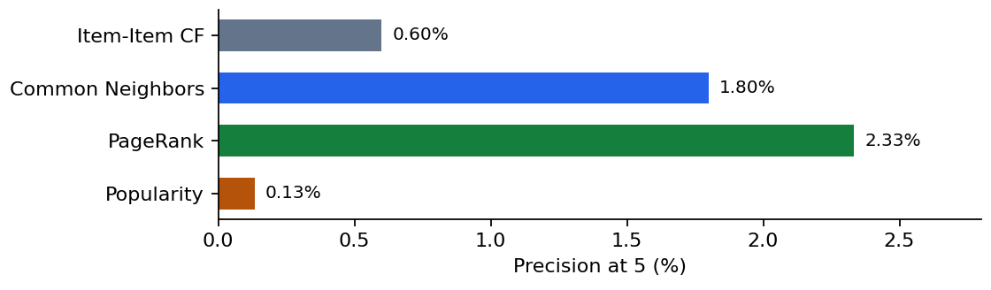
Figure 1 Saved mean Precision at 5 across 300 evaluated users

18 Interpretation
PageRank has the highest observed mean for precision, recall and NDCG. Its Precision@5 of 2.33% corresponds to 35 relevant recommendations across 1,500 recommendation slots. Its hit rate is 10%, meaning that 30 of the 300 users receive at least one relevant item. Common Neighbors reaches an 8.67% hit rate, Item-Item CF 3%, and popularity 0.67%. The absolute values therefore remain modest despite improvements over the baseline.
PageRank's mean request time is approximately 1,425 times the CF time and 137 times the Common Neighbors time in this saved run. These ratios describe the reported implementation and hardware, rather than universal algorithm speed ratios. The repository uses 1,000 bootstrap samples for 95% confidence intervals. Comparing individual interval overlap is not a valid substitute for a paired statistical test of per-user differences.

Scalability and Validation

19 Experimental Design
Scalability experiments use nested samples containing 10%, 30%, 60% and 100% of the filtered active-user population. Each sample retains those users' training interactions and builds its own CF model and graph. Up to 200 eligible users are evaluated per sample; the smallest sample contains only 82 evaluable users. The dataset percentages refer to active training users, rather than percentages of the entire raw event log.
Sample | Users | Edges | Build s | PPR ms
10% | 1,605 | 16,026 | 0.107 | 106.0
30% | 4,816 | 46,471 | 0.152 | 173.1
60% | 9,632 | 91,878 | 0.331 | 308.4
100% | 16,053 | 152,818 | 0.620 | 511.7

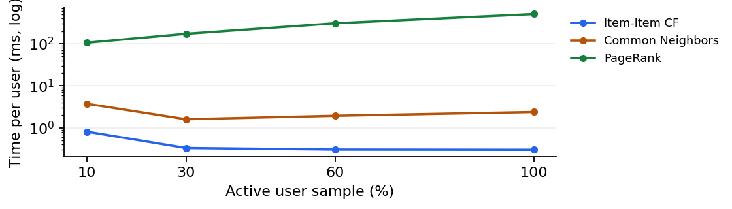
Figure 2 Saved mean recommendation time as the active user sample grows

20 Observations and Measurement Limits
Edges increase from 16,026 to 152,818, while graph construction rises from approximately 0.107 to 0.620 seconds. PageRank time increases from 106.0 to 511.7 milliseconds per user. CF and Common Neighbors remain much faster, although their averages vary with the sampled graph and users. These four sizes demonstrate behaviour within the tested range; they do not establish performance on much larger production datasets.
Graph memory is estimated from process RSS before and after construction. The 10% sample reports zero additional megabytes because allocator reuse can hide incremental allocation. These measurements are approximate, not exact graph sizes. Different test users across sample sizes also prevent treating quality changes as a controlled effect of dataset size alone.

21 Validation Record
The saved Phase 1 test file records 17 passing checks covering preprocessing, temporal separation, graph counts and weights, recommendation validity, fallback behaviour, probability normalisation and metric consistency. During local review, both saved models loaded, 20 sampled live lists matched saved recommendations, and quality metrics were independently reproduced from the saved rankings and ground truth. All seven dashboard pages subsequently passed headless execution checks. The complete pytest suite was not run because pytest was unavailable; the saved checks and local checks are separate evidence.

Limitations Conclusion and References

22 Limitations
Evaluation covers a selected group of returning, active users with eligible new products. Only 861 users qualify, compared with more than 308,000 visitors in the test period. New users receive non-personalised popularity recommendations, so the model comparison does not establish strong cold-start performance. Product IDs are anonymised and the implementation does not use product descriptions or categories.
All test event types count as relevant, even though training weights assign different strengths to views, carts and transactions. Ranking accuracy therefore measures future interaction retrieval rather than purchase prediction. The edge cap, activity thresholds, neighbour counts and damping factor are fixed settings, without a reported separate validation-period tuning study. Strong accuracy claims require broader evaluation and paired statistical analysis.
NetworkX stores Python graph objects in memory and PageRank recomputes a graph-wide vector for each uncached user. This limits request throughput and dataset scale. The application is a local experimental dashboard, without demonstrated concurrent load handling, online feedback collection or production monitoring. Saved timings must not be interpreted as current laptop benchmarks.

23 Future Work
A stronger study should evaluate all eligible users or multiple random samples, use a separate temporal validation window and report paired bootstrap confidence intervals for metric differences. Additional metrics such as catalogue coverage, diversity, novelty and results by user-history length would clarify recommendation behaviour. Purchase-specific ground truth would test a distinct business objective.
Engineering improvements include sparse or approximate PageRank, precomputed candidate sets, incremental artifact refreshes and performance tests under concurrent requests. Adding product content could support new-item recommendations. Larger experiments should use fresh processes for memory measurements and hold evaluation cohorts fixed where possible.

24 Conclusion
The project implements a complete path from implicit event data to an explainable recommendation dashboard. Graph methods achieve higher average ranking quality than Item-Item CF in the saved experiment, at greater computational cost. PageRank is the strongest measured ranker, while Common Neighbors offers a practical compromise for the tested workload. The findings support an educational comparison and motivate further validation before deployment.

25 References and Attribution
[1] Project repository: github.com/shravaniii29/Graph-Based-Product-Recommendation-Engine. Implementation evidence: src/, dashboard/ and notebooks/Graph_Recommendation_Phase1.ipynb.
[2] Experimental evidence: outputs/results/evaluation_summary.csv, per_user_evaluation.csv, recommendations.csv, scalability_results.csv, dataset_overview.json, graph_stats.json, config.json and test_results.csv.
[3] Retailrocket recommender system dataset: kaggle.com/datasets/retailrocket/ecommerce-dataset. Repository notices identify original code as MIT and dataset-derived outputs as CC BY-NC-SA 4.0. See LICENSE and DATA_LICENSE.md for attribution and reuse conditions.

