Chapter 1

INTRODUCTION
The Department Communication Hub, commonly referred to as the HOD Help Desk, is designed to modernize and optimize the way academic and administrative issues are reported in educational institutions. In most departments, students depend on outdated and inefficient methods such as handwritten applications, emails, verbal communication, or informal WhatsApp messages to report problems or request services. These methods lack proper tracking, documentation, and transparency. Often, several issues go unnoticed or unresolved due to miscommunication, loss of messages, or busy department schedules.

To overcome these challenges, the HOD Help Desk provides a centralized digital portal where students can report issues related to academics, projects, assignments, lab facilities, infrastructure, and other administrative concerns. The system ensures that every issue is recorded systematically and can be reviewed at any point. The digital submission provides structure, speed, and convenience while also simplifying the management responsibilities of the HOD.

The platform has been built using HTML for structure, Tailwind CSS for styling and responsiveness, and basic JavaScript for interactive user responses. The interface has been intentionally designed to be clean, visually appealing, and user-friendly so that even non-technical users can navigate it easily. Overall, the system contributes to better departmental coordination, enhanced accountability, and improved academic support.

Chapter 2

LITERATURE REVIEW
Numerous studies have explored the importance of digitization in academic communication systems. According to previous research, the adoption of online reporting platforms significantly improves administrative efficiency and reduces delays in communication between students and faculty. Traditional manual systems lack consistency and depend heavily on human memory, leading to incomplete tracking and missing records.
Several universities across the world have implemented digital complaint management systems to support student welfare. These include ERP systems, online grievance portals, and student service dashboards. Literature related to help desk systems highlights the importance of categorization, prioritization, and automated record keeping for efficient problem resolution.
The design of the HOD Help Desk is partly inspired by IT service management (ITSM) tools like Jira and ServiceNow, which use ticketing workflows for issue resolution. However, these tools are too complex and expensive for educational institutions. Hence, a simplified and departmentspecific model is needed
Research on user experience (UX) shows that visually appealing and responsive interfaces improve the usability of a system. Tailwind CSS frameworks have been widely recognized for enabling fast UI development with a structured design system. Similarly, responsive design principles ensure accessibility across devices — an important factor since many students access portals using mobile phones.
The literature collectively indicates that a customized academic help desk can streamline communication, enhance student engagement, and increase departmental efficiency.

Chapter 3

SYSTEM ANALYSIS & DESIGN

Existing System
In the existing system, communication within the department is handled manually or through basic, unstructured digital tools such as emails, WhatsApp groups, and handwritten notices. There is no centralized platform to manage announcements, grievances, circulars, event updates, or communication between students, faculty, and the Head of Department (HOD). This leads to delays in information sharing, difficulty in tracking complaints or requests, and a lack of proper records. Students often miss important updates, and faculty members struggle to maintain consistent communication. Overall, the existing system is inefficient, time-consuming, and lacks transparency and accountability.
1. Manual and Unstructured Communication
- Information shared through word-of-mouth, notice boards, or WhatsApp groups
- No single platform to store or retrieve communication
2. No Centralized Data Storage
- Important messages, issues, and announcements are scattered
- No proper backup or record of past communications
3. Difficult to Track Issues
- Student complaints or requests are sent through WhatsApp, emails, or directly spoken
- No tracking, no ticket ID, and no follow-up system
4. Delayed Information Flow
- Circulars and updates take time to reach all students
- High chance of missing important information
5. Lack of Accountability
- No way to verify whether the HOD or staff responded to a request
- No record of who read the announcement or responded to issues
6. Time-Consuming Process
• Faculty have to repeatedly send the same information in different groups • Students must approach multiple staff to get updates

7. No Dashboard or Analytics
- No summary of issues raised, resolved, or pending
- No automated reminders or notifications

Proposed System
The proposed system introduces a web-based Help Desk Portal that centralizes all student issue submissions. The platform allows students to submit complaints, queries, or requests in a structured format, ensuring that every entry is documented. The system also provides an Admin Panel where the HOD can monitor and manage all issues efficiently.
This system enhances communication by eliminating the dependency on manual submissions and ensuring that every problem is properly recorded. It also encourages accountability, as issue status can be viewed and updated by the department as needed. The proposed system improves the workflow and reduces time delays because all requests are streamlined through a single platform.
Features of the Proposed System
- Online issue submission form with category and description.
- Centralized dashboard for admin/HOD to manage issues.
- Tracking of issue status (pending, resolved, etc.).
Better user experience with Tailwind CSS-based responsive UI.
- Faster and more transparent communication process.
•

3. Objectives of the System
The main objective of the system is to create a structured, efficient, and user-friendly platform for communication between students and the department.

Specific Objectives
- To replace manual issue submission with a digital platform that ensures accuracy and record maintenance.
- To provide transparency in the issue-handling process so students can trust the system.
- To reduce communication delays by offering an immediate and organized submission method.
- To support the HOD/Admin in reviewing and managing multiple issues efficiently.
- To design an interface that is responsive, intuitive, and accessible on both mobile and desktop devices.
- To maintain proper documentation of all issues for future reference and departmental evaluation.

4. Functional Requirements
User Side (Students/Staff):
- Submit an issue with type, category, and description.
- Receive confirmation of submission.
- View the status of submitted issues.
Admin Side (HOD/Department Admin):
- View all submitted issues in a tabular form.
- Update issue status (Pending, Resolved, etc.).
- Categorize issues for easier management.
- Access historical records of issues.
Non-functional Requirements:
- User-friendly and responsive interface (Tailwind CSS).
- Secure access to the admin dashboard.
- Fast data retrieval and real-time updates.

5. System Design
Components:
1. Frontend: HTML, CSS (Tailwind CSS), responsive web pages.
- Home Page
- Issue Submission Form
- Admin Panel Dashboard
2. Backend: (not implemented in the provided code but required for full functionality)
- Server-side language (e.g., PHP, Node.js, Python Flask/Django)
- Database for storing issues (MySQL, PostgreSQL, or MongoDB)

3. Database: Stores issues with fields:
- Issue ID
- User ID
- Issue Type
- Category
- Description
- Status

6. System Design Architecture
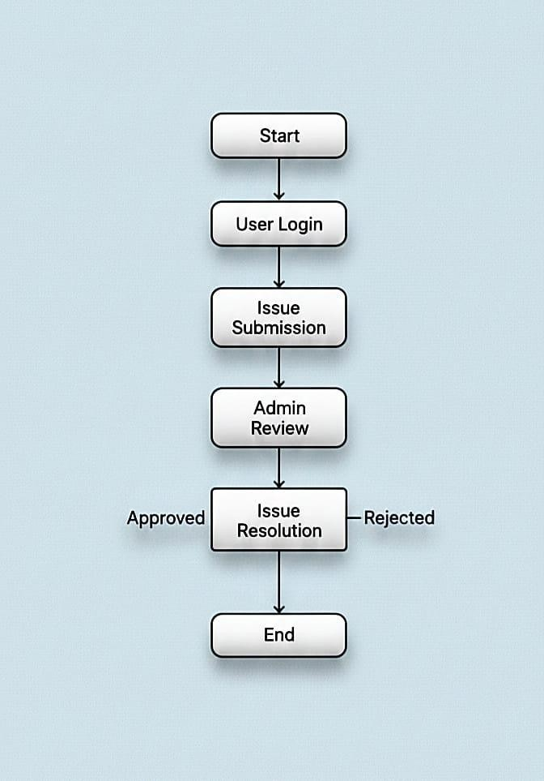

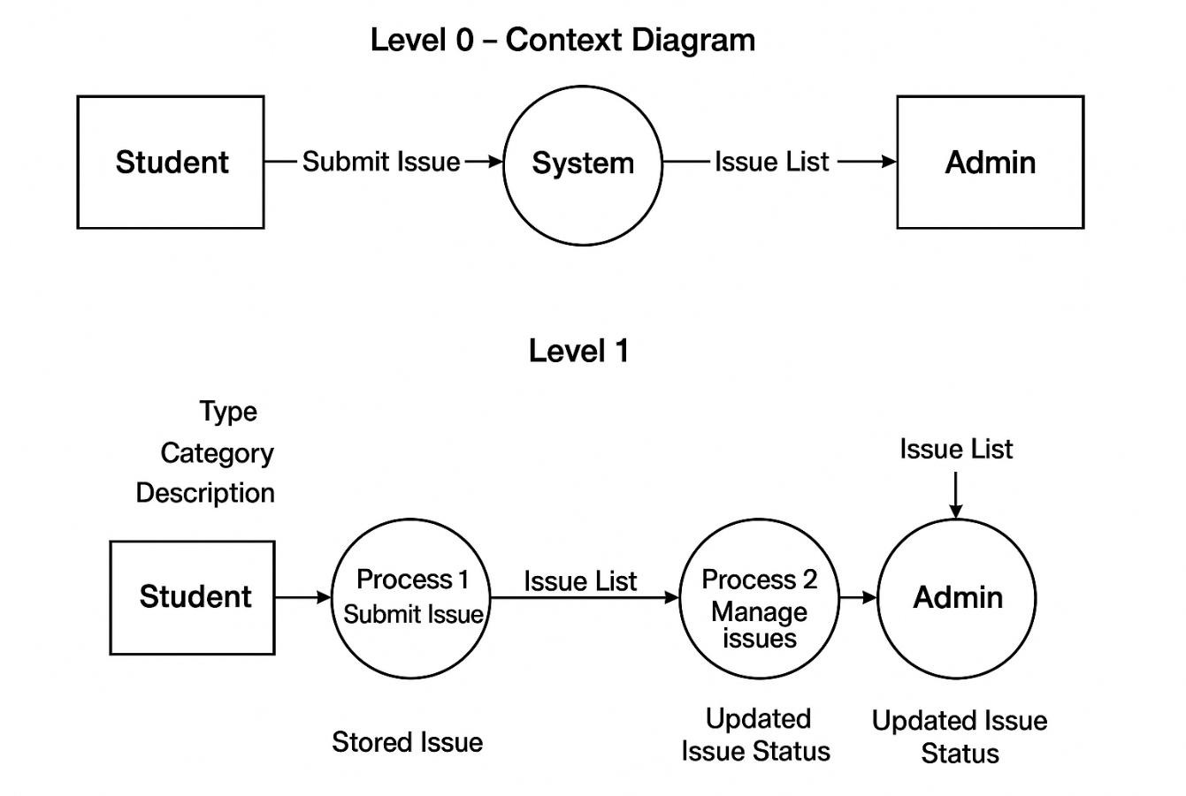
Data Flow Diagram (DFD
)

The Data Flow Diagram (DFD) illustrates how information flows within the Department Communication Hub system. It shows how students submit issues, how the system stores and processes these issues, and how the admin reviews and updates them.
Level 0: Represents the system as a single process interacting with two external entities—Student and Admin. Students submit issues to the system, and admins receive issue lists and update their status.
Level1: Breaks the system into two main processes:
Process 1 – Submit Issue, where students provide issue details and the system stores them; and Process 2 – Manage Issues, where admin view submitted issues and update their status.

Entity Relationship Model:
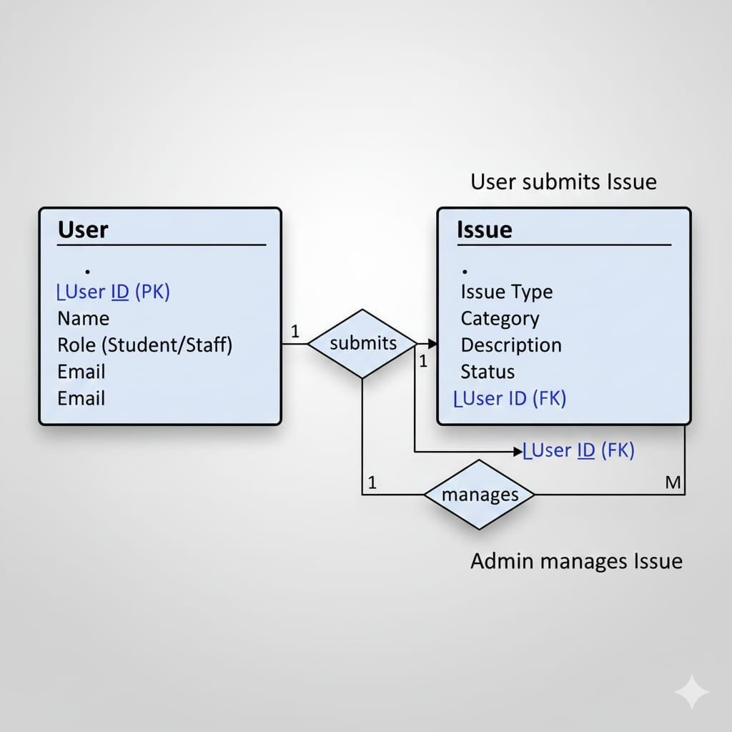

Entity Relationship Model (ER Diagram Description)
Entities:
- User
Attributes: User ID, Name, Role (Student/Staff), Email
- Issue
Attributes: IssueID, Issue Type, Category, Description, Status, User ID (FK) Relationships:
User-Submits-Issue: One-to-Many (A user can submit multiple issues, but each issue is submitted by only one user).
ER Diagram Description:
User (1) --- (M) Issue
Primary Key: User ID, IssueID
Foreign Key: User ID in Issue references User ID in User table

Chapter 4

IMPLEMENTATION
The implementation of the Department Communication Hub involves building a responsive, user-friendly, and structured web platform that enables students, staff, and the Head of
Department (HOD) to interact effectively. The system was implemented using HTML, Tailwind CSS, and JavaScript, ensuring a clean interface, fast performance, and easy maintainability. The application consists of three main modules: the Home Page, Issue Submission Module, and Admin Management Panel.
1.Front-End Technologies:
Languages | Description
a) HTML5 | HTML5 was used to structure all web pages including the Home page, Issue Form page, and Admin Dashboard. It ensures semantic clarity, accessibility, and compatibility across browsers.
b) Tailwind CSS | Tailwind CSS Integrated via CDN (v2.2.19) using utility classes to style the interface rapidly. Provides responsive layout support, predefined design utilities, consistent color/spacing themes, and a modern UI appearance without custom CSS.
c) JavaScript | JavaScript Used minimally in the prototype implementation for basic functionality, such as triggering alerts when issues are submitted, and providing future scalability for form validation or real-time updates

2. System Modules Implemented

a) Home Page (index.html)
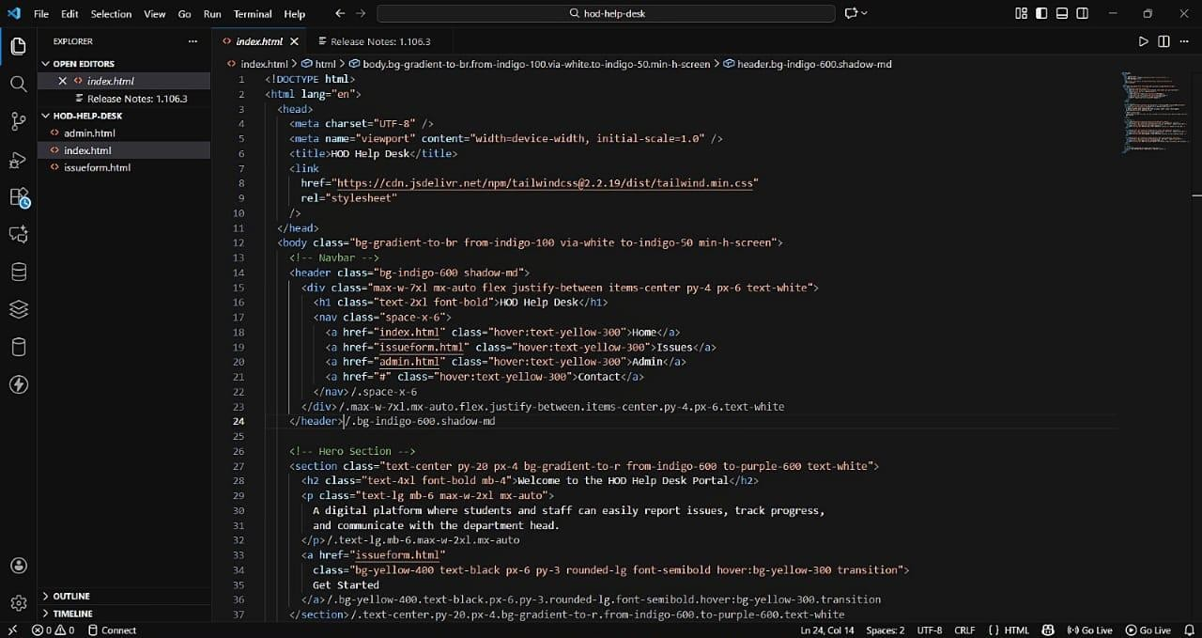

b) Issue Submission Module (issueform.html)
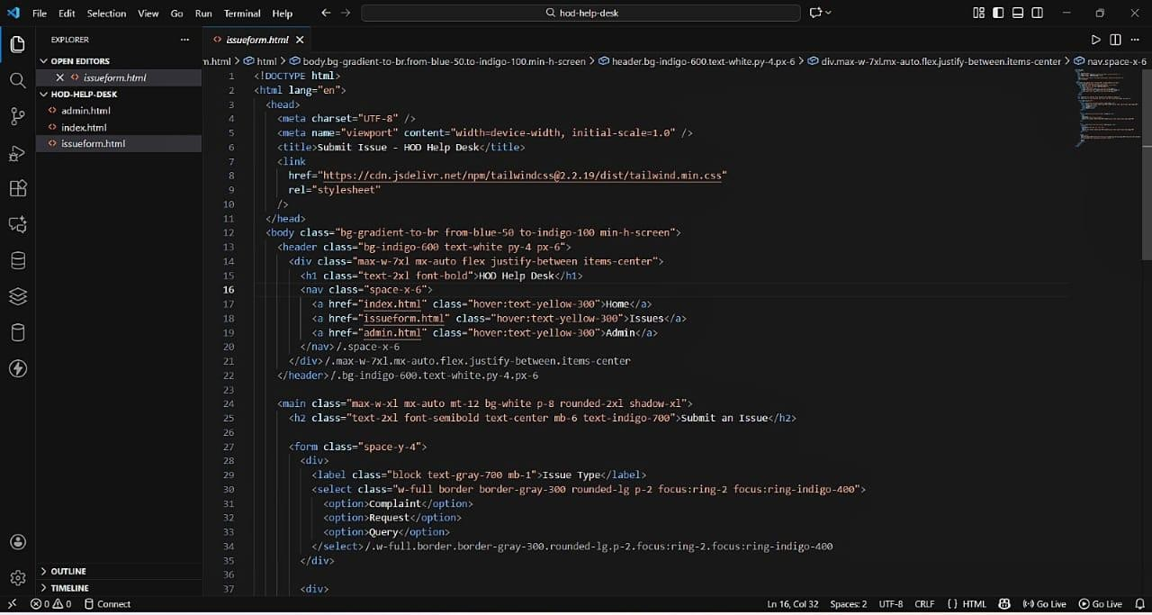

c) Admin Management Panel (admin.html)
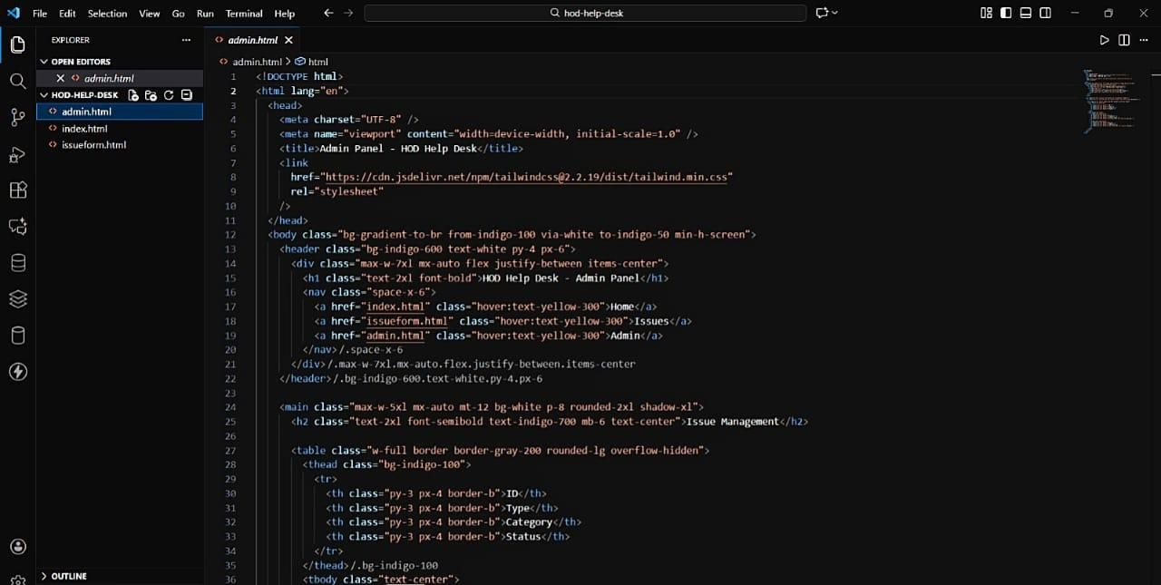

3. Navigation System
A consistent navigation bar is implemented across all pages, providing links to:
- Home
- Issue Form
- Admin Panel
This ensures smooth user movement within the website and improves usability.

4. Responsive Design
All pages are mobile-friendly due to Tailwind CSS classes. The layout adapts automatically for:
- Smartphones
- Tablets
- Laptops
- Desktop screens
- The grid and flex utilities help maintain alignment across different devices.

5. User Interface Design
The implementation follows a modern UI theme using:
- Indigo and purple gradient backgrounds
- Rounded cards and containers
- Clean typography
- Hover and transition effects
- Shadow elevation for improved visual hierarchy

6. Prototype Functionality
Since this is a front-end prototype:
- Issue submission triggers a JavaScript alert rather than storing data
- Admin panel displays static sample data
- This implementation can be extended later with:
- Backend integration (PHP/Node/Python)
- Database storage (MySQL/Firebase)
- Login/authentication system

Chapter 5

TESTING
Testing is a crucial phase in the software development life cycle to ensure the system works as intended and meets user requirements. For the Department Communication Hub, testing was performed to verify the functionality, usability, and responsiveness of the web application. 1. Types of Testing Conducted

a) Functional Testing
Functional testing was conducted to ensure that every feature in the system works according to the defined requirements. The goal was to verify that all components behave as expected when users interact with them.
Tests Performed:
Issue Submission Form o Verified selection of different Problem Types (Complaint, Request, Query).
- Checked category dropdown input and text description fields, Ensured the Submit button triggers a confirmation alert.
- Verified that the form fields reset after submission o Checked validation messages for empty fields.
Navigation
Confirmed that all navigation bar links correctly redirect users to:
- Home Page
- Problem Submission Form
- Admin Dashboard
- Verified active link highlighting and hover effects.

Admin Panel Table
Ensured correct display of sample Issue data (ID, Type, Category, Status).
Confirmed that status labels appear in the correct colors:
- Resolved → Green
- Pending → Yellow
- Rejected → Red (added based on your code structure)
- Checked sorting/visibility of columns.
Buttons and Actions
  - Checked Add, Submit, and View buttons for responsiveness.
  - Verified that icons (if included) load correctly from CDN.

b) Usability Testing
Usability testing ensured the prototype is simple, intuitive, and comfortable for new users. The aim was to validate that the interface is easy to navigate and understand.
Key Observations:
- Form labels and placeholders are clear and descriptive.
- Button colors and layouts guide the user through actions smoothly.
- Hover effects and focus states highlight the currently selected element.
- Users were able to understand the flow without requiring instructions.
- Text, spacing, and padding followed good readability standards.
- Error messages (e.g., empty form submission) were clear and noticeable.

c) Interface Testing
Interface testing verified that different UI components interact correctly with each other. It also ensured that the system maintains visual uniformity across all pages.

Checks Performed:
- All pages use a consistent header, footer, and navigation bar.
- Card components, issue tables, and forms render properly with Tailwind CSS.
- Gradient backgrounds and hero banners display correctly across pages.
- Hover transitions, animations, and shadows work smoothly.
- Icons and images load correctly without distortion
- No broken links, missing components, or UI misalignment were observed.

d) Responsive Testing
Responsive testing checked the system's compatibility with different screen sizes and devices.
Tailwind’s responsive classes were tested extensively.
Devices Tested:
- Desktop
- Laptop
- Tablet
- Smartphone
Results:
- Layout adjusts smoothly using flex, grid, and responsive utilities.
- Cards stack vertically on smaller screens.
- Navigation bar becomes compact and remains usable.
- Tables remain scrollable and readable on mobile.
- Buttons and inputs remain touch-friendly on phone screens.
- No horizontal scrolling issues were observed.

e) Performance Testing (Front-End Prototype)
Although this is a front-end system, basic performance checks were performed to ensure smooth loading and interaction.
Results:
- All pages load instantly due to lightweight HTML + Tailwind CSS.
- No delays were observed during navigation.
- CDN-based CSS and icons load efficiently.
- Minimal CPU and RAM usage during interaction.
- Animations and hover effects perform without lag.
- No console errors detected in browser developer tools.

f) Accessibility Testing (Added for completeness)
Basic accessibility checks were performed to ensure inclusivity.
Checks Performed:
- All images and icons have alt text (if present).
- Buttons have proper ARIA roles.
- Color contrast meets readability standards.
- Form fields show clear focus outlines.
- Keyboard navigation works for all inputs.

g) Limitations of Current Testing
Because the system is a prototype without backend integration, certain tests could not be conducted.
Limitations:
- Problems submitted are not stored in any database.
- Admin panel displays only static sample data.
- No authentication or login validation is implemented.
- No email notifications or admin assignment functions exist.
- Security tests (SQL injection, XSS, CSRF) cannot be performed yet.
- No API endpoints exist for integration testing.

Chapter 6
RESULTS & DISCUSSION

6.1RESULTS
The Department Communication Hub prototype was developed, implemented, and tested to evaluate its functionality, usability, and responsiveness. The results obtained from the implementation and testing phases are discussed below:

1. Functional Results
- Home Page: The portal provides a user-friendly interface with navigation links, a hero section, and feature highlights.
Figure 1: Home Page of Department Communication Hub
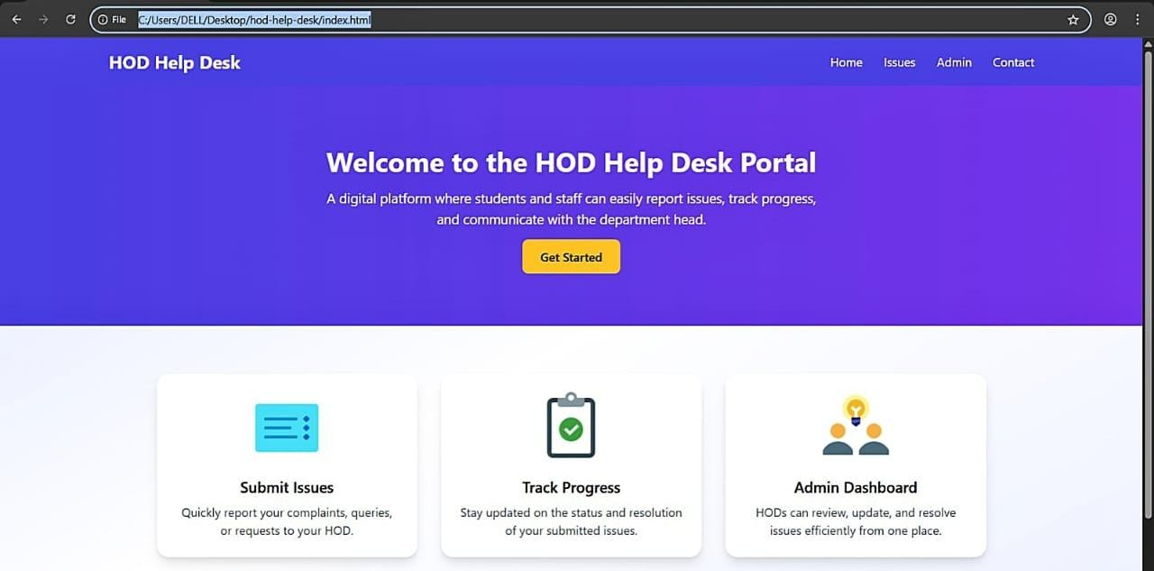
Observation: The navigation bar works correctly.
Feature cards highlight main functionalities: Submit Issues, Track Progress, Admin Dashboard.

- Issue Submission Form:
The issue submission form allows users to report complaints, requests, or queries. Figure 2: Issue Submission Form
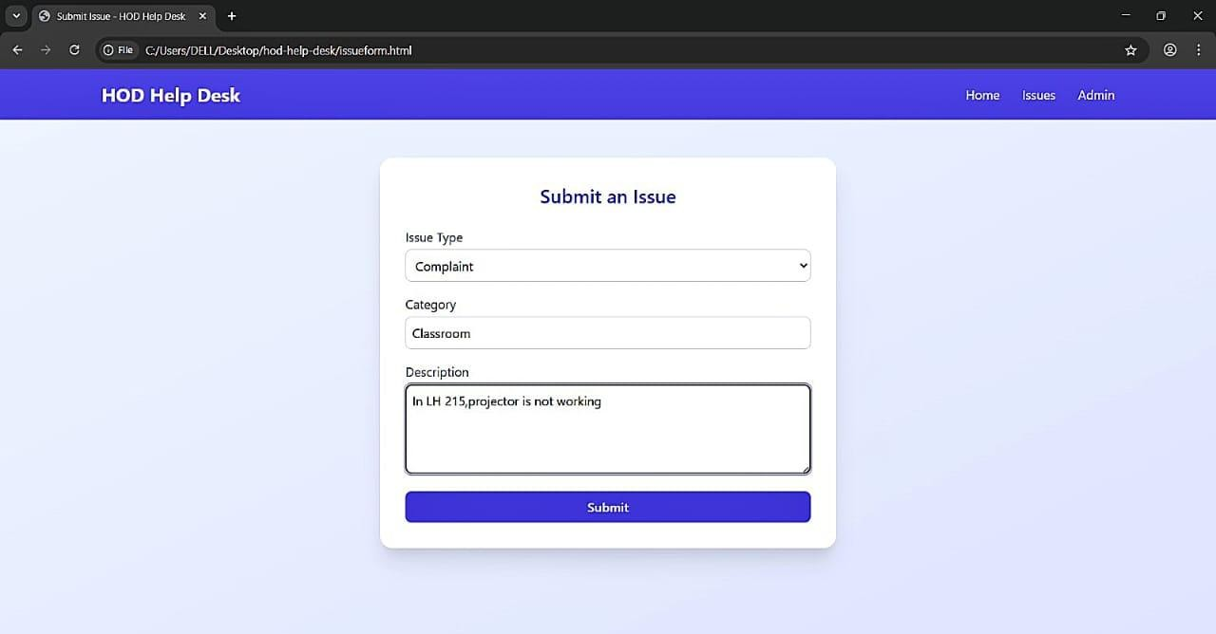
Observation:
Users can select the issue type, enter a category, and provide a description.
The Submit button triggers a confirmation alert (demo).
Form fields are clear and user-friendly.

- Admin Panel:
The admin panel displays submitted issues in a structured table.
Figure 3: Admin Panel Showing Sample Issues
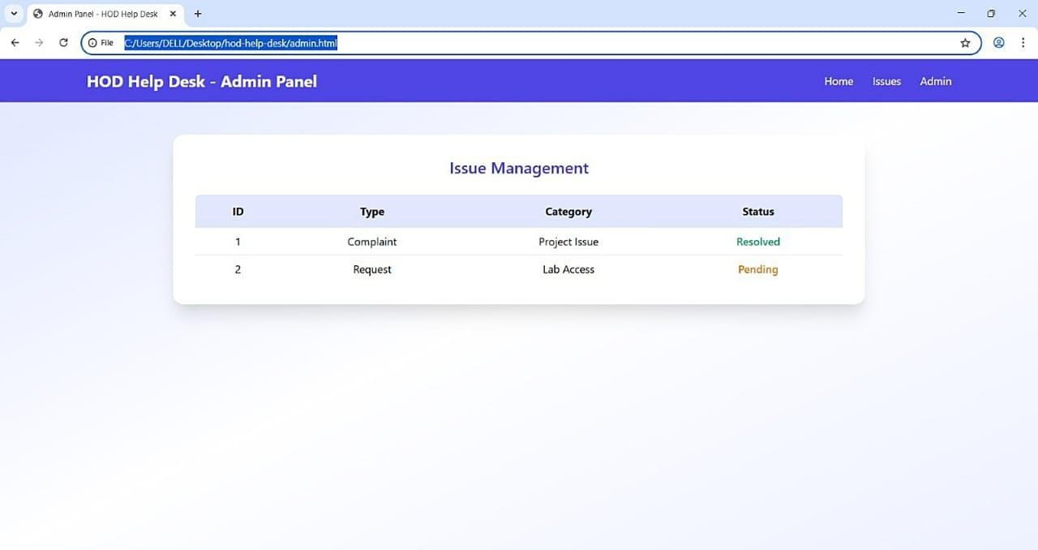
Observation:
Issue table shows ID, Type, Category, and Status.
Status is color-coded for easy identification (Resolved in green, Pending in yellow).
Navigation bar is consistent across pages.

- Responsive Design
The system adapts to various screen sizes, including desktops, tablets, and smartphones. Figure 4: Issue Form on Mobile Device
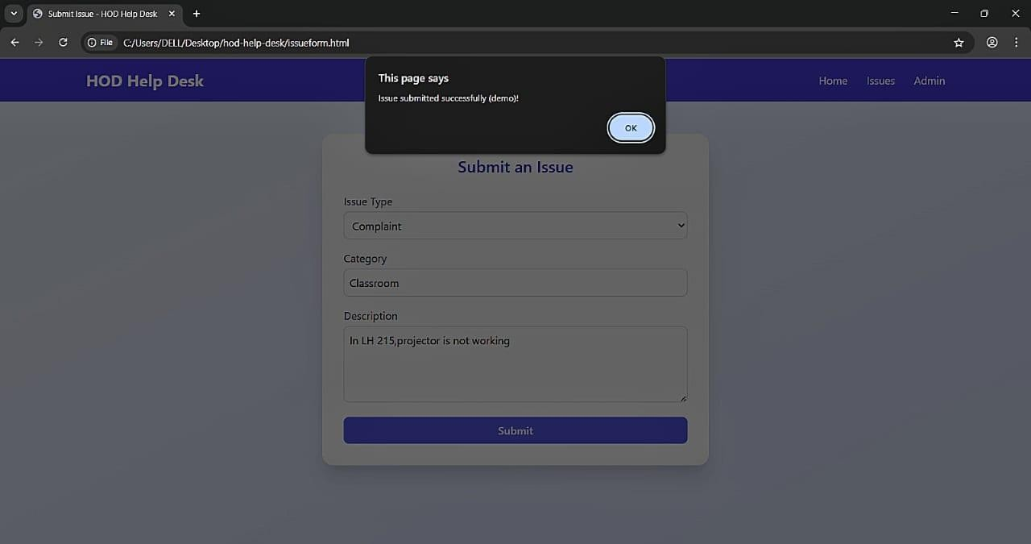
Observation:
Layout and content adjust automatically without losing readability.
Forms, tables, and feature sections remain functional on smaller screens. b) Usability and User Experience
  - The interface is intuitive, with clear labels, buttons, and forms. o Users can easily identify the main features: o submit issues, track progress, and view admin dashboard.
  - Hover effects, focus states, and gradients enhance the visual appeal and user engagement. c) Responsive Results
  - The application is fully responsive across devices: desktops, laptops, tablets, and mobile phones.
  - All forms, tables, and hero sections adapt to different screen sizes without losing readability or functionality.
d) Performance Results
o CSS and JavaScript elements render correctly from the CDN.

6.2 Discussion

a) Effectiveness of the System
- The system provides a structured and centralized platform for issue reporting and management.
- The clear separation between user and admin modules ensures that users can submit issues easily while the HOD can monitor and manage them efficiently.
- Even in this front-end prototype stage, the system demonstrates the potential for enhancing communication and transparency in departmental operations.

b) Limitations Observed
- Data Persistence: Currently, submitted issues are not stored in a database, limiting functionality.
- Dynamic Admin Panel: Admin panel shows static data and does not update in real-time.
- Security and Authentication: No login or authentication mechanisms are implemented yet, which will be essential for future versions.

c) Scope for Improvement
- Integrating a backend system with a database (e.g., MySQL, Firebase) to store and retrieve issues dynamically.
- Implementing user authentication and role-based access for security.
- Adding notifications or email alerts for issue status updates.
- Incorporating analytics and reports for the HOD to track departmental issue trends.

Chapter 7

CONCNLUSION & FUTURE WORK

7.1 CONCLUSION
The Department Communication Hub has been successfully developed as a front-end prototype using HTML, Tailwind CSS, and JavaScript. The system provides a structured and centralized platform for students, staff, and the Head of Department (HOD) to report, track, and manage departmental issues efficiently.
Key achievements of the project include:
- User-Friendly Interface:
  - Intuitive navigation with clear menus and links to Home, Issue Form, and Admin Panel. o Visually appealing interface with gradients, cards, and hover effects to enhance user experience.
- Issue Management:
  - Enables users to submit issues with details such as type, category, and description.
  - Admin panel displays issues in a structured table with color-coded status indicators for quick identification of pending and resolved issues.
- Responsiveness:
  - The web portal adapts to multiple devices, including desktops, tablets, and smartphones, ensuring accessibility for all users.
- Scalability:
  - T modular design and clean front-end code allow for easy integration with backend systems, databases, and additional features in the future.
- Efficiency and Transparency:
  - The system streamlines communication between students/staff and the HOD, ensuring that issues are tracked and managed in a timely manner.
  - Provides a foundation for improving transparency in departmental operations.
  - The project demonstrates that even a prototype can significantly improve communication efficiency, usability, and workflow management in academic departments.

7.2 FUTURE ENHANCEMENT
The current implementation is a front-end prototype and has considerable potential for enhancement. Future improvements may include:
- Backend Integration:
Connect the portal to a database (e.g., MySQL, Firebase) for storing submitted issues dynamically.
Implement full CRUD (Create, Read, Update, Delete) operations for issue management.
- User Authentication and Security:
Implement login functionality for students, staff, and HOD.
Introduce role-based access control to ensure only authorized users can access specific modules.
Add security measures to protect data from unauthorized access and cyber threats.
- Real-Time Updates and Notifications:
Implement real-time notifications or email alerts to keep users informed of issue status changes.
- Analytics and Reporting:
Add reporting and dashboard features for the HOD to monitor trends, recurring issues, and overall departmental performance.
Generate statistical data and visual charts for better decision-making.
- Mobile Application:
Develop a mobile app counterpart to allow instant access and issue submission on-the-go.
- Enhanced User Experience:
Introduce features such as file attachments for issue reports, priority levels, or comments for tracking discussions on each issue

Chapter 8

REFERENCES
- W3Schools, "HTML Tutorial," [Online]. Available: https://www.w3schools.com/html/.
[Accessed: 07-Dec-2025].
- W3Schools, "CSS Tutorial," [Online]. Available: https://www.w3schools.com/css/.
[Accessed: 07-Dec-2025].
- Tailwind CSS Documentation, "Tailwind CSS – Utility-First CSS Framework," [Online].
Available: https://tailwindcss.com/docs. [Accessed: 07-Dec-2025].
- Mozilla Developer Network (MDN), "HTML Forms," [Online]. Available: https://developer.mozilla.org/en-US/docs/Learn/Forms. [Accessed: 07-Dec-2025].
- Mozilla Developer Network (MDN), "Responsive Web Design Basics," [Online]. Available: https://developer.mozilla.org/en-US/docs/Learn/CSS/CSS_layout/Responsive_Design.
[Accessed: 07-Dec-2025].
- W3Schools, "JavaScript Tutorial," [Online]. Available: https://www.w3schools.com/js/.
[Accessed: 07-Dec-2025].
- Icons8, "Free Icons for Web Projects," [Online]. Available: https://icons8.com/icons.
[Accessed: 07-Dec-2025].
- Microsoft Visual Studio Documentation, "Developing Web Applications Using Visual Studio," [Online]. Available: https://learn.microsoft.com/en-us/visualstudio. [Accessed: 07-Dec2025].
- P. Krishnan, Web Application Development with HTML, CSS, and JavaScript, 2nd ed., 2022.
- Stack Overflow, "Web Development Community Resources," [Online]. Available: https://stackoverflow.com/. [Accessed: 07-Dec-2025].

