=>To check if any device is connected to your system

adb devices

=>To view the connected device

adb devices -l

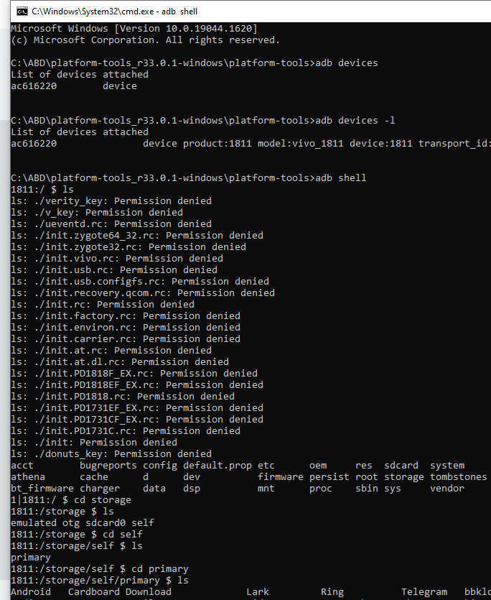

=>To push file to android adb push “source.jpg” /sdcard/data/temp

=>To pull any file from device adb pull /sdcard/abc.txt user/admin/desktop (source location) (destination location)

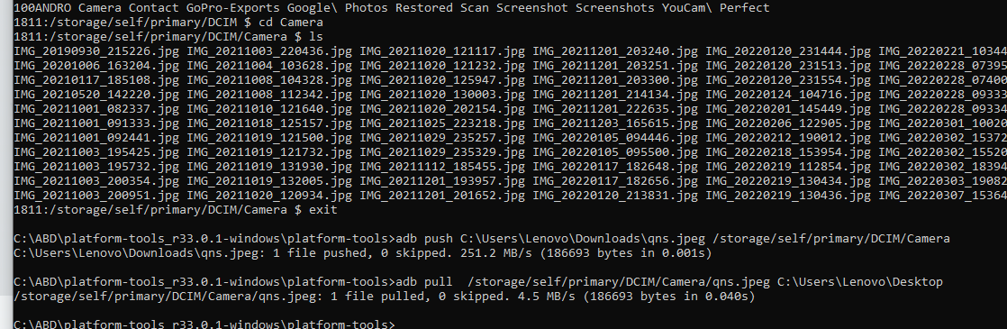

=>To store logs in a fileadb shell logcat -v threadtime >ts.txt

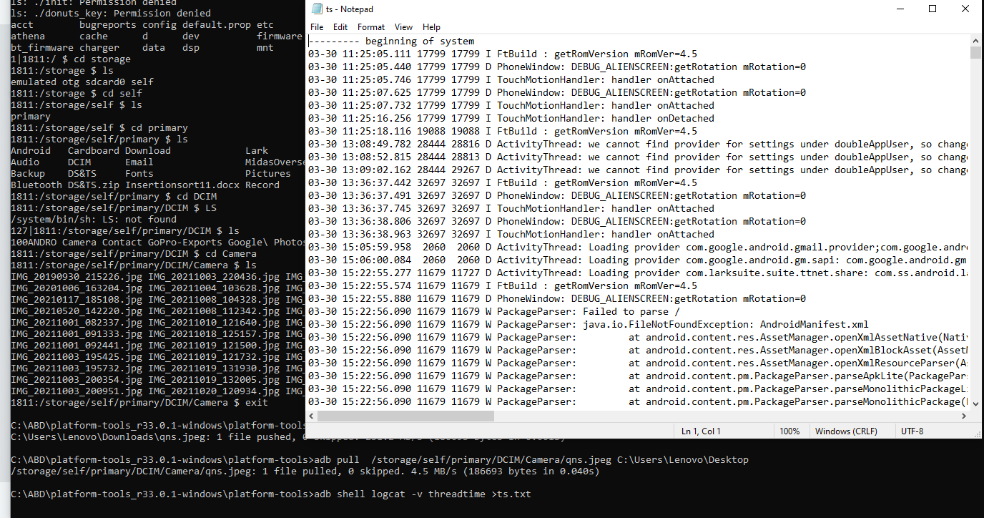

=>To find the packages present on the deviceadb shell pm list packages

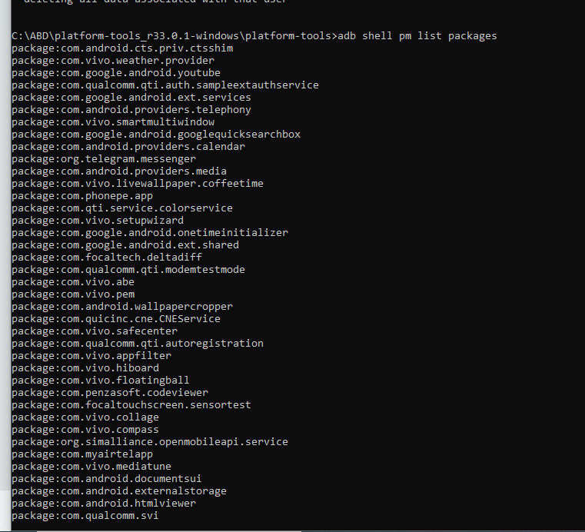

=>for screen brightnessadb shell settings put system screen_brightness 0

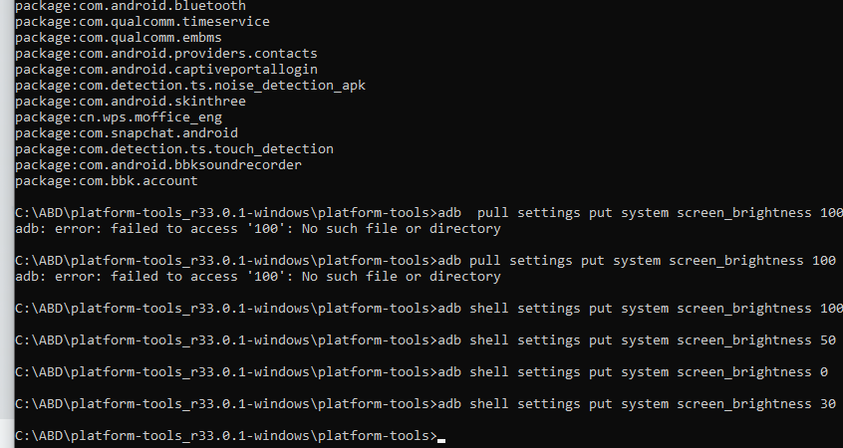

=>To give the input textadb shell input text “\typing\on\adb\is\ cool”

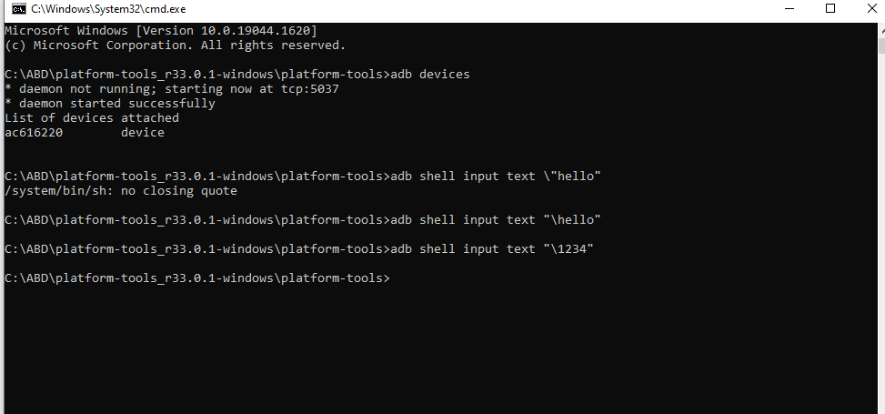

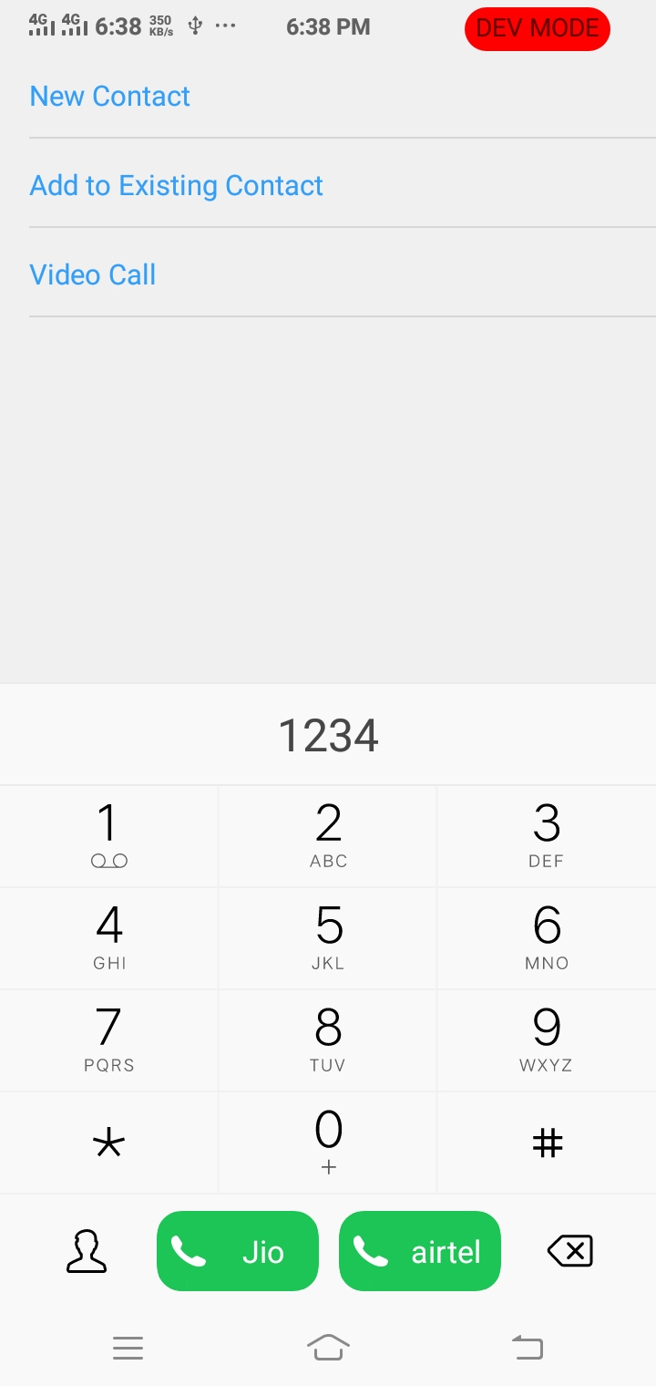

=>To connect the device over WIFIadb tcpip 5555

adb connect (IP address)

adb connect 26.131.84.164

=>To disconnect WIFI :

adb disconnect (IP Address)

adb disconnect 26.131.84.164

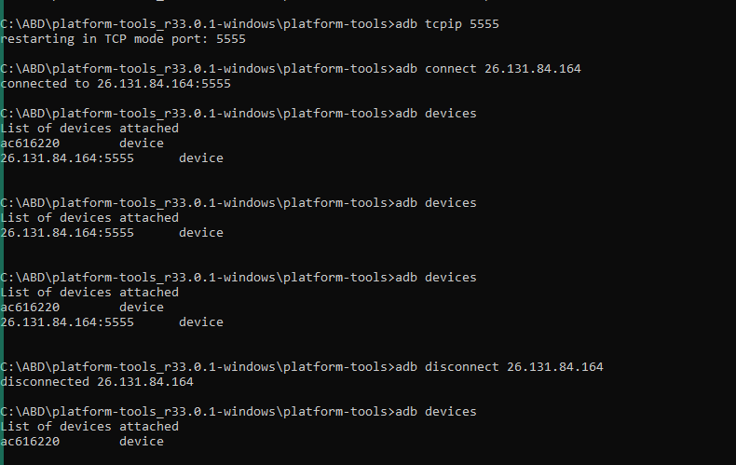

=>It will list out the 3rd party applications packages of android

adb shell pm list packages -3

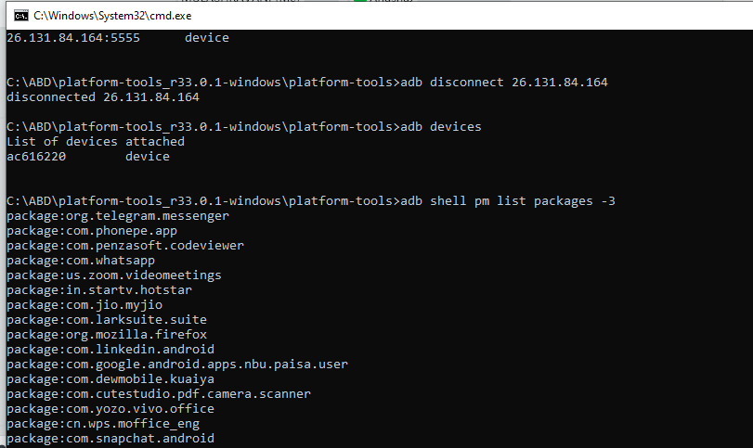

=>to uninstall the package

adb uninstall “package name”

adb uninstall com.jio.myjio

=>To see all the processes running on androidadb shell ps

