**\*\*\*\*\*\*\*\*\*\*\*\*\*\*\*Automation Assignment\*\*\*\*\*\*\*\*\*\*\*\*\*\*\***

**\*\*\*\*\*\*\*\*\*\*\*\*\*\*\*\*\*\*\*\*\*\*\*\*\*\*\*\*\*\*\*\*\*\*\*\*\*\*\*\*\*\*\*\*\*\*\*\*\*\*\***

**To Clone/Download the project** :

**<https://github.com/shravanipalivela/SNDTestAutomation.git>**

**Tools & Framework:**

Test Automation Using Selenium,Cucumber,Page Object Model,TestNg,Maven,JAVA 8,GIT,CircleCI, extent reports

More details on the framework and tools is available in the README.md in the project below.

**To Run Tests From Command Line :**

**Prerequisites** - MAVEN_HOME and JAVA_HOME are set in environment variables.

**To Run Tests** - mvn clean install

mvn test

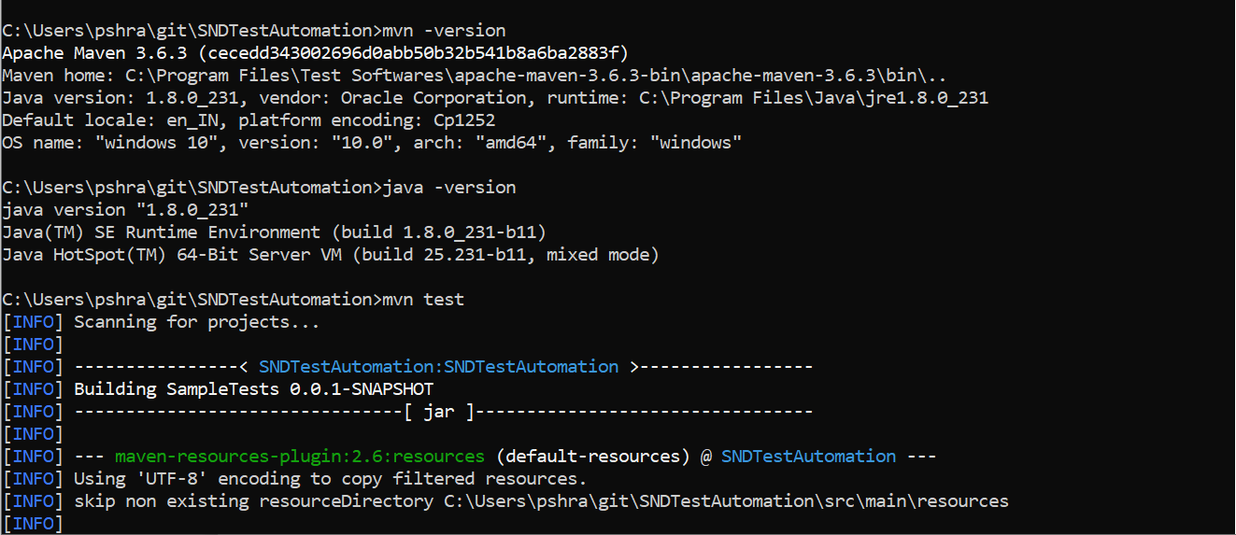

**Test Results and Logs:**

**Test Results Folder** : /src/test/resources/cucmberReports/report.html

**Logs Folde**r : /src/test/resources/logs/Output.log

**Test Results on command Line :**

