Advanced Data Analysis & Visualization
in Two-Wheeler Last-Mile Logistics
Week 3 Task — Data Science & Analytics Internship
Domain Focus: Bike / Scooter / E-Bike Delivery Fleet Operations
Prepared by: Shra
Tools Used: Python (Pandas, NumPy, Matplotlib, Seaborn)
August 2026

1. Objective
This report presents an advanced exploratory data analysis (EDA) and visualization study of a two-wheeler last-mile delivery logistics operation. The goal is to analyze delivery performance, cost drivers, and operational bottlenecks using Python, and to translate the findings into actionable recommendations for improving delivery efficiency across a fleet of scooters, motorbikes, and e-bikes.
Two-wheelers are the backbone of last-mile delivery in dense urban environments (food, grocery, and parcel delivery) because they navigate traffic and narrow lanes far faster than four-wheeled vehicles. This makes performance analysis of two-wheeler fleets especially valuable for operational decision-making.

2. Data Simulation & Dataset Structure
Since a live operational dataset was not available, a realistic hypothetical dataset of 2,000 delivery records was simulated in Python using NumPy's statistical distributions, with deliberately engineered relationships between variables (e.g., higher traffic and rain increasing delivery time and delay probability) so the dataset reflects genuine logistics behaviour rather than random noise.

2.1 Key Variables
- delivery_id, date, rider_id — record identifiers
- vehicle_type — Scooter / Motorbike / E-Bike
- zone — one of 5 delivery zones across the service area
- distance_km, shipment_weight_kg — trip characteristics
- traffic_condition, weather, time_of_day — environmental context
- delivery_time_min, sla_minutes, delayed — performance & SLA compliance
- fuel_cost_inr, delivery_cost_inr — cost metrics (INR)
- customer_rating — 1-5 satisfaction score

2.2 Data Generation Logic (Python excerpt)
# Delivery time depends on distance, traffic, weather & vehicle type
base_speed_kmph = 26
speed = base_speed_kmph / (traffic_penalty[traffic] *
weather_penalty[weather] *
vehicle_speed_factor[vehicle_type])
travel_time = (distance_km / speed) * 60
delivery_time_min = travel_time + handling_time + noise
# Delay flag vs zone-specific SLA
delayed = (delivery_time_min > sla_minutes).astype(int)

3. Exploratory Data Analysis (EDA)

3.1 Central Tendency & Dispersion
Summary statistics for the core numeric metrics are shown below. Delivery time shows a right-skewed distribution (skew = 1.66), meaning most deliveries are completed quickly but a long tail of delayed deliveries pulls the mean above the median.
Metric | Mean | Median | Std Dev | Min | Max
Distance (km) | 4.25 | 3.65 | 2.60 | 0.55 | 17.93
Shipment Weight (kg) | 2.35 | 2.02 | 1.47 | 0.21 | 11.44
Delivery Time (min) | 20.23 | 18.35 | 10.49 | 4.00 | 109.70
Fuel Cost (₹) | 7.37 | 5.92 | 5.43 | 0.34 | 39.64
Delivery Cost (₹) | 32.60 | 31.54 | 6.42 | 20.00 | 69.20
Customer Rating (1-5) | 4.77 | 4.90 | 0.39 | 2.80 | 5.00

3.2 Data Quality
The simulated dataset contains zero missing values across all 17 columns, allowing the analysis to proceed directly to distribution and correlation analysis without an imputation step.

3.3 On-Time Performance
Across all 2,000 deliveries, the fleet achieved a 90.9% on-time rate against zone-specific SLAs, with 9.1% of deliveries breaching their promised delivery window.

3.4 Correlation Analysis
A Pearson correlation matrix was computed across the six numeric variables to quantify relationships between trip characteristics, cost, and customer satisfaction:
- distance_km ↔ delivery_time_min: r = 0.81 (strong positive) — distance is the dominant driver of delivery duration
- distance_km ↔ fuel_cost_inr: r = 0.82 (strong positive) — confirms distance-based fuel consumption model
- delivery_time_min ↔ customer_rating: r = -0.62 (moderate negative) — slower deliveries directly erode customer satisfaction
- shipment_weight_kg ↔ delivery_cost_inr: r = 0.17 (weak positive) — weight surcharges have a smaller cost impact than distance

4. Visualizations
Eight visualizations were produced using Matplotlib and Seaborn, each selected to answer a specific operational question about the logistics process.

4.1 Delivery Time Distribution
A histogram with a kernel density overlay shows the shape and spread of delivery times, highlighting the right-skew caused by a minority of high-delay trips.
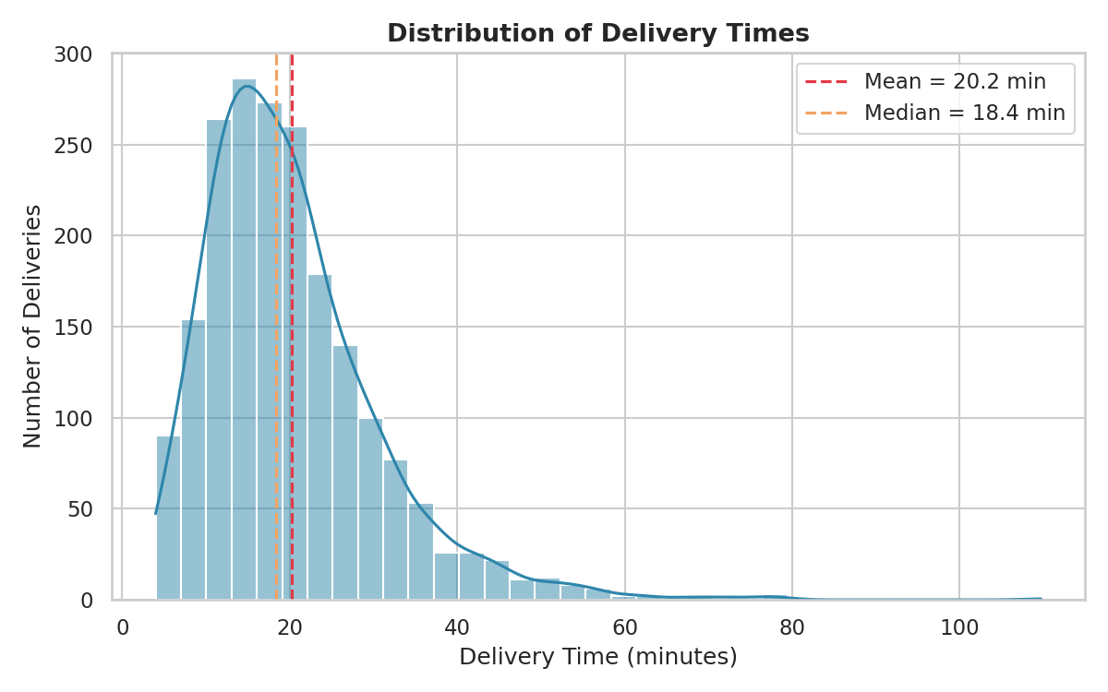
Figure 1: Distribution of delivery times (mean 20.2 min, median 18.4 min).

4.2 Delivery Time by Traffic Condition
A boxplot compares the spread of delivery times across Low, Medium, and High traffic conditions, making it easy to see both the shift in median and the growth in variability (and outliers) as traffic worsens.
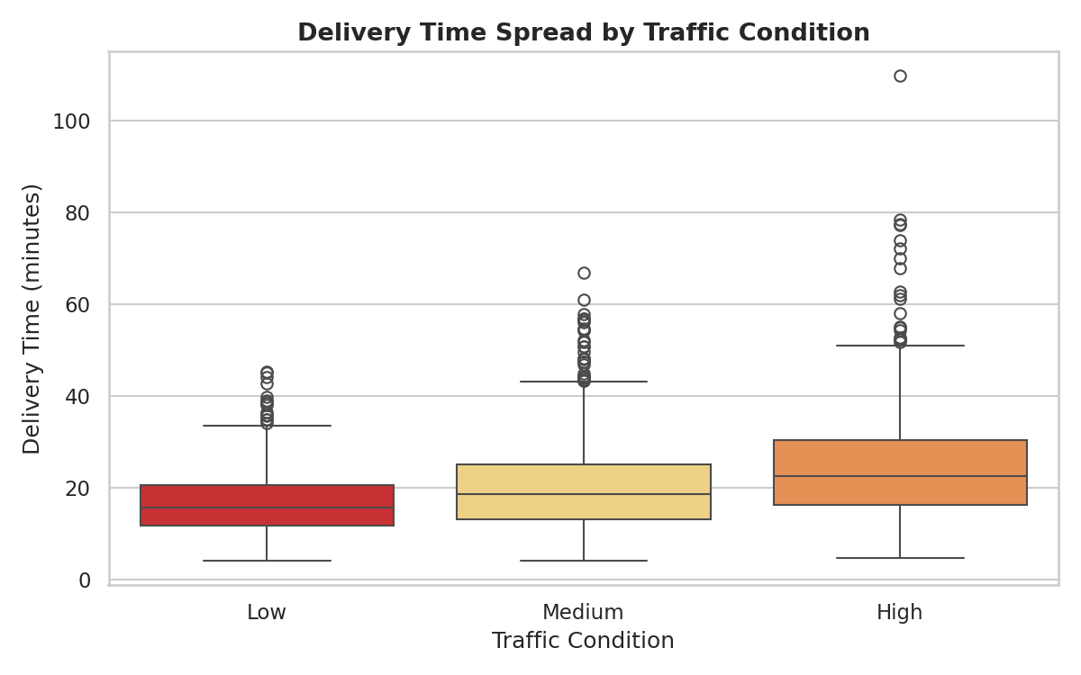
Figure 2: High traffic nearly doubles median delivery time versus low traffic and produces far more extreme outliers.

4.3 Distance vs. Delivery Time by Weather
A scatter plot with weather as a color dimension reveals both the strong linear relationship between distance and delivery time, and how rain shifts the entire relationship upward (longer time for the same distance).
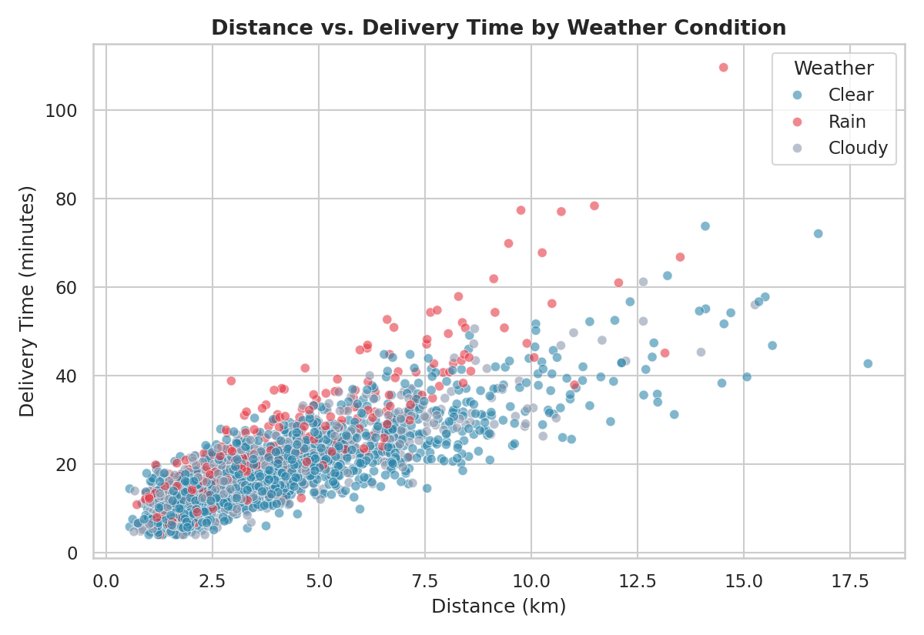
Figure 3: Rain-day deliveries (red) consistently take longer than clear-day deliveries (blue) at the same distance.

4.4 Average Cost by Vehicle Type
A grouped bar chart compares average fuel cost and total delivery cost across the three vehicle types, useful for fleet-mix cost optimization decisions.
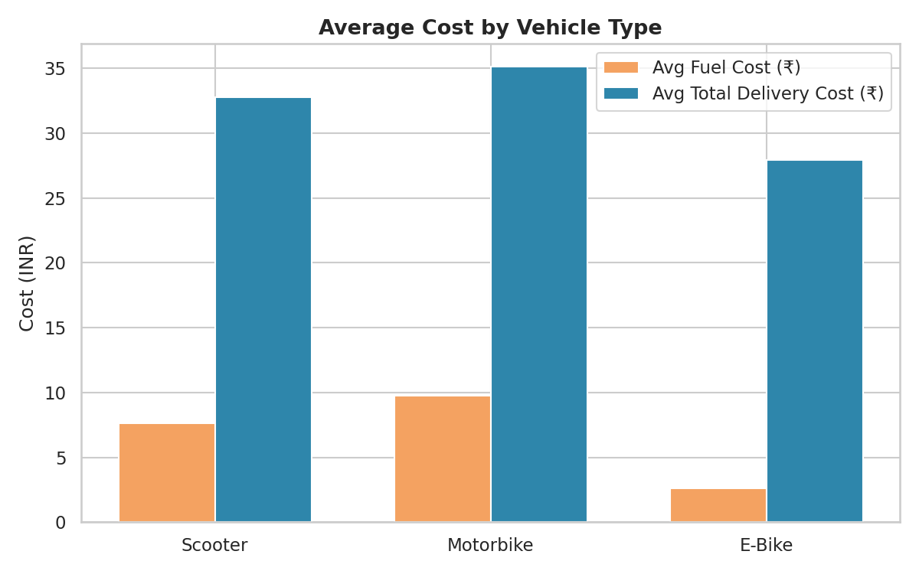
Figure 4: E-bikes are the cheapest to operate per delivery; motorbikes are fastest for short trips but costliest.

4.5 Correlation Heatmap
A heatmap visualizes the full correlation matrix at a glance, making it immediately clear which metrics move together and which are largely independent (e.g., shipment weight is nearly uncorrelated with delivery time).
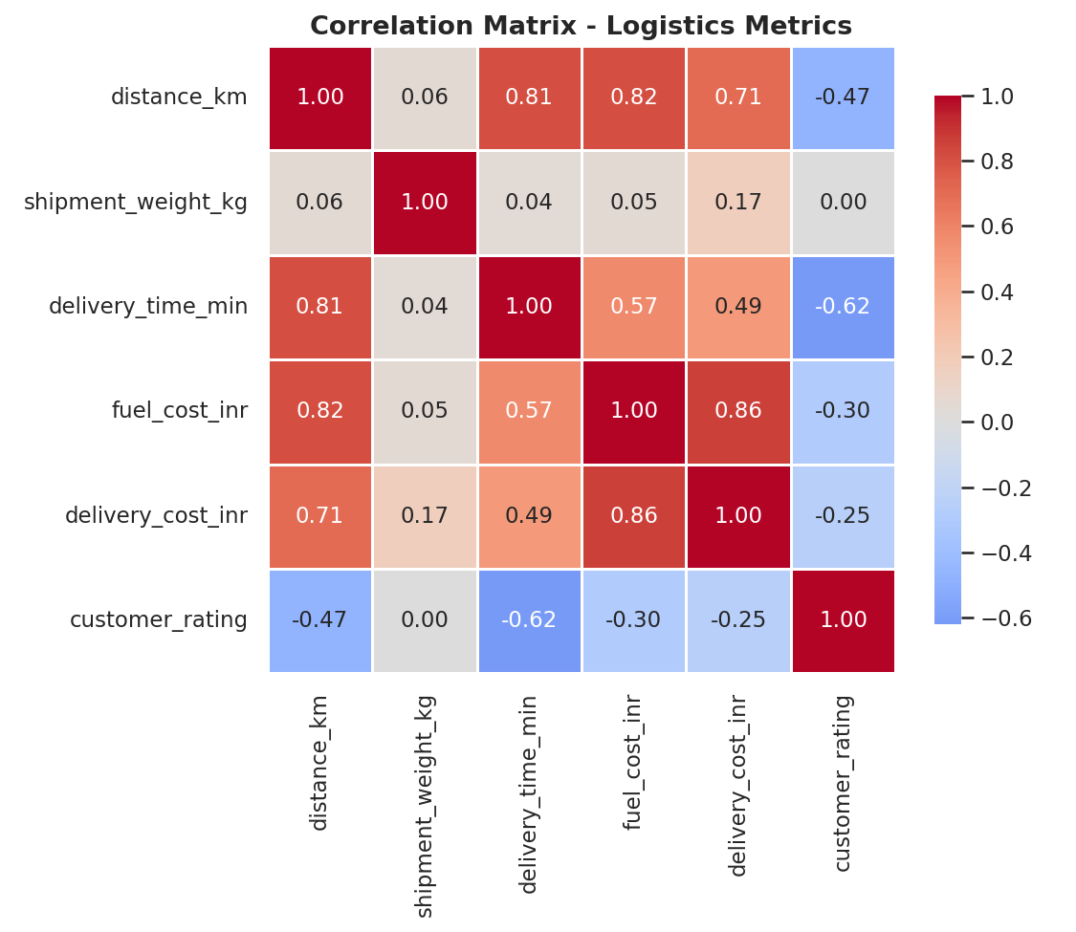
Figure 5: Distance is the strongest driver of both time and cost; delivery time is the strongest (negative) driver of customer rating.

4.6 Delay Rate by Zone
A horizontal bar chart ranks the five delivery zones by delay rate, immediately surfacing the operational bottleneck zone that should be prioritized for intervention.
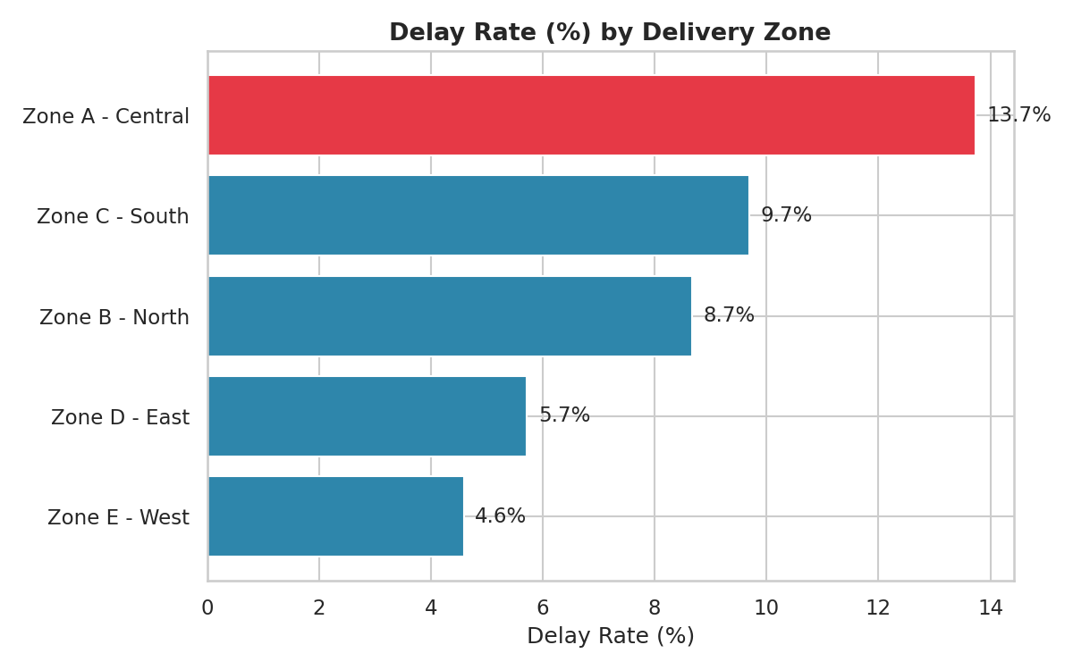
Figure 6: Zone A (Central) has the highest delay rate (14.0%), roughly 3x Zone E (West) at 5.0%, despite a shorter average distance — pointing to a congestion/SLA-design issue rather than distance.

4.7 Daily Delivery Time Trend
A line chart with a 7-day rolling average smooths day-to-day noise to reveal the underlying operational trend across the 90-day window, useful for spotting seasonal effects or deteriorating performance over time.
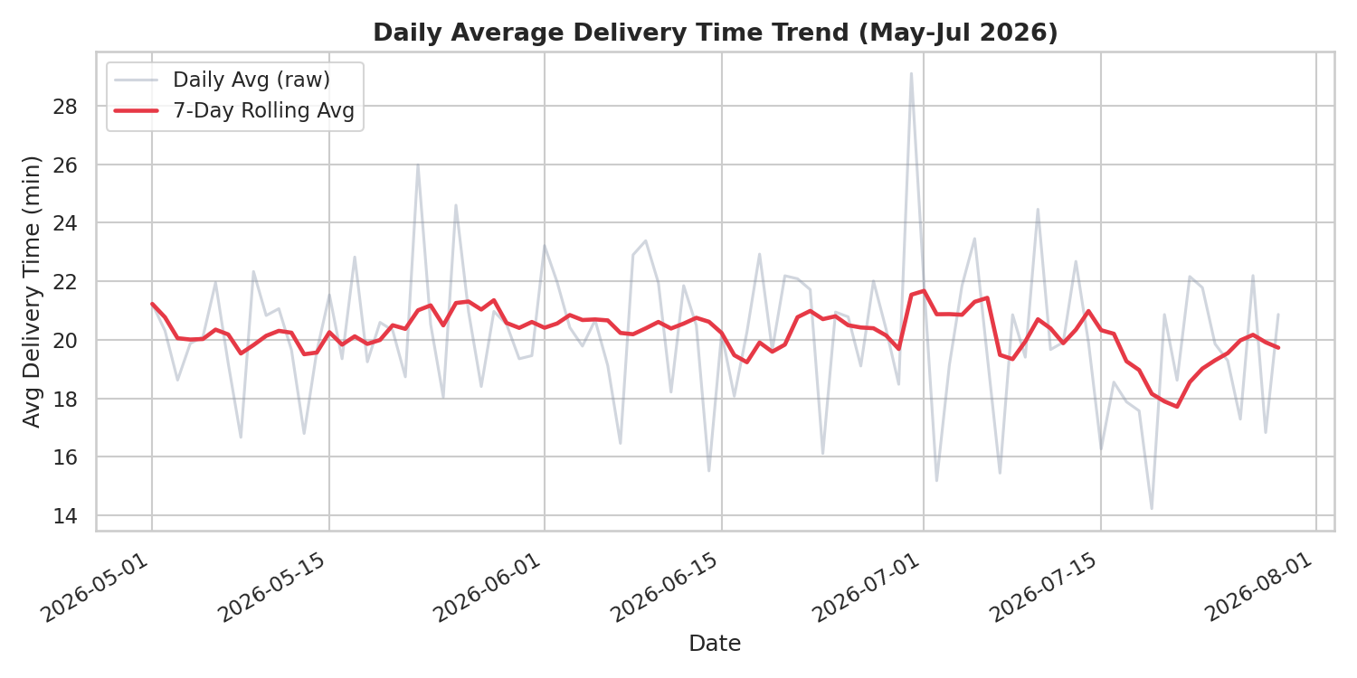
Figure 7: Daily average delivery time fluctuates with weather/traffic conditions but shows no long-term structural drift over the period.

4.8 Fleet Composition
A pie chart shows the current vehicle mix in the fleet, providing context for interpreting the cost and speed comparisons above.
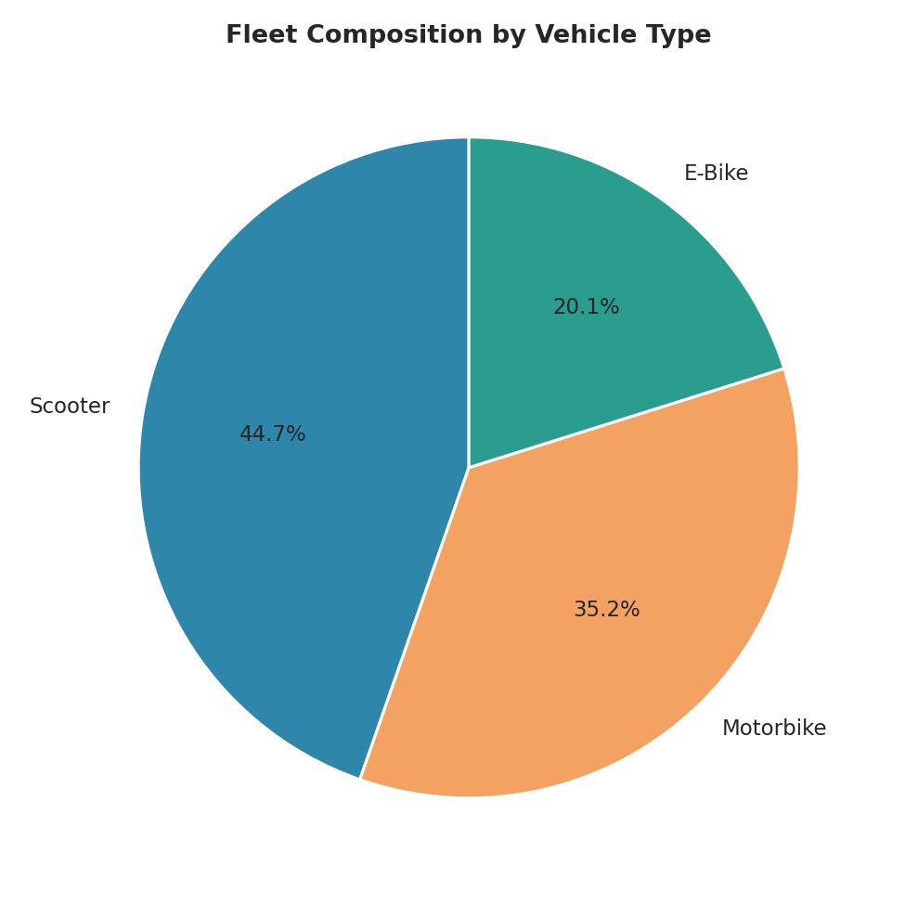
Figure 8: Scooters make up the largest share of the fleet (44.6%), followed by motorbikes (35.2%) and e-bikes (20.2%).

5. Group-Wise Performance Breakdown

5.1 By Vehicle Type
Vehicle Type | Avg Delivery Time (min) | Avg Fuel Cost (₹) | Avg Total Cost (₹) | Delay Rate (%)
Motorbike | 18.47 | 9.74 | 35.12 | 5.0
Scooter | 20.36 | 7.64 | 32.75 | 9.0
E-Bike | 22.98 | 2.63 | 27.90 | 16.0

5.2 By Delivery Zone
Zone | Avg Delivery Time (min) | Delay Rate (%) | Avg Cost (₹)
Zone A - Central | 20.18 | 14.0 | 32.65
Zone B - North | 20.70 | 9.0 | 32.78
Zone C - South | 20.60 | 10.0 | 32.67
Zone D - East | 19.79 | 6.0 | 32.65
Zone E - West | 19.78 | 5.0 | 32.18

6. Analytical Insights & Recommendations

6.1 Operational Efficiency
- Distance is the single strongest driver of both delivery time (r=0.81) and fuel cost (r=0.82) — route optimization and rider allocation by proximity should be the top efficiency lever.
- Motorbikes deliver fastest on average (18.5 min) with the lowest delay rate (5%), making them the best choice for time-critical, longer-distance orders.
- E-bikes are ~40% cheaper to run than motorbikes but have the highest delay rate (16%) — best suited for short, non-urgent, low-traffic routes rather than peak-hour central deliveries.

6.2 Cost Drivers
- Fuel cost and total delivery cost are highly correlated (r=0.86), confirming fuel is the dominant variable cost component versus weight-based surcharges.
- Shipment weight has a comparatively minor effect on cost (r=0.17) and almost none on delivery time (r=0.04) — pricing models overly focused on weight may be misallocating cost drivers.

6.3 Bottlenecks
- Zone A (Central) is the clearest bottleneck: highest delay rate (14%) despite not having the longest average distance, suggesting congestion or an overly aggressive 30-minute SLA rather than a distance problem.
- High-traffic conditions increase delivery time by ~49% versus low traffic (24.9 vs 16.7 min) and nearly 6x the delay rate (18% vs 3%) — the single largest controllable operational lever.
- Rain conditions increase delivery time by ~32% versus clear weather and roughly triple the delay rate (22% vs 7%), with a measurable drop in customer rating (4.50 vs 4.82).

6.4 Recommendations
- Re-evaluate the Zone A SLA (currently 30 min) against realistic central-zone traffic patterns, or add rider capacity during peak central-zone hours.
- Shift e-bike deployment away from high-traffic central routes toward short suburban routes where their cost advantage does not compromise SLA compliance.
- Introduce a dynamic, weather-and-traffic-adjusted SLA so that customer expectations (and rider performance scoring) account for genuinely uncontrollable delay factors.
- Use the strong distance-time-cost relationship to build a route-optimization or zone-based rider assignment system that minimizes average trip distance.

7. Conclusion
This analysis demonstrates how structured EDA and targeted visualization can convert raw two-wheeler delivery data into clear, actionable operational insight. Distance, traffic, and weather emerged as the dominant, statistically supported drivers of delivery time, cost, and customer satisfaction, while shipment weight played a comparatively minor role. The zone- and vehicle-level breakdowns pinpoint specific, addressable bottlenecks (Zone A congestion, e-bike delay risk) that provide a concrete starting point for operational improvement in a real-world two-wheeler logistics fleet.

8. Tools & Methodology Summary
- Language: Python 3
- Libraries: pandas, numpy (data simulation & analysis), matplotlib, seaborn (visualization)
- Techniques: descriptive statistics, skewness analysis, Pearson correlation, group-by aggregation, histogram/boxplot/scatter/heatmap/bar/line/pie visualization
- Full source code and dataset are provided in the accompanying scripts/ and data/ folders of this project.

