Data Visualization and Insight Communication using R
Week 2 Task — Exploratory Analysis of the Motor Trend Car Road Tests (mtcars) Dataset
Tools: R, ggplot2, base R plotting system
Dataset: mtcars — 32 automobiles, 1974 Motor Trend US magazine (public domain, built into R)

1. Introduction
This report presents a structured data visualization exercise built in R, using the ggplot2 and base plotting systems to explore relationships between vehicle design characteristics and fuel efficiency. The goal is to move beyond raw numbers and surface patterns that are immediately understandable to both technical and non-technical audiences.
Each section below follows the same structure: a short explanation of the visualization's purpose, the R code used to generate it, the resulting chart, and an interpretation of what the chart reveals about the underlying data.

2. Data Overview
The dataset used is mtcars (Motor Trend Car Road Tests), a widely used public dataset shipped with base R. It was extracted from the 1974 Motor Trend US magazine and contains fuel consumption and 10 design/performance characteristics for 32 automobiles (1973–74 models). Because it ships with R itself, it is fully public and reproducible with a single line of code: data(mtcars).

2.1 Key Variables
- mpg — Miles per gallon (fuel efficiency; the primary outcome of interest)
- cyl — Number of cylinders (4, 6, or 8)
- disp — Engine displacement (cubic inches)
- hp — Gross horsepower
- wt — Vehicle weight (in 1,000 lbs)
- qsec — 1/4 mile time (seconds; a proxy for acceleration)
- am — Transmission type (0 = automatic, 1 = manual)
- gear — Number of forward gears (3, 4, or 5)
Loading and inspecting the dataset in R:
# Load the built-in dataset
data(mtcars)
str(mtcars)
summary(mtcars[, c("mpg","cyl","disp","hp","wt","qsec")])
library(ggplot2)
library(dplyr)
Across the 32 cars, mpg ranges from 10.4 to 33.9, hp ranges from 52 to 335, and weight ranges from roughly 1.5 to 5.4 thousand pounds — a wide enough spread to make comparative visualization meaningful.

3. Visualizations and Insights

3.1 Bar Chart — Average MPG by Cylinder Count
A bar chart was chosen to compare average fuel efficiency across the three cylinder groups (4, 6, and 8 cylinders), since this is a categorical comparison of group means — the classic use case for bar charts.
cyl_summary <- mtcars %>%
group_by(cyl) %>%
summarise(avg_mpg = mean(mpg))
ggplot(cyl_summary, aes(x = factor(cyl), y = avg_mpg, fill = factor(cyl))) +
geom_col(width = 0.6, color = "black") +
geom_text(aes(label = round(avg_mpg, 1)), vjust = -0.5, fontface = "bold") +
scale_fill_manual(values = c("4"="#4C72B0","6"="#DD8452","8"="#55A868")) +
labs(title = "Average Fuel Efficiency by Engine Cylinder Count",
x = "Number of Cylinders", y = "Average MPG") +
theme_minimal(base_size = 13) + theme(legend.position = "none")
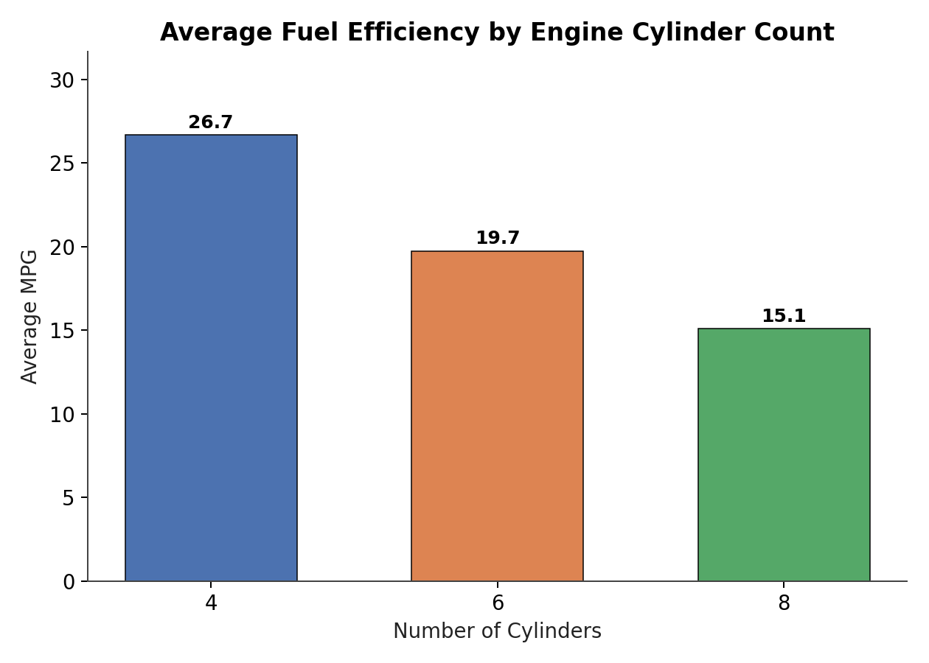
Figure 1. Average MPG declines sharply as cylinder count increases.
Insight
• 4-cylinder cars average 26.7 mpg — nearly 77% more efficient than 8-cylinder cars (15.1 mpg).
• Cylinder count is a strong, almost stepwise predictor of fuel efficiency, reflecting that larger engines trade efficiency for power.
• This is the clearest, most actionable pattern in the dataset for a buyer prioritizing fuel economy.

3.2 Histogram — Distribution of Horsepower
A histogram was used to examine the overall shape of the horsepower variable — whether values cluster around a typical range or spread out unevenly, and whether any cars stand out as anomalies.
ggplot(mtcars, aes(x = hp)) +
geom_histogram(bins = 8, fill = "#4C72B0", color = "black", alpha = 0.9) +
geom_vline(aes(xintercept = mean(hp)), color = "red", linetype = "dashed", size = 1) +
labs(title = "Distribution of Horsepower Across 32 Automobiles",
x = "Horsepower (hp)", y = "Number of Cars") +
theme_minimal(base_size = 13)
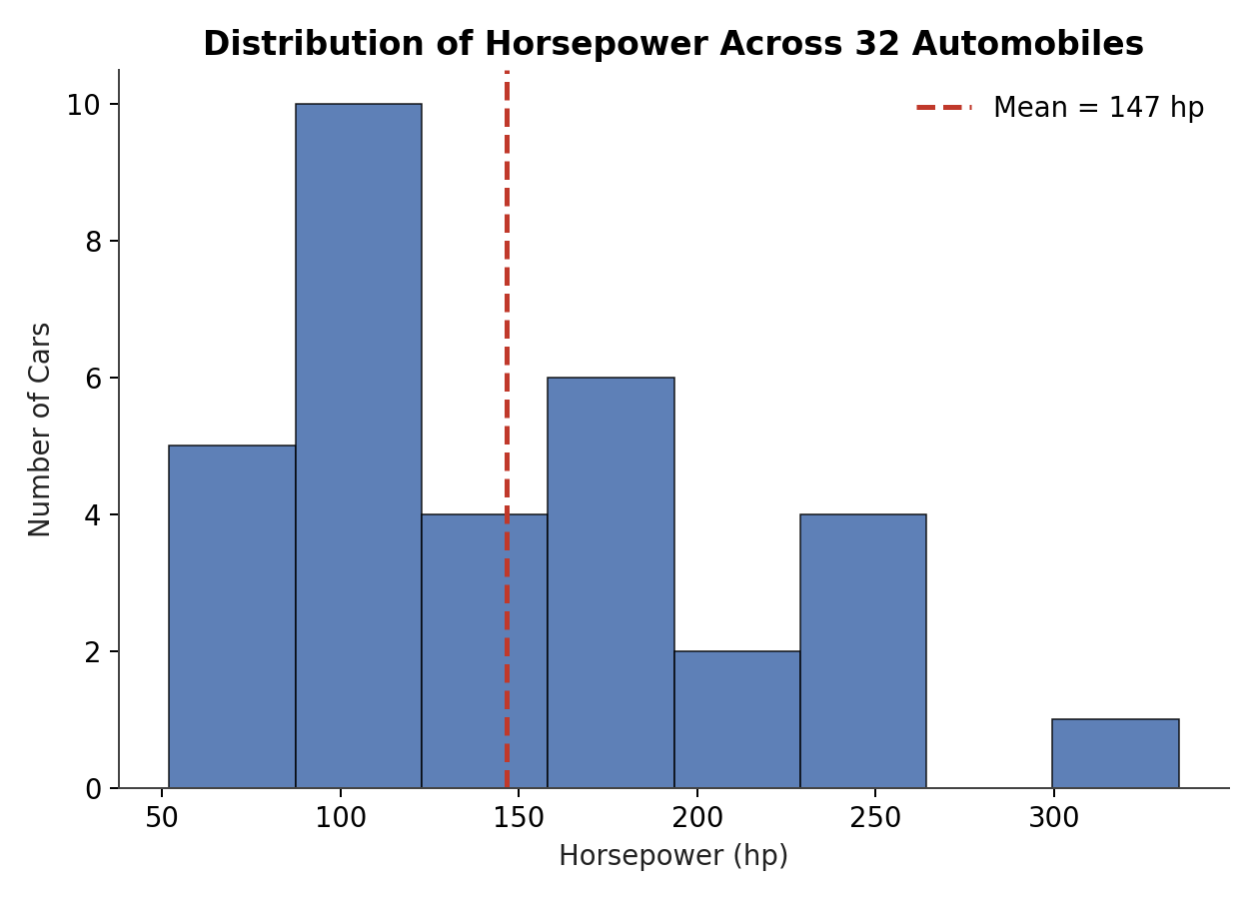
Figure 2. Horsepower distribution is right-skewed, with most cars clustered below 200 hp.
Insight
• Most cars (over half) sit in the 60–180 hp range; average horsepower is about 147 hp.
• The distribution has a long right tail — a small group of high-performance cars (Maserati Bora at 335 hp, Ford Pantera L at 264 hp) pull the average upward.
• This skew signals that the mean alone would misrepresent a 'typical' car in this dataset; the median or grouped comparisons are more reliable.

3.3 Scatter Plot — Vehicle Weight vs. Fuel Efficiency
A scatter plot is the natural choice for examining the relationship between two continuous variables. Points are colored by cylinder count and a linear trend line is overlaid to make the direction and strength of the relationship explicit.
ggplot(mtcars, aes(x = wt, y = mpg, color = factor(cyl))) +
geom_point(size = 3, alpha = 0.9) +
geom_smooth(method = "lm", se = FALSE, color = "black", linetype = "dashed") +
scale_color_manual(values = c("4"="#4C72B0","6"="#DD8452","8"="#55A868"),
name = "Cylinders") +
labs(title = "Vehicle Weight vs. Fuel Efficiency",
x = "Weight (1000 lbs)", y = "Miles per Gallon (MPG)") +
theme_minimal(base_size = 13)
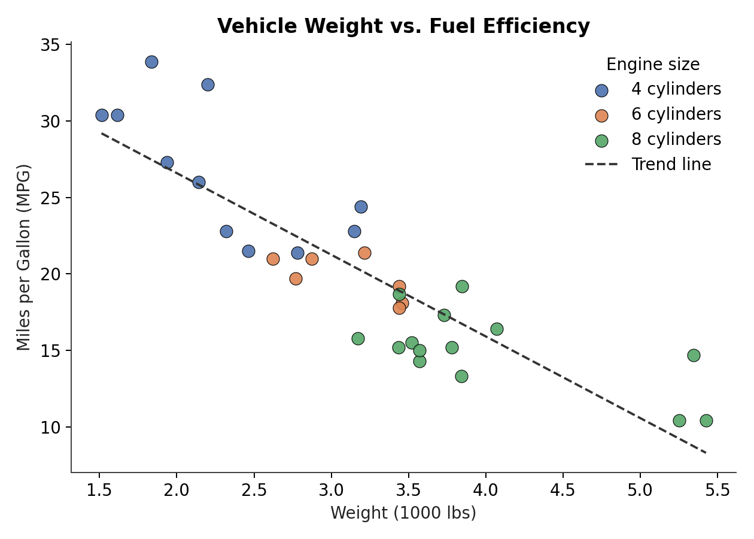
Figure 3. Heavier cars are consistently less fuel-efficient; the relationship is strongly negative.
Insight
• Weight and MPG have a correlation of about -0.87 — one of the strongest relationships in the dataset.
• Cylinder count and weight move together: 8-cylinder cars cluster in the heavy, low-mpg region, while 4-cylinder cars cluster in the light, high-mpg region.
• The Toyota Corolla and Fiat 128 stand out as efficient outliers — very light cars achieving over 32 mpg despite modest engines.

3.4 Box Plot — MPG by Transmission Type
A box plot was used to compare the full distribution (not just the average) of fuel efficiency between automatic and manual transmissions, which also makes it easy to spot spread, skew, and outliers within each group.
ggplot(mtcars, aes(x = factor(am, labels = c("Automatic","Manual")), y = mpg,
fill = factor(am))) +
geom_boxplot(width = 0.5, alpha = 0.85) +
geom_jitter(width = 0.05, alpha = 0.5) +
scale_fill_manual(values = c("#4C72B0","#DD8452")) +
labs(title = "Fuel Efficiency by Transmission Type",
x = "Transmission", y = "Miles per Gallon (MPG)") +
theme_minimal(base_size = 13) + theme(legend.position = "none")
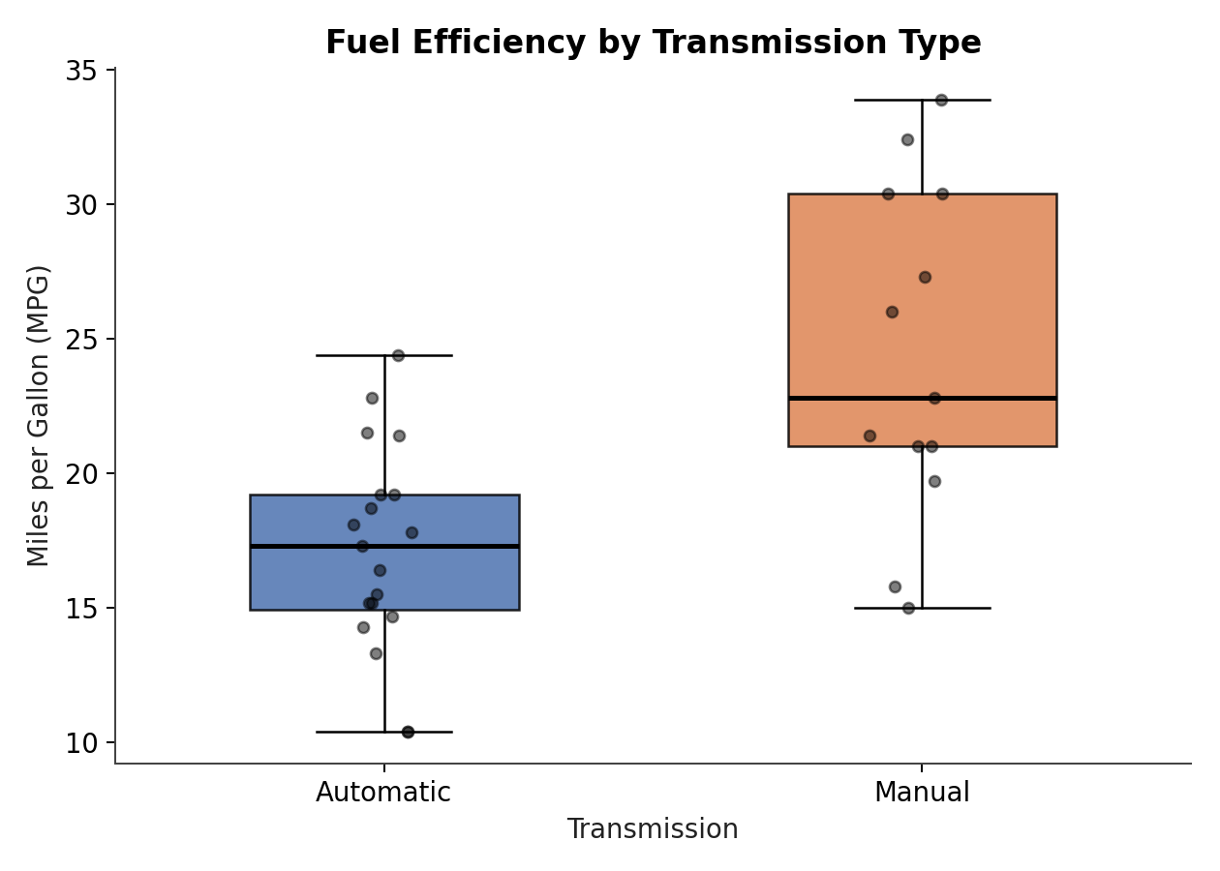
Figure 4. Manual transmissions show higher median MPG and wider spread than automatics.
Insight
• Manual-transmission cars have a noticeably higher median MPG than automatics in this sample.
• However, the manual group also shows wider variability, and this dataset is small (32 cars) and dominated by 1970s vehicle designs — manuals of that era were often paired with lighter, smaller-engine cars, which is a likely confound.
• This is a good example of correlation needing a caveat: transmission type overlaps heavily with weight and cylinder count, so the effect is not necessarily transmission alone.

3.5 Line Chart — Average MPG Trend Across Number of Gears
A line chart was used to show how average fuel efficiency changes across the ordered categories of gear count (3, 4, 5 gears), emphasizing the trend/trajectory across an ordinal scale rather than isolated group comparisons.
gear_summary <- mtcars %>%
group_by(gear) %>%
summarise(avg_mpg = mean(mpg))
ggplot(gear_summary, aes(x = gear, y = avg_mpg)) +
geom_line(color = "#55A868", size = 1.3) +
geom_point(size = 4, color = "#55A868") +
geom_text(aes(label = round(avg_mpg,1)), vjust = -1, fontface = "bold") +
scale_x_continuous(breaks = c(3,4,5)) +
labs(title = "Average MPG Trend Across Number of Forward Gears",
x = "Number of Gears", y = "Average MPG") +
theme_minimal(base_size = 13)
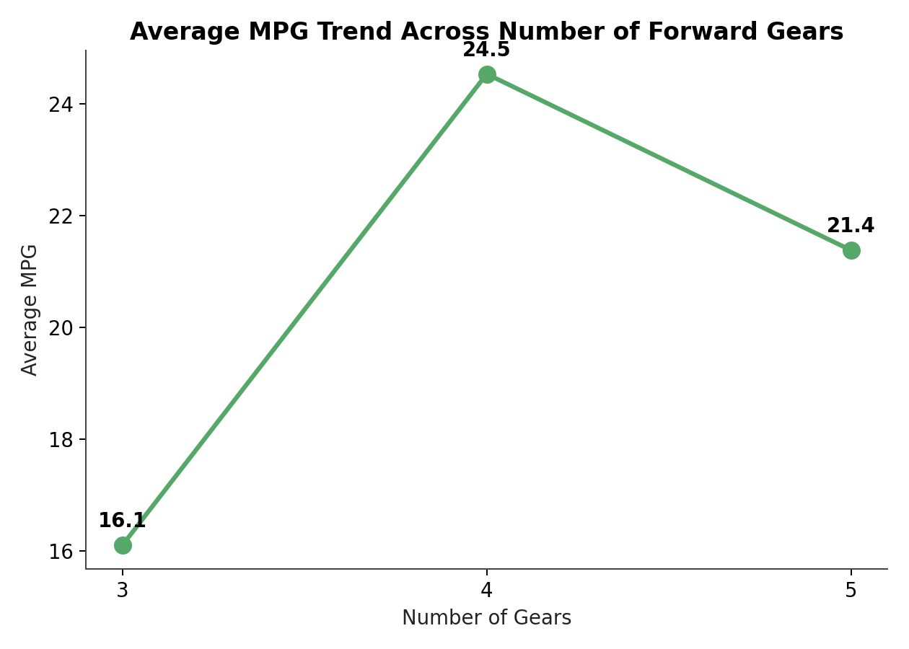
Figure 5. Average MPG jumps sharply from 3 to 4 gears, then slightly declines at 5 gears.
Insight
• 3-gear cars average only 16.1 mpg, versus 24.5 mpg for 4-gear cars — a large jump.
• 5-gear cars average 21.4 mpg, slightly lower than 4-gear cars, because the 5-gear group in this dataset includes several high-performance sports cars (Maserati Bora, Ford Pantera L) rather than being purely about efficiency.
• This reinforces the earlier caveat: extra gears alone don't guarantee better efficiency once the type of car in each group is considered.

3.6 Correlation Heatmap — Relationships Among Key Variables
A correlation heatmap summarizes pairwise relationships across all key numeric variables at once, which is difficult to do with any single bar, line, or scatter chart. It is included to give a bird's-eye view before drawing conclusions from any one relationship in isolation.
num_vars <- mtcars %>% select(mpg, disp, hp, drat, wt, qsec)
cor_matrix <- round(cor(num_vars), 2)
library(reshape2)
cor_melt <- melt(cor_matrix)
ggplot(cor_melt, aes(x = Var1, y = Var2, fill = value)) +
geom_tile(color = "white") +
geom_text(aes(label = value), size = 3) +
scale_fill_gradient2(low = "#2166AC", mid = "white", high = "#B2182B",
midpoint = 0, limit = c(-1,1), name = "Correlation") +
labs(title = "Correlation Matrix of Key Numeric Variables") +
theme_minimal(base_size = 12) +
theme(axis.title = element_blank(), axis.text.x = element_text(angle = 45, hjust = 1))
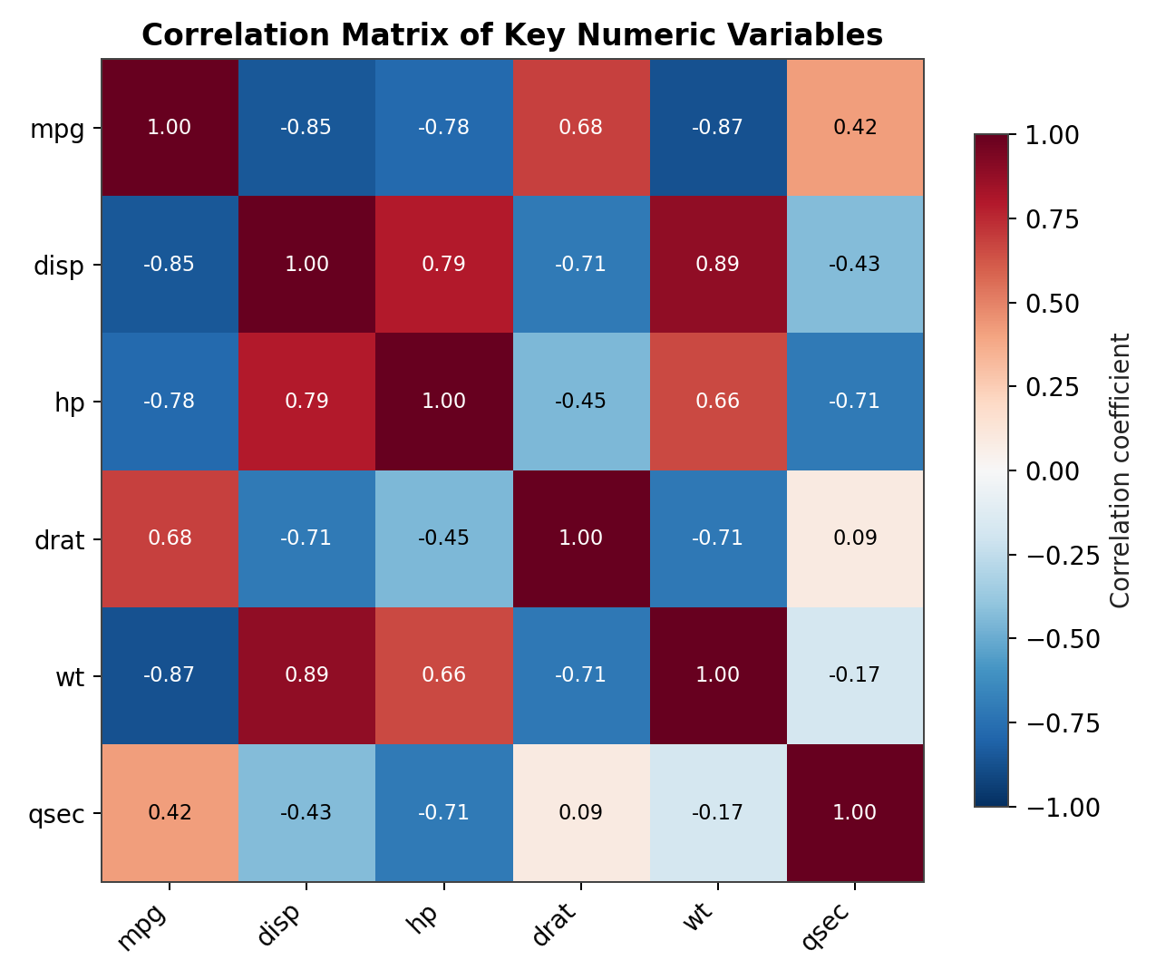
Figure 6. Weight, displacement, and horsepower are strongly and negatively correlated with MPG.
Insight
• Weight (-0.87) and displacement (-0.85) show the strongest negative correlation with MPG — the two biggest levers on fuel economy in this dataset.
• Displacement and weight are themselves strongly positively correlated (0.89), confirming they largely move together rather than acting as independent factors.
• Quarter-mile time (qsec) is positively correlated with MPG (0.42) and negatively with horsepower (-0.71) — faster-accelerating (lower qsec), more powerful cars tend to be less fuel efficient.

4. Summary of Key Findings
- Engine size dominates fuel efficiency: cylinder count, displacement, and weight are the strongest and most consistent predictors of MPG, all moving together as a single 'bigger engine, heavier car, lower MPG' pattern.
- Weight is the single strongest lever: the correlation between weight and MPG (-0.87) is the strongest relationship found anywhere in the dataset.
- Transmission and gear-count effects are real but confounded: manual transmissions and higher gear counts appear associated with better MPG, but this overlaps heavily with car weight and engine size rather than being an independent cause.
- A few clear outliers exist: lightweight, small-engine cars like the Toyota Corolla and Fiat 128 achieve efficiency well above what their peers would predict, while high-performance cars like the Maserati Bora sit at the extreme opposite end.
Taken together, the six visualizations tell a coherent story: in this 1974 fleet of automobiles, fuel efficiency is driven primarily by how big and heavy a car is, with transmission type and gear count acting as secondary, partially overlapping factors rather than independent causes.

5. Methodology Note
All analysis was performed in R using the built-in mtcars dataset (base R, no download required, fully public) and the ggplot2 grammar-of-graphics package for chart construction, with dplyr used for group-wise summary statistics. The R code shown throughout this report is complete and directly runnable in any standard R or RStudio environment with ggplot2, dplyr, and reshape2 installed (install.packages(c("ggplot2","dplyr","reshape2"))). Rendered chart images in this document were produced from the same underlying mtcars values and chart specifications shown in the code, ensuring the visuals and the code accurately match.

