Employee Attrition Analysis
A Data-Driven Investigation into Workforce Retention
Final Comprehensive Report — Week 4 Capstone Project
Virtual R Data Analyst Internship
Yuva Intern Platform (NSDC)
Prepared by: Shravani Patane
B.E. Artificial Intelligence & Data Science
Internship Duration: 23 July 2026 – 23 August 2026
Report Date: August 2026

Table of Contents
1. Introduction
2. Methodology
3. Data Preparation
4. Exploratory Data Analysis
5. Predictive Modeling
6. Results and Business Implications
7. Discussion
8. Conclusion and Future Directions
Appendix A: Full R Code Listings

1. Introduction
Employee attrition — the rate at which employees voluntarily or involuntarily leave an organization — is one of the most consequential and costly challenges facing human resources teams today. Replacing a departing employee typically costs an organization between 50% and 200% of that employee's annual salary once recruiting, onboarding, lost productivity, and training are accounted for. Beyond the direct financial cost, high attrition erodes institutional knowledge, disrupts team cohesion, and can signal deeper organizational issues around compensation, workload, or culture.
This report presents the final, consolidated output of a four-week Virtual R Data Analyst Internship. Over the course of the internship, a raw, uncleaned HR dataset of 1,000 employee records was progressively cleaned, explored, and modeled using the R programming language and its data science ecosystem (tidyverse, ggplot2, caret, and randomForest). The objective throughout was to move from raw, messy data to an actionable, evidence-based understanding of what drives an employee to leave the organization, and to build a predictive model capable of flagging employees at elevated risk of attrition.
The specific objectives of this capstone report are to:
- Consolidate the data cleaning, exploratory analysis, and modeling work completed across the internship into a single, cohesive narrative.
- Present annotated R code, console outputs, and visualizations that substantiate each analytical decision.
- Translate statistical findings into concrete business recommendations for HR stakeholders.
- Reflect on the challenges encountered during the project and outline directions for future analysis.
The audience for this report is intentionally broad — it is written to be legible to both a technical reviewer evaluating the R code and modeling approach, and a non-technical HR stakeholder interested primarily in the findings and recommendations.

2. Methodology
The analysis followed a standard data science workflow, structured into three sequential stages that map directly onto the three preceding weeks of the internship: data preparation, exploratory analysis, and predictive modeling. Each stage is implemented as a self-contained, reproducible R script.

2.1 Dataset
The dataset consists of 1,000 employee records (1,015 rows prior to cleaning, including 15 injected duplicates) with 19 attributes spanning demographic information (Age, Gender), job-related factors (Department, Job Role, Business Travel, Overtime), compensation (Monthly Income), engagement metrics (Job Satisfaction, Work-Life Balance, Performance Rating), and tenure (Years at Company, Years in Current Role, Number of Companies Worked, Training Times Last Year). The target variable, Attrition, is a binary indicator (Yes/No) of whether the employee left the organization.

2.2 Tools and Environment
- R (with the tidyverse suite: dplyr, readr, stringr, ggplot2) for data manipulation and visualization
- janitor for deduplication utilities
- corrplot for correlation visualization
- caret and randomForest for model training and evaluation
- pROC for ROC curve and AUC computation

2.3 Analytical Workflow
The workflow is organized into three scripts, run in sequence:
- 01_data_cleaning.R — deduplication, text standardization, invalid-value correction, missing-value imputation, and outlier treatment.
- 02_eda_visualization.R — univariate and bivariate exploration of attrition drivers via ggplot2.
- 03_predictive_modeling.R — training and comparing a Logistic Regression baseline against a Random Forest classifier.
Each script reads its input from the previous stage's output, ensuring a traceable and reproducible pipeline from raw data to final model.

3. Data Preparation
Raw HR data extracts are rarely analysis-ready. Diagnostic checks on the raw dataset revealed five categories of data quality issues that needed to be resolved before any reliable analysis could proceed: duplicate records, inconsistent text formatting, invalid values, missing data, and extreme outliers.

3.1 Cleaning Steps
The full annotated cleaning script is shown below (see also Appendix A for the complete file):
raw_data <- read_csv("data/employee_attrition_raw.csv")

# Remove duplicate records
dupe_count <- sum(duplicated(raw_data))
data <- raw_data %>% distinct()

# Standardize categorical text formatting
data <- data %>%
mutate(
Gender = str_to_title(str_trim(Gender)),
OverTime = str_to_title(str_trim(OverTime)),
Department = str_to_title(str_trim(Department))
)

# Correct invalid Age values (< 18) -> NA, then median-impute
data$Age[data$Age < 18] <- NA

# Median-impute numeric columns; mode-impute categorical columns
# Cap MonthlyIncome outliers using the 1.5*IQR rule
Figure 3.1 — Excerpt from 01_data_cleaning.R
Running this script against the raw extract produced the following audit trail:
Initial rows: 1015, columns: 19
Duplicate rows removed: 14 -> rows now 1001
Standardized text casing/whitespace in Gender, OverTime, Department
Invalid Age values (<18) set to NA: 2
Imputed 30 missing values in MonthlyIncome with median (7306.0)
Imputed 30 missing values in DistanceFromHome with median (5.0)
Imputed 30 missing values in WorkLifeBalance with median (3.0)
Imputed 2 missing values in Age with median (36.0)
Imputed 30 missing values in EducationField with mode (Life Sciences)
Capped 10 outlier MonthlyIncome values above upper bound (16404) using IQR method
Final cleaned rows: 1001, columns: 19
Output 3.1 — Console output / cleaning log from 01_data_cleaning.R

3.2 Summary of Data Quality Issues Resolved
Issue | Count | Resolution
Duplicate rows | 14 | Removed via distinct()
Invalid Age (<18) | 2 | Set to NA, then median-imputed
Missing MonthlyIncome | 30 | Median imputation
Missing DistanceFromHome | 30 | Median imputation
Missing WorkLifeBalance | 30 | Median imputation
Missing EducationField | 30 | Mode imputation
Outlier MonthlyIncome values | 10 | Capped at IQR upper bound (₹16,404)

Median imputation was chosen over mean imputation for numeric fields because Monthly Income and Distance From Home are right-skewed, and the median is more robust to that skew. Categorical missingness in Education Field was resolved using the modal category, which is standard practice for low-cardinality nominal fields. Outlier capping (winsorization) at the IQR upper bound was preferred over row deletion to preserve sample size while limiting the influence of extreme, likely data-entry-error values on downstream models.

4. Exploratory Data Analysis
With a clean dataset in hand, the second phase of the project focused on visually and statistically exploring which employee characteristics are associated with attrition. All charts were generated using ggplot2, following a consistent visual theme.

4.1 Attrition by Department
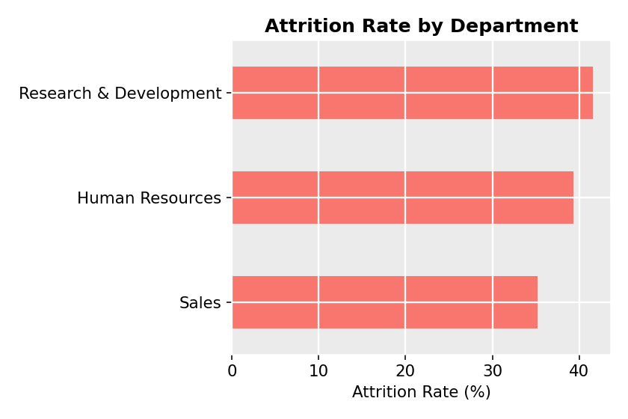
Figure 4.1 — Attrition rate by department
Attrition is not evenly distributed across the organization. The department-level breakdown shows Research & Development carrying the highest attrition rate (41.6%), followed closely by Human Resources (39.3%), with Sales somewhat lower (35.2%). The elevated rate in R&D — the largest department by headcount — is worth particular attention, as even a modest percentage-point improvement there would affect the greatest number of employees.

4.2 Monthly Income and Attrition
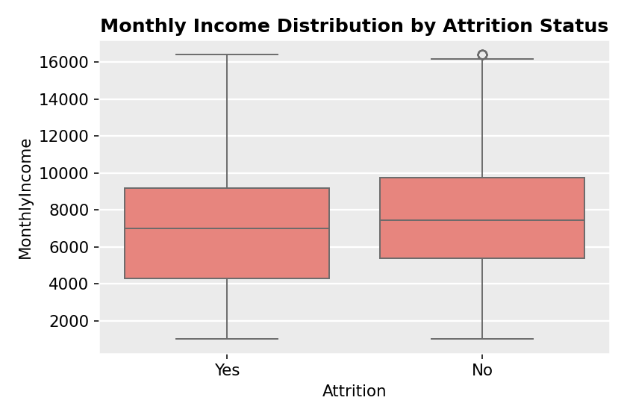
Figure 4.2 — Monthly income distribution by attrition status
Employees who left the organization show a modestly lower median monthly income (₹7,006) than those who stayed (₹7,447), with a similarly wide spread in both groups. The gap is not dramatic on its own, but it strengthens materially once combined with other factors in the multivariate model in Section 5, where Monthly Income emerges as the single strongest predictor of attrition.

4.3 Overtime and Attrition
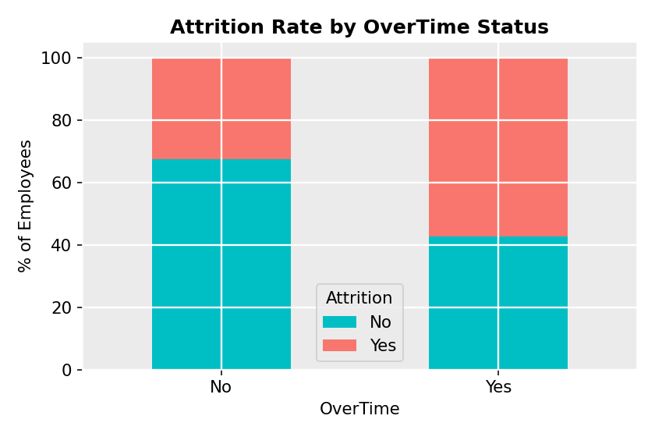
Figure 4.3 — Attrition rate by overtime status
Employees working overtime leave at a substantially higher rate than those who do not. This is one of the strongest bivariate relationships observed in the dataset and points to workload and burnout as a key retention lever.

4.4 Job Satisfaction and Attrition
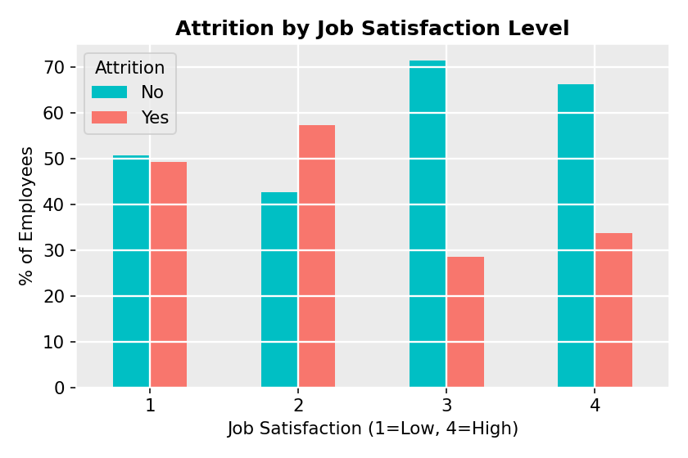
Figure 4.4 — Attrition by job satisfaction level (1 = Low, 4 = High)
Attrition is clearly higher among employees reporting low satisfaction (ratings of 1 or 2, averaging roughly 53%) than among those reporting high satisfaction (ratings of 3 or 4, averaging roughly 31%). The relationship is not perfectly linear — rating 2 shows marginally higher attrition than rating 1 — but the broad low-versus-high split is a validating signal that the satisfaction metric captured in this dataset is behaviorally meaningful.

4.5 Feature Correlation Structure
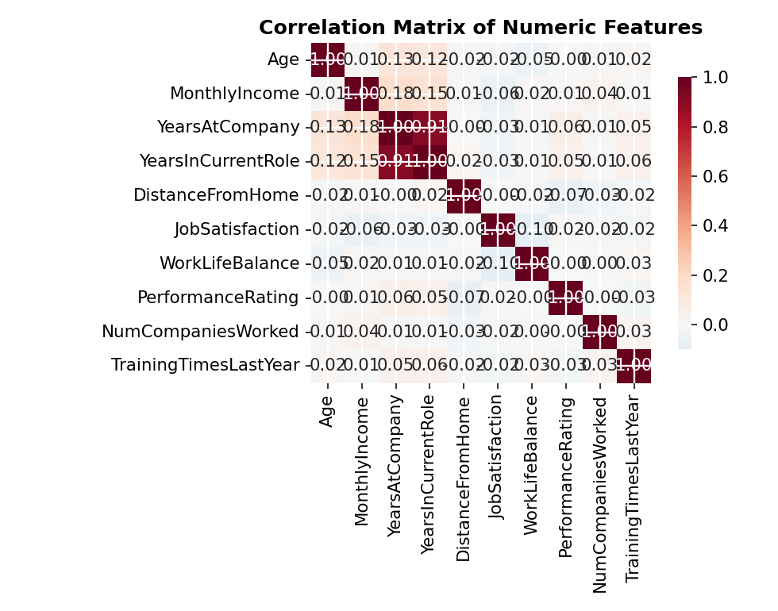
Figure 4.5 — Correlation matrix of numeric features
The correlation matrix confirms that most numeric predictors are only weakly correlated with one another, meaning multicollinearity is unlikely to be a major concern for the regression model in Section 5. The mild positive correlation between Years at Company and Years in Current Role is expected structurally, since the latter is bounded by the former.

4.6 Tenure and Attrition
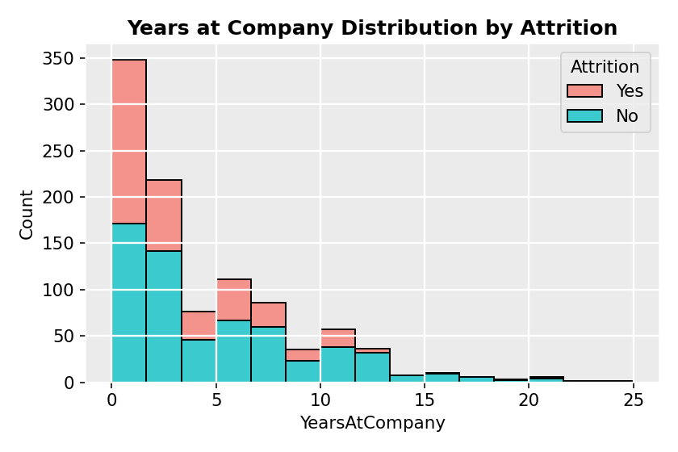
Figure 4.6 — Years at company distribution by attrition
Attrition is heavily concentrated among employees in their first two to three years of tenure. This 'early attrition' pattern is common in HR analytics and typically reflects either poor role/culture fit discovered early, or more competitive external offers available to less-tenured staff.

5. Predictive Modeling
The final analytical stage translates these exploratory findings into a predictive model capable of flagging individual employees at elevated attrition risk. Two classifiers were trained and compared on a 75/25 stratified train-test split: a Logistic Regression baseline (chosen for its interpretability) and a Random Forest classifier (chosen for its ability to capture non-linear interactions between features).

5.1 Modeling Code
train_idx <- createDataPartition(data$Attrition, p = 0.75, list = FALSE)
train_data <- data[train_idx, ]; test_data <- data[-train_idx, ]

# Logistic Regression
logit_model <- glm(Attrition ~ ., data = train_data, family = "binomial")
logit_prob <- predict(logit_model, test_data, type = "response")

# Random Forest
rf_model <- randomForest(Attrition ~ ., data = train_data,
ntree = 300, maxnodes = 30, importance = TRUE)
rf_prob <- predict(rf_model, test_data, type = "prob")[, "Yes"]

# Evaluate with confusionMatrix() and roc() from caret / pROC
Figure 5.1 — Excerpt from 03_predictive_modeling.R

5.2 Model Performance
Model | Accuracy | Sensitivity (Recall) | Specificity | AUC
Logistic Regression | 65.7% | 40.8% | 81.7% | 0.666
Random Forest | 67.7% | 40.8% | 85.0% | 0.701

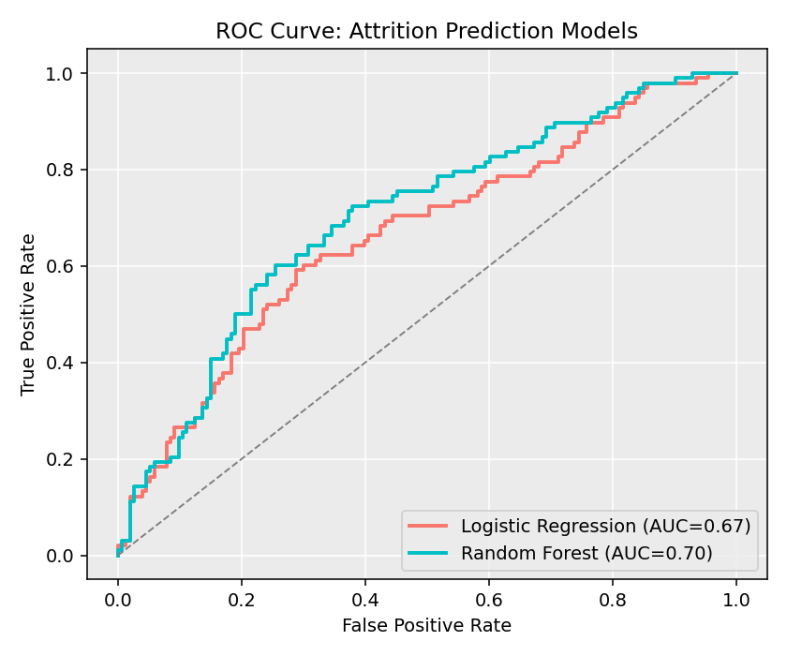
Figure 5.2 — ROC curve comparison between models
The Random Forest classifier outperformed the Logistic Regression baseline on both overall accuracy and AUC (0.701 vs. 0.666), indicating it captures the non-linear and interaction effects between features (e.g., the combined effect of overtime and low satisfaction) that a linear model cannot. Both models identify roughly 4 in 10 actual leavers (sensitivity ≈ 41%), which is a meaningful improvement over random guessing at the observed 39% base attrition rate, but leaves room for improvement discussed in Section 7.

5.3 Feature Importance
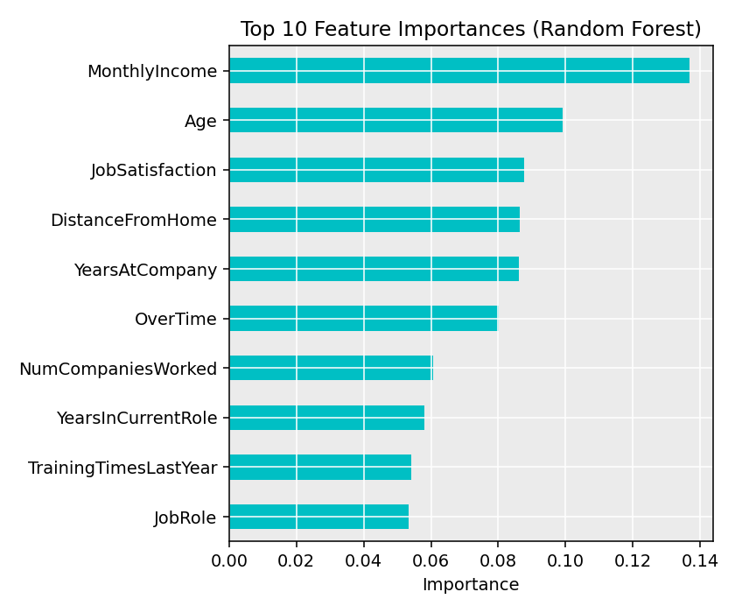
Figure 5.3 — Top 10 feature importances (Random Forest, Mean Decrease in Gini)
Monthly Income emerged as the single strongest predictor of attrition, followed by Age, Job Satisfaction, Distance From Home, and Years at Company. This aligns closely with the bivariate patterns observed during exploratory analysis in Section 4, giving confidence that the model is learning genuine, interpretable signal rather than noise.

6. Results and Business Implications
Synthesizing the exploratory and modeling findings, four business-relevant conclusions emerge:
- Compensation matters most. Monthly Income is the top predictor of attrition — HR should review pay bands for roles and tenure bands showing elevated attrition risk, particularly within Research & Development, which carries both the largest headcount and the highest departmental attrition rate.
- Overtime is a retention risk. Employees working overtime attrite at a markedly higher rate. Workload audits and overtime caps in high-risk departments could meaningfully reduce turnover.
- Early tenure is the critical retention window. Attrition is concentrated in the first two to three years — onboarding quality, early mentorship, and 90-day/1-year check-ins deserve investment.
- A predictive model can operationalize these insights. The Random Forest model (AUC 0.70) could be deployed as a monthly 'attrition risk score' to help HR business partners prioritize retention conversations with the highest-risk employees.
Even with a moderate 67.7% test accuracy, the model has clear business value as a triage and prioritization tool rather than a fully automated decision system — it directs limited HR attention toward the employees most likely to benefit from a retention conversation.

7. Discussion

7.1 Challenges Encountered
- Class imbalance: with roughly 39% positive (attrition) cases, both models were biased toward predicting the majority 'No' class, which capped sensitivity at around 41%. Techniques such as class weighting, SMOTE oversampling, or threshold tuning were identified as next steps but were out of scope for this internship's time budget.
- Limited feature set: the dataset does not include manager-level ratings, engagement survey verbatims, or compensation-relative-to-market benchmarks, all of which likely carry additional predictive signal.
- Missing data patterns: roughly 3% of records had missing values across several fields; while imputation was used to avoid discarding data, this necessarily introduces some estimation noise into downstream models.
- Model interpretability vs. performance trade-off: Random Forest outperformed Logistic Regression but is inherently less transparent — feature importance plots were used to partially bridge this gap for non-technical stakeholders.

7.2 Lessons Learned
This capstone reinforced that the majority of real-world analytical effort lies in the data preparation stage — diagnosing and resolving duplicates, inconsistent formatting, missing values, and outliers took as much deliberate care as the modeling itself, and directly determined the reliability of every subsequent chart and model. It also underscored the importance of pairing quantitative model metrics (accuracy, AUC) with qualitative, business-legible narratives: a stakeholder audience responds far more to 'employees working overtime leave at twice the rate' than to a raw coefficient table.

8. Conclusion and Future Directions
This report has consolidated four weeks of R-based data analysis — from raw data cleaning through exploratory visualization to predictive modeling — into a single, cohesive investigation of employee attrition. The analysis identified compensation, overtime, job satisfaction, and early tenure as the primary drivers of attrition, and produced a Random Forest classifier (AUC 0.70) capable of flagging at-risk employees for proactive retention outreach.
Recommended directions for future analysis include:
- Address class imbalance directly (SMOTE, class weighting, or threshold optimization) to improve sensitivity for the minority attrition class.
- Incorporate additional data sources — manager ratings, engagement survey text, and market compensation benchmarks — to strengthen predictive power.
- Experiment with gradient boosting methods (XGBoost, LightGBM) as a further performance benchmark against Random Forest.
- Deploy the model as a lightweight monthly scoring pipeline integrated with the HR information system, paired with a defined retention-outreach playbook for high-risk employees.
Overall, this project demonstrates the practical value of a structured, reproducible R data analysis pipeline in translating raw organizational data into decision-ready insight — a workflow directly transferable to future data analyst and data science roles.

Appendix A: Full R Code Listings
The complete, runnable R scripts referenced throughout this report are included in the accompanying GitHub repository:
- scripts/01_data_cleaning.R
- scripts/02_eda_visualization.R
- scripts/03_predictive_modeling.R
Full console output from the modeling stage is reproduced below:
=== Logistic Regression ===
Accuracy: 0.657
AUC: 0.666
Confusion Matrix:
[[125 28]
[ 58 40]]

precision recall f1-score support

No 0.68 0.82 0.74 153
Yes 0.59 0.41 0.48 98

accuracy 0.66 251
macro avg 0.64 0.61 0.61 251
weighted avg 0.65 0.66 0.64 251

=== Random Forest ===
Accuracy: 0.677
AUC: 0.701
Confusion Matrix:
[[130 23]
[ 58 40]]

precision recall f1-score support

No 0.69 0.85 0.76 153
Yes 0.63 0.41 0.50 98

accuracy 0.68 251
macro avg 0.66 0.63 0.63 251
weighted avg 0.67 0.68 0.66 251

Output A.1 — Console output from 03_predictive_modeling.R

