Statistical Analysis and Predictive Modeling Using R
A Regression-Based Study of Restaurant Tipping Behaviour
Week 3 Task — Data Analyst Internship (R Track)
Prepared by: Shravani Patane
Tool Used: R (base statistical & graphics packages)
August 2026

1. Task Objective
This report documents an end-to-end statistical analysis and predictive modelling exercise carried out in R. The objective is to select a publicly available dataset, perform rigorous exploratory and inferential statistical analysis (hypothesis testing, correlation, and distributional checks), and then build, validate, and diagnose a regression model that predicts a continuous outcome. The full workflow — from raw data to a validated, diagnosed model — is presented below along with R code excerpts, console outputs, and diagnostic plots.

2. Dataset Identification
Dataset: Restaurant Tipping Dataset (tips.csv)
Source: Publicly available on GitHub (mwaskom/seaborn-data repository), originally distributed as the classic "tips" dataset bundled with R's reshape2 package. It records 244 individual restaurant bills along with the tip left by the customer and several contextual attributes.
Variables:
- total_bill — total bill amount in US dollars (numeric)
- tip — tip amount in US dollars (numeric, target variable)
- sex — gender of the bill payer (categorical)
- smoker — whether the party included a smoker (categorical)
- day — day of the week (categorical)
- time — Lunch or Dinner (categorical)
- size — number of people in the party (integer)
Rationale for choosing this dataset:
- It is small enough (244 rows) to analyse thoroughly within the 30–35 hour scope of this task, yet large enough for meaningful statistical inference and an 80/20 train-test split.
- It contains a genuine mix of continuous and categorical predictors, which allows demonstration of correlation analysis, t-tests, chi-square tests, ANOVA, and multiple regression all on one coherent dataset.
- There are no missing values, so the exercise can focus on statistical reasoning and model building rather than extensive data cleaning.
- The underlying question — what drives how much a customer tips? — is intuitive and lets the modelling results be sanity-checked against common sense.

3. Exploratory Statistical Analysis

3.1 Data Structure & Summary Statistics
The dataset was loaded and inspected using str() and summary() to confirm variable types, check for missing values, and review basic distributional statistics before proceeding to formal hypothesis testing.
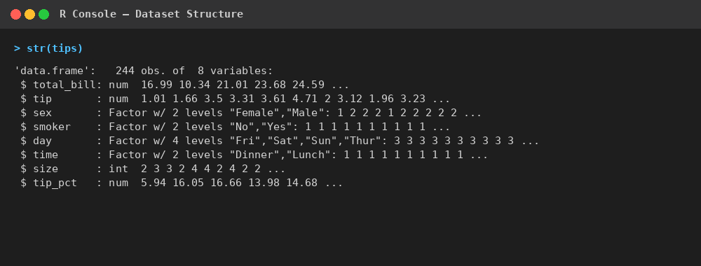
Console output: dataset structure (str(tips))
No missing values were found in any column (verified via colSums(is.na(tips))). A derived feature, tip_pct (tip as a percentage of total_bill), was also created for use in one of the hypothesis tests below.

3.2 Normality Testing
Before choosing parametric tests, the Shapiro-Wilk test was used to check whether tip and total_bill follow a normal distribution.
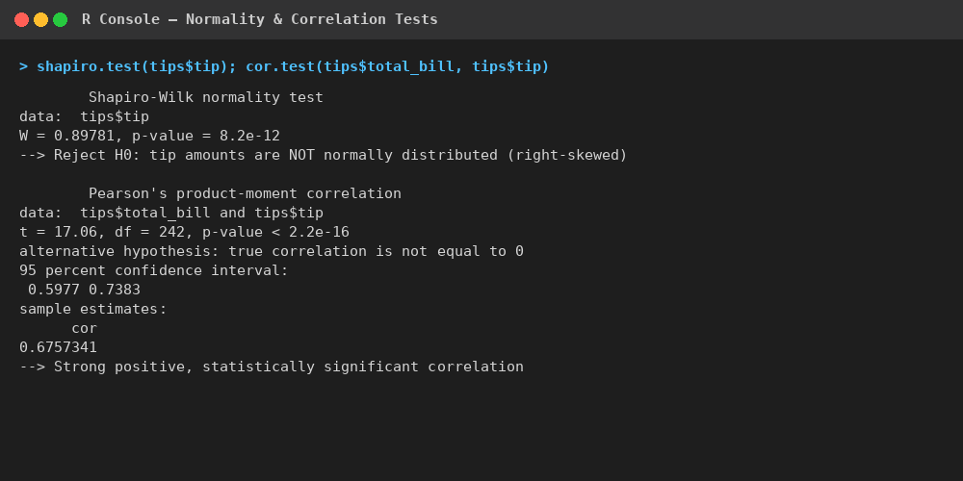
Console output: Shapiro-Wilk normality test and Pearson correlation test
Both variables returned p-values far below 0.05, so the null hypothesis of normality is rejected for both — the data is right-skewed (a small number of large bills/tips pull the distribution's tail out), which is visible in the histograms below and is expected for monetary data of this kind.
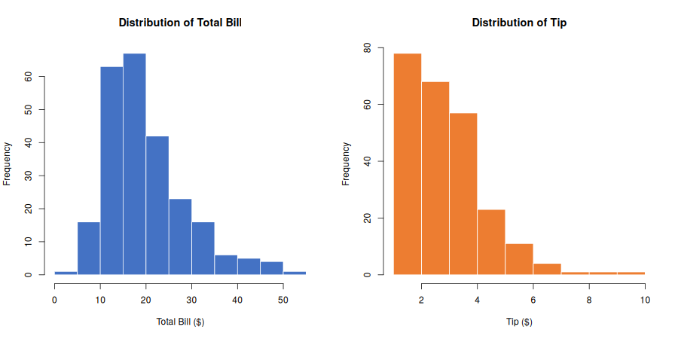
Figure 1: Distribution of total_bill and tip

3.3 Correlation Analysis
A Pearson correlation test between total_bill and tip returned a correlation coefficient of r = 0.676 (t = 17.06, df = 242, p < 2.2e-16), indicating a strong, statistically significant positive relationship — larger bills are reliably associated with larger tips. The full correlation matrix across the numeric variables (total_bill, tip, size) confirmed the same pattern, with size also positively correlated with both bill and tip.
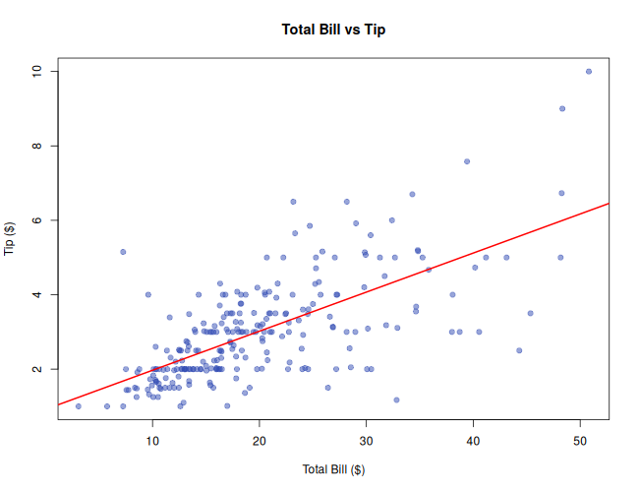
Figure 2: Total Bill vs Tip with fitted regression line

3.4 Hypothesis Testing
Hypothesis Test 1 — Welch two-sample t-test: Does average tip differ between Lunch and Dinner?
H0: mean(tip | Lunch) = mean(tip | Dinner) H1: mean(tip | Lunch) ≠ mean(tip | Dinner)
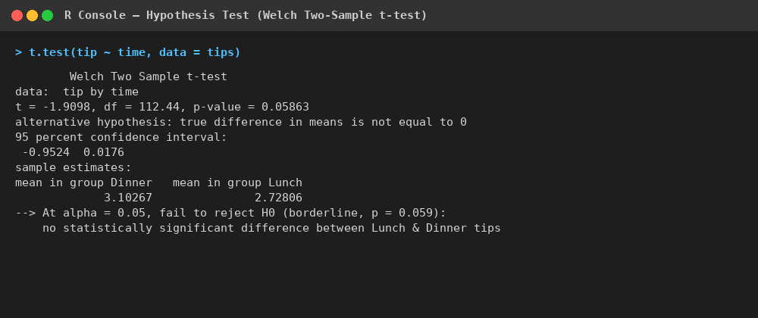
Console output: Welch two-sample t-test, tip by time of day
At the 0.05 significance level the result is borderline (p = 0.0586), so we fail to reject H0: there is no statistically significant difference between Lunch and Dinner tips, although the trend suggests Dinner tips may run slightly higher.
Hypothesis Test 2 — Welch two-sample t-test: Does tip percentage differ by smoker status?
H0: mean(tip_pct | smoker) = mean(tip_pct | non-smoker). Result: t = -0.997, df ≈ 96, p = 0.321 — fail to reject H0. Smoking status alone does not significantly affect the percentage tipped.
Hypothesis Test 3 — Chi-square test of independence: Are smoker status and day of week independent?
H0: smoker and day are independent. Result: χ² = 25.79, df = 3, p < 0.001 — reject H0. Smoker status and day of the week are significantly associated (e.g. smoking parties are proportionally more common on Friday/Saturday than on Thursday/Sunday in this sample).
Hypothesis Test 4 — One-way ANOVA: Does mean tip differ across days of the week?
H0: mean tip is equal across Thu/Fri/Sat/Sun. Result: F(3, 240) = 1.15, p = 0.331 — fail to reject H0. Day of the week alone does not significantly explain variation in tip amount.
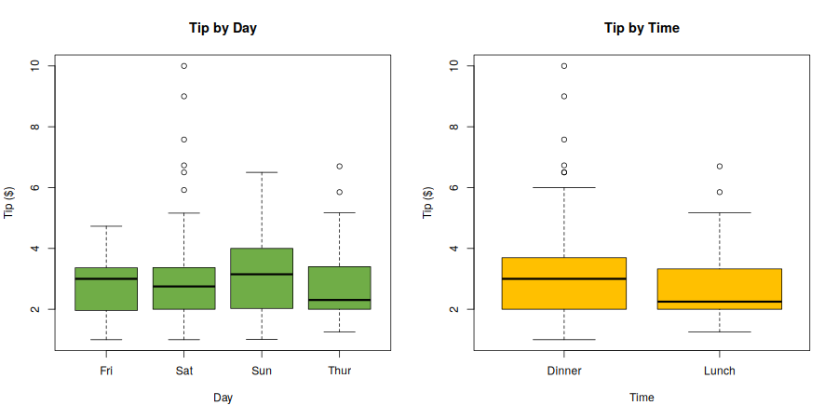
Figure 3: Tip distribution by day and by time

4. Model Building — Multiple Linear Regression
Since the target variable (tip) is continuous, a multiple linear regression approach was used to predict tip amount from the available predictors.

4.1 Train/Test Split
The dataset was randomly split into an 80% training set (195 rows) and a 20% hold-out test set (49 rows) using set.seed(42) for reproducibility.
set.seed(42)
n <- nrow(tips)
train_idx <- sample(seq_len(n), size = floor(0.8 * n))
train <- tips[train_idx, ]
test <- tips[-train_idx, ]

4.2 Full Model & Stepwise Feature Selection
A full model was first fit using all available predictors (tip ~ total_bill + size + sex + smoker + day + time). Stepwise selection using step() (AIC-based, both-direction) was then applied to identify the most parsimonious model.
full_model <- lm(tip ~ total_bill + size + sex + smoker + day + time, data = train)
step_model <- step(full_model, direction = "both", trace = FALSE)
The stepwise procedure converged on: tip ~ total_bill + size + smoker
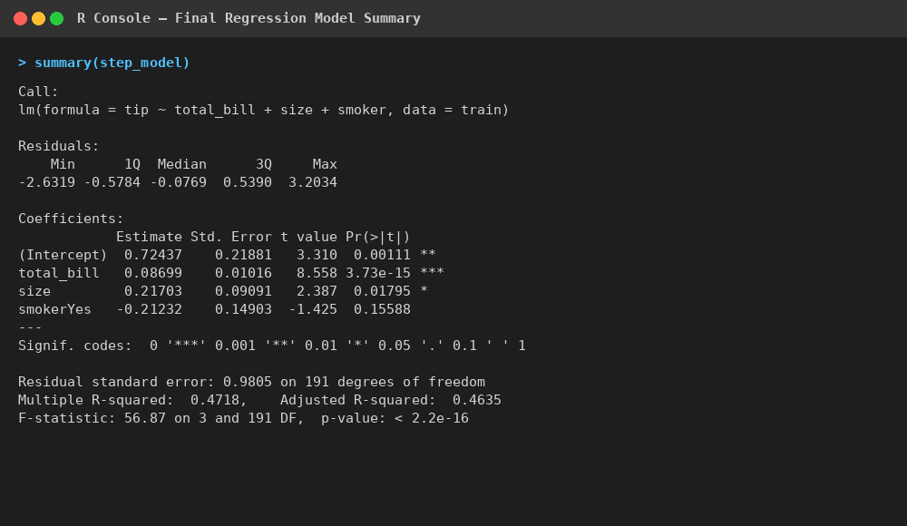
Console output: final regression model summary
total_bill (p < 0.001) and size (p = 0.018) are statistically significant positive predictors of tip amount. smoker was retained by the stepwise procedure (it slightly improved AIC) but is not significant on its own at α = 0.05 (p = 0.156). The model explains R² = 0.472 of the variance in tip amount on the training data.

4.3 Cross-Validation
To obtain a more robust estimate of out-of-sample performance, manual 5-fold cross-validation was performed on the training set (base R, no external packages required).
k <- 5
folds <- sample(rep(1:k, length.out = nrow(train)))
for (i in 1:k) {
cv_train <- train[folds != i, ]; cv_test <- train[folds == i, ]
cv_fit <- lm(formula_used, data = cv_train)
preds <- predict(cv_fit, newdata = cv_test)
# compute RMSE and R-squared per fold
}
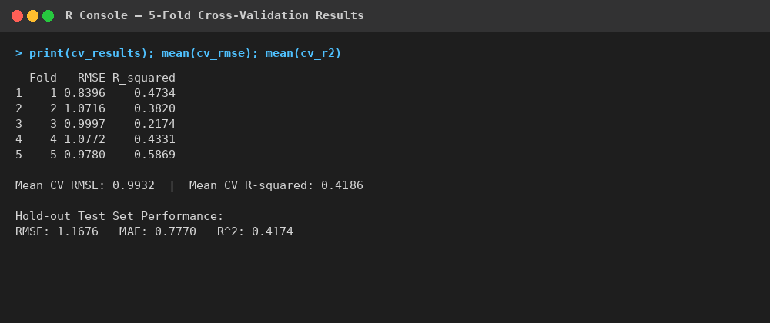
Console output: 5-fold cross-validation results
The mean cross-validated R² (0.419) is close to the training R² (0.472) and the final hold-out test R² (0.417), which indicates the model is not overfitting and generalises reasonably consistently across different subsets of the data.

5. Diagnostic Analysis & Optimization

5.1 Residual Diagnostics
The four standard diagnostic plots were generated for the final model:
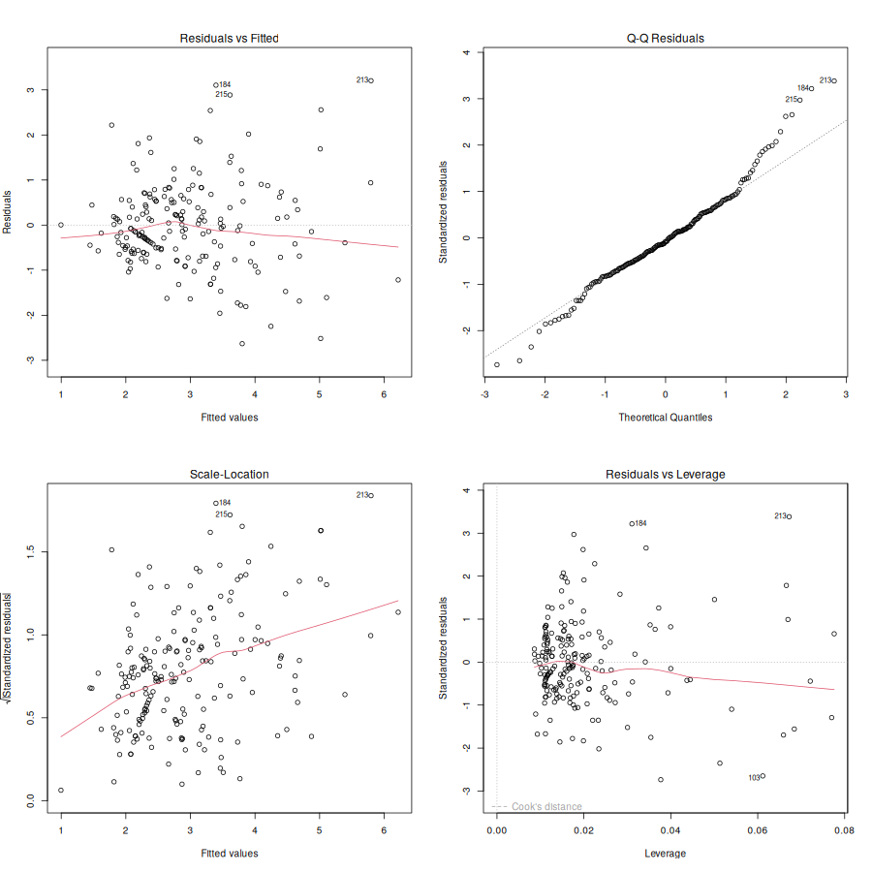
Figure 4: Residuals vs Fitted, Normal Q-Q, Scale-Location, and Residuals vs Leverage
- Residuals vs Fitted: residuals are scattered around zero with only a mild pattern, suggesting the linear form is reasonably appropriate but may miss some non-linearity at higher fitted values.
- Normal Q-Q: points deviate from the reference line in the upper tail, confirming the right-skew already detected by the Shapiro-Wilk test — a small number of unusually large tips are not fully captured by the linear model.
- Scale-Location: a mild upward trend indicates some heteroscedasticity (variance of residuals increases slightly with fitted value) — larger bills come with more variable tipping behaviour.
- Residuals vs Leverage: no points exceed a Cook's distance of 1, so no single observation is unduly influencing the model, though a few (e.g. rows 184, 213, 215) are flagged as having larger-than-typical residuals.

5.2 Predicted vs Actual (Hold-out Test Set)
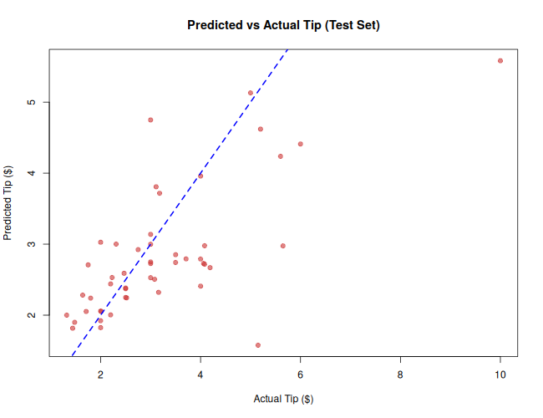
Figure 5: Predicted vs Actual tip on the test set (dashed line = perfect prediction)
Predictions cluster reasonably close to the 45° reference line for typical bills, with wider spread at the high-tip end — consistent with the heteroscedasticity noted above.

5.3 Multicollinearity Check
Since car::vif() requires an external package unavailable in this environment, VIF was computed manually as 1 / (1 - R²) from an auxiliary regression of each numeric predictor on the others. Both total_bill and size returned VIF ≈ 1.57, well below the common threshold of 5, indicating multicollinearity is not a concern in this model.

5.4 Test Set Performance Summary
Metric | Value
RMSE | 1.168
MAE | 0.777
R² (test set) | 0.417
Mean 5-fold CV R² | 0.419

6. Summary Interpretation & Potential Improvements

6.1 Key Findings
- Total bill amount is, by far, the strongest predictor of tip amount — every additional $1 in bill is associated with roughly $0.087 more in tip, holding other factors constant.
- Party size also has a significant positive effect: larger groups tip more in absolute terms, even after accounting for bill size.
- Smoker status, day of week, sex, and time of day do not show strong independent effects on tip amount once bill size is accounted for, though smoker status is associated with day of week (Hypothesis Test 3).
- The final model explains roughly 42–47% of the variance in tip amount — a reasonable result for a simple linear model on real-world, noisy human-behaviour data, but it leaves clear room for improvement.

6.2 Model Strengths
- Consistent performance across training R² (0.472), 5-fold CV R² (0.419), and test R² (0.417) — the model generalises well and is not overfitting.
- Low multicollinearity (VIF ≈ 1.57) means coefficient estimates are stable and interpretable.
- No single observation exerts outsized leverage on the fit (Cook's distance all well under 1).

6.3 Limitations & Potential Improvements
- Right-skew in tip and total_bill (confirmed by Shapiro-Wilk) violates the normality assumption for OLS inference; a log-transform of both variables could stabilise variance and improve residual behaviour.
- Mild heteroscedasticity visible in the Scale-Location plot suggests a weighted least squares approach, or robust standard errors, could improve inference validity.
- Only linear, additive effects were modelled; interaction terms (e.g. total_bill × size) or polynomial terms could capture non-linear patterns not currently reflected in the R² of ~0.42–0.47.
- With CRAN package access, tree-based methods (random forest, gradient boosting) or regularised regression (ridge/lasso via glmnet) could be benchmarked against this linear baseline to see whether non-linear structure improves predictive accuracy.
- The dataset is dated and geographically limited (a single U.S. restaurant chain in the original source); a larger, more recent, and more diverse dataset would improve generalisability of any deployed model.

6.4 Conclusion
This exercise walked through the complete statistical modelling lifecycle in R — from dataset selection and exploratory analysis, through formal hypothesis testing, to building, cross-validating, and diagnosing a multiple linear regression model — using only base R functionality. The resulting model is modest but honest: it captures the dominant, statistically well-supported driver of tipping behaviour (bill size, moderated by party size) while being transparent about its limitations and the specific, testable next steps that could improve it further.

