**The Mobility House**

**Shell Script to find, delete and replace file.**

|  |  |  |  |  |
| --- | --- | --- | --- | --- |
| **Utility Name** | **Developer** | **Version** | **Documented By** | **Date** |
| task1.sh | Shravani | V1 | Shravani | 08/08/2021 |
|  |  |  |  |  |

**Table of contents**

1. Description
2. Script Location
3. Execution Details
4. **Description:**

This is bash shell script used to:

1. Locate all directories which contain a file called .prune-enable.
2. In those directories, delete’s any files named crash.dump
3. In those directories, for any file having the suffix ".log", if the file is larger than one megabyte, it will replace the file with a file containing only the last 20,000 lines.
4. **Script Location:**

Script can be placed in any location on host.

For example:

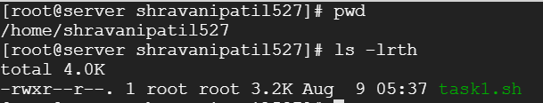

1. **Execution Details:**

Script executes within 5 seconds.

Files where the output will be collected and starting directory are all mentioned in script itself.

The script will run and print all details on screen.

How to run:



Snippet of execution details:

