STUDENT PERFORMANCE
PREDICTION SYSTEM
Machine Learning Capstone Project Report

Prepared by: Shravani S
Programme / Department: Computer Science Engineering (AI & ML)
Institution: SkillOrbit
Date: 25 October 2026

Abstract
The Student Performance Prediction System is an educational machine-learning prototype that estimates a student performance category—Low, Average, or High—from five academic indicators: attendance, daily study hours, internal marks, class participation, and previous academic score. A Streamlit interface provides an interactive prediction page, descriptive dataset charts, a classification report, and feature-importance visualization. The implementation uses Python, Pandas, NumPy, and scikit-learn, with a Random Forest classifier inside a preprocessing pipeline. The included dataset contains 360 synthetic demonstration records. Consequently, reported evaluation results are useful for demonstrating the software workflow only and do not establish real-world predictive validity.

1. Introduction
Academic performance is influenced by several interacting factors. A simple analytics application can help learners explore the relationship between academic habits and outcomes and can present actionable study-planning prompts. This project demonstrates an end-to-end machine-learning workflow in a compact web dashboard.

2. Problem Statement
Students and educators need an accessible way to explore selected academic indicators and view an estimated performance category alongside practical improvement suggestions. The prototype addresses this as a demonstration task; it is not a validated assessment tool.

3. Objectives
- Prepare a tabular dataset for model training.
- Explore performance-level distributions and feature summaries.
- Train a classifier for Low, Average, and High performance categories.
- Present an interactive prediction interface and rule-based suggestions.
- Report hold-out evaluation metrics and communicate limitations clearly.

4. Scope
The implementation is limited to a local Streamlit application, five numeric input features, three output categories, descriptive charts, and a Random Forest model. It does not include deep learning, real-time monitoring, institutional integration, or a production database.

5. Technology Stack
- Python — application and modelling language.
- Pandas and NumPy — tabular data handling and numerical operations.
- scikit-learn — preprocessing pipeline, Random Forest classifier, train/test split, and evaluation metrics.
- Streamlit — interactive web interface and dashboard.

6. Dataset Description
The bundled CSV contains 360 synthetic records created to make the prototype immediately runnable. Each record has attendance (percentage), study_hours (hours per day), internal_marks (percentage), participation (percentage), previous_score (percentage), and performance_level (Low, Average, or High). The target categories are generated from a synthetic score rule and quantile thresholds. These records are not collected from real students.
For a final empirical study, replace the demonstration file with an appropriately licensed and documented academic dataset. Record the dataset source, permitted use, data dictionary, cleaning steps, and any missing-data treatment.

7. Methodology

7.1 Data preparation
The application reads the CSV and selects the five numeric features and the performance-level target. A scikit-learn Pipeline uses median imputation and standard scaling, followed by a Random Forest classifier. Median imputation makes the workflow more tolerant of missing numeric values if they occur.

7.2 Model training
The dataset is split into 80% training and 20% test data using a stratified split and a fixed random seed of 42. The classifier uses 250 trees, a fixed random seed, and balanced class weights. The fitted pipeline produces class predictions and class-probability estimates.

7.3 Evaluation
The dashboard reports hold-out accuracy and per-class precision, recall, F1-score, and support. It also plots Random Forest feature importance. The displayed values depend on the bundled synthetic dataset and the software environment; they must be rechecked if the data or code changes.

7.4 Recommendation logic
The recommendation component uses transparent thresholds: attendance below 75%, study time below two hours per day, internal marks below 60%, participation below 50%, and previous score below 60% each trigger a corresponding study-improvement prompt. These are illustrative rules rather than learned recommendations.

8. System Design
Workflow: CSV dataset → feature/target selection → preprocessing pipeline → stratified train/test split → Random Forest training → prediction and evaluation → Streamlit dashboard → rule-based suggestions.

9. Application Features
- Prediction tab: editable academic inputs, predicted category, model probability, and suggested actions.
- Dataset insights tab: record count, average attendance, average internal marks, performance-level distribution, grouped feature summaries, and a data preview.
- Model evaluation tab: hold-out accuracy, classification report, and feature-importance chart.

10. Evaluation Results
The working demonstration observed during development displayed 72.2% hold-out accuracy on 72 test records from the synthetic dataset. The displayed class F1-scores were 0.545 for Average, 0.863 for High, and 0.735 for Low. These values document the current demonstration run only; they should be regenerated from the submitted code before final submission and must not be described as real-world performance.
The prototype's class-level metrics differ, which illustrates why accuracy alone is insufficient. In particular, the Average class has a lower F1-score in the observed run. A future evaluation should include cross-validation, comparison with baseline models, and testing on a permitted real dataset.

11. Limitations
- The dataset is synthetic and small; its patterns may not represent real academic populations.
- Hold-out metrics are not evidence of external validity or fairness.
- The model may encode assumptions built into the synthetic label-generation process.
- Rule-based recommendations are generic and do not account for individual circumstances.
- The application has not been audited for bias, accessibility, privacy, or institutional deployment.

12. Ethical Considerations
Student performance estimates can affect confidence and opportunity if misused. This prototype should be used only for educational demonstration and supportive reflection. It should not determine grades, admissions, scholarships, disciplinary actions, or access to resources. Real student data must be handled with appropriate consent, privacy protection, access control, and institutional approval.

13. Future Enhancements
- Replace synthetic data with an approved, documented student-performance dataset.
- Compare Random Forest with Decision Tree and Logistic Regression baselines.
- Use cross-validation and report confusion matrix, class-wise metrics, and uncertainty.
- Add input validation, exportable reports, and subject-wise analysis.
- Conduct fairness, privacy, usability, and accessibility reviews before any real-world use.
- Deploy only after evaluation and review, with clear notices about limitations.

14. Conclusion
The project demonstrates a complete introductory machine-learning application: data loading, preprocessing, model training, prediction, descriptive analytics, evaluation, and user-facing recommendations. The local Streamlit dashboard runs with three tabs. The current deliverable is a functional educational prototype; meaningful claims about student outcomes require a suitable real dataset and rigorous validation.

Appendix A: Run Instructions
From the project directory on macOS, run: python3 -m venv .venv; source .venv/bin/activate; python -m pip install -r requirements.txt; streamlit run app.py. Open the local URL printed in the terminal, typically http://localhost:8501.

Appendix B: Submission Checklist
- Replace bracketed cover-page details.
- Confirm that the submitted CSV and code are the same versions used for screenshots.
- Capture screenshots of Prediction, Dataset insights, and Model evaluation.
- Rerun the app and regenerate the metrics before quoting them.
- Clearly disclose that bundled demonstration data are synthetic.
- Add references and dataset attribution if an external dataset is introduced.

Appendix C: Running Application Screenshots
The following screenshots were captured from the local Streamlit application during the demonstration. They document the user interface and the displayed synthetic-data results.

C.1 Prediction tab
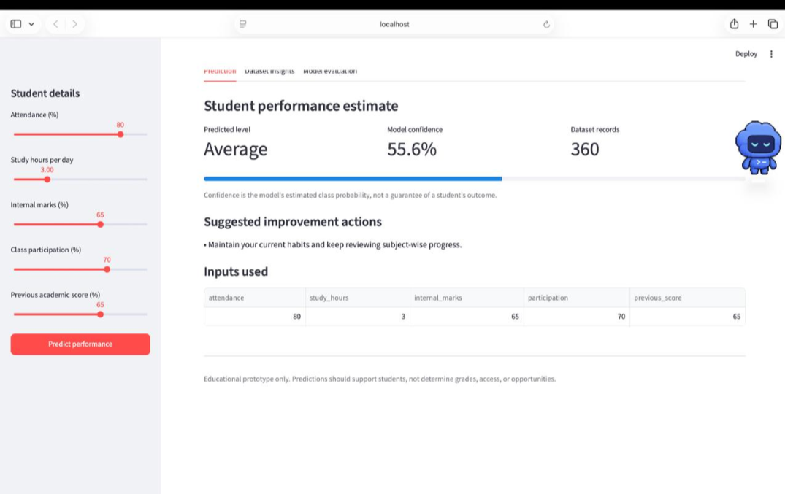

C.2 Dataset insights tab
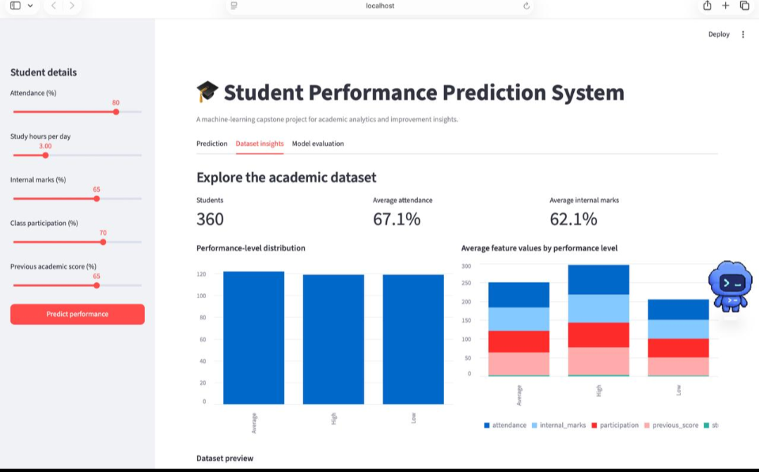

C.3 Model evaluation tab
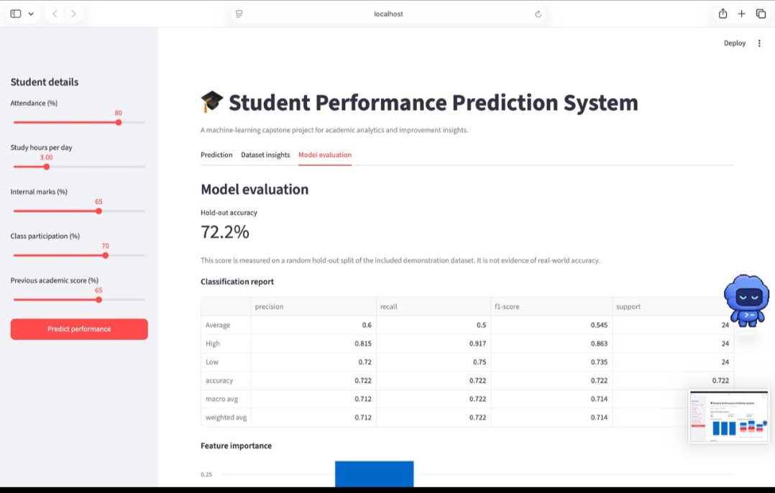

C.4 Feature importance view


