Terraform-01
Install Terraform on your PC
Download terraform for windows
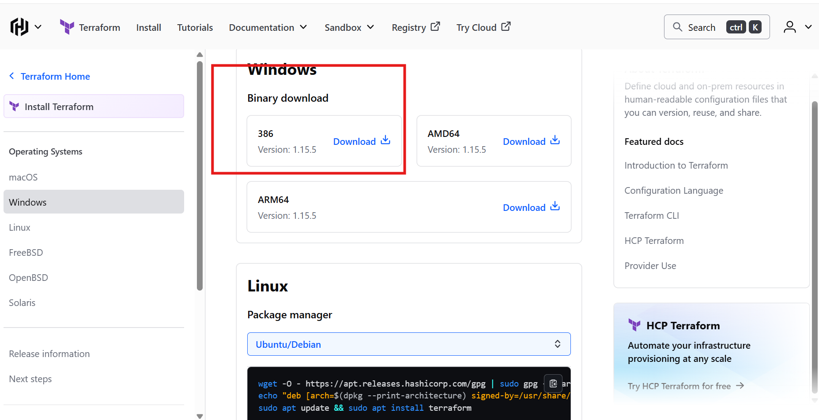
Extracted to c folder
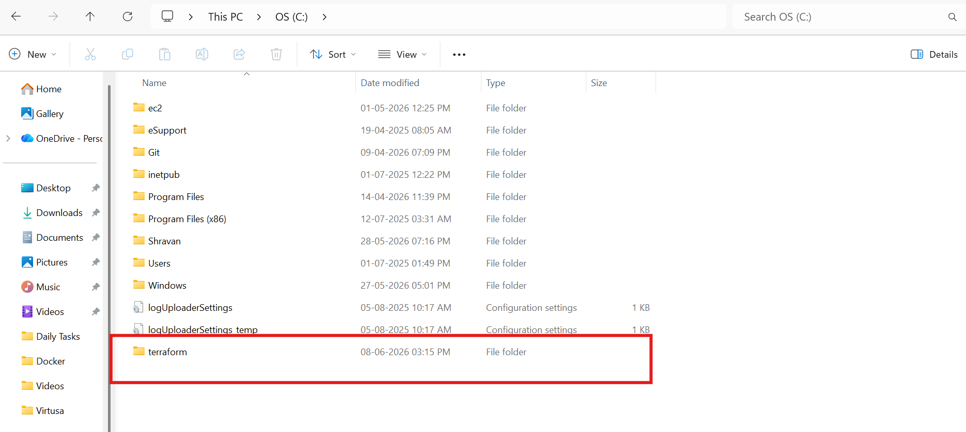
Go to environmental variables and give the path to the folder
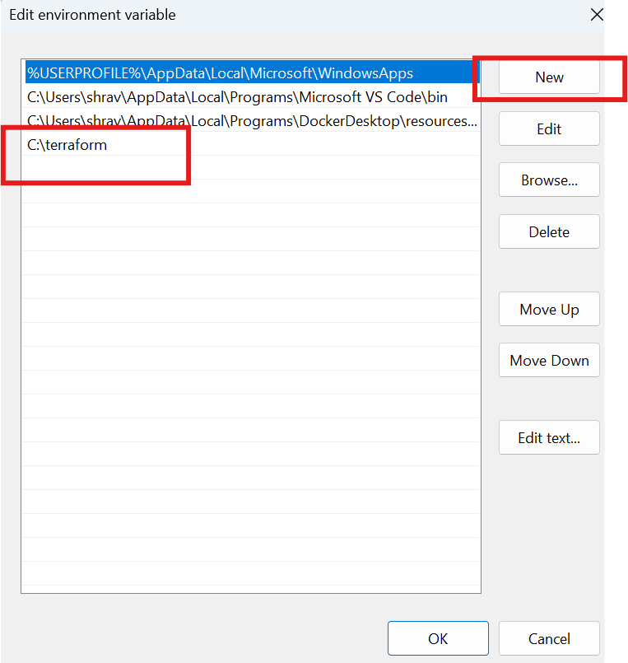
Now check in gitbash
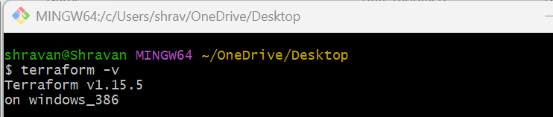
2.Execute all the templates shown in video
3). Note down below points, Terraform Init Terraform Plan Terraform Apply Terraform Provider.
Install hashi corp terraform in visual studio
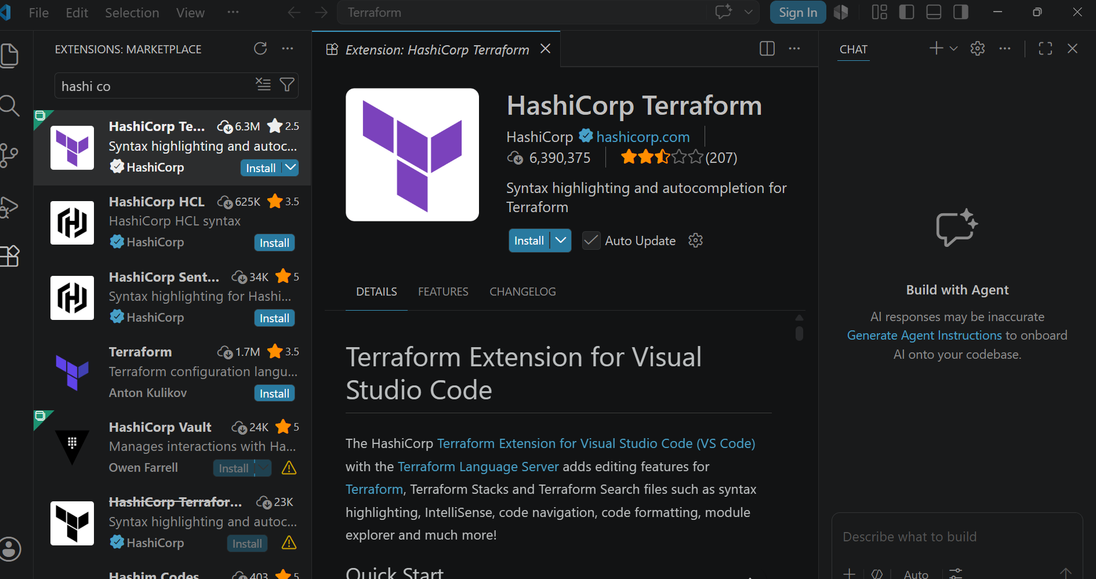
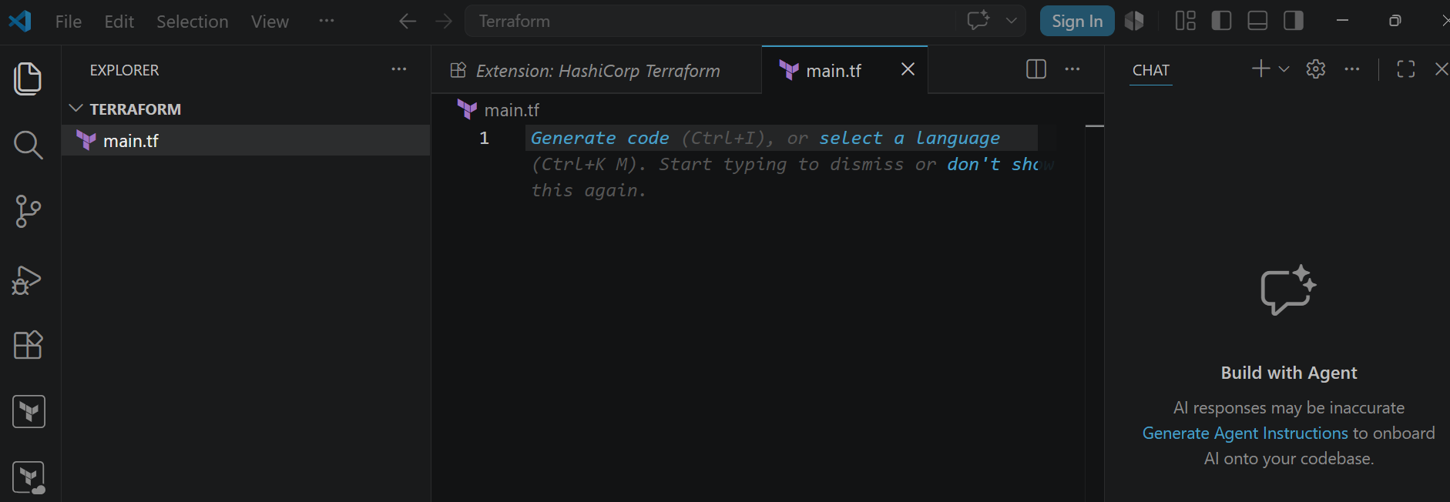
resource "local_file" "my_pet" {
filename = "pets.txt"
content = "I love pets!"
}
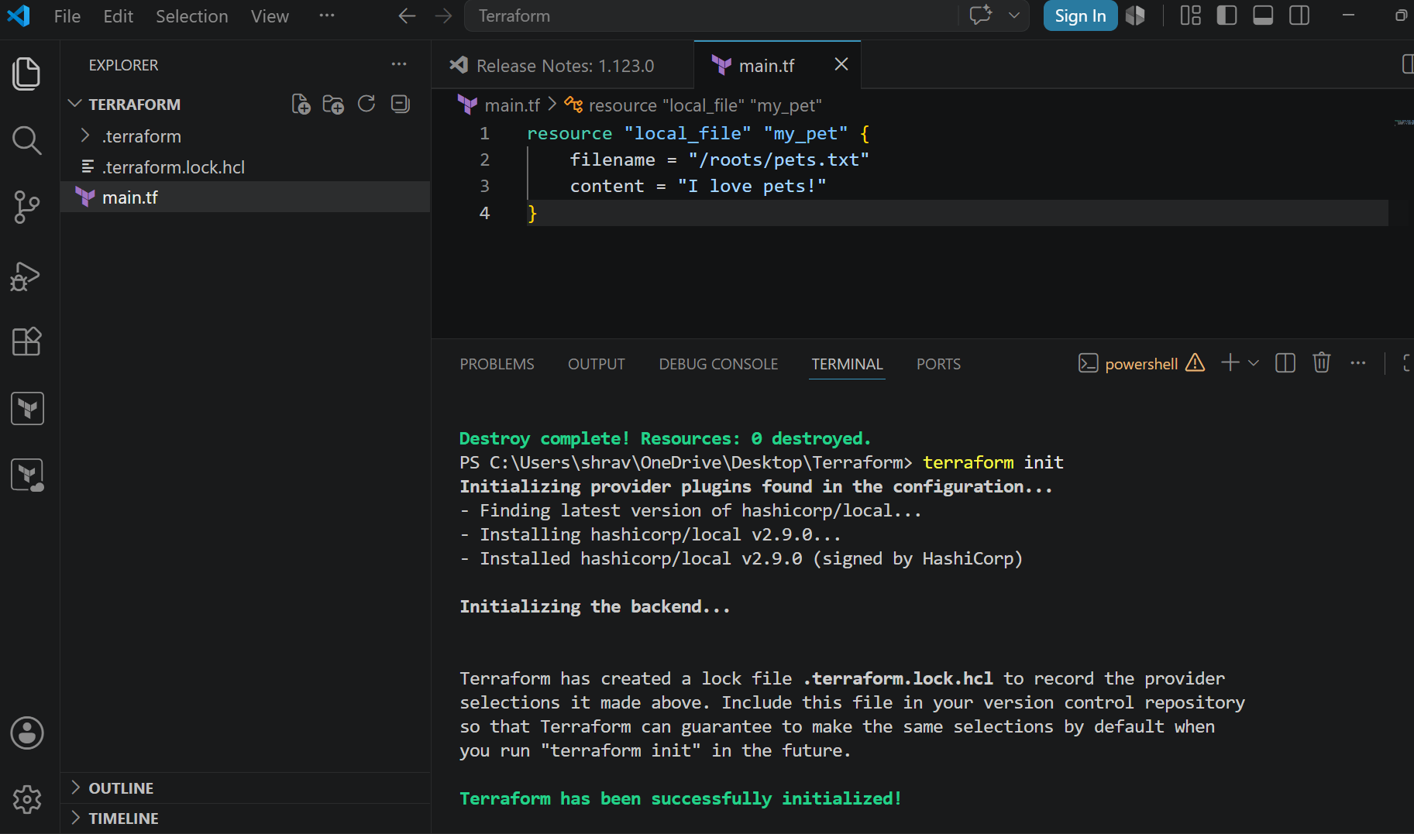
terraform plan
terraform apply
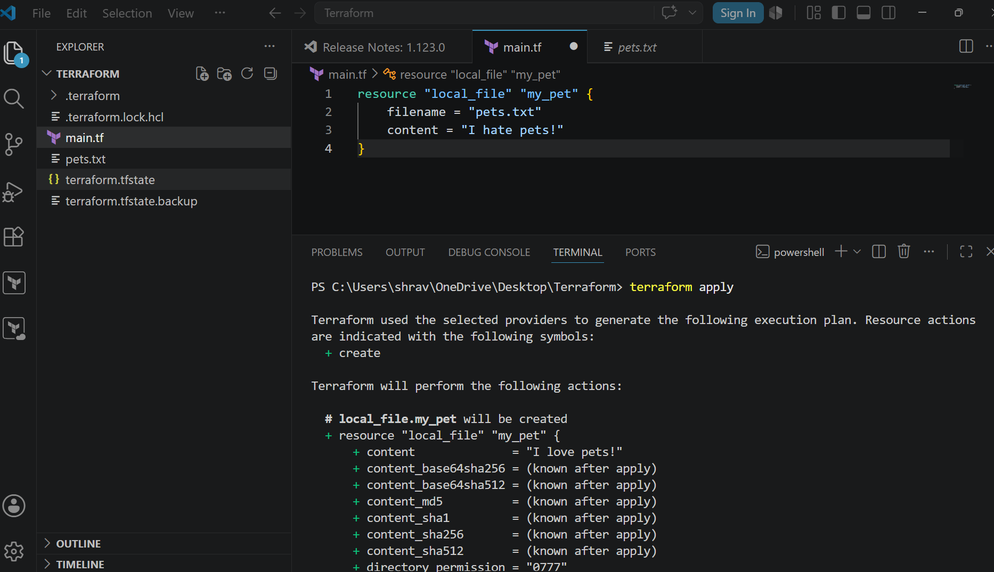
Change the content to I hate pets
Now again do terraform plan and terraform apply
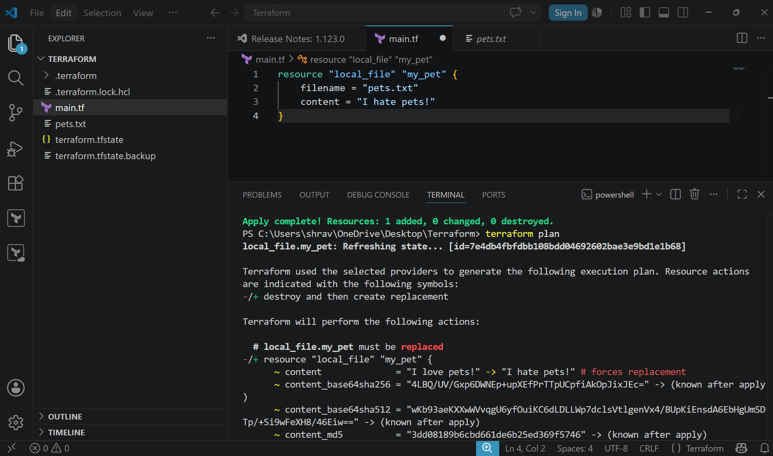
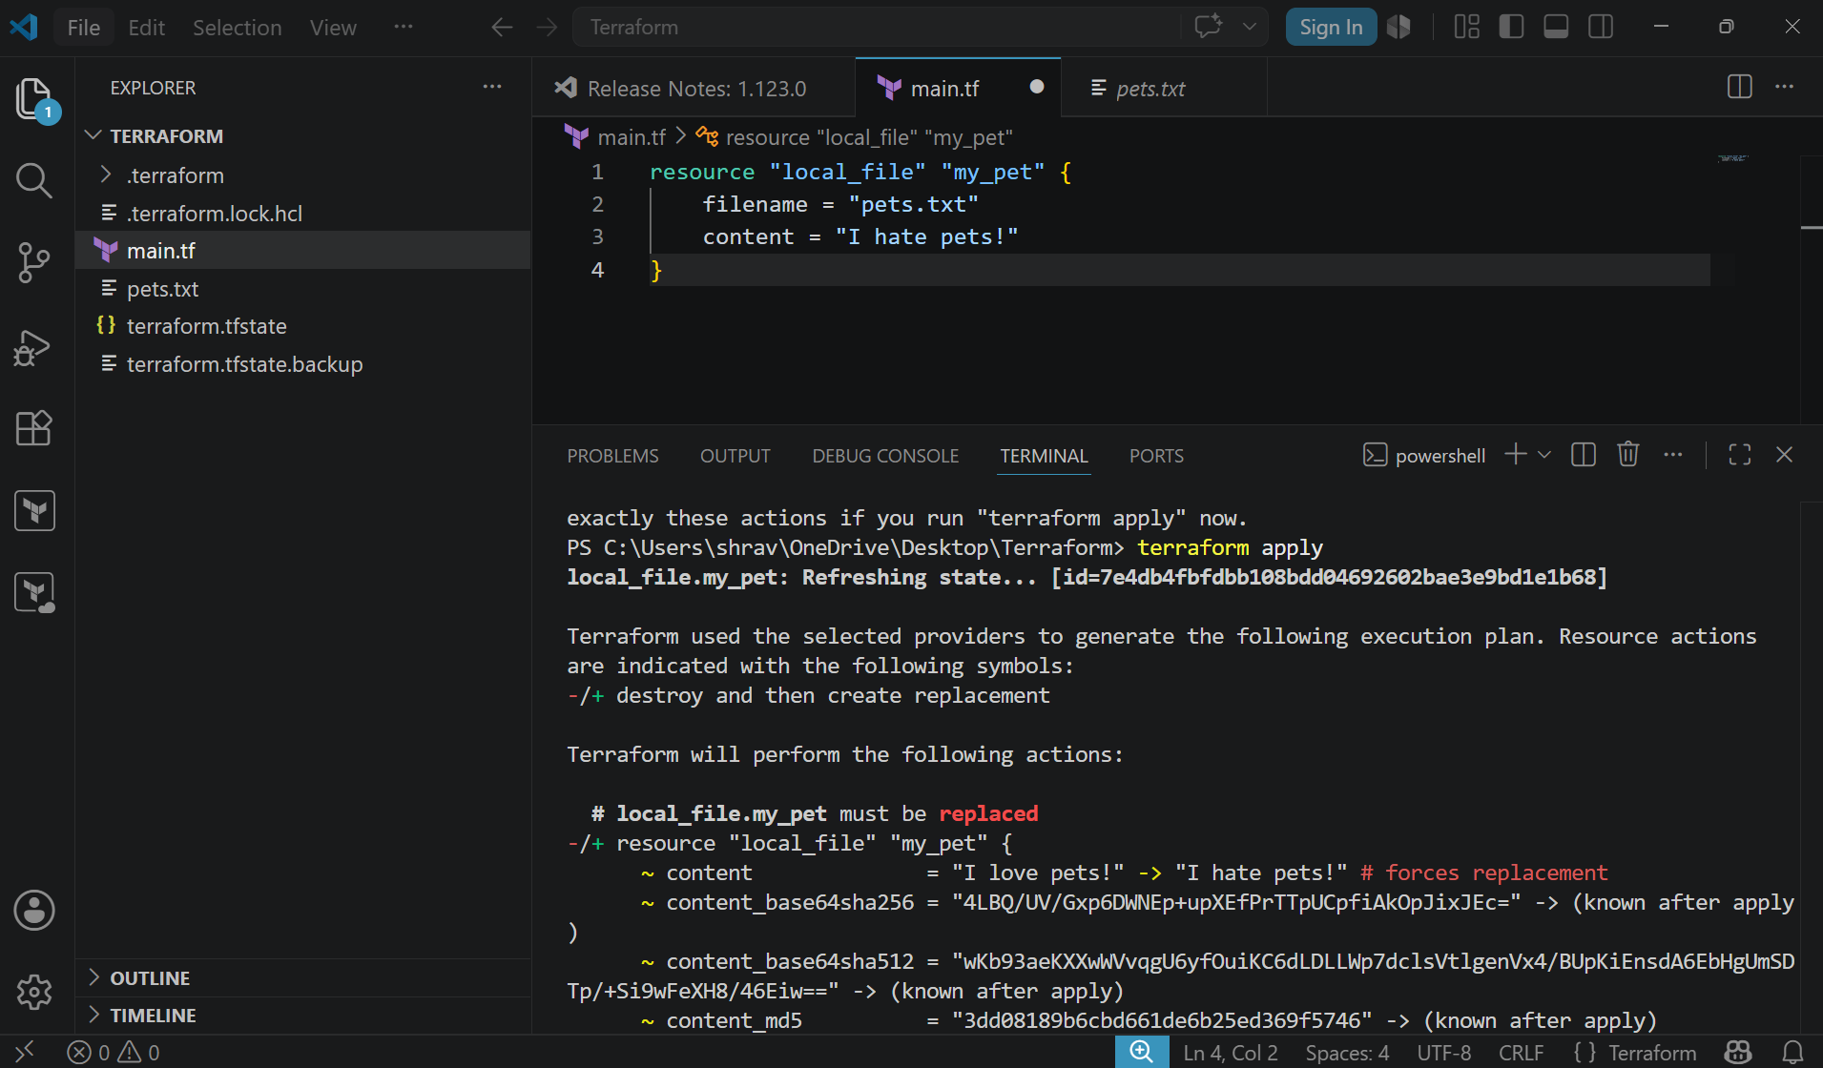
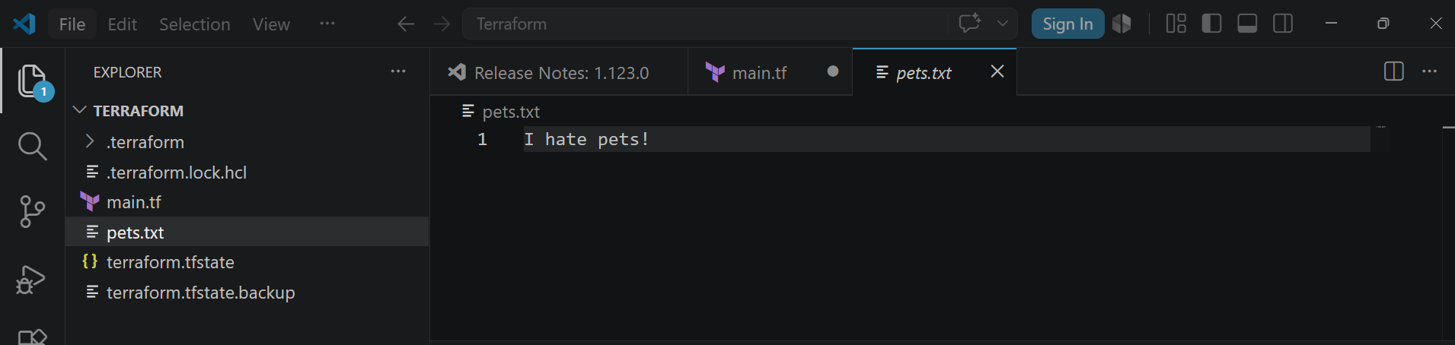
No changes has been done
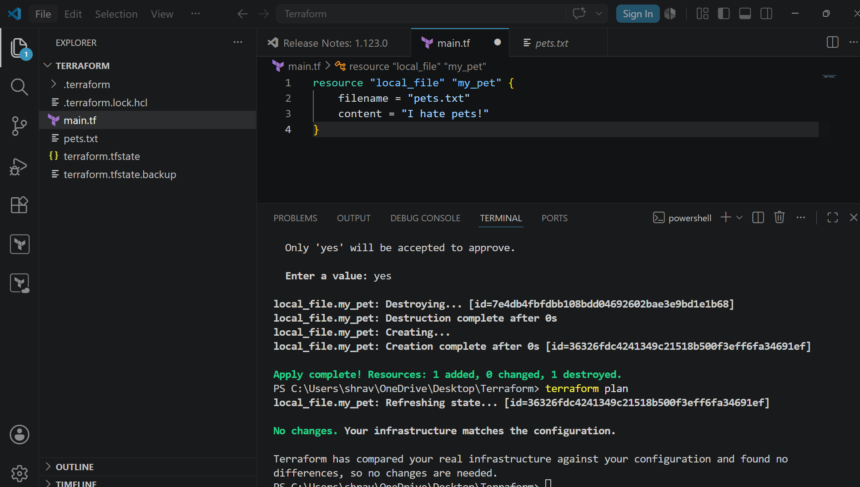
Terraform destroy
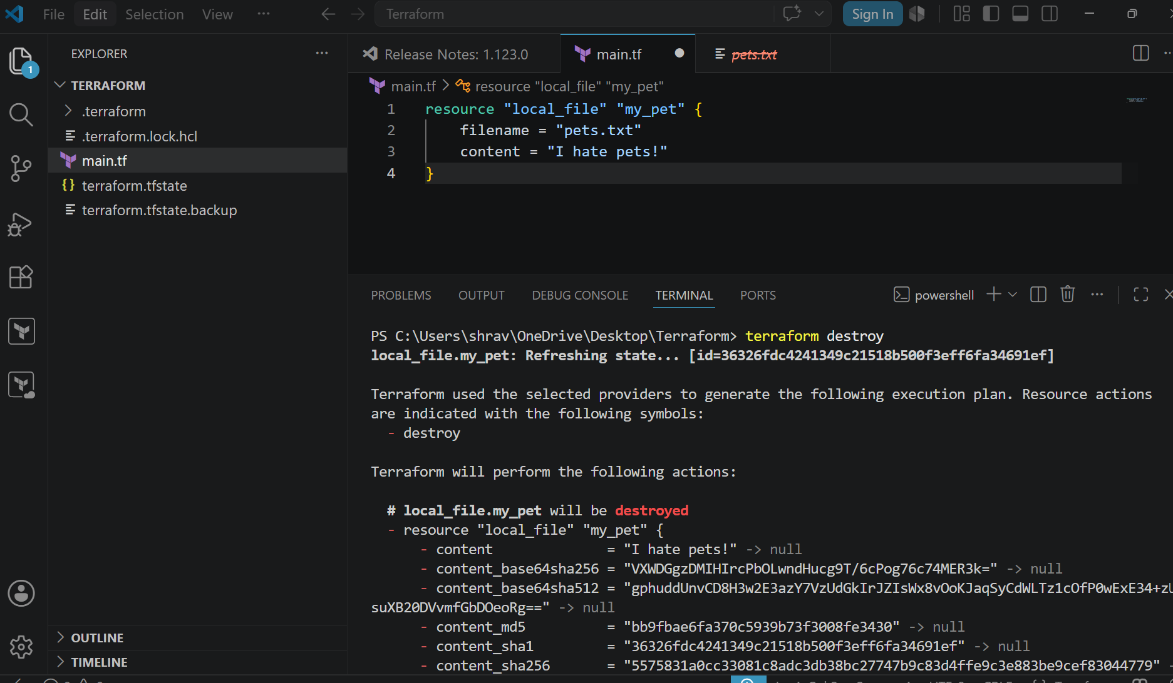
Update the file
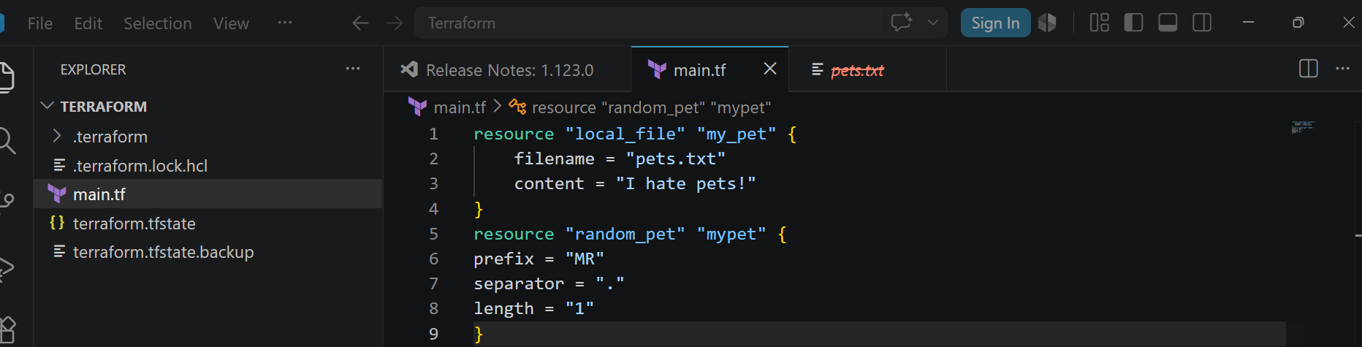
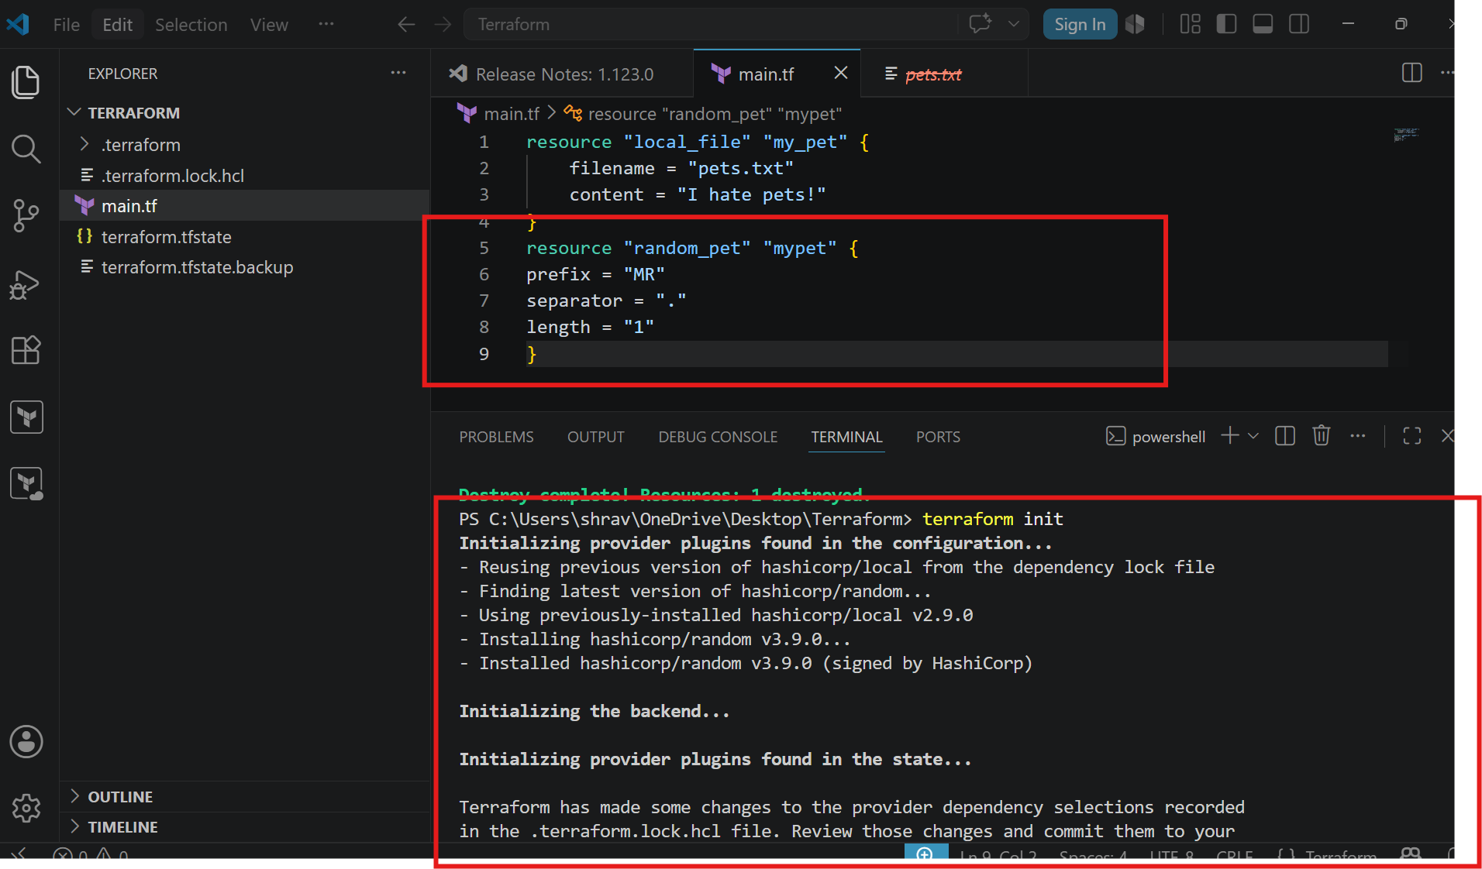
terraform plan and terraform apply
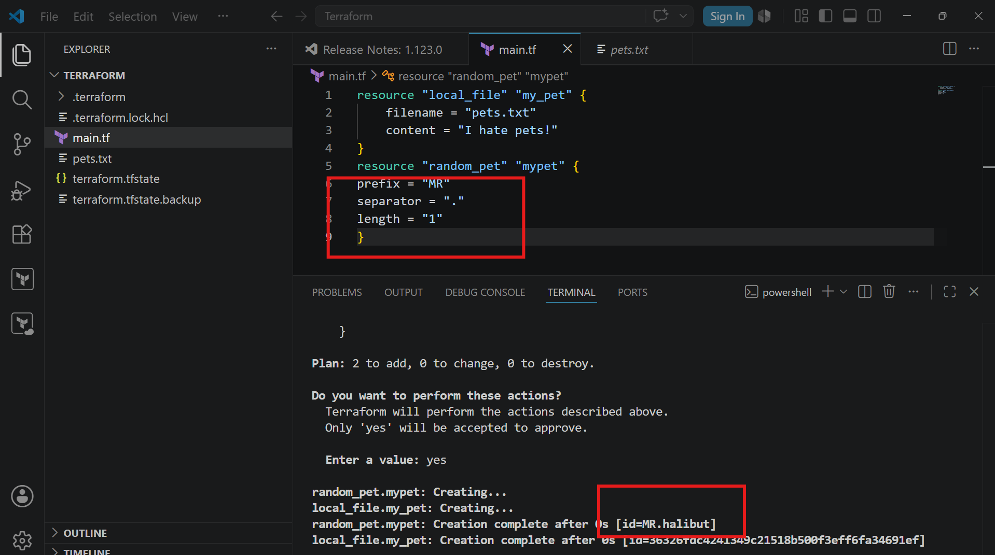
Now change it to miss and then terraform plan and terraform apply
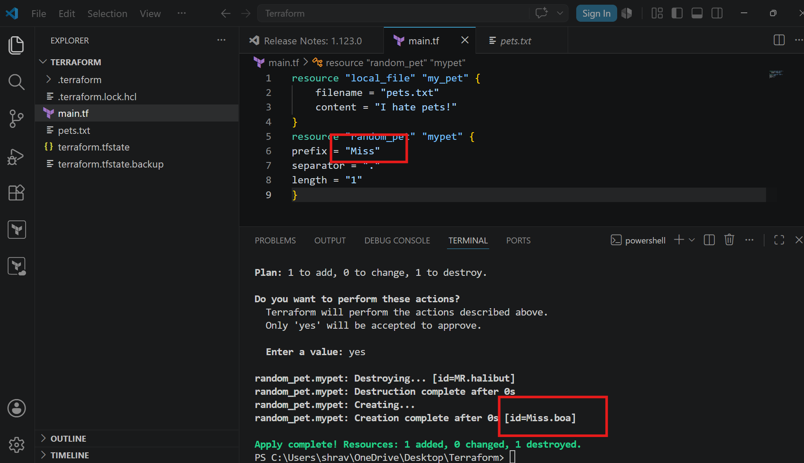
terraform destroy
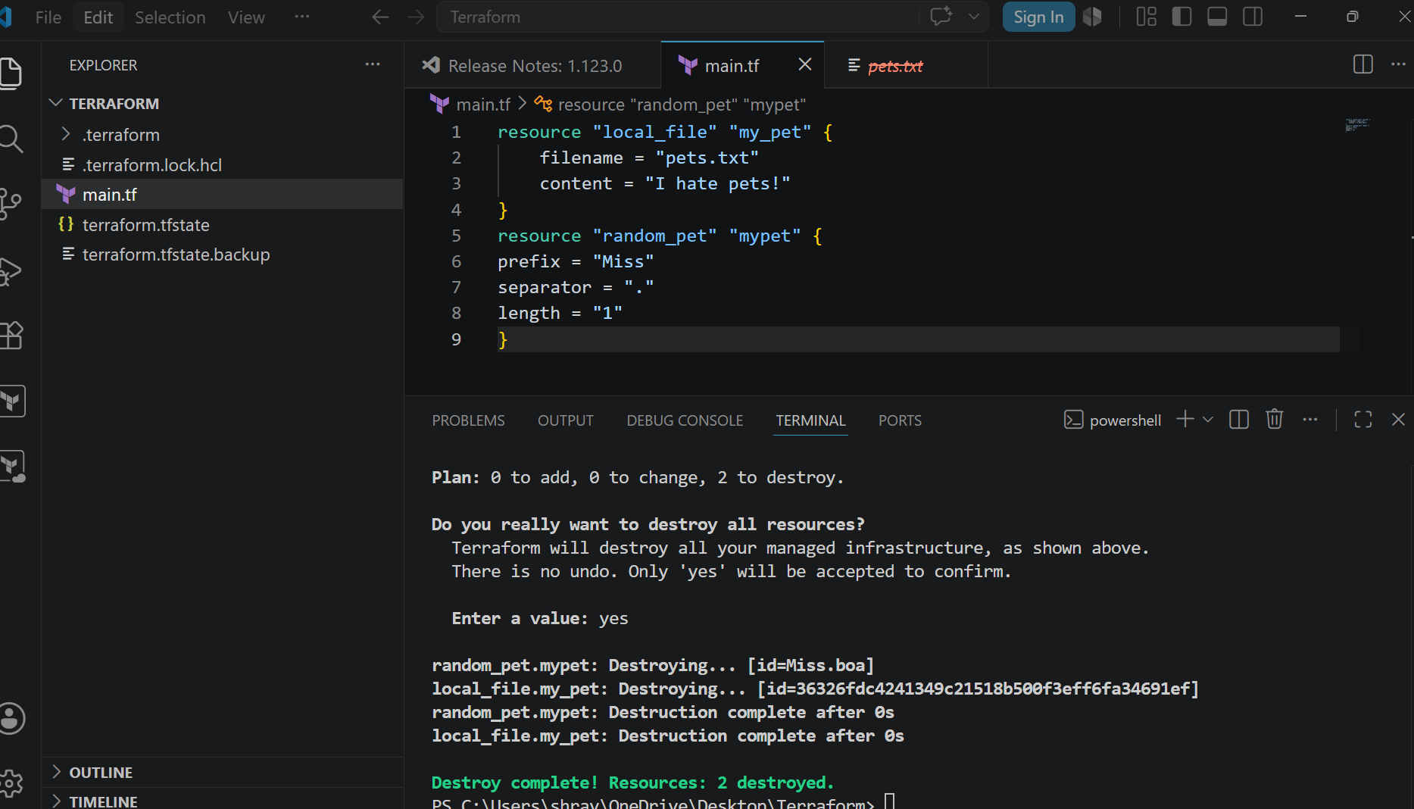
terraform fmt
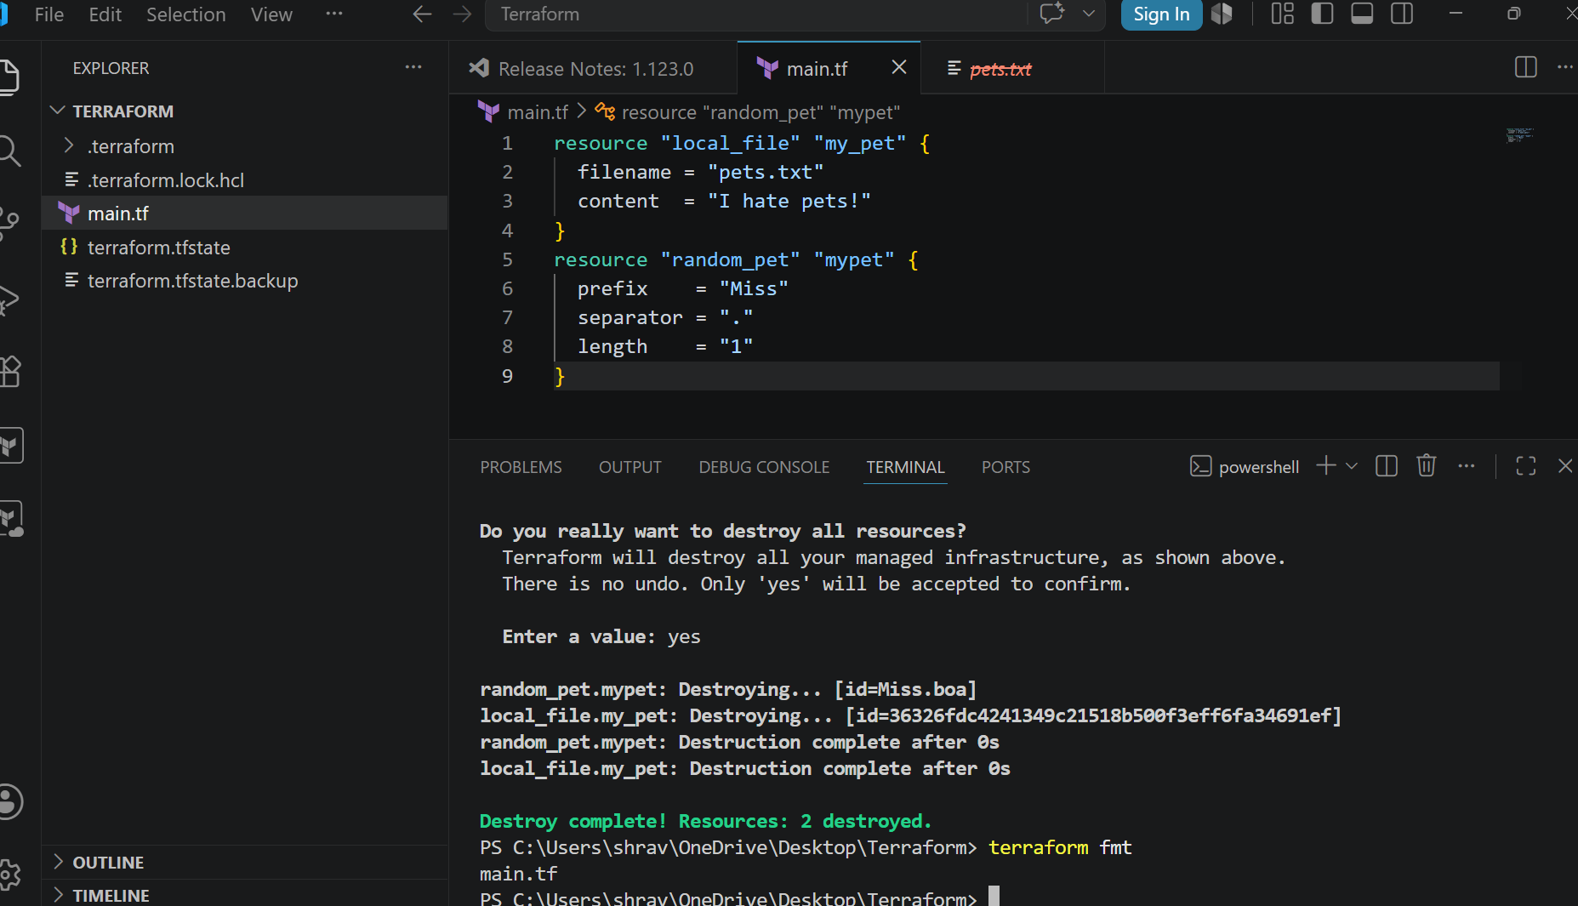
4). Integrate a sample Terraform template in Jenkins.
sudo dnf install -y dnf-plugins-core
sudo dnf config-manager addrepo --from-repofile=https://rpm.releases.hashicorp.com/AmazonLinux/hashicorp.repo
sudo dnf install -y terraform
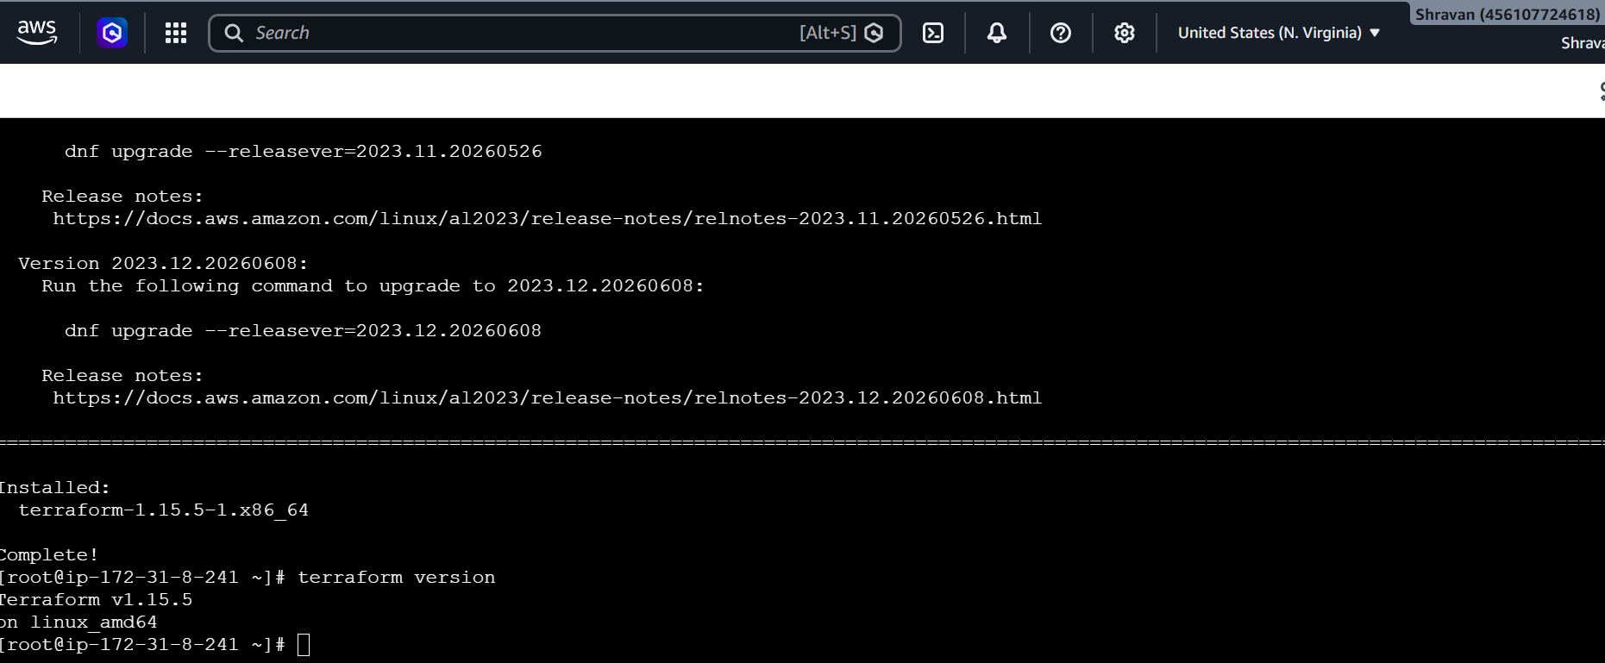
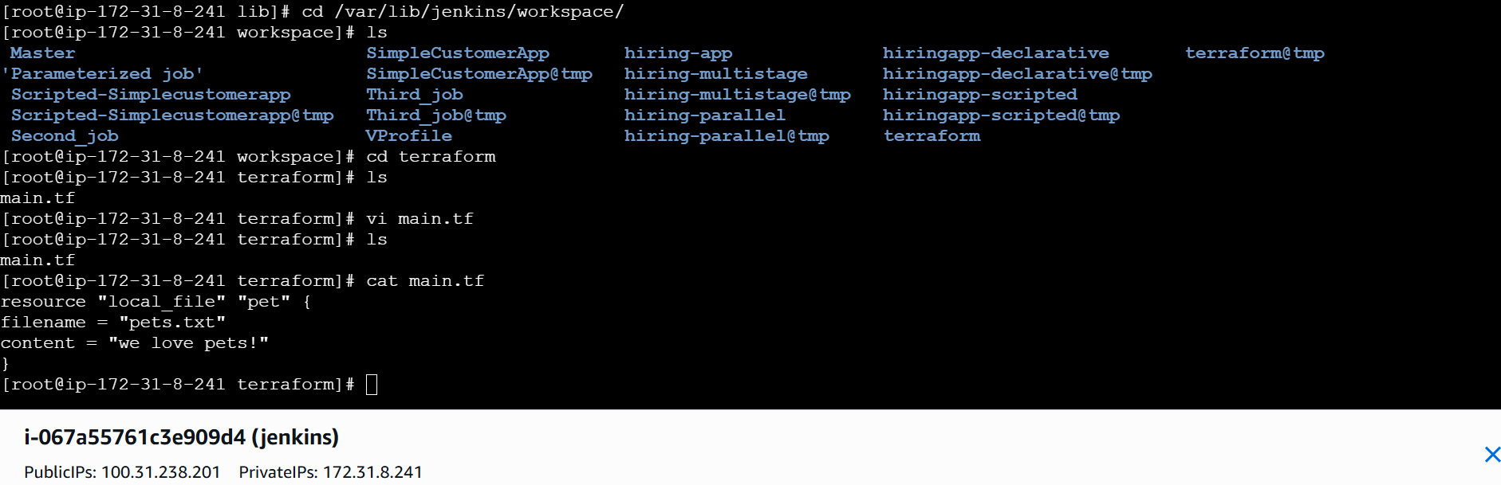
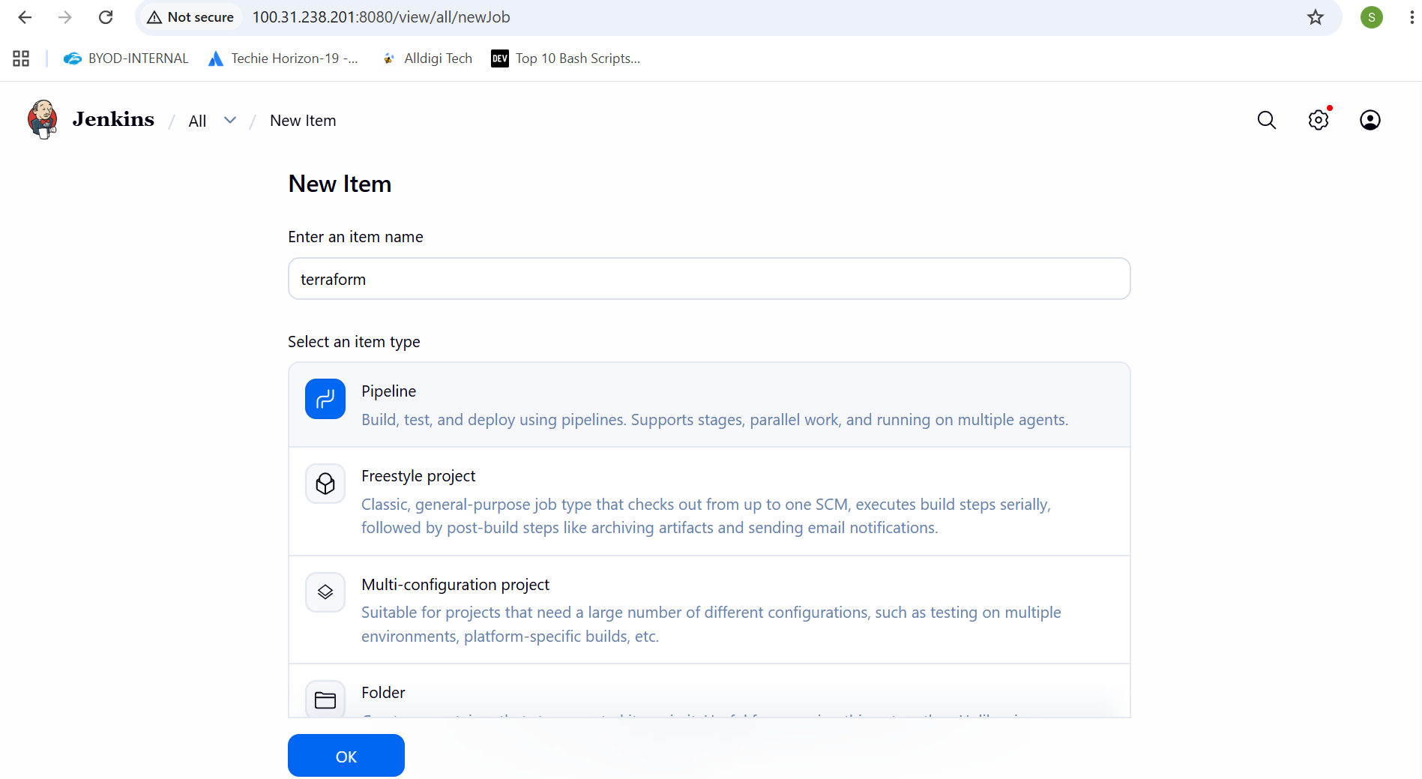
Write a pipeline
pipeline {
agent any

stages {

stage('Check Terraform') {
steps {
sh 'terraform version'
}
}

stage('Terraform Init') {
steps {
sh 'terraform init'
}
}

stage('Terraform Plan') {
steps {
sh 'terraform plan'
}
}

stage('Terraform Apply') {
steps {
sh 'terraform apply -auto-approve'
}
}

}
}
