Terraform-02
1). Watch the Terraform-02 video.
2). Execute all the templates shown in the video.
terraform init
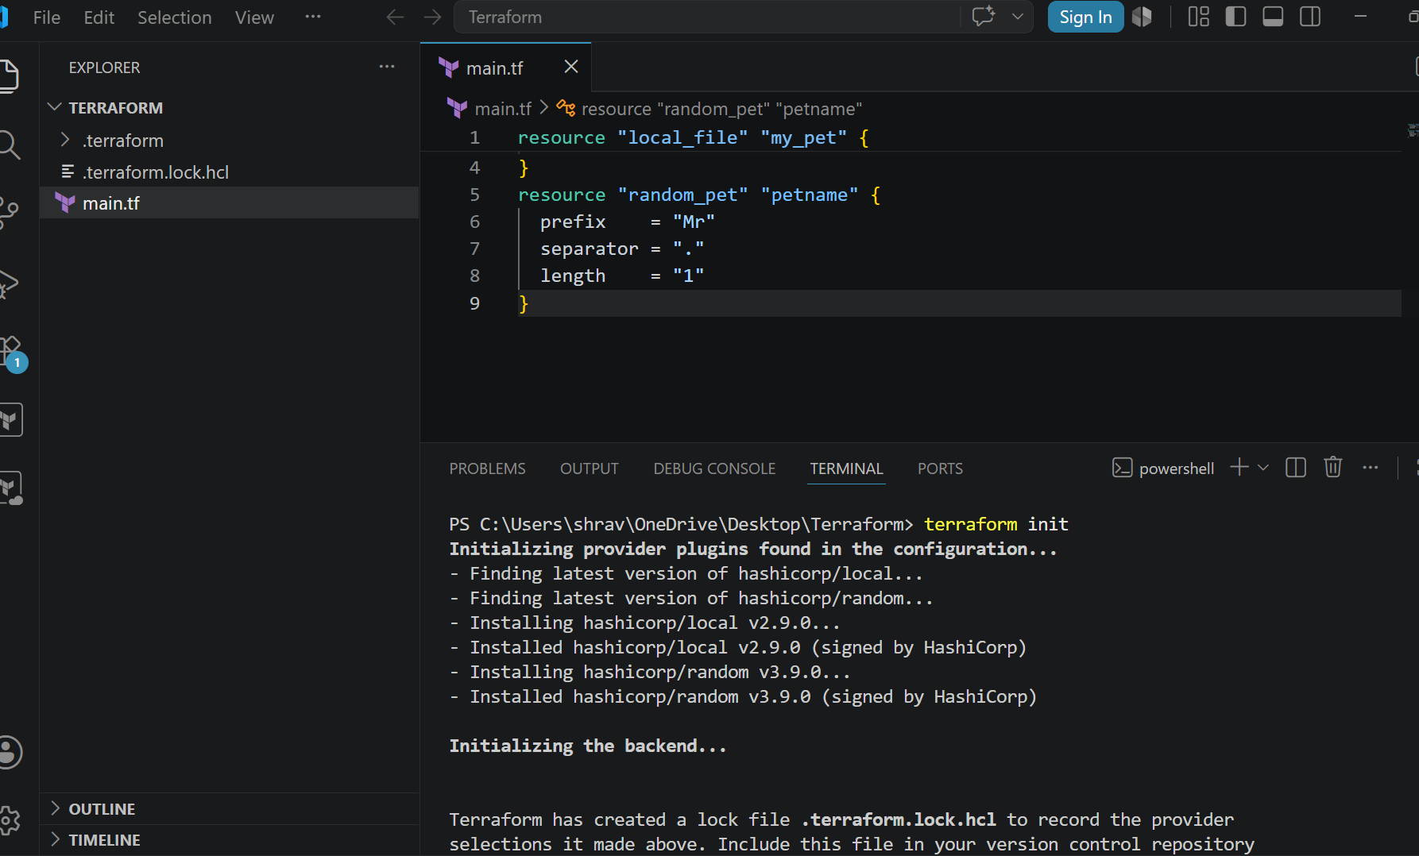
terraform plan
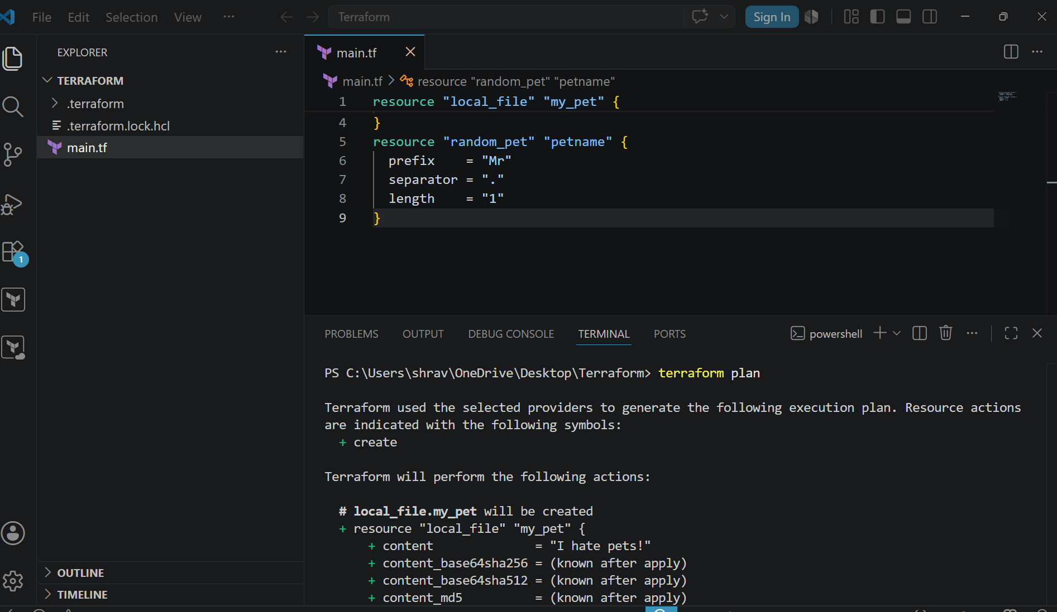
terraform apply
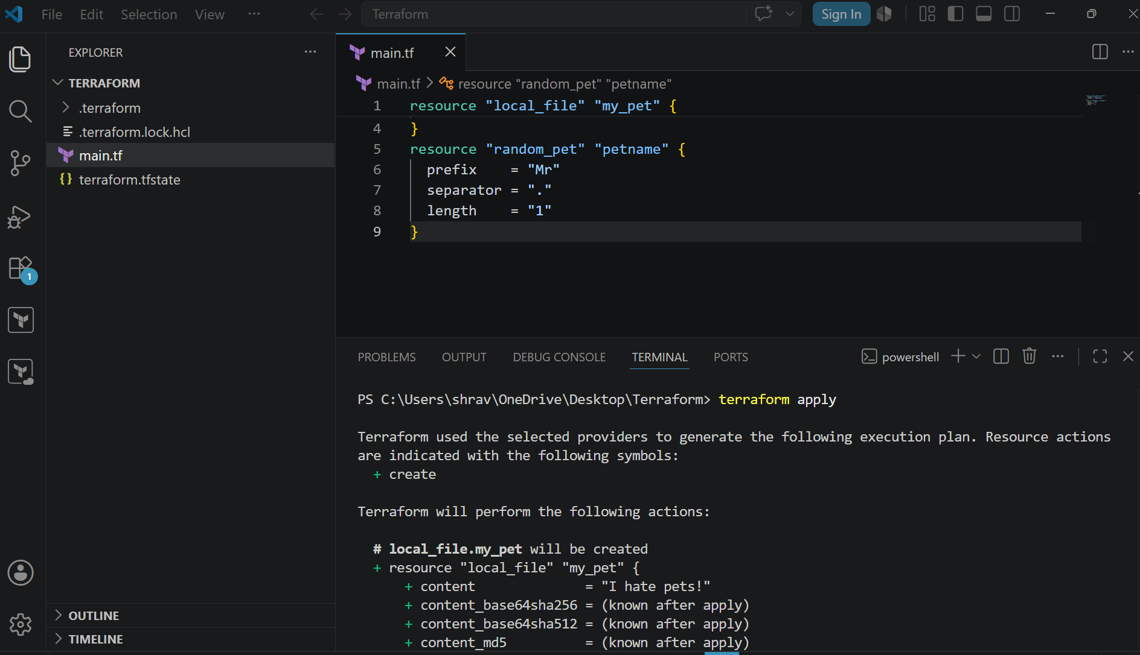
Lifecycle rules
Create before destroy
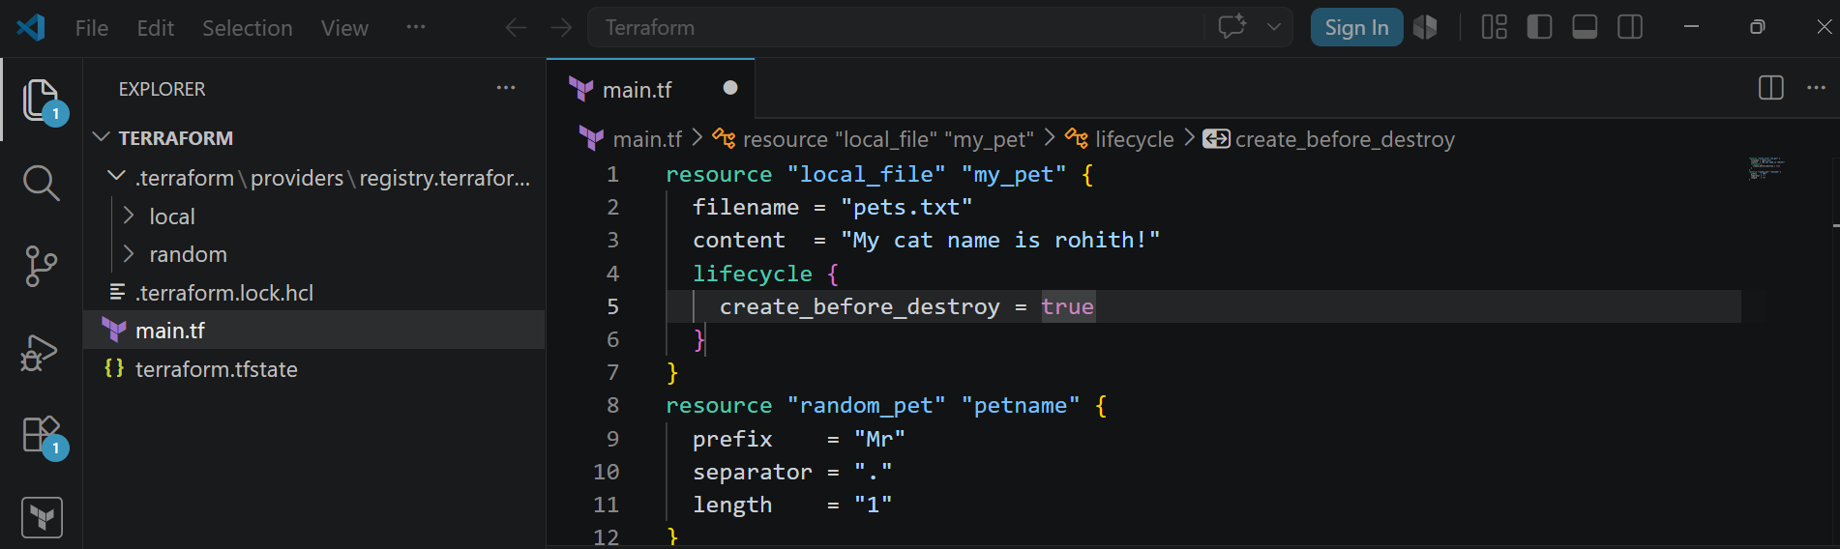
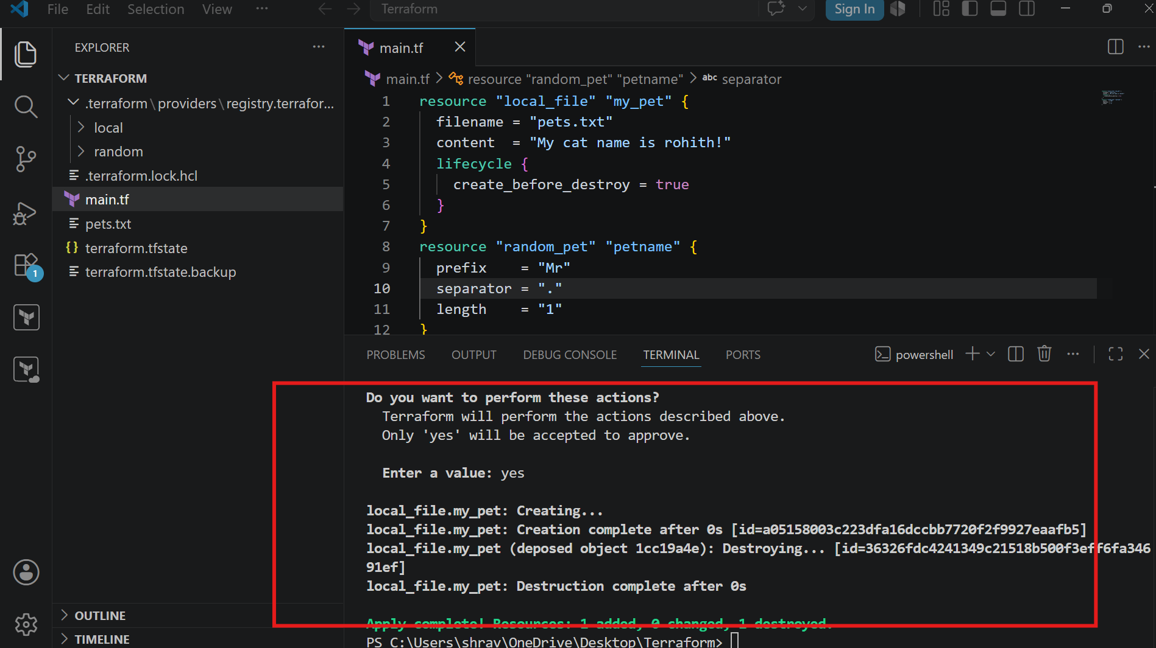
terraform destroy
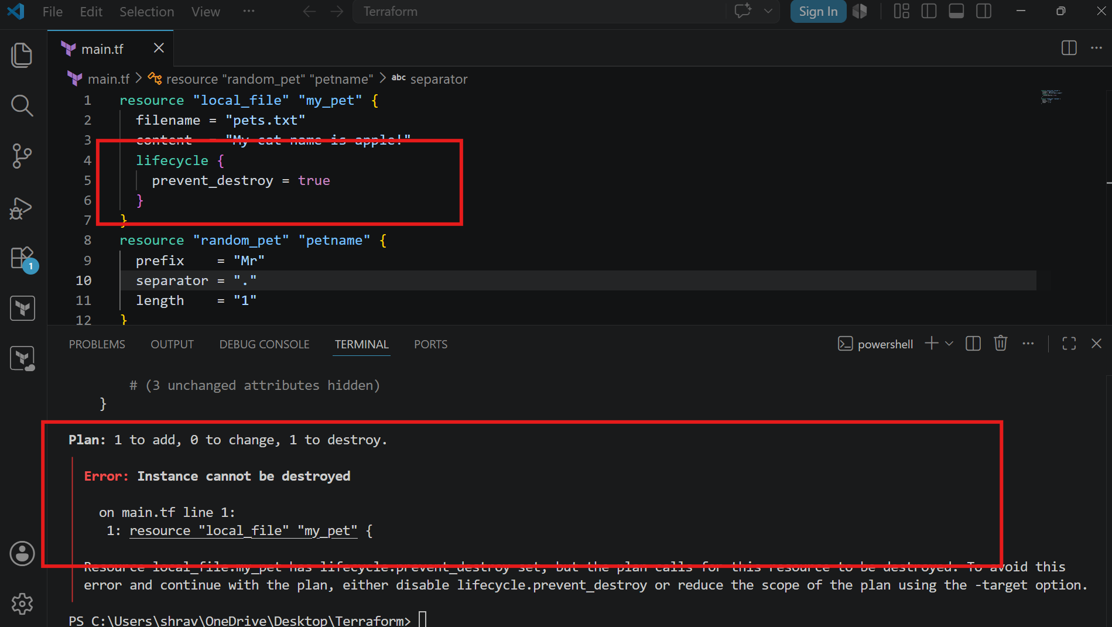
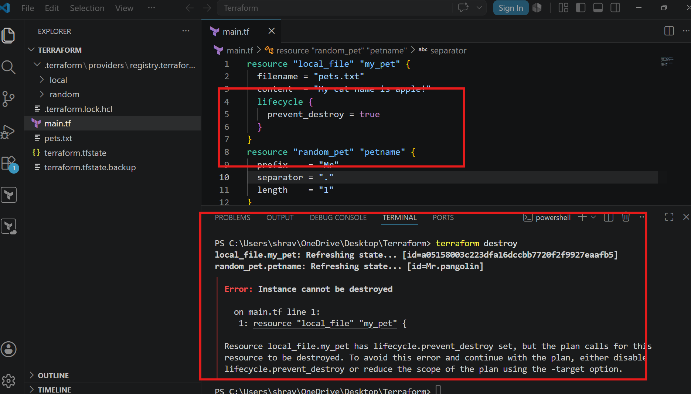
Changed in state file
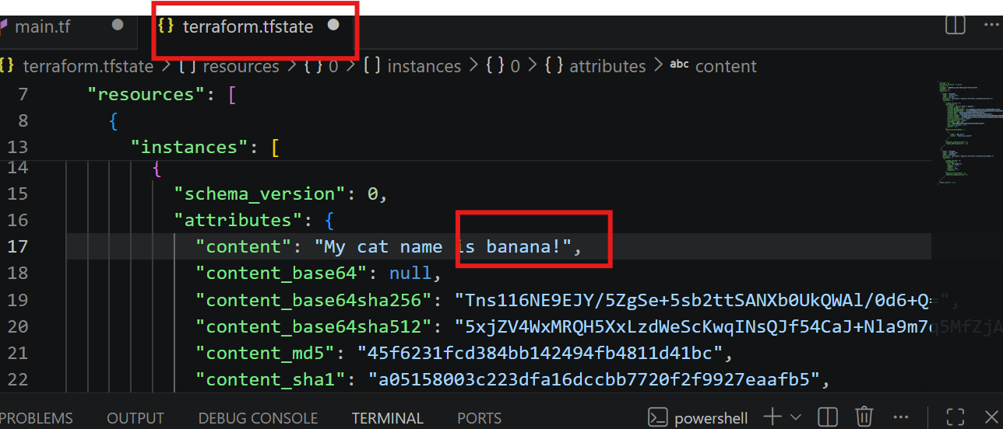
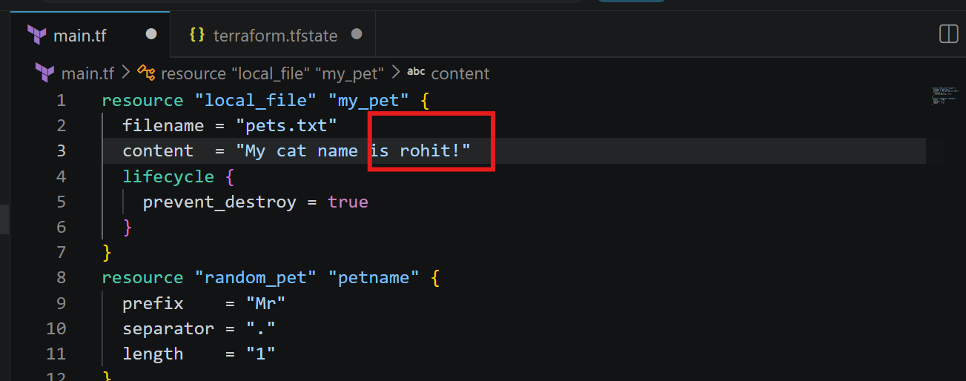
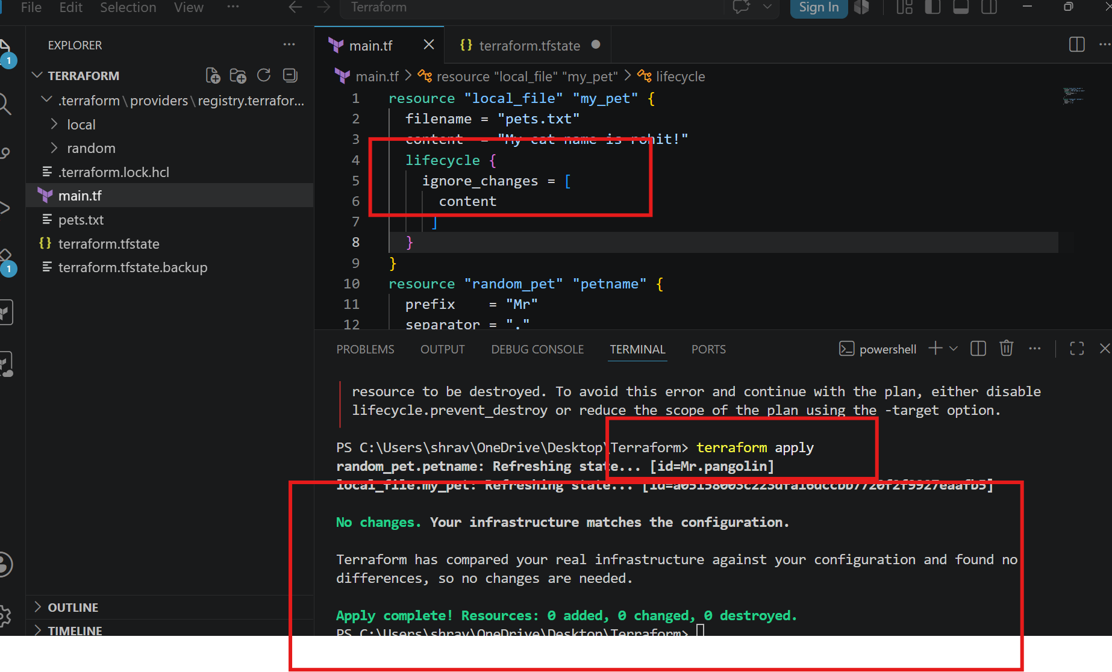
Changed to normal
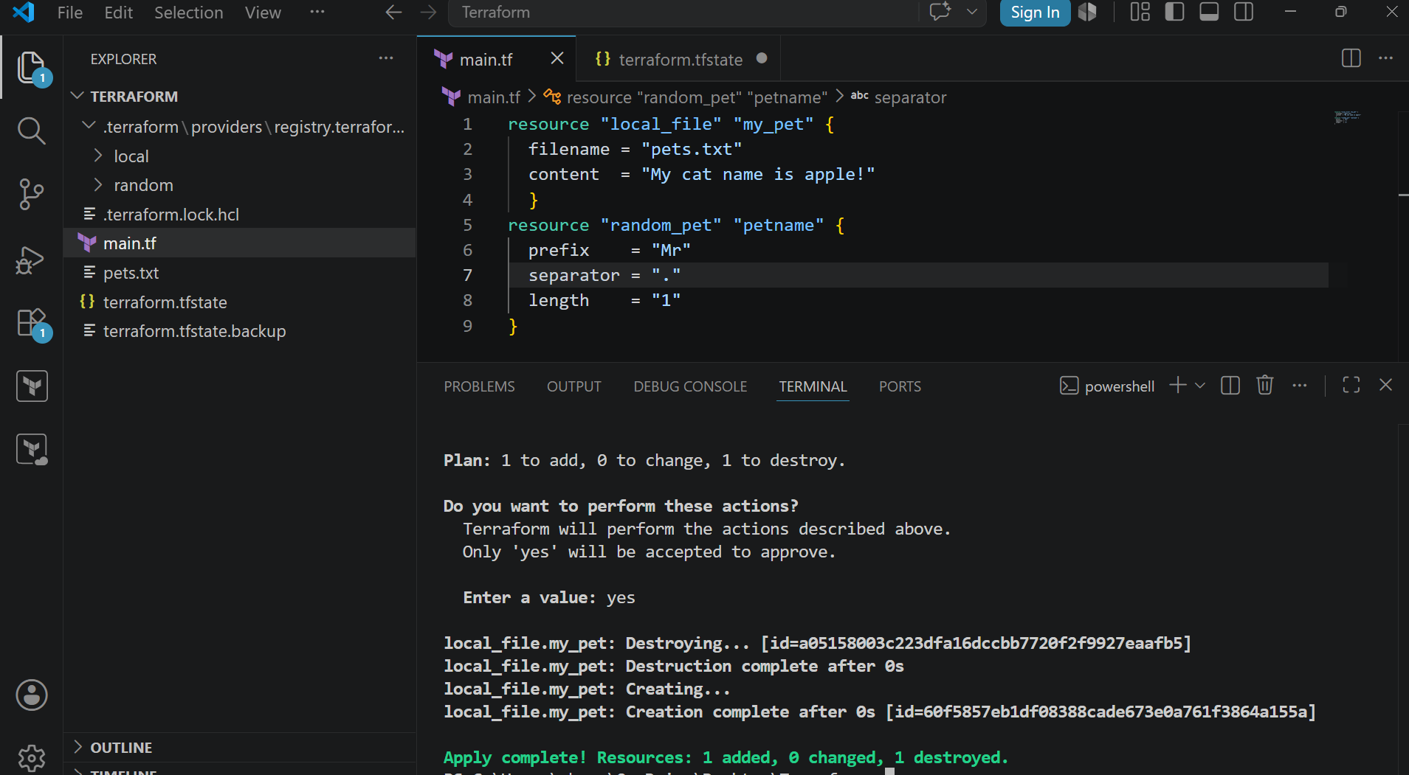
By using variables
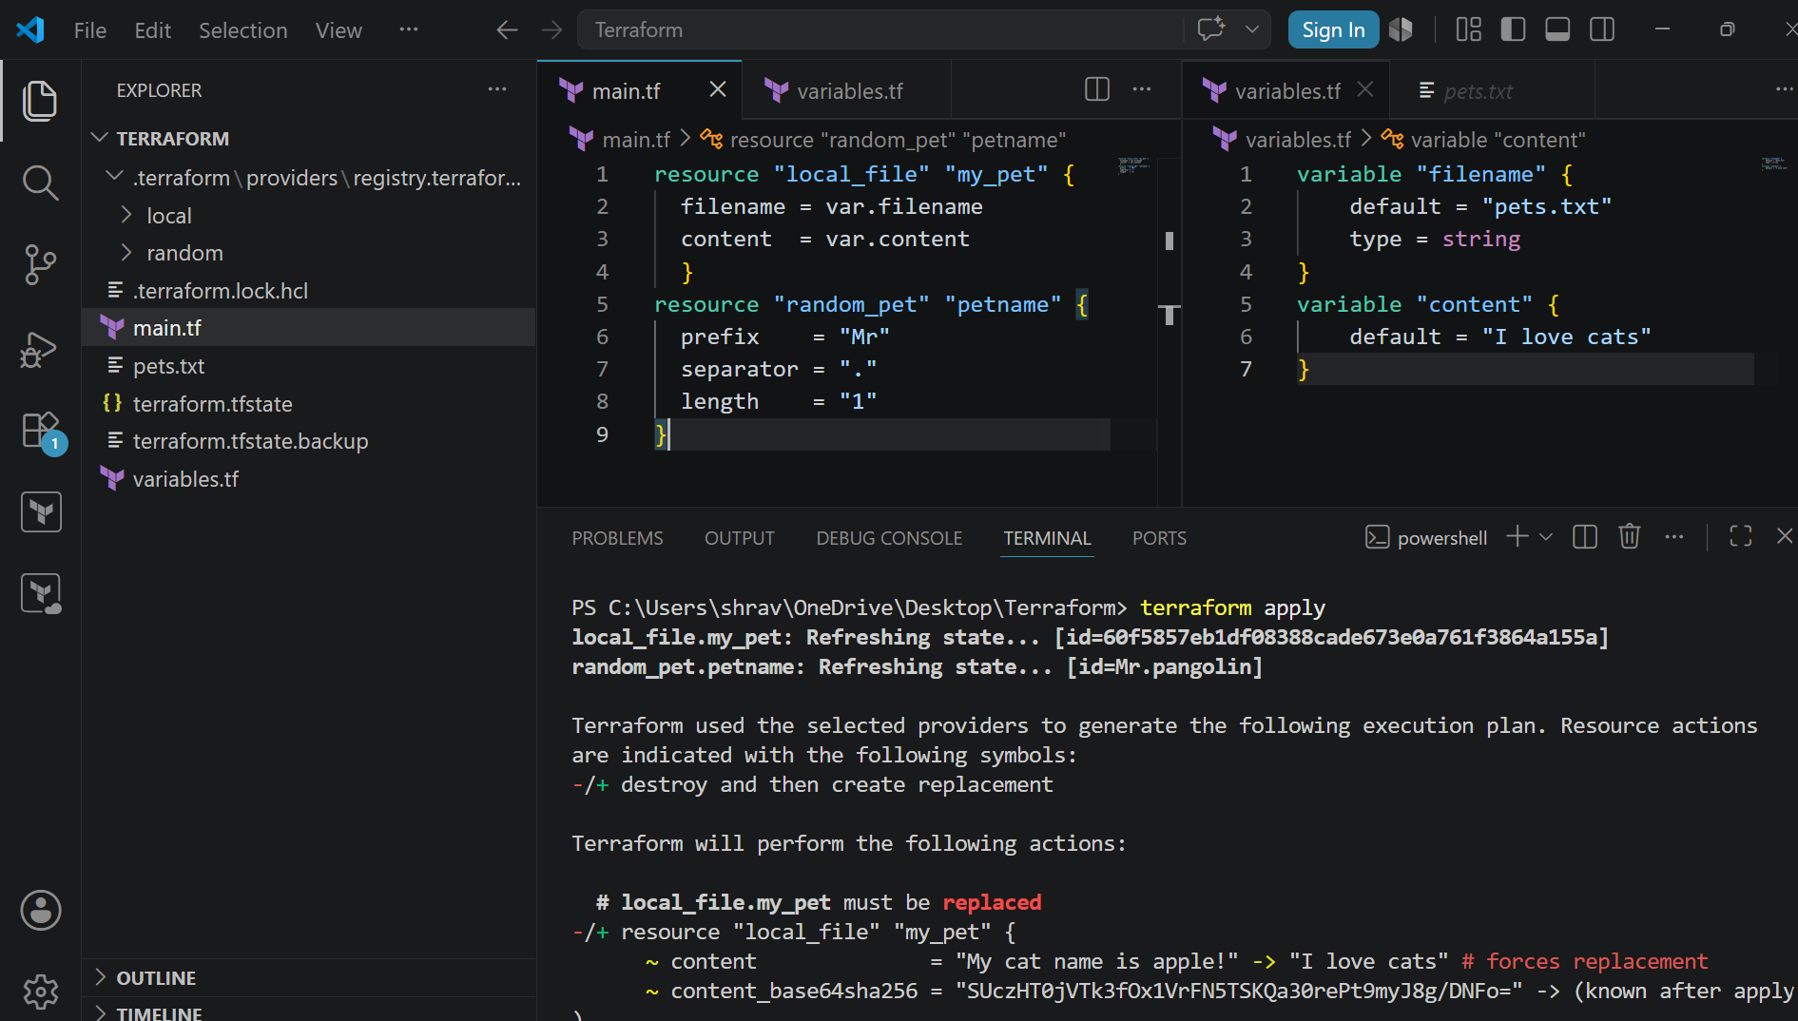
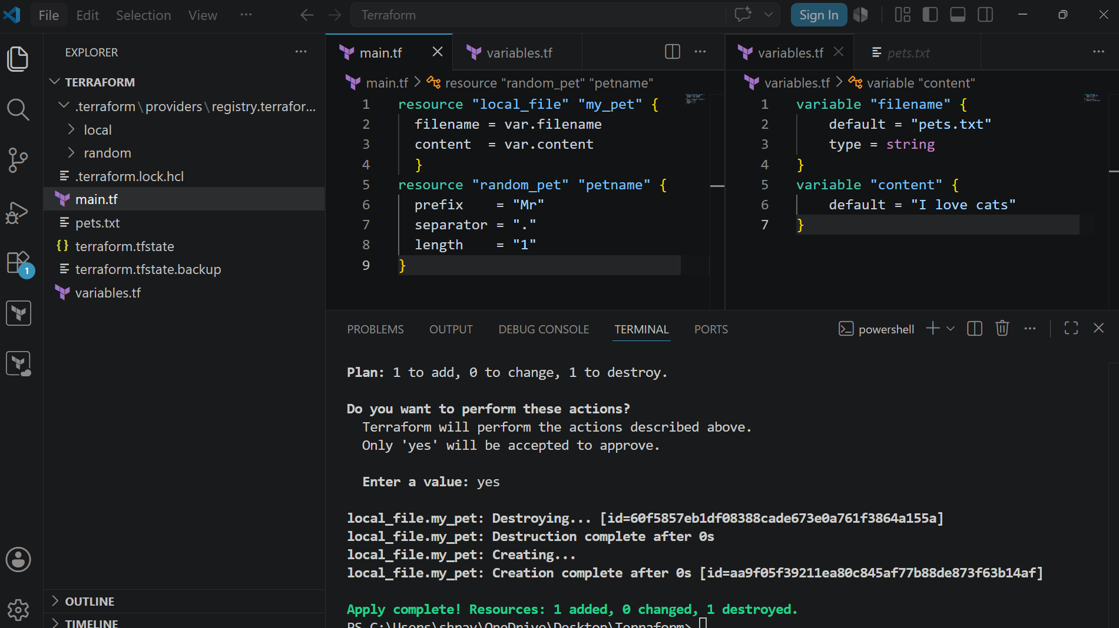
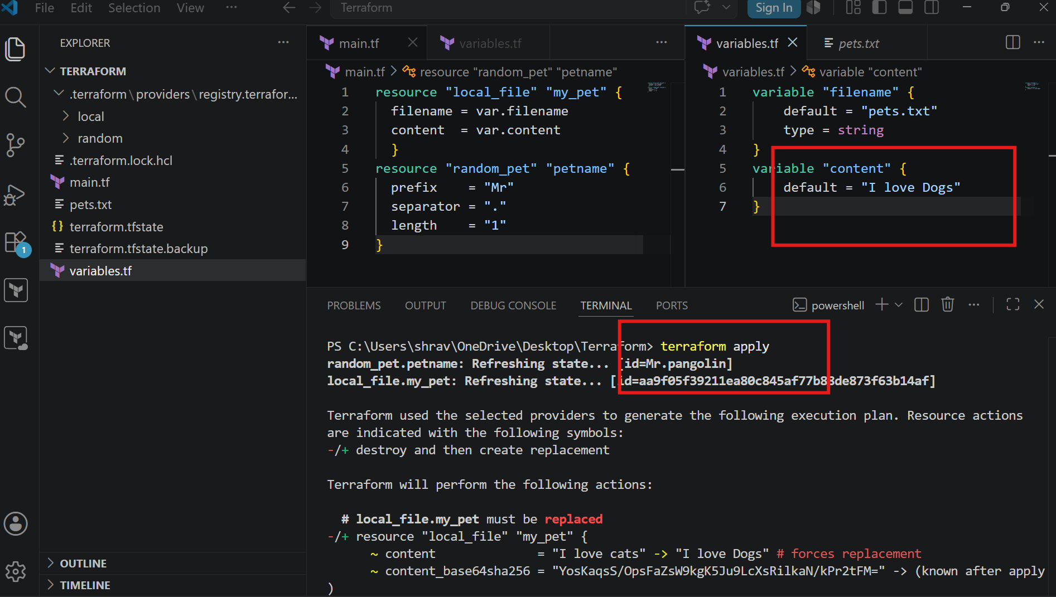
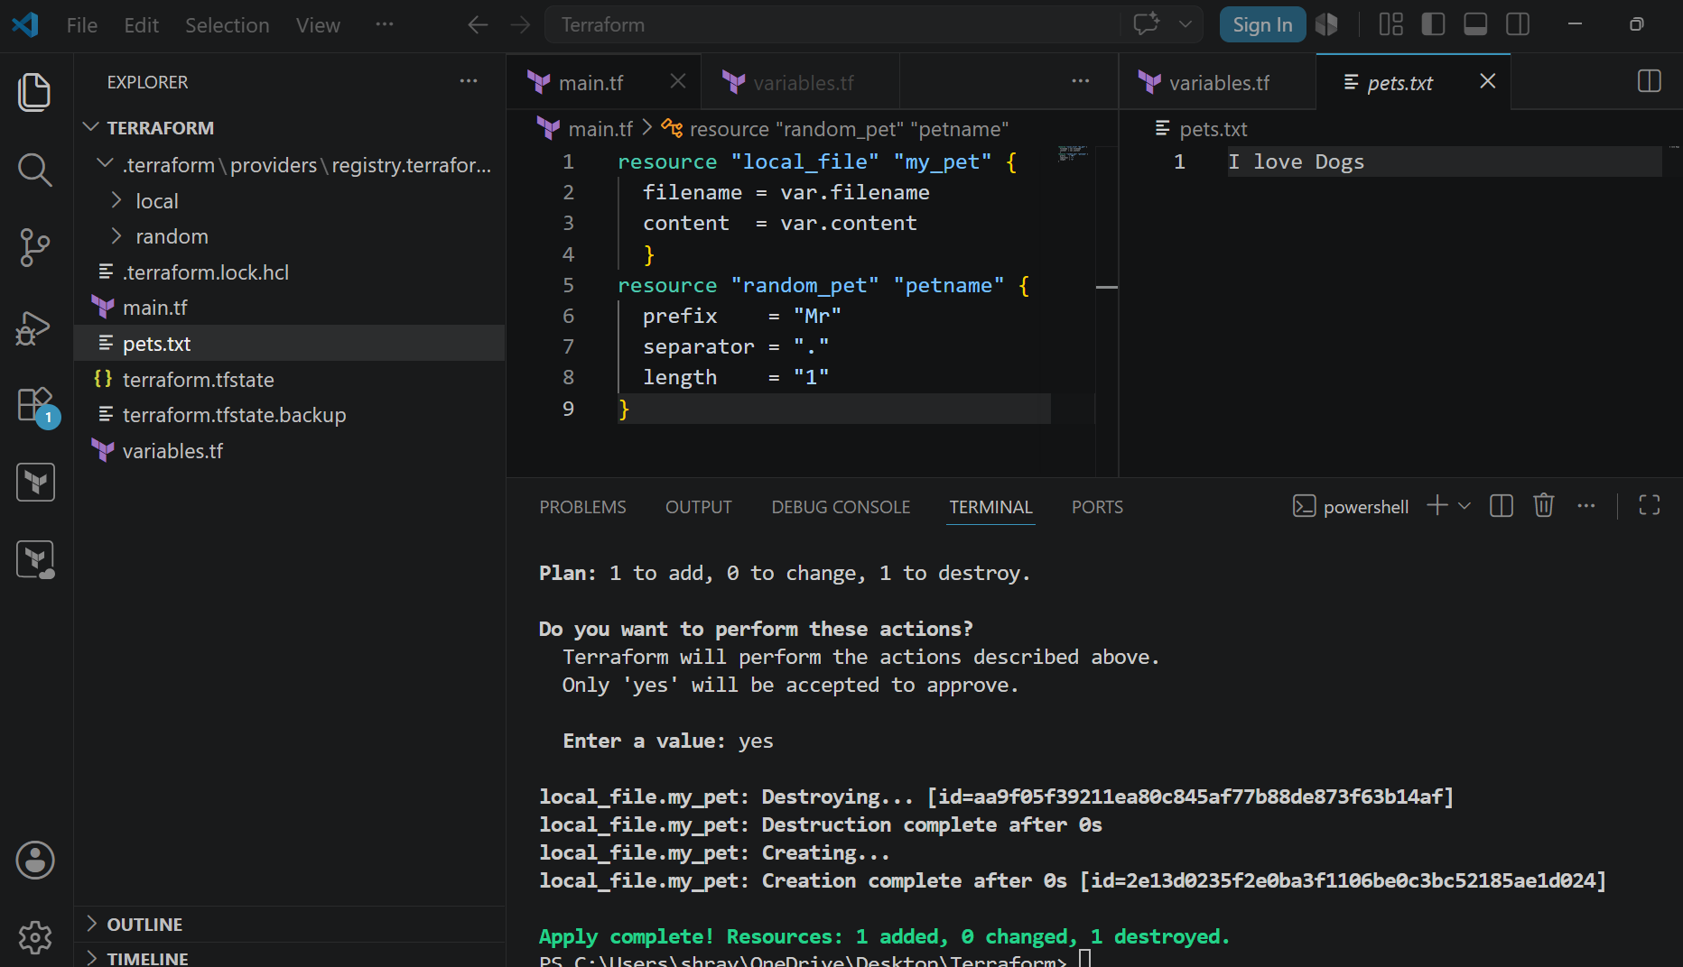
Change all into variables
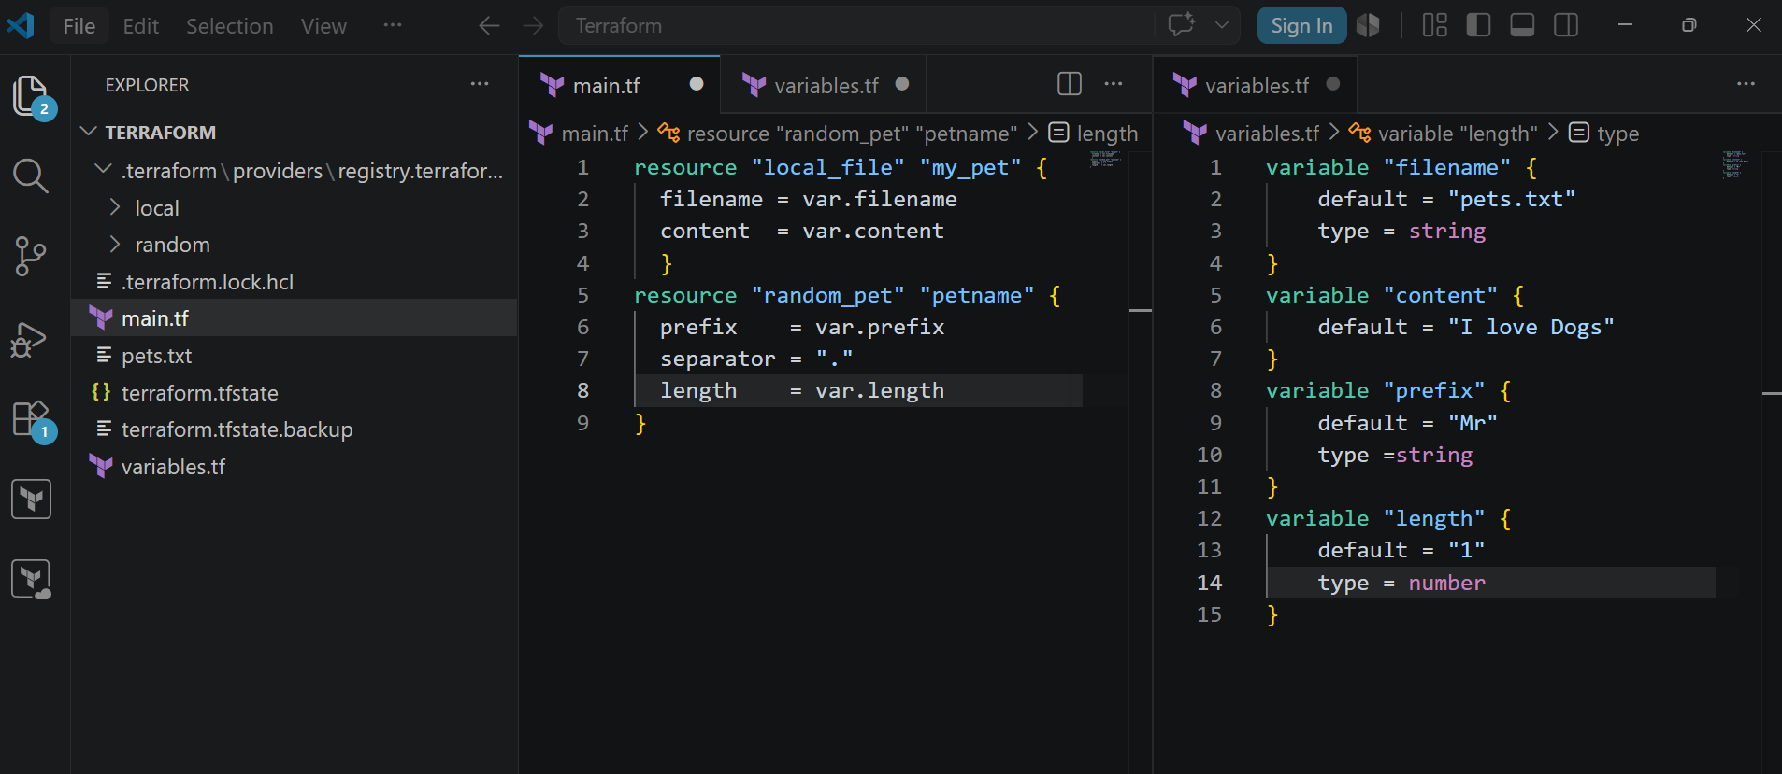
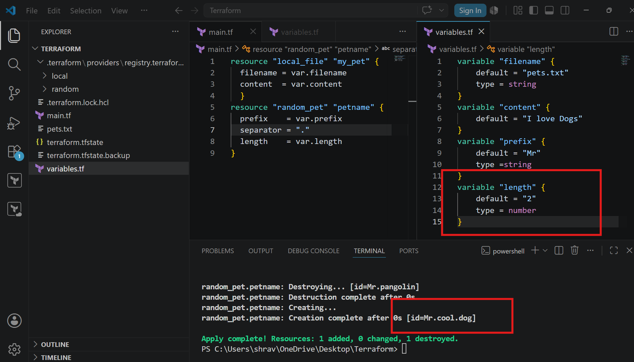
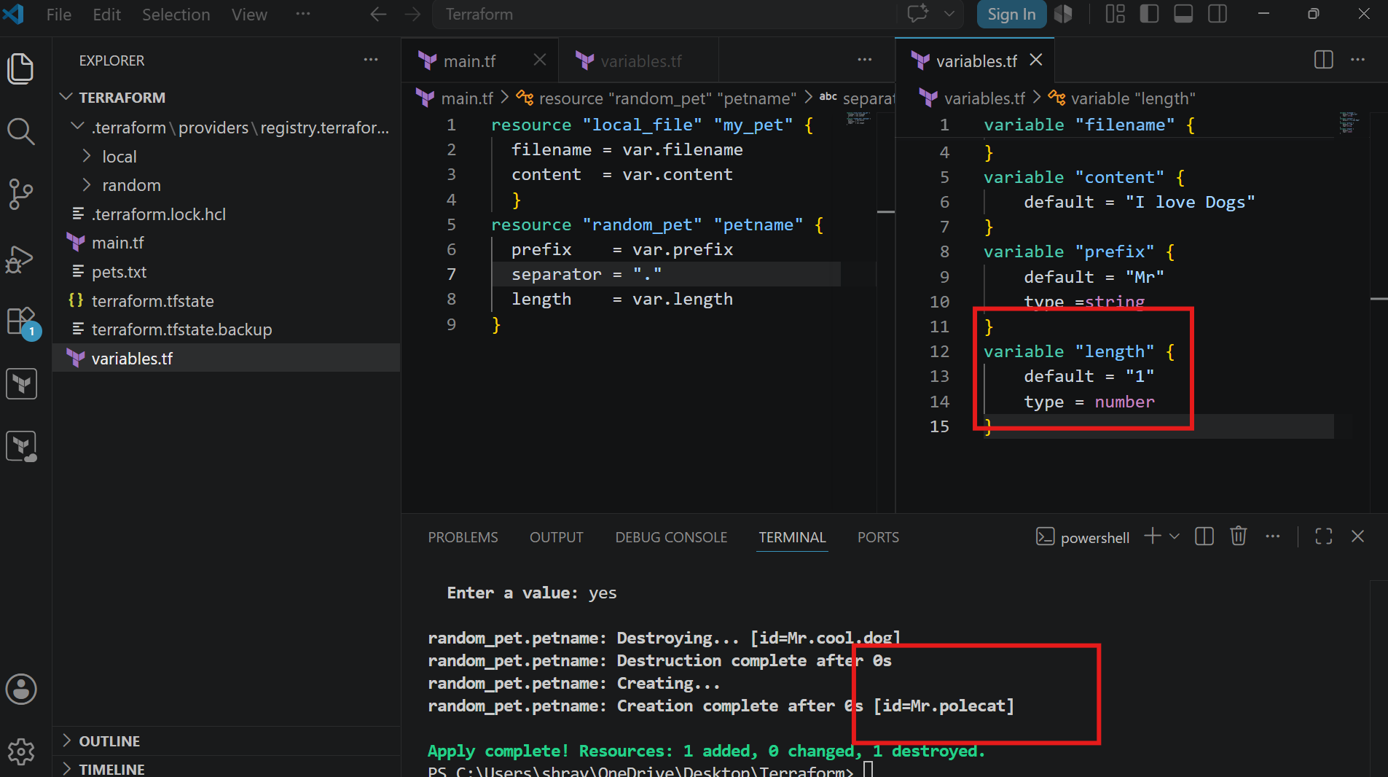
Modify the variable
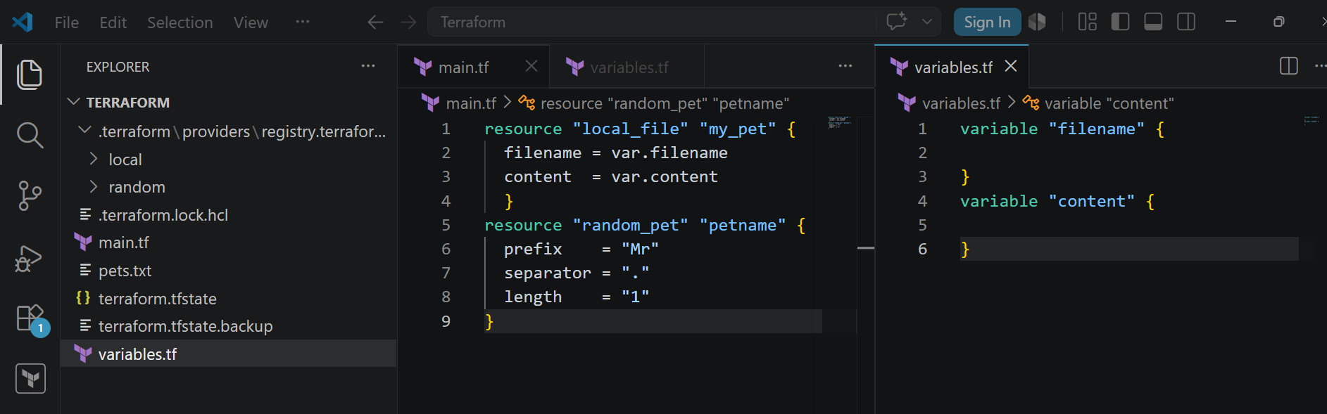
Enter the values
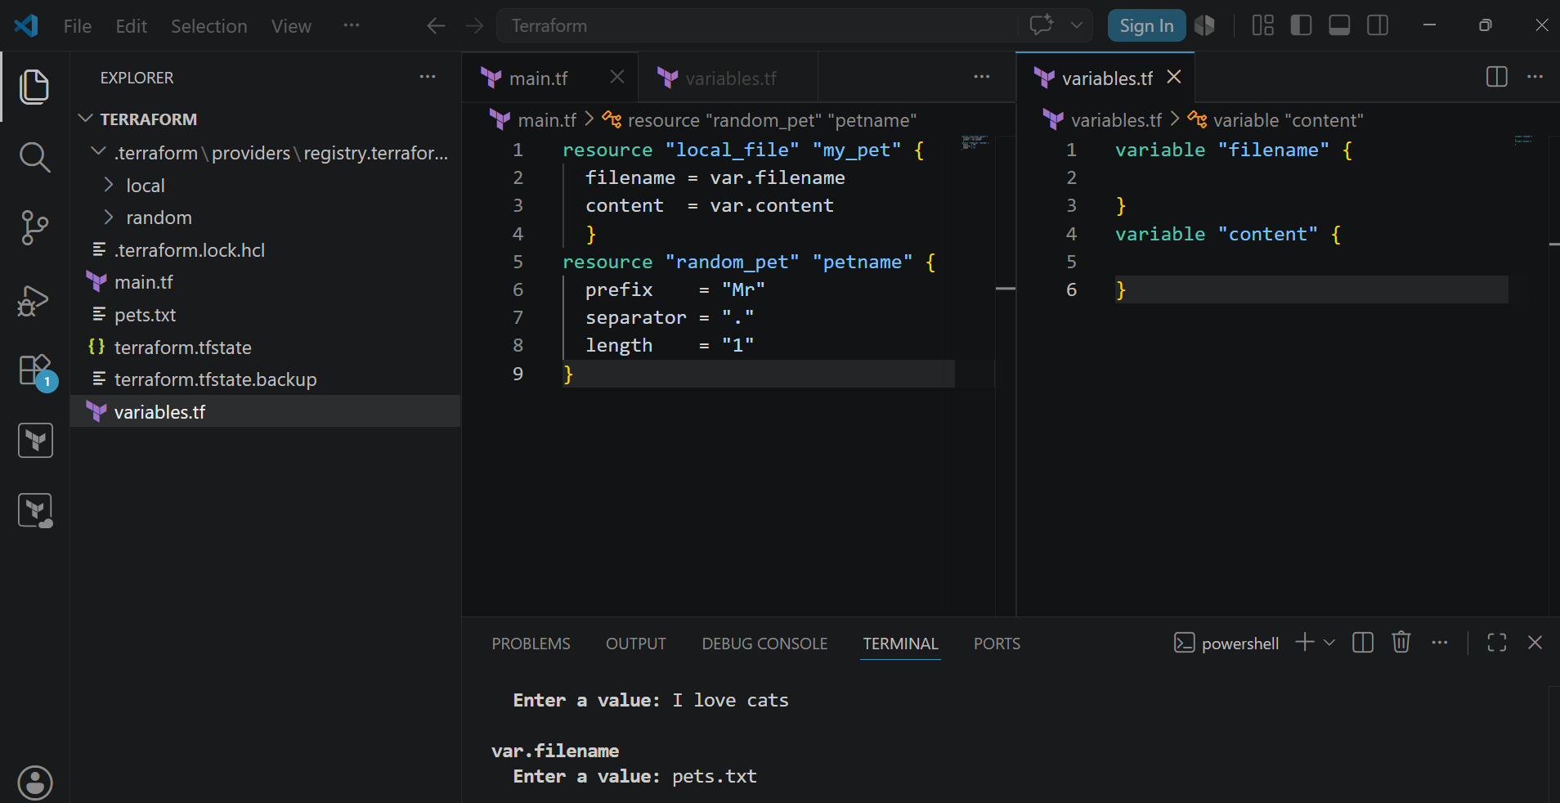
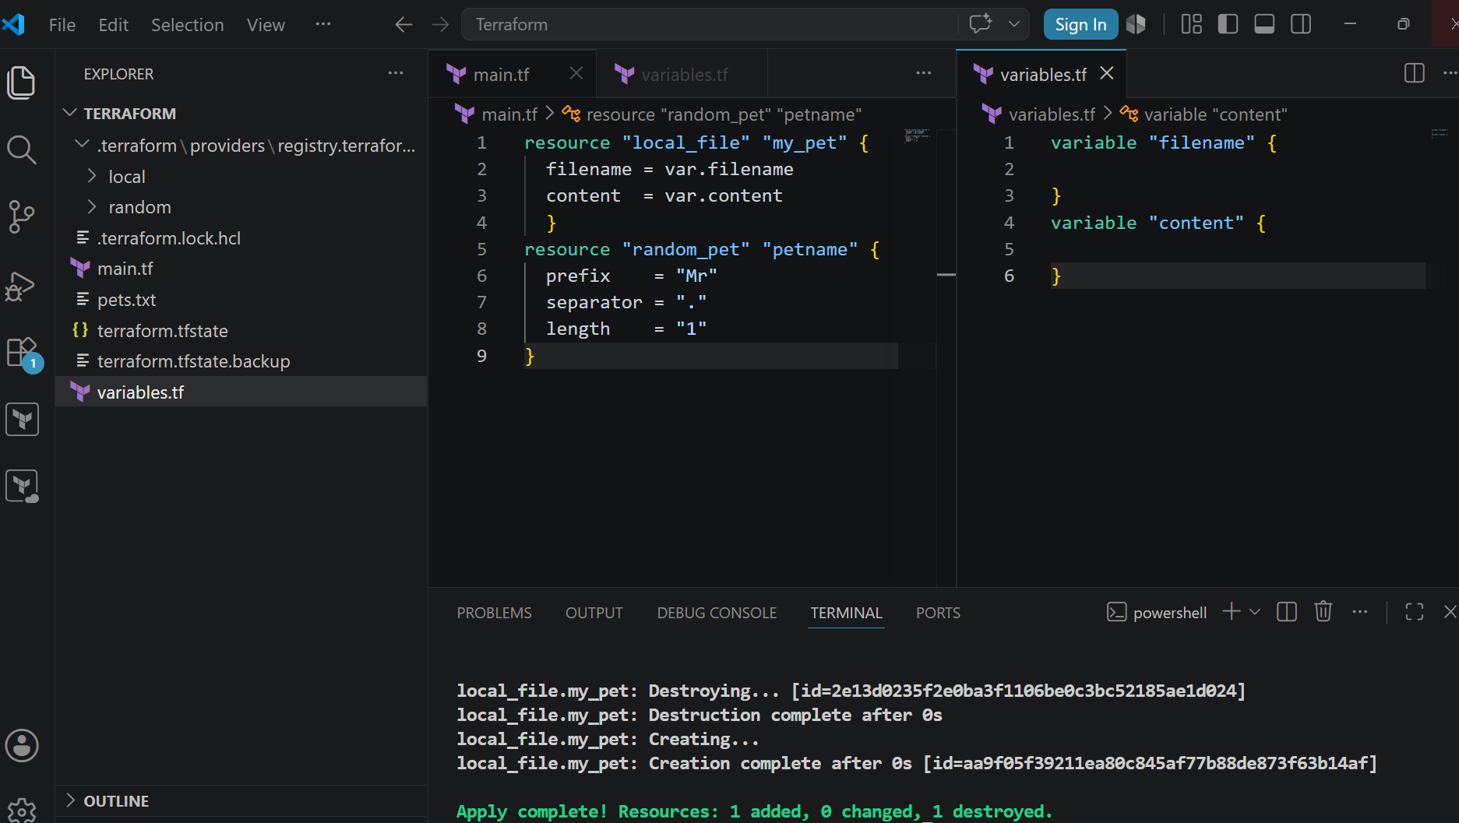
You can directly pass in the terminal as well
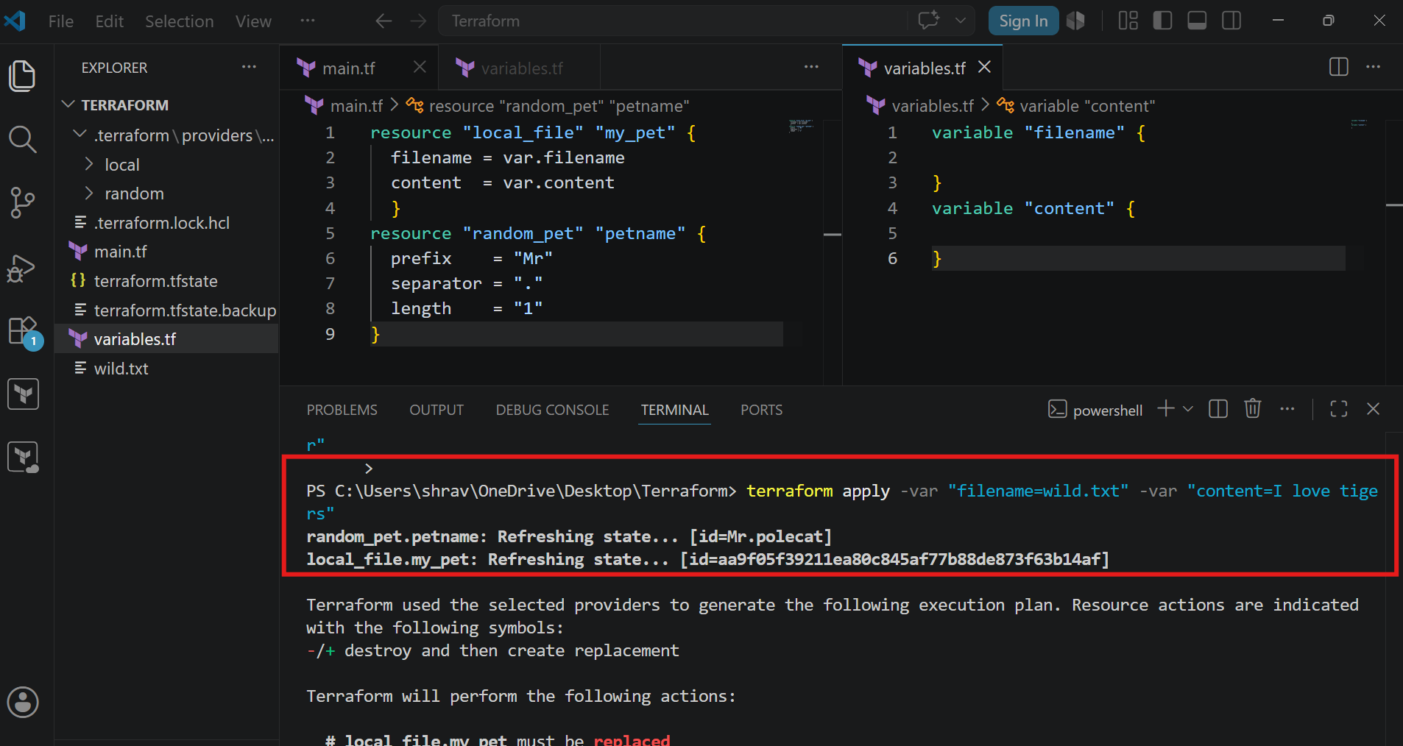
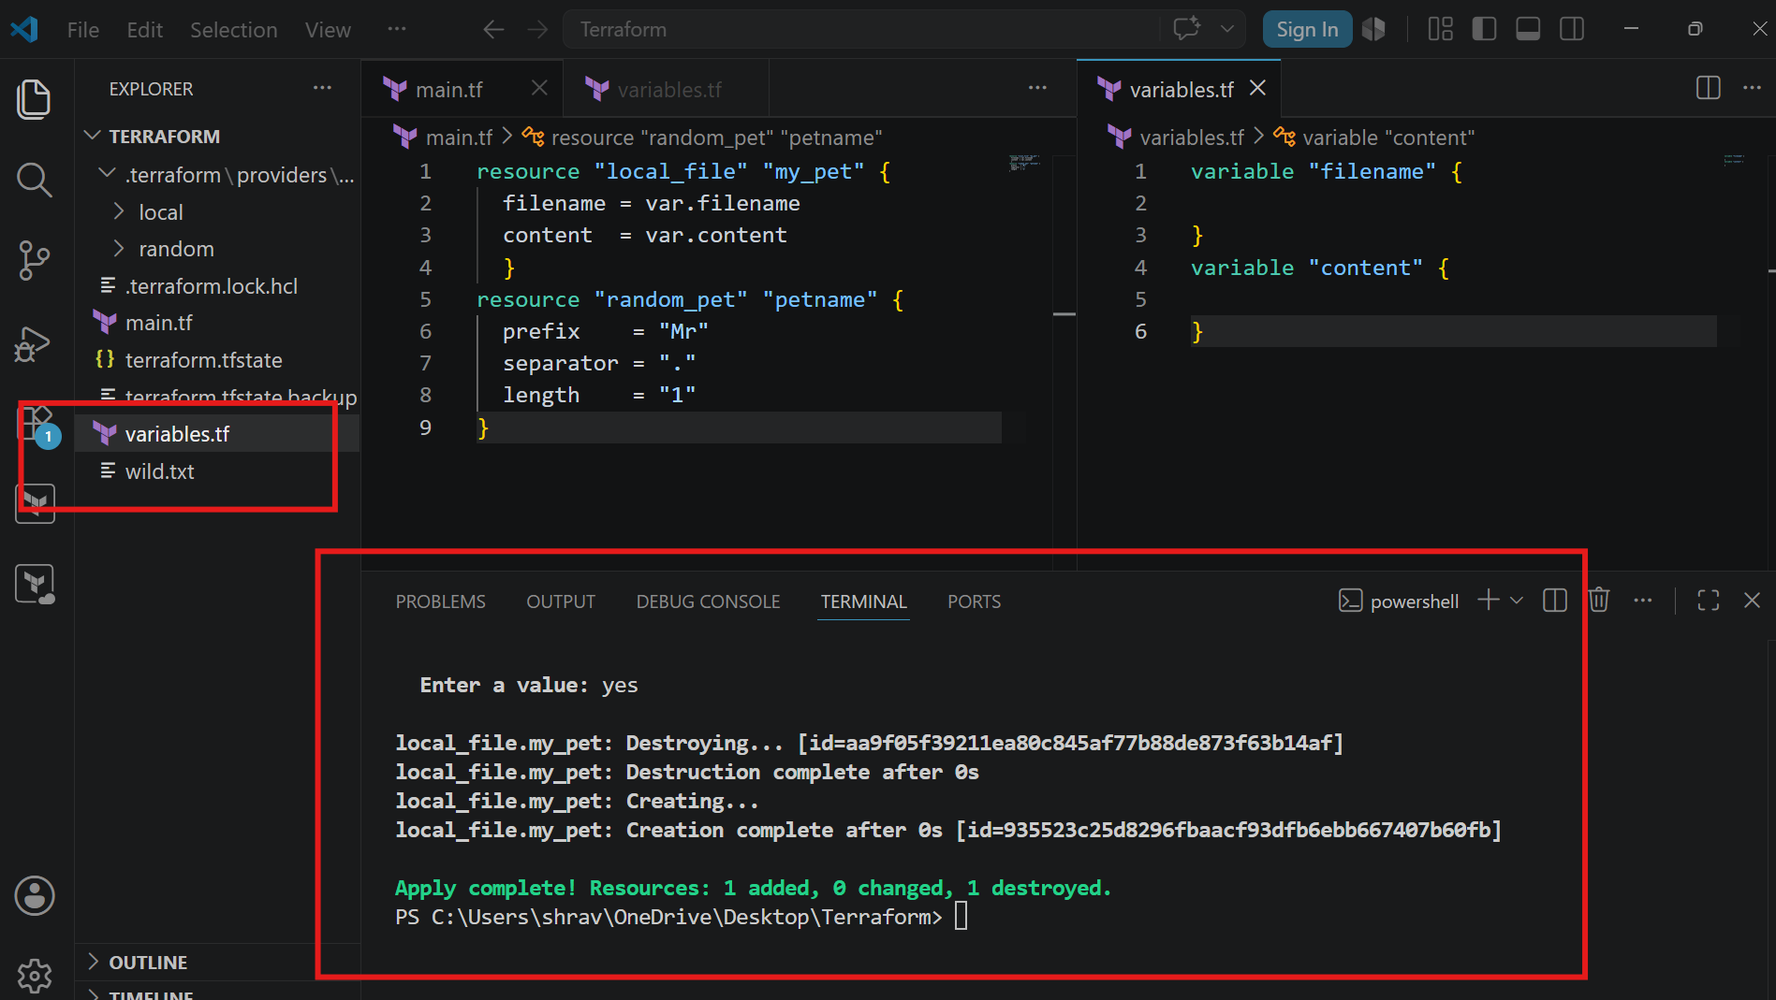
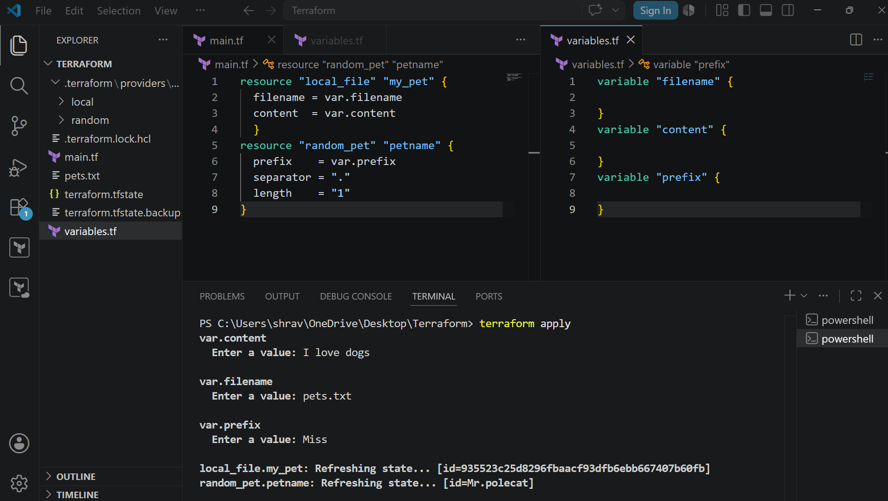
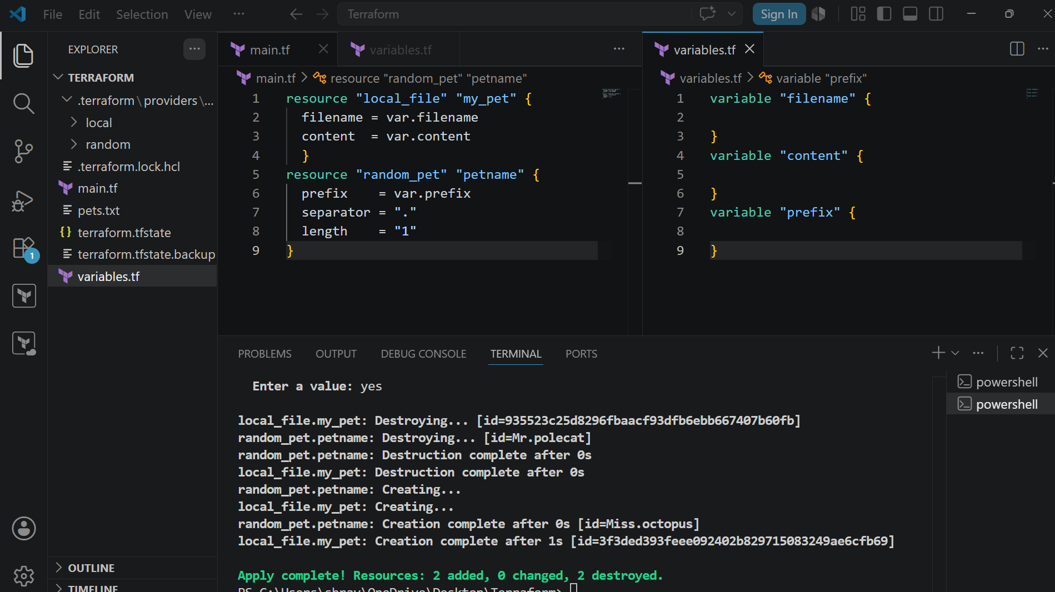
3). Integrate Terraform in Jenkins using the Terraform plugin.
Go to cd /var/lib/Jenkins/workspace/terraform-jenkins-pipe
Vi main.tf
terraform {
required_providers {
local = {
source = "hashicorp/local"
}
}
}

resource "local_file" "demo" {
filename = "shravan.txt"
content = "Hi Shravan, Welcome to Jenkins Terraform"
}
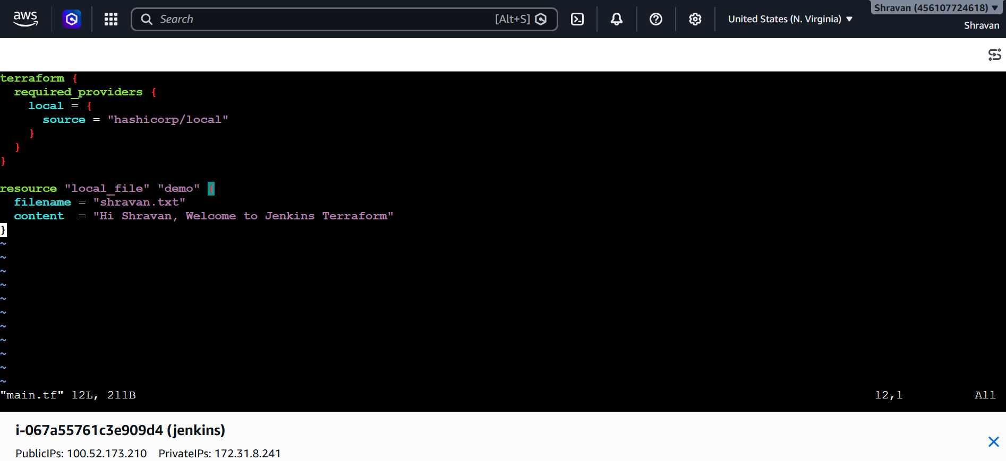
Now write a pipeline script
pipeline {
agent any

tools {
terraform 'terraform'
}

stages {

stage('Check Terraform Version') {
steps {
sh 'terraform version'
}
}

stage('Terraform Init') {
steps {
sh 'terraform init'
}
}

stage('Terraform Validate') {
steps {
sh 'terraform validate'
}
}

stage('Terraform Plan') {
steps {
sh 'terraform plan -out=tfplan'
}
}

stage('Terraform Apply') {
steps {
sh 'terraform apply -auto-approve tfplan'
}
}
}

post {
success {
echo 'Terraform deployment completed successfully.'
}
failure {
echo 'Terraform deployment failed.'
}
}
}
